Synthesis of Schiff Bases Derived From Benzaldehyde and Salicylaldehyde With Some Amino Acids by a New Develop Method.

A.S.P.Azzouz
Chemistry Dept. College of Education, Mosul University, Iraq
R.T. Ali
Chemistry Dept. College of Education for Girls, Mosul University, Iraq

Key words : synthesis of Schiff bases , new catalyzed method , new Schiff bases , aromatic aldehydes , amino acids , physical methods .

(NJC)

(Recevied on 14/12/2008) (Accepted for publication 12/1/2010)

Abstract
The project is aimed at the synthesis of some Schiff bases derived from benzaldehyde and salicylaldehyde with some amino acids as glycine, DL-alanine ß-alanine, and L- methionine, with a new alternative method. The development includes the use of 10⁻²mole sodium hydroxide as a new catalyst, which is added to the classical method of Schiff bases synthesis. This method is applied successfuly to the synthesis of six imines from compounds mentioned .The structures of these Schiff bases are confirmed by using physical methods, namely, melting points or boiling point, UV and IR spectra. Finally a new suggested mechanism for the reaction mechanism is given, which is composed from three steps, on of them is slow, the other two are fast .
الخلاصة
يهدف هذا البحث الى تحضير بعض قواعد شيف المشتقة من البنزالديهايد والساليسالدهايد مع بعض الاحماض الامينية مثل الكلايسين , DL- الانين , -ß الانين و-L ميثيونين بطريقة بديلة . التحديث في طريقة التحضير يتضمن استعمال 10⁻²mole من هيدروكسيد الصوديوم كعامل محفز جديد والذي اضيف الى الطرق التقليدية لتحضير قواعد شيف . طبقت هذه الطريقة وبنجاح لتحضير ستة ايمينات من المركبات المشار اليها اعلاه . لقد تم التاكد من تحضير قواعد شيف باستعمال الطرق الفيزيائية مثل قياس درجات الانصهار او الغليان و قياس طيف IRو UV.
اخيرا تم اقتراح ميكانيكية جديدة للتفاعل والتي تتضمن ثلاثة خطوات احدها تكون بطيئة اما بقية الخطوات فهي سريعة .

Introduction
The condensation of primary amines with aldehydes and ketones has a numerous applications⁽¹⁾, for preparative, detection, determination and purification uses. These applications ⁽²⁻³⁾ encourage the workers to prepare these imines for the last 10 decades.
The classical method⁽¹⁾ for synthesis of imines is by mixing equimolar quantities of aldehyde or ketone with with the primary amines. The reaction of imine formation is reversible, usually, it was advisable to remove the water was formed by distillation or by using an azeotrope – forming solvent⁽⁴⁻⁵⁾. This method had applied successfuly to the synthesis of Schiff bases from reactions of 4,4-dimethyl-3-oxo valeraldehyde, acetylacetone and benzoylacetone with aromatic amine⁶, hydroxy Schiff bases⁽⁷⁾ from salicylaldehyde, o-hydroxy acetophenone, ß-hydroxyl naphthaldehyde and 4,5- dimethyl-o-phenylene diamine, benzil mono benzylidene aniline ⁽⁷⁾, amono and bi Schiff bases ⁽⁸⁾ from salicylaldehyde with o,m and p-phenylene diamine and others ⁽⁹⁻¹¹⁾. With ketones ⁽¹⁾, especially the aromatic ones, higher temperatures, longer reaction times and catalyst are usually required, in addition to the removal of water as it formed. Among the catalyst ⁽¹⁾ were used in the synthesis as protonic acid ¹², BF₃ ¹³, ZnCl₂ ¹² and POCl₃ ¹⁴.
In our laboratory, some difficulties are observed during synthesis of Schiff bases from amino acids with benzaldehyde or salicylaldehyde. This is probably for a similar reasons mentioned before. Therefore, it is of valuable importance to deal with alternative method of synthesis for these compounds. This prompted the synthesis of a new Schiff bases from some amino acids with salicylaldehyde and benzaldehyde. A special care is give to the structural elucidation of these new imines by using physical methods namely, melting points or boiling point, UV and IR spectra.
Experimental
All chemical compounds are used throughout the work are of Fluka origine. They are use as supplied as ethanol, sodium hydroxide, glycine, DL- alanine, ß-alanine, and L-methionine. Salicylaldehyde and benzaldehyde are purified by distillation. They have a B.p's of 197C◦ and 95C◦(50 mmHg) respectively.
InstrumentalLLLLL
The m.p's of solid Schiff bases are measured by electrothermal m.p apparatus model BÜCHI 510.
The IR spectra for liquid or solids Schiff bases are measured by a computerized FTIR, Bruker model Tensor 27 .
The UV for 10⁻³M ethanolic solutions of Schiff bases are measured by a computerized double beam Shimazu type UV-1601. Silica cells of dimensions 1×1×3 cm³ are used. Synthesis of Schiff bases The general theortical procedure of synthesis is by mixing 10⁻² mole each of benzaldehyde or salicylaldehyde, the suitable amino acid and sodium hydroxide in ethanol, as in the following details:-
1- Synthesis of salicylidene glycine (1), salicylidene DL- alanine (2)and salicylidene ß-alanine (3) .
- In a 50 ml conical flask, prepare a separate 10⁻² mole solutions by dissolving (1.2g) of salicylaldehyde, (0.75g) of glycine, (0.89g) of DL- alanine, (0.89g) of ß-alanine,and (0.4g) of sodium hydroxide, in 15 ml of ethanol.
- To prepare any Schiff bases stated, mix the salicylaldehyde solution with the proper amino acid solution and the mixture is stirred. By gradual addition, adds the sodium hydroxide solution to each mixture during a period of 30 minntes. The final mixture is left for about 15 minutes, filtered, washed with cold ethanol and dried. Pure products have m.p's of 180C◦ , 195C◦ ( decomp. ) and 120C◦ for Schiff bases 1-3 respectively.
  - Synthesis of salicylidene L-methionine (4)
A similar procedure is given to salicylidene glycine, by replacement of (0.75g) pure liquid glycine with (1.81g) L-methionine. Pure product has B.p of(100-102) C◦.
- Synthesis of benzylidene glycine (5)and benzylidene DL-alanine (6) .
In 50 ml round bottom flask attached with a reflux condenser, mix 1.06 g of benzaldehyde, (0.75g) of glycine or (0.89g) of DL-alanine and (0.4g) of sodium hydroxide. Add 20 ml of ethanol to each mixture and the final mixture is refluxed for 3 hours for benzylidene glycine or 2 hours for benzylidene DL- alanine. The mixture is cooled and filtered. Products are washed with cold ethanol and dried. Pure products have a melting points of 195C◦ (decomp.) and 110C◦ for Schiff bases (5) and (6) respectively. A confirmation for carboxylic sodium salt for Schiff bases (2) and (5) are obtained by solubility test in water and flame ignition. They have a moderated to good solubility in water and left a black solid materials by flame ignition.
InstrumentalLLLLL
The m.p's of solid Schiff bases are measured by electrothermal m.p apparatus model BÜCHI 510.
The IR spectra for liquid or solids Schiff bases are measured by a computerized FTIR, Bruker model Tensor 27 .
The UV for 10⁻³M ethanolic solutions of Schiff bases are measured by a computerized double beam Shimazu type UV-1601. Silica cells of dimensions 1×1×3 cm³ are used. Results and Discussion
This project describs failure synthesis of Schiff bases from salicylaldehyde or benzaldehyde with some amino acids, by the usual classical synthetic method ⁽¹⁾. This is because of the reversible nature of synthesized Schiff bases reaction. Some workers had previously used a several catalysts ^{(1,12-14)} to overcome on such problem. Now we report the use of sodium hydroxide catalyst for the first time during synthesis of Schiff bases under study. This developement in the procedure of synthesis by adding sodium hydroxide as a new catalyst is highly accepted from kinetic ⁽¹⁵⁾ point of view.
Table (1) shows the nomenclature, melting point or boiling point of Schiff bases prepared, beside their IR and UV spectra.
The IR spectra of Schiff bases under study are shown in Fig.1, and illustrate the following wavenumbers:-
- A broad stretching wavenumbers range between (3385.41- 3424.33)cm⁻¹
Which confirm OH group in the carboxyl group of Schiff bases.
- A strong to medium intensity bands are assigned to carbonyl groups in Schiff bases. They have a stretching frequency ranged between (1633.20-1745.51) cm^{-1.} All stretching frequency lower than 1700 cm⁻¹ can be explained by the fact of carboxylic acids can exist in dimeric, trimeric and polymeric⁽¹⁶⁾ species by the aid of intermolecular hydrogen bonding and the condition of IR measurement i.e whether if it is in solid or solution state and the temperature. Hence these strong hydrogen bondings stated are accompined by weaken the double bond of carbonyl group in carboxylic acid. The last results are expected and will shift the frequency of C = O
group to lower value ⁽¹⁷⁾ of wavenumber.
- A strong to medium intensities bands are assigned to carbon nitrogen double bond i.e C = N, with stretching frequency range between (1594.01-1625.00)cm⁻¹.
- Schiff bases (4), shows a medium absorption band a wavenumber of 738.75cm⁻¹for carbon sulphur C-S linkage.
- Schiff bases numbers 2 and 4 show a linkage for sodium of carboxyl acid i.e -ONa at a wavenumbers of 645.95(s) and 759.86 (m) respectively. These values confirm the existence of these compounds as a sodium salts for carboxylic acids.These support the solubility and ignition testes stated before.
The UV spectra of Schiff bases under study are also shown in Fig.2 and are summarized in Table (1). This table shows that all UV spectra of Schiff bases have two bands at wavelengths of λ nm values with their molar extinction coefficient values of ε_{max} in units of Liter.mole⁻¹.cm⁻¹.The lower wavelengths bands for all Schiff bases have a range of values between 246-255nm.They are assigned to the aromatic nature of all Schiff bases observed in Table (1).These bands have a molar extinction coefficient values ⁽¹⁸⁾ of greater then one thousand and are attributed to the π → π* of the aromatic system . The longer wavelengths bands for the same Schiff bases as in Table (1) also have a range of values between 282-328 nm and are assigned to C = N or C = O linkages or a combination of them . Their ε_{max} have either a values ⁽¹⁸⁾ greater than a thousand for π → π* as in Schiff bases number 2-4 or lower than the value ⁽¹⁸⁾ mentioned for n → π* as in Schiff bases numbers 1,5 and 6.
Finally, all IR and UV data beside other physical constants collected in Table (1) agree ⁽¹⁸⁻²¹⁾ well with the chemical structures of Schiff base shown in the same Table.
Hence, from the foregoing discussions the following mechanism is suggested for the synthesis of our Schiff base:-

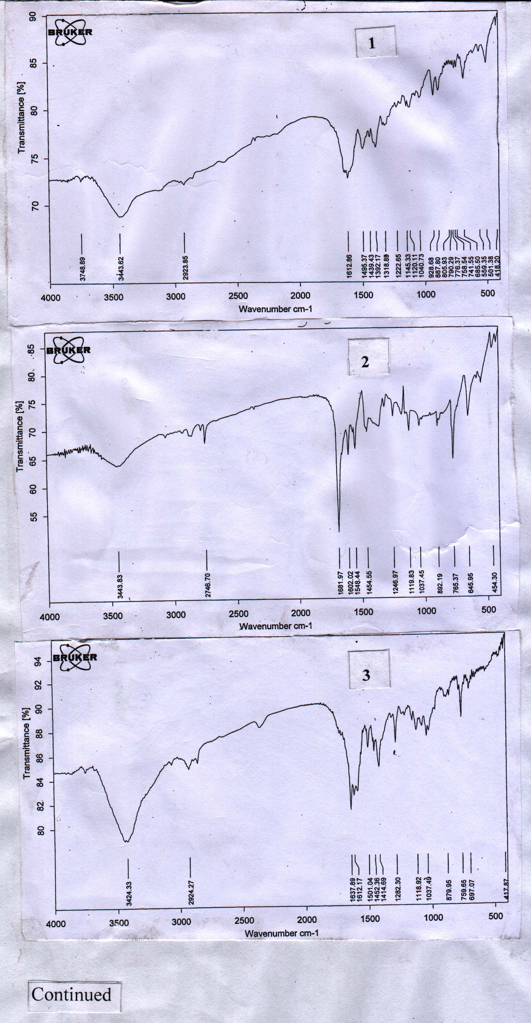

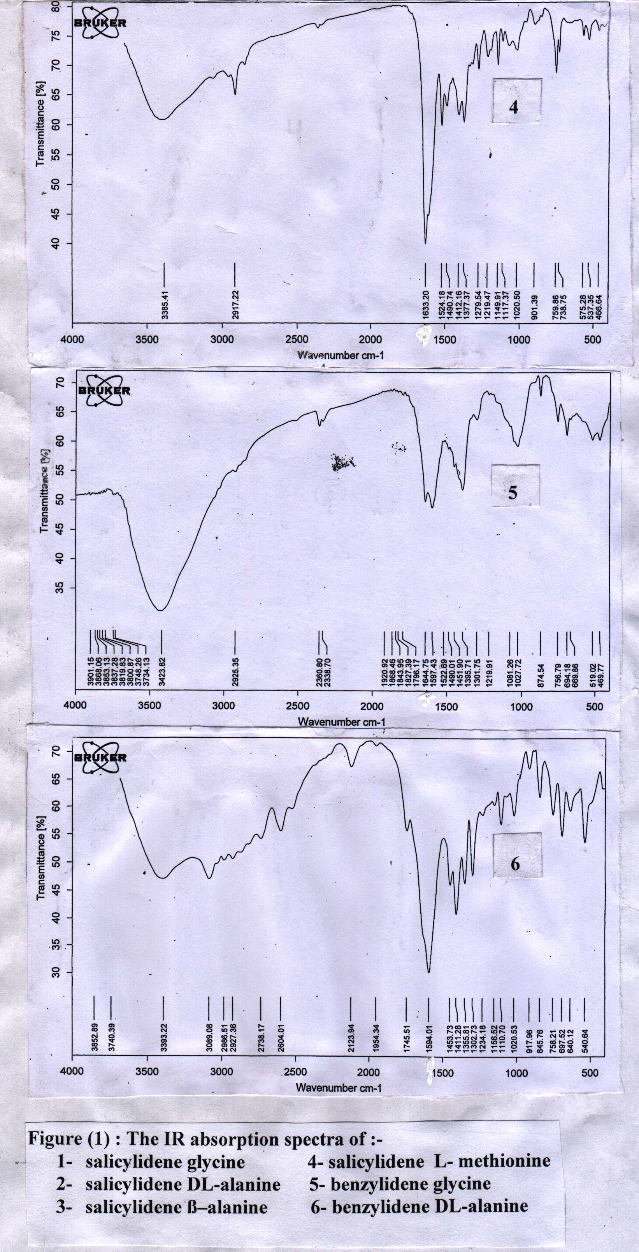

Table (1) Physical constants for Schiff bases prepared.
UV bands λnm(ε_{max}) | IR bands cm⁻¹ |  |  |  |  | colour | m.p or B.p* (c◦) | Nomenclator | No.
UV bands λnm(ε_{max}) | ONa- | C-S | C = N | C = O | OH
255(1932),327(680) |  |  | 1618 |  | 3443.62 (b) | yellow | 180 | salicylidene glycine | 1
247(2933),327(1950) | 645.95 (s) |  | 1602.02  (m) | 1681.97  (s) | 3443.83 (b) | orange | 195C◦  (decomp.) | salicylidene DL-alanine | 2
250(2669),326(1376) |  |  | 1612.17 (s) | 1637.89(s) | 3424.33 (b) | Faint yellow | 120 | salicylidene ß–alanine | 3
251(2478),328(1116) | 759.86  (m) | 738.75  (m) | 1625.00 (s) | 1633.20(s) | 3385.41 (b) | brown | 100-120* | salicylidene L- methionine | 4
247(1472),282(91) |  |  | 1597.43 (s) | 1644.75(s) | 3423.82 (b) | milky | 195C◦ (decomp.) | benzylidene glycine | 5
246(1693),283(194) |  |  | 1594.01 (s) | 1745.51(m) | 3393.22 (b) | Faint orange | 110 | benzylidene DL-alanine | 6

1- 4-

2- 5-

3- 6-

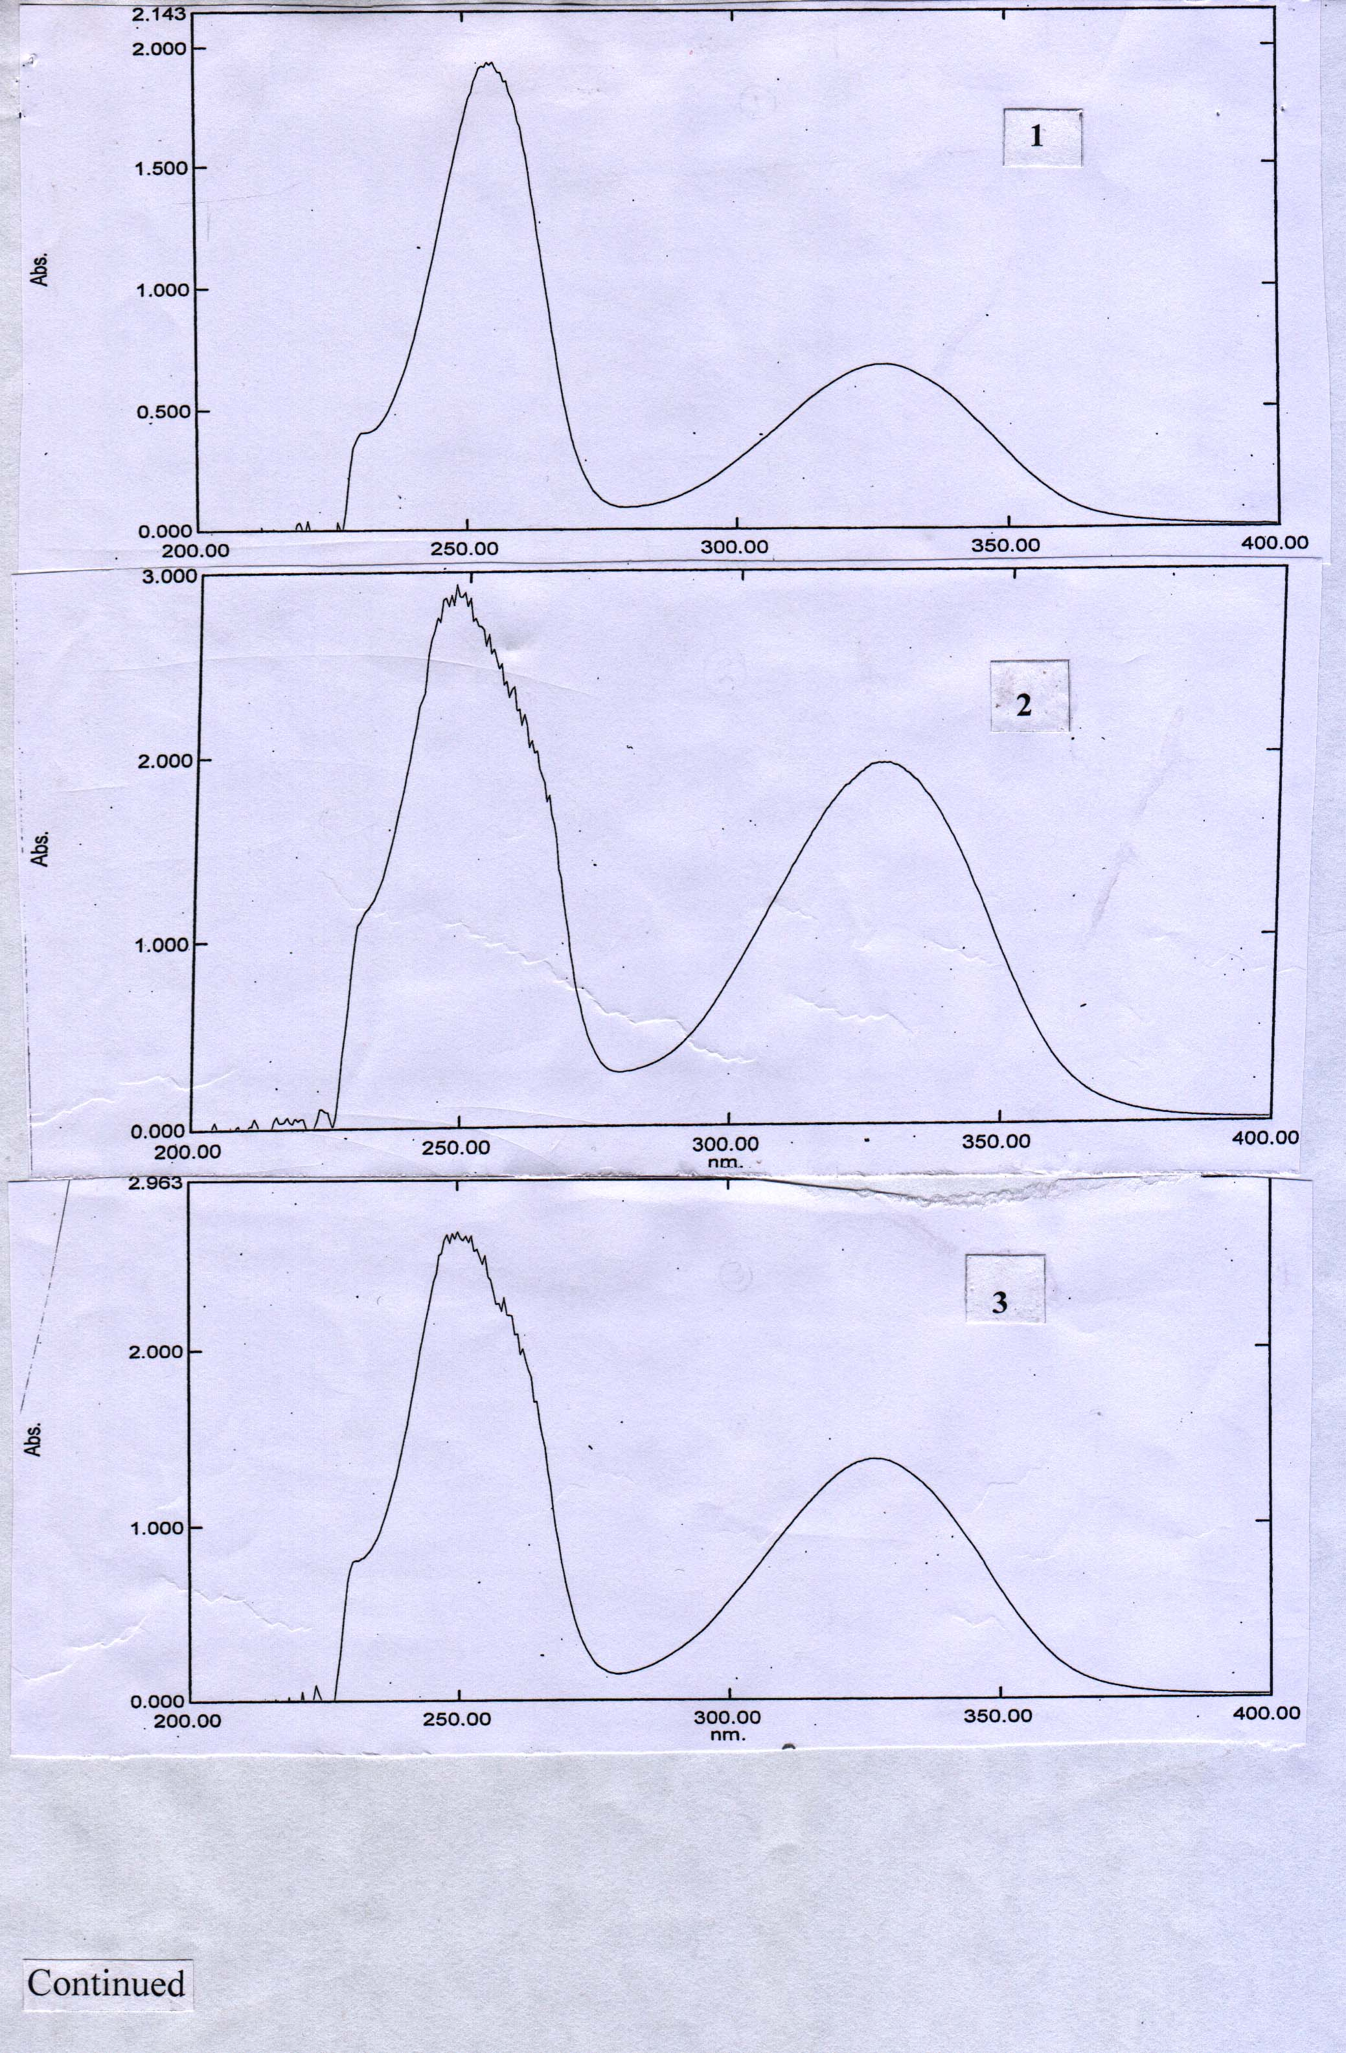
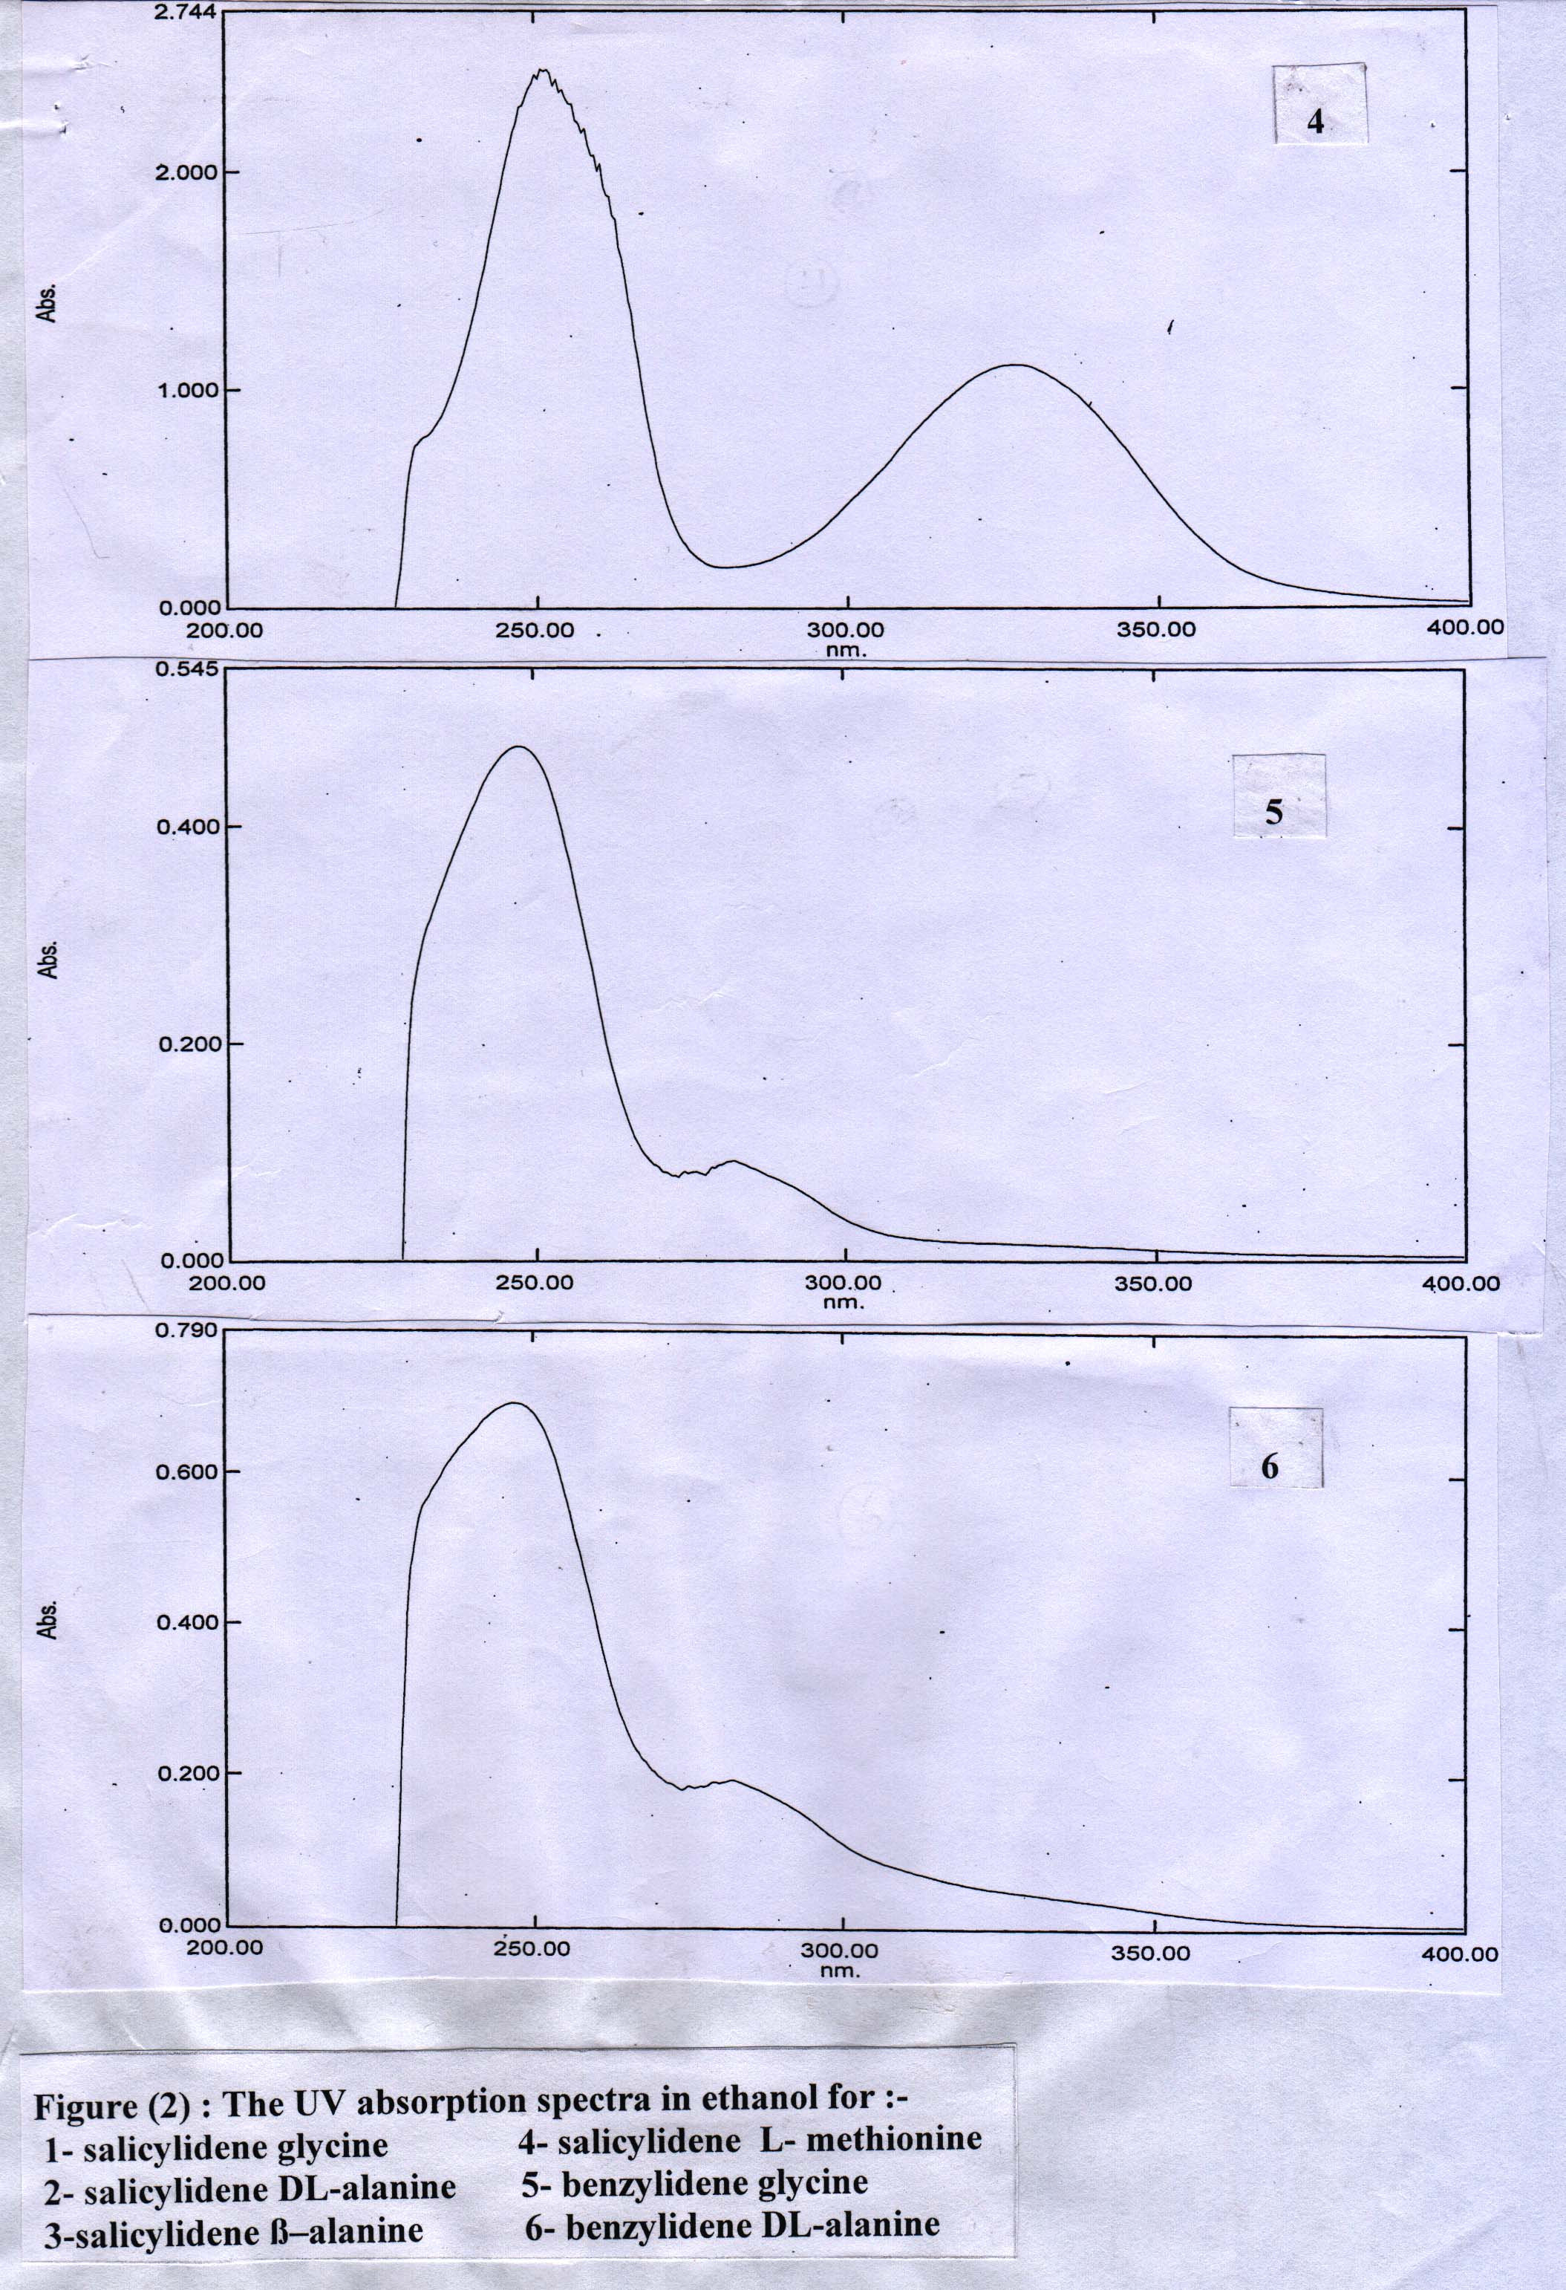
This mechanism is consist of three steps as follows:-
- Step (1) is a fast reversible and is accompanied by the formation of intermediate (I) which is stablized to intermediate (II) through a reversible step. The anion produces in intermediate (II) may has a strain energy due to its three membered cyclic ring. Hence, it is believed that intermediate (I) is more stable than intermediate (II).
- Step (2) is the slow determining step which involves the addition intermediate (I) to the positive carbon of carbonyl group. This results to the formation of intermediate (II).
- Step (3) is a fast dehyration step, led to the formation of Schiff bases.
Our suggested mechanism is similar to the oximation of ketone by hydroxylamine is basic medium as given by Pearson etal ⁽²²⁾ and supports our suggestion. Nevertheless these two mechanisms led to the formation of C=N in oxime or in Schiff bases under study.
Conclusions
- A new alternative method for synthesis of some Schiff bases from benzaldehyde and salicylaldehyde with some amino acids is given.
- The development includes the use of NaOH as a new catalyst during synthesis of Schiff bases mentioned.
- The chemical structures of Schiff bases were studied by the use of physical methods, namely melting point's or boiling point, IR and UV spectra.
- A new suggested mechanism for the synthesis of these new Schiff bases is given and confirmed by other study ⁽²²⁾.
- The mechanism stated, includes three elementary steps, one of them is a slow and its a rate determining step.The other steps are fast and reversible or irreversible leading to products.
References
- Ed.S.Patai, "The chemistry of carbon-nitrogen double bond", John Wiley and Sons, New York, 1970, pp.61-146.
- E. Brand and M. Sandberg, Org. Synth. Coll., 1943, 2, 49.
- J.C. Sheehan and V.J.Grenda, J.Amer.Chem.Soc., 1962, 84, 2417.
- R.B.Moffet and W.M.Hoehn, J.Amer.Chem.Soc., 1947, 69, 1792.
- M. Freifelder, J.Org. Chem., 1966, 31, 3875.
- A.A.H.saeed , A.W.A. Sultan , S.A.Selman and N.A.Abood , Canad. .J.Spectroscopy , 1983 , 28 , 104 .
- A.S.P.Azzouz, Z. phys. Chem., 2002, 216, 1053.
- A.S.P.Azzouz and A.B.N.AL-Dabagh, National J. Chem., 2007, 26, 295.
- A.S.P.Azzouz, M.S.Saeed and K.I. AL-Niemi, J. Edu. Sci., 2005, 17, 29.
- ibid, 2005, 17, 16.
- A.S.P.Azzouz, National J. Chem., 2006, 22, 214.
- J. H. Billman and K. M. Tai, J.Org. Chem., 1958, 23, 535.
- M. E. Taylor and T. J. Fletcher, J.Org. Chem., 1961, 26, 940.
- D.Y.Curtin and J.W.Hausser, J.Amer.Chem.Soc., 1961, 83, 3474.
- P.W.Atkins, "Physical chemistry", Oxford, 1977, pp.851-885.
- A.S.P.Azzouz and M.M.H.Al-Niemi, Z. phy. Chem., 2005, 216, 1591.
- W.Kemp, Organic Spectroscopy, Macmillan, London, 1975, p.22.
- A.S.P.Azzouz, A.A.Rahman and A.G.Taki, J. Edu. Sci., 2003, 15, 1.
- A.S.P.Azzouz, and S.M.Saleh, J. Edu. Sci., 2000, 46, 51.
- A.S.P.Azzouz, and S.S.Othman, J. Edu. Sci., 2001, 48, 32.
- R.M.Silverstein and G.C.Bassler, "Spectrophotometeric identification of Organic Compounds", 2nd ed., John Wiley, New York.
- D.E.Pearson and O.O. Keaton, J. Org. Chem., 1963, 28, 1557.

