Synthesis of new Schiff Bases via α,β-unsaturated carbonyl compournds

Krrar A. Arab, Ahmed T. Salim and Nuha S. Kareem
Chemistry Depart. , Science College , Kufa University , Najaf-Iraq
e-mail: karemchemist@yahoo.com

(NJC)

(Recevied on 23/6/2008) (Accepted for publication 12/1/2010)

Abstract
The synthesis of new Schiff Bases have been achieved by interesting of aldol condensation product of two carbonyl compounds, the products have been treated with thioethane in type of Michael reaction, to produce Michael product, which finally was treated with different aromatic amines to give the Schiff Bases.
These compounds have been characterized by spectroscopic methods ( FTIR , HNMR , UV-Vis ) , TLC and melting points.

الخلاصة
تم تحضير قواعد شف جديده , بالاستفادة من تفاعل تكاثف الدول بين مركبي كاربونيل , وبمعاملة الناتج مع ثايوايثان من خلال تفاعل اضافة مايكل Michael Addition, ومعاملة ناتج اضافة مايكل مع امينات اروماتية مختلفة تم الحصول على قواعد شف .
تم تشخيص المركبات الناتجة بالتقنيات الطيفية (الاشعة تحت الحمراء , الرنين النووي المغناطيسي, والاشعة فوق البنفسجية المرئية ) و درجات الانصهار و كروموتغرافيا الطبقة الرقيقة TLC.

Introduction
The importance of Schiff bases in organic synthesis has increased over the past few decades because they are among the most versatile organic synthetic intermediates ⁽¹⁾ and they also present a broad range of biological activities such as herbicidal ⁽²⁾, antifungal ⁽³⁾, antimicrobial ⁽⁴⁻⁷⁾ and antitumor properties ⁽⁸⁻⁹⁾. Moreover, Schiff bases have also attracted much attention because of their ability to act as ligands for complexation of different metal ions in various oxidation states ⁽¹⁰⁻¹¹⁾ .In consideration of these facts , herein we are gratified to report the synthesize some new Schiff bases with expected significant biological activity, which will studied in the future.
Experimental
The melting points were measured on Electrothermal 9300 . The FTIR spectra were recorded on Shimadzu FTIR -8400S spectrophotometer using KBr disc. The UV-Visible spectra were recorded on Shimadzu UV Visible -1650 spectrophotometer . The ¹H-NMR spectra were recorded on a Fourier transform Bruker spectrometer operating at 300 MHz in detoured chloroform with tetramethylsilane as internal standard in DMSO- d⁶

3-(4-hydroxyphenyl)-1-phenylprop-2-en-1-one (1a):
To a mixture of (0.02 mole, 2.4gm) of acetophenone dissolved in solution of [(0.1 mole, 4gm) sodium hudroxide 20 ml ethanol and 20 ml water ], then (0.02 mole , 2.4 gm) of p-hydroxybenzaldehyde was added drop wise with stirring for 30 min. a yellow precipitate was obtained , washed with water,and then recrystallized from ethylacetate-ethanol, table (1 and 2).
3-(4-(dimethylamino)phenyl)-1-phenylprop-2-en-1-one (1b):
To a mixture of (0.02 mole, 2.40 gm) of acetophenone dissolved in solution of [(0.1 mole, 4gm) sodium hudroxide 20 ml ethanol and 20 ml water ], (0.02 mole , 2.98 gm) of 4-(N,N-dimethylamino) benzaldehyde was added drop wise with stirring for 30 min. a white-yellowish precipitate was obtained , washed with water,and then recrystallized from ethylacetate-diethylether, table (1 and 2).
|General procedure
3-aryl -3-ethylthio -1-aryl propan-1-one (2a-b)⁽¹²⁾
To solution of 1-aryl-3-arylprop-2-en-1-one ( 0.01 mole) dissolved in 20ml absolute methanol , added solution of (0.01 mole ) ethylthiol in absolute methanol catalyzed with a catalytic amount of aluminum oxide (Al₂O₃) ,refluxed for 2 hours , the solution was distilled to obtain the precipitate , recrystallized from diethyl ether. Table (1 and 2).
N-(3-aryl-3-(ethylthio)-1-phenylpropylidene)aryl-2-amine⁽¹³⁻¹⁴⁾
To a mixture of 3-aryl -3-ethylthio-1-aryl propan-1-one (0.01 mole) in 25ml ethanol , the aryl amine (0.01 mole ) solution in 10ml ethanol, 2-3 drops of glycial acetic acid was added , the mixture was refluxed for 2hours. After the mixture was cooled , the crystals was filtered , washed with water, and then recrystallized from ethanol-water 2:1. Tables (1-2)

Results and Discussion
The aim of this work is to synthesize new Schiff bases containing sulfur atom in the beta position to the imine group, via Micheal addition type.
Synthesis of starting materials α,β-unsaturated carbonyl compounds which based on the Aldol condensation of aldehyde and methyl ketone in sodium hydroxide solution afforded compounds 1a-b. Their structures were confirmed by FTIR spectra which show v 3100 cm⁻¹ (C=C-H), v 1640 cm-1 (C=C),1690-1665 cm⁻¹ for (C=O).
Treatment of α,β-unsaturated carbonyl compounds (1a-1b) with thioethane in Michael type addition catalyzed by aluminum oxide to give β-ethylthio carbonyl compounds (2a-b), Their structures were confirmed by FTIR spectra which show the absence of the peak near 3100 cm⁻¹ for (C=C-H), 1640 cm-1 for (C=C) and appear a new peak near 2960 and 2870 cm⁻¹ for (CH₃,CH₂) , 1690-1665 cm⁻¹ for (C=O).
Finally treatment of ethylthio carbonyl compounds (2a-b) with different aromatic amines (2-aminopyrimidine, 4-aminoacetophenone and 2-bromoaniline) gives new Schiff bases (3a-f) , the structures were determined by FTIR spectra which show the absence of C=O stretching vibration in the region (1695-1665 cm⁻¹) and appear a new peak in the region 1630-1595 cm⁻¹ according to stretching vibration for (C=N) bond.
The 1HNMR of compound [4-(3-(ethylthio)-3-phenyl-1-(pyrimidin-2-ylimino)propyl)phenol] (Fig. 1)show multiple peaks at δ ppm 8.3,8.2 and 7.5 for 3H (pyrimidine protons ), 4H multiplet for aromatic protons (7.2-6.6) ,3.75 for (OH) , 1H triplet (3.4,3.2)for (CH) .and 2H doublet (1.4,1.2) for (CH₂).⁽¹⁵⁾
Physical and spectral data are listed in table (1 and 2).

Table (1) Physical Data of Prepared Compounds
Comp. no. | structure | m.p.  ºC | Colour | Yield  %
1a |  | 224-226 | Redish  brown | 82%
1b |  | 251-253 | Greenish yelow | 79%
2a |  | 284-286 | Yellowish  orange | 77%
2b |  | .  313-314 | yellow | 71%
3a |  | 363-364 | Orange | 72%
3b |  | 290-292 | Red | 66%
3c |  | 223-225 | Yellow greenish | 91%
3d |  | 61-63 | Green | 76%
3e |  | Decom.  244 | Redish yellow | 58%
3f |  | 250-253 | Green | 65%
Table (2) Spectral Data of Prepared Compounds
Comp. no. | λmax  EtOH | IR v cm⁻¹ KBr disc |  |  |  |  | 1HNMR δ(ppm)  DMSO-d₆
Comp. no. | λmax  EtOH | O-H | C=C-H | C=O | C=N | C=C alph. | 1HNMR δ(ppm)  DMSO-d₆
1a | 450 | 3500-3400 |  | 1685 |  | 1640
1b | 460 |  |  | 1675 |  | 1645
2a | 455 | 3500-3400 | 3100 | 1680
2b | 470 |  | 3095 | 1665
3a | 385 | 3500-3500 |  |  | 1595 |  | δ(OHal.,3.75),δ(C-Hal.3.4 and 1.4),δ(C-Har.,7.2,6.80.6.6),δ(C-Hhet.(8.3,8.2,7.4)
3b | 370 | 3500-3500 |  |  | 1610
3c | 395 | 3500-3500 |  |  | 1615
3d | 407 |  |  |  | 1620
3e | 410 |  |  |  | 1630
3f | 430 |  |  |  | 1625
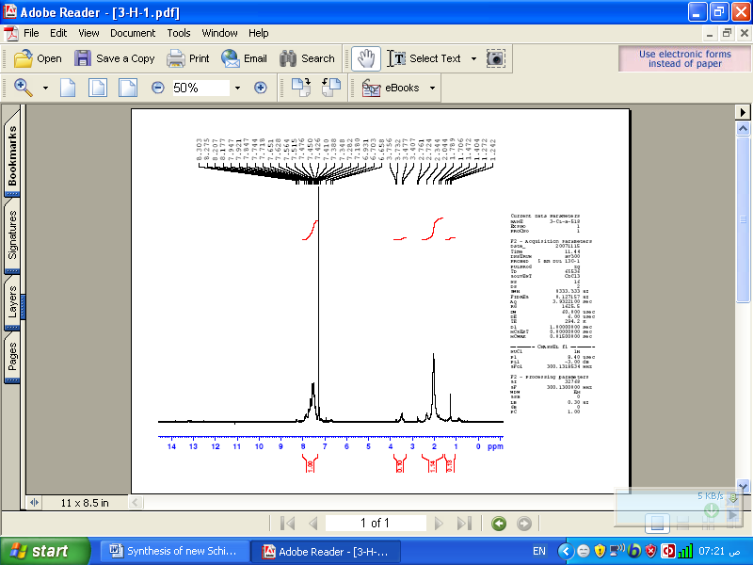

Fig. 1: The ¹HNMR of compound [4-(3-(ethylthio)-3-phenyl-1-(pyrimidin-2-ylimino)propyl) phenol]

References
1. Karia, F. D.; Parsania, P. H., Synthesis, biological and thermal properties of Schiff bases of bisphenol-C,. Asian J. Chem., 1999, 11, 991.
2. Samadhiya, S.; Halve, A. Synthetic utility of Schiff Bases as potential herbicidal agents., Orient. J. Chem., 2001, 17, 119.
3. Singh, W. M.; Dash, B. C. Synthesis of some new Schiff bases containing thiazole and oxazole nuclei and their fungicidal activity., Pesticides, 1988, 22, 33.
4. Pandeya, S. N.; Sriram, D.; Nath, G.; De Clercq, E. Synthesis and antimicrobial activity of Schiff and Mannich bases of isatin and its derivatives with pyrimidine. Farmaco, 1999, 54, 624.
5. Baseer, M. A.; Jadhav, V. D.; Phule, R. M.; Archana, Y. V.; Vibhute, Y. B. Synthesis and antimicrobial activity of some new Schiff bases., Orient. J. Chem., 2000, 16, 553.
6. El-Masry, A. H.; Fahmy, H. H.; Abdelwahed, S. H. A. Synthesis and antimicrobial activity of some new benzimidazole derivatives., Molecules, 2000, 5, 1429.
7. More, P. G.; Bhalvankar, R. B.; Pattar, S. C. Synthesis and biological activities of Schiff bases of aminothiazoles., J. Indian Chem. Soc, 2001, 78, 474.
8. Pathak, P.; Jolly, V. S.; Sharma, K. P. Synthesis and biological activities of some new substituted arylazo Schiff bases., Orient. J. Chem., 2000, 16, 161.
9. Desai, S. B.; Desai, P. B.; Desai, K. R. Synthesis of some Schiff bases, thiazollidones, and azetidinones derived from 2,6-diaminobenzo[1,2-d:4,5-d,]bisthiazole and their anticancer activities, Heterocycl., Commun., 2001, 7, 83.
10. Aydogan, F.; Öcal, N.; Turgut, Z.; Yolacan, C. Transformations of aldimines derived from pyrrole-2-carboxaldehyde. Synthesis of thiazolidino-fused compounds., Bull. Kor. Chem. Soc., 2001, 22, 476.
11. Cozzi, P. G. Metal-Salen Schiff base complexes in catalysis: practical aspects., Chem. Soc. Rev., 2004, 33, 410.
12. Kohler E. P.and Chadwell H. M., Organic Syntheses,Coll., 1941, 1, 78.
13. Furniss S. Brian, Vogel's textbook of Practical Organic Chemistry, 5th edition , John Wiley & Sons. Inc., NY, 1989.
14 . Lucius A. Bigelow and Harry Eatough, Organic Syntheses, Coll., 1941, 1, 80.
15. R. M. silverstein , Spectrometric Identification of Organic Compounds, 5th edition , Wiley, New York, 1991.

