Synthesis of 2-[(3-Chloro-4,6-disulfanamide phenyl ) azo] -4,5 –
diphenyl imidazole (Cdsai)as a new analytical reagent
for the determination of Cu(II) .

Abid Allah. M. Ali
Dept. of Chemistry, College of Education for Women, University of Kufa
Muneer .A. Al-Da`amy, Ahmed Fadhil Kadhier, Raghad Saad Hatam
Dept. of Chemistry, College of Science, University of Kerbala

(NJC)

(Recevied on 24/5/2009) (Accepted for publication 12/1/2010)

Abstract
A new spectrophotometric method is described for the determination of Cu(II) in analytical sample . The proposed method based on the formation violet complex with 2-[(3-Chloro-4,6-disulfanamide phenyl ) azo] -4,5-diphenyl imidazole (Cdsai) as a new chromogenic reagent in nutral media that has a maximum absorption at λmax 588 nm . Linearity was observed from 0.25-6.00 µg.ml⁻¹ with detection limit and 0.15µg.ml⁻¹ . The effect of chemical, physical and analytical parameter is evaluated.
الخلاصة
يتضمن البحث وصف طريقة طيفية جديدة لتقدير ايون النحاس الثنائي في النماذج التحليلة تعتمد الطريقة المقترحة على تكوين معقد بنفسجي مع الكاشف الجديد
2-[(3-Chloro-4,6-disulfanamide phenyl ) azo] -4,5 – diphenyl imidazole (Cdsai)
في الوسط المتعادل الذي يعطي اعلى امتصاص عند الطول الموجي 588 نانوميتر. حدود الخطية كانت بين 0.25-6.0 µg.ml⁻¹ مع حد كشف مقداره µg.ml⁻¹ 0.15.كما تم تثبيت الضروف الفضلى لطريقة التقدير .

Introduction
A many spectrophotometric study to determined the copper by using a different organic reagents, where used a acetohydroxamic reagent to determine a cobalt and copper ions quantitatively ⁽¹⁾.Also by Uv-vis spectrophotometer in acidic medium (pH = 6) could be determined a Ni, Co and Cu by using 5-bromo –salicyladehyde thiosemicarbozone ⁽²⁾.Anather study by 1-phenyl-1,2-prpanedion-thiosemicarbazone reagent in the acidic medium pH(5-6) at λ_{max} (468nm) a copper was estimated ⁽³⁾. In the other round a many studies were appeared that a some of aldehyde and keton derivatives used to determination of copper in the ultra violet region ⁽⁴⁾.A cobalt and copper ions quantitative determined by formation complex with diethyldithiocarbamate reagent ⁽⁵⁾. In the modern study a cobalet , copper and nickel determined by used 2-methoxy banzaldehyde thiosemicarbozone reagent in the acidic medium (pH=6) ⁽⁶⁾.
The chemical study of imidazole show that it is a mixture of pyridine and pyrole characteristics ⁽⁷⁾ , and the coupling of diazonium salt occurs in position (C₂) in alkaline solution to give shining azo dayes ⁽⁸⁾. This type of hetro cyclic compounds play acentral role as chelating agents for alarge number of metal ions .They form astable five –membered ring after complexation with metal ions and can also be used as analytical reagents.⁽⁹⁻¹¹⁾
This study describe a new spectrophotometric method to determine Cu(II) in analytica sample based on the formation violate complex with a new cdsia reagent, the complex has a maximum absorption at λ_{max} 588nm.
Experimental part
Materials
All chemicals used of analytical grade reagent unless otherwise stated.
Copper stock solution (20 µg.ml⁻¹) was prepared by dissolving 0.0536 g of CuCl₂.2H₂O in 1000 ml distilled water.
2-[(3-Chloro-4,6-disulfanamide phenyl ) azo] -4,5-diphenyl imidazole (Cdsai)solution (1x10⁻³M) was prepared by dissolving 0.05165g of pure reagent in 100 ml of absolute ethanol.
Worker solutions were prepare freshly by appropriate dilution of the stock solution.
Apparatus
Infrared spectrum was recorded on FT-IR Test scan Shimadzu model 8400 Fourier transform infrared spectrophotometer covering the rang 400-4000 cm-1.
Ashimadzu 260 UV-visible spectrophotometer with a 1 cm matched quartz cell (Japan ) used for all absorbance measurements.
pH-measurements were made with knick pH-meter ( England ).
Elemental analysis measured on EA-1108 Carlo-Erba elemental analyzer.
Gallen kamp capillary melting point apparatus was used to measure the melting points
Digital balance, sartorius ( Bp3015-Germany ).
Water bath , Gesellschft for labortechnik (Germany ) were used .
Synthesis and characterization of reagent
The hetrocyclic azo reagent (Cdsai) Fig(1) was synthised following the procedure as describe for the 2-(arylazo ) imidazole^{(12).}
The diazonium chloride solution was prepared by dissolving (0.15025 g, 0.005 mole ) of 4-amino-6- chlorobenzen-1,3-disulfanamide in 40ml of distilled water and 6ml of concentrated hydrochloric acid . The solution was treated with 12ml of aqueous (0.5 M) Sodium nitrite dropwise and stirred for 1hr at (0-5 Cº ). The resulting diazonium salt solution was added dropwise with cooling to solution of (1.1 g , 0.005mol ) of a 4,5- diphenyl imidezole dissolved in 100ml alkalin ethanol .After leaving in the refrigerator over night . The mixture was nuterilized with dilute hydrochloric acid antil (pH=6.5 ). The precipitated was filtered off, washed with 500ml of distlled water ,air dired and recrystallized twice from chloroform and then dried in the oven at 80Cº for 6 hours. The yield was 65% shine red crystals ,melting at 152 Cº , which insoluble in water, but soluble in most organic solvents. The structure of (Cdsai ) was confirmed by C.H.N analysis and IR spectroscopy ,where the analysis required C 48.79 ,H 3.29 and N 16.26 found C 48.54 , H 3.18 . and N 16.09 . The IR spectrum of 2-[(3-Chloro-4,6-disulfanamide phenyl ) azo] -4,5-diphenyl Fig(1) displayed two bands at 1089cm⁻¹ and 1096cm⁻¹ can be derivative of mono chloro benzene The bands at 1370cm⁻¹ and 1170cm⁻¹ assigned to sulfonamide group ,the other bands at (3390)cm⁻¹ and 3180cm⁻¹ due to the vibration frequencies of ν(N-H) .while the band at 760cm⁻¹ and 690cm⁻¹ due to the diphenyl rings of imdazole ⁽¹²⁾. Fig(2) show the structure of azo reagent

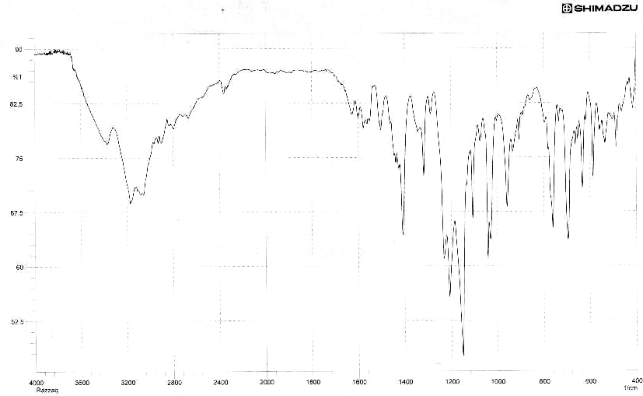

Fig 1. IR spectrum of Reagent

Fig 2.The structure of azo reagent (Cdsai )

General procedure
In to series of 5ml calibrated flask, transfer increasing volumes of Cu(II) solution containing not more than 6µg.ml⁻¹.Add 0.4ml of 1x10⁻³ Cdsai reagent .Dilute the solution to the mark with distilled water and allow the solution mixture to stand for 15min. at room temperature. Measure the absorbance at 588nm against a reagent blank prepared in the same way but without containing Cu(II) solution.

Results and Discussion
Physical and chemical properties of Cdsai reagent and complex
The reagent is the orange color which is insoluble in water but its soluble in methanol, ethanol, acetone, benzene , ether and chloroform, it is red in alkaline solution but yellow in weakly acidic solution . The reagent have melting point 152Cº.The Cu(II) complex is violet color.

Absorption spectra
The absorption spectrum of Cdsai reagent and Cu(II)complex under the optimum conditions are shown in Fig (3).The λ_{max} for the reagent and the complex at 457nm and 588nm respectively.

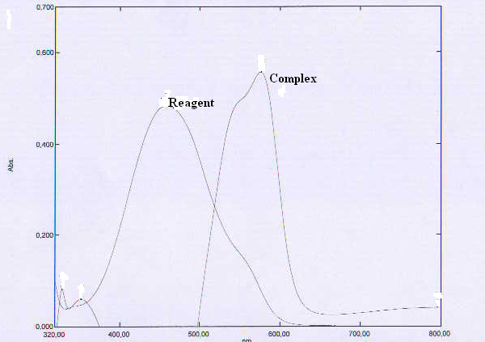

Fig 3.Absorption spectra of Cdsai reagent and Cu(II)- complex

Optimum conditions for the maximum formation of Cu(II) complex
Copper (II) ion react with 2-[(3-Chloro-4,6-disulfanamide phenyl ) azo] -4,5-diphenyl imidazole in neutral medium to form a violet complex that has a maximum absorption at λmax 588 nm[ Fig (2)] . The absorbance of the violet complex is directly related to the concentration of copper (II) and that can be used for its spectrophotometric determination. The development of the color intensity and stability of complex depends on the reaction conditions and were optimize as follows:

Effect of reagent concentration
when various concentration of 2-[(3-Chloro-4,6-disulfanamide phenyl ) azo] -4,5-diphenyl imidazole solution in the range of (8x10⁻⁶ – 6x10⁻⁴ M ) were added to fixed amount of copper(II) ( 4.72x10⁻⁵ M) . A concentration of ( 8x10⁻⁵ M ) give the highest absorbance [Fig (4)] and were used for further experiments .

Fig 4. Effect of reagent concentration on the absorbance of Cu(II)-Complex

Effect of time
The color intensity reached a maximum after copper (II) solution had been reacted immediately with the reagent and became stable after 15 min [Fig (5)] .Therefore 15 min development time was selected as optimum in the general procedure. The violet complex was stable for more thane 60 mint .

Fig 5. Effect of time on the absorbance of Cu (II)-Complex

Effect of temperature
The effect of temperature on the color intensity and complex stability was studied. In practice the same absorbance was obtained when the violet complex developed at room temperature ( 25 Cº ) but when the calibrated flask was placed in an ice –water at (10,15 Cº ) or in a water –bath at (30,40,50 Cº ) a loss in color intensity and stability were observed [Fig(6)]. Stability is therefore recommended that the formation of complex should be carried out at room temperature (25 Cº ) .

Fig 6. Effect of temperature on the absorbance of Cu(II)-Complex

Calibration curve
Under the optimum condition linear calibration graph Fig (7), was obtained over the concentration range of (0.25-6.00 µg.ml⁻¹) .The limited of detection (signal/ noise = 3 ) was 0.15µg.ml⁻¹ and the correlation coefficient was 0.9998 . The relative standard deviation of the method was better than 0.34 %.

Fig 7. Calibration curve for determination of Cu(II)

Stoichiometry of complex
The stoichiometry of the complex was investigated using mole – ratio under the optimizes conditions. The result obtained Fig (8), show a 1: 2 metal to reagent complex was formed. The structure of the complex may probably be written as follows:

Fig 8. Mole ratio of the Cu(II)-complex

The stability constant is calculated by comparing the absorbance of a solution containing stoichiometric amount of Cu(II) , and Cdasi reagent with that of asolution containing a five fold excess of cdasi reagent , the average conditional stability constant of the complex in water under the described experimental condition is 1.22 x10⁸L.mole⁻¹ , The result obtained are shown in table 1⁽¹⁴⁾.

Table 1.The stability constant (K) and dissociation degree (α) of the formed complex
Am | As | α =Am-As/Am | K
0.320 | 0.115 | 0.640 | 1.2x10⁸ L. mole⁻¹

Reference
- Dixon N. E , Gazzola . G , Watters J.J and Zerner B, J. Ch. Soc.., 1975, 97(14), 4130.
- Raman J. G. Reddy R. P. and Reddy V. K. J .Indian . of Chem. Soc., 2002, 41(7), 1436.
- Reddy K. H. Prasad N. B. and, Reddy V. K. , Talanta, 2003, 59(3), 425.
- Sah P. and Peoples S. A. , J. Ame Pharm . Asso., 1954, 43(2).
- Angelis G. and Gerdi M. , J. Article , 2001, 1(2), 67.
- Praveen A. Raveendra P. and Kishna R. V., J. Amer. Chem. Soc., 2007, 2(3), 1.
- A. Albert and E. P. serjeant "Ionization constant of acids and bases" John Wiely and Sons , Inc. New York 1962.
- J. D. Vaughan , D. G. Lamdert and V. L. Vanghani, J. Amer. Chem. Soc., 1964, 86, 2857.
- S. Shibata, M. Furkaw and R. Nakashima; J. Anal . chim. Acta, 1976, 81, 131.
- A. M. Ali, S. J. Baqir, A. A. Alkurymy and A. Saadon ., Nat. J. Chem., 2007, 27, 510.
- A. M. Ali, D. N. Taha, A.A. Alkurymy and A. Saadon., Nat J. Chem., 2008, 31, 383.
- S.shibate ,M. Furukawa and R. Nakashima; Anal Nakashima, Anal. Chem.. Acta, 1976, 81, 131 .
- L. E. Mattison , J.M. Metaxas and C. S. O' Dell , Anal. C hem., 1969, 41(12), 1690.
- A. K. aggrawala , P. A. And Gary , S.P. Talanta (1972): 1481-1482.

