Synthesis and Characterization of Some New Spiroazetidine-2- one Derivatives

M. S. Magtoof AL-Tamemey, M. A. AL-Dakilley
Thiqar University, Science College, Chemistry Deptt, Thiqar, Nashyria, Iraq
Ala'a J. Mahrath
Babylon University, Medical College, Haila, Babil, IRAQ
A, H. Maeky
Thiqar University, Science College, Chemistry Deptt, Thiqar, Nashyria, Iraq

(NJC)

(Recevied on 15/9/2009) (Accepted for publication 12/1/2010)

Abstract
The present work include the synthesis and characterization of spiro azetidin-2-one which achieved and expected to have some biological activity . the first step include the treatment of primary aromatic amine with primary aromatic aldehydes in boiling ethanol to give schiff bases which reacted in the second step with carboxylic acid ( 1,3-dithia-2-carboxylicacid )in the presence of triethylamine with phosphorusoxychloride in dry dichloromethane under nitrogen atmosphere at 0°C. To give spiroazetidin-2- one.The new synthesized compound were identified by melting points and UV,FT. IR, Mass, ¹H NMR and ¹³C NMR spectrum.
Key words: spiro: Azetidine-2-one, Phosphorusoxychloride, N2-atm, 1, 3 dithiacarboxylic acid.

الخلاصة
تم في هذه الدراسة تحضير وتشخيص مركبات مركبات سبايرو ازديتيين -2-ون الجديدة ذات الفعالية البيولوجية , الخطوة الأولى لتحضير هذه المركبات تضمنت تفاعل الأمينات الاروماتية الأولية مع الالديهايدات الاروماتية الأولية في درجة غليان الايثانول لتنتج قواعد شيف والتي تتفاعل في الخطوة الثانية مع 1, 3 داي ثايان -2-حمض كاربوكسليك بوجود ثلاثي اثيل أمين , اوكسي كلوريد الفسفور في ثنائي كلوروميثان الجاف تحت غاز النيتروجين عند درجة الصفر المئوي ليعطي الناتج سبا يرو ازدتيدين -2- ون . تم تشخيص المركبات المحضرة بقياس درجات الانصهار وقياس طيف الاشعه تحت الحمراء وطيف الاشعه المرئية والفوق البنفسجية وطيف ألكتله ومطيافية الرنين النووي المغناطيسي ألبروتوني وكاربون13 .

Introduction
Since the discovery of penicillin -β-lactams including penicillins ,cephalosporins mono lactams ,and carbapenems ) have become amajor class of antibacterial agents¹ .azetidin-2-one commonly known as -β-lactams, heterocyclic compound are four member cyclic amides² .the first member was synthesized by Staudinger³, by reaction [2+2] keten –imine cycloaddition reaction is regarded as one of the most fundamental and versatile methods have been developed to date . Reaction process is described as follow 1 – the cycloaddition reaction is stepwise reaction rather then concerted one 2 the reaction is initiated by the nucleophilic attack of imines to ketens giving to zwitteronic intermediate 3 aconrotatory electrocyclic ring –closure of the zwitteronic intermediate produces the final 2-azetidin one product .
Spiro -β-lactams have become a centre of attraction for many reasons .The main reason of interest in such compounds is due to their antiviral ^{4a} and antibacterial properties^{4 b}. Recently , it has been shown that some Spiro-β- lactams also exhibit activity as absorption inhibitors (CAI)⁵, making them potentially useful compounds not only for development of drugs for lowering the high level of cholesterol , but also due to recent evidence indicating that the activity of the enzyme responsible for the cleavage of the amyloid precursor Protein (a protein thought to be involved in the pathogenesis of Alzheimer's disease) is coupled to cholesterol regulation⁶.
Structure-activity studies identified 3-spiro –β-lactams SCH 54016 A and SCH 58053 B as the one of most potent cholesterol absorption inhibitors⁷ (Figure 1).

SCH 58053 B SCH 54016 A
Figure (1)

Experimental
All the melting points are uncorrected and are expressed in degree (°C), Using melting point \SMP₃1. IR spectra were recorded using shimadzu FT-IR 8400 using KBr disks. ¹H NMR spectra were recorded using Bruker system AL 300 (300 MHz) using tetramethylsilane (TMS) as internal standard. ¹³C NMR spectra were recorded using Bruker system AL 300 (300 MHz) using tetramethylsilane (TMS) as internal standard in the Department of Chemistry,AL-Albyt University, AL-Mafraqh, Jordan. UV spectra were recorded on T60, PG Instruments, Germany UV/VIS spectrophotometer.
Synthesis of Schiff bases 3a, 3b,8, 9
1) N-Phenyl benzyldine 3a
A mixture of 0.01 mole (0.93 ml )of aniline , 0.01 mole (1.1 ml ) of benzaldehyde , 10 ml ethanol and drop of glacial acetic acid , was heated in water bath at (70-80 ) for 30 min .Then left to cool in bath of ice -water , whereby yellowish white crystals separated out . the crystals were filtered , washed with 2% HCl ,then with water and recryastalized from ethanol .to give imine 3a (80%),m.p:49-50°C .IR(KBr disk):1635cm⁻¹,due to stretching carbonyl group(Fig 2-4).
2) N-(4–diethyl amino) phenyl -4-chloro benzylidine 3b.
It was prepared by reacting 4- chloro benzaldehyde (0.01mole , 1.405g ) and N,N-diethyl -P- phenylenediamine (0.01 mole , 1.64g ) to give imine 3b(88%) m.p: 67-68˚C IR (KBr disk):1654cm⁻¹.
3) Synthesis of 1, 3-dithiane-2-carboxylic acid (2)⁹
In 100 mL round bottom flask was placed ( 0.01 mole 0.9205 g) of glyoxylic acid monohydrate in dry benzene 20mL ,added amount of P-TSA as catalyst was and gently refluxed. A solution of 1, 3-dithaipropane (0.01 mole , 1.0823 mL) in dry benzene 25mL was added in such away that the refluxing should not be vigorous. The reaction mixture was refluxed under stirring for 2hr .The progress of the reaction was monitored by TLC. After completion of the reaction ,the reaction mixture was filtered and the solvent was evaporated under reduced pressure , recrystalized from benzene to give acid 2, white crystals, Yield 72%,m.p:112-114˚C,IR(KBr disk) :2831-2900,1693 ,2500-3066.¹H-NMR(CDCl₃)δ:3.02-3.12 (CH₂,m,2H) ,1.87-2.02 (CH₂,m,2H) , 2.67-2.75(CH₂,m,2H) , 4.59(CH,s,1H), 13.0(OH,d,1H).¹³C-NMR (CDCl₃):25.35, 26.68, 125.94, 171.13.
4)Synthesis of Spiro azetidine -2-one 4a, 4b
2, 3-diphenyl-5, 9-dithia-2-azaspiro [3.5] nonan-1-one 4a

To a suspension of 1,3-dithiane-2-carboxylic acid ( 0.67955 gm , 0.0041436 mole) , N-phenylbenzylidine 3a ( 0.5 gm , 0.0027624mole) and triethylamine ( 0.837 gm, 0.0082873 mole) in 40 mL of dry dichloromethane was added dropwise , under nitrogen atmosphere, a solution POCl₃ ( 0.6353453gm , 0.0041436 mole) in 20 mL dry dichloro methane with constant stirring at 0˚C .The reactants were stirred overnight at room temperature . There after , the contents were washed successively with 1N HCL (20mL ), water (2×20mL) , 5% NaHCO₃(20mL) and brine (20mL) .The organic layer was separated and dried over anhydrous Na₂SO₄ .The Solvent was removed under vacuum and the crude product was column chromatagraphed over silica gel using 7:3 ethyl acetate/ hexane as eluent .Solvent evaporation furnished pure β- lactam 4a(76.67%).white color m.p. 144-146˚C ,UV : λ_{max}chloroform : 251 nm, ε_{max} = 15680; UV : λ_{max}ethanol :249 nm, ε_{max} = 14500 .FT. IR (KBr disk) : 1739.67 cm⁻¹
¹HNMR (DMSO):1.80-2.16(CH₂,m,2H),2.66-2.95(CH₂,m,2H),3.23-3.36 (CH₂,m,2H) ,4.59(CH,s,1H),7.08-7.58(aromatic protons,m,8H).
¹³C-NMR (DMSO): 25.40, 27.56, 28.23, 60.41, 168.06, 117-139, 168.06
(4-chloro phenyl) - 2-(4-diethyl amino) phenyl -5, 9 –dithia-azaspiro [3.5] nonan-1-one 4b
To a suspension of 1,3-dithiane-2-carboxylic acid 2 (0.8563 gm, 0.0052213 mole) ,N-(4- diethyl amino )phenyl -4-chloro benzyl dine 1b (1.0gm, 0.0035 mole) and triethyl amine (1.0575916 gm , 0.0104712 mole) in 40 mL of dry dichloromethane ,was added dropwise ,under nitrogen atm at 0˚C , a solution of POCl₃ (0.8027749 gm ,0.0052306 mole) in 20 mL of dry methylene chloride with constant stirring .The reaction mixture after completion of reaction was worked up as usual . The crude product was column chromotographed over silica gel using 3:7 ethyl acetate – hexane as eluent solvent . Solvent evaporation furnished pure -β- lactam 4b(84.86%) m.p. 168-170˚C.UV : λ_{max}chloroform : 303 nm, ε_{max} = 18550; UV : λ_{max}ethanol : 301 nm, ε_{max} = 12240 IR(KBr disk): 1737.74(s) ¹HNMR(DMSO): 1.68-2.11(CH₂,m,2H), 2.6-3.04(CH₂,m,2H), 3.35-3.52(CH₂,m,2H), 5.31(CH,s,1H), 6.59-7.46(aromatic protons,m,8H).¹³⁻C-NMR(DMSO) : 12.79, 14.44, 25.05,27.51,28.17,60.59,65.64, 112.145,163.35, could be attributed to β-lactam group and it’s substituted.
Results discussion
In view of the associated biological activity and its utility in organic synthesis, the synthesis of spiroazetidin-2-one 4a, b were our interest .The key step involves the treatment of imine 3a, b with 1; 3-dithiane-2-carboxylic acid with triethylamine in the presence of phosphorusoxychloride in dry methylene chloride under nitrogen atmosphere affords spiroazetidin-2one4 a, b as shown in scheme 1.

4a :R¹ =C₆H₄N(C₂H₅)₂ , 4b :R² = C₆H₄Cl [Scheme 1]

The 5,9-dithia-2-azaspiro[3.5]nonan-1-one 4a,bwhich required for this study was prepared by reacting the 1,3-dithiane-2-carboxylic acid 2 and appropriate Schiff’s base 3 using triethylamine as the base in methylene chloride at 0°C. Various Schiff's bases 3 a,b , for the reaction , were prepared from appropriate aldehydes and amines by reacting them either in dry methylene chloride in the presence of molecular sieves (4Aº) or refluxing in ethanol The structure of these imines , were confirmed on the basis of their spectral data (IR) ⁸.

3a, 3b
R¹=Phenyl, p-N, N-diethylPhenyl. 3a
R²=Phenyl, p-Chlorophenyl. , 3b

The 1,3-dithiane-2-carboxylicacid 2 which required for this study is prepared by reacting 1,3-propanedithiol with glyoxylic acid in dry benzene according to the procedure reported in the literature The structures of these compounds were confirmed by spectral analysis IR and NMR spectra

The 5,9-dithia-2- azaspiro[3.5]nonan-1-one 4a,b were prepared by reacting 1,3-dithiane-2-carboxylic acid 2 with the appropriate Schiff’s base 3a,b in the presence of triethylamine with phosphorusoxychloride in dry dichloromethane under nitrogen atmosphere at 0°C. The active acid chloride reacts with triethylamine to generate corresponding ketene in situ which further reacts with Schiff’s base to furnish corresponding 5, 9-dithia-2-azaspiro [3.5] nonan-1-one 4a, b in moderate yields as shown in scheme 2.

4a :R¹ =C₆H₄N(C₂H₅)₂ , 4b :R² = C₆H₄Cl

[Scheme 2]

The structures of these azetidin-2-ones was established on the basis of spectral data UV, IR , Mass, ¹H NMR and ¹³C NMRFig 4-1,4-2,4-3,4-4,4-5,4-6,4-7,4-8 ,. IR spectra showed absorption band at 1743-1650 cm⁻¹ due to (C=O) ^{11, 12, 13} .These compounds were characterized by a light white co lour and strong UV absorption (λ_{max} = 249-301 nm) in ethanol and (λ_{max} =251-303 nm) in chloroform. The characteristic spiroazetidin-2-one proton (C₃-H) appeared more downfield at δ 4.6-5.5 ppm in ¹H NMR spectrum ^{14, 15}. ¹³C NMR spectrum exhibited that the β-lactam carbonyl carbon (C=O) resonances downfield at 163-168 ppm (amide carbonyl)^{16,17} .Mass spectra of the compound 4b showed the molecular ion peak corresponding to the particular compound (M⁺,432.1,75%) .The fragmentation of the spiroazetidin-2-one leading to the imine (286.1, 100%) base peak and the corresponding 1, 3-dithiane ketene (146, 8%) also the fragmentation of this compound showed the alkene peaks (242, 20%) and isocyanates (190, 33%). The fragmentation mechanism of compound 4b was shown below¹⁶ in scheme 3.

[Scheme 3]

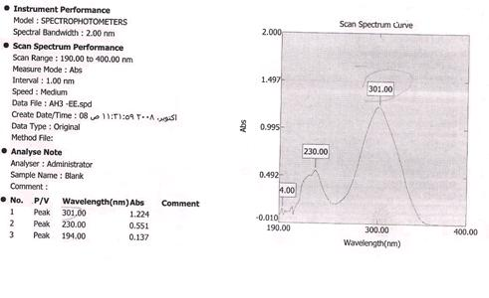
Figure (4-1): UV spectra in ethanol for 3-(4-chlorophenyl)-2-(4- diethylamino phenyl) - 5, 9-dithia-2-azaspiro [3.5] nonan-1-one 4b.

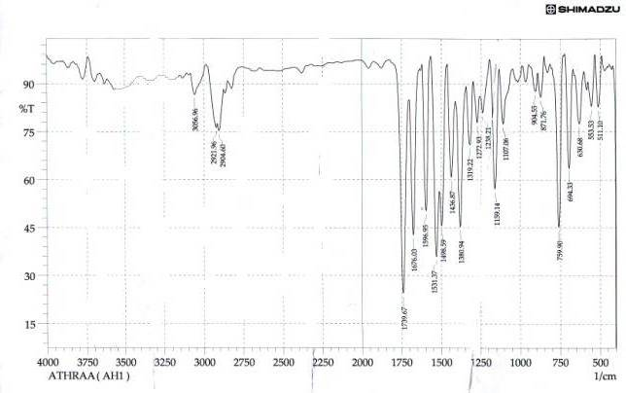

Figure(4-2) IR spectra of 2,3 diphenyl-5,9-dithia-2- aza-spiro[3.5]nonan- 1-one 4a.

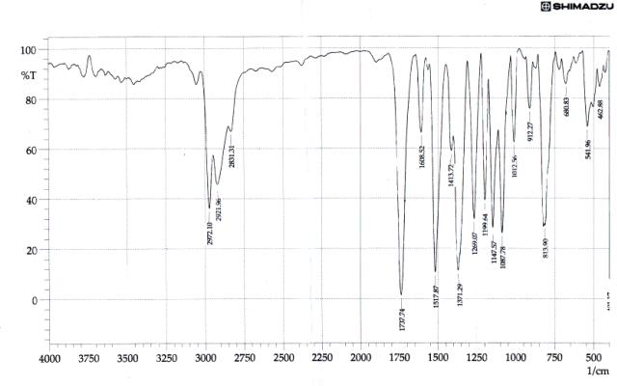

Figure (4-3): IR spectra of 3- (4-chloro phenyl) - 2-(4-diethyl amino phenyl) -5, 9-dithia-2- azaspiro [3.5] nonan-1-one 4b.

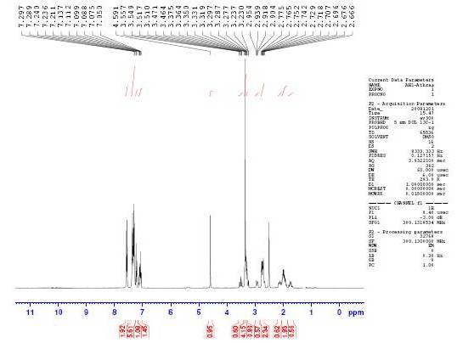

Figure ( 4-4) ¹H -NMR spectra of 2,3-diphenyl -5,9-dithia-2-azaspiro[3.5] nonan -1-one 4a.

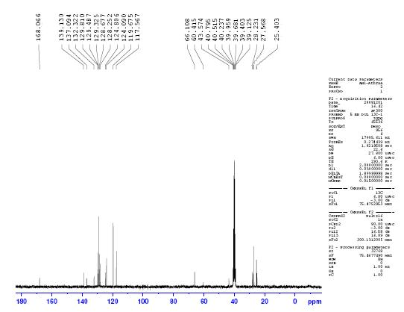
Figure (4-5) ¹³C NMR spectra of 2, 3-diphenyl-5, 9-dithia-2-azaspiro [3.5] nonan -1-one 4a.

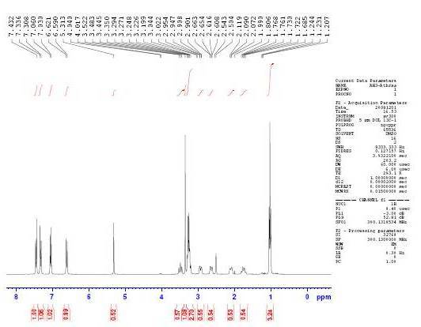

Figure (4-6) ¹H-NMR spectra of 3- (4-chlorophenyl)-2-(4-diethylamino phenyl)5, 9-dithia-2-azaspiro [3.5] nonan-1-one4b.

Figure (4-7) ¹³C NMR spectra of 3-(4-chlorophenyl-2 -(4-diethylaminophenyl)- 5,9-dithia-2-azaspiro[3.5]nonan-1-one 4b.

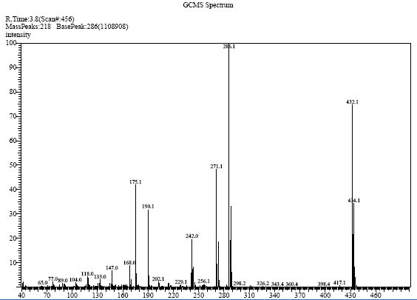

Figure ( 4-8) Mass spectra of 3- (4-chloro phenyl ) 2-(4-diethyl aminophenyl)-5,9dithia-2-azaspiro[3.5]nonan-1-one,4b .

References
- (a) Bruggink , A., "synthesis of β-Lactam Antibiotics ,Chemistry Biocatalysts and process Integration" , Ed., kulwer : Dordercht , Netherlands ,2001. (b) Morin, M.B.,and Gorman,M., "Chemistry and biology of β-lactam antibiotics" , Eds.,Academic press : New York , 1982, (c) Katritzky,A.R.,Rees,C.W.,and scriven ,E.F.V., "Comprehensive Heterocyclic Chemistry I I" Eds .,Elsevier:New York ,1996 ,vol, 1b ,Chapters 1.18-1.20(d) Georg, G.I., "The Organic Chemistry of β-lactams ", Ed .,VCH New York,1993 .
- Palomo, C., Aispura, J .M. Jake, G., Oiarbide, M. Eur., J.Org.Chem., 1999, 3235.
- Staudinger, H., Annalen., 1907, 51, 356.
- (a) Skiles, J. W., and Mcneil , D ., Tetrahedron Lett ., 1990,31 , 7277.(b) Sheehan , J. C ., Chacko , E ., Y . S., Ponzi, D. R., and Sato, E., J .Org. Chem. ., 1978,43, 4856.
- (a) Guangzhong, Wu. W., and Tormos. J . Org. Chem ., , 1997,62 , 6414.(b)Chen ,L. Y., Zarks , A., Chackalamamil, S.,and Dugar , S. , J .Org Chem ., 1996,61 , 8341.
- Austen, B. M., Frears ,E. R., and Davies , H. "In international Symposium on proteinase inhibitors and Activators" , university . Of oxford, U.K April, 2000, Abstract Book P.6.
- Dugar, S., Calder, J., Chan, T. M., and Davis, H., J. Med. Chem., , 1995,. 38, 4875 .
- Hello, K. M., Iraqi, J .of Chem., , 2000,24, 266.
9. Krishnaswamy, D., Tetrahedron, 2002,34, 4567.
10. Deshmukh, A. R. A .S. Shaikh, A. L., Kale .A.S., Shaikh. M. A and Puranik , V. G., Tetrahedron,. 2007,63, 3381.
11. Bahalla, A., Vunugo palan, P., Bhasin, K. K., and Bari , S .S., Tetrahedron , 2007,63 , 3204.

12. Singh, G. S., Pheko, T., Spectrochimica Acta part, 2007,111, 111. 13.Lacroix , S ., Cheguillaume ,A., Gerard , S. ,and Marchand –Brynaert, J ., Synthesis , 2003,2483 .
14. Cremonesi , G., Croce , P. D., and Rosa , C. L., Tetrahedron , 2004,60 , 96.
15. Singh, G. S., Mini-Rev. Med. Chem. , 2004,4, 109.
16. Shirode N. M., Kulkarni, K. C., Gumatse, V .K. Deshmukh, A. R. A .S. Arkivoc 2005, 1, 60.

17. Shirode N. M., Kulkarni, K. C., Gumatse, V .K. Deshmukh, A. R. A .S. Arkivoc , 2005,1, 60.

