Radical Polymerization of Vinyl acetate in the presence of
Chain Transfer agents: Determination of Chain Transfer Constants
and Activation Energy of transfer

Salah M. Aliwi, Tariq S. Najim* and Asma M. Ali
Chemistry Department, College of Science, Mustansiriyah University
Baghdad, Iraq

(NJC)

(Recevied on 13/7/2008) (Accepted for publication 19/4/2009)

Abstract
Vinyl acetate has been polymerized by bulk process with and without different types of amines compunds as chain transfer agents. The various chain transfer constants(Cs) and their temperature dependence over a range of temperatures of (65–85˚C) have been determined and discussed.
The chain transfer constants of propylamine, dipropylamine and N-ethylaniline were evaluated by using May plot, their values found as follows:
N – ethyl aniline > dipropyl amine > propyl amine
The high values of chain transfer constants of N-ethyl aniline were attributed to the resonance stability of the radical derived after the transfer process.
Activation energies of the chain transfer processes in the present polymerization systems were also determined using the usual Arrhenius relationship, which were found inconsistent with the values of chain transfer constants.
الخلاصة
تمت بلمرة خلات الفنيل بالطريقة البلكية (بدون استخدام مذيب) بوجود وبعدم وجود مركبات الامين كعوامل ناقلة للسلسلة. تم تعيين ثوابت انتقال السلسلة بمدى معين من درجات الحرارة بين (65-85م).
استخدمت معادلة مايو في تعيين ثوابت انتقال السلسلة للبروبيل امين وثنائي بروبيل امين ن-اثيل انيلين وكان ترتيب قيم ثوابت الانتقال كالاتي:
N-ethyl aniline>dipropyl amine> propyl amine
ان القيم العالية لثوابت انتقال السلسلة لل ن-اثيل انيلين اعزي الى الريزونانس الذي يعانيه الجذر الحر الناتج من عملية الانتقال.
تم كذلك تعيين طاقات التنشيط لعمليات الانتقال في انظمة البلمرة الحالية وذلك باستخدام علاقة ارينهوس والتي وجد بانها تتفق مع قيم ثوابت انتقال السلسلة.

Introduction
Radical polymerization is one of the most important commercial processes leading to high molecular weight polymers, because a wide variety of monomers can be polymerized and copolymerized. The drawback of this process is the lack of control of the molecular weight due to the presence of unavoidable chain – breaking reactions, such as chain transfer reactions. In recent years, there has been renewed interest in the use of chain transfer agents to control the molecular weights of polymers obtained by free–radical polymerizations ⁽¹⁾. This interest is mainly due to the increased use of low molecular weight polymers.
Thiols have been employed early as efficient, rather ideal, chain transfer agents. This behavior is expected in terms of the weakness of the S–H bond ⁽²⁾ and the high reactivity of the thiyl radicals ⁽³⁾.On the other hand ,allyl compounds have been used as transfer agents in radical polymerization ⁽⁴⁻⁶⁾.
The chain transfer reaction in vinyl polymerization is a radical displacement process of the type:
R_{r}˙+ SX R_{r}X+S˙…..(1)
In which R_{r}˙ represents a polymeric free radical, SX the transfer agent and S˙ the free radical derived from SX by displacement of the atom X ⁽⁷⁾. Measurement of the velocity coefficients of reaction of this kind have been used to provide data on the general reactivities of polymeric radical derived from different vinyl monomers and on the structures which determine the reactivity of a molecule towards radicals. As a rule the velocity coefficient of reaction (1) increases as the general reactivity of R_{r}˙ increases and as the stability of S˙ increases. It has recently become apparent that specific factors which include the participation of polar structures in the transition state is one of the most important.
In this, paper, primary and secondary amine (aliphatic and aromatic) compounds were used as transfer agents in free radical polymerization of vinyl acetate in bulk, in order to estimate their ability to cut down the polymer chains, such compounds have never been used before as transfer agent in vinyl acetate polymerization.

Experimental
Purification of Chemicals:
- Vinyl acetate was purified by vacuum distillation and stored in a cool place.
- Dibenzoyl peroxide was purified by dissolving in minimum amount of chloroform at room temperature and precipitated by addition of methanol, dried at room temperature for 24 hours, then stored in a dissicator in the dark at 0˚C ⁽⁸⁾.
- Propylamine, dipropylamine and N-ethylaniline were purified by simple distillation before use.
- Heptane (Flucka AG) was used without further purification.
- Benzene (99% pure, BDH).was used without further purification.
Polymerization Processes:
The polymerization of vinyl acetate was carried out in bulk system. Dibenzyol peroxide (1×10^{–3} mol/L) was used as free radical initiator for polymerization process at different temperatures. the dissolved oxygen was removed by passing argon gas for five minutes. The polymerization was carried out in a sealed Pyrex tube for 40 minutes, then the polymer was precipitated in heptane. The solid polymer was filtered, dried under reduced pressure at 40˚C to constant weight. The produced polymer was used for determination of rate of polymerization and %conversion using the following equations:
% conversion = weight of polymer produced(g) / weight of monomer (g) × 100……..(2)
$\frac{−d\left[M\right]}{\text{dt}}=ω=\frac{M_{o}}{\text{100}×t}$% conversion…….(3)
Where $ω$: rate of polymerization, M_{o}: initial monomer concentration, % conversion: percent conversion t = time in seconds.
The chain transfer reaction were carried out using propylamine, dipropylamine and N-ethylaniline as transfer agents, with different concentrations, the monomer and initiator concentrations were kept constant (10.849) mol.L^{–1} and (1×10^{–3}) mol.L^{–1} respectively at fixed polymerization temperature.
Molecular weight measurements
Molecular weight of the produced poly(vinyl acetate) with and without transfer agent were determined by viscometric technique using Ostwald tube viscometer. Benzene was used as solvent for viscosity measurements at 30˚C. The temperature was controlled by thermostat type (HAAKE – EK45). The number average molecular weight ($\bar{M}n$) is deduced from the usual Mark – Hounwink equation ⁽⁹⁾ :
$$\left[η\right]=k\bar{M}n^{α}\text{.}\text{.}\text{.}\text{.}\text{.}\text{.}\text{.}\text{.}\text{.}\text{.}(4)$$
Where $\left[η\right]$ is the intrinsic viscosity, k and α are constants,and can be obtained from litreture ⁽¹⁰⁾.
Results and Discussion
From evaluation of percent conversion of polymerization of vinyl acetate which was below 8% in all polymerization experiments. It has been found that the rate of polymerization of vinyl acetate reaches zero at the beginning of the reaction which carried out in presence of constant concentration of transfer agent, that was a good indication for the absence of inhibition or retardation in the polymerization processes. Moreover, the generated radicals from transfer process have enough activity ( although it is different ) to form new macromolecular chains.
Chain transfer constant (Cs) in free radical polymerization is normally determined by the well known Mayo's equation ⁽¹¹⁾ :
$$\frac{1}{\bar{P}n}=\frac{1}{\bar{P}n^{o}}+\text{Cs}\frac{\left[S\right]}{\left[M\right]}+\text{Cm}+\text{Ci}\frac{\left[I\right]}{\left[M\right]}\text{.}\text{.}\text{.}\text{.}\text{.}\text{.}\text{.}\text{.}\text{.}(5)$$
Where $\bar{P}n$: The number average degree of polymerization obtained with different concentrations of chain transfer agents, $\bar{P}n^{o}$: the number average degree of polymerization without chain transfer agent, Cs: The chain transfer constant to transfer agent, [S]: chain transfer agent concentration, [M]: Monomer concentration, Ci: chain transfer constant to initiator, [I]: initiator concentration.
Because the chain transfer constant to monomer Cm and initiator Ci are very low 2.4×10^{–4} and 0.04 respectively ⁽¹⁰⁾, Then the last two terms in the above equation is neglected in this work, the Mayo's equation become:
$$\frac{1}{\bar{P}n}=\frac{1}{\bar{P}n^{o}}+\text{Cs}\frac{\left[S\right]}{\left[M\right]}\text{.}\text{.}\text{.}\text{.}\text{.}\text{.}\text{.}\text{.}\text{.}\text{.}(6)$$
From the number average molecular weight ($\bar{M}n$) of produced poly(vinyl acetate), $\bar{P}n$ can be calculated, all these values are shown in table (1).
From equation (6) a plot of ($1\bar{P}n$) versus values of ($\left[S\right]\left[M\right]$) give straight line with slope equal to Cs and intercept equal to, ($1\bar{P}n^{o}$). Figure (1) shows this plot at different temperatures and from the slope of each amine Cs value was calculated table(2). As expected, the chain transfer activity of secondary amine is greater than that for primary amine ⁽⁷⁾ . Secondary amine have reactive N–H bond which can be displaced, in addition to the C–H bonds in α–position to amine group. The N–H bond in primary amine are much less reactive than secondary N–H bond. The values obtained from figure (1) suggest that the highest chain transfer constant Cs is obtained when N–ethyl aniline is used as chain transfer agent (7.86) then dipropylamine (5.55) and propylamine (0.69) at 70 ⁰C table 2. The trend can be written as follows.
N – ethylamine > dipropylamine > propylamine
This trend of Cs values can be attributed to the greater resonance stabilization of N–ethyl aniline radical derived from chain transfer process, while, the presence of two α-C–H bond and one secondary N–H bond in dipropyl amine can be displaced with higher stability than primary N–H and one α-C–H in propyl amine ⁽¹²⁾.

Table1: intrinsic viscosity, average molecular weight ($\bar{M}n$) and number average degree of polymerization ($\bar{P}n$) for different concentration of transfer agents at constant temperature (70˚C) and constant reaction time (40 min), initiator concentration 1×10^{–3} mol.L^{–1} and monomer concentration 10.849 mol.L^{–1}.
Chain Transfer agent | Conc. of transfer agent mol.L^{–1} | Intrinsic viscosity $\left[η\right]$ dl g⁻¹ | $\bar{M}v$g/mole | $$\bar{P}n$$ | $\frac{1}{\bar{P}n}$×10^{–3} | $$\left[S\right]\text{10}\text{.}\text{849}$$
Propyl amine | 0.0 | 60.21 | 76863 | 893 | 1.120 | 0.0
Propyl amine | 5×10^{–3} | 49.28 | 55654 | 646 | 1.547 | 0.461×10^{–3}
Propyl amine | 7×10^{–3} | 47.29 | 52062 | 605 | 1.654 | 0.645×10^{–3}
Propyl amine | 9×10^{–3} | 45.83 | 49489 | 575 | 1.740 | 0.830×10^{–3}
Propyl amine | 10×10^{–3} | 44.19 | 46665 | 542 | 1.845 | 0.922×10^{–3}
Propyl amine | 13×10^{–3} | 41.36 | 41952 | 487 | 2.052 | 1.198×10^{–3}
Dipropyl amine | 3×10^{–4} | 53.61 | 63744 | 740 | 1.351 | 2.765×10^{–5}
Dipropyl amine | 5×10^{–4} | 51.96 | 60604 | 704 | 1.421 | 4.607×10^{–5}
Dipropyl amine | 7×10^{–4} | 49.77 | 56547 | 657 | 1.522 | 6.452×10^{–5}
Dipropyl amine | 9×10^{–4} | 47.77 | 52926 | 615 | 1.627 | 8.296×10^{–5}
Dipropyl amine | 10×10^{–4} | 46.26 | 50247 | 584 | 1.713 | 9.217×10^{–5}
N–ethyl aniline | 1×10^{–4} | 47.82 | 53015 | 616 | 1.624 | 0.922×10^{–5}
N–ethyl aniline | 3×10^{–4} | 45.83 | 49489 | 575 | 1.740 | 2.765×10^{–5}
N–ethyl aniline | 5×10^{–4} | 43.67 | 45789 | 532 | 1.880 | 4.609×10^{–5}
N–ethyl aniline | 7×10^{–4} | 44.72 | 42530 | 494 | 2.024 | 6.452×10^{–5}
N–ethyl aniline | 9×10^{–4} | 39.55 | 39026 | 453 | 2.206 | 8.296×10^{–5}

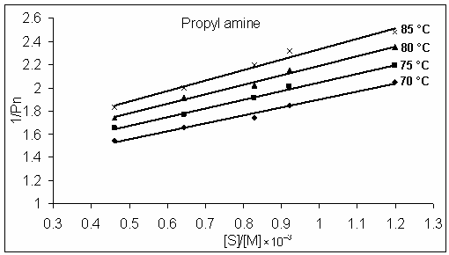
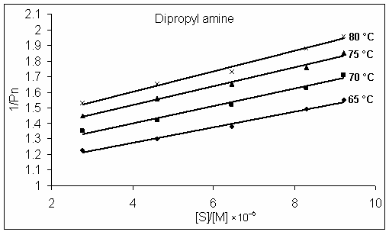
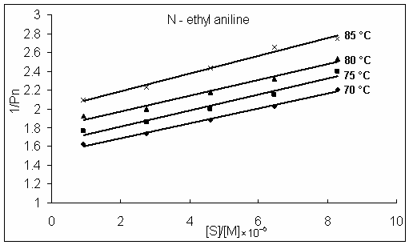

Figure 1: The variation of$1\bar{P}n$versus $\left[S\right]\left[M\right]$ values for the polymerization of vinyl acetate at different temperatures, initiator concentration (1×10^{–3}) mol.L^{–1} and monomer concentration is 10.849 mol.L^{–1}.

In the present work the value of activation energy of transfer for each amine have been determined using Arrhenius equation:
$k={\text{Ae}}^{−E\text{RT}}$
$$\text{ln}k=\text{ln}A−\frac{E}{\text{RT}}$$
or $\text{ln}\text{Cs}=\text{ln}A−\frac{E}{\text{RT}}$ where $E=E_{\text{fs}}−E_{p}$
$\text{ln}\text{Cs}=\text{ln}A−\left(\frac{E_{\text{fs}}−E_{p}}{\text{RT}}\right)$……(7)
Where E_{fs} and E_{p} are activation energy of the chain transfer and propagation process respectively A is frequency factor. A straight line is obtained from Arrhenius plot of lnCs versus 1/T, figure (2), with slope equal to E_{fs} – E_{p}/R. Since the E_{p} for bulk polymerization of vinyl acetate is already determined being equal to 19.6 kJ.mol^{–1} ⁽¹⁰⁾ and accordingly the E_{fs} is equal to 40.35, 34.1 and 31.9 kJ.mol^{–1} for propyl amine, dipropyl amine and N–ethyl aniline respectively table (4).
E_{fs} N–ethyl aniline < E_{fs} dipropyl amine < E_{fs} propyl amine
These values are in consistence with values of the chain transfer constant (Cs).

Table 2: chain transfer constants of propyl amine, dipropyl amine and N–ethyl aniline in bulk polymerization of vinyl acetate at different temperature and constant monomer and initiator concentrations.
Chain Transfer agent | T ˚C | T ˚K | $1T$×10^{–3} | Cs | lnCs | 5 + lnCs
Propyl amine | 70 | 343 | 2.915 | 0.686 | – 0.3768 | 4.6231
Propyl amine | 75 | 348 | 2.874 | 0.741 | – 0.2997 | 4.7002
Propyl amine | 80 | 353 | 2.833 | 0.848 | – 0.1648 | 4.8351
Propyl amine | 85 | 358 | 2.793 | 0.920 | – 0.0833 | 4.9166
Dipropyl amine | 65 | 338 | 2.959 | 5.336 | 1.6744
Dipropyl amine | 70 | 343 | 2.915 | 5.547 | 1.7130
Dipropyl amine | 75 | 348 | 2.874 | 6.204 | 1.8251
Dipropyl amine | 80 | 353 | 2.793 | 6.590 | 1.8855
N–ethyl aniline | 70 | 343 | 2.915 | 7.859 | 2.0616
N–ethyl aniline | 75 | 348 | 2.874 | 8.402 | 2.1284
N–ethyl aniline | 80 | 353 | 2.833 | 8,827 | 2.1778
N–ethyl aniline | 85 | 358 | 2.793 | 9.447 | 2.2456

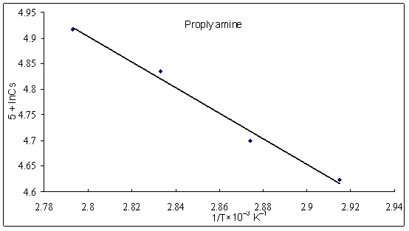
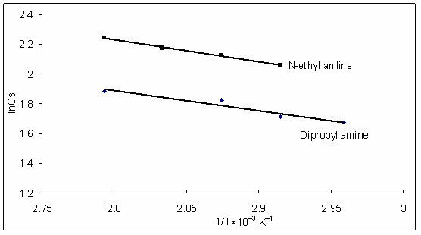

Figure 2: The Arrhenius plot of lnCs versus 1/T for the polymerization of vinyl acetate in the presence of propyl amine, dipropyl amine and N–ethyl aniline.

The chemical structure of the transfer agents used in this work with their expected free radical after chain transfer processes are shown in table ( 3 ).

Table 3: The chemical structure of propyl amine, dipropyl amine and N– ethyl aniline and their expected free radicals after chain transfer processes.
Chain transfer agent | Chemical structure
Propyl amine
Dipropyl amine
N – ethyl aniline
Table 4: the total activation energy, activation of transfer processes and frequency factor of polyvinyl acetate.
Transfer agent | Total activation energy  E (kJ.mol^{–1}) | Activation energy of transfer reaction  E_{fs} (kJ.mol^{–1}) | ln(Afs/Ap) cm³.mol^{–1}.sec^{–1}
Propyl amine | 20.75 | 40.35 | 11.9
Dipropyl amine | 14.46 | 34.1 | 6.8
N – ethyl aniline | 12.3 | 31.9 | 6.4

Conclusion
One might conclude that N–ethyl aniline is reactive as transfer agent which can stop growing of polymer chains easily at 70 C, and higher reactivity at higher temperatures. On the other hand diproplyl amine is some what reactive as transfer agent, while propyl amine is weak in its activity as transfer agent.

References
- Heuts, J.P.A., T.P. Davis, and G.T. Russell, Macromolecules, 1999, 32 (19), 6019.
- Bordwell, F.G., X.M. Zhang, A.V. Satish and J.P. cheng, J. Am. Chem. Soc., 1994, 116 (15), 6605.
- Wordman, P. and C. Von Sonntag, Methods in Enzymology, 1995, 251, 31.
- Kudyshkin,V.O., N.R. Vokhidova, N.I. Bozorov, O.E. Sidorenko, I.N. Ruban, N.L. Voropaeva and Rashidova,S.Sh., Russian Journal of Applied Chemistry, 2004, 77(6), 994.
- Dawson, T.L. and R.D. Lundberg, J.polym.Sci.partA:General papers, 1965, 3(5), 1801.
- Kudyshkin,V.O., N.I. Bozorov, O.E. Sidorenko, N.L.Voropaeva, I.N.Ruban,G.Kogan and S.Sh. Rashidova, Chem. Pap., 2004, 58(4) , 286.
- Bamford, C.H. and E.F.T. White, trans. Faraday Soc., 1965, 52, 716.
- Armarego, W.L.F. and D.D. Perrin, Purification of Laboratory chemicals,Butherworth, Heinmann, London (1998)
- Moore, W.R. and M. Merphy, J. Polym. Sci., 1962, 56 (164), 519.
- Brandrup, J., E.H. Imnergut and E.A. Cruke, Polymer Handbook, 4th Ed., Wiley – Interscience, New York (1999).
- Mayo, F.R., J. Am. Chem. Soc., 1943, 65, 2324.
- Mortimer, G.A., J. Polymer. Sci., 1970, A – 1, 8, 1513.

