Preparation some new complexes of methacrylic acid derivatives and evaluation as a bonding agent in tooth
Amer A. Taqa
Dept. of DBS, College of Dentistry, Mosul University

(NJC)
(Recevied on 3/11/2008) (Accepted for publication 19/7/2009)

Abstract
Ligands were prepared by reacting Methacrylic acid with each of Ethylene chlorohydrine, Chloro acetic acid, 2-hydroxy benzal Chloride , 2- chloro-6- hydroxy aniline, 2- chloro-6- hydroxy pyridine. The ligands were formed and then interacted with Ca(II); The Complexes resulted from ligand : metal (2:1) interaction that have the general formula [Ca(H₂ C=C(CH₃)CO₂R)₂]. Ten complexes were done by preparing a mixture of ligand compounds prepared above and Glutaraldehyde. The mixture was reacted with Calcium ion taken from healthy teeth solved in concentrated Nitric acid. Then it was tried to use these complexes as to be bonding materials that connect the composite with the enamel.
The complexes were studied by Conductivity, Infrared spectra, biocompatibility, and antibacterial measurements. The conductivity measurements of the prepared complexes indicated that all the complexes prepared in Methylcyanid solvent at (10⁻³ M concentration) at 25ºC are non-electrolyte. The infrared spectra showed displacement of stretching vibration ν (C=O) presented in all the complexes. Also, a band belonged to metal –oxygen bonding stretching was indicate that the bonding occurred via oxygen.
As for the study of biocompatibility and antibacterial, it was clear that the prepared complexes had a prohibiting effect on bacteria and fungi, but no negative effect on oral (mouth) tissues.
الخلاصة
حضرت الليكاندات من التفاعل بين حامض الميثاكريلك والمركبات اثلين كلوروهيدرين، 2 كلورو حامض الخليك، 2-هيدروكسي بنزيل كلزرايد،2 كلورو-6-هيدروكسي انيلين، 2-كلورو-6-هيدروكسي بيريدين. تم مفاعلة اليكاندات المحضرة مع ايون الكالسيوم الثنائي التكافؤ ونتجت معقدات بنسبة 1:2 بصيغة عامة .[Ca(H₂C=C(CH₃)CO₂R)₂] تم تحضير عشرة معقدات اضافية بمفاعلة اللكياندات المحضرة مع مركب الكلوتالديهايد ثم مفاعلة المركب الناتج مع ايون الكالسيوم المستخلص من اسنان سليمه والمذابه في حامض النتريك المركز. جرت محاولة استخدام المعقدات الناتجة كمركبات رابطة بين ماد الكومبوزت وميناء السن. تم قياس التوصيلية المولارية ، الاشعة تحت الحمراء،الفعالية البايولوجية،والتاثير البكتيري للمعقدات المحضرة. دلت قياسات التوصيلية المولارية ان المعقدات المحضرة غير موصلة في مذيب سيانيد المثيل. اظهرت قياسات الاشعة تحت الحمراء وجود ازاحة في الاهتزاز الامتطاطي لمجموعة الكاربونيل (C=O) لجميع المعقدات. بينت قياس الفعالية البايولوجية والبكتيرية للمعقدات المحضرة ان لها تاثير مثبط للبكتيريا والفطريات وليس لها اي تاثير سلبي على انسجة الفم.

Introduction
Calcium compounds have a great scientific value; many studies have been executed to prepare it^{(1,2)}. Clark et al (1989) ⁽³⁾ managed to prepare and study (calcium dipyrromethene) through the interaction of calcium ion(II) and (3,3’,4,4’tetrachloro or,5,5’dicarbethoxy 2,2’dipyrromethene) within the limitations of x-ray. They found that calcium ion had eight patterns to distorted dodecahedral combination with eight facets and it combines four nitrogen atoms of pyroll ring and also four atoms of oxygen of carbonyl group which belong to carboxyl group. It was also found that ligand dipyyromethene has an importance in studying the structure of metalloprophrims in the haem as well as chlorophyll. The importance of these researches is ascribed to their relatedness to dentistry. Calcium and its compounds are valuable for being a constituent part of tooth formation. Among those studies are the one related to bonding agent, which is a term used to describe a number of methods that involve putting the resin compound in the tooth⁽⁴⁾. The bonding process is made on the teeth which have spaces in- between them, fractured ones, cracked and eroded^{(5,6)}, removing stains, treating discoloration⁽⁷⁾, protecting discolored roots due to gum recession⁽⁸⁾, restoration of curious teeth by filling small cavities⁽⁴⁾. The process of bonding enamel and restorative resin are based material involve independent digging of tooth enamel in order to obtain a selective dissolution and micro-porosity⁽⁹⁾. Enamel which consists of hydroxyapatite Ca₅(PO₄)₃OH) does not mean that the enamel consists of independent molecules; rather of three dimensional compound called (lattice) in which a series of calcium (Ca²⁺)ions, phosphate (PO₄⁻³), Hydroxyl ion(OH⁻) are put around together⁽¹⁰⁾. One of the most particular compounds used in bonding teeth is the ratings with a group of phosphate at the end of it. This is attributed to the ability of the group to be negative, compared with the original group of phosphate with exists in hydroxyapatite. Among the bonding agent is glutaraldehyde, known to be tied with collagen, when a partial bonding is made like hydroxyl ethyl methyl acrylate(HEMA) with glutaraldehyde which is combined with collagen , and using methylacrylate in HEMA with a multi-compound material during the process of polymerization, it was believed that the chemical bonding can be made between collagen and the multi component material⁽⁹⁾. The aims of the present study are to prepare some new calcium complexes by using ligands contain oxygen atom, then study physical properties of these complexes and trying to used these complexes as a bonding agent between tooth enamel and filling, also the biological and biocompatibility measure to show the effect of complexes on the tissue using laboratory mice type Albino.
Materials and Methods
All chemicals used from Fluka Company without any further purification.
Preparation of hydroxyl ethylmethyl acrylate(L₁)⁽²⁵⁾
40mmole(1.6gm) of sodium hydroxide was dissolved in 35 ml of absolute ethyl alcohol then added to a mixture of 50mmole(4.2ml) methylacrylic acid and 45mmole (3ml)of ethylene chlorohydrine; The solution was heating and stirring until a white precipitate was formed, then washed with ether and dried(Table1).
Preparation of Carboxy
Methylmethacrylate(L₂)
2-Hydroxybenzyalmethacrylate(L₃), 2-Amino-3-Hydroxyphenyl methacrylate(L₄),2-6-Hydroxy pyridenemethacrylate(L₅). Same method used to prepare the above ligands by using chloroacetic acid, 2-hydroxy chlorobenzyl, 2-6-chlorohydroxyaniline, 2-chloro-6-hydroxypyridene instated of ethylene chlorohydrine, to obtain; bale brown, white, white, white precipitate respectively (Table1).

Preparation of [M(L)₂] complexes
The complexes were prepared by the following general methods:
2mmole(0.26gm) of ligand was dissolved in 5ml distilled water then added to a solution contain 1mmole(0.15gm) of CaCl₂.2H₂O in distilled water with continues stirring. The precipitate was filtered and washed several times with distilled water then dried.(Table2) Preparation of bonding agent compounds The preparation of chemical bonding agent were especially used to bond the enamel tooth and filling materials by reaction between the prepared ligands and glutaric dialdehyde.(Table2) Preparation of [L₁HCO(CH₂)₃CHO] compound 0.4mmole(0.05gm) of L₁ was dissolved 15 ml of absolute alcohol then added to a solution contain 0.5mmole(0.047ml) glutaric dilaldehyde in 5ml of absolute alcohol the mixture then was heating with continues stirring until to obtain a homogenous solution. The same methods was used to prepared[L₂HCO(CH₂)₃CHO],[L₃HCO (CH₂)₃CHO],[L₄HCO(CH₂)₃CHO], [L₅HCO (CH₂)₃CHO].
Preparation the bonding compounds with enamel tooth
Preparation of tooth solution: This was done by dissolving one gram of grained sound tooth in 3ml of concentrated nitric acid; the volume was completed to 100ml.
Prepared of the calcium tooth complexes
The complexes (table3) were prepared by adding 3 ml of each prepared bonding compound to 0.5 ml of tooth solution with mixing, a brown precipitate was formed, and the complexes was filtered and dried.The calcium in the complexes was evaluated by flame photometer method⁽¹¹⁾. 20, 40, 60, 80 and 100 ppm solutions of calcium acetate were prepared to made standard curve. 0.1 gm of calcium complex was dissolved in 3 ml concentrated hydrochloric acid, this solution was diluted by distilled water to 50 ml using volumetric flask. Flame photometer type EEL was used to measured the optical density of the calcium concentration in both standard solutions and complexes. Molar conductivity measurements were done by conductivity meter model PCM3-JENWAY at 10⁻³M concentration at 25˚C in methyl cyanide solution. The ultraviolet spectra measured by using Cintra scientific equipment UV-Visible sepectrophotometer) in 1-4 dioxane as solvent at 25˚C using quartz cell between 200-1100nm.
The infrared spectra measurements was done by using ThermoNicolte, Fourier-tranform Infrared (FT-IR)Spectrophotometer(400-4000cm⁻¹) using KBr disk. The antimicrobial assay of the bonding compounds was measured by a turbidity method⁽¹²⁾ The microorganisms Staphylococcus aureus, Streptococcus mutans and Candida albicans were selected to examine the antimicrobial activity of our complexes, were isolated and identified*.

------------------------------------------------------------------------------------------------------------
* Identified at the Biology Department, College of Sciences, Mosul University

Turbidity method for the assay; 1 gm of the powdered compound was dissolved in 9 ml distilled water, then 1/10, and 1/100 concentration were prepared from the first concentration.
0.1 ml of each concentration was added to small vials contain 4 ml of the Tryptic Soya Broth medium and inoculated by 0.1 ml of the bacterial suspension. The compounds were incubated for 18 hours at 37°C. The compounds then reading at the optical density of the cultures (595 nm wavelength) by using spectrophotometer Type Spectronic 21, and the average were taken for triplicates of each compound and each concentration. Contact tissue reaction was tested on the laboratory mice type Albino by washing the oral tissues of mice by with 0.5ml of bonding agent for three days⁽¹²⁾. A bonding resin material was used as a control compound(10). After five days, the mice were killed and biopsy samples of the tissue gum were collected and stored in 15%formalin for 24hours. The biopsy then stored in alkaline alcohol solutions 70%,80% and 90% then in a absolute alcohol to remove water . The samples were immersed in xylol solvent and paraffin wax. The samples then immersed in liquid paraffin and after solidified the blocks were cutting by microtome machine ⁽¹³⁾. The slides samples were colored with Hematoxilen-hares-Iosen⁽¹⁴⁾ and readied under light microscope. The test were done in the Veterinary college Mosul University.
Results and Discussion
The chemical formula, melting point, calcium analysis, conductivity and electronic spectra measurement for the complexes were tabulated in table 2. The conductivity of the prepared complexes (tablel 2) was measured in methyl cyanide at 10⁻³ M concentration (25˚C), (table1) gives molar conductivity values between (12.5-88.4 ohm⁻¹ cm²), The very low molar conductance values indicated the weak electrolytic nature of the complexes in methyl cyanide solvent ⁽¹⁵⁾. The electronic spectra(Table2)(Figures 1-3)for the complexes gives absorbance bands between (396-360nm) this bands attributed to the charge transfer from ligand to metal⁽¹⁶⁾.
The infrared spectra measurements(Table 4)(figures 4-6) showed that the stretching vibration of (C=C) lie in 1680-1620cm⁻¹ in both ligands and complexes, this results refer that this group was not coordinate with calcium⁽¹⁷⁾ . This behavior was similar to the stretching vibration of υ(C-O-C) ⁽¹⁸⁾ which appeared in1240-1264cm⁻¹in both ligands and complexes. The υ(C=O) esters showed bands in 1719-1770cm⁻¹ (table3) this bands shifted to a low frequency (1650-1683cm⁻¹) also the bands had split in the complexes. This confirm the happen complexes between ligand and calcium⁽¹⁹⁾. The υ(C=N) of pyridine for ligand L5 showed a band in the 1554cm⁻¹. These bands are shift to a low frequency 1530cm⁻¹ in complex. This indicated that the coordination done through nitrogen atom⁽²⁰⁾. The υ(O-H) band appeared in the ligand at 3418-3447cm⁻¹ region. This band disappear in the complex. This results indicate that the proton of hydroxyl group was displacement in coordination⁽²¹⁾. The υ(COO- ) stretching show two types of bands, a strong unsymmetrical band at υas(1540-1570cm⁻¹) and a strong band symmetrical at υs(1440-1360cm⁻¹) . When the acetate group was coordinate as monodentate these two bands shifted to a high and low frequency respectively⁽²²⁾. The infrared measurement of the complex showed a differences ∆υ value between the two high frequency less than 150cm⁻¹ this value indicate that the coordinate between acetate group and calcium as a monodentate manner⁽¹⁵⁾. The stretching vibration υ(Ca-NO₃) group: the nitrate group coordinate as mono, bidentate or ionic form, this can be identification by infrared spectra measurements. Logen and Addison ⁽²³⁾ measured some the stretching of (M-NO₃) for some ionic metals in a specific region and they concluded that the differences between the two higher frequency ∆υ value, if the value is equal to 230cm⁻¹ this indicate the nitrate group coordinate as bidentate ligand, and if the differences is equal to 150cm⁻¹ the coordinate is a monodentate. also Gatehouse⁽²⁴⁾ was found that the nitro group coordinate as a monodentate form and they indicate three bands at (1008,1305 and 1420cm⁻¹), so the differences between the higher frequency ∆υ is 115cm⁻¹ and if the differences ∆υ is 186cm⁻¹ the nitrate group coordinate as a bidentate ligand.the prepared complexes showed a stretching of (Ca-NO₃) bands at υ1(1026-1078cm⁻¹), υ2(1240-1276cm⁻¹) and υ3(1386-1384cm⁻¹). The differences between the higher two frequency ∆υ(υ3-υ2) was less than 150cm⁻¹, this results confirm that nitrate group was coordinate as a monodentate manner in these complexes. The analysis of calcium metla indicate that the calcium coordinate in these complexes as 1: 2 molar ratio with a tetrahedral configuration.
Antimicrobial assay of the bonding agent compounds
The mean values of antimicrobial effect and standard deviation of the prepared compounds at 10⁻³M concentration for Staphylococcus aureus, Candida albicans and Streptococcus mutans were listed in (Tables 5,6,7) and presented in figure(7-9). T-test analysis was performed to test the differences in their antimicrobial effects of compounds tested .It was found that there is a highly significant effect of the prepared compounds on the Staphylococcus aureus, Candida albicans and there was no effect on the Streptococcus mutans. (A,B,C,D,E)(figure1,2,3) is a mixture of (L1,L2,L3,L4,L5) with glutaric dialdehyde respectively.
Biocompatibility Test
The study of the tissues were extracted from the gum mice that treated with the control material (bonding resin) and prepared compounds under electric microscope at 370X, 165X, 100X. Amplification showed that both of them give the same results and have no effects on the tissue as shown in the figures (10-15).
Table 1: The prepared ligands; their color and melting point.

Ligand | Sodium hydroxide | Methyl acrylic acid | ethylene chlorohydrine | Chloro acetic acid | 2-hydroxy chlorobenzyl | 2-6-chloro hydroxyaniline | 2-chloro-6-hydroxypyridene | color | mp ºC
L₁ | 40mmole(1.6gm) | 50mmole(4.2ml) | 45mmole(3ml) |  |  |  |  | White | 315
L₂ | 40mmole(1.6gm) | 50mmole(4.2ml) |  | 45mmole(4.3ml) |  |  |  | Bale Brown | 270
L₃ | 40mmole(1.6gm) | 50mmole(4.2ml) |  |  | 45mmole(5.2ml) |  |  | White | 325
L₄ | 40mmole(1.6gm) | 50mmole(4.2ml) |  |  |  | 45mmole(5.2ml) |  | White | 350
L₅ | 40mmole(1.6gm) | 50mmole(4.2ml) |  |  |  |  | 45mmole(4.7ml) | White | 320

Table2: The chemical formula, melting point, calcium analysis, conductivity and electronic spectra for the prepared complexes
No | Formula | Color | Dec C | Yield % | Ca%  (Found) | Conductivity value  Λ_{M}(ohm⁻¹cm⁻¹) | Uu-Vis (nm)  value
1 | [Ca(H₂C=C(CH₃)CO₂(CH₂)₂O)₂] | White | >350 | 78 | 8.1(8.00) | 18.1 | 259,360,300
2 | [Ca(H₂C=C(CH₃)CO₂CH₂CO₂)₂] | White | >350 | 20 | 3.46(14.25) | 18.2 | 290,307,360
3 | [Ca(H₂C=C(CH₃)CO₂CH₂C₆H₄O)₂] | White | 330 | 67 | 8.3(8.00) | 15.0 | 273,300,396
4 | [Ca(H₂C=C(CH₃) CO₂ PhNH₂O)₂] | White | >350 | 64 | 7.31(7.00) | 17.1 | 290,300,360
5 | [Ca(H₂C=C(CH₃)CO₂PyO)₂] | Brown | >350 | 73 | 9.64(9.66) | 12.5 | 260.32,300,392

Table 3: Some physical properties of prepared bonding agent
no | Bonding compound | Formula structure of product complex | Color | Dec. C | Yield % | Conductivity value Λ_{M}(ohm⁻¹ cm⁻¹)
6 | L₁ (CH₂)₃(CHO)₂ | Ca(NO₃)₂L₁CO(CH₂)₃CHO | Dark brown | 250 | 53 | 57
7 | L₂(CH₂)₃(CHO)₂ | Ca(NO₃)₂L₂CO(CH₂)₃CHO | Dark brown | 250 | 50 | 63
8 | L₃ (CH₂)₃(CHO)₂ | Ca(NO₃)2L₃CO(CH₂)₃CHO | Dark brown | 266 | 76 | 88.1
9 | L₄ (CH₂)₃(CHO)₂ | Ca(NO₃)₂L₄CO(CH₂)₃CHO | Brown | 285 | 97 | 88.4
10 | L₅ (CH₂)₃(CHO)₂ | Ca(NO₃)₂L₅CO(CH₂)₃CHO | Brown | 270 | 84 | 48

Table 4: The infrared spectra of the ligand and complexes (cm⁻¹)

Compound | ν(C=O) | COO Asym | COO  sym | ∆ν | N-H | C=N | _{M-O} | _{M-N} | _{M-OH2} | _{ν(Ca-NO3)} | _{ν(Ca-NO3)} | ν(Ca-NO₃) | ∆ν
L₁ | 1719
L₂ | 1770
L₃ | 1735
L₄ | 1770
L₅ | 17770
[Ca(H₂C=C(CH₃)CO₂(CH₂)₂O)₂] | 1687
[Ca(H₂C=C(CH₃)CO₂CH₂CO₂)₂] | 1650 | 1559 | 1422 | 137
[Ca(H₂C=C(CH₃)CO₂CH₂C₆H₄O)₂] | 1685 |  |  |  |  |  | 446
[Ca(H₂C=C(CH₃) CO₂ PhNH₂O)₂] | 1683 |  |  |  | 3110
[Ca(H₂C=C(CH₃)CO₂PyO)₂] | 1660 |  |  |  |  | 1570
Ca(NO₃)₂L₁CO(CH₂)₃CHO | 1637 |  |  |  |  |  |  |  |  | 1039 | 1238 | 1385 | 147
Ca(NO₃)₂L₂CO(CH₂)₃CHO | 1638 |  |  |  |  |  |  |  |  | 1078 | 1250 | 1384 | 134
Ca(NO₃)2L₃CO(CH₂)₃CHO | 1652 |  |  |  |  |  |  |  |  | 1027 | 1245 | 1385 | 140
Ca(NO₃)₂L₄CO(CH₂)₃CHO | 1637 |  |  |  |  |  |  |  |  | 1031 | 1240 | 1384 | 144
Ca(NO₃)₂L₅CO(CH₂)₃CHO | 1638 |  |  |  |  |  |  |  |  | 1030 | 1276 | 1384 | 108
(Complex)
Table 5: The effect prepared bonding agent on Candida albicans bacteria
Bonding compound | Control | Concentration  C1(10⁻³M) C2(10⁻²M) C3(10⁻¹M) |  |  | St.D | t-test | p-value
A | 0.185 | 0.013 | 0.016 | 0.088 | 0.43 | -0.6.082 | 0.26
B | 0.185 | 0.055 | 0.088 | 0.180 | 0.65 | -2.099 | 0.17
C | 0.185 | 0.008 | 0.014 | 0.111 | 0.58 | -4.280 | 0.05
D | 0.185 | 0.018 | 0.022 | 0.092 | 0.065 | -4.846 | 0.04
E | 0.185 | 0.017 | 0.002 | 0.065 | 0.43 | -4.947 | 0.02

Table 6: The effect prepared bonding agent on staphylococuus bacteria
Bonding compound | Control | Concentration  C1(10⁻³M) C2(10⁻²M) C3(10⁻¹M) |  |  | St.D | t-test | p-value
A | 0.909 | 0.057 | 0.251 | 0.289 | 0.124 | -9.957 | 0.01
B | 0.909 | 0.433 | 0.214 | 0.357 | 0.111 | -8.918 | 0.012
C | 0.909 | 0.231 | 0.284 | 0.324 | 0.047 | -23.876 | 0.002
D | 0.909 | 0.081 | 0.192 | 0.213 | 0.071 | -18.483 | 0.003
E | 0.909 | 0.415 | 0.386 | 0.361 | 0.027 | -32.242 | 0.001

Table 7: The effect prepared bonding agent on Streptococcus mutans bacteria
Bonding compound | Control | Concentration  C1(10⁻³M) C2(10⁻²M) C3(10⁻¹M) |  |  | St.D | t-test | p-value
A | 0.136 | 0.004 | 0.025 | 0.111 | 0.057 | -2.775 | 0.109
B | 0.136 | 0.003 | 0.026 | 0.130 | 0.068 | -2.154 | 0.164
C | 0.136 | 0.020 | 0.040 | 0.100 | 0.060 | -2.818 | 0.106
D | 0.136 | 0.008 | 0.011 | 0.084 | 0.054 | -3.726 | 0.065
E | 0.136 | 0.015 | 0.008 | 0.074 | 0.046 | -4.352 | 0.49
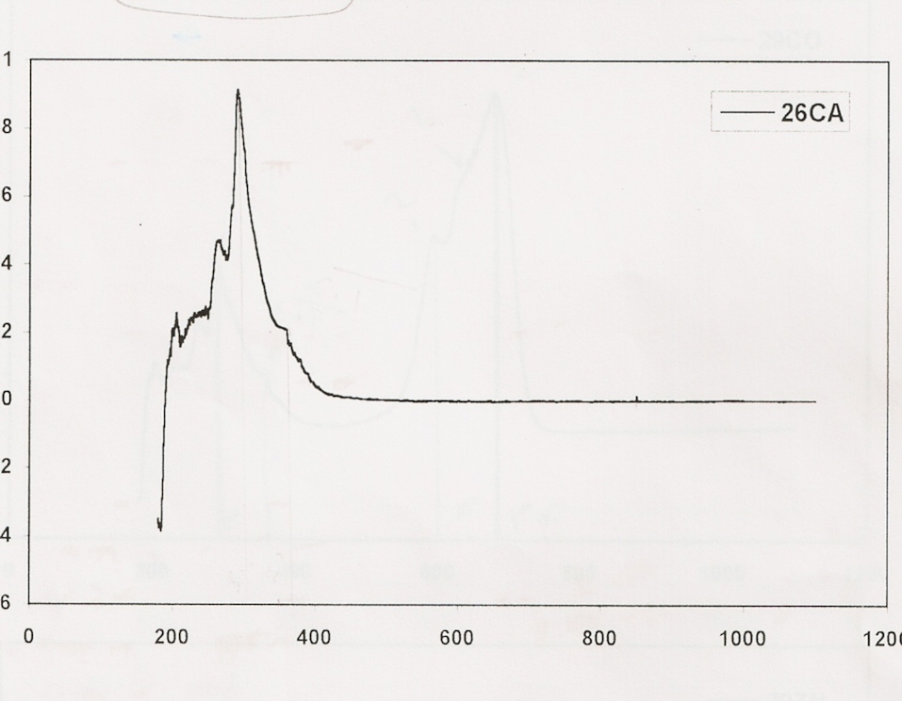nm
Figure1: The UV-Vis spectra to [Ca(H₂C=C(CH₃) CO₂ PhNH₂O)₂] complex
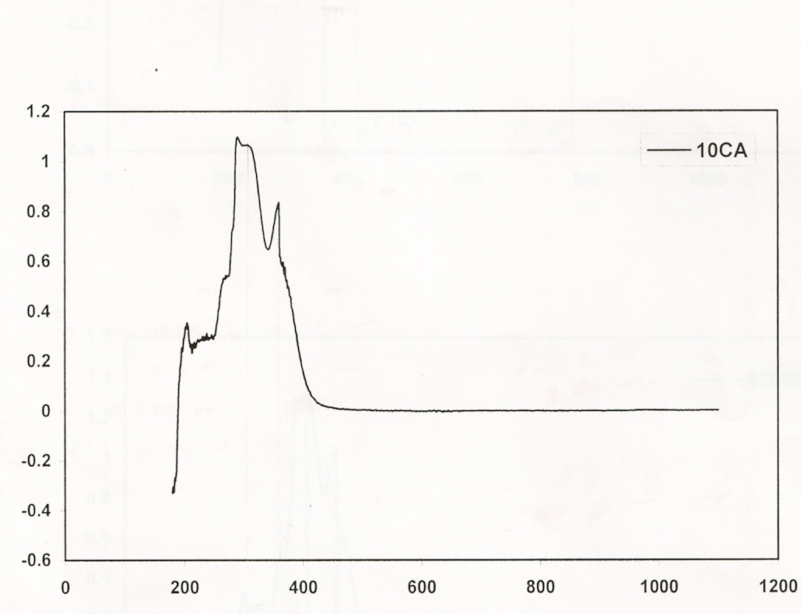nm
Figure2: The UV-Vis spectra to Ca(H₂C=C(CH₃)CO₂CH₂CO₂)₂] complex
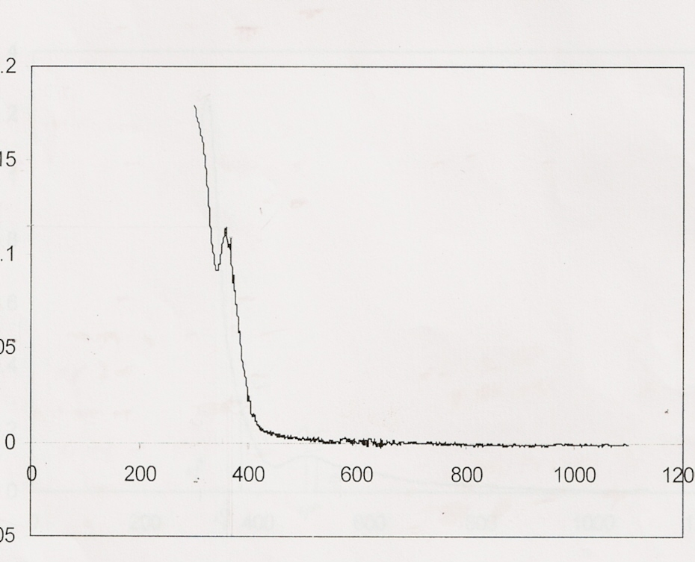nm
Figure3: The UV-Vis spectra to [Ca(H₂C=C(CH₃)CO₂(CH₂)₂O)₂] complex
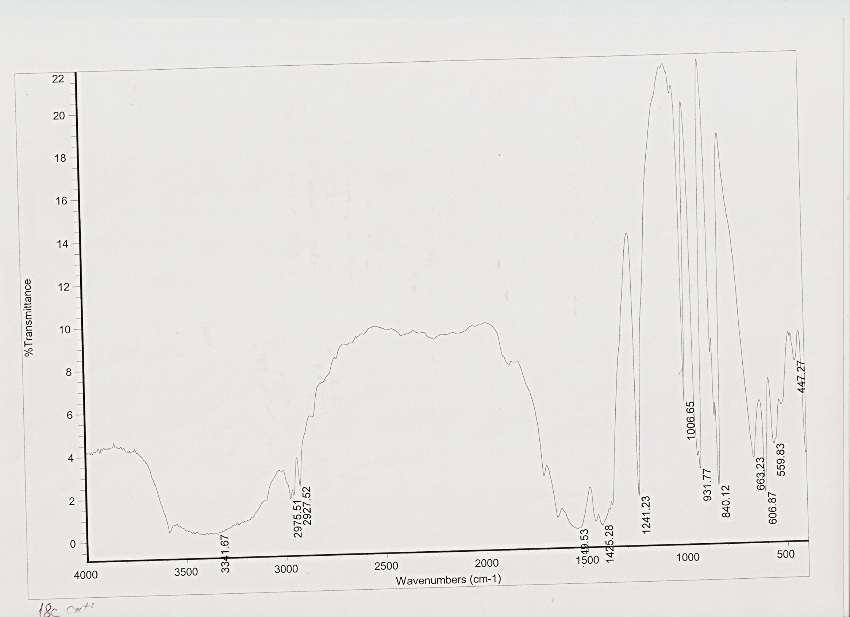
Figure 4: The infrared spectra to [Ca(H₂C=C(CH₃)CO₂CH₂C₆H₄O)₂] complex
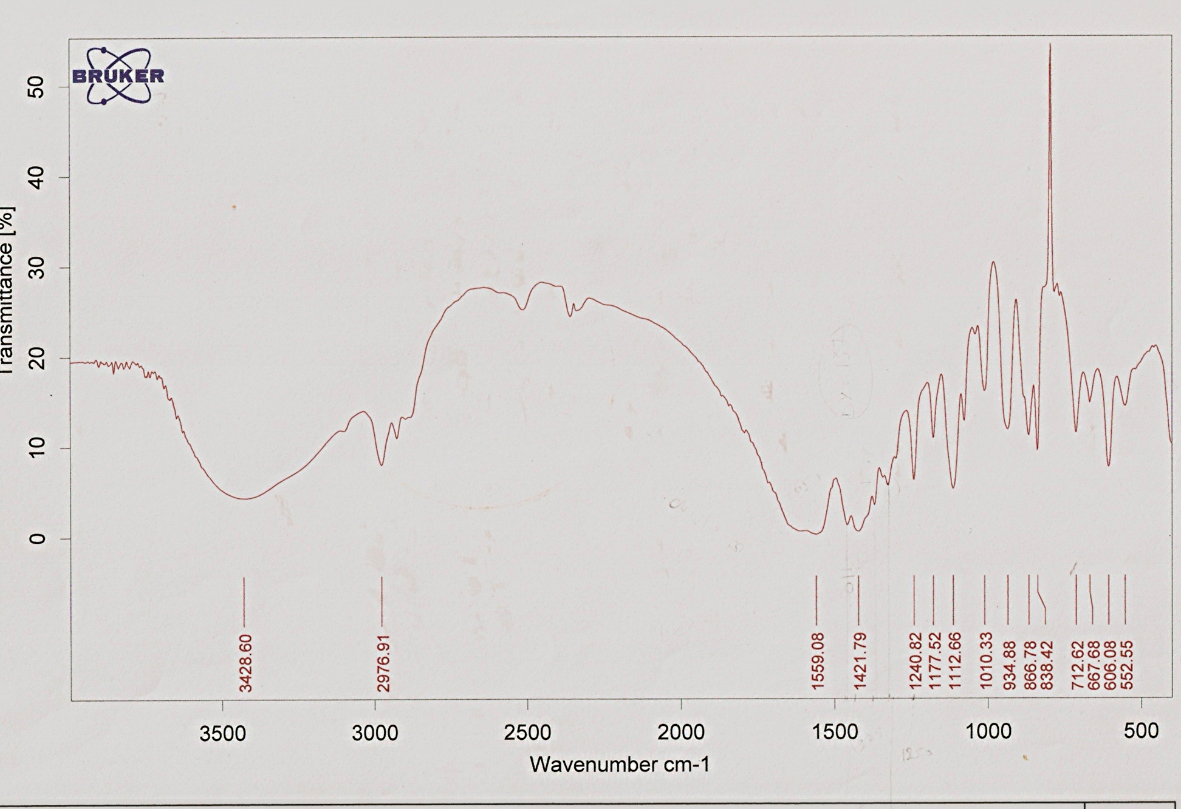
Figure 5: The infrared spectra to Ca(H₂C=C(CH₃)CO₂CH₂CO₂)₂] complex
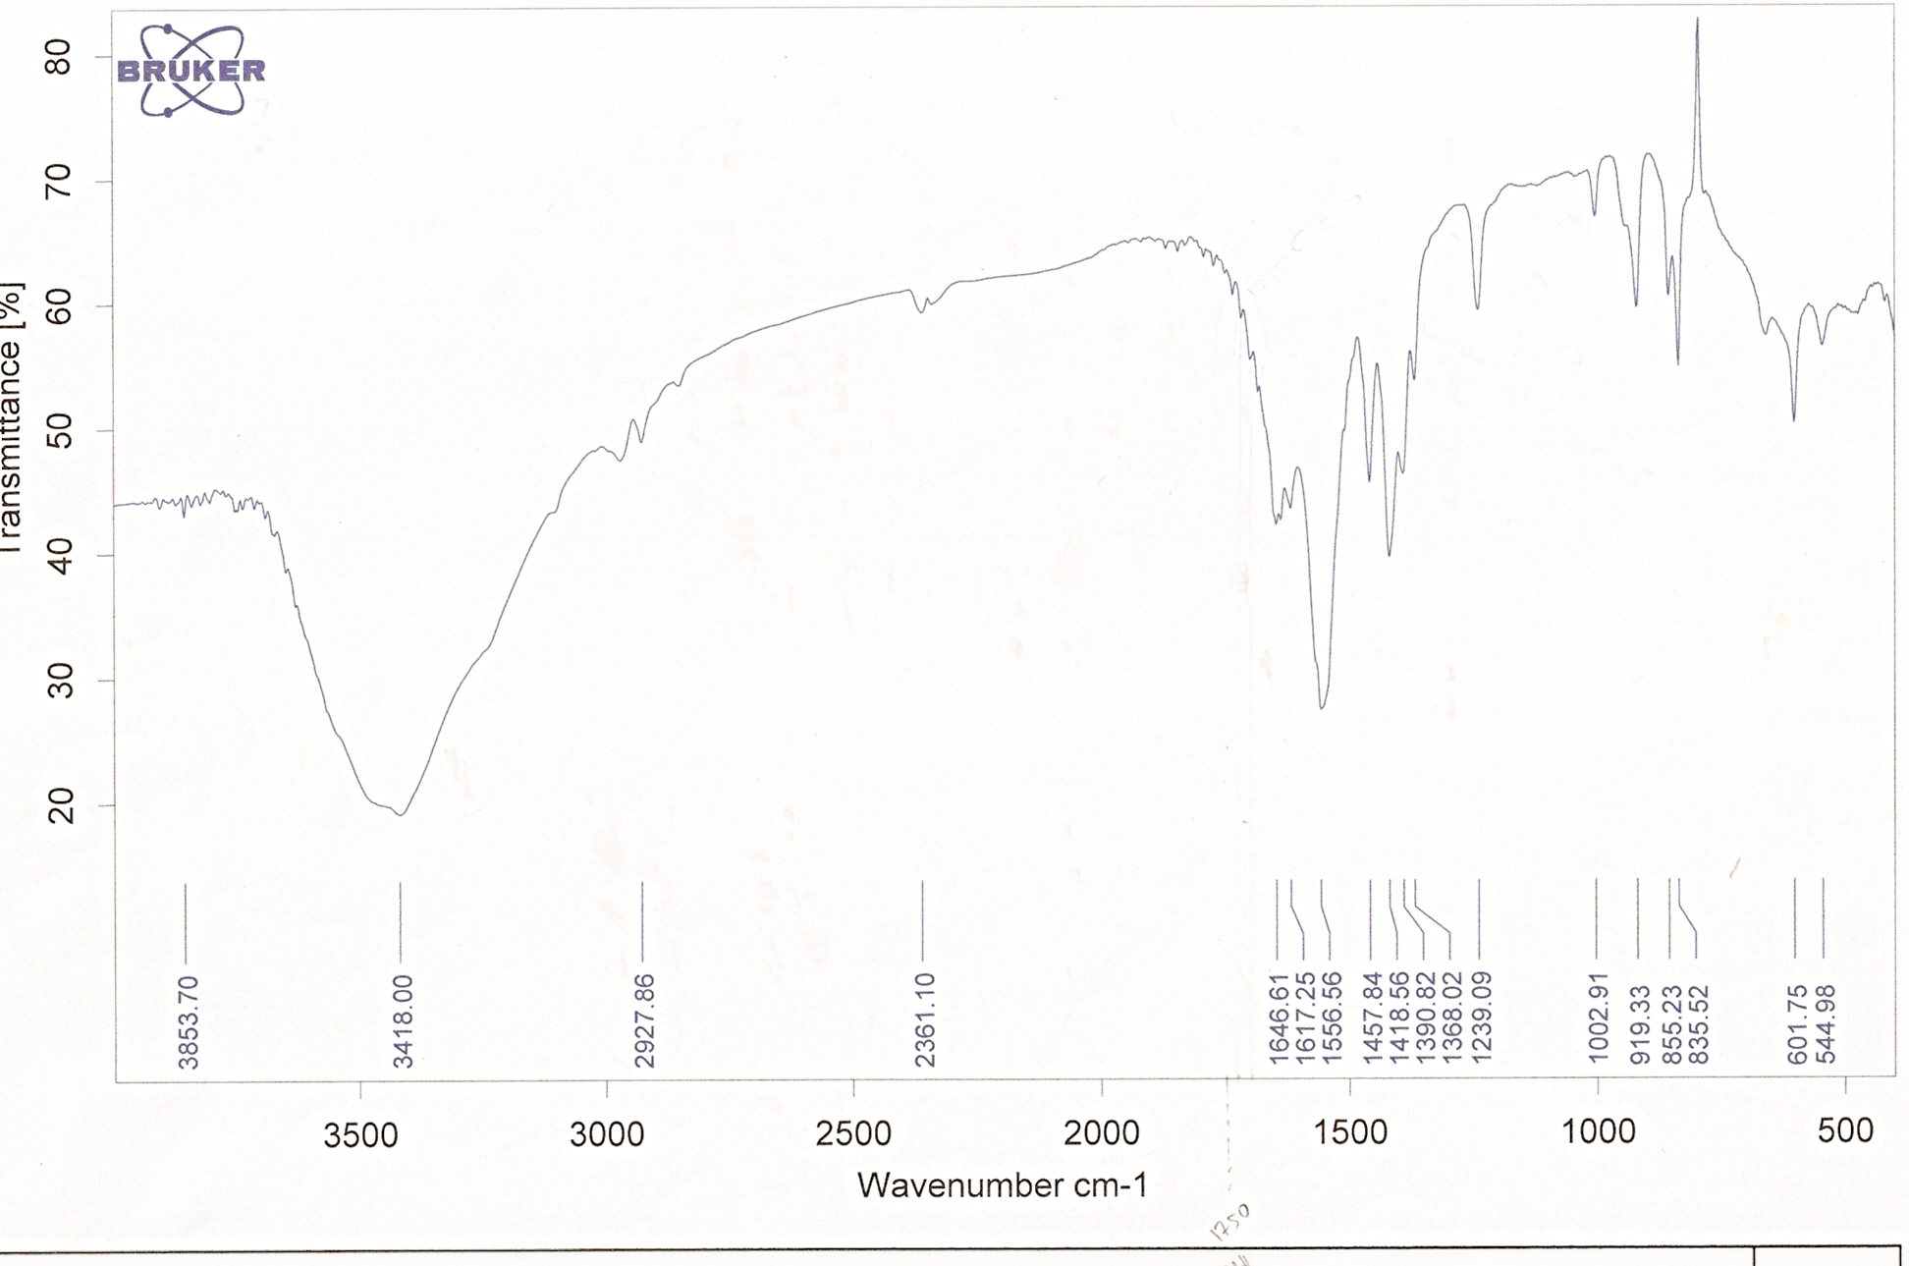
Figure 6: The infrared spectra to [H₂C=C(CH₃)CO₂CH₂C₆H₄O] ligand

Figure7:The effect of bonding agent on Candida albicans
Figure 8: The effect prepared bonding agent on staphylococuus bacteria
Figure 9: The effect prepared bonding agent on Streptococcus mutans bacteria

Figure 10: The effect of control compound on oral tissues
Figure 11: The effect bonding compound on oral tissues

Figure 12: The effect of control compound on oral tissues
Figure 13:(left): Transverse section on gum tissue treated with control compound
(amp 100X)
Figure 14:(right): Transverse section on gum tissue treated with bonding agent compound(amp 100X)

Figure15: Transverse section on gum tissue treated with bonding agent compound
(amp 370X)

References
1- M. Whitaker and J. Smith, Philos Trans R Soc Lond B Biol Sci., 2008, 12,1307.
2- M.Whitaker , Physiol. Rev., 2006, 2006, 86,25.
3- E. T. Clarke, P.J. Squattrito, P. R. Rudolf, R. J. Motekaitis, A. E.Martell and A.
Clearfield, Inorg. Chim Acta, 1989, 166, 221.
4- K. Wolski, M. Goldman, J. H. Kronman and D. Nathanson, OperDent., 1989, 14, 87.
5- L.Wang, L. G. Lopes and J. C. Pereira, J. Appl Oral Sci., 2003, 11, 162.
6- K. Takamori, N. Hokari, Y. Okumura and S. Watanabe, J. Clin Laser Med Surg., 2001, 19, 267.
7- M. Nakajima, M. Ogata, M. Okuda, J. Tajami, H. Sano and D. H.Pashley, Am. J.Dent., 1999, 12, 309.
8- P. M. Mcinnes ledoux, W. R. Ledoux and R. Weinberg, Dent Mater., 1987, 3, 331.
9-K. J. Anusavice, “Phillips Science of Dental Materials”, 10th Ed., W. B. Saunders Company,132 (1996).
10-W. R. Stine “Applied Chemistry” 2nd Ed., Allyn & Bacon, Inc., Boston,Massachusetts,
chapter 19, (1981).
11- A.D.Sakoog and M.V.Donald ”Fundamentals of analytical chemistry”, second edition, Butler
and Tanner Ltd. 193 (1969).
12-Taqa A. preparation and study some complexes than can be used as a restorative
materials, Ph. D. Thesis, University of Mosul ,(2001).
13-J.D.Bancroft and M.Churchill, Theory and practice of histological techniques, 5th Edition Livirgstone, 85 (2004).
14-R. Whistehad, S. C. Truelove, M. W. L. Gear, J. Clin. pathol, 1972, 25, 1.
15-T. Al-Allaf and N. Buttrus, Abhath Al-Yarmouk, 1994, 3, 101.
16- D. Nicholls. “ Complexes and first –row transition elements” White friars press LTD, 100 (1974).
17-J. Chatt and L. A. Duncauson, J. Chem. Soc., 1958, 2939.
18-R. M. Silverstein, C. G. Bassler and T. C. Morrill, “Spectrometric Identification of Organic Compound”, 3rd Ed., John Wiley and Sons,95, (1974) .
19-B. B. Mahapatra, S. K. Pujari and A. Chiranjeevi, J. Indian Chem, Soc., 1981, LVIII, 742.
20-R. L. Dutta and T. Ray, J. Indian Chem. Soc., 1981, LVIII, 1005.
21- R. N. Roy, S. B. Mishra and B. K. Mohapatra, J. Indian Chem., Soc., 1982, LIX, 1094.
22- M. Vidali, P. A. Vigato and V. Casellato, J. Inorg. Nucl. Chem., 1975, 37, 955.
23- C. C. Addison, N. Logan, S. C. W. Work and C.D Barner, Q. Rev. Chem. Soc., 1971, 25, 289.
24- B.M. Gatehouse, S. E. Livinstone and R.S. Nyholm, J. Inorg. Nucl. Chem., 1958, 8, 75.
25- A.I.Vogel “Text book of practical organic chemistry” Fourth edition, Logman group Ltd.,511 (1978).

