Kinetics and Mechanism of Hydrogen Sorption in Yttrium-Silicon D8₈- Structure Phases, Part I

Mouaid A. Hassen
Jubail Industrial College, JIC, KSA
E-mail: mouaid_hassen@yahoo.com
I. J. McColm
School of Engineering, Design and Technology. University of Bradford,
Bradford BD7 I DP. UK
M. Y. Shareef
Jubail Industrial College, JIC, KSA
Tahseen A. Alsalim, Jabbar S.Hadi
College of Education, Basrah University, Basrah-Iraq

(NJC)

(Recevied on 19/4/2009) (Accepted for publication 10/11/2009)

Abstract
A relationship between the size of the z-axis lattice parameter and the rate of hydrogenation of D8₈ phases has been established. Materials with c-axis in the range 0.632-0.642 nm are most resistant to hydrogen content increase whilst maintaining a fast sorption capability for 0.9-10 H (fu)⁻¹. From this Y₅Si₂Ge and Y₅Si₂GeN_{0.1} have been prepared and used to establish the hydrogen sorption kinetics at a range of temperatures and pressures of hydrogen. The effect that nitrogen has on the alloy is to increase reaction rates by a factor of approximately 3. Thermogravimetric plots were first analysed by the J-M-A equation as used by Goudy ⁽⁶⁾. Arrhenius representation of the first and second order equations indicate a significant change in reaction mechanism at 740-745 K. Activation energies are in the range 84-166 kJ (mol)⁻¹ depending on order and temperature.
Keywords: Hydrogen storage material, Interstitial alloys, Gas-solid reactions,
Kinetics; Thermal analysis
الخلاصة
تم في هذا البحث ايجاد علاقة بين معامل شبكية المحور –Z وسرعة هدرجة اطوار D8₈ . ان المواد التي تمتلك المحور -C ضمن المدى 0.632-0.642 نانوميتر هي الكثر مقاومة لزيادة محتوى الهيدروجين . وانطلاقا من ذلك تم تحضير كل من Y₅Si₂Ge و Y₅Si₂GeN_{0.1} واستخدمت لتحديد مركبات امدصاص الهيدروجين ضمن مدى من درجات الحرارة وضغوط الهيدروجين . لقد كان تاثير وجود النتروجين في السبيكة هو زيادة معدلات التفاعل بمعدل ثلاث مرات تقريبا . وقد تم تحليل البيانات الثرموكرافية بواسطة معادلة J – M – A المستخدمة من قبل Goudy .

Introduction
The reaction of D8₈ -phases, such as Y₅Si₃, with hydrogen has been described in previously ^{)1,2(}. A potentially useful, fast absorption/desorption reaction has been described with an unusual feature in that it eventually ceases as the overall H content of the silicide builds-up. When x in Y₃Si₃H_{x} is ≥4.5 the 0.9-l.0 H(fu)⁻¹( Hydrogen / Formula unit) that is rapidly reversible in this total ceases to be active. A possible explanation for this behavior lies in the transfer of hydrogen atoms from sites that are affected by an α↔β phase change to more stable sites within the crystal structure. Several techniques have been applied in an attempt to probe this possibility ⁾³⁻⁵⁽. Here we describe kinetic experiments developed to study the process.
From kinetic studies it is possible to derive reaction pathways and models⁽⁶⁻⁹⁽ and this may enable the detrimental process leading to the loss through the fast reaction to be better understood. Furthermore, no quantitative kinetic data has been reported and yet a fast process is constantly assumed ⁾¹⁻⁵⁽. Most hydrogen storage kinetic studies have involved LaNi₅ and it derivatives ⁾⁶⁻¹²⁽ . The hydrogen reaction kinetics of the hexagonal D8₈ special ceramics has not been previously reported.
When we had been attempting to study the reaction kinetics of the aristotype Y₅Si₃ we were faced with the various problems, some of which are due to the properties of the materials while others were due to the technical problems associated with the limitation of the equipment available for this work, they are as following :-
1. As the temperature increases the composition of the alloys changes (due to the slow build up of the irreversible hydrogen). This means that it is not possible to obtain result from material of exactly the same hydrogen composition at a range of temperatures and pressures.
- As the pressure is increased the problem in 1 becomes more acute i.e. the composition at which α↔β transformation and the rapid reaction happens, changes as the hydrogen content increases, and is not just a function of temperature and pressure. There is also the added complication that as the hydrogen content increases the volume of hydrogen moved at the α↔β transformation decreases.
- The thermogravimetric balance available for this work, due to its excellent sensitivity, had an in-built problem, which limited the way the experiments could be performed If too great a pressure change was needed to promote desorption then the electronic output became locked and no data was available for several seconds
- Thermal capacitance i.e. it takes a long time to reach an equilibrium temperature due to the thickness of the autoclave walls.
In order to limit these problems and make a quantitative kinetic study a system that took the longest time to reach the critical value of x ≥ 4 5 in M₅X₃H_{x} at high temperatures and elevated hydrogen pressure had to be identified. This was undertaken by exploring the change in hydrogen content over a 5-cycle-heating/cooling program for a number of D8₈-phases. The results from this survey are presented here and are interesting in that a relationship between hydrogen reactivity and c-axis lattice parameter was identified.
Two compositions were found to show the most promise for kinetic experiments, namely Y₅Si₂Ge and a nitrogen doped variant: Y₅Si₂Ge(N). The work presented in this paper was done using these two materials.
A procedure was developed to minimize some of the general problems encountered in this type of investigation and assist in establishing comparative data. It is common to use powdered material to increase sensitivity but this leads to heat transfer problems whereby the kinetics are limited by heat transfer and not chemical reactivity. In this work to overcome heat transfer difficulties, the samples were maintained as single, small arc-cast beads of nearly identical surface area and a very sensitive microbalance was used throughout.
Mass change against time plots were obtained over a limited but not constant hydride composition. The data was examined using a simple approach based on the Johnson-Mehl-Avrami equation as set out by Goudy et.al⁾ ⁶⁽ . This approach generates two equations for first and second order reactions respectively:
ln(C_{o}/C) = k₁t (1)
and
l/C - I/C_{o} = k₂t (2)
In these equations C_{o} is the hydrogen concentration in the hydride at the start of the experiment, C is the concentration of hydrogen in the hydride at time t and k₁ and k₂ are the reaction rate constants.
The order is indicated from the linearity of plots of these equations. To use this method with the materials studied in this work one is facing with is the problem of overall composition change as the alloys gradually increase their irreversible hydrogen content while still rapidly exchanging about 0.9 H(fu)⁻¹ at each temperature cycle is occurred . Thus, a definition of C and C_{o} is needed. Here we define C_{o} as being equal to x_{o} / (8 + x_{o}) and C as x_{t} /(8 + x_{t}), where x_{t} is the number of H(fu)⁻¹ at the start of the experiment and x_{t} is the number of H(fu)⁻¹ at any time t. The value 8 is the number of non-hydrogen atoms in the alloy.
Experimental Details
All the silicide, germanide and nitride alloys were made by the procedures described in the most recent previous publications ^{(1,2)}. These stock samples were fractured into small pieces so that x-ray and metallographic analyses could be done. The x-ray lattice parameters were found using a Hagg-Guinier focusing x-ray camera and Cu K_{α1} wavelength. The samples selected for the desorption kinetics were subjected to EDX analysis on a Philips 626 SEM machine to establish their complete composition (university of Bradford , UK). This practice revealed that care had to be taken in the selection because some arc melted beads were found to contain argon as shown in Fig 1. Samples containing argon gave weight losses at 495 K that might have interfered with the hydrogen desorbtion results. The interesting question is where does this argon come from, is it physically trapped or occluded into the open network structure of these materials?
Approximately 50 mg pieces were quickly remelted. The resultant was an almost spherical sample, the dimensions of which were determined by a micrometer guage and the volume calculated as a hemisphere plus residual disc. This process showed that surface areas and sample volumes were always within 10%.
The best samples for the quantitative kinetic study were found by measuring the final hydride composition, M₅X₃H_{y} after 5 cycles of absorption and desorption. In this context best means the smallest value of y.
For the kinetic work most effort was devoted to desorption studies and the procedure was as follows; A small beads was heated in hydrogen gas at 1 atmosphere pressure and the weight gain was monitored. At some elevated temperature, the weight gain ceased and the sample began to desorb hydrogen previously absorbed. The hydrogen pressure was increased to prevent desorption and an isothermal temperature was set.
When the isotherm was reached the pressure was rapidly reduced to 1 atmosphere to allow desorption. This process did cause the electronic response to be delayed and the first seconds of the reaction could not be monitored. When sufficient data was collected,
the pressure was re-established causing re-absorption and a new isotherm was set and the process repeated. This went on until the hydride composition exceeded the range set as described in the introduction.
Plot of mass loss against time and fraction reacted against time were established from the data outputs.
Results
A series of D8₈-alloys were prepared with their x-ray c-axes in the range 0.558 nm, Zr₅Si₃, to 0.663 nm, Nd₅Ge₃, and standard hydrogen absorption tests were carried out to determine their hydrogen reactivity; the results are summarized in Table1 along with data from earlier work. The results show that the rate of composition drift to higher hydride compositions is least in the materials with c-axis parameters in the mid-range, 0.632-0.642 nm. This is why Y₅Si₂GeN_{0.1} and Y₅Si₂Ge were chosen for these kinetic studies.
Figure 2 is a typical fraction of hydrogen desorbed against time at various temperatures temperature for Y₅Si₂GeH_{x+y}, where y is the desorbed amount of hydrogen. From plots such as those shown, the reaction was tested by applying the data to equations (1) and (2) for both the alloy and the nitride samples. Reaction rate constants from this exercise are given in Table 2. The lines that can be drawn through the amount desorbed against time data according to Eqns (1) and (2), such as those in Fig 3, show that it is not possible to distinguish between first order and second order as both give equally good linearity.
Amount of hydrogen desorbed against time plots were used to test for reaction order in both cases at temperatures up to 790 K. In the case of the Y₅Si₂GeN_{0.1}H_{x+y} alloy they were found to be sigmoidal up to 745 K for both first and second order functions. At temperatures above 745 K the plots become linear like those for the nitrogen-free alloy above 718 K. The rate constants in Table 2 show that nitrogen has the effect of increasing the desorption rate by nearly three times. There is a noticeable temperature effect, more so for the nitride, that in the range 743-763 K a minimum rate occurs on either side of which a different controlling process must be operating. To investigate this possibility semi-log Arrhenius plots were made from the data in Table 2. Figure 4 is one such plot for the first order equation for Y₅Si₂GeH_{x+y}. The temperature effect on the rate is clearly shown as a break at 740-745 K. The lines for low temperature points produced an activation energy of 166 kJ mol⁻¹ for the nitrogen-free alloy. The possible reasons for the unusual, slightly negative slope of the line above 745 K are discussed later. For the second order reaction the low-temperature range activation energy is 127.9 kJ mol⁻¹ while the high temperature results produce a line of greater negative slope.

Table 1: The c-axis parameter effect on the hydrogen reactivity of D8₈ alloys
Alloy | c-axis parameter  nm | Fast  reversibility  H(fu) ⁻¹ | Composition  After 5 hydrogenation cycles  H(fu) ⁻¹ | Reference
Nd₅Ge₃ | 0.6630 | 0 | 7.0 | 14
Y₅Sn₃ | 0.6520 | 0.12 | 6.0 | this work
Gd₅Ge₃ | 0.6440 | 0.91 | 4.0 | this work
Er_{5-x}La_{x}Ge₃ | 0.6421-0.6396 | 0-1.18 | 6.0-3.0 | 14
Gd_{5-x}Sc_{x}Si₃^{(e)} | 0.6419-0.6272 | 0-0.76 | 6.0-4.0 | 14
Y₅Si₃C_{0.3} | 0.6419 | 1.2 ^{(a)} | 5.0 | 2
Y₅Si₂GcN_{0.1} | 0.6400 | 1.0 | 2 ^{(c)} | 1, this work
Y₅Ge₃ | 0.6400 | 0.9 | 5.5 | 14
Y₅Si₂Ge | 0.6378 | 0.6 | 3.0 | this work
Y₅Si₃N_{0.4}^{(b)} | 0.6361 | 0.7 | 4.5 | 1
Y₅Si3 | 0.6351 | 0.95 | 3.7 | this work
Er_{5-x}Nd_{y}Ge₃ | 0.6320-0.6276 | 1.0-0.35 | 3.4^{(d)} | 14
Er₅Ge₃ | 0.6280 | 0.68 | 3.5 | 14
Sc₅Si₃ | 0.5810 | 0 | < 1.0 | this work
Zr₅Si₃ | 0.5580 | 0 | < 0.5 | 14
(a) Sample needed to be activated and overall the reversible was 2.5 H(fu)⁻¹ consisting of 1.0 fast plus
1.5 by a fairly rapid diffusion process, hence the value of 1.2 at the temperature for last reversibility. Unusual in that it never lost fast reversibility even when the composition exceeded 4.5
- N composition is nominal and sample was single phase made from YN + Y + Si
- Main sample for kinetic experiments
- Sample is resistant to hydrogen content build-up
- Sample had to be activated by pressure and temperature cycles and showed two stage reactions

Table 2: The effect of temperature on hydrogen desorption rates for Y₅Si₂GeH_{x+y} and Y₅Si₂GeN_{0.1}H_{x+y} using equations 1 & 2
Temperature K | Y₅Si₂GeH_{x+y} |  | Y₅Si₂GeN_{0.1}H_{x+y}
Temperature K | Reaction Rate from Eq 1  s⁻¹ | Reaction Rate from Eq 2  mol⁻¹ s⁻¹ | Reaction Kate from Eq 1  s ⁻¹ | Reaction Rate from Eq. 2 mol⁻¹ s⁻¹
710 | 1.19 | 5.8 | 5.41 | 30.3
718 | 2.44 | 11.1 | 5. 71 | 31.3
728 | 3.03 | 13 3 | 9.09 | 50.0
733 | - | - | 8.70 | 55.6
738 | 3.45 | 15.0 | - | -
743 | 3.13 | 13.2 | 7.70 | 47.0
760 | 4.55 | 17.6 | - | -
763 | - | - | 10.50 | 59.0
768 | 4.55 | 15.8 | 14.3 | 79.0
783 | - | - | 16.00 | 91 0
789 | 4.29 | 13.6 | - | -
The nitride alloy gave rise to sigmoidal shaped lnC/C_{o} v time and I/C - l/C_{o} v time curves up to 744K for both first and second order reactions and it was not possible to distinguish between the two. However, considering the mid-part of the curves to be linear, values for activation energies were calculated and found to give an average first order value of 116 kJ mol⁻¹ and 141 kJ mol⁻¹ for the second order possibility. At temperatures above 744K the reaction rate function plots were all linear that led to activation energies of 98.4 kJ mol⁻¹ for the first order function and 84.3 kJ mol⁻¹ for the second order. The effect that nitrogen has in the solid is to increase the rate of desorption on average by factor of 3. When considering the change in activation energies it is only the first order data that predicts a decrease in the energy for the process as would be expected from an increasing rate of reaction at constant temperature.
Discussion
The wide ranging preparations and hydrogen sorption experiments done to find suitable candidate materials for reaction kinetic studies have revealed an interesting correlation between the volume of the x-ray unit cell and the stability of the D8₈-phases towards hydrogen. Increasing the unit cell volume has the effect of enhancing the hydrogen reactivity. This property of these materials is particularly associated with the c-axis length. Subsequent calculations, to be reported later, show that the c-axis length is the parameter directly involved in changing the size of the interstitial site where non-metal atoms may reside. The calculations indicate that the key to a fast desorption is to have H atoms in sites that have 4M and 2X atoms, where X is Si, Ge or C, in an elongated octahedral interstitial space. The size of such sites and hence their availability and bonding energy between H and M and X is related to the distance between X-X and X-M. Since the X-X distance is mostly a function of c-axis length, this is why these systems seem to be very sensitive to c-axis parameter changes. No specific reaction rate data are given in Table 1 but reactivity is implied in the H (fu)⁻¹ figures quoted after the 5 abs/des cycles. Several points emerge from Table 1:-
- When the c-axis exceeds 0.65nm the reaction is very rapid and
saturation soon occurs. This results in no fast reversible hydrogen
content
- When the c-axis is less than 0.60nm reaction is extremely slow and sites responsible for the fast reversibility are not filled.
• Materials with c-axis length between the above values have reaction
rates that decrease as the c-axis length decreases and useful
reversibility can be maintained for many cycles.
• The volume of reversible hydrogen in samples with the c-axis values between the two limits can be influenced by the non-metal composition of the alloy. Control is through M-H and X-H site bond energies and by including other non-metal atoms in the octahedral sites.
The choice of Y₅Si₂Ge and Y₅Si₂GeN_{0.1} for kinetic experiments was made on the basis of the above analysis and provides for the first time a numerical comparison of rate data for samples with a small change in c-axis and a small inclusion of atoms in the octahedral sites.
The physical form of the samples had to be taken into account because hydrogenation in other systems is often reported as being dominated by heat transfer problems caused by large enthalpy changes. Fine powders diluted with metal powders, such as aluminium, are sometimes used (6). Such loose powders, even with metal diluents, have heat transfer difficulties because of limited interparticle contact. In this work a detection system sensitive enough to enable a small arc-cast bead to be used was available. In such a bead the grains are in close contact. Only one bead was used per experiment and the simple shape enabled a surface area to be calculated and used to standardize the rate data.
A small amount of nitrogen, 0.1N (fu)⁻¹, is able to increase reaction rates by approximately a factor of 3 whether the process is considered as first or second order. However it is only the simple first order approach that shows a decreased activation energy in all temperature ranges which may be an indication that the simple analysis as a first order process is correct. The percentage increase in c-axis length for Y₅Si₂GeN_{0.1} compared to Y₅Si₂Ge is only 0.3% which is sufficient to cause a 3 fold increase in reaction rate. This emphasizes the importance of the c-axis parameter as a rate determining feature.
A second order presentation of the data, Fig. 5 indicates most clearly the temperature of 745 K at which the dominant mechanism changes. It also confirms the critical role of hydride composition in the change over as 3.0-3.3 H (fu)⁻¹.

Fig. 1 EDX analysis showing argon release from Y₅Si₂Ge

Fig. 2 Fraction of hydrogen desorbed as a function of time at different temperatures.

Fig. 3 Typical experimental plots of equations (1) and (2) for hydrogen desorption " from Y₅Si₂GeH_{x} at 718 K.

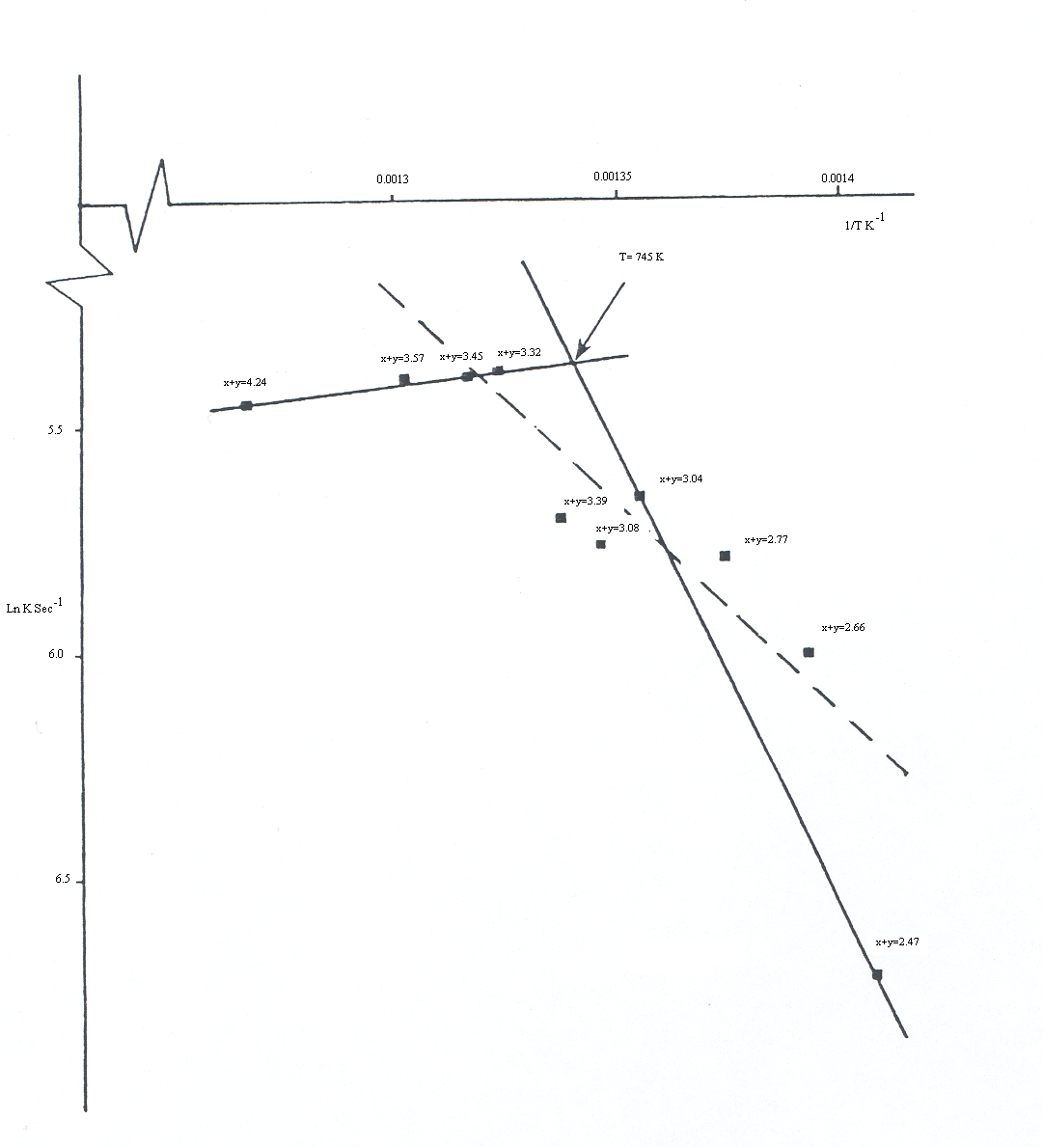
Fig. 4 Semi-log plot of first order rate constants for desorption from Y₅Si₂GeH_{x+y}

Fig 5 Semi-log plot of second order rate constants for desorption from Y₅Si₂GeH_{x+y}

References
1- M.A. Hassen, I.J. McColm, J Alloys Comp., 2002, 339, 105.
2- M.A. Hassen, I.J. McColm, J Alloys Comp., 2000, 313, 95.
3- T.W. Button, I.J. McColm, J. Less-Common Metals, 1984, 97, 237.
4- S.M. Bennington, I.J. McColm, D.K. Ross, J. Less-Common Metals, 1991, 172, 307
5- T.W. Button, I.J. McColm, J. Ward, J. Less-Common Metals, 1990, 150, 205.
6- A. J. Goudy, D.J Stokes, J.A. Gazilio, J. Phys. Chem., 1983, 91, 149.
7- M.Y. Song, M. Pezat, B. Darriet, J.Y. Lee, P.Hagenmuller, J. Mater. Sci., 1986, 21, 346.
8- K.R. Clay, A.G. Goudy, R.G. Schweibenz, A. Zarynow, J. Less-Common Metals, 166, 153.
9- A. Zarynow, K R. Clay, A.G. Goudy, R.G. Schweibenz, J. Less-Common Metals, 1991, 172, 1009.
10- C.N. Park, J.Y. Lee, J. Less-Common Metals, 1982, 83, 39.
11- W.E. Wallace, R.F. Karlicek, K. Imamura, J. Phys. Chem., 1979, 83, 1708
12- S. Suda, Z.P. Li, Y.M. Sun, B H. Liu, X.P. Gao, Mat. Res. Soc. Symp. Proc., 1998, 513, 25.
13- A. C. Richards, J. B. Harness and I. J. Mc Colm, J. Pharm. Sci., 2000, 89, 1187.
14- I. J. Mc Colm and J. M. Ward, J. Alloys and Compounds, 1992, 198, 91.

