Interpenetrating polymer networks based on polyamine modified
castor oil , chitosan and poly methylmethacrylate: Synthesis,
chemical, physical and mechanical properties

Ali Taha Yassen
Department of Basic Sciences, College of Dentistry University of Basrah, Iraq

(NJC)

(Recevied on 21/12/2008) (Accepted for publication 19/4/2009)

Abstract
A series of interpenetrating polymer networks (IPNs) of castor oil based polyamine/Polymethylmethacrylate (Polyamine/Polymethylmethacrylate: 80/20, 60/40, 50/50, 40/60 and 20/80) were synthesized by condensation reaction of castor oil with chitosan and methylmethacrylate, employing benzoyl peroxide and ethylene glycol dimethylacrylate as initiator and cross linkers respectively. The physical, chemical, optical and some of the physical and mechanical properties of Polyamine/Polymethylmethacrylate were studied.

Keywords : castor oil; chitosan; interpenetrating; mechanical; physical ; strain.
الخلاصة
تم تحضير سلسلة من البوليمرات المتشابكة (IPNs) من زيت الخروع كبولي أمين مع البولي ميثايل ميثا اكريليت وفق النسب التالية (Polyamine/Polymethylmethacrylate: 80/20, 60/40, 50/50, 40/60 , 20/80 ) , حيث تم بلمرة زيت الخروع مع الكايتوسان بطريقة البلمرة التكثيفية بعدها تمت بلمرة الميثايل ميثا اكريليت باستخدام البنزوايل بيروكسيد كبادئ والاثيلين كلايكول داي ميثا اكريليت كمادة شابكة .
شملت الدراسة الحالية على دراسة الخواص الفيزيائية والكيميائية والضوئية والميكانيكية للبولي أمين / بولي ميثايل ميثا اكريليت المحضر

Introduction
Interpenetrating polymer networks (IPNs) constitute a group of polymer composite materials possessing unique properties which are related to their method of synthesis ^{[1]}.
Interpenetrating polymer networks (IPNs) is defined as a combination of two polymer networks where at least one polymer is synthesised or crosslinked in the presence of the other. As physical blends and copolymerization the IPN is another way to combine two different polymers. There are no covalent bonds between the two polymers, so a generic A monomer reacts only with other A ones, and on the other hand B monomer reacts only with B ones. The resulting material swells but does not dissolve in a given solvent ^{[2]}.
IPNs could be classified as sequential or simultaneous, depending on the way that the polymerisation is carried out. They could be also defined as a latex IPNs, when the polymers are synthesised by emulsion polymerisation; a gradient IPN, when each surface of the film is predominately of one type of polymer and there is a gradient inside the film; a thermoplastic IPN, when there is physical crosslink rather than chemical crosslink in the polymers, and a semi-IPN (SIPN) when just one of the polymers is a network ^{[3]}.
Chitosan a natural linear polyamine with a high ratio of glucosamine to acetyl-glucosamine units, is a weak base and carries a positive charge. Its solubility is pH-dependent, and it reacts readily with negatively charged surfaces^{[4]}
Chitosan is obtained from the deacetylation of chitin. Chitin is one of the most abundantly available polymers after cellulose. Chitosan is a copolymer of glucosamine and N-acetyl -glucosamine and it has an amine functional group which is strongly reactive ^{[5]} .
In terms of its chemical structure (Scheme 1), chitin and chitosan have similar chemical structure. Chitin exhibits structural similarity to cellulose and differs from it with the replacement of C-2 hydroxyl residues by acetamide groups ^{[6]}.

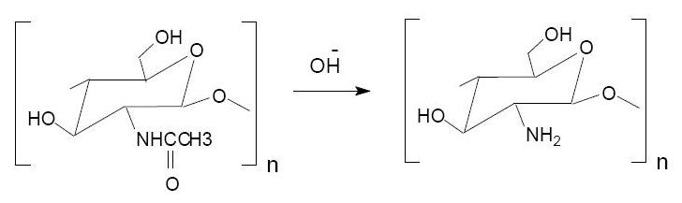

Scheme 1: Chemical structures of chitin and chitosan

Chitin can be transformed into chitosan that has free amino groups by removing acetyl groups (CH₃-CO) from chitin molecules. Chitosan (deacetylated chitin) is insoluble in water, alkali and organic solvents, but soluble in most diluted acids with pH less than 6. When chitosan is dissolved in an acid solution, it becomes a cationic polymer due to the protonation of free amino groups on the C-2 position of pyranose ring ^{[7]} .
Its cationic properties in acidic solutions give it the ability to interact readily with negatively charged molecules such as fats, cholesterols, metal ions, and proteins ^{[8]} .
Experimental
Materials and Sample Preparation
Castor oil and chitosan was obtained from the local market , ethylene glycol dimethylacrylate and benzoyl peroxide from Aldrich, USA. Methylmethacrylate monomer from MR. Dental supplies LTD,UK was freed from stabilizer prior to use.
Preparation of chitosan
The raw material, exoskeleton of fresh prawn for preparation of chitosan was obtaind from local market . The shells and head of fresh prawn were thoroughly and repeatedly washed in water and sun drained. The raw material was completely immersed (steel container) in 3 % sodium hydroxide and boiled for 30 minutes for deprotenization. After cooling the alkali solution is drained off and washed repeatedly and finally with ionized water to obtain neutral pH . The contents were transferred to a plastic container and 5 % hydrochloric acid added and allowed to act for 30 minutes. The acid was decanted and repeatedly washed with water and then with ionized water. The excess water from the chitin obtained is removed by squeezing in a sterile lint cloth and air-dried. Chitin was immersed in 40 % sodium hydroxide and heated up to 90 °C for 90 minutes. The sodium hydroxide is quickly drained off, the content washed repeatedly with water, finally with ionized water and the chitosan obtained was air dried after removing the excess water as above. The prepared chitin and chitosan was sterilized with ethylene oxide and packed in pre autoclaved polyethylene containers ^{[9]} .
Prepolymer preparations
The prepolymer was prepared by reacting the chitosan (2.11 g) and castor oil (3.14 g) were taken in 50 ml beaker, thoroughly mixed with a glass rod and then heated about 4 hours at 170 °C in a vacuum oven until bubbling ceased followed by( 2 ) hours post-curing. Stirring was carried out for 15– 20 min to complete the reaction such that terminated polyamine prepolymer was obtained as a thick yellow syrup.
Synthesis of Poly amine– Polymethylmethacrylate interpenetrating
polymer networks
The required quantities of amine prepolymer methylmethacrylate, ethylene glycol dimethylacrylate (0.5% based methylmethacrylate used), and benzoyl peroxide (0.5%) were placed in a round bottom flask fitted with a mechanical stirrer. The mixture was stirred at room temperature for (10–15) min. to form a uniform mixture. Compositions having higher amounts of prepolymer were highly viscous and the air entrapped during mixture was removed by applying vacuum. On the other hand, compositions rich in methylmethacrylate were heated at 70°C (to initiate the polymerization of methylmethacrylate) for different intervals of time until an optimum viscosity was obtained.

Polymer Characterization
Infrared spectra
Infrared spectra of the synthesized IPNs in KBr pellets were obtained from Shimadzu FTIR-8400S spectrophotometer. Whereas in case of PA, being a liquid, a thin film was cast over the NaCl block and its FTIR was recorded in laboratory of sciences college .
Physical properties
The IPNs were characterized according to the ASTM standard specification. Density was determined by the displacement method according to ASTM-D-792-86[10] , ASTM D-676-58 J for shore-A hardness ^{[ 11 ]} .
Optical properties
The optical properties were measured using a Suga Test, Hazemeter (Japan) using dust and grease free film of IPNs as per ASTM D-1003 ^{[ 12 ]} .
Mechanical properties:
The tensile strength and elongation at break were measured at room temperature using Instron Houns-Field universal testing machine model 4204 as per ASTM D-638 method ^{[13]} . Hardness measurements were made on Shore A hardness test apparatus using ASTM-2240 method ^{[ 14 ]} .
Resistance to chemical reagents:
Acid, alkali and solvent resistance were estimated according to ASTM-D-543-67 method. Samples were hung in the reagent for seven days and tested for change in weight and for their film appearance ^{[ 15 ]} .
Results and Discusion
Infrared spectroscopy (IR)
The IPNs synthesis consists of sequential polymerization reactions as shown in the Scheme 2. In the first reaction, a step-growth polymerization between the castor oil hydroxyl groups and amine groups occurs resulting in chitosan . If the mixture was heated for a shorter period, then gelling took place, and the viscosity was so low that it led to the formation of molds in the sheet. The polyamine obtained in a network form is swelled in methylmethacrylate and a free-radical polymerization of it is carried out initiated by benzoyl peroxide.

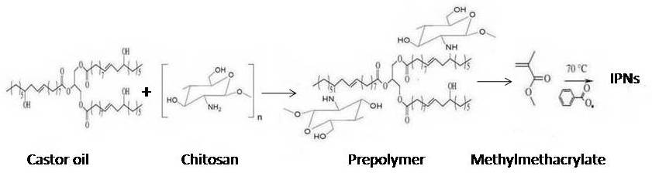

Scheme 2 : Chemical reaction between castor oil , chitosan and methylmethacrylate

The chemical structure of castor oil polyamine network was analyzed by infrared spectroscopy. Figure 1 shows the infrared spectrums of castor oil , chitosan and the polyamine prepolymer. The reaction between castor oil -OH groups and chitosan -NH₂ groups run out after 30 min, regarding to the disappearance of the broad band in the spectrum around 3418 cm⁻¹, due to - OH axial stretching vibration, and the appearance of a narrow absorption in 3344 cm⁻¹, related to the - NH axial stretching vibration. On the other hand the carbonyl absorption at 1737 cm⁻¹ changes the profile from the castor oil monomer to the polyamine been wider in that one obtained after 30 min. and the broad band in the region 3200 -3300 cm ⁻¹ due to -NH in the spectrum of chitosan have become quite smaller around 3200 cm⁻¹ in the spectrum of polyamine . These indicate the formation of amine bonds .

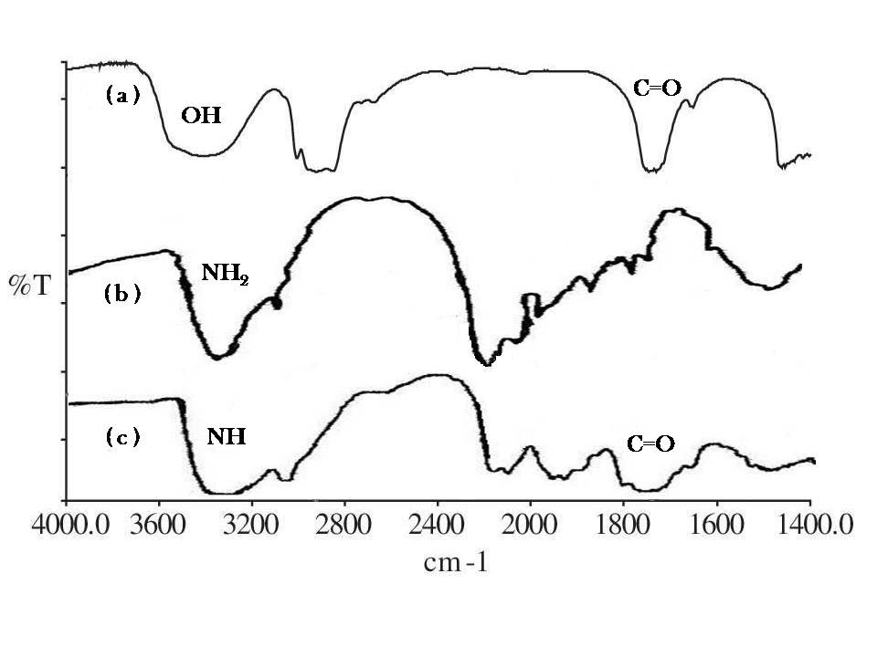

Figure 1 : FTIR spectra of a) castor oil; b) chitosan ; c) polyamine prepolymer .

Physical properties
All IPNs were synthesized as tough films from golden yellow to yellow color. The IPNs are almost insoluble and their densities are heavier than water. The densities of IPNs range from 40 to 67 g/cc. Density of IPNs increases with increase in Polymethylmethacrylate (because polymethylmethacrylate density is > 1) composition. The densities of all IPNs are given in table 1 along with the composition of individual IPNs.
Surface hardness of the IPNs (table 1) reflects the resistance to local deformation which is a complex property related to modulus strength, elasticity and plasticity. Surface hardness values lie in the range 6.1–19.5. Shore A surface hardness increases with increase in polymethylmethacrylate percentage which is due to hard nature of polymethylmethacrylate
Optical properties
Results of diffuse light, total light transmittance and haze measurements are given in table 1. These indicate that the percentage of transmittance of light was very good in all IPNs films and in the range 49.2–82.8%. The difference is attributed to the variation in PA content of IPNs. The increase in polymethylmethacrylate content of IPNs decreases the transmittance and increases percent haze. Comparison of optical properties of 100% poly amine, as well as 100% polymethylmethacrylate component polymers indicate that polymethylmethacrylate is a transparent film than polyamine (castor oil + chitosan), has transmittance around 43% depending on the levels of NH₂/OH ratios. Thus IPNs containing a low poly amine content are good transparent films with minimum haze percentage.
Mechanical properties
From the stress–strain curve, tensile strength, percent elongation at break, tear strength and initial modulus were tabulated in table 2. Tensile strength, tear strength and modulus increased with increasing methylmethacrylate component, whereas, percent elongation decreased. It is probably because polymethylmethacrylate is harder and brittle in nature. Interpenetration of poly amine as a separate phase in polymethylmethacrylate brings about the enhanced modification in mechanical properties such as, tensile strength, tensile modulus and tear strength.
Chemical resistance
The percentage weight loss of IPNs were determined in H₂SO₄, CH₃COOH, HCl, HNO₃, and NaOH etc. the results are furnished in table 3. All the IPNs show excellent acid and alkali resistance .
IPNs are swelled in solvents like methyl ethyl ketone (MEK), CCl₄ and toluene.
Conclusion
Interpenetrating polymer networks prepared from polymethylmethacrylate and the castor oil+ chitosan (polyamine) showed excellent chemical resistance, hardness, elongation, tensile strength properties and higher compatibility. Hence, it can be concluded that using the IPN concept, it is possible to design the most desirable material for a specific end use
requirement.

Table 1. Physical and optical properties of Poly amine / Polymethylmethacrylate IPNs.

Sample code | Density  (g/cc) | Shore A  hardness | Total percentage of  Transmittance | Percentage  of haze
IPN1 | 40.0 | 6.1 | 49.2 | 90.0
IPN2 | 42.1 | 10.9 | 58.0 | 82.2
IPN3 | 52.8 | 16.8 | 75.5 | 80.1
IPN4 | 61.6 | 18.0 | 79.0 | 79.7
IPN5 | 67.0 | 19.5 | 82.8 | 78.0

Table 2. Effect of Poly amine / Polymethylmethacrylate composition on the mechanical properties of IPN.

Sample code | Tensile strength  (MPa) | % Elongation | Tear strength  (N/mm²) | Tensile modulus  (MPa)
IPN1 | 2.00 | 109.6 | 1.45 | 27.0
IPN2 | 3.50 | 89.6 | 2.71 | 35.8
IPN3 | 7.11 | 84.0 | 2.96 | 43.0
IPN4 | 13.25 | 39.9 | 5.69 | 69.1
IPN5 | 30.95 | 15.3 | 8.98 | 91.2
Table 3: Chemical resistance test (% weight loss on treatment with different chemical reagents).

Chemical reagents | IPN1 | IPN2 | IPN3 | IPN4 | IPN5
25% CH₃COOH | 2.82 | 2.24 | 2.00 | 1.86 | 1.63
25% H₂SO₄ | 1.20 | 1.20 | 1.21 | 1.15 | 1.13
25% HCl | 0.60 | 0.58 | 0.53 | 0.49 | 0.45
5% HNO₃ | 0.56 | 0.51 | 0.50 | 0.44 | 0.41
10% NaOH | 0.51 | 0.55 | 0.59 | 0.62 | 0.64
CCl₄ | 18.52 | 17.23 | 15.42 | 13.00 | 12.04
Toluene | 9.31 | 9.10 | 8.43 | 7.88 | 7.43
MEK | 10.33 | 9.52 | 9.00 | 8.45 | 8.12

References
- Sperling L. H; Interpenetrating polymer networks and related materials , 1981 (New York: Plenum Press)
- Mark, Bikales, Overberg, Menges, Encyclopedia of Polymer Science and Engineering, second edition, 1987, 8, John Wiley and Sons Inc .
- Athawale W.D., Kolekarand S.L., Raut S.S.;Journal of Macromolecular Science- Polymer Reviews, 2003 , 43, 1.
- Yan Chen., Vellore J., Mohanraj., and Fang Wang .; AAPS PharmSciTech, 2007, 8, 98.
- Rhazi M., Desbrières J., Tolaimate A., Rinaudo M., Vottero P.,and Alagui A.;
Polymer, 2002.. 43, 1267.
- Kurita K.; Polymer Degradation and Stability, 1998, 59, 117.
7. Hsu, S.C., Don, T.M., and Chiu, W.Y.; Polymer Degradation and Stability, 2002, 75,73.
- Li Q., Dunn E.T., Grandmaison E.W., and Goosen M.F.; Journal of Bioactive and Compatible Polymers, 1992, 7, 370.
- Rao G., and Balasubramanian N.; Tamilnadu J. Veterinary & Animal Sciences, 2007, 3,160.
- ASTM D 792 Standard test method for density and specific gravity ( relative density ) of plastics by displacement, american society for testing and materials, Philadelphia, PA, (1991).
- ASTM D 676 Standard test method for shore A hardnes (Durometer ) , american society for testing and materials, Philadelphia, PA, (1991).
- Yuan chen.; Design and fabrication of transparent polycarbonate /carbon nanotube composite films , master thesis, Department of Industrial Engineering, (2007), Florida state university .
- ASTM D 638 Standard test method for tensile properties of plastics, American society for testing and materials, Philadelphia, PA,( 1991), pp 161-173.
- Hancox N. L.; Fibre Composite Hybrid Materials, Applied Science Publishers Ltd, Essex England, 1981, pp 63 – 166
- ASTM D 2240 Standard test method for rubber properties , american society for testing and materials, Philadelphia,PA,( 1991), pp 701-704.
- Miao, X.; Chemical resistance of four different polymeric liner materials, Master thesis, dep civil & envr.Eng., (2003), Tulane university, LA

