Synthesis and Characterization of Some New Substituted
Benzimidazolyl Acrylonitriles

Jasim M. El-Sabaway
College of Environmental Science and Technology, University of Mosul
Badie A. Ahmed and Salim J. Mohammed
Department of Chemistry, College of Science, University of Mosul

(NJC)

(Recevied on 29/11/2008) (Accepted for publication 19/4/2009)

Abstract
The reaction of 2-cyanomethylbenzimidazole (I) with substituted benzaldehyde in presence of piperidine afforded a series of new benzimidazolyl acrylonitriles (IIa-i). The structures of the products were confirmed by physical and spectroscopic methods, and supported by the 3D-configurational diagram.
الخلاصة
لقد وجد أنه عند مفاعلة 2- سيانو مثيل بنزيميدازول (I) مع معوضات مختلفة للبنزالديهايد، أعطت مشتقات جديدة لمركبات البنزيميدازوليل اكريلونترايل (II a-i). تم إثبات الصيغ التركيبية للمركبات الجديدة المحضرة باستخدام الطرق الفيزياوية والطيفية المختلفة، إضافة إلى الأشكال الهندسية متمثلة بالتراكيب ثلاثية الأبعاد.

Introduction
Many heterocyclic compounds containing benzimidazole moiety were reported to possess antibacterial, antiprotozoal, antimicrobial, antifungal and antihelmiritic activities⁽¹⁾.
Benzimidazole has widespread pharmacological effect and was included in many commercially available drugs⁽²⁾.
Recently, the antiviral activity of series of benzimidazole derivatives against selected RNA and DNA viruses was evaluated.⁽³⁾
The chemistry of benzimidazoles has been extensively studied by many authors. They reported a simple, rapid and efficient method for the preparation of benzimidazole derivatives from the reaction of orthoesters with o-phenylenediamine in the presence of silicasulfuric acid under heterogeneous and solvent-free conditions⁽⁴⁾.
We observed that 2-cyanomethyl-benzimidazole (I) could be serve as
a useful synthone in projected synthesis of (II) and can easily be obtained from o-phenylene diamine with ethyl cyanoacetate⁽⁵⁾.

Experimental
Melting points were determined on Gallenkamp, Melting Point Apparatus and are uncorrected. Infrared spectra ($λ_{\text{max}}$, cm⁻¹) were recorded on a Pye Unicam SP200 Spectrophotometer in KBr disk. Ultraviolet spectra were measured on Shimadzu UV.160 Spectro-photometer. ¹H-NMR spectra were determined on Bruker Spectrophotometer (90 MHz) using TMS as internal reference. Elemental analysis were performed on Carlo Erba type 1106 CHN analyzer.

We observed that 2-cyanomethyl-benzimidazole (I) could be serve as
a useful synthone in projected synthesis of (II) and can easily be obtained from o-phenylene diamine with ethyl cyanoacetate⁽⁵⁾.

Preparation of 2-cyanomethyl-benzimidazole (I):

o-phenylenediamine (1.08gm, 0.01 mole) and ethylcyanoacetate (1.7 gm, 0.01 mole) were refluxed in ethanol for (20 minutes). After cooling, the solution was extracted with ether (3×25ml). The solvent was evaporated and the resulted solid product was recrystallized from aqueous ethanol yield (11gm) (70%) m.p. 211-212 C⁰.
Synthesis of substituted benzimidazolylacrylonitriles (II a-i) (General procedure)⁽⁶⁾:

Equimolar of 2-cyanomethyl-benzimidazole (I) (1.57gm, 0.01mole) and substituted benzaldehyde in the presence of piperidine (5 ml) were refluxed in ethanol (25 ml) for 30 minute. The resulted dark-red heavy liquid was cooled and water (20 ml) was added with stirring. A solid product was separated and filtered. Recrystallization of the products from suitable solvent (table 1) gave the title compounds. Melting points, yields and other analyses of all the products
(IIa-i) are listed in table I.

Table 1: Physical data of compounds (II a-i)

(II a-i)
Compd. No. II | X | m.p. C⁰ | Yield % | Crys. Solvent | Molec. Formula | Analysis % Calcd. (found)
 |  |  |  |  |  | C% | H% | N%
a | H | 194-6 | 88 | H₂O | C₁₆H₁₁N₃ | 73.0  (73.12 | 3.8  3.78 | 15.96  16.01)
b | p-F | 229-30 | 89 | EtOH-H₂O | C₁₆H₁₀FN₃ | 73.0  (73.08 | 3.8  3.82 | 15.96  16.04)
c | p-CH₃ | 228-29 | 85 | EtOH-H₂O | C₁₇H₁₃N₃ | 78.76  (78.81 | 5.02  5.04 | 16.22  16.18)
d | p-Br | 254-56 | 92 | EtOH-H₂O | C₁₆H₁₀BrN₃ | 59.44  (59.48 | 3.09  3.12 | 13.0  13.03)
e | m-NO₂ | 256-58 | 94 | EtOH-H₂O | C₁₆H₁₀N₄O₂ | 69.56  (69.36 | 3.62  3.71 | 20.3  20.28)
f | p-OCH₃ | 208-10 | 82 | H₂O | C₁₇H₁₃N₃O | 74.18  (74.18 | 4.73  4.68 | 15.27  15.3)
g | p-NO₂ | 289-91 | 91 | EtOH-H₂O | C₁₆H₁₀N₄O₂ | 69.56  (69.61 | 3.62  3.08 | 20.3  20.19)
h | o-F- | 213-14 | 79 | H₂O | C₁₆H₁₀FN₃ | 78.36  (78.41 | 4.48  4.02 | 17.14  17.2)
i | m-Cl | 234-36 | 86 | EtOH-H₂O | C₁₆H₁₀ClN₃ | 68.69  (68.64 | 3.58  3.48 | 15.02  15.12)

Results And Discussion

The substituted benzimidazolyl compounds have pharmacological activity, as well as benzimidazole ring systems are key systems for preparing a series of other compounds^{(7,8)}.
Substituted benzimidazolyl acrylonitriles (II a-i) were smoothly prepared from the reaction of 2-cyanomethylbenzimidazole (I) [which was prepared from the reaction of o-phenylenediamine and ethyl cyanoacetate in ethanol⁽⁹⁾] as a base. See scheme (1).

Scheme (1)

We found that the reaction of 2-cyanomethylbenzimidazole (I) with aromatic aldehyde in presence of pipridine as a base can be conviently applied to synthesize different substituted benzimidazolyl acrylonitriles⁽¹⁰⁾ (II a-i).
The postulated mechanism for the formation of the products (II a-i) is shown in scheme (2).

Nucleophilic tetrahedral attack of the produced α-carbanion on aldehyde carbonyl group gave addition intermediate which on water molecule elimination afforded the final product.

Scheme (2)

The structure of compounds
(II a-i) has been characterized and identified on the basis of their U.V, I.R and ¹H-NMR spectra, as well as by physical methods.
The ¹H-NMR spectra of compounds (II a-i) showed the following absorptions: two multiplets at (7.15-7.95 ppm) and at (7.9-8.5 ppm) due to ring (A) and (B) protons respectively. A broad singlet at (4.5-7.7 ppm) due to NH proton, while the benzilic proton appeared as a singlet at (8.5-8.8 ppm).
The IR spectrum showed absorptions for CN band in the rang of (2050-2150 cm⁻¹) and characteristic NH band in the range of (3240-3410cm⁻¹), as well as other absorptions for C=C band in the range of (1595-1615 cm⁻¹).
Finally UV spectra of these compounds showed $λ_{\text{max}}$(MeOH) at (345-360 nm).

Table 2: Spectral data for compounds (II a-i)

Comp. No. II | U.V MeOH $λ_{\text{max}}$(nm) | I.R (KBr) υ cm⁻¹ |  |  |  | ¹H-NMR δ (ppm)
Comp. No. II | U.V MeOH $λ_{\text{max}}$(nm) | CN | NH | C=C | others | ring A | ring B | NH | ArCH
a | 350 | 2090 | 3240 | 1605 | --- | 7.2-7.6  (m,4H) | 7.9  (m,4H) | 6.3  (s,1H) | 8.7  (s,1H)
b | 352 | 2150 | 3310 | 1610 | --- | 7.2-7.5  (m,4H) | 8.2  (m,4H) | 4.5  (s,1H) | 8.7  (s,1H)
c | 355 | 2085 | 3400 | 1598 | --- | 7.95  (m,4H) | 8.2  (m,4H) | 5.0  (s,1H) | 8.8*  (s,1H)
d | 348 | 2100 | 3355 | 1603 | --- | 7.4  (m,4H) | 8.1  (m,4H) | 5.2  (s,1H) | 8.7  (s,1H)
e | 358 | 2075 | 3250 | 1615 | 1540 asy.(NO₂)  1320 sym.(NO₂) | 7.15  (m,4H) | 8.5  (m,4H) | 7.0  (s,1H) | 8.8  (s,1H)
f | 345 | 2085 | 3250 | 1605 | 1510 asy.(NO₂)  1330 sym.(NO₂) | 7.9  (m,4H) | 8.15  (m,4H) | 7.5  (s,1H) | 6.65**  (s,1H)
g | 360 | 2100 | 3410 | 1610 | 1110 sym.(OCH₃)  1305 asy. (OCH₃) | 7.2-7.8  (m,4H) | 8.45  (m,4H) | 7.7  (s,1H) | 8.5  (s,1H)
h | 350 | 2095 | 3305 | 1605 | --- | 7.5-7.7  (m,4H) | 8.0  (m,4H) | 6.3  (s,1H) | 8.0  (s,1H)
I | 354 | 2110 | 3280 | 1595 | --- | 7.6-7.8  (m,4H) | 8.15  (m,4H) | 5.5  (s,1H) | 8.7  (s,1H)
* singlet abs. in ¹H-NMR at 3.2 ppm due to CH₃ group.
** singlet abs. in ¹H-NMR at 3.4 ppm due to OCH₃ group.

From structure – activity relationship and drug design point of view, further structural information for the product was obtained from the 3D-configurational structure as shown in figure.
Heat of formation (H.F.) and steric energy (S.E.) for the product was calculated too. Discussion of the theoretical calculations is beyond the scope of this research.

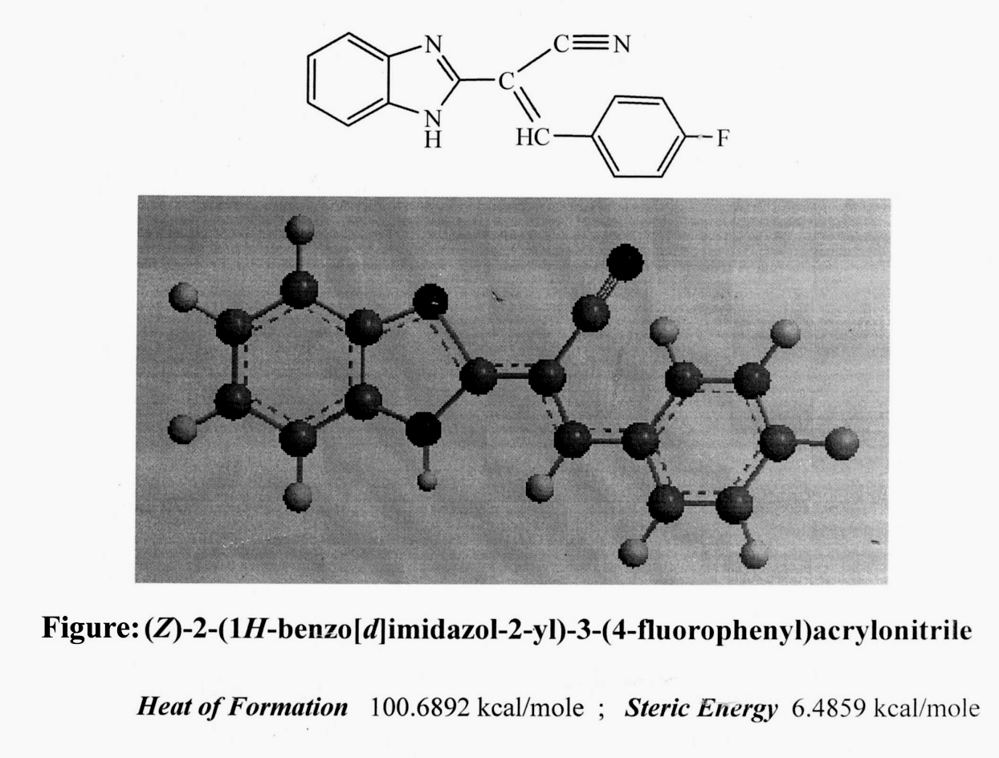

References

- A. Seleen Alpqn, H. Semith Gunes and Zeki Topcu; Acta Biochimica polonic; 2007, 54(3), 561.
- A. Matumori; Eur. J. Heart Fial; 2003, 5, 669.
- S. Budow, M. Kalowska, A. Gorska, Z. Kazimierczuk and F. Seela; Arkivoc, 2009, iii, 225.
- I. Mohammud, M. Mogjadam, S. Tangestaninejad and S. F. Hojat; J. Iranian. Chem. Soc.; 2008, 5, 565.
- A. B. Ralf, Copeland and Allan R. Day, J. Am. Chem. Soc.; 1943; 65; 1072.
- H. Marijana and G. Kaminsk; Molecules; 2007, 12, 1817.
- T. Sakai, T. Hamada, N. Avata and J. Watanobe; Pharmacobio-Dyne; 1989, 12, 530.
- T. A. Fairly, R. R. Tidwell and R. J. Lombard; J. Med Chem.; 1993, 36, 1746.
- R. A. Copeland and A. R. Day; J. Am. Chem. Soc.; 1943, 65, 1072.
- F. Saczewski, P. Rezka and P. J. Bendnaski; J. Med. Chem., 2004, 47, 3438.

