Study on Association Between o-methoxy-benzylidene-p-aminoaniline with phenols

A.S.P Azzouz
Chemistry Dep. , College of Education , Mosul University
S.S Othman and A.N. Al-Dabagh
Medical Instrumentation department , Technical College , Mosul.

Keywords : Association , Schiff base , Phenols , Hydrogen bonding , UV spectra , Thermodynamics , Proton transfer .

(NJC)

(Recevied on 14/12/2008) (Accepted for publication 19/7/2009)

Abstract
The interactions of o-methoxy-benzylidene-p-aminoaniline (MBAA) with phenol, p-methoxyphenol ,and p-chlorophenol in n-hexane are studied by using UV spectroscopy . The study led to the formation of hydrogen bond species of types
O – H∙∙∙∙∙O and O – H ∙∙∙∙∙ N between MBAA with phenol and p-methoxyphenol . The last is appeared from the UV spectra record of MBAA with phenols stated at relative concentrations ratio of phenol / MBAA and p-methoxy phenol / MBAA of values 4/1 and 4/1 respectively. Similar result is obtained on using p-chlorophenol at relative concentration ratio of p-chlorophenol / MBAA of a value 4/1 , with additional appearance of two UV protonated bands at a wavelengths of 463 nm and 474 mm .
them . The equilibrium constants for hydrogen bond formations of MBAA with phenols stated are included . The interactions of systems under study are confirmed by thermodynamic method . These show that $\overline{ΔH}$ and $\overline{ΔS}$ have a negative signs , as well as their values which support hydrogen bondings . Moreover , the processes of non spontaneous hydrogen bonding as observed and evident from the positive values of $\overline{ΔG}$ are included . These final abnormal results are unexpected and discussed in details .
الخلاصة
يتضمن البحث دراسة تداخلات MBAA مع الفينول ، بارا ميثوكسي فينول وبارا كلورو فينول في مذيب الهكسان وبأستعمال مطيافية UV . اكدت الدراسة على تكوين اواصر هيدروجينية بنوعي O – H∙∙∙∙∙O و O – H ∙∙∙∙∙ Nبين MBAA مع الفينول ومشتقاته . الاواصر الهيدروجينة المذكورة تواً ظهرت من اطياف UV المسجلة للمركب MBAA وبنسب تراكيز 4/1 . بارا كلورو فينول اظهر نتائج متشابهة وعند نفس نسبة التركيز المذكورة مع ظهور حزمتي برتنة اضافية عند الاطوال الموجية nm 463 و nm 474 واللتان تعودان الى ايوني النتريليوم والاوكزونيوم . كما تضمن البحث تعيين ثوابت التوازن التداخلات المذكورة بين MBAAوالفينولات والمثبتة بالطريقة الثرموديناميكية . دللت الاخيرة على أن اشارات $\overline{ΔH}$ و $\overline{ΔS}$ هي سالبة بأضافة الى قيمها والمؤكدة للاواصر الهيدروجينية بين الجزيئات المتداخلة . اشتمل البحت على حساب $\overline{ΔG}$ والذي يؤكد ان التفاعل المذكور غير تلقائي . النتيجة الاخيرة كانت غير متوقعة ونوقشت بأسهاب .

Introduction
A survey of literature ⁽¹⁾ reveals that association reactions are very important in DNA molecules and other polymeric systems . These may result in an increase in the stability ⁽²⁾ of many systems , change in absorption spectra ⁽³⁻⁵⁾ and other physico-chemical properties ⁽²⁾ .
It was expected that UV-visible spectrum of a molecule may be altered by formation of hydrogen bond , if a chromophore in a molecule is perturb by the hydrogen bond ⁽⁶⁾ .
In the last two decades , several studies ^{( 4,5,7-10 )} , were performed in our laboratory in the field of hydrogen bonding . Among them the thermodynamic and UV studies of association reaction between phenols and benzil mono benzylidene aniline ⁽⁴⁾, the thermodynamic study ⁽⁸⁾ of interaction of benzil di Schiff base with phenol and the UV absorption spectra of cinnamylidene n-butylamine ⁽⁹⁾ . These studies were showed that a hydrogen bond formation in these systems were accompanied by UV spectral changes .
The present investigation is an extension of the last three studies it deals with effect of phenol , p-methoxyphenol and p-chlorophenol on the UV absorption spectrum of o-methoxy-benzylidene-p-aminoaniline in n-hexane .The study includes the thermodynamic method for the investigation of a type of interaction in systems under study . This may open another subsequent future works on another studies .

Experimental
All chemicals used throughout this work are supplied from Fluka origin . They were used as supplied without any further purification , with an exception of phenol and o-anisaldehyde . The last were purified by distillation . Pure phenol and o-anisaldehyde have b.p ,s of 70ºC (12 torr ) and 243 ºC ( 760 torr )respectively .
Crude n-hexane was purified by standard method ⁽¹¹⁾ . o-Methoxybenzylidene-p-amino-aniline was synthesized by standard method ⁽⁴⁾. Recrystillization of the product is performed in ethanol . Pure product has a m.p of 144 ºC . The UV spectra are measured using Shimadzu UV – visible – 160 by using matched 1*1*3 cm ³ . All UV spectra were measured against phenolic blank solutions . Also the IR spectrum of solid MBAA was measured by using computerized Tensor -27 and by KBr disk method. The linear plots were performed by using Excel computer program .

Results and Discussion
The IR spectrum of pure solid MBAA sample, shows a bands at wavenumbers values of 1102.83 (s) , 1599.35 (s) , 1615.36 (s) and 3400.74 (b) . They are assigned to the stretching frequencies of ether linkage, the aromatic ring , the azomethine group HC = N and the hydrogen bonding group of types Oـــ H ….O or O ـــ H ….N
respectively . These confirm the chemical structure of MBAA .
The preliminary UV spectrum of 10 ⁻³ M MBAA in n-hexane is shown in Fig. 1, it shows a four bands at wavelengths values of (λ) nm with molar extension coefficient (ε) values . Similarly the UV spectrum of 10 ⁻³ M phenol in the same solvent shows two bands only . These results are collected in Table 1 .

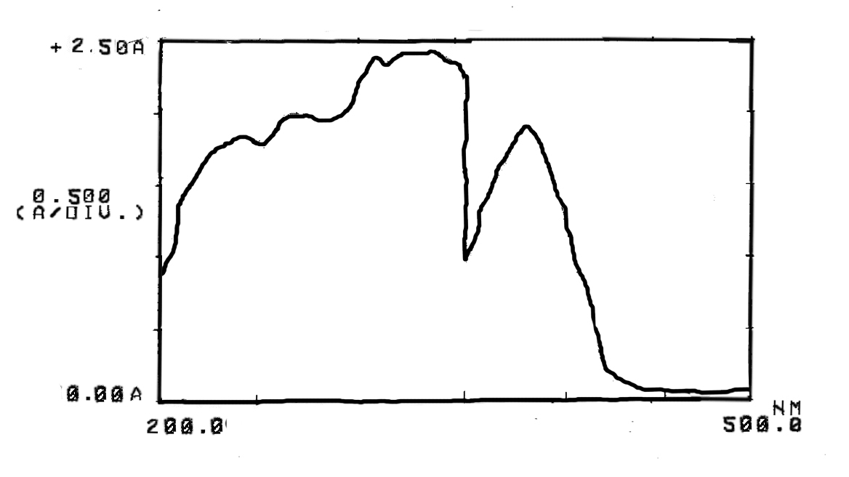

Fig.1 The UV spectrum of 10⁻³M MBAA in n-hexane

Table 1 The UV spectra of 10⁻³ M MBAA and phenol in n-hexane

Compound | λ (nm) | ε ( liter.mole⁻¹.cm²)
MBAA | 382.5  331.5  264.5  239.5 | 1866  2448  1993  1817
Phenol | 261  219 | 1641  1061

Table 2 Influence of excess phenols concentrations on the UV absorption spectra of 10⁻⁵ M MBAA in n-hexane

Phenols | Conc. Of MBAB (M) | Conc. Of phenol | Relative conc. | Wavelengths nm | Absorbance A | Relative absorbance
Phenol  * | 10⁻⁵ | 10⁻⁵ | 1:1 | 367  347 | 0.026  0.027 | 0.96
Phenol  * | 10⁻⁵ | 2x10⁻⁵ | 2:1 | 367  348 | 0.059  0.059 | 1.0
Phenol  * | 10⁻⁵ | 3x10⁻⁵ | 3:1 | 364  349 | 0.109  0.125 | 0.872
Phenol  * | 10⁻⁵ | 4x10⁻⁵ | 4:1 | 365  347 | 0.097  0.125 | 0.78
Phenol  * | 10⁻⁵ | 5x10⁻⁵ | 5:1 | 367  348 | 0.064  0.068 | 0.94
Phenol  * | 10⁻⁵ | 6x10⁻⁵ | 6:1 | 365  348 | 0.074  0.081 | 0.91
Phenol  * | 10⁻⁵ | 7x10⁻⁵ | 7:1 | 364  345 | 0.071  0.074 | 0.95
Phenol  * | 10⁻⁵ | 8x10⁻⁵ | 8:1 | 365  348 | 0.065  0.071 | 0.91
p-methoxy phenol  * | 10⁻⁵ | 10⁻⁵ | 1:1 | 367  347 | 0.093  0.097 | 0.95
p-methoxy phenol  * | 10⁻⁵ | 2x10⁻⁵ | 2:1 | 367  347 | 0.095  0.086 | 1.10
p-methoxy phenol  * | 10⁻⁵ | 3x10⁻⁵ | 3:1 | 367  347 | 0.09  0.09 | 1.0
p-methoxy phenol  * | 10⁻⁵ | 4x10⁻⁵ | 4:1 | 367  347 | 0.039  0047 | 082
p-methoxy phenol  * | 10⁻⁵ | 5x10⁻⁵ | 5:1 | 367  347 | 0.055  0.055 | 1.0
p-chloro phenol  * | 10⁻⁵ | 10⁻⁵ | 1:1 | 363  347 | 0.158  0.177 | 0.89
p-chloro phenol  * | 10⁻⁵ | 2x10⁻⁵ | 2:1 | 364  348 | 0.141  0.165 | 0.85
p-chloro phenol  * | 10⁻⁵ | 3x10⁻⁵ | 3:1 | 362  348 | 0155  0.182 | 0.85
p-chloro phenol  * | 10⁻⁵ | 4x10⁻⁵ | 4:1 | 360  348 | 0.151  0.221 | 0.68
Relative absorbance is estimated by diving absorbances of longer wavelength band by shorter wavelength .

The influence of excess different concentrations of phenol on the UV absorption spectra of 10⁻⁵ M MBAA in n-hexane are studied , by preparing a set of solutions containing a fixed concentration of MBAA and a variable excess quantities of phenol , or phenols , having a relative range ratio values between 1:1 – 8:1 . Then after the UV spectra for these eight solutions are measured versus phenolic blank for each mixture . The results obtained from such studies are collected in Table 2 . It is cleared from Table 2 that mainly two UV bands at longer wavelengths of range wavelengths values between (345 – 348) nm and (364 – 367) nm are obtained , beside other bands seen at shorter wavelength is seen in Fig 1 . These two bands mentioned are abbreviated A₁ and A₂ respectively . The lower relative absorbance ratio value of 0.78 for the bands mentioned are observed when the relative concentration of phenol \MBAA has a value of 4:1 as in Table 2 .The last is considered here , to represent the optimum condition for obtaining a greater UV changes , as compared with same UV band of MBAA listed in Table2 and with whole spectrum of MBAA seen in Fig 1 . Similar results are obtained by replacing p-methoxyphenol and p-chlorophenol in stead of phenol on the UV absorption spectra of MBAA with a maximum UV changes are obtained when relative concentrations of last phenols have a values of 4:1 and 4:1 respectively . Also the UV spectrum of MBAA is the presence of p-chlorophenol is resulted to the additional appearance of two weak absorptions at longer wavelengths values of 463 nm and 474 nm in n-hexane.They are assigned^{(4,12-13)} to the nitrilium

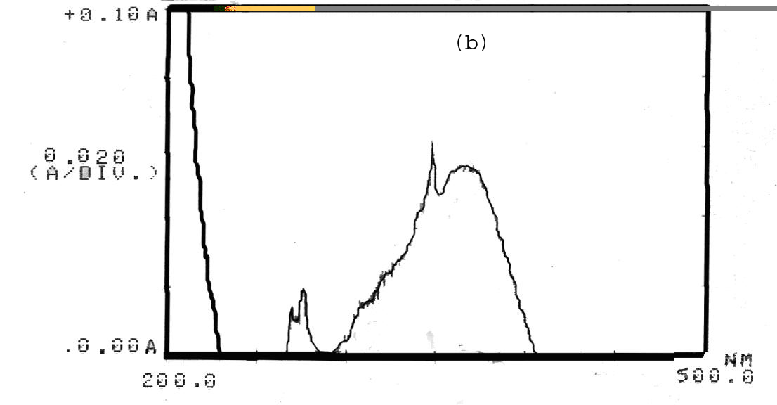
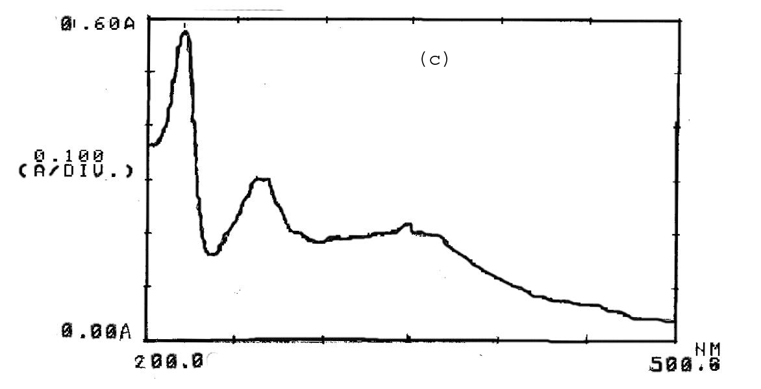
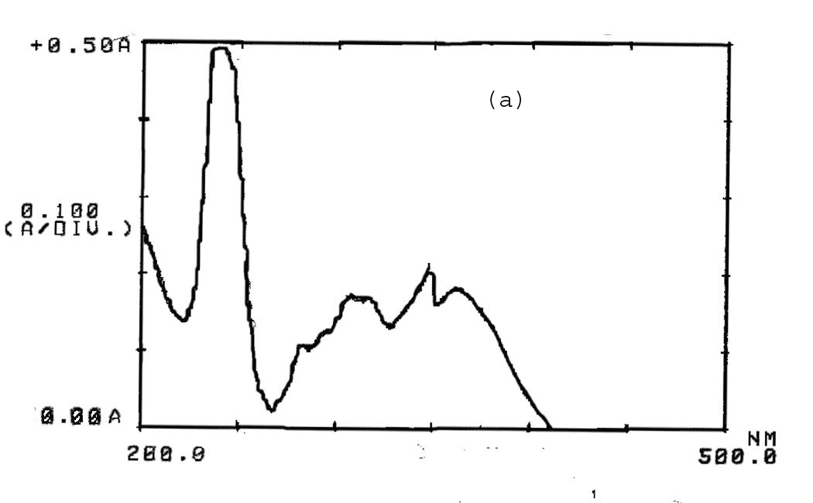
Fig.2 The UV absorption spectrum of 10⁻³M BMAA in n-hexane after addition
Of:
- Phenol
- P-methoxy phenol
- P- chlorophenol

These polar ions are formed by proton^{(3,14)} transfer reactions from phenol to an electronegative atoms , namely oxygen and nitrogen atoms available in MBAA . The weak intensities of absorptions for nitrilium and oxonium ions are due to low expected solubility of these ions in non polar n-hexane solvent . This is in accordance ⁽²⁾ to the rule like dissolves like .
Now the question which can be arise , why the UV spectra of MBAA are changed after addition of phenol , p-methoxyphenol and p-chlorophenol . Although the pka values⁽¹⁵⁾ of last compounds have a values of 9.95 , 10.21 , 9.41 respectively . Actually , on can expect that these phenols are able to form a hydrogen bonding species by donor-acceptor mechanism ⁽ ²⁻⁴ ⁾ with different strengths . Phenol here is regarded as an acceptor species , while MBAA is a donor species . The formation of hydrogen
bonding can be expected in this study to be of types Oـــ H ….O or O ـــ H …. N
These hydrogen bondings perturb the chromophore system of original MBAA and hence it not a strange to obtain UV spectral changes after additions of phenols . This is in a good agreement with other similar studies⁽³⁻⁴⁾ in this field .
Now it is important to prove the type of interaction between MBAA and phenols by thermodynamic method . The equilibrium reactions occure between MBAA and phenols added before UV measurements of solutions outlined before , and are

The equilibrium constant K of the interaction reaction stated above is evaluated from the UV spectrum from the relationship :
K = $\frac{A2}{A1}$ ……….(1)
A₂ and A₁ are absorbance of bands generated after addition of optimized quantity of phenols seen in this work respectively .
Table (3) shows the equilibrium constant values of interactions of MBAA with phenol, p-methoxyphenol and p-chlorophenol in n-hexane and at a temperatures range ( 283-323 ) K . They have a direct relationship with the inverse of absolute temperatures . This facilitates the evaluation of heat of reaction ∆H from Vant hoff equation of the form as in equation (2) :
Ln K = constant - $\frac{ΔH}{\text{RT}}$ ……..( 2 )
By using excel computer program , the plots of lnK versus T⁻¹ for phenol , p-methoxyphenol and p-chlorophenol .They show a straight lines of R² values 0.9530,0.9655 and 0.9294 respectively.
These straight lines collected in Fig (3) . From the last plots are shown to fit an equation ( 3-5 ) , for phenols mentioned above respectively .
Lnk = 138.5 X - 0.5012 ………..(3)
lnK = 198.35 X – 0.7761 ………..(4)
lnK = 849.35 X - 2.9798 ……….(5)
Hence X = - ∆H \ R

Equations (3-5) allow the evaluations the heats of interactions for MBAA with the phenols at any temperature . They have an average values of $\overline{ΔH}$ equal to -1148.7 , -1658.9 and -6993.4 J. mole⁻¹ for phenol , p-methoxyphenol and p-chlorophenol respectively .
The Gibbs free energy ∆G is calculated from equation ( 6 ) of the form :
∆G = - RT ln K …………….( 6 )
All average $\overline{ΔG}$ values have a positive range values between ( 128.2 – 513.2 ) J. mole⁻¹ . Their positive signs are far away of our expectations , since mixing MBAA with phenols generate bands A₂ and A₁ spontaneously . In other words , that the interacting molecules under study is occur by a non spontanous process . An acceptable explanation for such abnormal result is given here , by the fact of magnitude A₂ absorbance has a lower value if compared with A₁, for any interacting equilibrium systems seen in Table ( 3 ) at any constant temperature . This produces K of a value lower than unity according to equation ( 1 ) , or hence its logarithmic numbers must be negatives . Finally a positive ∆G values are appeared in (3) for all systems from equation ( 3 ) . These positive ∆G values are in agreement ⁽⁴⁾ with other similar system as the interaction benzil monobenzyliden aniline with 2,4- dimethylphenol and phenol at some elevated temperature of 293 and 298 K . Another explanation for the smaller A₂ value of complex molecule or ions products for the interacting systems is by the assumption of smaller stabilities of interacting products by hydrogen bonding . This proposal may be to the steric hindarance of ortho methoxy group presents in MBAA . The last results due to the difficulty for phenolic protons to approach the hetero oxygen or nitrogen atoms in MBAA or to the smaller absorbance A₂ values of interacting products .
The ∆S values for systems above are estimated for Gibbs equation ⁽⁷⁾ of a form :
∆G = ∆H – T ∆S ……………. (7)
All ∆S values listed in Table (3) have a negative signs and are agreed with the interacting systems in this study .
Now both the values and the negative signs of $\overline{ΔH}$ and $\overline{ΔS}$ thermodynamic parameters are in full agreement ^{( 3,4,6 )} with hydrogen bondings O – H ∙∙∙∙∙∙ O or
O – H ∙∙∙∙∙ N available in this study .
Finally it is of great importance to study the influence of chloro and methoxy substitutents on the $\overline{ΔH}$ and $\overline{ΔS}$ thermodynamic parameters of association system under study . The higher acidity of p-chlorophenol as seen above by its low pKa value as compared with p-methoxyphenol , results to a larger negative values of thermodynamic parameters mentioned as shown in Table (3) . In other words , that p-chlorophenol produces a more stable and more order products after association of p-chlorophenol with MBAA .

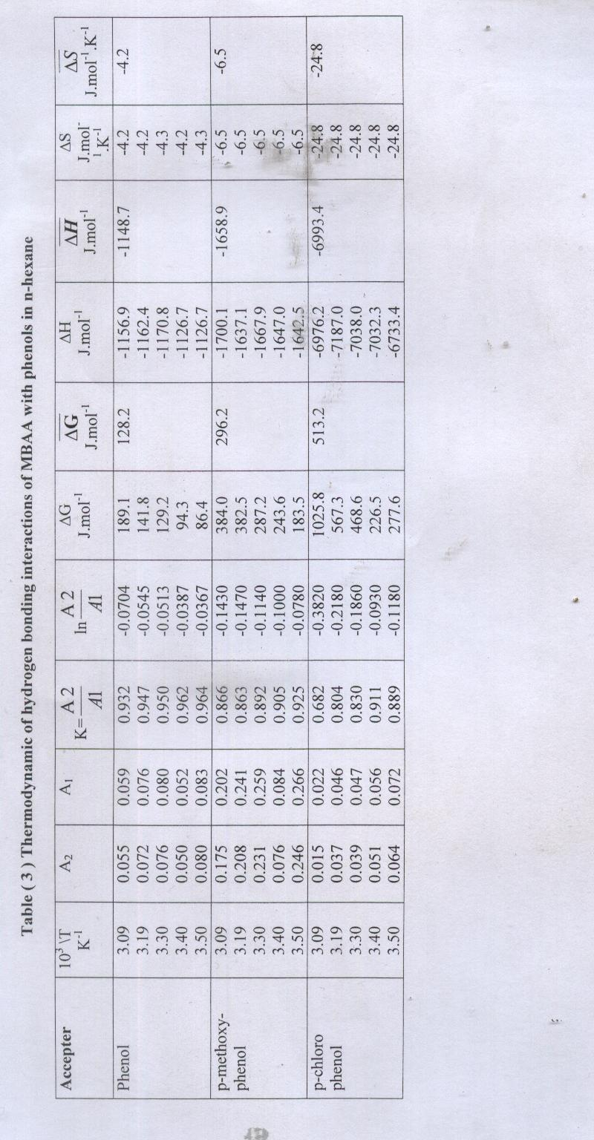

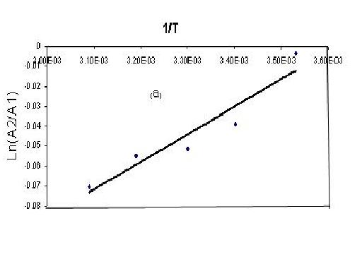
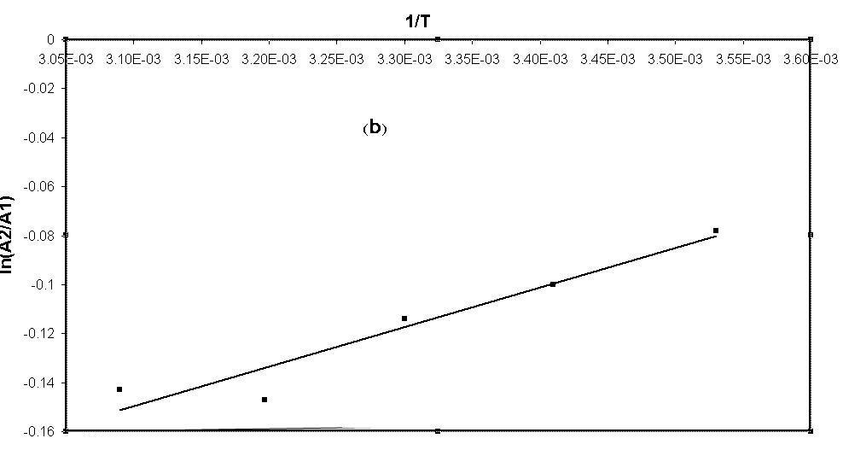

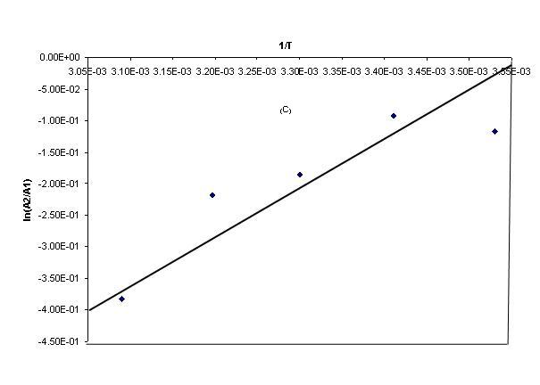

Fig.3 Vant Hoff equations plots for the interactions of MBAA in n – hexane
With :-
- phenol.
- p-Methoxy phenol.
- p-Chlorophenol.

Conclusions
- The interactions of MBAA with phenol , p-methoxyphenol and p-chlorophenol are studied by UV spectroscopy and thermodynamic method .
- At optimal relative concentrations values of 4/1 for phenol /MBAA and 4-methoxyphenol / MBAA , generate two new UV bands are observed in the UV spectrum of MBAA . They are assigned to the complex molecule or ions formed by the hydrogen bonding species , and the non hydrogen bonding species in reacting molecules .
- The interactions in the reactants molecules by hydrogen bonding are of types O ∙∙∙∙∙ H – O and N ∙∙∙∙∙ H – O . These perturb the chromopher of MBAA and results to the appearance of a new UV band after addition of phenols .
- p-Chlorophenol shows a similar behavior to those given for phenol and p-methoxyphenol with additional appearance of diprotonated UV bands at wavelength of 463 nm and 474 nm. They are arised from oxonium or nitrilum

- Both negative signs of $\overline{ΔH}$ and $\overline{ΔS}$ calculated thermodynamic parameters for the equilibrium interacting systems under study , support ^{( 3, 4, 6)} the interaction processes by hydrogen bondings .
- The observed entropy changes $\overline{ΔS}$ for the interactions of phenol , p-methoxyphenol and p-chlorophenol with MBAA have a negative values of 4.2, 6.5 and 24.8 cal.mole⁻¹.K⁻¹ . The last smaller value supports the hydrogen bonding as well as the diprotonated UV bands shown above and in Fig.2.c .
References
- R. Chang ,Physical Chemistry with Applications to Biological Systems , Macmillan , New York , 1981 , pp. 487-501 .
- A.Martin , Physical Pharmacy ,4th ed. , Lea and Febiger , 1993 , pp. 408-494 .
- S.K.Al-Dilami , J.C. Aumiller , R.H Johnson and P.E Blatz , Photochem. Photobiol. ,1987 ,46 ,403.
- A.S.P.Azzouz , Z. Phys.Chem. ,2002 ,216 ,1053 ,
- A.S.P.Azzouz and S.M . Saleh , J. Edu.Sci. , 2000 ,46 ,151.
- G.C. Pimentel and A.L. Mecellellan , The Hydrogen Bond , Freeman , New York , 1960 , pp 129-195 .
- S.K.Al-Dilami and A.S.P. Azzouz , J . Indian Chem . Soc. ,1977 ,LIV , 678 .
- S.K.Al-Dilami and A.S.P. Azzouz and N.G. Ahmed , Muta J.Res.Stud. , 1992 ,7 , 409.
- S.K.Al-Dilami and A.S.P. Azzouz and K.S.Tawfique, J .Edu. Sci . , 1990 , 10 , 65.
- A.S.P. Azzouz ,J.Edu.Sci. ,2001 , 50,45.
- A.F.Vogel , Text Book of Practical Organic Chemistry , 4th ed. , Longman, London, 1974.
- H.Saeed , M.H.Watton and A.W.A.Sultan , Thermochemica Acta ,1983 ,67 , 17 .
- A.S.P. Azzouz ,K.A.Abdullah and K.I.Niemi ,Mutah J.Res. Stud. ,1995 ,10 , 77.
- P.F.Dupuis , F.F. Harosi , C.Sandorfy , J.M. Leclercq and D.Vocelle, Rev.Can.Biol. ,1980 ,39, 247.
- A.Albert and E.P.Serjeant , The Determination of Ionization Constants , Chapman and Hall , London , 1984 , p.145.

