Vibration Frequencies , Normal Coordinates and IR Absorption Intensities of 1-; 1,2-; 1,3- and 1,2,3- Methylene Cyclobutane Dirivatives

Rehab M. Kubba, S. H. Rida and A. H. Hanoon
Department of Chemistry, College of Science, University of Baghdad,

Jadiriya, Baghdad, Iraq.

(NJC)

(Received on 16/9 /2004) (Accepted for publication on 22/6 /2005)

Abstract

SCF-MO calculations of the vibration frequencies and IR absorption intensities, applying the MINDO/3-FORCES method, are reported for the four molecules, mono-, di- (1,2- and 1,3-), and 1,2,3-trimethylene cyclobutane. In addition, normal coordinate analysis of all vibration modes is described for each molecule. The obtained results allow interesting correlations between the frequencies of similar modes as calculated for the different methylene cyclobutanes.
الخلاصة

تم حساب ترددات اهتزاز و شدة امتصاص الاشعة تحت الحمراء باسلوب MINDO/3- FORCES لجزيئات احادي و ثنائي1,2-) و(1,3- وثلاثي (1,2,3-) مثلين سايكلوبيوتان الاربع، اضافة الى تصنيف جميع الانماط الاهتزازية3N-6)) العائدة لهذه الجزيئات تماثليا و تكافؤيا. تضمنت النتائج التي تم الحصول عليها علاقات مهمة تربط بين الانماط الاهتزازية المتشابهة في التصنيف التكافؤي للجزيئات الاربع و المختلفة في عدد مجاميع المثلين.

Introduction

The molecules for which calculations were done, are cyclobutane derivatives in which one, two or three CH₂ groups are replaced by one, two or three C=CH₂ to form mono-, di- and tri-methylene cyclobutane as shown below:

Monomethylene cyclobutane (MCB) was synthesized and characterized by different researh groups ^{[1,2]}. Theoretical calculations, applying the ab initio method were also performed for this molecule ^{[3]}. The two isomers 1,2- and 1,3-dimethylene-cyclobutane (1,2- DMCB and 1,3- DMCB) were synthesized and characterized by different research groups too^{[4,5]}. Dewar et al. studied the equilibrum geometries and heats of formation of these two isomers applying the MINDO/3 method ^{[6]}. An x-ray diffraction measurement for 1,2 dimethylene cyclobutane showed that the molecule is planar with C_{2V} symmetry ^{[7]}. Little work was done for trimethylene cyclobutane (TMCB) as might be found on studying the literature, obviously due to the fact that this molecule dimerizes quickly at room temperature. Williams and Sharkey ^{[5]} could isolate it and characterize its IR spectrum at -80Cº.

The present study is based on the MINDO/3-FORCES method, as described and applied for many other molecules by Shanshal et al. ^{[8]}. In this method the force constants are estimated applying Pulay,s FORCES method ^{[9]}. Applying the so evaluated force constants to the Wilson,s Secular equation ^{[10]};

$\sum_{j}{L_{j}}$ (F_{ij} - M_{ij} λ) = 0...........(1)

and solving the equation, one obtains both vibration frequencies (λ = 4π²c² ν²) and vibration mode’s eigenvector coefficients (L_{j}). These coefficients allow the graphical description of the vibration modes of each atom in the molecule when introduced to the DRAW.MOL routine developed by Shanshal et al. ^{[11]}. The same coefficients are used to evaluate the partial participation (APP) values ^{[12]} of each atom in each vibration mode too. PM3 program ^{[13]} were applied for the calculations of the vibration frequencies for these molecules present too.

Results and Discussion

In the present study, the equilibrium geometry of each molecule was calculated, minimizing the total energy of the molecule as a function of all its 3N cartesian coordinates. The calculated geometry values are listed in Table 1.

It is found that the calculated heat of formation value (ΔH_{f} kJ/mol.) decreases as the number of substituted methylene groups increases:

MCB > 1,3- DMCB > 1,2- DMCB > TMCB
71.57 kJ/ mol 176.54 kJ/ mol 177.96 kJ/ mol 284.34 kJ/ mol

1,2-DMCB is found slightly less stable than 1,3-DMCB. A possible reason is the different repulsion energies between the adjacent atoms of the two exo-methylene groups. These results are in quantitative agreement with those of the PM3 method when applied to the same problem as shown in Table 2.

The calculated vibration frequencies, these were scaled applying the following scaling factors ^{[15]}: 0.87 (C=CH₂ str.), 0.85 (ring CH₂ str.), 0.88 (C=C str.), 1.06 (C=CH₂ sciss.), 1.05 (ring CH₂ sciss.), 1.06 (=CH₂ sciss. + ring str.), 1.05 (ring CH₂ sciss. + ring str.), and no scaling for others.

For methylene cyclobutane (MCB), C_{2V,} (fig.1), the total number of fundamental vibrations is 33. According to the group theoretical argumentation ^{[16]} the vibration modes are classified into the following irreducible representations:

11 A₁ + 5A₂ + 9B₁ + 8B₂
Where A₁, B₁ and B₂ vibration modes are Raman and IR active, while A₂ modes are Raman active only. Our treatment based on the MINDO/3-FORCES method yielded all these vibration modes correctly. The scaled frequency values are listed in Table 2 together with the calculated IR absorption intensities as well as the frequency values obtained by and PM3 method. Fig. 2. shows the graphical representation of some vibration modes of (MCB) molecule as drawn through the DRAW. MOL. routine.

Fig. 1: Equilibrium geometry of methylene-cyclobutane (MCB, C_{2V}) as calculated applying MINDO/3-FORCES and PM3 methods.

Table 1. MINDO/3-FORCES calculated geometric values of methylene-cyclobutane, length (A°)/ angle (deg.).

THIS WORK |  | OTHER WORK
Bond length, bond angles and Dihedral angles | MINDO/3-FORCES | exptl. [17a] | calcd. [17b]
(=C-H vinyl)  (C₂-H₈),(C₃-H₆),(C₂-H₉),(C₃-H₇)  (C₅-H₁₀),(C₅-H₁₁)  C=C  (C₁-C₂), (C₁-C₃)  (C₂-C₅), (C₃-C₅)  C=C-C  >C₂C₁C₃  >C₁ C₃ C_{5,} > C₁C₂C₅  >C₂CC₃  >HC=C  >HCC  $ϕ$HC=CC  $ϕ$H₆C₃C₁C_{2,} $ϕ$H₈C₂C₁C₃  $ϕ$C=C-C-C  $ϕ$CCCC ring | 1.100  1.115  1.113  1.330  1.522  1.524  135.2  89.7  90.4  89.6  124.7  115.7  0.00  119.4  180.0  0.00 | 1.104  1.104  1.104  1.331  1517  1.565  ——  ——  ——  ——  ——  ——  ——  ——  ——  —— | 1.089  1.105  1.105  1.333  1520  1.553  ——  ——  ——  ——  ——  ——  ——  ——  ——  ——

Table 2: Calculated vibration frequencies and IR absorption intensities for

methylene-cyclobutane, compared with available experimental frequencies.
Symmetry and description |  | MINDO/3-FORCES |  | PM3 | expt.[18]
 |  | Scaled Freq.  cm-1 | Intensity  A  km/mol | Freq.  cm⁻¹ | Freq.  cm⁻¹
A₁
 | =CH₂ sym.str. | 3069 | 21.30 | 3130 | 3070
$$υ_{{}_{2}}$$ | ring CH₂ sym.str.(5) | 3907 | 69.63 | 3035 | 2935
$$υ_{3}$$ | ring CH₂ sym.str.(2,3,5) | 2931 | 1.02 | 3025 | -------
$$υ_{4}$$ | C=C str. | 1669 | 0.56 | 1890 | 1665
$$υ_{5}$$ | ring str.+ ring ($δ$CH₂ sciss.) | 1422 | 0.23 | 1395 | 1395
$$υ_{6}$$ | $δ$(=CH₂ sciss.) + ring str. | 1406 | 1.75 | 1335 | 1385
$$υ_{7}$$ | $δ$(=CH₂ sciss. )+ ring($δ$CH₂ sciss. ) | 1400 | 0.24 | 1315 | -------
$$υ_{8}$$ | ring ($δ$CH₂ sciss.) + ring str. | 1338 | 27.03 | 1280 | -------
 | ring ($δ$CH₂ sciss.) | 1198 | 8.87 | 1122 | 1175
 | ring($δ$CH₂ sciss.) +$δ$ring(CCC) | 1007 | 5.87 | 965 | 990
$$υ_{\text{11}}$$ | ring ($δ$CCC) | 578 | 0.06 | 610 | -------
A₂
$$υ_{\text{12}}$$ | ring CH₂ asym.str. | 2900 | 0.01 | 3020 | -------
$$υ_{\text{13}}$$ | ring ($δ$CH₂ rock) | 1041 | 0.00 | 1126 | -------
$$υ_{\text{14}}$$ | ring($γ$CH₂ twist. ) +$γ$(=CH₂ twist.) | 929 | 0.00 | 970 | -------
$$υ_{\text{15}}$$ | Ring($δ$CH₂ rock.) +$γ$(=CH₂ twist.) | 744 | 0.00 | 806 | -------
$$υ_{\text{16}}$$ | $γ$(=CH₂ twist.) + ring ($δ$CH₂ rock.) | 686 | 0.00 | 612 | -------
B₁
$$υ_{\text{17}}$$ | =CH₂ asym.str. | 3080 | 1.02 | 3025 | 3082
$$υ_{\text{18}}$$ | ring CH₂ sym.str.(2,3) | 2905 | 0.56 | 1890 | 2900
$$υ_{\text{19}}$$ | ring (CC str.)+ring($δ$CH₂ sciss. ) | 1423 | 0.23 | 1395 | -------
$$υ_{\text{20}}$$ | ring str.+ ring($δ$CH₂ sciss. ) (2,3) | 1274 | 1.75 | 1335 | 1228
$$υ_{\text{21}}$$ | ring str.+ ring($γ$CH₂ wag.)(2,3) | 1225 | 0.24 | 1315 | -------
$$γ$$ | ring ($γ$CH₂ wag.) + ring str. | 1134 | 1134 | 1133 | 1150

Table 2: Continued
$$υ_{\text{23}}$$ | ring ($γ$CH₂ wag.) + ring str. | 1044 | 3.40 | 1123 | 1055
$$υ_{\text{24}}$$ | $δ$(=CH₂ rock.) + $δ$ring (def.) | 868 | 0.84 | 1002 | 870
$$υ_{\text{25}}$$ | $δ$(=CH₂ rock.) + $δ$ring (def.) | 339 | 0.26 | 307 | -------
B₂
$$υ_{\text{26}}$$ | ring CH₂ asym. str. | 2918 | 119.23 | 3045 | -------
$$υ_{\text{27}}$$ | ring CH₂ asym.str. | 2895 | 33.87 | 3017 | 2870
$$υ_{\text{28}}$$ | ring($γ$CH₂ twist.) | 1057 | 0.08 | 1107 | -------
$$υ_{\text{29}}$$ | $γ$ring (puck.) + ring($δ$CH₂ rock.) | 980 | 4.07 | 1008 | 960
$$υ_{\text{30}}$$ | $γ$(=CH₂ twist.) | 870 | 1.26 | 913 | -------
 | Ring ($γ$CH₂ rock.) | 692 | 3.00 | 709 | 715
$$υ_{\text{32}}$$ | $γ$ring (puck.)+ring ($δ$CH₂ rock. ) | 397 | 0.01 | 416 | -------
$$υ_{\text{33}}$$ | $γ$ring(puck.) + ring ($δ$CH₂ rock.) | 143 | 0.00 | 228 | -------

scaling factors [13]: 0.87 (C=CH₂ str.), 0.85 (ring CH₂ str.), 0.88 (C=C str.), 1.06 (C=CH₂ sciss.), 1.05 (ring CH₂ sciss.), 1.06 (=CH₂ sciss. + ring str.), 1.05 (ring CH₂ sciss. + ring str.).
$γ$: in-plane
$δ$ : out of plane

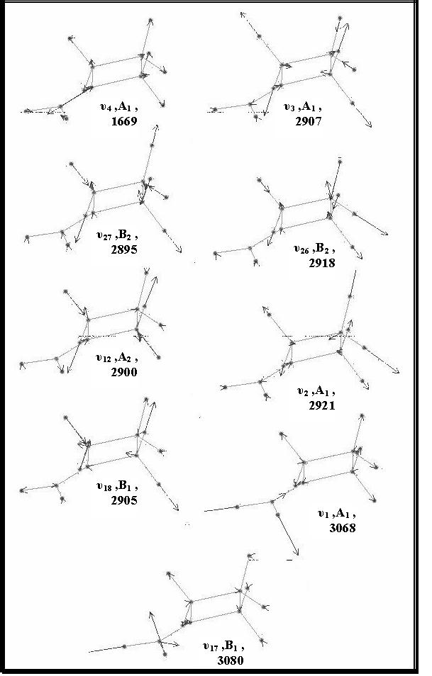

Fig. 2. The graphical representation of some vibration modes of (MCB) molecule as drawn through the DRAW. MOL. routine.

For 1,2- dimethylene cyclobutane, with C_{2V} symmetry (fig.3), the calculated geometry values are listed in table 3. It possess 36 vibration modes. These are classified into the following irreducible representations:

12 A₁ + 7A₂ + 11B₁ + 6B₂

The corresponding scaled frequencies for all these modes are listed in table 4.

Fig. 3: Equilibrium geometry for 1,2-bis (methylene) cyclobutane (DMCB) molecule with C_{2V} symmetry as calculated by MINDO/3- FORCES and PM3 methods.

Table 3. MINDO/3-FORCES calculated geometric parameters of 1.2-bis methylene cyclobutane, length (A°)/ angle (deg.).
THIS WORK |  | OTHER WORK
Bond lengths, angles and Dihedral angles | MINDO/3-FORCES | exptl. [19] |  | Calcd. [20]
(=C-H vinyl)  (C=C)  (C₁-C₂)  (C₁-C₂),(C₂-C₅)  (C₃-C₅)  (C-H ring)  > C₁ C₃ C₅ , > C₂C₅C₃  > C₂ C₁ C₃ , > C₁C₂C₅  > H₇ C₃ H₈ , > H₉C₅H₁₀  > H₇ C₃ C₅ , > H₈C₃C₅  > H₁₁ C₄ H₁₂ , > H₁₃C₆H₁₄  > C₄ C₁ C₂ , > C₆C₂C₁  > C₄ C₁ C₃ , > C₆C₂C₅  > H₁₁ C₄ C₁ , > H₁₂C₄C₁  $ϕ$H₁₂C₄C₁C₂  $ϕ$C₄C₁C₃ C₅  $ϕ$C₁C₂C₅ C₃ | 1.100  1.332  1.518  1.522  1.523  1.114  89.9  90.1  103.9  115.7  110.5  135.6  134.3  125.1  0.0  180.0  0.00 | 1.111  1.343  1.486  1.530  1.575  1.122  ——  91.5  ——  110.3  ——  ——  133.8  123.7  ——  ——  —— | 1.100  1.332  1.518  1.522  1.523  1.114  90.1  ——  104.0  ——  110.5  135.6  ——  ——  ——  ——  ——

Table 4: Calculated vibration frequencies and IR absorption intensities for 1,2-bis methylene-cyclobutane, compared with available experimental frequencies.
Symmetry and description |  | MINDO/3-FORCES |  | PM3 |  | expt.[ ]
In-plane |  | Freq.  cm⁻Scaled | Intensity  A  km/mol | Freq.  cm⁻¹ | Freq.  cm⁻¹
A₁
 | =CH₂ sym.str.(1,2) | 3081 | 44.01 | 3143 | 3080
$$υ_{{}_{2}}$$ | =CH₂ sym.str.(1,2) | 3069 | 13.15 | 3129 | 3065
$$υ_{3}$$ | ring CH₂ sym.str. | 2913 | 88.24 | 3037 | 2925
$$υ_{4}$$ | C=C str. | 1683 | 0.29 | 1902 | 1640
$$υ_{5}$$ | ring str.+ ring $δ$CH₂ (sciss.) | 1390 | 2.46 | 1406 | 1380
$$υ_{6}$$ | $δ$(=CH₂ (sciss.))(1,2) + ring str. | 1416 | 3.81 | 1372 | ——
$$υ_{7}$$ | ring str. + ring$δ$CH₂ (sciss.) | 1266 | 15.89 | 1290 | 1240
$$υ_{8}$$ | ring str. | 1212 | 0.49 | 1259 | ——
 | ring$δ$CH₂ (sciss.) + ring str. | 1136 | 5.83 | 1107 | 1125
 | ring (def.)+ring$δ$CH₂(sciss.) | 939 | 1.74 | 996 | ——
$$υ_{\text{11}}$$ | $δ$(=CH₂(rock.))(1,2)+ring(def.) | 828 | 0.53 | 884 | ——
$$υ_{\text{12}}$$ | $δ$(=CH2(rock.))(1,2)+ring(def.) | 260 | 0.15 | 315 | ——
A₂
$$υ_{\text{13}}$$ | =CH₂ sym.str.(1,2) | 2896 | 0.00 | 3027 | ——
$$υ_{\text{14}}$$ | =CH₂ sym.str.(1,2) | 1046. | 0.00 | 1103 | ——
$$υ_{\text{15}}$$ | ring CH₂ sym.str. | 939. | 0.00 | 997 | ——
$$υ_{\text{16}}$$ | C=C str. | 865. | 0.00 | 923 | ——
$$υ_{\text{17}}$$ | ring str.+ring $δ$CH₂ (sciss.) | 804. | 0.00 | 723 | ——
$$υ_{\text{18}}$$ | $δ$(=CH₂ (sciss.))(1,2) + ring str. | 475. | 0.00 | 531 | ——
$$υ_{\text{19}}$$ | ring str.+ring$δ$CH₂ (sciss.) | 115. | 0.00 | 208 | ——
B₁ | ring str.
$$υ_{\text{20}}$$ | ring$δ$CH₂ (sciss.) + ring str. | 3079. | 34.62 | 3142 | ——
$$υ_{\text{21}}$$ | ring (def.) + ring$δ$CH₂(sciss.) | 3067. | 27.94 | 3120 | ——
$$γ$$ | $δ$(=CH₂(rock.))(1,2)+ring(def.) | 2906. | 50.28 | 3031 | 2890
$$υ_{\text{23}}$$ | $δ$(=CH2(rock.))(1,2)+ring(def.) | 1617. | 0.37 | 1851 | ——

Table 4: Continued

$$υ_{\text{24}}$$ | ring $δ$CH₂ sciss. + ring str. | 1406 | 8.20 | 1362 | ——
$$υ_{\text{25}}$$ | ring $δ$CH₂(sciss.)+ $δ$(=CH₂ (sciss.))(1,2) | 1382 | 0.02 | 1350 | ——
$$υ_{\text{26}}$$ | ring str.+ ring$δ$CH₂(sciss.) | 1233 | 11.60 | 1273 | ——
$$υ_{\text{27}}$$ | ring $δ$CH₂(sciss.) + ring(def.) | 1138 | 2.84 | 1138 | ——
$$υ_{\text{28}}$$ | $δ$=CH₂(rock.)(1,2) + ring(def.) | 876 | 0.00 | 926 | ——
$$υ_{\text{29}}$$ | ring(def.) + CC=C (def.) | 554 | 0.41 | 618 | ——
$$υ_{\text{30}}$$ | ring (def.) + $δ$(=CH₂ (rock.))(1,2) | 403 | 0.81 | 512 | ——
B₂
 | ring CH₂ asym.str.(rock.) | 2909 | 109.30 | 3037 | 2930
$$υ_{\text{32}}$$ | ring$δ$ CH₂(rock.) + ring(puck.) | 970. | 1.97 | 1022 | 950
$$υ_{\text{33}}$$ | $γ$(=CH2(wag.))(1,2) | 870. | 4.07 | 929 | 880
$$υ_{\text{34}}$$ | ring $δ$CH₂(rock.) + ring(puck.) | 717 | 2.75 | 803 | 725
$$υ_{\text{35}}$$ | $γ$(=CH₂(twist.))(1,2)+ring$δ$CH₂(rock.) | 679 | 0.11 | 619 | ——
$$υ_{\text{36}}$$ | $γ$(C=C) + ring(puck.) | 291 | 0.03 | 415 | ——

scaling factors [13]: 0.87 (C=CH₂ str.), 0.85 (ring CH₂ str.), 0.88 (C=C str.), 1.06 (C=CH₂ sciss.), 1.05 (ring CH₂ sciss.), 1.20 (=CH₂ twist.), 1.06 (=CH₂ sciss. + ring str.), 1.05 (ring CH₂ sciss. + ring str.), and 1.00 for others.

Fig. 4. shows the graphical representation of some vibration modes of 1,2-dimethylene cyclobutane C_{2v} as drawn through the DRAW. MOL. routine.

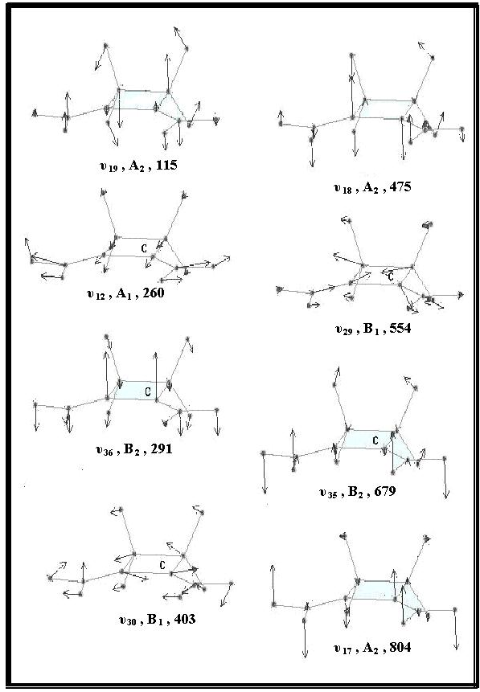

Fig. 4. Graphical representation of some vibration modes of 1.2,bis, methylene cyclobutane as drawn through the DRAW. MOL routine.

As for 1,3-dimethylene cyclobutane(DMCB), D_{2h}, (fig. 5) the calculated geometric values are listed in table 5. Its total number of vibrations (3N-6) is 36. These are classified into the following irreducible representation:

7A_{g} + 3B_{1g} + 3B_{2g} + 5B_{3g} + 2A_{u} + 5B_{1u} + 6B_{2u} + 5B_{3u}

where A_{g,} B_{1g,} B_{2g} and B_{3g} modes are Raman and IR inactive; B_{1u,} B_{2u} and B_{3g} modes are IR active only; and A_{u} mode is Raman and IR inactive, since D_{2h} group includes a center of symmetry; and the rule of mutual exclusion holds. The corresponding scaled frequencies and IR intensities are listed in table 6.

Fig. 5: Equilibrium geometry for 1,3-bis methylene cyclobutane (DMCB) molecule with D_{2h} symmetry as calculated applying both MINDO/3-FORCES and PM3 methods.

Fig. 6 shows the graphical representation of some vibration modes of 1,3-bis methylene cyclobutane as drawn through the DRAW. MOL. routine.

Table 5. MINDO/3-FORCES calculated geometric values of 1,3-bis methylene cyclobutane molecule, length (A°)/ angle (deg.).

THIS WORK |  | OTHER WORK
Bonds length, Bond angles and Dihedral angles | MINDO/3-FORCES | calcd.[20]
(C-H vinyl)  (C-H ring)  (C=C)  (C-C ring)  > C1 C3 C6 , > C1C8C10  > C3 C5 C8 , > C3C1C8  > C1 C3 C5 ,< C1C8C5  > HC1H , <HC5H  > HC=C  > HC6H ,< HC10H  > HC-C  $ϕ$HC=C-C  $ϕ$C=C-C  $ϕ$HC-C-C  $ϕ$C=C-C-C  $ϕ$CCCC ring | 1.100  1.115  1.330  1.521  135.3  90.7  89.3  104.1  124.7  110.5  115.7  0.0  180  119.3  180.0  0.0 | 1.100  1.115  1.330  1.521  ——  ——  89.3  104.0  ——  110.6  ——  ——  ——  ——  ——  ——

Table (6): Calculated vibration and IR absorption frequencies for 1,3-bis methylene cyclobutane (DMCB) molecule, compared with available experimental frequencies.
Symmetry and description |  | MINDO/3-FORCES |  | PM3 | expt.[17]
In-plane |  | Freq.  cm⁻Scaled | Intensity  A  km/mol | Freq.  cm⁻¹ | Freq.  cm⁻¹
A_{g}
 | =CH₂ sym.str. | 3068. | 0.00 | 3131 | ——
$$υ_{{}_{2}}$$ | ring CH₂ sym.str. | 2899 | 0.00 | 3019 | ——
$$υ_{3}$$ | C=C str. | 1693. | 0.00 | 1933 | ——
$$υ_{4}$$ | $δ$=CH₂(sciss.) + ring $δ$CH₂(sciss.) + ring (breathing) | 1436 | 0.00 | 1397 | ——
$$υ_{5}$$ | $δ$=CH₂(sciss.)+ ring$δ$CH₂(sciss.) | 1392. | 0.00 | 1368 | ——
$$υ_{6}$$ | ring (breathing) +ring $δ$CH₂ (sciss.) | 1105 | 0.00 | 1104 | ——
$$υ_{7}$$ | ring (breathing) | 531. | 0.00 | 622 | ——
A_{u}
$$υ_{8}$$ | ring $γ$CH₂(twist.) | 954. | 0.00 | 1016 | ——
 | $γ$(=CH₂(twist.)) | 711. | 0.00 | 687 | ——
B_{1g}
 | ring CH₂ asym.str. | 2891 | 0.00 | 3011 | ——
$$υ_{\text{11}}$$ | ring$γ$CH₂(twist.)+$γ$(=CH₂(twist.)) | 962. | 0.00 | 867 | ——
$$υ_{\text{12}}$$ | $γ$(=CH₂(twist.))+ring$δ$CH₂(rock.) | 664. | 0.00 | 679 | ——
B_{1u}
$$υ_{\text{13}}$$ | =CH₂ sym. Str. | 3068. | 49.74 | 3130 | 3060
$$υ_{\text{14}}$$ | C=C str. | 1650. | 1.60 | 1897 | 1650
$$υ_{\text{15}}$$ | $δ$(=CH₂(sciss.)) + ring(def.) | 1416. | 2.55 | 1390 | ——
$$υ_{\text{16}}$$ | ring$γ$CH₂(wag.)+$δ$(=CH₂(sciss.)) | 1226. | 48.86 | 1277 | 1220
$$υ_{\text{17}}$$ | ring$γ$CH₂(wag.) | 927. | 6.48 | 1009 | ——
B_{2g}
$$υ_{\text{18}}$$ | ring$γ$ CH₂(twist.) + ring(puck.) | 1028. | 0.00 | 1106 | ——
$$υ_{\text{19}}$$ | $γ$(=CH₂(wag.)) | 871. | 0.00 | 953 | ——
$$υ_{\text{20}}$$ | ring(puck.) +$γ$(=CH₂(wag.)) | 379. | 0.00 | 454 | ——

Table 6: Continued

B_{2u}
$$υ_{\text{21}}$$ | =CH₂ asym.str. | 3080. | 82.82 | 3139 | 3070
$$γ$$ | ring CH₂ sym.str. | 2895. | 134.72 | 3028 | 2890
$$υ_{\text{23}}$$ | ring str.+ ring$δ$CH₂(sciss) | 1337. | 18.17 | 1392 | 1330
$$υ_{\text{24}}$$ | ring str.+ ring$δ$CH₂ (sciss.) | 1246. | 1.12 | 1293 | 1235
$$υ_{\text{25}}$$ | $δ$(=CH₂(rock.)) + ring(def.) | 864. | 2.68 | 921 | 860
$$υ_{\text{26}}$$ | ring (def.) + $δ$(=CH₂(rock.)) | 267. | 0.22 | 363 | ——
B_{3g}
$$υ_{\text{27}}$$ | =CH₂ asym. Str. | 3080 | 0.00 | 3140 | ——
$$υ_{\text{28}}$$ | ring str.+ ring $γ$CH₂(wag.) | 1225. | 0.00 | 1276 | ——
$$υ_{\text{29}}$$ | ring $γ$CH₂(wag.) + ring (def.) | 1118. | 0.00 | 1193 | ——
$$υ_{\text{30}}$$ | $δ$(=CH₂(rock.)) + ring$γ$CH₂ (wag.) | 876. | 0.00 | 933 | ——
 | ring (def.) + $δ$(=CH₂(rock.)) | 396. | 0.00 | 467 | ——
B_{3u}
$$υ_{\text{32}}$$ | ring CH₂ asym. Str. | 2891. | 70.88 | 3006 | 2885
$$υ_{\text{33}}$$ | ring (puck.) + ring $δ$CH₂(rock.) | 940. | 940. | 942 | 1008
$$υ_{\text{34}}$$ | $γ$(=CH₂(wag.)) | 868. | 868. | 868 | 923
$$υ_{\text{35}}$$ | ring (puck.) + ring$δ$CH₂ (rock.) | 410. | 410. | 412 | 493
$$υ_{\text{36}}$$ | ring (puck.) +$γ$(=CH₂(wag.)) | 95. | 95. | 97 | 215

scaling factors [13]: 0.87 (C=CH₂ str.), 0.85 (ring CH₂ str.), 0.88 (C=C str.), 1.06 (C=CH₂ sciss.), 1.05 (ring CH₂ sciss.), 1.20 (=CH₂ twist.), 1.06 (=CH₂ sciss. + ring str.), 1.05 (ring CH₂ sciss. + ring str.), and 1.00 for others.

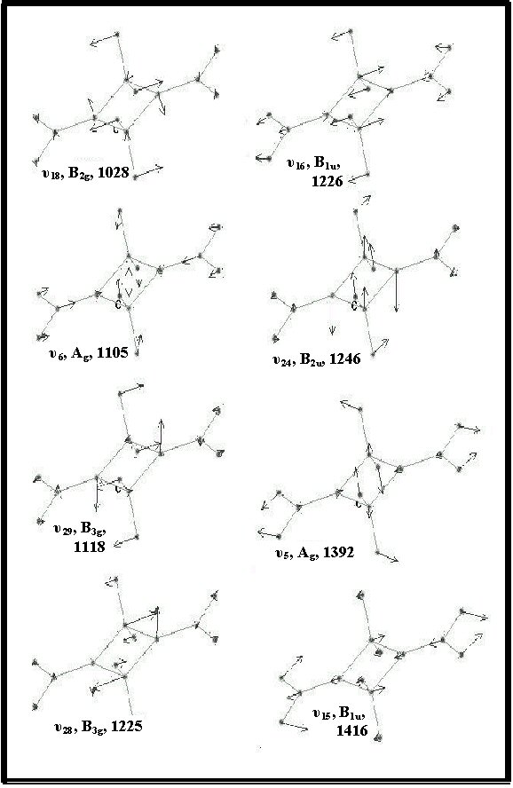

Fig. 6. Graphical representation of some vibration modes of 1.3-bis methylene cyclobutane as drawn through the DRAW. MOL routine.

Finally MINDO/3-FORCES treatment was done for trimethylene cyclobutane, the resulting geometric parameters, C_{2V} symmetry (fig. 7), are listed in table 7. Its 39 fundamental vibrations are classified into the following irreducible representations:

14A₁ + 5A₂ + 12B₁ + 8B₂

Its corresponding scaled frequencies and IR absorption intensities as yielded by the MINDO/3-FORCES treatment are listed in table 8.

Fig. 7: Equilibrium geometry for 1, 2, 3 -Tis (methylene) cyclobutane (TMCB) molecule with C_{2V} symmetry as calculated by MINDO/3- FORCES and PM3 methods.

Figure 8 shows the graphical representation of some vibration modes of 1,2,3 tri- methylene cyclobutane molecule as drawn through the DRAW. MOL. routine.

Table 8. MINDO/3-FORCES calculated geometric parameters of 1,2,3-tris methylene cyclobutane, length (A°)/angle (deg.).

Bonds length, bond angles and Dihedral angles. | MINDO/3-FORCES
(=C-H)  (C₆-H₈),(C₆-H₉)  (C₁-C),(C₁-C₃)  (C₃-C₆),(C₂-C₆)  (C₂=C₅),(C₃=C₇)  (C₁=C₄)  > H₁₄ C₅ H₁₅ , > H₁₁C₇H₁₀  >H₁₄ C₅ C₂ , >H₁₅C₅C_{2 ,}> H₁₀ C₇ C₃ ,> H₁₁C₇C₃  C₅C₂C₁ >, < C₇ C₃ C₁ , < C₅ C₂ C₆ ,< C₇C₃C₆  > H₈C₆ H₉  > H₈ C₆ C₂ , > H₉C₆C₃  > C₁ C₂ C₆ , > C₁C₃C₆  > C₂ C₁ C₃ , > C₂C₆C₃  $ϕ$H₈C₆C₂C₅  $ϕ$H₈C₆C₃C₇  $ϕ$CCCC ring  $ϕ$C₁C₂C₆H₉ | 1.100  1.115  1.518  1.520  1.332  1.334  110.5  125.1  134.8  103.9  115.8  89.7  90.2  60.7  -60.7  0.00  118.8

Table (8: Calculated vibration and IR absorption frequencies for 1,2,3 tris metlenecyclobutane (DMBC) molecule, compared with available experimental frequencies.

Symmetry and description |  | MINDO/3-FORCES |  | PM3 | expt.[21]
In-plane |  | Freq.  cm⁻Scaled | Intensity  A  km/mol | Freq.  cm⁻¹ | Freq.  cm⁻¹
A₁
 | =CH₂ asym.str.(2,3) | 3080 | 76.051 | 3145 | 3075
$$υ_{{}_{2}}$$ | =CH₂ sym. str. (1,2,3) | 3070 | 4.47 | 3137 | -------
$$υ_{3}$$ | =CH₂ sym. str. (1,2,3) | 3067 | 14.93 | 3133 | -------
$$υ_{4}$$ | ring CH₂ sym. str. | 2900 | 67.375 | 3088 | 2890
$$υ_{5}$$ | ( C=C) str. (1,2,3) | 1703 | 0.04 | 1920 | -------
$$υ_{6}$$ | ( C=C) str. (1) | 1603 | 0.14 | 1805 | -------
$$υ_{7}$$ | ring $δ$CH₂ (sciss.) | 1420 | 3.68 | 1386 | -------
$$υ_{8}$$ | $δ$(=CH₂(sciss.)) (1) | 1413 | 10.65 | 1322 | -------
 | $δ$(=CH₂ (sciss.))(1,2,3) +ring $δ$CH₂ (sciss.) | 1390 | 0.02 | 1305 | -------
 | ring str.+ ring $δ$ CH₂ (sciss.) | 1208 | 1.04 | 1231 | -------
$$υ_{\text{11}}$$ | ring ( def.)+$δ$(=CH₂ (rock.)) (2,3) | 940 | 0.22 | 953 | -------
$$υ_{\text{12}}$$ | $δ$( =CH₂ (rock.)) (2,3) +ring (def.) | 826 | 1.42 | 850 | -------
$$υ_{\text{13}}$$ | ring breathing | 517 | 0.21 | 633 | -------
$$υ_{\text{14}}$$ | $δ$(=CH₂(rock.)) (2,3 )+ring (def.) | 268 | 0.33 | 264 | -------
A₂ |  |  |  |  | -------
$$υ_{\text{15}}$$ | ring $γ$CH₂(twist.) | 992 | 0.00 | 1032 | -------
$$υ_{\text{16}}$$ | $γ$(=CH₂(wag. )) (2,3) | 867 | 0.00 | 984 | -------
$$υ_{\text{17}}$$ | $γ$(=CH₂ ( twist.)) (1) +ring (puck.) | 786 | 0.00 | 670 | -------
$$υ_{\text{18}}$$ | $γ$(=CH₂ (twist.)) (1,2,3) | 681 | 0.00 | 592 | -------
$$υ_{\text{19}}$$ | ring ( puck .) +$γ$(=CH₂(twist.)) | 364 | 0.00 | 384 | -------
B₁ |  |  |  |  | -------
$$υ_{\text{20}}$$ | = CH₂ asym. str. (1,2,3) | 3081 | 25.41 | 3145 | -------
$$υ_{\text{21}}$$ | =CH₂ asym. str. (1, 2,3) | 3079 | 10.99 | 3144 | -------
$$γ$$ | =CH₂ sym. str. (2,3) | 3068 | 46.68 | 3136 | -------

Table 8:Continued

$$υ_{\text{23}}$$ | C=C str.(2,3) | 1633 | 0.89 | 1720 | 1644
$$υ_{\text{24}}$$ | $δ$(=CH₂(sciss.))(2,3) | 1413 | 7.41 | 1324 | -------
$$υ_{\text{25}}$$ | $γ$(=CH₂(twist.)) | 1224 | 11.28 | 1229 | -------
$$υ_{\text{26}}$$ | ring str. +ring$γ$CH₂ (wag.) | 1181 | 9.79 | 1211 | -------
$$υ_{\text{27}}$$ | ring (def.) +ring $γ$CH₂ (wag.) +$δ$( =CH₂ (rock.) ) (1,2,3) | 1034 | 1.14 | 1080 | -------
$$υ_{\text{28}}$$ | $δ$(=CH₂( rock.)) (2,3) +ring$γ$CH₂ ( wag.) | 886 | 0.73 | 878 | -------
$$υ_{\text{29}}$$ | $δ$(=CH₂( rock.))(1) | 829 | 0.20 | 851 | -------
$$υ_{\text{30}}$$ | ring (def.) +$δ$(=CH₂( rock. ))(1,2,3) | 456 | 0.74 | 485 | -------
 | $δ$(=CH₂( rock.))(1,2,3) | 258 | 0.15 | 237 | -------
B₂ |  |  |  |  | -------
$$υ_{\text{32}}$$ | ring CH₂ asym. str. | 2893 | 64.12 | 3031 | -------
$$υ_{\text{33}}$$ | ring $δ$CH₂ (rock.) + ring(puck.) | 903 | 5.43 | 1035 | -------
$$υ_{\text{34}}$$ | $γ$(=CH₂ (wag.))(1) | 868 | 5.92 | 1007 | 865
$$υ_{\text{35}}$$ | $γ$(=CH₂ (wag.)) (1,2,3) +ring$δ$CH₂ (rock.) | 855 | 0.35 | 954 | -------
$$υ_{\text{36}}$$ | ring (puck.)+ $γ$(=CH₂(twist.)) (2,3) | 694 | 0.06 | 727 | -------
$$υ_{\text{37}}$$ | ring $δ$CH₂ (rock.)+ $γ$(=CH₂( twist.)) (2,3) | 504 | 0.06 | 559 | -------
$$υ_{\text{38}}$$ | ring (puck.) +$γ$(=CH₂ (wag.)) (1,2,3) | 261 | 0.05 | 272 | -------
$$υ_{\text{39}}$$ | ring (puck.) +ring $δ$CH₂ (sciss.) + $γ$(=CH₂ (wag.)) (1,2,3) | 77 | 0.00 | 106 | -------

scaling factors [13]: 0.87 (C=CH₂ str.), 0.85 (ring CH₂ str.), 0.88 (C=C str.), 1.06 (C=CH₂ sciss.), 1.05 (ring CH₂ sciss.), 1.20 (=CH₂ twist.), 1.06 (=CH₂ sciss. + ring str.), 1.05 (ring CH₂ sciss. + ring str.).

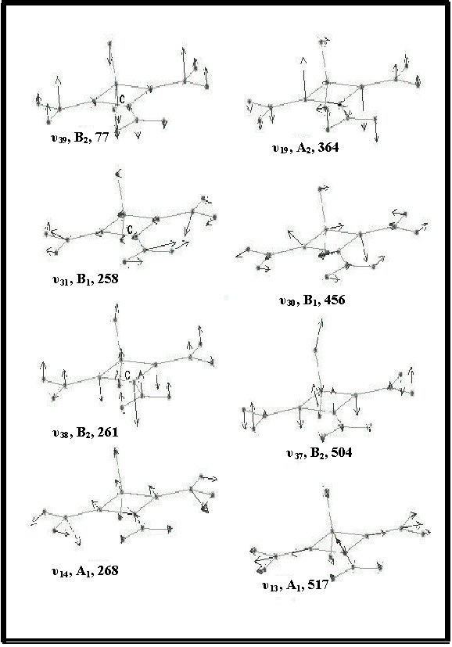

Fig. 8. Graphical representation of some vibration modes of 1,2,3-trimethylene cyclobutane as drawn through the DRAW. MOL routine.

Inspection of the frequency values in table 2, 4, 6 and 8 indicates that all four molecules show the following common relations;

νasym(=CH₂ str.)> νsym (=CH₂ str.)
νsym (ring CH₂ str.) > νasym (ring CH₂ str.)
δ (=CH₂ (sciss.)) > δ (=CH₂ (rock.))
γ (=CH₂ (wag.)) > γ (=CH₂ (twist.))

It was further found that;

- the (=CH₂) stretching vibrations are unaffected by the number of methylene groups.
- the ring CH₂ vibrations depend on the number of methylene groups as follows:

a. ring CH₂ sym. str. > ring CH₂ sym. str. > ring CH₂ sym. str.
1,2-DMCB MCB TMCB
2913 cm⁻¹ 2905cm⁻¹ 2900 cm⁻¹
and
ring CH₂ sym. str. > ring CH₂ sym. str.
1,2-DMCB 1,3-DMCB
2913 cm⁻¹ 2895cm⁻¹

b. ring CH₂ asym. str. > ring CH₂ asym. str. > ring CH₂ asym. str.
MCB 1,2-DMCB TMCB
2918 cm⁻¹ 2910 cm⁻¹ 2893 cm⁻¹
and
ring CH₂ asym. str. > ring CH₂ asym. str.
1,2-DMCB 1,3-DMCB
2910 cm⁻¹ 2891 cm⁻¹

3-The asym. ringCH₂ stretching frequency decreases as the number of the exo- methylene groups increases.
4- The C=C stretching frequency decreases as the number of the same methylene groups increases;

C=C str. > C=C str. > C=C str.
MCB 1,3-DMCB TMCB
1669 cm⁻¹ 1650 cm⁻¹ 1633 cm⁻¹

the C=C stretching vibration frequency of 1,2-DMCB showing the lowest values 1617 cm⁻¹.

5-The ring stretching frequency decreases as the number of methylene groups increases:

ring str. > ring str. > ring str.
MCB 1,2-DMCB TMCB
1274 cm⁻¹ 1266 cm⁻¹ 1225 cm-¹

the ring stretching frequency of 1,3-DMCB showing the highest value 1337cm⁻¹.

The =CH₂ bending frequency decreases as the number of methylene groups increases:

a. δ(=CH₂ (sciss.)) > δ(=CH₂ sciss.)) ; δ(=CH₂ sciss.)) > δ(=CH₂ (sciss.))
MCB 1,3-DMCB 1,2-DMCB TMCB
1422 cm⁻¹ 1417 cm⁻¹ 1416 cm-¹ 1413 cm-¹
b. δ(=CH₂ (rock.)) > δ(=CH₂ (rock.)) > δ(=CH₂ (rock.))
MCB 1,2-DMCB TMCB
868 cm⁻¹ 828 cm⁻¹ 826 cm-¹
and
δ(=CH₂ (rock.)) > δ(=CH₂ (rock.))
1,3-DMCB 1,2-DMCB
864 cm⁻¹ 828 cm⁻¹

The reason for these sequences may be attributed to the crowding strain which makes the scissoring or rocking motion in the same plane more difficult as the number of methylene groups increases.

6-The CH₂ bending vibration frequency increases as the number of methylene groups increases:

ring δ(CH₂ (sciss.)) > ring δ(CH₂ sciss.)) > ring δ(CH₂ (sciss.))
TMCB 1,2-DMCB MCB
1421cm⁻¹ 1406 cm⁻¹ 1338 cm-¹
and
ring δ(CH₂ (rock.)) > ring δ(CH₂ (rock.)) > ring δ(CH₂ (rock.))
TMCB 1,2-DMCB MCB
903 cm⁻¹ 717 cm⁻¹ 692 cm⁻¹

the ring CH₂ rocking frequency of 1,3-DMCB shows the highest value 940 cm⁻¹.

Acknowledgement
The authors thank Prof. Dr. M. Shanshal for allowing them to use his computational facilities usefull discussion of the results.

References
- S. Schömaker and J.R.Fisher , J.Am.Chem.Soc., 1944, 66 ,636.
- T.B.Malloy , JR.F.Fischer and R.M.Hedges, J.Chem .Phys.,1970, 52(10), 5325.

- A. Skancke, P. N. Skancke, Eckert-Maksic, Z. Maksic B. Theochem, 1987, 35 (3-4), 259, (Eng.).
- A. T. Blomquist and J. A. Verdol, J. Am . Chem. Soc.,1956, 78 ,109.
- J.K.Williams and W.H.Sharkey ,J.Am .Chem. Soc., 1959, 81, 4269.
- R. C. Bingham, M. J. S. Dewar and D. H. LC, J. Am. Chem. Soc., 1975, 97, 1285, 1294, 1302, 1307.
7- L. Montgomery, C. A. Wilson and J. D. Wieeser, S. Mol. Struct., 129, 69-79 (1985).
8- A) D. H. Abed and M. Shanshal, Arbeitsberich Des Institüts FürTheoretische Chemie, Stüttgart,1990, 27, 389. B)-D. H. Abed, S. F. Al-Saidi and M. Shanshal, Chim. Acta Turc., 1995, 23, 7.
9- P. Pulay, Mo . phys., 1969, 17,197.
10- E. B. Wilson, Ir., J. C. Decius, P. C. Cross, “ Molecular Vibration”, Mc Graw-Hill, New York, (1955).
11- D. H. Abed, M. B. Mammo, S. F. Al-Saidi and M. Shanshal, Iraqi, J. Sci., 1990, 9(31) , 539.
12- M. Shanshal, Z. Naturforsch, 28a, 1892 (1975).
13-R.C.Bingham,M.J.S.Dewar and D.H.LC,J.Am.Chem.Soc., 1975, 97,1285, 1294, 1302, 1307.
14- R. Leach Andrew, “Molecular Modelling Principles and Applications” , Second Edition , Prentice Hall , London,(2001).
15- R.M.Kubba , Z.Naturforsc., 2001, 56a ,505.
16- G. Davidson, “Introductory Group Theory For Chemists”, Applied Science Publishers Ltd. London ,Elsevier Publishing Comp. Ltd., (1990).
17- a: N. L. Allinger ,V. S. Mastyukov. Zk. Struct. khim., 1983, 24 ,172. b: M.Eckert–Maksic, Z. B. Maksic, A. Skancke and P. N. Skancke, J. Phys. Chem.,1987, 91, 2786.
18- A. I. D′yachenko and M. Yu. Lukina , Izv-Akad. Sauer. Nauk SSSR, 1966, Ser. Khim (12), 2237,(Russ).
19- LAWRENCE. MONTGOMERY, CRAIG. A.WILSON and JOHN D. WIESER , J. Mol. Struct., 1985, 129, 69.
20- P. Hemmersbach, M. Klessinger and P. Bruckmann , J. Am. Chem. Soc., 1978, 100, 6344.
21- J. K. Williams and W. H. Sharkey, J. Am .Chem. Soc., 1959, 81, 4269.

