Spectrophotometric Determination of Catechol Amine Drugs in Pharmaceutical Preparations via Oxidative Coupling Reaction with 3-Amino Pyridine and Sodium Periodate

Mouayed Q. Al-Abachi and Muneer A. Al-Da'amy
Department of Chemistry /College of Science / University of Baghdad
Baghdad – Iraq

(NJC)

(Received on 13/12 /2004) (Accepted for publication on 22/ 6/2005)

Abstract
A rapid and sensitive spectrophotometric method is described for the determination of some Catechol amine drugs (methyldopa (I), adrenaline (II), and dopamine (III)) in both pure and dosage forms. The proposed method uses 3-amino pyridine as a chromogenic reagent. The method is based on the oxidative coupling reaction of Catechol amine drugs with 3-amino pyridine and sodium periodate to form an orange-water-soluble dye product, that has a maximum absorption at 476, 488 and 490 nm for (I), (II), and (III) respectively. The optimum reaction conditions and other analytical parameter are evaluated. The proposed method was applied successfully to the determination of these drugs in pharmaceutical formulation. The results have demonstrated that the method is equally accurate and reproducible as the official methods.
الخلاصة
يتضمن البحث اقتراح طريقة طيفية سريعة وحساسة لتقدير ادوية الكاتيكول امين في المستحضرات الصيدلانية. تعتمد الطريقة على تفاعل الازدواج التأكسدي بين هذه الادوية والكاشف العضوي الـ 3-امينو بردين بوجود بيرايودات الصوديوم حيث يعطي ناتج برتقالي ذائب في الماء وله اعلى امتصاص عند طول موجي 476، 488 و 490 نانوميتر نسبة الى المثيل دوبا ( I )، الادرينالين (II) والدوبامين ( III) على التوالي. طبقت الطريقة المقترحة بنجاح لتقدير ادوية الكاتيكول امين في المستحضرات الصيدلانية.

Key words: Methyl dopa, Adrenaline, Dopamine, Spectrophotometry.

Introduction
Catechol amines have been determined by visible spectrophotometry after reaction with meta periodate⁽¹⁾, Chloranil and Fluranil⁽²⁾, Fe(III) and O-phenanthroline⁽³⁾, palladium chloride⁽⁴⁾, ammonium meta vanadate ⁽⁵⁾ and isoniazid in the presence of N-Bromo succinimide⁽⁶⁾. Oxidative coupling organic reactions seem to be one of the most suitable spectrophotometric determination of drugs such as Sulphonamides⁽⁷⁾, Paracetmole⁽⁸⁾, Methyl dopa⁽⁹⁾, Folic acid⁽¹⁰⁾ and Phenylphrine.Hcl⁽¹¹⁾. The present investigated describes a simple and sensitive method for the determination of some Catechol amine drugs (Methyl dopa (I), Adrenaline (II), and Dopamine (III)) in both pure and dosage forms. The proposed method is based on the reaction of the Catechol amine drugs with 3-amino pyridine in the presence of sodium periodate and in neutral medium to form an intense orange colored product which shows an absorption maximum at 476, 488 and 490 nm for (I), (II) and (III) respectively.

Experimental
Apparatus
A shimadzu 260 uv-visible spectrophotometer with a 1 cm matched quartz cell were used for all absorbance measurements.
Reagent
All chemicals used were of analytical reagent grade unless otherwise stated, Methyl dopa standard powder material was provided from state company for drug industries and medical appliances Sammara-Iraq (SDI).
Aldomate tablets were provided from SDI and ASIA (Jordanian Drug Company). The Adrenaline pure drug was obtained from Rhone pulence Company/ France. Where as the injections (1mg/1ml) were from life pharma - Italy.
The Dopamine pure drug and the injection samples (200mg/25 ml) were obtained from biological Italy- LAB.
Methyl dopa stock solution (1000μg.ml⁻¹):
0.1000 gm of Methyl dopa was dissolved in 100ml of distilled water in a volumetric flask of 100ml.

Adrenaline stock solution (1000μg.ml⁻¹):
0.1000 gm of Adrenaline was dissolved in 10ml of ethanol and completed the volume to 100ml with distilled water in a volumetric flask of 100ml.
Dopamine.HCL stock solution (1000μg.ml⁻¹):
2.5ml of (200mg/5ml)solution was diluted to 100ml of distilled water in a volumetric flask of 100ml.
3-Amino pyridine (0.1M):
0.9400gm of 3-amino pyridine was dissolved in 10ml of ethanol and completed the volume to 100ml with distilled water in a volumetric flask of 100ml.
Sodium periodate (0.1M):
5.2400gm of sodium periodate was dissolved in 250ml of distilled water in a volumetric flask of 250ml.
Results and discussion
Catechol amine drugs reacts with 3-amino pyridine in the presence of sodium periodate and in neutral media to form an intense orange colored product that can be measured at 476, 488 and 490 nm for (I), (II) and (III) respectively (Fig.1,2,3). The absorbance of the orange-red dye is directly related to the concentration of the Catechol amine drugs and that can be used for its spectrophotometric determination. The development of the colored products depends on the reaction conditions and were optimized as follows:
Effect of the 3-amino pyridine concentration:
When various concentration of 3-amino pyridine solution were added to fixed amount of the drug solution. A concentration of (0.005, 0.001 and 0.0025 M) for Methyl dopa, Adrenaline and Dopamine respectively was found enough to develop the colour to its full intensity and give a minimum blank value and was considered to be optimum.
Effect of oxidant concentration:
The product formation reached maximum about (0.00075, 0.00075 and 0.001 M) for Methyl dopa, Adrenaline and Dopamine respectively was found enough to develop the colour to its full intensity and give a minimum blank value and was considered to be optimum.

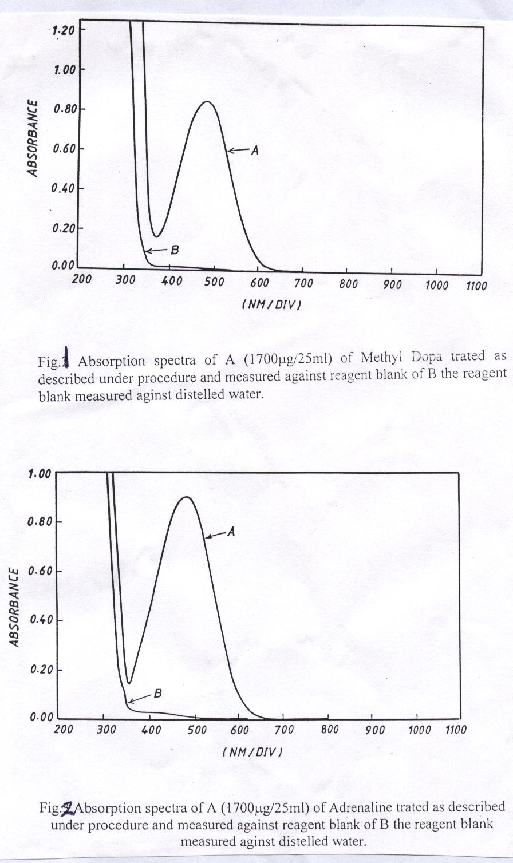
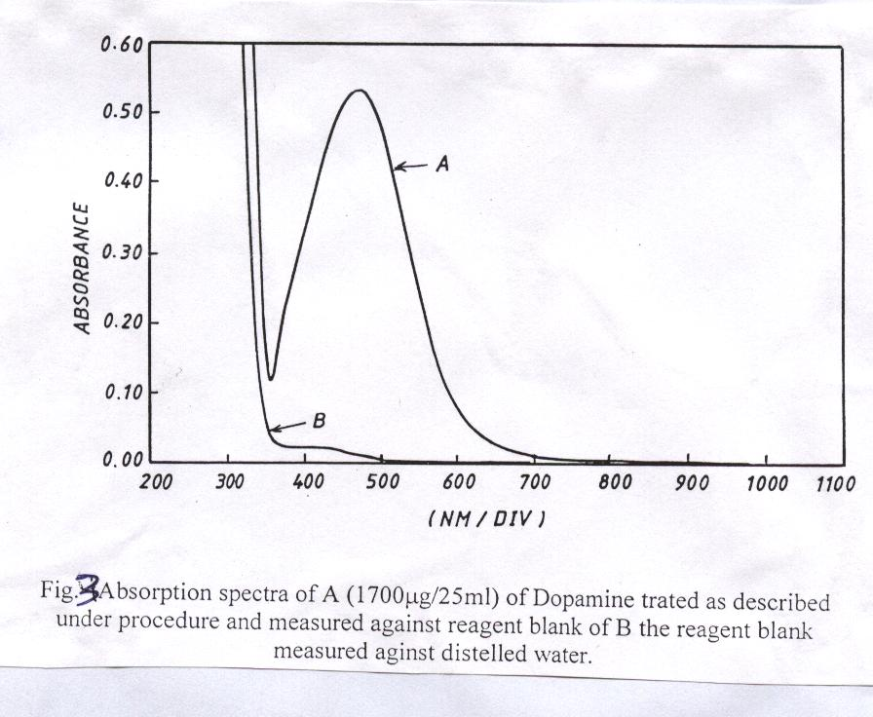

Effect of order of addition:
To obtained optimum results, the order of the addition given as addition of reagent, oxidant and then addition of drug give high sensitivity.
Effect of reaction time:
The colour intensity reached a maximum after Catechol amine drug solution had been reacted immediately with sodium periodate and 3-amino pyridine and became stable after 10 min., therefore 10 min. development time was selected as optimum in the general procedure. The colour obtained was stable for 120 min..

Effect of temperature:
The effect of temperature on the colour intensity of the product was studied. In practice the same absorbance was obtained when the colour was developed at room temperature (25°C) but when the calibrated flask was placed in an ice-bath at (10°C) or in a water-bath at (40°C) a loss in colour intensity and stability were observed, it is therefore recommended that the colour reaction should be carried out at room temperature (25°C).

Calibration Curve:
Under the optimum condition a linear calibration graphs Fig.4 was obtained over the concentration range of (1-40, 1-40 and 1-20 μg.ml⁻¹) for Methyl dopa, Adrenaline and Dopamine respectively. The limit of detections (signal/noise=3) were (0.24, 0.34 and 0.30 μg.ml⁻¹) and the correlation coefficients were 0.9997, 0.9998 and 0.9998 for Methyl dopa, Adrenaline and Dopamine respectively. The relative standard deviation of the method was better than 1.25%.
Nature of the dye product:
The stoichiometry of the reaction between Catechol amine and 3-amino pyridine was investigated using the molar ratio method⁽⁹⁾ under the optimized conditions. The results obtained (Fig.5), show a 1:1 drugs to reagent product was formed. The formation of the dye may probable be occur as follows:

R
OH
OH +
Catechol amine drugs
3-amino pyridine
H₂N
N
Sodium periodate
N
N
R
OH
O
Colour product

Where:
R= -CH₂CCH₃NH₂COOH for Methyl dopa.
R= -CHOHCH₂NHCH₃ for Adrenaline.
R= -CH₂CH₂NH₂ for Dopamine.

Analytical applications:
The proposed method was applied for the determination of Catechol amine drugs (Methyl dopa, Adrenaline and Dopamine) in pharmaceutical preparations. Good accuracy and precision were obtained for the studied drugs. The results obtained were given in Table 1 which confirm the applicability of the method. Finally, the proposed method was compared successfully with the standard method (Table 1).

Table 1: the application of the proposed method for the determination of Catechol amine drugs in pharmaceutical preparations.
Sample | Amount of drugs  Taken μg.ml⁻¹ | RSD % * | Recovery %
Sample | Amount of drugs  Taken μg.ml⁻¹ | RSD % * | Proposed  method | Standard  method*
Pure Methyl dopa | 20 | 0.44 | 100.40 | 101.17
Aldomate-SDI | 20 | 0.46 | 100.60 | 101.17
Aldomate-ASIA | 20 | 0.48 | 99.50 | 101.17
Pure Adrenaline | 20 | 0.84 | 100.90 | 100
Ampoules Adrenaline | 20 | 0.86 | 99.16 | 100
Ampoules Adrenaline | 40 | 0.43 | 100.40 | 100
Pure Dopamine | 10 | 0.78 | 99.22 | 102.5
Ampoules Dopamine.HCL | 10 | 0.79 | 99.21 | 102.5
Ampoules Dopamine.HCL | 20 | 0.38 | 99.64 | 102.5
* average of three determination.
* U.S.P standard method⁽¹²⁾.

Conclusions
A simple accurate and sensitive Spectrophotometric method for the determination of Catechol amine drugs in pharmaceutical preparation has been investigated. The method needs neither temperature nor pH control. This method compare with the standard method using U.S.P standard method.

Y=0.0109X-0.0016
R²=0.9995
Y=0.013X-.0018
R²=0.9997
Y=0.006X-0.0015
R²=0.9996

Fig. 4 Calibration graph of Catechol amine drugs

Fig. 5 Molar ratio of drug to reagent

References
- EI-Kommos, E.M., Mohamed, F.A., and Khedr, S.A., J. Assoc. of F. Anal-Chem., 1990, 73, 516.
- Al-Ghabsha, T.S., Al-Sabha, T.N., and Saleem, M.S., J. Techn. Res., 1994, 19, 49.
- Issopoulos, P.B., Fresenius, J. Anal. Chem., 1990, 336, 124.
- Zivanovic, L., Vasiljevic, M. and Kustrin, J. Pharm. Biomed. Anal., 1991, 9, 1157.
- San, R. T., Bhousule, G. I., and Sawant, S. V., Indian drugs, 1987, 24, 207.
- Nagaraja, P., Srinivasa Murthy, K. C., Rangappa, K. S. and Made Grouda, N. M., Talanta, 1998, 46, 39.
- Al-Abachi, M. Q., Salih E. S., Al-Ghabsha, T. S., Microchemical Journal, 1990, 41, 64.
- Al-Abachi, M. Q., Al-Ward, H. S., National Journal of Chemistry, 2001, 4, 548.
- Al-Abachi, M. Q., Farid, Y. Y., and Hamza, M. J., National Journal of Chemistry, 2002, 8, 520.
- Al-Abachi, M. Q., and Al-abudi, R. S., National Journal of Chemistry, 2002, 8, 527.
- Al-Abachi, M. Q., Hassan, M. J., and Mustafa, M. A., National Journal of Chemistry, 2003, 9, 79.
- U. S. Pharmacopia and National Kormulary, U.S.P. 24(2000).

