Photoprocesses Behavior Of Some Biologically Active
Bis-Oxadiazole Compounds

Abida I. Al-Elewi
Chemistry Dep., Education- Ibn-Al-Haitham College,
Baghdad University
Safaa S. Omar**
Chemistry Dept., Science College for Women, Baghdad Univ.
Jadairia, Baghdad.

key words : Fluorescence, Excitation, Quenching, Complex, Intersystem crossing
** Author for correspondence

(NJC)

(Received on 5/6 /2004) (Accepted for publication on 22/6/2005)

Abstract
The behavior of the absorption and fluorescence emission processes for some bis-1, 3, 4-oxadiazole sulphonyl compounds were studied in toluene, ethanol and di-methyl sulfoxide solvents. Fluorescence quenching processes of the compound bis- [2, 2/-5 ethyl sulphonyl-1, 3,4-oxadiazole]-1,4-butane, (4-Et), in toluene and ethanol using benzonitrile and benzophenone quenchers were studied too. The complex quenching mechanism of 4-Et by benzophenone, according to the obtained data, was proposed.
الخلاصه
سلوك عمليات الأمتصاص والأنبعاث الضوئي لعدد من مركبات 4,3,1, -أوكسادايزول سلفون قد تمت دراسته في مذيبات التولوين ، الأيثانول وثنائي مثيل سلفوكسايد .كما درست عمليات تثبيط فلورة المركب ثنائي ] 2⁻2 - 5 –أثيل سلفونيل- 4,3,1 –أوكسادايزول [ -4,1 بيوتان، ( 4-Et )، في مذيب الأيثانول بأستعمال مثبط البنزوفينون ، وفي مذيب التولوين مع المثبط- البنزونايترايل . وفي ضوء النتائج المستحصله من التثبيط تم اقتراح ميكانيكيه لعملية تثبيط فلورة المركب ( 4-Et ) عند تسحيحه بمحلول البنزوفينون .

Introduction
1, 3, 4-oxadiazole compounds received a growing interest due to their bactericidal, fungicia and other activities ^{(1,2)}. A great number of 1,3,4- oxadiazole derivatives have been synthesized and tested for their biological activities ^{(3,4)} .The fluorescence and absorption behavior of some of these compounds were investigated in different solvents ⁵. The structural and substitution effects on the Photoprocesses were investigated, as well as their fluorescence self-quenching process and the singlet excited state energy ^{6,7}. A new derivatives of the bis-1, 3,4-oxadiazole sulphones were synthesized. These are bis [2,2/-(5-alkyl sulphonyl-1, 3,4-oxadiazole)]-1,4-butane and bis [2,2/-(5-alkyl sulphonyl-1, 3,4-oxadiazole)]-1,8-octane .⁸
In this work our interest is to study the change in the behavior of the absorption and fluorescence of these new compounds in the absence and presence of quenchers in various solvents.

Experimental
Materials: The sulphonyl oxadiazole compounds and their derivatives were synthesized and their physical properties were studied. These derivatives were a generous gift of Prof...M.Mahmoud and I.F.Mustafa (Chem. Dept., Ibn Al-Haitham college of education) and shown in Figure-1- are :
1- Bis [2, 2/-5-methyl sulphonyl-1, 3, 4-oxadiazole] - 1, 4- butane ; (4- Me)
2- Bis [ 2,2/-5-ethyl sulphonyl-1,3,4-oxadiazole ]-1,4-butane ; ( 4- Et )
3- Bis [ 2,2/-5-benzoyl sulphonyl-1,3,4-oxadiazole ]-1,4- butane ; ( 4- Ben. )
4- Bis [2, 2/-5-methyl sulphonyl-1, 3, 4-oxadiazole] –1,8- octane ; (8- Me )
5- Bis [2, 2/-5- ethyl sulphonyl-1, 3, 4-oxadiazole] –1, 8 –octane ; (8 – ET)

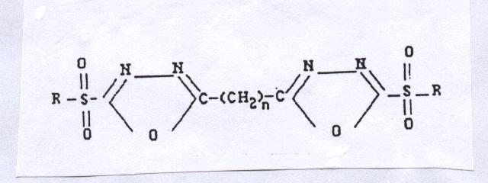

Figure-1- Structure of the Bis-Oxadiazole compounds ;
4-Me , 2 – 4-Et , 3 – 4-Ben , 4 – 8-ME , 5 – 8-Et .
1 - n = 4 , R = CH₃
2 - n = 4 , R= C₂H₅
3 - n = 4 , R= CH₂ –ph
4 - n = 8 , R = CH₃
5 – n= 8 , R = C₂H₅

Toluene, ethanol (spectroscopic) and DMSO solvents from BDH are used with out further purification. Benzophenone and benzonitrile are used as quenchers of oxadiazole fluorescence.
Spectroscopic measurements: Fluorescence excitation spectra, fluorescence emission spectra and fluorescence quenching measurements are carried out using JASCO –770 specrofluorometer at room temperature . The solutions used are of concentrations of 10 ^{–3} and 10 ^{–4}M for absorption and fluorescence measurements respectively .Fluorescence quenching data are treated using Stern-Volmer equation:

Fo / F = 1 + K_{SV} [Q ]
Where Fo & F are the fluorescence intensity of the compounds in the absence and presence of quencher. K_{sv} is the Stern-Volmer rate constant and is equal to k _{q} τ ; k _{q} is the quenching rate constant, τ is the life time of the singlet excited state. [Q] is the quencher concentration.

Results and Discussion
Excitation processes
Table-1- explores the spectroscopic data of the excitation wavelength of the maximum absorption of the oxadiazole compounds in toluene, ethanol and DMSO solvents. In toluene the maximum peak is red shifted in changing the alkyl group in the 5- position from methyl to ethyl to benzyl as shown in Figure2-. This substitution effect in observed clearly in the variation of the energy of the first excited singlet state E_{S1} for the studied compounds listed in Table-2- . The energy of the S₁ state (nπ*) decreases as we change the end group from CH₃ to C₂H₅ to CH₂C₆H₅.

Table 1: Excitation wavelength (nm) of the bis-Oxadiazole compounds in different solvents

Compound | Toluene λ _{ext} nm | Ethanol λ _{ext} nm | DMSO λ _{ext} nm
4-Me | 290 | 298 | 309
4-Et | 310 | 294 | 312
4-Ben | 338 | 333 | ----------
8-Me | 355 | 295 | ----------
4-Et | 315 | 291 | -------

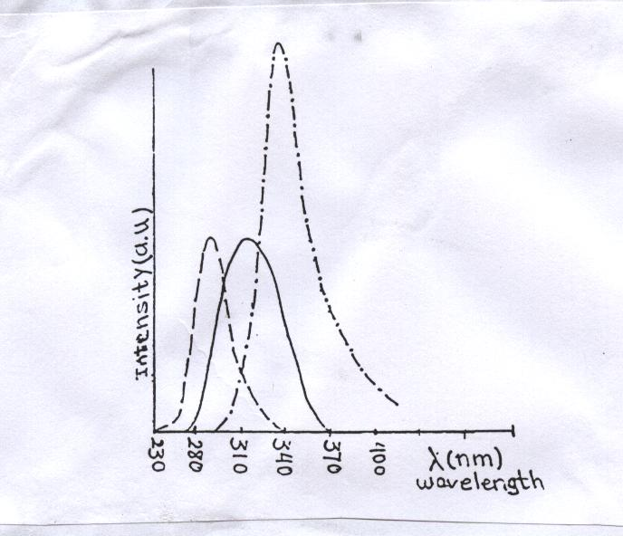

Fig.2. Excitation spectra of bis-oxadiazole compounds in toluene,
------- 4-Me; ______ 4-Et; -.-.-.-.- 4-Be

Table 2: Singlet excited state energy E_{S1} (kJ/ mol )of the compounds in various solvents.

Compound | Toluene | Ethanol | DMSO
4-Me | 364.82 | 345.84 | 373.94
4-Et | 346.84 | 342.85 | 371.62
4-Ben | 341.89 | 336.13 | -------
8-Me | 332.93 | 349.89 | -------
8-Et | 357.2 | 347.85 | -------

It is interesting to note that increasing the chain length between the oxadiazole rings from n= 4 to n = 8 results in the opposite effect of the substituent. This may indicate the clear affect of the CH₂ chain on the energy of S₁ state in toluene solvent due to the possible orientation motion occur in the long chain compounds ( n = 8 ) which leads to many interactions such as intermolecular interactions (ie Van der walls ) between CH₃ or C₂H₅ groups and the neighboring sulphonyl part of the molecule . For the 8-Me compound, the E_{S1} is lower than that of 8-Et compound (Figure-3).
The picture of the excitation spectra and S₁ energy of these compounds in ethanol solvent is different; (a) there are more than one peak for the compounds 4-Me and 4-Et and 4- Ben, with a low intensity peak at 280 nm. (b) Changing the CH₂- chain length has a little effect on the absorption maximum of 4-Me and 4-Et compounds compared to that seen in toluene solvent (see table-1- ). Also this is clear in the E_{S1} picture presented in Table-2-. In the case of DMSO solvent there is a red shift in the absorption peak in going from 4-Me to 4-Et compound as presented in Figure –4-.
From the data obtained in this work it is obvious to say that many effects other than solvent polarity may affect the position of the S₁ state of these compounds (e.g., Orientation effect, Vander Wales interaction.).

Fluorescence processes
The fluorescence intensity of the compounds 4-Me,4-Et and 4-Ben in all solvents used increases in going in substitution by CH₃ to C₂H₅ to CH₂C₆H₅ groups at the ends as presented in Table-3- and shown in Figure-5-.

Table 3: Spectroscopic data of the fluorescence emission of the bis-Oxadiazole Compounds at short wavelength.

Compound | Toluene λ_{emiss} _{nm ( max)} | Ethanol λ_{emiss nm (max )} | DMSO λ _{emiss nm ( max)}
4-Me | 350 | 368 | 335
4-Et | 370 | 360 | 340
4-Ben | 371 | 374 | --------
8-Me | 420 | 360 | --------
8-Et | 385 | 364 | --------

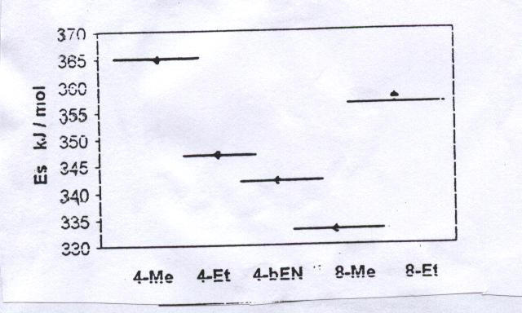

Fig.3. Energy diagram of S₁ state of the compounds in toluene.

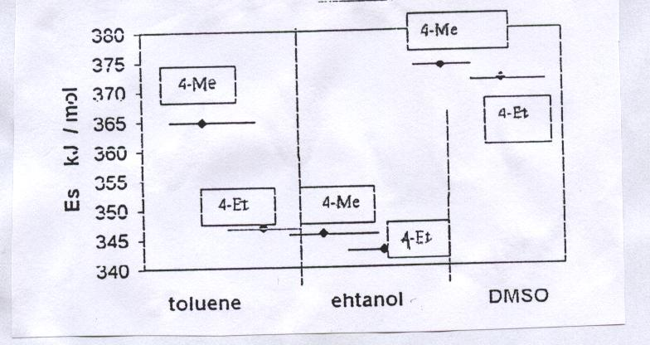

Fig,4. Energy diagram of S₁ state for 4-Me and 4-Et in
different solvents.

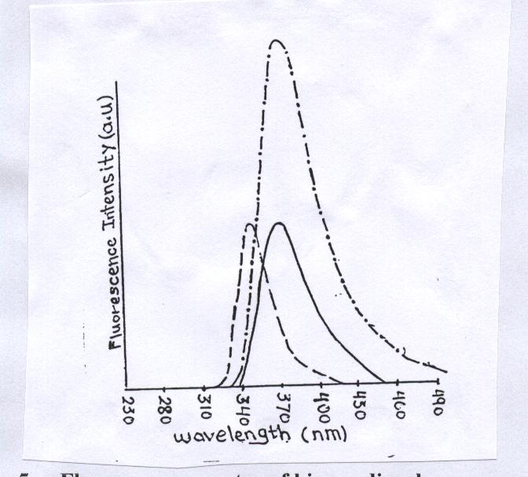

Fig.5-a. Fluorescence spectra of bis-oxadiazole compounds in
toluene; ------- 4-Me, ______ 4-Et , -.-.-.-.- 4-Be .

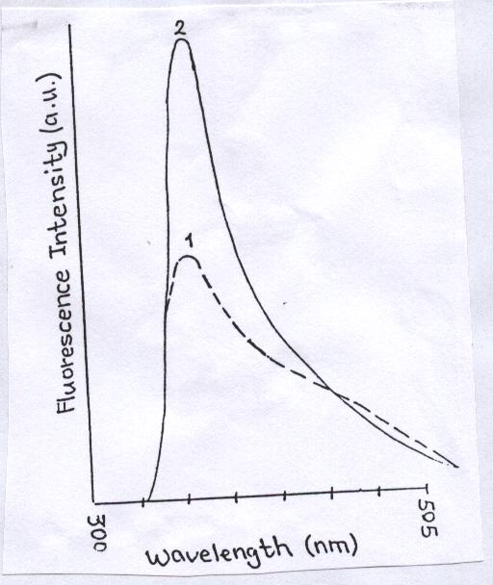
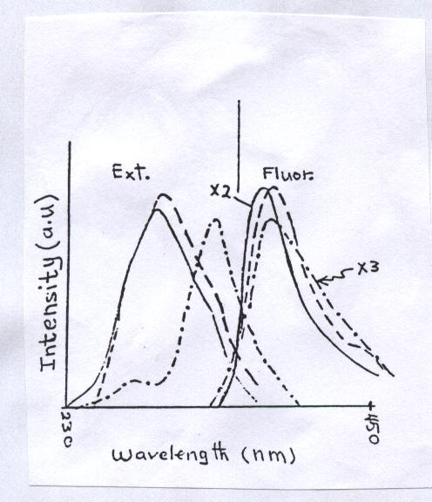
Fig.5-b. Excitation and fluorescence spectra in ethanol,
------ 4-Me, _____ 4-Et , -.-.-.-.- 4-Be.

Fig.5-c. Fluorescence spectra of bis-oxadiazole compounds in
DMSO solvent. -------- 4-Me , ______ 4-Et.

The fluorescence quantum yield represented as fluorescence intensity coincide with the values of S₁ ( n π*) energy for the three compounds in the solvents used ( see Figure-4- and Table-2- ). Photo physically speaking, the difference in intensity between the three compounds may be due to the singlet-triplet energy gap, ΔE_{S1-T}, in each solvent. The sequence of ΔE_{S-T} is for 4-Me < 4-Et <4-Ben which affect on the rate of the nonradiative intersystem crossing S₁ T process , k_{ISC} for the three compounds. This leads to the conclusion that k_{ISC}, the intersystem crossing rate constant, for 4-Me >4-Et>4-Ben. depending on the theory that the high k_{ISC} results from the low energy difference between the excited singlet and triplet states ΔE_{S1-T} and this consequently results in a lower fluorescence intensity. The position of the fluorescence maximum of the three compounds does not obey the sequence of solvent polarity or group substituent effects (see Figure-5- ).
In the case of the compounds 8-Me and 8-Et, the fluorescence intensity in toluene is quite larger than that in ethanol solvent as shown in Figure-6- .Also, the fluorescence intensity of 8-Et compound is 10 times larger than that of 8-Me in toluene and ethanol solvents which might be due to the small energy difference between singlet and triplet states for 8-Et compound.

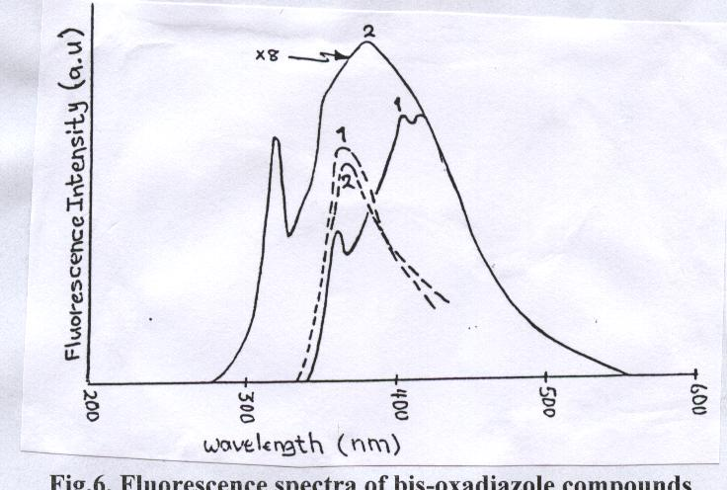

Fig.6. Fluorescence spectra of bis-oxadiazole compounds
1- 8-Me , 2- 8-Et ; _____ in toluene, ------ in ethanol solvent.

Long wavelength emission
The emission at wavelength longer than 500 nm is not observed for the compounds (4-Me, 4-Et and 4-Ben) when they dissolved in toluene. In ethanol these compounds posses a low intensity emission between 550-690 nm with a maximum peak around 662 nm as illustrated in Figure- 7-.This emission may be initiated from a low energy singlet state of an intermolecular excited complex D₂* in the polar environment⁹.Furthermore, an intense and broad emission is observed around 400-460 nm which most probably to be due an excimer D₁* fluorescence. The general reactions are shown in equation (1).

D₁* hυ₂ (400-460 nm)

M M* ( 1 )

D₂* hυ₃ ( ~ 660 nm)

hυ₁ (~ 360 nm)

Fluorescence quenching
The fluorescence emission behavior of the compound 4-Et in ethanol is examined in the presence of two compounds: Benzophenone and benzonitrile:
a- Quenching by benzophenone
Benzophenone ( E_{S1}= 309.6 k J / mol , E_{T1}= 288.69 kJ /mol) , with concentration of ~ 10 ^{–4} M , is used to quench 4-Et fluorescence when excited at 275nm. From the quenched fluorescence spectra and Stern-Volmer plot one can notice the following:
1- The quenching of the 4-Et fluorescence peak at 360 nm is with a dynamic pattern (Figure. 8-a-).
2-a new fluorescence emission peak at longer wavelength (420 nm) which may be due to another type of quenching, i.e. electronic energy transfer, that may contribute to the total quenching process. It is very interesting to note that this emission (420 nm peaks) is quenched too by increasing benzophenone concentration. There might be a complex quenching mechanism of 4-Et fluorescence in ethanol solvent that is responsible for this phenomena.
3- Quenching of the low intensity, long wavelength emission at 662 nm with a static pattern (Figure .8-b-).

b- Quenching by benzonitrile
Figure.-9-. Illustrate the quenching pattern of 4-Et by benzonitrile in toluene solvent at 352 nm when excited at 298 nm. Qualitative analyses of this pattern reveals that the quenching of 4-Et fluorescence may takes place in both singlet and triplet states. A blue shift in the fluorescence maximum position with increasing quencher concentration is observed. This was attributed to the change in the medium after the addition of the good electron donor, benzonitrile quencher.

c- Quenching mechanism
According to the results obtained in this work, one can propose a possible mechanism for the quenching of 4-Et fluorescence by benzophenone (Be) .

I_{a}
1- ¹( 4-Et )⁰ + h υ ¹( 4-Et )*
k_{F}
2- ¹( 4-Et )* h υ_{F1} ( 360 nm) + 4-Et
k_{ISC}
³(4-Et )*
k_{IC}
¹(4-Et )⁰ + Δ
k¹_{C}
3 - ¹(4-Et)* + 4-Et ¹( D₁ )*
k¹_{CF}
4 - ¹( D₁ )* hυ_{F2} ( ~ 420 nm ) + 4-Et
k _{ET}
5 - ¹( D₁…. Be)* 4-Et + ³Be*
k_{q}
6 - ¹( D₁ )* + Be Be + 4-Et + Δ

k²_{C}
7 - ¹(4-Et)* + ¹( 4-Et)⁰ ¹( D₂ )*

k²_{CF}

8 - hυ_{F3} ( ~ 660 nm ) + 4-Et

k_{q}
9 - ¹( D₂ )* + Be Be + (4-Et )_{n}

The suggested mechanism propose the formation of a complex between like molecules, i.e. D₁*, as in step 3 . These complexes emit fluorescence (step- 4) or might undergo through a quenching process of energy transfer type (step-5) or through the ordinary quenching mechanism (step-6). The other proposition is the formation of another complex D₂* between alike 4-Et molecules in the ground and excited singlet states (step-7) that have an energy lower than that of D₁* complex . This complex may deactivated by two processes, the first is the emission at 662 nm (step-8) and the other is the quenching of the excited complex due to the presence of benzophenone (Be) molecules (step-9) which observed as quenching of the 662 nm emission peak.

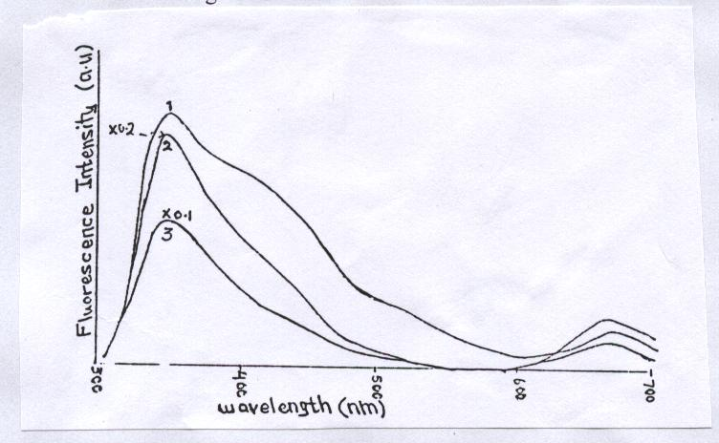

Fig.7. Short and long wavelength emission of some bis-
oxadiazole compounds in ethanol solvent ,
1, 4-Me ; 2, 4-Et ; 3, 4-Be

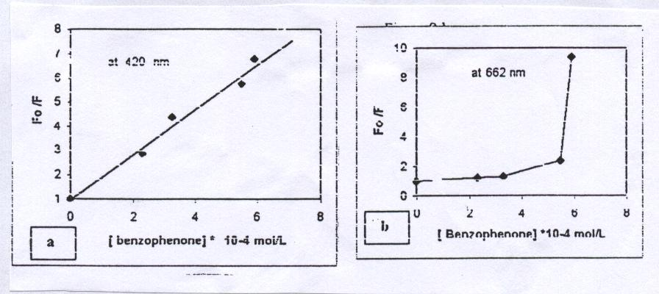

Fig.8. Stern-Volmer plot of 4-Et by benzophenone in
ethanol , (a) at 360 nm , (b) at 662 nm.

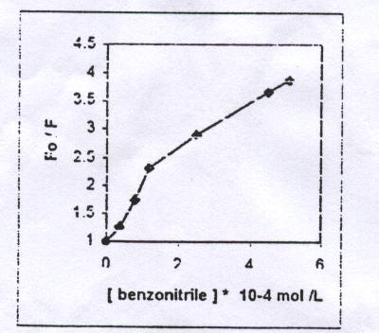

Fig.9. Stern-Volmer plot of 4-Et by benzonitrile in toluene.

Conclusion
Bis-(sulphonyl-oxadiazole) compounds posses an intense fluorescence. In ethanol 4-alkyl oxadiazoles gave emission at both short and long wavelengths. The position and intensity of the absorption and fluorescence spectra were structure and chain length dependence. The quenching mechanism of 4-Et fluorescence by benzophenone is thought to be a complex process and involve more than one type of quenching.

Acknowledgment
We are grateful to Prof. M.J.Mahmoud and I.F.Mustafa for Their generous gift and to Dr. Souad S.AL-Azzawi for her support to complete this research.

References

- Rai,L.and Singh,R.A.,Acta.Sci.B.N.,Indian, 1983, 9, 15.
- Morrin, M.and Mysinger, D., Pharmazie, 1983, 38(8), 56.
- Mustafa, I.F., Mu, tah J. of Res. And Studies, 1997, 12(3), 153.
- Mahmoud,M.J.,Mustafa,I.F.,Ali,M.A., Ibn Al-Haitham J.for pure and
Appl.Sci., 1999, 11(2), 82.
- Omar, S.S.and Mustafa, I.F., Basrah J.for Science, 2000, C-18(2), 205.
- Omar,S.S. and Mustafa,I.F., Iraqi J. of Chem., 2001, 27(4), 861.
- Omar S.S., Unpublished results.
- Mahmoud,M.J. Mustafa,I.F. , Ali,M.A., Proceeding of the first science
conference, Mu,tah University, 1997, 1, 191.
- Strehmel, B., Advanced Functional Molecules and Polymers, 2001, 3, chapter
7, 299, Edited by H.S.Nalwa, Overseas Publishers Association,N.V.

