Isolation and Identification of Volatile oils from Iraqi Thyme
( Thymbra Spicata ) and study the antimicrobial activity

Ikbal S. Al-Sheibany
Chemistry Dep., College of Education, Baghdad University
Kasim H. Kadeem and Amal S. Abdullah
Chemistry Dep., College of Science, Babylon University

(NJC)

(Received on 19/12 /2004) (Accepted for publication on 22/ 6/2005)

Abstract

Thyme, is commonly used as a cough-medicine. Especially liquid thyme extracts are in some countries a fundamental part of many galenicals with antitussive action.
Essential oils of thyme with different methods extract were compared by using HPLC. The major constituent of the oils was carvacrol and thymol. The biological activity against (Staphylococcus aureus, Escherichia coli and Klebsiella pneumoniae) was studied. All essential oils inhibited all bacteria at concentrations of ( 1/50 v/v ), the Glavenger method was found to be the most effective one than the other steam distillation extract.
الخلاصة
الزعتر , نبات واسع الاستخدام لامراض الجهاز التنفسي ( الكحة ) خاصة المستخلص المائي لنبات الزعتر والذي يستخدم في بعض البلدان كمادة اولية لتحضير العديد من المستحضرات النباتية. تم استخلاص الزيت الطيار من نبات الزعتر بطريقتين مختلفتين وتمت المقارنة بين نتائج الطريقتين باستخدام تقنية HPLC حيث كانت المركبات الاساسية هي الكارفكرول والثايمول . تم دراسة الفعالية البايولوجية للزيت العطري تجاه ثلاث انواع من البكتريا وبتركيز (1/50 v/v) . الزيت العطري المستخلص من التقطير البخاري باستخدام جهاز كلافينجر كان الاكثر فعالية من الزيت العطري المستخلص من التقطير البخاري العادي.

Introduction
Thyme, belongs to the family Labiatae is commonly used as a cough-medicine. Especially liquid thyme extracts are in some countries a fundamental part of many galenicals with antitussive action⁽¹⁾.
Thyme (Fig.1) has several names :- common thyme, herba thymi, red thyme⁽²⁾, in Arabic it is called "Za`atar" and in Kurdesh is called "Jatra"⁽³⁾.
The medicinal parts are the oil extracted from the fresh, flowering herb, the dried leaves, and the fresh aerial part of the flowering plant⁽⁴⁾ .
The leaves of most kinds of thyme can be used to good effect with almost any savoury dish: vegetable, fish, poultry, meat. The essential oils produced from any of several species have many used in the food industry⁽⁵⁾ .
Herba thymi contains (1.0-2.5%) volatile oil^{(2,4)} , and about (55%) phenolic material^{(6,7)} but not less than (0.5%) phenols⁽²⁾, the major constituent of Thymbra Spicata was carvacrol (75.5%)⁽⁸⁾, while in Thymus Vulgaris the chief components of volatile oil are thymol (20-55%), carvacrol (1-10%) ⁽⁹⁾.
Volatile oils or essential oils are colorless liquids consisting of mixtures of saturated or unsaturated cyclic hydrocarbons ⁽¹⁰⁾.
The antimicrobial activity of plant oils and extracts has been recognized for many years⁽¹¹⁾. In 1977, it was reported that 60% of the essential oil derivatives examined to date were inhibitory to fungi, while 30% inhibited bacteria⁽¹²⁾.
The aims of this work were:-
- to extract the volatile oils from Thymbra Spicata that grown in north of Iraq by two ways.
- Study the antimicrobial activities of different extracts.
Material and Methods
The study was carried out on two essential oils samples obtained from different ways of local Thymbra Spicata.
The dry plant Thyme was obtained from the Ministry of health/center of herbal medicine. The plant was identified by " herbelizem college of science" Baghdad University. It was air-dried, and packed in plastic containers until used.
Volatile oils were extracted by steam distillation and the other way by using Glavenger apparatus (Fig. 2 ). The test organisum obtained from the Biotechnology department / Baghdad University.
Steam distillation
one handerd grams of the leaves and flowers are placed in a 1000 ml round-bottomed flask and add 300 ml of distilled water, the distillation process was carried out for seven hours; and then transfer the yield to the separatory funnel, the oils will separated from the aqueous phase with diethylether and then evaporate in water path at 40°C and dried over anhydras sodium sulphate.
Glavenger apparatus
One handerd grams of plant were placed in a 1000 ml round-bottomed flask, and distilled water was added in a ratio of (5:1) (water : plant). The distillation process was carried out for three hours, the yield of volatile oils will separated from the aqueous phase with diethylether and then evaporate in water path at 40°C and dried over anhydras sodium sulphate.
High Performance Liquid Chromatography ( HPLC ) analysis of Volatile oils.
Thymol and carvacrol content in thyme oil was quantitatively determined by HPLC model Waters 2795 outo injector: column 250X4.6 mm I.D., packed with µBondapak C₁₈ ( water Assoc.) at wavelength 283 nm, an acetonitrile-water ( 40 : 60 ) mobile phase and a flow-rate of 1.5 ml / min were used⁽¹⁴⁾. The volatile oil components were identified by comparing their retention times with those of authentic samples.
Determination of antimicrobial activity:-
Antimicrobial activity of essential oils obtained by steam distillation, were determined by dilution with dimethyl sulphoxide ( DMSO ) ( 1/50 v/v ) by using the well method⁽¹⁵⁾.
- Staphylococcus aureus.
- Escherichia coli.
- Klebsiella pneumoniae.

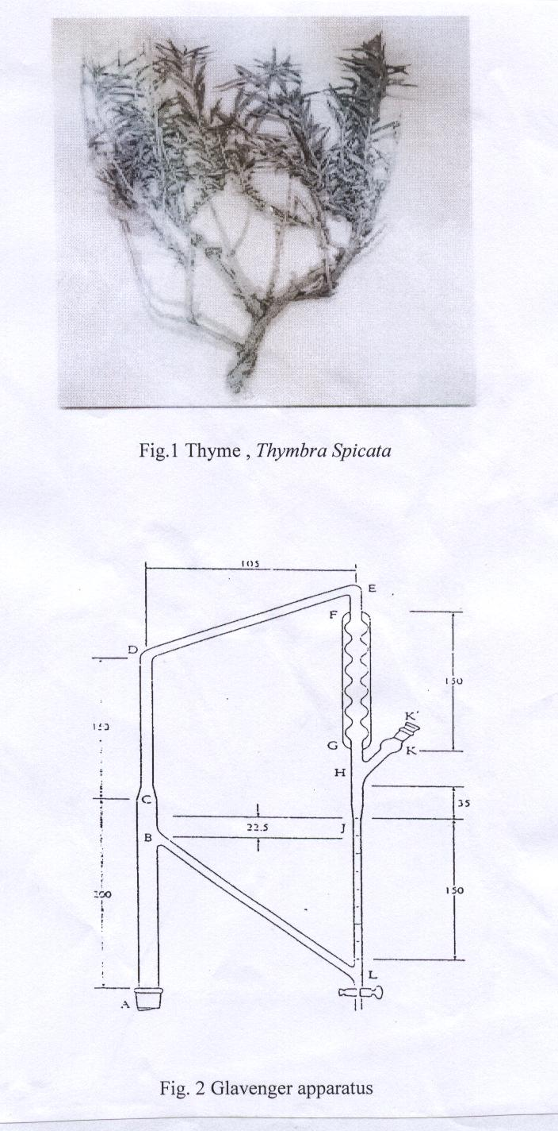

It has been reported that the volatile oil that extracted from thyme plant at concentration of essential oils at (1/10 v/v ), ( 1/20 v/v ) has no antimicrobial activities⁽¹⁶⁾ . 50 µL of essential oils concentration ( 1/50 v/v ) were placed in the hole of nutrient agar pleas cover by the above bacteria, the plate were left at room temperature for 1 hour then been moved to incubator 37°C were left then for 24 h. The result taken for every kind of bacteria after been repeated three times. The diameters of the inhibitory zones were measured.
Results
The major constituents of volatile oils of Thymbra Spicata are carvacrol ( 2-methyl-5-isopropylphenol) and thymol (5-methyl-2-isopropylphenol).
The two isomers carvacrol and thymol were identified by using HPLC, the result are shown at ( Table 1 ).The HPLC results of compound of carvacrol and thymol was shown in (Fig.3). By using 100 gm of dried plant, the yield obtained by Glavenger is 3 ml , while only 1.2ml oils obtained from steam distillation method.
Antimicrobial activity of volatile oils extracted by two methods in present research as shown in (Table 2). The exhibiting of oils extract against bacteria as shown in (Fig.4).

Table (1) Retention time (t_{R}), of carvacrol and thymol compound, using water-acetonitrile as eluent.
compound | t_{R} ( min ) |  | Height (µv)
compound | Glavenger | Steam distillation | Glavenger | Steam distillation
Carvacrol | 13.769 | 13.770 | 102530 | 27596
Thymol | 15.77 | 15.678 | 910 | 87130
Table (2) Illustrated a biological activity against different
type of bacteria
Microorganisms | Diameter of inhibitory zone (mm)
Microorganisms | Glavenger method | Steam distillation
Staph. aureus | 54 | 35
E.coli | 69 | 28
Klebsiella | 81 | 31
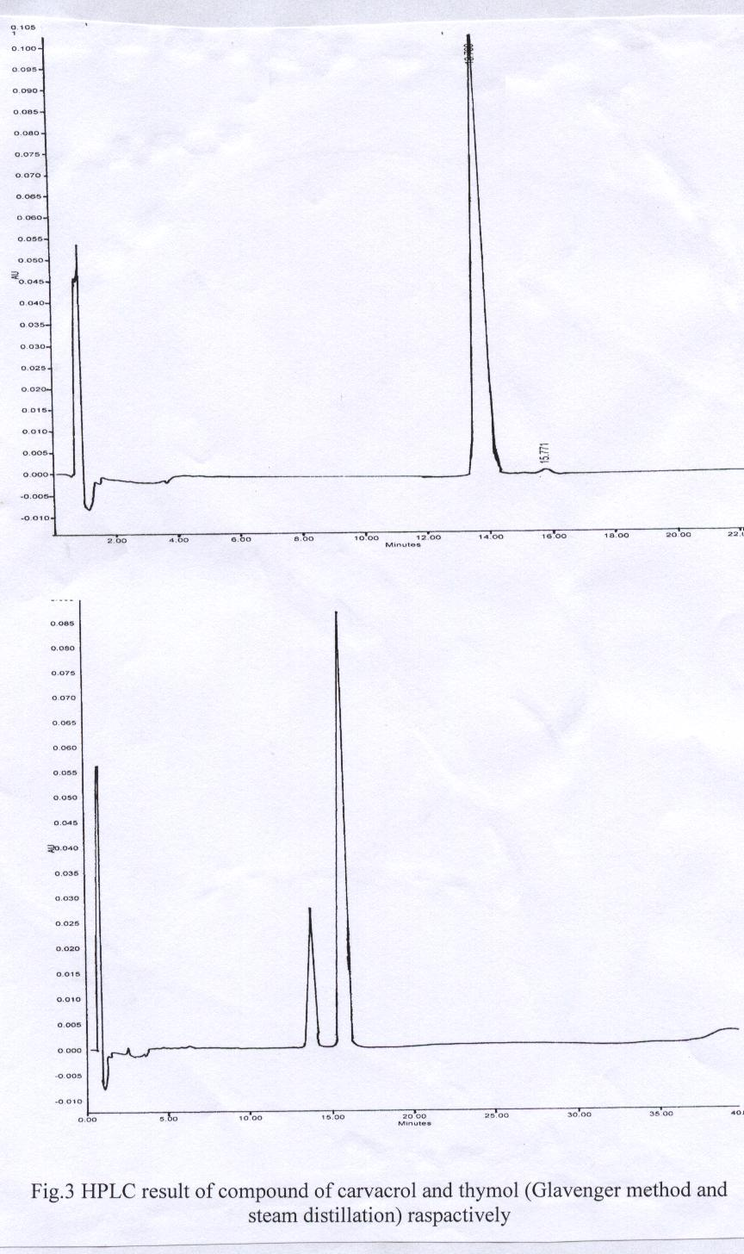
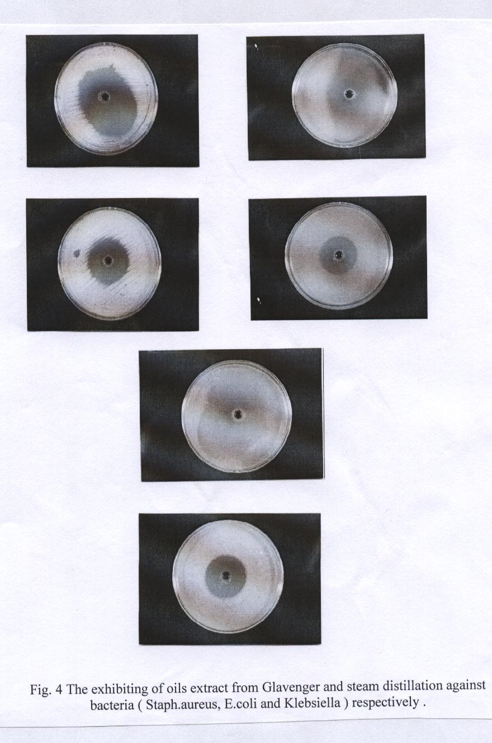

Discussion
From the work described above the conclusion which are to be drown are as follow:-
Glavenger method is the best method for extraction the essential oils, which given yield 3 ml , while only 1.2 ml oils from the other way. Another study which was carried out is HPLC technique which shown from ( Fig.3 ) that the major compound is carvacrol and the minor is thymol in Glavenger method. While the major compound is thymol and the minor is carvacrol from the steam distillation method, that which possibly due to that thymol is very sparingly soluble in water.

Antimicrobial activity has been shown in (Table 2), the exhibited similarly levels of antimicrobial activity, but the oils extracted from Glavenger method appeared to be more efficient, which due to the percent of carvacrol compound at a high concentration than thymol, this is in agreement with the finding of other authors^{(16,17)}.
From the above data and (Fig.4) , the antimicrobial activity has been concluded, the Gram negative ( E.coli ) gave inhibition zone (69mm), while the Gram positive bacteria (Staph.) gave inhibition zone (54mm), and the Gram negative bacteria (Klebsiella ) shown inhibition zone (81mm) are the most inhibited bacteria by using the oils obtained from the Glavenger method, at concentration ( 1/50 v/v ), this result agree with the other study⁽¹⁸⁾.
The results of this study confirmed the possibility of using the essential oils in food systems to prevent the growth of foodborne bacteria.

References
  - Van Den Brouck, C.O., and Lemli, J.A., J.Planta Medica, 1981, 41, 129.
  - World Health Organization monographs on selected medicinal plants, (1996) Geneva.
  - Al-Rawi A., and Chakravarty, H.L., "Medicinal Plants of Iraq",2th ed.Baghdad, (1988).
  - PDR For Herbal Medicines, 1sted. , Medical economics company,(1968).
  - Alan Davidson, "The Oxford Companion To Food",1st ed. , Oxford University Press, (1999).
  - Al-Shahatt, N., "Organo plant Medical and agricultural products", Aldar Al-arabia, (1988).
  - Hussain, F.T.,"Medicinal plants",Aldar A-arabia, (1979).
  - Hasan,B.,Osman S., Gulcan O., and Tahsin, K., J.Food Control, 2004, 15, 169.
  - Evans, W.C., "Pharmacognosy", 15thed., W.B.Saunders, (2002).
  - Robert H., and Robertson O.W.,"Handbook of Poisoning : Prevention, Diagnosis and Treatment",12thed., Middle East Edition, (1987).
  - Cosentino,S. Tuberoso, G.I.,Pisano,B., Satta,M., Mascia, V., Arzedi,E. , and Palmas,F.,J.Applied Microbiology, 1999, 29,130.
  - Cowan, M.M.,J.Clinical Microbiology Reviews, 1999, 12, No.4,564.
  - Indian Herbal Pharmacopoeia, Ajoint Puplication of National Research Laboratory, V.II, (1999).
  - Solinas,V., and Gessa, G., J.Chromatography, 1981, 219, 332.
  - Vignolo, G.M., Suriani, F., Holgado, A.P. and Oliver, G., J.App. Bac., 1993, 75, 344.
  - Kandil,O., Radwan,N., Hassan,A., Amer A.M ., El-Banna H., J. Ethnopharmacology, 1994, 44, 19.
  - Kunle,O., Okogun,J.and Shok,M.J.Phytomedicine, 2003, 10, 59.
  - Jenan,K.,Ph.D.,Thesis, Baghdad University, (2003).

