Spectroscopic Studies of Prostate Specific Antigen (PSA) Molecule

Hassan H. AL-Said and Sami A. Al-Mudhaffar
University of Baghdad, College of Science

(NJC)

(Received on 27 / 1 /2009) (Accepted for publication 18/2 /2009)

Abstract
Spectroscopic studies in the U.V region were carried out on human PSA. The U.V spectra of PSA, was obtained and revealed that PSA have a characteristic spectrum. The effect of pH and polarity on PSA U.V spectra was studied. Spectrophotometric pH titration and solvent perturbation were carried out and the data revealed that about 83.3% of tyrosine residues are located on the surface of the PSA molecule, while about 16.7% of tyrosine residues are buried interior the folded structure of the PSA. About 27.4% of histidine residues is located on the surface of the PSA molecule, while about 72.6% of histidine residues is embedded in the interior region of the PSA molecule.
الخلاصة
تم اجراء دراسة طيفية على المستضد النوعي البروستاتي البشري (hPSA) في منطقة الاشعة مافوق البنفسجية U.V. تم الحصول على منحني (hPSA)، ودلت الدراسة على امتلاك (hPSA) منحني متميز.
تم دراسة تاثير الاس الهيدروجيني pH والقطبية على منحني طيف (hPSA)، فضلا عن اجراء دراسات في تاثير منحني تسحيح الاس الهيدروجيني pH وتاثير تشويش المذيب.
دلت البيانات الى تموضع حوالي 83.3% من ثمالات التايروسين على سطح جزيئة (hPSA)، فيما ان 16.7% من ثمالات التايروسين تكون مدفونة داخل تركيب (hPSA)، كما دلت البيانات الى تموضع حوالي 27.4% من ثمالات الهستدين على سطح جزيئة (hPSA)، فيما ان 72.6% من ثمالات الهستدين تكون مدفونة داخل تركيب (hPSA).

Introduction
Molecules absorb light; the wavelengths that are absorbed and efficiency of absorption depend on both the structure and environment of the molecule making absorption spectroscopy a useful tool for characterizing both small and large molecule.
The wavelength range (210-300) nm is the most important one for the protein characterization. This region is related to tryptophan, tyrosine, phenylalanine and histidine amino acid residues, which considered to be chromophores ⁽¹⁾. Changes in the charge or the environment of these chromophores can lead to alteration in the absorption spectrum, and the conformational changes of a protein may also involve environmental changes of its chromophoric groups ⁽²⁾.
The electronic transitions for these chromophors come from n →π*and π → π *. These transitions are affected by many factors, which in turn affected the electronic environment that surround these transitions. Among these factors is the pH of the solvent, which determines the ionization state of ionizable chromophore. Also, the solvent polarity or perturbing agent affect the chromophore electronic transition where the λ_{max} for π → π * transition occurs at shorter wavelength (blue shift) in polar erotic solvents (H₂O, alcohol) than in longer wavelength (red shift) ⁽³⁾. The shift may or may not be accompanied by a change in intensity of the spectrum ^{(3, 4)}. Thus absorbance measurements can give an idea of the location of particular amino acids in a protein. Furthermore, information about the amino acids that are in a binding site is invariably valuable to the enzymologist to determine the reaction mechanism of an enzyme.
Although several new immunochemical techniques were developed to study such interactions ^{(5, 6)}, UV spectral remain as one of the most important methods in immunology because it provides a sensitive and quantitative measurements for the study of antibody structure and its specific ligand binding^{(7, 1)}.
This work is planned to study the spectroscopic behavior of standard PSA equipped with the supplied kit and a complex prepared for this standard PSA antigen.

Chemicals and Instruments

Chemicals
All common laboratory chemicals and reagents were of analar grade and were used with out further purification Tris (hydroxy methyl) aminomethan, PEG M.W 6,000, Ethanol, Citric Acid, Na₂HPO₄.2H₂O were obtained from Fluka.
EDTA (disodium salt), Ethylene glycol, NaOH, HCl, , Glycerol, dimethylsulfoxide were obtained from BDH
Immunoradiometric assay Kit for total- PSA was purchased from Immunotech- Beckman Coulter Company Czech Repoblic.

Instruments
The instruments used in this work were:
LKB spectrophotometer ultraspace type 4050, Pye-unicom pH meter, Magnetic stirrer hotplate (Staurt scientific).

Reagents and Solutions

Reagents
The standard PSA, tracer PSA antibody that provided by total PSA IRMA kit from Immunotech- Czech Republic, and their complex were used in this study.

Solutions
Tris/HCl buffer as working buffers pH (7.2-9) were prepared by mixing 25 ml of solution A consist of 0.2 M tris buffer with an appropriate amount of solution B consist of 0.1N HCL to adjust the required pH, then the volume was made up to 100 ml with distilled water.
Citric acid/phosphate buffer as working buffers pH (4–6) were prepared by mixing appropriate volumes of solution C consist of 0.1 M Citric acid with an appropriate amount of solution D consist of 0.2 M Disodium phosphate to reach the required pH in a final volume of 100 ml.
Glycin/ NaOH Buffer as working buffers pH (12.5) was prepared by mixing appropriate a mounts of solutions E consist of 0.1M Glycin in 0.1N NaCl with an appropriate amount of solution F consist of 0.1N NaOH in a final volume of 100 ml.

Spectroscopic studies

The U.V Spectrum of PSA

The U.V spectrum of human PSA
One hundred microliters of human PSA (5.0 ng/ml) provided by (total PSA IRMA kit from Immunotech- Beckman Coulter company Czech Republic) was completed to 500µl with Tris/HCl buffer pH 7.2. Then placed in a 0.5 cm cuvette in sample beam. The absorption spectrum was immediately measured against the same buffer in reference beam in the area of (200-320 nm).

Factors Effecting the Absorption Properties of PSA

pH Effect
One hundred microliters of human PSA (5.0 ng/ml) provided by (total PSA IRMA kit from Immunotech- Beckman Coulter company Czech Repoblic) was completed to 500µl with Tris/HCl buffer at different pH (4, 7.2, 9 and 12.5). The pH was adjusted using 1N HCL Then placed in a 0.5 cm cuvette in sample beam.
The absorption spectrum was immediately measured against the same buffer in reference beam in the area of (200-320 nm).

The effect of solvent polarity
One hundred microliters of human PSA (5.0 ng/ml) provided by (total PSA IRMA kit from Immunotech- Beckman Coulter company Czech Repoblic) was completed to 1000µl with Tris/HCl buffer pH 7.2 containing 20% ethanol, then placed in a 0.5 cm cuvette in sample beam.
The previous step was repeated using 20% of each of ethylen glycol, glycerol and Dimethylsulphoxide (DMSO). The absorption spectrum was immediately measured against the same buffer in reference beam in the area of (200-320 nm). The absorption of human PSA in Tris/HCl buffer pH 7.2 was immediately measured against the λ_{max} of human PSA in each solvent.

Spectrophotometic pH Titration of PSA
One hundred microliters of human PSA (5.0 ng/ml) provided by (total PSA IRMA kit from Immunotech-Beckman Coulter company Czech Republic) was completed to 500µl with different buffers at different pH ranging 4 to 8. The maximum absorbency of each sample was measured at a wavelength of 211nm.
One hundred microliters of human PSA (5.0 ng/ml) provided by (total PSA IRMA kit from Immunotech-Beckman Coulter company Czech Republic) were completed to 500µl with different buffers at different pH ranging 9 to 12.5. The maximum absorbency of each sample was measured at a wavelength of 295nm.
The absorbance of λ_{max} at each pH value was plotted versus corresponding pH.

Results and Discussion

The U.V Spectrum of PSA and ¹²⁵I-anti total PSA antibody
The UV spectra of h-PSA and ¹²⁵I-anti total PSA antibody were scanned from 200-320 nm to determine the absorption spectra, and the alternation in the UV spectra as a result of their conformation.

The U.V spectrum of human PSA
Figure (1) illustrates the U.V spectrum of human PSA (provided by total PSA IRMA kit from Immunotech- Beckman Coulter Company Czech Republic) at pH 7.2. The spectrum shows that the λ_{max} for PSA is consisted of 2 peaks, at 229 nm and at 277 nm. Both peaks may be assigned to tyrosine residue ⁽¹⁾ and located in a way that large part of it is on the surface of the protein molecule while the other part is buried.
As a result human PSA has a characteristic spectrum and can be identified by its peaks.

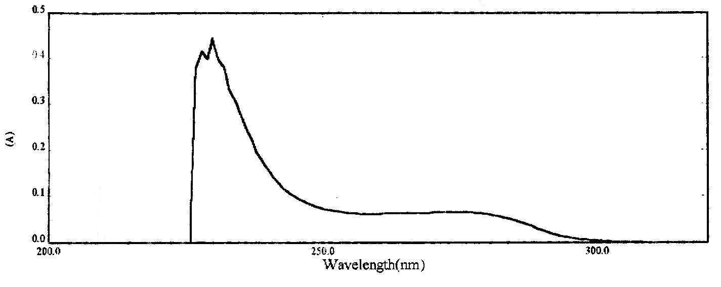
Figure (1): The U.V spectrum of human PSA at pH 7.2.

Factors Effecting the Absorption Properties of PSA
The absorption spectrum of a chromophore is primarily determined by the chemical structure of the molecule. However, a large number of environmental factors produce detectable changes in λ_{max} and ε.
The general features of these environmental effects are the following:

pH Effect
The pH of the solvent determines the ionization state of the ionizable chromophore in the protein molecule ⁽⁸⁾. The UV spectrum of PSA was determined at different pH (4, 7.2, 9 and 12.5) and λ_{max} was obtained as shown in table (1).In a neutral pH (7.2), Two λ_{max} were obtained for PSA, λ_{max1} and λ_{max2} of PSA were (229 and 277) nm respectively respectively.
In an acidic pH (4), there were decreases in both λ_{max1} and λ_{max2} of PSA with decreasing in pH. The blue shift has been observed in absorption of tyrosine residue may be attributed to conformational changes and chromophore in native PSA is on the surface of it ^{(9, 10)}. On the other hand the blue shift may be due to the increasing of hydrogen bond formed in the presence of highly positively charged state ⁽¹⁰⁾.
When the pH value was increased from (7.2 to 9), there were an increase in both λ_{max1} and λ_{max2} of PSA. The red shift has been observed in absorption of tyrosine residue, and this certainly related to the ionization of side chain of the tyrosine and this led to availability of the lone pair on the oxygen atom to be happened easier and at lower energy level (red shift).
At pH 12.5 no absorbance was recorded. The disappearance of both λ_{max1} and λ_{max2} of PSA of tyrosine residue due to conformational changes and chromophore in native complex were buried in the interior of their complexes ^{(11, 9)}.

Table (1): Effect of increasing pH on the λmax of PSA
pH | λ_{max} (nm)
pH | Standard PSA
4 | 225, 274
7.2 | 229, 277
9 | 232, 279
12.5 | --

It must be noted that the spectral shifts of proteins produced by pH cannot be simply attributed to the inductive effects of vicinal charges, such spectral changes must therefore be attributed mainly to rearrangements of secondary and tertiary structure, although the possibility of field effects due to unusually close conjunction of charges to aromatic groups is not excluded ⁽¹²⁾.

The Effect of Solvent Polarity
Table (2) shows the effect of 20% ethanol and ethylene glycol at neutral pH on the human PSA spectrum.
The data obtained previously from pH effect, show that the λ_{max} of PSA at neutral pH were (229 and 277) nm. The λ_{max} value of tyrosine in PSA was shifted towards longer wavelengths (red shift) in 20% of each ethanol and ethylene glycol due to the hydrogen bonding of the OH groups of tyrosines with the solvent or with theλ-electron system of the benzene ring where tyrosine was functioned as a hydrogen donor ^{(1, 4)}. These two shifts in λ_{max} were accompanied with a decrease in the absorbency of tyrosine, these findings could be attributed to a change in the protein structure that made the tyrosine residues were partly embedded in a hydrophobic region of the protein molecule.
The λ_{max} of tyrosine residues in PSA was shifted towards longer wavelengths in 20% glycerol without affecting the structure of PSA. The shift indicates that at 20% glycerol, the exposed tyrosines become solvated with glycerol (dipole–dipole interaction) ^{(4, 12)}.
Also table (2) show the λ_{max} of PSA in 20% dimethylsulfoxide at neutral pH. It was found that two newer λ_{max} were appeared for PSA, at (263.2 and 293) nm which were assigned to phenylalanine and tryptophan residues respectively.
The appearance of these new λ_{max} values indicates that the protein was defolded due to change in the secondary and tertiary structure of the protein that bring the phenylalanine and tryptophan residues for PSA to expose to absorbance while tyrosine residue was buried inside PSA molecule, also it was found that PSA was highly sensitive to change in the polarity of the solvent.

Table (2): Effect of solvent polarity on the λmax of PSA
Solvent | λ_{max} (nm)
Solvent | Standard PSA
Ethanol | 233.4, 280.1
Ethylene glycol | 235.41, 281.09
Glycerol | 236.02, 282.81
DMSO | 263.2, 293

Spectrophotometic pH titration of PSA
Spectrophotometric pH titration is the following of the change in absorbance of the chromophore with increasing pH ⁽¹³⁾. Many studies of protein structure require the determination of pk values for proton dissociation from ionizable amino acid side chains, because these values give an indication of the location of the amino acid in the protein. This can often be done spectrophotometrically because dissociation often changes the spectrum of one of the chromophores, the observation of tyrosine dissociation was performed by measuring the absorption at 295 nm (λ_{max} for the ionized form of tyrosine), and the observation of histidine dissociation was carried out by measuring the absorption at 211 nm.
Figure (2 A&B) shows the pH titration curves of PSA for tyrosine and histidine respectively.

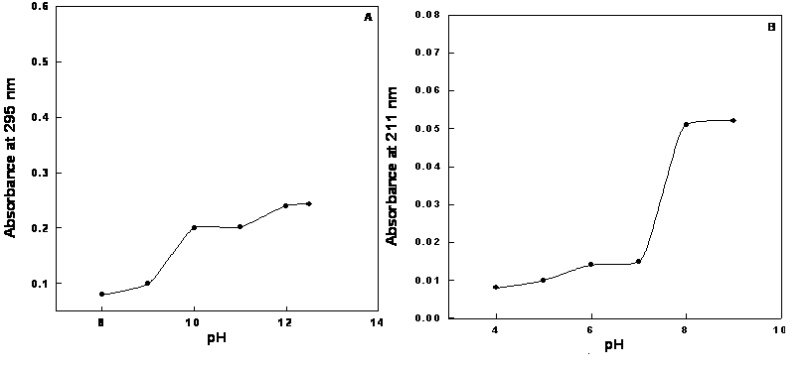
Figure (2): Spectrophotometric pH titration of PSA for:A. Tyrosine residue
B. Histidine residue

The (A) curves show that the pk_{a} values for tyrosine is 9.2 for PSA, while the pk_{a} values for histidine in (B) curves was equal to 5.5 for PSA. From the same figure, it was found that:
About 83.3 % of tyrosine residues are located on the surface of the PSA molecule. About 16.7 % of tyrosine residues are buried interior the folded structure of the PSA. About 27.4 % of histidine residues is located on the surface of the PSA molecule. About 72.6 % of histidine residues is embedded in the interior region of the PSA molecule. The tyrosine residues of PSA was largely present on the surface of the molecule and the internal tyrosines are in a strongly nonpolar environment. On the other hand, the histidine residues are slightly present on the molecular surface of PSA and the internal histidine residues of PSA are in a nonpolar environment

Solvent perturbation studies
The determination of whether an amino acid is internal or external by measuring the spectra of a protein in polar and nonpolar solvents is called the solvent perturbation method. In fact, proteins are rarely studied in completely nonpolar solvents because most proteins are either insoluble or denaturated in these solvents; therefore, mixtures of 80% water and 20% of reduced polarity solvent were used ⁽¹⁾. Solvents alter the peak positions and intensities by altering the energy and probability of electronic transitions and this alteration arises from a difference in the salvation energies of the ground state and the first excited singlet state ⁽¹²⁾.
Table (3) shows the λ_{max} and ∆A values in the presence of different perturbants (20% ethanol, 20% ethylene glycol, 20% glycol and 20% DMSO).

Table (3): Solvent perturbation on PSA.
Perturbent substance | PSA
Perturbent substance | λ_{max} | A | ∆A
Ethanol | 233.4 | 1.35 | 0.84
Ethanol | 280.1 | 0.9 | 0.83
Ethylene glycol | 235.41 | 1.15 | 0.85
Ethylene glycol | 281.09 | 0.94 | 0.84
Glycerol | 236.02 | 1.15 | 0.81
Glycerol | 282.81 | 087 | 0.82
DMSO | 263.2 | 0.25 | 0.15
DMSO | 293 | 0.34 | 0.3

From the results listed in the Tables (2) and (3), it was found that several spectral changes were obtained in the presence of these perturbants, like the alteration of the λ_{max} positions and intensities of PSA spectrum, and the appearance of new chromophores on the surface of the PSA molecule. These chromophores were embedded in an interior region of the protein in the absence of solvent.
From the solvent perturbation studies, the following remarks could be drawn:
About 0.83of tyrosine residues, 0.15 of phenylalanine residues and 0.3 of tryptophan residues are on the surface of PSA molecule.
From spectrophotometic pH titration and solvent perturbation studies we conclude that
About 83,30, 15 and 25% of tyrosine, tryptophan, phenylalanine and histidine residues are on the surface of PSA molecule respectively,
Finally if assumed that human PSA that used in spectrophotometric studies consisted only f-PSA that composed 4, 7, 6 and 11 of tyrosine, tryptophan, phenylalanine and histidine residues respectively ⁽¹³⁾, then about 3, 2, 1 and 3 of tyrosine, tryptophan, phenylalanine and histidine residues are on the surface of PSA molecule respectively, while about 1, 5, 5 and 10 of tyrosine, tryptophan, phenylalanine and histidine residues are buried interior the folded structure of the PSA molecule.

References
1. Freifelder, D.; Physical biochemistry; application to biochemistry molecular biology; 2nd ed., San Francisco: W.H. Freeman & Company; 1982; Chapter 14: pp. 494-591.
2. Laskowski, M., Leach S. ∂. and Scheraga H.A.; J. Am. Chem. Soc.; 1960; 5, 71.
3. Scheraga, H.A.; Protein structure; New York: Academic Press; 1961; pp. 365- 571.
4. Leach, S.J. and Scheraga H.A.; J. Boil. Chem.; 1960; 235, 2827.
5. Kiernan, J.A.; Histological & histochemical methods, theory & practice; 3rd ed., Reed Educational and Professional Publishing Ltd; 1999; Chapter 19: pp. 391-398.
6. Johustone, A. and Thorpe R.; Immuno-Chemistry in practice; 3rd ed., Blackwell Science Ltd; 1996; pp. 292-311, 1-4.
7. Williams, C.A. and Chanse M.W.; Methods in immunology and immunochemistry; New York, Acadimic Press; 1968; Vol II; Chapter 10, pp163-174.
8. Giai M., Yu H., Roagna R., etal.; British Journal of Cancer; 1995; 72, 728.
9. Tanforel C., Buzzell J.G. and Rands D.G.; J. Am. Soc.; 1955; 77, 6421.
10. W.A.Banjamin, Inc; 1983;
11. Yang, J.T. and Foster J.F.; J. Am. Chem. Soc.; 1954; 76, 1588.
12. Yanari S.and Bovey F.A.; J.Biol.Chem.; 1960; 235(10), 2818.
13. Lundwall A. and Lilja H.; F.E.B.S. Lett.; 1987; 214, 317.

