Spectrophotometric Study of 2-Aminophenol and Catechol Via
Reaction with p-Aminoacetophenone .

* Huda S. Hassen , Hayfaa J. Mohammed & Hussain J. Mohammed

Dept. Chemistry, College of Education for Girls, Kufa University, Iraq
*Email : Hudash@edu.kuiraq.com

(NJC)

(Received on 15 / 5 /2008) (Accepted for publication 3/5 /2009)

Abstract
A simple, sensitive and selective method has been developed for the determinations of 2-aminophenol and catechol. The method is based on the reaction of 2-aminophenol and catechol with p-aminoacetophenone and dichromate at pH 5 and 4.5 were Studied. The reactions gave and an intense water soluble color products their have a maximum absorption at 506.5 , 540 nm and ε_{max} 0.3*10⁴ and 0.7*10⁴ for 2-aminophenol and catechol respectively .
A linear correlations (1-9 μgml⁻¹) for both compounds were found between absorbance at λ_{max} and concentration. The results obtained are both precise (RSD were better than 1.9 % and 2.2 % respectively) and accurate (relative error were better than 0.47% and 0.25%) . The colored products were found to be 1:1 2-aminophenol : p-aminoacetophenon and catechol : p-aminoacetophenon . The stability constants and the rate constants of the reactions under optimized conditions and at room temperature were 5*10⁴ L.mole⁻¹, 3.46*10⁻² min⁻¹ and 3*10⁶ L.mole ⁻¹ , 1.39*10⁻² min⁻¹ respectively.
Key Words : p-aminoacetophenon, Catechol and 2-aminophenol , Spectrophotometry .
الخلاصة
تم تطوير طريقة سريعة وانتقائية وذات حساسية عالية في تقدير٢-امينوفينول والكاتيكول مع بارا امينواستيوفينون والدايكرومات عند دالة هيدروجينية ٥ و ٥,٤ على التتالي . أعطت التفاعلات نواتج ملونة ذائبة في الماء ولها أقصى امتصاص عند طول موجي٥, ٥٠٦ و٥٤٠ نانومتر لكل من ٢- امينوفينول والكاتيكول على التتالي ومعاملات امتصاص مولا ري٣,٠× ^{٤}١٠ و ٧,٠×^{٤}١٠ لتر مول^{-١} سم ^{-١} وكانت العلاقة بين الامتصاص عند طول موجة أقصى امتصاص والتركيز خطية في مدى التركيزات بين (١- ٩مايكرو غرام /مل)لكلا المركبين وأعطت نتائج ذات تكرارية (الانحراف النسبي أفضل من ٩,١ و٢,٢% ) ودقة ( نسبة الخطأ أفضل من ٤٧,٠% و٢٥,٠ %) عاليتين ، لقد كانت النسبة المولية للنواتج الملونة هي ١:١ ٢- امينوفينول : بارا امينواسيتوفينون وكاتيكول : بارا امينواسيتوفينون وبلغت ثوابت الاستقرارية لنواتج التفاعلات وثوابت السرعة تحت الظروف المثلى ودرجة حرارة الغرفة هي ٥×^{٣}١٠ لتر مول^{-١} ، ٤٦,٣×١^{٠-٢} دقيقة^{-١} و٣×^{٦}١٠، ٣٩,١×١^{٠-٢} دقيقة^{-١}على التتالي

Introduction
The phenolic compounds are important environmental pollutants because they are toxic to humans and difficult to degrade. Furthermore , because they have similar structures and properties , they usually coexist in products ^{[1]}. Phenolic compounds are reported to be carcinogenic and exposure to phenol results in several symptoms such as convulsions and irregular respiration^{[2-5]} .
Oxidative coupling reactions have long been used for the determination of many drugs such as amoxicillin^{[6]}, folic acid^{[7]}, sulphonamide^{[8]} and phenols^{[9,10]}. Spectrophotometric methods often suffer form limitations in sensitivity and selectivity but are widely used due to both the resulting experimental rapidity and simplicity. Therefore the objective of the investigation reported in this paper was to evaluate a spectrophotometic determination of 2-aminophenol and catechol with p-aminoacetophenone in the presence of potassium dichromate .
Experimental
Apparatus:
- All spectral and absorbance measurements were carried out on a shimadzu
UV-visible 1700 double beam spectrophotometer using 1 cm glass cells .
- A digital pH meter was used .
-All Kinetic measurements were made on TRUV 754 UV-visible spectrophotometer.
Reagents:
All chemicals used were of analytical grade. Standard 2-aminophenol solution (100 μg/ml) was prepared by dissolving 0.02 gm of 2-aminophenol in 10 ml of ethanol and made up to 200 ml with distilled water, working standard 2-aminophenol were prepared by simple dilution of the appropriate volume of the standard 2-aminophenol (100 μg/ml) with distilled water .
Catechol (100µg.ml⁻¹) :
0.02 gm pure catechol was dissolved in 10 ml of ethanol and made up to 200 ml with distilled water .
P-aminoacetophenone (1x10⁻³ M):
0.027 gm pure p-aminoacetophenone was dissolved in 10 ml of ethanol and made up to 200 ml with distilled water.
Dichromate solution (0.01 M):
0.735 gm of potassium dichromate was dissolved in 250 ml distilled water .
Foreign ions (1 mg. ml⁻¹):
These solutions were prepared by dissolving, an amount of the compound in distilled water completing the volume in volumetric flask.
General procedure:
An aliqaul of samples containing 10-100 μg of 2- aminophenol and catechol were transferred into a series of 10 ml standard flasks. A volume of 2.5 ml 1*10⁻³ M p-aminoacetophenone solution, 1.5 ml of 0.01 M of potassium dichromate and 2 ml of H₂SO₄ were added. The contents of the flasks were diluted to the mark with distilled water, mixed well and left for 10 min. The absorbance was measured at 506.5 nm for 2-aminophenol and at 540 nm for Catechol against reagent blanks containing all materials except 2-aminophenol for determination of 2- aminophenol and catechol for determination of catechol .
Reaction mechanism of the method :
2-aminophenol and catechol forms colored products with p-aminoacetophenone in the presence of potassium dichromate in acidic medium . Under the reaction conditions, p-aminoacetophenone, upon oxidation with potassium dichromate loses two electrons and one proton, forming an electrophilic intermediate which is an active coupling species. The intermediate of p-aminoacetophenone undergoes electrophilic substitution with the phenolic moieties of 2-aminophenol and catechol to from a colored product (8) according to scheme 1-2.

Scheme 1 : proposed mechanism of the reaction 2-aminophenol
with p-amino acetophenone .

Scheme 2 : proposed mechanism of the reaction catechol and
p-amino acetophenone.

Results and Discussion
The result of this investigation indicated that the reactions between 2-aminophenol with p-aminoacetophenone and catechol with p-aminoacetophenone in the presence of potassium dichromate and sulphuric acid in the pH 5 and 4.5 yield highly soluble colored condensation products which can be utilized as a suitable assay procedures for 2-aminophenol and catchol respectively .These colored products have a maximum absorption at 506.5 nm and at 540 nm respectively, the blank at these wave lengths shows Zero absorbance Fig (1)
The influence of various reaction variables on the color development was tested to establish the most favorable conditions and these are:

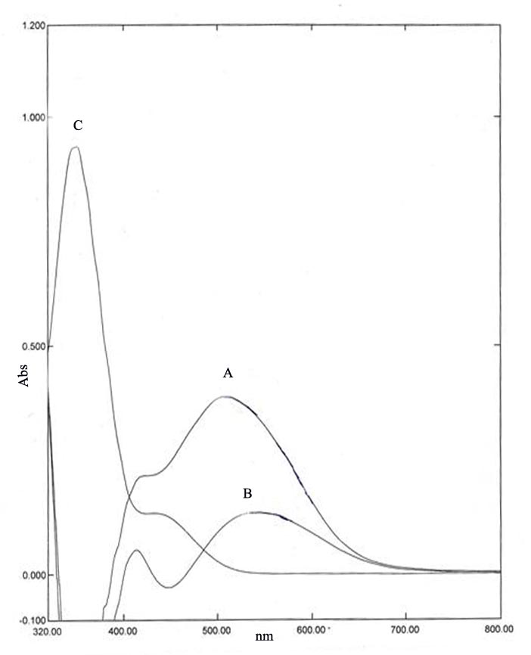
Fig.1 : Absorption spectra of (A) 2-aminophenol complex in the presence of potassium dichromate (B) catechol complex in the presence of potassium dichromate (C) reagent blank p-aminoacetophenone with potassium dichromate.

Optimization of reagent concentration:
The effect of various concentrations of p-aminoactophenone were investigated. 2.5 ml of 1*10⁻³ ml was found necessary for developing the colored products and increase their stability Fig 2 .

Fig 2: Effect of the volume reagent .

Effect of oxidant concentration :
Various concentrations of potassium dichromate solutions were added to a fixed amount of 2-aminophenol or catechol, 1-5 ml of 0.01 m potassium dichromate was used in the procedure since it gives high sensitivity Fig 3 .

Fig 3: Effect of the volume oxidizing agent .

Effect of acid:
It was found experimentally that the colored products were formed only in acidic medium. Different acids were examined these include hydrochloric, sulphuric and phosphoric acid only sulphuric acid was found optimum since it gives a high sensitivity, minimum blank value and high stability of the colored products. The effect of the amount of sulphuric acid was also tested and 2 ml of 0.05 M was selected was used in determination of 2-aminophenol and catechol Fig 4 , 5 .

Fig 4 : Effec of volume acid in the 2-aminophenol .

Fig 5 : Effect of volume acid in the Catechol .

Calibration carves :
The calibration curves were constructed at their respective absorption maxima and these were linear over concentration range in table.1 for phenolic compounds. The molar absorptivity are given in table. 1.

Table .1 : Analytical data of determinations of 2-aminophenol and catechol
catechol | 2-aminophenol | Characteristic
540 | 506.5 | Absorption maxima (nm)
4-5 | 5 | pH
(1-9) | (1-8) | Beer's 1aw range (μg/ml)
0.7*10⁴ | 0.5*10⁴ | Molar absorptivity (L.mol⁻¹cm⁻¹)

Development time and stability period :
The color intensity reached maximum after 2-aminophenol or catechol had been reacted with p-aminoacetophenone and potassium dichromate solutions for 10 min . The color obtained was stable for at least 2hr and this stability, period was sufficient to allow several measurements to be performed sequentially.
Order of addition of reagents :
To obtained the optimum results, the order of addition of reagents should be followed as given by the procedures, otherwise, a loss in color intensity and stability are observed .
Accuracy and precision :
To determine the accuracy and precision of the method, 2-aminophenol and catechol were determined at three different concentrations . The results are shown in table 2-indicate that satisfactory precision and accuracy could be attained with the proposed method .

Table.2 : Accuracy and precision of the method .
%RSD of catechol | %RSD of 2aminophenol | %E of catechol | %E of 2-aminophenol | Amount af 2-aminophenol or catechol taken ppm
2.2 | 1.9 | + 0.47 | - 0.11 | 4
0.52 | 1.3 | + 0.14 | + 0.25 | 6
0.29 | 0.36 | - 0.35 | - 0.21 | 8

Composition of the complexes :
The composition of the complexes were studied by mole of ration method_{[11]}. A break of 1:1 suggested the formation of 2-aminophenol with p-aminoacetophenone complex and catechol with p-aminoacetophenone complex Fig 6,7 .The apparent stability constants were calculated by comparing the absorbance of solution containing stoichiometric amounts of 2-aminophenol or catechol and p-aminoacetophenone with that of a solution containing a five-fold excess of p-aminoacetophenone reagent. The average conditional stability constants of the dyes in water, under the described experimental conditions are 5.0*10⁴ and 3.0*10⁶ for 2-aminophenol and catechol complexes .

Fig 6: Mole ratio of the 2-aminophenol Complex .
Fig 7: Mole ratio of the Catechol Complex .

Rate of reactions :
Rate of reactions were determined spectrophotometrically by measurement of the change in absorbance of the reaction mixture with time. All experiments were curried out under pseudo-first order conditions by keeping concentrations of two reactants in twenty fold excess over that the third one. The solutions were thermo stated at 25₊⁻ 0.1 ºC and the change in absorbance was measured until the reaction was complete. Rate constant was determined by the first order plot using the equation :
Kt = 2.303 log A∞/ A∞-A_{t}
Where A∞ is the final absorbance and A_{t} the absorbance at any time t, after addition of p-aminoacetophenone and appearance of the color. The validity of this interpretation was checked by plotting log A∞/A∞-A_{t} against t, straight line was obtained and the pseudo – first order rate constant is determined from the slope and were found to be 3.46*10⁻² and 1.39*10⁻² min⁻ ¹ for 2-aminophenol and catechol respectively .
Interferences :
The effects of diverse ions on the determination of these phenolic compounds were studied in detail. To test of diverse ions were determined by the general procedure, in the presence of their respective foreign ions . Each of 2-aminophenol and catechol can be determined with serious interferences in the presence of a 10 fold excess of cations tables .3 .

catechol  E% | 2-aminophenol  E% | Amount added  p.p.m | Foreign ions
12.6 | 20.3 | 100 | Co ⁺²
14.24 | 17.8 | 100 | Cd ⁺²
46.5 | 30.9 | 100 | Mn ⁺²
25.5 | 35.9 | 100 | Zn ⁺²
-6.8 | 18.7 | 100 | Pd⁺²
27 | -6.8 | 100 | Ni⁺²
32.34 | 15.04 | 100 | K⁺
46.8 | 12.1 | 100 | Sr⁺²
13.3 | 20.02 | 100 | Fe ⁺³
45.4 | 10.8 | 100 | Ag ⁺

Table (3) : effect of foreign ions .

Conclusions :
The present study demonstrates an excellent approach for the development of spectrophotometric method for determination of 2-aminophenol and catechol, high selectivity and excellent sensitivity for the oxidative coupling reaction of 2-aminophenol and catechol are achieved with p-aminoacetophenone.

References
1- A.E.Manahan , Lewis, Boca Raton, 1993, 618 .
2-F.A. Patty, Interscience, New York, 1963, 2, 1363.
3- I.M. Kolthoft, P.J.Elving, F.H. Stross , Wiley, New York, 1971, 2, 490.
4- W. Leithe , Ann Arbor Scince, 1971, MI, 246.
5-W.Lithe, Ann Arbor Science, 1972, MI, 113.
6. M.Q. Al-Abachi, H. Hddi , A.M.Al-Abachi , J. Anal. Chem. Acta, 2005, 554, 184.
7- M.Q.Al-Abachi, R.S.Al-Abaidi, J. Chem., Natl,2002, 8, 527.
8- M.Q. Al-Abachi, E.S. Salih, M.S. Salem , J. Anal. Chem, 1990, 337, , 408.
9. R. Mohammed, M.J. Hussein, A.I Namir , Iraqi. J. Chem., 1999, 25, 79
10- M.J. Hussein, Al-Kufa , J. Pure and App. SCi, 2007, 8, 77.
11- H.Sigga, 1972 " Organic micro analysis Via functional group" John Willey and Sons, New York .

