Mesomorphic properties of a new homologous series of ortho hydroxyl-functionalized Schiff bases .

Muayed G. Jalhoom
Ibn-Sina Company, Baghdad – Iraq
Uhood J. AL-Hamdani and Ra’ed A. Aubed
Chemistry Department , College of Education , Basrah University
Basrah, Iraq.

(NJC)

(Received on 25/5 /2008) (Accepted for publication 19/2 /2009)

Abstract
Nine members of a homologous series of the Schiff bases [4(4'-n-alkoxy -2- hydroxybenzylidene ) amino biphenyl ] have been prepared and their mesomorphic properties and phase transitions were determined for all compounds by polarizing hot stage microscopy and differential calorimatry for some of them . The properties of this series are compared with those the analogous Schiff bases , the [4(4'-n-alkoxy -2- hydroxybenzylidene ) amino biphenyl ] .The effect of the hydroxyl group in ortho position on the type of liquid crystal phases in this series and thermal stability has been assessed .
الخلاصة
حضرت سلسلة من تسعة مركبات ( قواعد شف ) ودرست صفاتها البلورية السائلة وحددت درجات الانتقال لهذه السلسلة من خلال دراسة جميع المركبات بالمجهر ذو الضوء المستقطب ومركبين فقط بجهاز المسح الحراري التفاضلي ونوقش تأثير طول السلسلة الطرفية ومجموعة الهيدروكسيل المعوضة في الموقع اورثو على صفاتها البلورية السائلة .

Introduction
Numerous studies have been made in recent years of the effect of changes in molecular frame work on the incidence and stability of various liquid crystal phases ^{(1,2,3 )} .
Many of these studies have involved investigation of these effect of changes in terminal alkyl chain length ^{(4,5)} and the effect of the intermolecular hydrogen bonding ⁽⁶⁾ on the incidence of their thermal stability .
We have prepared nine members of the homologous series (I) of [4(4'-n-alkoxy-2-hydroxybenzylidene) amino biphenyl ] in order to establish both the variations in liquid crystal properties with increase in the terminal alkyl chain length and to provide a direct comparison of the results obtained with those reported by Gray , Hartley , Ibbotson and Jones for the series II : [4(4'-n-alkoxy -2- hydroxybenzylidene) amino biphenyl] which unsubstantiated with hydroxyl group in ortho position ⁽⁷⁾.

Experimental
Synthesis a)Synthesis of4(4'-n-alkoxybenzoloxy)-2-hydroxybenzaldehyde ⁽⁸⁾
2,4 –dihydroxy benzaldehyde (0.1mole) , the appropriate n- alkyl bromide (0.15 mole, and anhydrous potassium carbonate (0.15 mole) and) were added to dry acetone , the mixture was reflexed with stirring for 24 h. , the hot mixture was filtered then removal of acetone and finally yielded the alkoxy as a yellow oily liquid (65%).
b) Synthesis of the Schiff bases ⁽⁹⁾
The respective Schiff bases were synthesized using a well known method by mixing an ethanolic solution of (1mmol) of 4(4'-alkoxybenzoloxy)-2- hydroxybenzal- dehyde with (1mmol) of 4-amino biphenyl and 2 drops of acetic acid as catalyst . The reaction mixture was heated under reflex for 3h. the solution was allowed to cool , the yellow precipitate was separated by filtration and finally repeated recrystallization (several times) from heptane yielded (80%) the pure Schiff bases (schem 1).

Schem 1 .

Measurements
IR spectra were obtained using FTIR – 8400 S Spectrometer .
UV spectra were recorded on UL -1500 spectrophotometer.
¹H NMR spectra were recorded on Bruker WH – 400 MHz .
Measurement of transition temperature were using Seiko Instrument Inc. differential scanning calorimeter with a heating rate of 10C^{о} min⁻¹.
The phase transitions were observed with a Leitz Laborlux 12 pol optical microscope with polarized light in conjunction with a Leitz 350 hot stage equipped avario – orthomat camera .ﻛ
Results
Characterization
IR spectrum ( KBr dick ) , cm⁻¹: un saturated stretch C – H ( 3050 - 3037) , saturated C – H ( 2956 – 2850 ) , C = N ( 1637 ) C = C ( 1625 , 1592 ) .
The UV spectra in CH₂Cl₂ of the series were identical and contained two bands λmax At 480 nm (Є= 1.6 X10⁻⁴ L.mol⁻¹.cm⁻¹ ) , 349 nm (Є= 2.39 X10⁻⁴ L.mol⁻¹.cm⁻¹) attributed to π - π* transition.. The ¹H NMR spectra data for the series compound show broadly similar spectral characteristics and data of ABA₄ is representave of the series ( triblet , 3H , CH₃ ) 0.912 ppm ( hextet ,2H , CH₂ ) 1.47 – 3.92 ppm , (pentet , 2H , CH₂ ) 1.75 – 1. 68 ppm , (triplet , 2H ,OCH₂) 3.96 – 3.92 ppm , (multiplet,12H, ring protons) 7.58 – 6.41 ppm , (singlet , 1H , OH ) 13.7 ppm ^{(10 , 11)} (Fig. 1) .

Table 1: Elemental analytical data ( Calculated values in parentheses )

Compound | Molecular Formula | C % | H% | N%
ABA₂ | C₂₁H₁₉O₂N | 79.162 ( 79.471) | 6.013 (6.034) | 4.387 ( 4.413)
ABA₅ | C₂₄H₂₅O₂N | 79.791(80.191) | 6.985 (7.010) | 3.875 ( 3.896 )
ABA₇ | C₂₆H₂₉O₂N | 80.177 ( 80.585) | 7.511 ( 7.543) | 3.597 ( 3.614)
ABA₁₀ | C₂₉H₃₅O₂N | 80.629 ( 81.079) | 8.180 (8.211) | 3.244 ( 3.260)

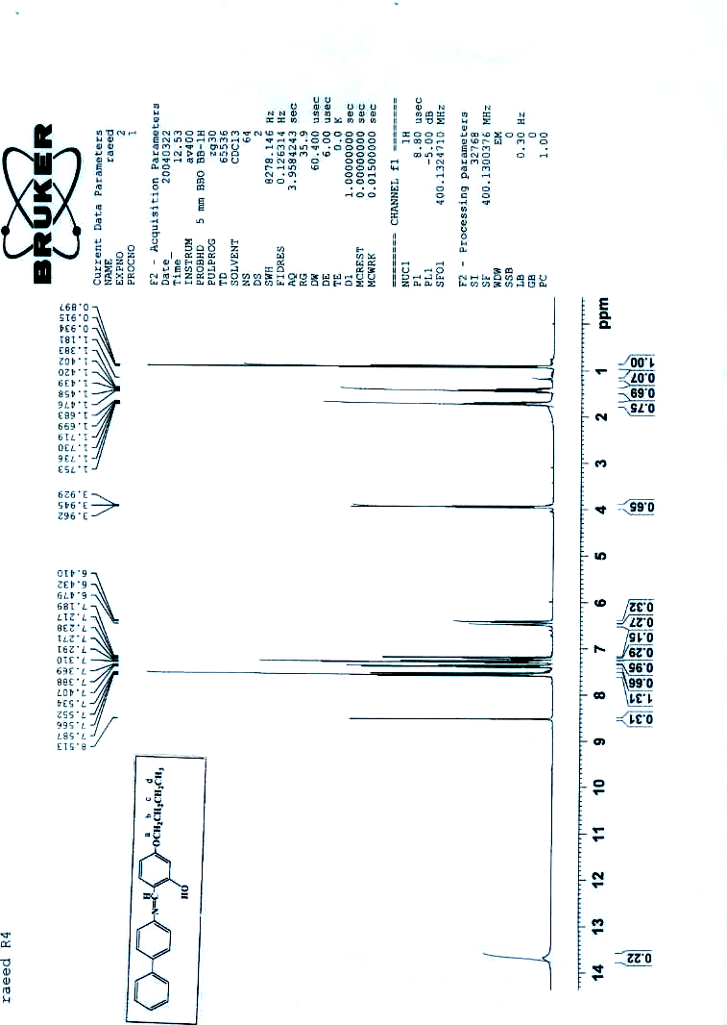
Fig.1: The ¹H-NMR Spectra of Compound ABA₄

Mesogenic behavior
The transition temperatures for all members of the series carried out by optical microscopy but DSC scans carried out on the members n = 5 and 7 only . Fig . 2 and 3 show the transition temperatures for ABA₅ and ABA₇ which are in a agreement with those obtained with optical microscopy (table 1).
As can be observed all the Schiff bases synthesized exhibit enantiotropic mesogenic behavior. All the members of the series show nematic (N) phase . The nematic phase showed the marbaled texture on heating and schilieren texture on cooling , but the members from n = 5 – 10 Showed smetic ( B) phase in broken fan shaped texture as well as nematic phase Fig. 4 ( a, b, c).
A plot of transition temperatures versus the number of carbon atoms ,n , in the alkyl chain for the series of compounds is shown in Fig. 5.
The plot show typical mesomorphic – isotropic transition temperature curve is a falling one with an apparent odd- even effect for the all members .
Increase in the alkyl chain length should have two effect two effects :
- To increase the inter molecular attractions between the sides of the molecules , because of the polarizability of each added methylene group .
- To decrease the inter molecular terminal attractions because of the increasing separation of the parts of the molecules containing the dipolar units .
Increase in the alkyl chain length should therefore increase the ratio of the lateral to the terminal attractions between the molecules , so making the probability greater that the layer arrangement will persist after melting when the terminal attractions are weakened . Smectic properties are therefore most likely to be observed in the long chain members of an homologous series of mesomorphic compounds . A common pattern of behavior is that the lower homologous are nematic , the middle members exhibit a smectic mesophase followed by a nematic and the long chain members e.g C₁₂ , C₁₆ are purely smectic .
When the numbers of atoms is made up to an even numbers by the addition of a CH₃ group , the terminal C – C bond lies in the direction of the major axis of the chain , but makes an angle of about 70⁰ with this axis when the number of carbon atoms is made up from even to odd . Thus , for an even number of carbon atoms in the new chain , the terminal C – CH₃ unit make a given contribution to the polarizability of the chain in the direction of its major axis , which is reduced by a factor of cos 70⁰ when the chain contains an odd number of carbon atoms . That is the polarizability of the alkyl chain in the direction of the major axis of the molecule increases most on passing from an odd to an even member of the series , and the nematic – isotropic transition temperature for the homologues containing an even number of carbon atoms should lie on a curve which is above the nematic – isotropic transition line for the odd members of the series⁽¹²⁾ .
In these terms , we can explain the alternation of the nematic – isotropic transition temperatures for an homologues series of alkyl ethers .

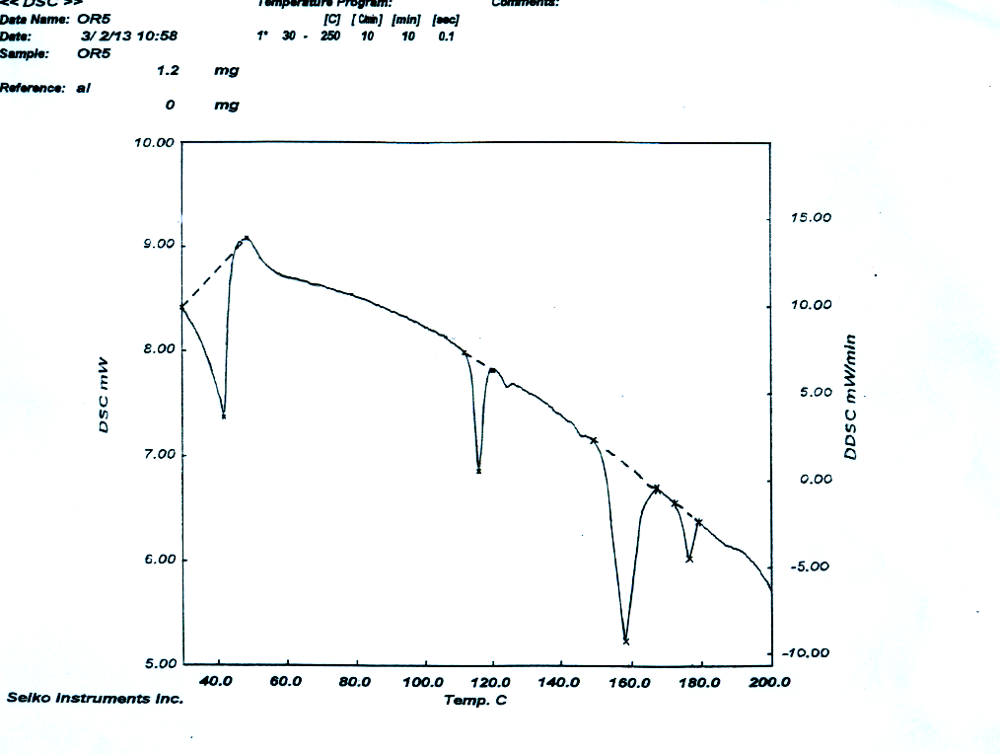
Fig . 2: The DSC curve of compound ABA₅

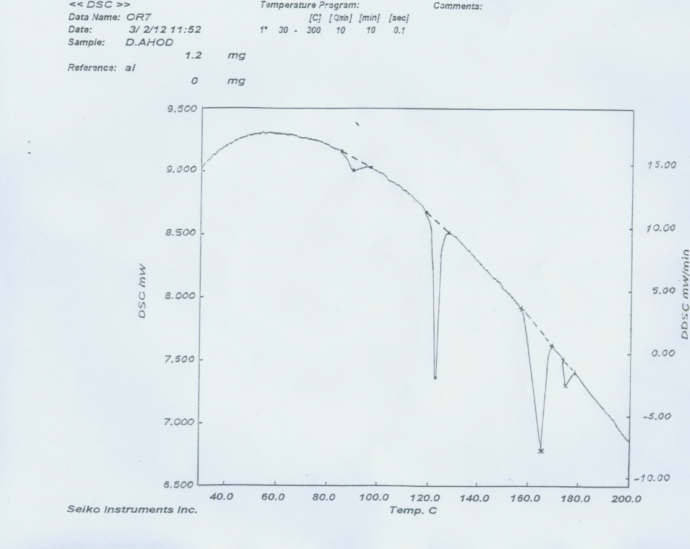

Fig. 3: The DSC curve of compound ABA₇

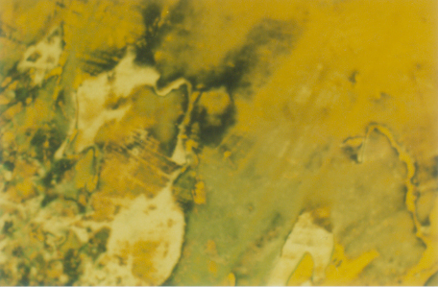
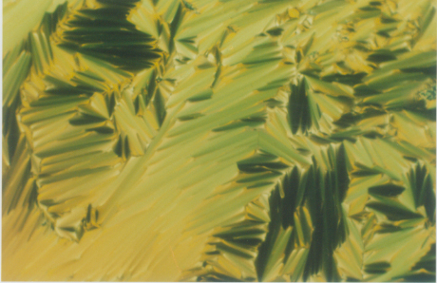
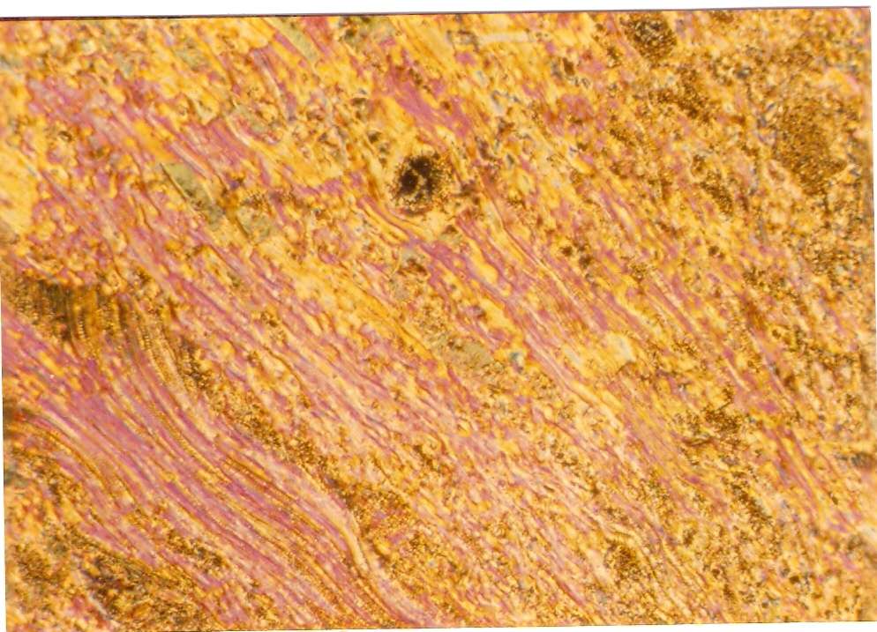
B
C
A

Fig.4 : Polarizing optical micrographs :
A : Marbaled texture in nematic phase for ABA₂ at 165^{O}C
B : Schilieren texture in nematic phase for ABA₂ at 189^{O}C
C : Broken fan shaped texture for smectic phase (S_{B} ) for ABA₅ at 132 ^{O}C

C - N
C - S_{B}
S_{B} - N
N - I
100
120
140
160
180
200
0
2
4
6
8
10
12
14
NO. of Carbon atoms
Transition temperatures (⁰C)
S_{B}
N
I

Fig.5 : phase transition temperature as a function of the alkyl length for the ABAn series

Comparison of the [4(4'-n-alkoxy -2- hydroxybenzylidene) amino biphenyl]
(table 1) with those for the analogous Schiff bases [4(4'-n-alkoxy benzylidene) amino biphenyl] (table 2) reveals the following :
- The Schiff,s bases of both series differ only by the replacement of ortho hydroxyl group in series I .
- The nematic phase appear at (n=1) in the two series and the phase remains up to and including the (n=10) in series I and II . The nematic thermal stability for members of series (I) is significantly lower than that reported for the corresponding members of series II .
- The smectic (S_{B}) phase appears in series II at ( n = 4,5) in cooling and appears in cooling and heating at (n = 6 ) to ( n = 10 ) as well as S_{A} , but in series I appears only S_{B} at ( n = 4 ) to ( n=10 ) .
Examination of the molecular structures of the compounds sherries I and series II follows this evidence is presented indicating that the introduction of hydroxyl group in the ortho position of the azomethine group leat to intra hydrogen bond .
This hydrogen bonding is reported to favour more order mesomorphisim phase ( S_{B} ) due to the increase in molecular planarity (gives the molecular a rigid central core) , the appearance of local permanent dipole moment and at the same time enhancement of the anisotropy of the electronic polarizability ⁽⁶⁾ .

Table 2 : phase transition temperatures (Cº) of series I (ABAn)
∆T_{S} | ∆T_{N} | N → I | C → N | S _{B} → N | C → S_{B} | C → C | رمز المركب
___ | 36 | 189 | 153 | ___ | ___ | ___ | ABA₁
___ | 34 | 193 | 159 | ___ | ___ | ___ | ABA₂
___ | 23 | 178 | 155 | ___ | ___ | ___ | ABA₃
19 | 21 | 183 | ___ | 162 | 143 | ___ | ABA₄
31.9 | 19 | 177 | ___ | 158 | 116.1 | 41.9 | ABA₅
37.6 | 16 | 182 | ___ | 166 | 128.4 | ___ | ABA₆
42.3 | 10 | 175 | ___ | 165 | 122.7 | 89.6 | ABA₇
44.0 | 3 | 173 | ___ | 170 | 124 | ___ | ABA₉
48.0 | 2 | 170 | ___ | 168 | 120 | ___ | ABA₁₀

Table3 : phase transition temperatures(Cº) of series II ⁽⁷⁾
∆T_{SA} | ∆T_{SB} | ∆T_{N} | N → I | C →N | S_{B} → S_{A} | C → S_{B} | N
___ | ___ | 8 | 169 | 161 | ___ | ___ | 1
___ | ___ | 40 | 187.5 | 147.5 | ___ | ___ | 2
___ | ___ | 30.5 | 168.5 | 156 | ___ | ___ | 3
___ | ___ | 28 | 175 | 147 | ___ | 132* | 4
___ | ___ | 30 | 167 | 137 | ___ | 136* | 5
7 | 5 | 25 | 169 | 144 | 137 | 132 | 6
9 | 7 | 15 | 165 | 150 | 141 | 134 | 7
13 | 14 | 10.5 | 164.5 | 154 | 141 | 127 | 9
17 | 14 | 2 | 159 | 157 | 140 | 126 | 10

C : Crystal , S_{B} : Smectic B , S_{A} : Smectic A , N : Nematic , I : Isotropic ΔT_{N} = Nematic range ΔT_{SB} = Smectic B range ΔT_{SA} = Smectic A range

References
- I . Carlescu , N . Hurduc , electronic – liquid Crystal Communications ., 2004, 31.
- H .T . nguyen , J.P . Bedel ., Pramana – Journal of physics , 2003, 61(2), 359.
- K.F .Csorba and A.Jakli , Macromol.Symp ., 2004, 218 , 81.
- A .K . Prajapati and N . L . Bon d . J Chem .Soc , 2006, 118(2) .
5. Z.S.Yuan , H.K. Zheng , Chinese Journal of chemistry , 2004, 22, 395.
6. M.Marcos, E.Melendez and J.L. Serrano, Mol.Cryst.Liq.Cryst., 983, 19, 157.
7. D.J.Byron, D.A.Keating M.T.O meill and R.C. Wilson Mol.Cryst.Liq.Cryst., 1980, 58, 179.
8. A.K.Prajapati and H.M.Pandya , J.Chem .Soc., 2005, 117(3).
9. B .K .Sadashiva and V.A . raghunathan , Pramana – Journal of physics, 2003, 61(2), 219.
10. M.Marcose . J.L. Serrano ., J. Chem .Mater., 1993, 5(9).
11. M.Marcose . J.L. Serrano ., J. Chem.Mater ., 1996, 6, 533.
12. G . W . Gray , Molecular structure and the properties of liquid crystals , ( London , academic press ) , 1962 .

