First- and Second-Order Derivative Spectrophotometry
for Individual and Simultaneous Determination of
amoxicillin and cephalexin

Sarmad B. Dikran
Department of Chemistry, College of Education- Ibn AlHetham, University of Baghdad
Mohammed J. M. Hussan
Department of Chemistry, College of Science, University of AL-Mustansiriya

(NJC)

(Received on 25/8 /2008) (Accepted for publication 11/1 /2009)

Abstract
A new spectrophotometric method for individual and simultaneous determination of amoxicillin and cephalexin depending on the first and second derivative mode techniques. The first and second derivative spectra of these compounds permitted individual and simultaneous determination of amoxicillin and cephalexin in concentration interval of (10 – 60μg.ml⁻¹) by measuring the amplitude of peak-to-base line, zero cross at certain wavelengths and the area under peak at selected spectrum intervals. The methods showed reasonable precisionand accuracy and have been applied to determine amoxicillin and cephalexin in four different pharmaceutical preparations.
الخلاصة
تم تطوير طريقة طيفية جديدة لتقدير الاموكسسلين و السفلكسين بشكل مفرد و وبشكل آنـي بالاعتماد على تقنيـــة المشتقة الأولى والمشتقة الثانية لأطياف هذه المركبات. لقد وجد ان المشتقة الأولى والمشـــتقة الثانية لأطياف هذه المركبــات تمكن من التقدير الاني لالاموكسسلين و السفلكسين بمدى تراكيز يتراوح بين ( 10 – 60 مكغم.مل⁻¹) و ذلك بقياس ارتـفاع القمة-خط القاعدة و قيـــاس ارتفاع المنحنـــي في نقطة التقاطع الصفري عند اطوال موجـية محددة لكل مركب, وكذلك من خلال قياس المساحة تحت الحزمة لمجلات طيفية محددة. لقد كانت النتائج التي تم الحصول عليها من تحليل المركبات قيد الدراســـة متوافقـة ودقيقة بشـــكل مقبول, كما وأمكـــن تطبيقها لتقديـــــر الاموكسسلين و السفلكسين بشكل ناجح في اربعة مستحضرات صيدلانية.

Introduction
Although many methods have been reported for sensitive and selective determination of antibiotics including solid phase extraction^{(1,2)}, thin layer chromatography⁽³⁾, liquid chromatography-mass pectrometry^{(4,5)}, light scattering-resonance Raleigh^{(6,7)}, radioimmunoassay⁽⁸⁾ and spectrophotometry⁽⁹⁾, little attention have been paid to develop new method for simultaneous spectrophotometric determination of antibiotics.
The importance of the derivative spectroscopy for interpretation of UV-VIS spectra and for quantitative analysis is well known and documented⁽¹⁰⁾. It has a great utility to resolve the overlapping spectra especially in those methods which lack selectivity making them suitable for application⁽¹¹⁾. Derivative spectrophotometric methods have been utilized for simultaneous determination of metal ion mixtures^{(12,13)} and could extend its uses to other analytical fields.
The purpose of this work is to determine amoxicillin and cephalexin using first and second derivative spectrophotometry and to demonstrate that these methods can be very useful tools for determining amoxicillin and cephalexin in mixture, without tedious and time consuming separation procedures.
Experimental
Apparatus
A Shimadzu UV1601 double beam UV-VIS spectrophotometer was loaded with Shimadzu UVProb Version 1.10 software and interfaced to Pentium-4 computer and Canon-810 laser printer to record the spectra and perform subsequent calculations of their derivatives.
The spectrophometric measurements were made at wavelength range 200-350 nm using 1-cm quartz matched cells. The derivative spectra were recorded with a fast scan speed, sampling interval=1.0 and slit width=2.0 nm.
Reagents
Amoxicillin Standard Solution ( 100 μg.ml⁻¹): 0.01 g of amoxicillin (obtained from the state company for drug industries and medical appliance (S.D.I.), Samara-Iraq) is dissolved in 1 ml 0.1 M sodium hydroxide solution then the mixture is diluted to 100 ml in a volumetric flask with doubled distilled water.
Working solutions were freshly prepared by subsequent dilutions.
Cephalexin Standard Solution (100 μg.ml⁻¹): 0.01 g of cephalexin (obtained from the state company for drug industries and medical appliance (S.D.I.), Samara-Iraq) is dissolved in 1 ml 0.1 M sodium hydroxide solution then the mixture is diluted to 100 ml in a volumetric flask with doubled distilled water.
Working solutions were freshly prepared by subsequent dilutions.
Analysis of capsule: The content of 10 capsules were mixed well and a certain portion of the fine powder was accurately weight to give an equivalent to 0.01g of amoxicillin or cephalexin, and dissolved in 1 ml 0.1 M sodium hydroxide solution. The resulted solution was diluted to 100 ml with double distilled water in a volumetric flask. The solution was filtered by using Whatmann filter paper No. 40 to avoid any suspended or un dissolved material before use.
Procedure
Individual determination of amoxicillin and cephalexin:
In 10 ml calibrated flask, transfer aliquots of amoxicillin or cephalexin solutions expected to contain (100 –600 μg) and dilute to the mark with doubled distilled water. The absorption spectra were recorded and show absorption maxima at 226 nm and 274 nm for amoxicillin, and 212 nm for cephalexin.
Determinations were made by measuring the first and second derivative values and area under peaks of their spectra at certain given wavelengths and wavelengths regions. The concentration of amoxicillin and cephalexin could be determined respectively.
Simultaneous determination of amoxicillin and cephalexin:
( i ) The content of a series of 10 ml calibrated flasks, containing 200 μg of cephalexin and different amounts (100 – 600 μg) of amoxicillin, were diluted with doubled distilled water. The absorption spectra were recorded against blank( prepared by the same manner as test solution but without cephalexin or amoxicillin) ; then by measuring the derivative values of their first and second spectra, the concentration of amoxicillin could be determined.
( ii ) The content of a series of 10 ml calibrated flasks, containing 200 μg of amoxicillin and different amounts (100 – 600 μg) of cephalexin, were diluted with doubled distilled water. The absorption spectra were recorded against blank( prepared by the same manner as test solution but without amoxicillin or cephalexin); then by measuring the derivative values of their first and second spectra at selected wavelengths and reagins, the concentration of cephalexin could be determined.
Results and Discussion
Absorption spectra
The absorption spectra of amoxicillin and cephalexin and for their mixture were recorded. Fig. 1 (a) shows the absorption spectrum of amoxicillin solution (20 μg. ml¹) with two maxima at wavelength 226 nm and 274 nm, curve (b) show the absorption spectrum of cephalexin with maximum wavelength of absorption at 212 nm. The total spectrum of mixture of (200 μg of each per 10 ml) is shown in curve c with λ_{max} (214 nm) between the absorption maxima of the two components.

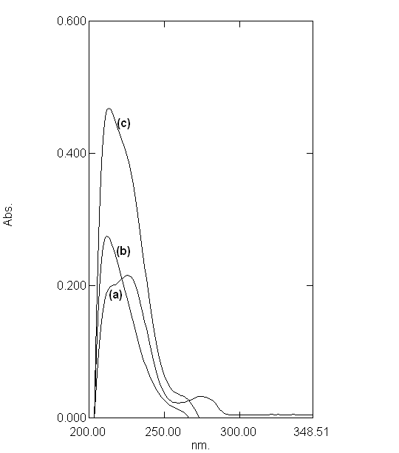
Figure 1: Absorpstion spectra of (a) 20 μg.ml⁻¹ of amoxicillin, (b) 20 μg.ml⁻¹ of cephalexin, (c) amoxicillin plus cephalexin.

First and second derivative modes
The first order and second order derivative spectra of amoxicillin and cephalexin and for their mixture are shown in Fig. 2 and Fig. 3 respectively.
It is obvious that there is a large overlap of the spectra of amoxicillin and cephalexin therefore, their determination, using the zero order absorption measurements, when present in the same solution is very difficult when using traditional two wavelengths of maximal absorption or the tangential base-line approximation⁽¹⁴⁾ techniques. On the other hand, derivative spectrophotometric technique is of a particular utility in determining the concentration of single component in such mixtures, with a large spectral overlapping. For this reason, derivative spectrophotometric methods have been applied. Both first and second order modes were tested, the results obtained show that these techniques could successfully applied when the measurements are carried out under optimum selection of slit width, response time, and scan speed for the monochromator. These were done by measuring the magnitude of derivative at several slit widths and scan speed with different response times. A slit width of 2 nm, a response time of 4 seconds and fast scan speed were found to be optimum.

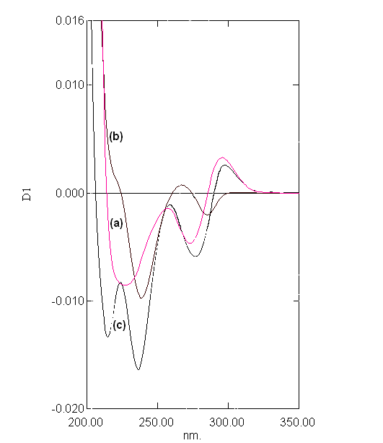

Figure 2: First derivative spectra of : (a) 20 μg.ml⁻¹ of amoxicillin, (b) 20 μg.ml⁻¹ of cephalexin, (c) amoxicillin plus cephalexin
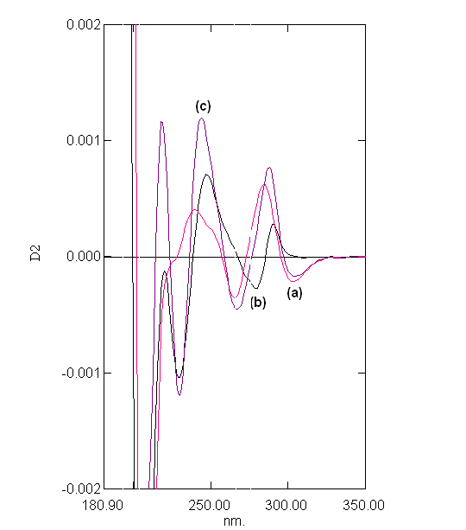

Figure 3: Second derivative spectra of : (a) 20 μg.ml⁻¹ of amoxicillin, (b) 20 μg.ml⁻¹ of cephalexin, (c) amoxicillin plus cephalexin

In the present work, graphically (peak-to-base line), zero-crossing technique in addition to peak area were used to deal with derivatives spectra to carry out the measurements.In fact that all these techniques in the first and second derivative modes show good proportionality to amoxicillin and cephalexin concentrations in their mixtures.
To select the derivative order, the first, second, third and fourth derivative spectra of amoxicillin and cephalexin were studied. The study reviles that first and second order spectra were simple and gave results of highest accuracy and detection limits.
Fig. 4 and Fig. 5 show sets of first order spectra of mixtures containing different amounts of each of amoxicillin and cephalexin in the presence of (20 μg.ml⁻¹) of the other compound respectively.
The results in Fig. 4 indicate that when the concentration of cephalexin is kept constant and the concentration of amoxicillin varied, the peak areas at the intervals (202 – 224 nm) and (224–262 nm) were proportional to the concentration of amoxicillin. Moreover, the peak-to-base line (i.e. amplitude measured in millimeter) at (236nm) was found in proportion to the amoxicillin concentration. The same features were found when inspecting Fig. 5 for the determination of cephalexin, i.e. peak areas in the wavelengths intervals of (225–254nm), (254–294 nm) and the peak amplitude measured at peak-to-baseline (275.5nm) and at zero cross of amoxicillin (223.9 nm) were in proportion to the concentration of cephalexin (Table1).

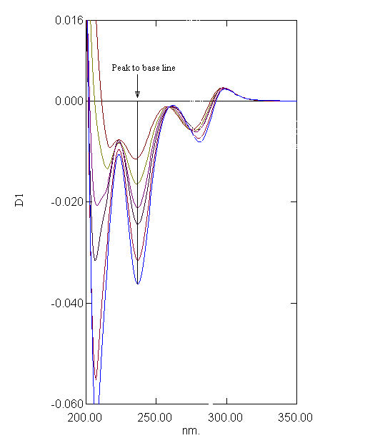

Figure 4: First derivative spectra of mixtures containing (10 – 60 μg.ml⁻¹) amoxicillin and 20 μg.ml⁻¹ of cephalexin.

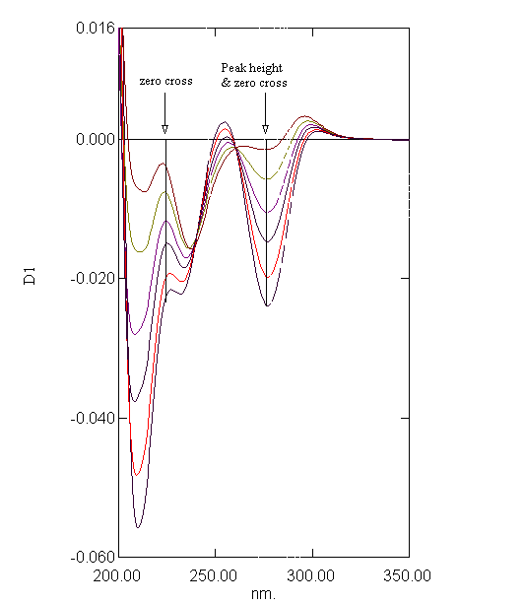
Figure 5: First derivative spectra of mixtures containing (10 – 60 μg.ml⁻¹) cephalexin and 20 μg.ml⁻¹ of amoxicillin.

Fig. 6 and Fig. 7 show further sets of second derivative of the same above mixtures. Applying the same mentioned techniques in measuring peak amplitudes (in millimeter) at peak-to-base line and at zero crossing point of the other compound, and peak areas at selected wavelengths intervals enable the measurement of amoxicillin and cephalexin respectively (Table 1).

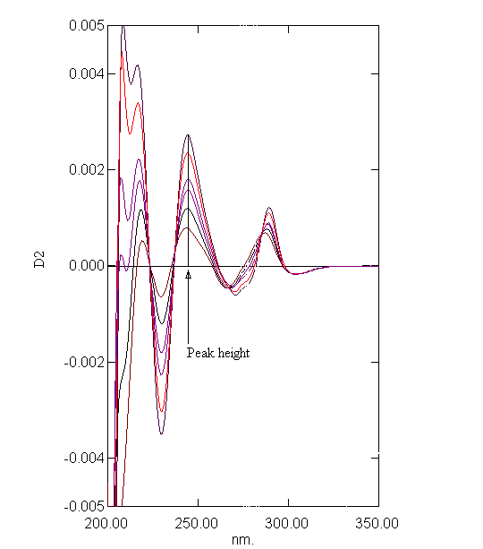

Figure 6: Second derivative spectra of mixtures containing (10 – 60 μg.ml⁻¹) amoxicillin and 20 μg.ml⁻¹ of cephalexin.
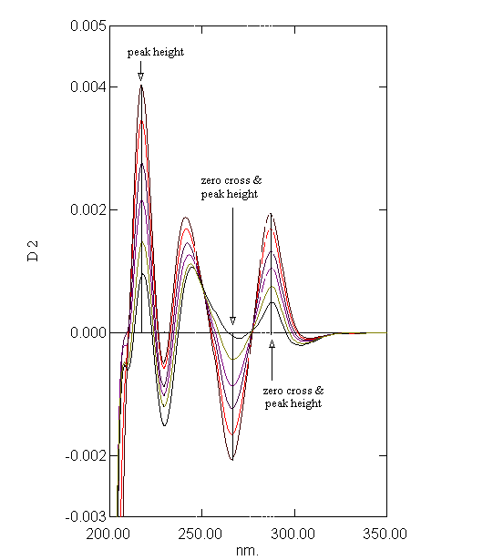

Figure 7: Second derivative spectra of mixtures containing (10 – 60 μg.ml⁻¹) cephalexin and 20 μg.ml⁻¹ of amoxicillin.

Calibration graph and statistical analysis
The analytical characteristics and most statistical data for each of the proposed methods are given in Table 1. Under optimum conditions, linear calibration graphs were obtained in the range of (10 – 60 μg.ml⁻¹) with correlation coefficient values ranging between (0.9995 – 0.9842) and detection limits values in the range of (4.2-0.21μg.ml⁻¹) for different techniques of measurements.

Accuracy and precision
Under the optimum conditions, the accuracy and precision of the proposed method (two different techniques for each of first and second order derivative modes) were checked. Table 2 shows the values of relative error percent and relative standard deviation percent for two different level of concentration of amoxicillin and cephalexin.

Application of the methods
Two of the proposed methods (namely first derivative – peak-to-base at 236 nm and second derivative - peak-to-base at 244.6 nm) were successfully applied for direct determination of amoxicillin in two different drugs. The results obtained are presented in Table 3, and are in quite agreement with the spiked values. On the other hand, amoxicillin has also been successfully determined in two different pharmaceutical preparations by two of the proposed methods. The results are shown in table 3.

Table 1: Statistical analysis of the determination of amoxicillin and cephalexin.

Compound | Order of derivative | Mode of calculation | λ (nm) | Regression equation | r | D. L.  μg.ml⁻¹
Amoxicillin | First | Peak area | 202-224 | Y=0.1105-0.01181 X | -0.8921 | 6.20
Amoxicillin | First | Peak area | 224-262 | Y=-0.0135-0.00774 X | -0.9987 | 0.56
Amoxicillin | Second | Peak area | 224-237 | Y=0.0001+0.00047 X | 0.9957 | 0.80
Amoxicillin | Second | Peak area | 237-259 | Y=0.0055+0.00057 X | 0.9991 | 2.00
Amoxicillin | First | Peak to base line | 236 | Y=0.0645+0.000485 X | 0.9987 | 0.21
Amoxicillin | Second | Peak to base line | 244.6 | Y=0.0004+(3.87e-5) X | 0.9993 | 0.27
Cephalexin | First | Peak area | 225-254 | Y=0.2088-0.00245 X | -0.9846 | -
Cephalexin | First | Peak area | 254-294 | Y=0.1426-0.01133 X | -0.9991 | 2.00
Cephalexin | Second | Peak area | 259-277 | Y=-0.0046+0.00052 X | 0.9984 | 0.51
Cephalexin | Second | Peak area | 277-320 | Y=0.0001+0.00042 X | 0.9965 | -
Cephalexin | First | Zero cross &  peak- to-base line | 275.7 | Y=-0.00365+0.00045X | 0.9992 | 3.40
Cephalexin | First | Zero Cross | 223.9 | Y=0.00037+0.00037X | 0.9994 | 2.10
Cephalexin | Second | Zero cross &  peak- to-base line | 287.5 | Y=0.00017+(2.98e-5)X | 0.9976 | 0.83
Cephalexin | Second | Zero cross & peak- to-base line | 266 | Y=-0.0003+(3.29e-5)X | 0.9986 | 4.13
Cephalexin | Second | Peak- to-base line | 229 | Y= 0.0003+(6.27e-5)X | 0.9995 | 0.53

Table 2: Precision and Accuracy of the methods.

Compound | Method of analysis | Taken (μg.ml⁻¹) | Fond *  (μg.ml⁻¹) | Relative error  % | Relative standard deviation %
Amoxicillin | First order (peak-to-base line) at  236nm | 10 | 10.213 | +2.130 | 2.130
Amoxicillin | First order (peak-to-base line) at  236nm | 60 | 60.460 | +0.766 | 0.299
Amoxicillin | Second order (peak-to-base line) at  244.6 nm | 10 | 10.197 | +1.970 | 0.568
Amoxicillin | Second order (peak-to-base line) at  244.6 nm | 60 | 60.343 | +0.572 | 0.165
Cephalexin | First order (peak area) in the range  254-294 nm | 10 | 10.410 | +4.100 | 0.748
Cephalexin | First order (peak area) in the range  254-294 nm | 60 | 60.200 | +0.333 | 0.135
Cephalexin | Second order (peak-to-base line) at  229 nm | 10 | 10.243 | +2.43 | 0.878
Cephalexin | Second order (peak-to-base line) at  229 nm | 60 | 60.388 | +0.646 | 0.277
* Average of four determinations.

Table 3: Results for analysis of amoxicillin and cephalexin in four pharmaceutical formulation samples.

Pharmaceutical preparation | Method of analysis | Labeled amount mg/tablet | Found amount mg/tablet
Pharmaceutical preparation | Method of analysis | Labeled amount mg/tablet | Mean value* | RSD% | E%
Amoxycillin S. D. I. - Iraq | First order (peak-to-base line) at  236nm | 250 | 244.53 | 0.74 | -2.18
Amoxycillin S. D. I. - Iraq | First order (peak-to-base line) at  236nm | 500 | 493.66 | 0.42 | -1.27
Amoxycillin S. D. I. - Iraq | Second order (peak-to-base line) at  244.6 nm | 250 | 245.90 | 0.64 | -1.64
Amoxycillin S. D. I. - Iraq | Second order (peak-to-base line) at  244.6 nm | 500 | 494.10 | 0.40 | -1.18
Pulmoxyl  MICRO LABS Ltd  India | First order (peak-to-base line) at  236nm | 250 | 242.67 | 0.98 | -2.93
Pulmoxyl  MICRO LABS Ltd  India | First order (peak-to-base line) at  236nm | 500 | 491.00 | 0.44 | -1.80
Pulmoxyl  MICRO LABS Ltd  India | Second order (peak-to-base line) at  244.6 nm | 250 | 242.79 | 0.59 | -2.88
Pulmoxyl  MICRO LABS Ltd  India | Second order (peak-to-base line) at  244.6 nm | 500 | 492.81 | 0.50 | -1.44
Cephalexin  S. D. I. -Iraq | First order (peak area) in the range  254-294 nm | 250 | 250.77 | 2.10 | +0.31
Cephalexin  S. D. I. -Iraq | First order (peak area) in the range  254-294 nm | 500 | 498.60 | 0.92 | -0.28
Cephalexin  S. D. I. -Iraq | Second order (peak-to-base line) at  229 nm | 250 | 248.80 | 0.71 | -0.48
Cephalexin  S. D. I. -Iraq | Second order (peak-to-base line) at  229 nm | 500 | 497.31 | 0.52 | -0.54
Cefalexin  APKES  Ajanta-Pharma Ltd | First order (peak area) in the range  254-294 nm | 250 | 244.10 | 1.98 | -2.15
Cefalexin  APKES  Ajanta-Pharma Ltd | First order (peak area) in the range  254-294 nm | 500 | 489.61 | 0.93 | -2.08
Cefalexin  APKES  Ajanta-Pharma Ltd | Second order (peak-to-base line) at  229 nm | 250 | 245.01 | 0.65 | -1.99
Cefalexin  APKES  Ajanta-Pharma Ltd | Second order (peak-to-base line) at  229 nm | 500 | 489.99 | 0.41 | -2.00
* Average of three determinations.

References
- Vimal K. B., Ken A. T. and John T.; Journal of Chromatography A, 2006, 1131(1-2), 1.
- Caro E., Marcé R. M., Cormack P. A. G., Sherrington D. C., Borrull F. ; Analytica Chimica Acta, 2005, 552(1-2), 81.
- Gulkowska A., He Y., So M. K., Yeung L. W. Y., Leung H. W., Giesy J. P., Paul K.S. Lam, Michael M. and Bruce J. R.; Marine Pollution Bulletin, 2007, 54(8), 1287.
- Choi K. J., Kim S. G., Kim C., Kim C. W., KimS. H.; Chemosphere, 2007, 66(6), 977.
- Lopez M. I., Pettis J. S., Smith I. B., Chu P. S.; Agric J.; Food Chem, 2008, 56 (5), 1553.
- Liu, S. P.; Hu, X. L.; Li, N. B.; Analytical Letters, 2003, 36 (13), 2805.
- Liu, S. P.; Hu, X. L.; Luo, H. Q.; Analytical Sciences, 2003, 19 (6), 927.
- Qin, Y.; Bao, L. J.; Zhu, L. M.; Fenxi Ceshi Xuebao, 2003, 22 (5), 60.
- Jiang, H.; Liu, S. P.*; Hu, X. L.; Liu, Z. F.; Zhan, H. L.; Kong, L.; Qin, Z. H.; Fenxi Huaxue, 2003, 31( 10 ), 1207.
- Askal H. F., Refaat I. H., Darwish I. A. , Marzouq M. A.; Spectrochimica Acta Part A: Molecular and Biomolecular Spectroscopy, 2008, 69(4), 1287.
- El-Sayed, A. Y. and Khalil, M. M. H.; Talanta, 1996, 43, 583.
- El-Sayed, A. Y., Abdel Rahem, M. A. and Omran, A.A.; Analytical Sciences, 1998, 14, 577.
- Koleva B. B., Kolev T. M., Spiteller M.; Journal of Pharmaceutical and Biomedical Analysis, 2008,48(1), 201 .
- O' Haver, T. C. and Green, G. L.; Anal. Chem., 1976, 48, 312.

