Extraction, Purification and Physicochemical Properties of Carcinoembryonic Antigen (CEA)

Sami A. Al-Mudhaffar and Sahib A. Al-Atrakchi
College of Science, Baghdad University College of Pharmacy, Karbala of Pharmacy,
Baghdad, Iraq Karbala, Iraq

(NJC)

(Received on 12/1 /2009) (Accepted for publication 19/1 /2009)

Abstract
A procedure has been described for the purification of the CEA of the human mammary carcinoma. Tumor tissue extraction in (0.6) M perchloric acid followed by Ion exchange and column chromatography on Sepharose CL–6B column resulted in highly purified CEA preparation as determined by both immunological and physico-chemical criteria. Such as, immunoelectrophoresis, stocks radius, isoelectric point, M.wt., stability and carbohydrate content. The collected data suggest that CEAs of mammary adenocarcinoma tissues with stocks radius (53 A°), pI (4) and the M.wt. have been found to be 175 KD.
Finally purified CEA preparation gave rise to single band by disc SDS – polyacrylamide gel electrophoresis and a single preciptin arc against corresponding monoclonal anti–CEA on immunoelectrophoresis. The purified CEA contained approximately 40% carbohydrate through determination by phenol – sulfuric acid method.
الخلاصة
تم تطوير طريقة لتنقية بروتينيات الـ (CEA) من مجانس الثدي الخبيثة بأستخدام عدة تقنيات شملت الاستخلاص بحامض البركلوريك وكروماتوغرافيا التبادل الايوني بأستخدام DEAE – cellulose وكروماتوغرافيا الترشيح الهلامي بواسطة Sepharose CL – 6B حيث تم عزل بروتينيات الـ CEA عالي النقاوة (وبلغت عدد مرات التنقية (66) مرة وقد اثبت الترحيل الكهربائي بهلام الاكريلامايد وبوجود المنظف SDS النقاوة العالية للبروتين المفصول نظراً لظهور حزمة واحدة فقط في الهلام).
قدر الوزن الجزيئي للـ CEA بطريقة الترحيل الكهربائي بهلام الاكريلامايد و بجود SDS حيث بلغ الوزن الجزيئي 155 كيلو دالتون اما بطريقة الترشيح الهلامي على عمود Sephasrose CL – 6B فبلغ الوزن الجزيئي 175 كيلو دالتون.
درست الصفات الفيزكوكيميائية والمناعية لهذه البورتينات والتي تتضمن نقطة تعادل الشحنة والقطر الجزيئي والترحيل الكهربائي المناعي والثابت الحراري.

Introduction
Carcinoembryonic antigen (CEA) is the name given by Gold and Freedman to a tumor – specific antigen found in adenocarcinoma of the digestive system ⁽¹⁾.
That the CEA is a glycoprotein was evident from its solubility and apparent stability in perchloric acid ⁽²⁾. In view of the heterogeneous nature of the glycoprotein it is impossible to define CEA precisely in terms of physical and chemical properties. A definition of CEA at the present time has to be based on its specific immunological reaction with a monospecific anti – CEA antiserum, which has been shown to be identical in specificity to the original antiserum prepared by Gold and Freedman ⁽³⁾. This is important since it has been clearly established that CEA possesses at least two different immunogenic groups; a unique group, which defines CEA – likes molecules and second is common to CEA and the normal glycoprotein (NGP) that is also found in normal and tumor tissues ^{(4,5,6,7)}.
There are several procedures available for the isolation and purification of CEA from different sources ^{(8,9,10)}. Most of these depends on routine methods by perchloric acid extraction and then using gel–filtration however, other methods such as affinity chromatography was used for purification of CEA from liver affected by metastasis of colon carcinoma ⁽¹¹⁾.
The objective of this paper was the preparation of a pure sample of CEA from mammary carcinoma (CEA) for immunological and physicochemical studies.

Materials and methods
1 CHEMICAL:
All laboratory chemicals and reagents were of annalar grade. Tris (hydroxymethylamino methane) was obtained from BDH.
All buffer solutions were prepared by dissolving the appropriate amount of salts in distilled water and the required pH was adjusted.
2. APPARATUS:
The apparatus used during this study were, LKB gamma Counter type 1270 Rack, Backman Model-25 spectrophotometer, cooling centrifuge type Hettsch, Pye-Unicam pH meter.
3. PATIENTS AND COLLECTION OF SPECIMENS:
All patients were admitted for treatment to Baghdad Medical city, AL–Husaney, AL-Arabia, and mursing home private hospital. They were histologically proven. Clinical information was recorded at the times were entered into the study by proper investigations and include age, menopausal status, tumor size, type of carcinoma.
The source of tumor tissues in this series of experiments were human breast. The specimens removed surgically from primary adenocarcinoma of the breast were taken only the central, obviously cancerous portion was used as tumor tissue for extraction.
Method

A- Extraction of CEA:
Samples were trimned of fat, weight, minced, in four volumes of homogenization buffer, (10% glycerol, 10-mM dithiotheritol, 10 mM Tris, 1.5 mM EDTA). The homogenization was done on an ice bath.
The homogenate was filtered through a nylon mesh sieve to eliminate fibers of connective tissues, then centrifuged at 2000 xg for 10 min at 4°C. The pellet was neglected and the supernatant was centrifuged at 2000 xg for 30 min at 4°C.
After removing the upper layer of fat, an appropriate volume of homogenate (500-μl) was diluted to 2.5 ml with homogenization buffer and treated with an equal volume of 1.2 mole/liter perchloric acid. After 30 min, the mixture centrifuge at 2000 xg for 10 min and the supernatant was dialyzed for 12 hours against distilled water⁽¹²⁾.
CEA was determined in an aliquot of perchloric acid extract by the solid phase sandwich (IRMA) as described in CEA kit provided by Byksangetec Diagostica GmbH & Co. KG/France.

B– Purification of CEA:

Ion Exchange chromatography
An aliquot of the lyophilized powder of the perchloric acid extracted from tumor tissue dissolved in 10 ml Tris buffer was loaded on the column. After an initial pre wash with 60 ml of Tris buffer pH 7.2 at flow rate of 60 ml/h. CEA was eluted with 400 ml linear gradient of sodium chloride, 0.0 M to 0.3 M, in Tris buffer. Fractions of 2 ml were collected. The eluate was constantly monitored for its spectrophotometric absorption at 280nm, and CEA activity was preformed as described previously. The specific binding of each fraction was calculated and plotted against the elution volume. Selected Fractions containing most of CEA were pooled, dialyzed against de-ionized water at 4°C for 48 hr and then concentrated to 5 ml with dialysis against sucrose. The protein content was determined using Lowry, et. al method⁽¹³⁾. CEA content was determined by IRMA method as described in CEA kit.

Gel filtration chromatography
The concentrated fractions obtained from DEAE-sephadex ion exchange, containing the CEA activity were loaded to a 6B-Sepharose column. Fractions of 4ml were obtained by elution with Tris buffer 0.2 M pH 7.2 at flow rate 20 ml/h. For each fraction, constant monitoring for its spectrophoto meteric absorption at 280 nm and CEA activity was performed as described in CEA kit. The total binding of each fraction was calculated and plotted against the elution volume.

C_ Analysis of the purified fraction by slab conventional polyacrylamide gel electrophoresis (PAGE):

PAGE technique was used to specify the purity of the CEA. Four protein solutions were used at concentration of 1300 μg/ml.

Homogenate protein (crude Extraction).

Protein fraction I: partially purified CEA by PCA.

Protein fraction II: purified by ion exchange.

Protein fraction III: purified by gel filtration.
The above two purified protein fractions were concentrated to the optimum concentration (1300 μg/ml.) by dialysis against sucrose
The procedure and PAGE technique were used as described in Ref(1,2,3)and (According to the application Note 306 issued by LKB Company).
3- Immunoelectrophoresis (IEP)

IEP technique was used for immunochemical identity of the purified CEA preparation and standard CEA against its corresponding mono clorat anti-CEA .

The method were used as previously described in Ref (1,2,3).
3-4 Determination of the Molecular Weight of Purified CEA by Gel Filtration Chromatography
Sepharose 6B column (2x90 cm) was used for this purpose . The gel was prepared according to manafacturey instruction .The partition coefficients (Kav) of the proteins eluted were determined using the following formula:

$$\text{Kav}=\frac{V_{e}−V_{o}}{V_{t}−V_{o}}$$

Where; Vo : void volume , Ve : elution volume Vt : the volume of the bed gel. The values of Kav were plotted vs. the values of log M. wt of the proteins eluted. The M. wt. of CEA was calculated from the standard curve obtained.
3-5 Estimation of Stock’s Radius of Purified CEA
The gel filtration procedure was run on 6B-sepharose column using Pharmacia calibration kit of six standard proteins, the partition coefficients (Kav) were determined and the values of (- log Kav) ½ were calculated, then plotted against the stock’s radius of standard proteins eluted. The stock’s radius of CEA was calculated from the straight line obtained.
3-6 Analysis of Purified CEA by Disc SDS - PAGE
Disk SDS–PAGE technique was used to assess the homogeneity of purified CEA and for the estimation of molecular weights.

- Sample preparation:
The samples were prepared by mixing 300 μl of stock sample buffer with 200 μl sample solution (0.2 mg/ml) followed by 50 μl 2–mercaptoethanol. Heating samples can be accomplished by inserting the vial of sample into a larger test tube and placing the test tube in boling water bath.
Standard proteins were treated exactly as described for sample preparation.

- The electrophoretic run:

The process for electrophoretic run ,protein staining and destatining according to manufacturey instruction and as described in Ref (1).
The relative mobility (Rm) of each standard protein and sample was measured as follows:

Distance moved by the protein
Rm =
Distance moved by the bromophenol blue

The log M.wt of the standard proteins was plotted against the Rm value and the molecular weight of CEA was calculated from straight line.
Determination of Isoelectric Point (PI) of Purified CEA ^{(95-97,99,100)}
Isoelectric focusing technique was used to determine the PI of CEA protein according to Wringley method ⁽⁹⁹⁾.
Carbohydrate Content Studies
The method of phenol-sulfuric acid which was described by Dubois⁽¹⁰¹⁾, used to determined the total carbohydrate of CEA in the sample.

Results and Discussion
Isolation and Purification of CEA
The results of a representative purification of CEA are shown in Table (1), Fig (1,2).
CEA has been purified by different techniques. In this study metastases tumor lesions was used whenever possible in order to obtain large quantities of cancer from single sources. Purification has been achieved by a sequence of procedures including perchloric acid extraction, Ion exchange and molecular sieve on sepharose 6B. Recent modification in this purification procedure has included the order of chromatographic steps, the gel filtration step of the purification protocol as the final. This protocol is more convenient than other methods of CEA purification that have been reported ^{(41,78,83-85,103-165)} . The final product (CEA) show a high degree of purity as determined by both phyiscochemical and immunochemical criteria (Fig 2,3), Also good yield and activity of CEA were obtained.
The purification by PCA was a chivied by denaturating and precipitating most of the tissue proteins while has a few effects on CEA, which remain in the solution ⁽¹⁰⁶⁾. CEA is generally considered to be stable in acid because it is soluble and its immunological properties are not destroyed. Table (1) shows that this step gives nearly 2.5 fold purification and complete recovery of CEA.
Upon DEAE – sephadex, the PCA of the tumor homogenate resolved into a number of components (Fig 1 (A&B)). The elution was performed with linear gradient of sodium chloride, 0.0 M to 0.3 M in Tris buffer then selected fraction containing CEA (Fig 1) were pooled, dialyzed, and then concentrated as described previously.
Ion exchange fractionation increased the specific binding activity 7.7 folds with a yield of 28% when this preparation was applied on gel filtration column, results obtained were depicted in greater details in (Fig 2) reveate three peaks. The second one was found to have binding activity, whereas the other were not. The resultant fraction that contained the binding activity of the second peak represents the finally purified CEA.
The purification fold by gel filtration step was 66.3 with 22.3% yield. The data suggested that the CEA proteins in mammary carcinoma are one form identical in molecular parameters.

Purity of CEA Preparation

The purity of isolated CEA was analyzed and confirmed by conventional polyacrylamide gel electrophoresis by using binding activity and coomasie blue stain as marker for detection of the CEA (Fig 3).
Immuoelectrophoresis of the CEA against its corresponding monoclonal anti – CEA gave rise to a single precipitin arc, corroborating that the CEA preparation contained no other cross – reacting substance contaminants.
An important considration in comparing the CEA isolated with CEA provided by Byksangetec Diagostic Gmbh&Co. France in it’s degree of immunochemical identity, both CEA gave a single preceptin arc in the same position when reacted with anti – CEA monoclonal antibody provided by Byksangetec Diagostic Gmbh&Co. France. As can be seen in Fig ( ) essentially similar arcs were obtained with both materials in beta globulin region.
Physicochemical Properties of Purified CEA
The physicochemical properties of purified CEA were investigated using different techniques. The molecular weight was determined by gel filtration and Disc–SDS– polyocrylamide gel electrophoresis (SDS – PAGE). The stock’s radius of purified CEA was estimated by gel filtration technique. The isoelectric point was evaluated using Disc gel of Ampholine PAGE.
Determination of molecular weight and stock’s radius by gel filtration was carried out using standard proteins of known molecular weights and stock’s radius. These proteins were applied to the column and eluted with Tris buffer (Fig 5,6). The elution volume (Ve) of each protein was estimated then Kav value was calculated as described previously . The application of the Kav value to the calibration curve (Fig 7 and 8) was led to the determination of the two molecular parameters. The purification of CEA by different techniques yielded finally purified CEA. The molecular weight and stock’s radius of this protein was175 KD and 53 A°.
The molecular weight of purified CEA also was determined by disc SDS–PAGE, (Fig 3–10) illustrated the calibration curve that was obtained in the presence of 1% SDS. The relative mobility’s (Rm) of the CEA protein was determined by segmentation of the gel into 0.5 cm slices after removing the SDS by washing and dialysis against Tris buffer the fraction was tested for the binding activity. Application of Rm value for CEA protein to the calibration curve yielded the molecular weight. (Fig 3 – 11) shows the disc SDS – PAGE profile for purified CEA. The results indicated a single band for CEA. The M.wt of CEA found to be 155 KD. The collected data of disc SDS – PAGE and those obtained from gel filtration chromatography suggested that the activated form of CEA were monomeric proteins. The molecular weight of activated CEA is 169 KD. These results are in agreement with studies revealed that CEA prepared from tissue and cells were M.wt 150 – 300 KD ⁽¹⁰⁷⁻¹¹²⁾.
Isolectric focusing technique was used for the estimation of isoelectric points (pI) of purified CEA.
Disc polyacrylamide gel was used containing ampholine with pH range 3.5 – 10.5, the gel then sliced and the binding activity of each segment with its pH was measured and coomasie blue as described previously. (Fig 3 – 12) was used to obtain the pI of CEA.
The results showed that the pI of purified CEA was (4). Many investigators have observed the CEA with isoelectric points of 3.5, 4.0, 4.25 and 4.5⁽¹¹²⁻¹¹⁵⁾. On the other hand, observations of CEA preparation with single isoelectric points of 4.8 ⁽¹¹⁵⁾ and 4.7 ⁽¹¹³⁾ has been reported.
Isoelectric focusing of crude tumor extracts yielded peaks of CEA activity at pH 2.4, 3 and 4.5 through 6.4 ⁽¹¹⁴⁾. In addition to that, Almudaffar and Al-Rubaee ⁽¹¹²⁾ isolated CEA from oral cancer tissue by gel filtration chromatography using sepharose CL-6B and sephadex G-50, and concluded that they were two types of CEA one with m.wt 1000 KD and pI value 6.3 while the second protein from the same tumor appeared to be (158 KD) and 8 as pI value.
Carbohydrate Content
The quantities of carbohydrate in finally purified CEA were approximately 40% as was determined by phenol–sulfuric acid method. These results are in good agreement with those reported previously.
The most marked variation between different CEA preparations is the content of carbohydrate, which can vary between about 80% for purified CEA of gastric origin to about 40% for CEA, derived from colonic metastases ⁽⁴⁴⁾.
The principal carbohydrate constituent of purified CEA preparation is N-acetylglucosamine, which was usually, constitutes approximatly 25% of total carbohydrate content of each preparation ⁽¹¹⁶⁾.
In contrast, N-acetylglucosamine is either absent or present only in very low concentrations in purified CEA preparations. Some degree of variation is usually noted in the fucose, mannose, galactose and sialic acid content of preparation of CEA derived from colonic tumor’s ⁽¹¹⁶⁾.
Stability of Crude and Purified CEA at -20°C
The crude and purified fractions of CEA were stored at -20°C during the experiment. It was carried out in order to study the stability of CEA and to check their efficiencies of binding through out the storage period. The results showed that CEA of crude fraction was more stable than this of purified fraction.

A-wash fractions

Fig. (1): Ion exchange chromatography of CEA Isolation on DEAE-Sephadex A50-
column equlibirated with 0.02 Moler tris buffer . 2ml fraction were collected.
After washing with 60 ml of tris buffer ( A-Fractions wash ) .The column was
developed with linear gradient of Sodium chloride ,0.00 - 0.3 M in tris buffer
(B-elution fractions ) .

Fig (2): Gel filtration profile of CEA on sepharose CL – 6B column
(All details are explained in the text)

(76)

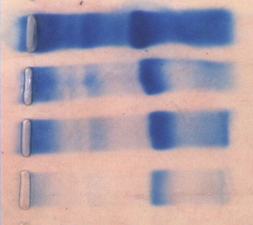

A

a

B

C

D

Fig. (3): Conventional – PAGE profile of CEA purification.
Fraction, A-D products of purification steps 1-4 as
described in table (3-3), and the binding activity in each
0.5 cm gel slice
(A)= Crude extract
(B)= Partially purified CEA by PCA
(C)= CEA purified by Ion exchange step
(D)= Finally purified CEA
(All details are explained in the text)

(77)

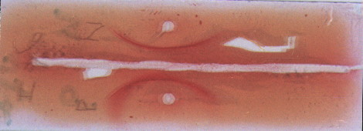

Fig. (4): Immunoelectrophoretic pattern of purified CEA
preparation. The upper well contains CEA standard,
and lower well contains purified CEA of human
mammary carcinoma.

Fig (5) Sepharose CL- 6B Chromatography of standard proteins
of Pharmacia gel filteration kit
(All details are explained in the text)

Fraction Number
Absorbance At 600 nm

Fig (6) Sepharose 6B-CL Chromatography of Blue Dextran 2000
(All details are explained in the text)

Fig. (7): Calibration Curve for Determination of M.wt by gel filtration
Chromatography
(All details are explained in the text)

Fig( 8) Calibration Curve for estimation of stock's radius by gel filtration
(All details are explained in the text)

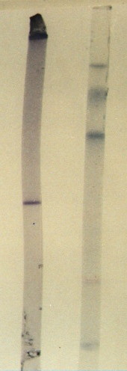
Thyroglobulin

Ferritin

Catalase
LDH

Albumin

Thyroglobulin

Ferritin

Catalase

Lectate Dehydrogenase

Albumin

Fig. (9): calibration Curve for determination of M.wt by
SDS – polyacrylamide gel disc electrophoresis.
(All details are explained in the text)

Fig. (10):SDS-PAGE disc electrophoresis. illustrate the electophoretic
profile of finally purified CEA (A) and high M.wt standard
protein (B). the anode is to the buttom
(All details are explained in the text)

(A) (B)
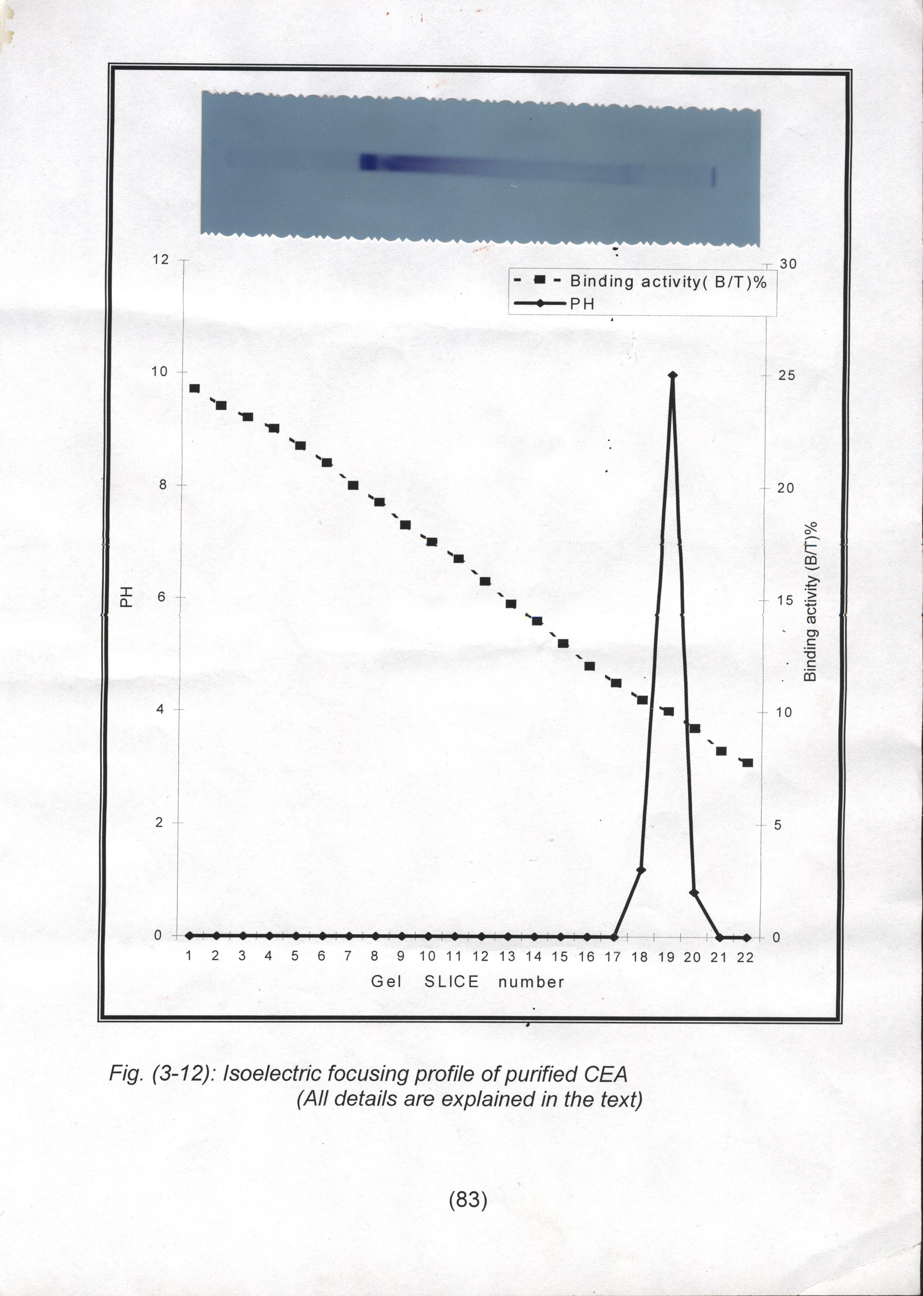

Fig. (11): Isoelectric focusing profile of purified CEA
(All details are explained in the text)

References
- Nakagoe, T., Nanashima, A., Sawai, T., Tuji, T., Yamaguchi, E., Jibiki, M., Yamaguchi, H., Yasutake, T., Ayabe, H.,Matuo, T., Tagawa, Y.; Oncology, 2000, 59, 131.
- Al-Kazzaz, F.F.; (2000), "Biochemical characterization of carcinoembronic Antigen in some colorectal Tumor"ph.D. Thesis, supervised by Al-Mudhaffar S.A., College of Science, Al-Mustansiriyah University.
- Al-Atrackchi, S.A.M; (2002), "Protein Engineering of carcinoembryonic Antigen and their Receptors Located in Mulignant Mammry tissues" ph.D. Thesis Supervised by Al-Mudhaffar S.A. College of Science, Baghdad University.
- Renehan, A. G., Painter, J. E., Atkin, W. S., potten, C. S., Shalet, S. M., O'Dwyer, S. T.; Br. J. caner.; 2001, 88(1); 107.
- Schullery, D. S., Ostrowski, J., Denisenko, O. N., stempka, I., shnurevs, M., Suzuki, H., Gschwendt, M. and Bomszty, K., J. Biol, Chem., 1999, 274, 15101.
- Wojciechowicz, D.C., Park, P.Y., Datta, R.V., and paty, P.B., Biochem. Biophys. Res. Commun., 2000, 273, 147.
- Zhou, D., Henion, T.J., J. Biol. Chem., 2000, 275, 22631.
- Kafasla, P., Patrinous–Georgoula, M., and Guialis, A.; Biochem, J., 2000, 338, 350, 495.
- Huang, S.; J. Struct. Biol., 2000, 129, 233.
- Eaman A. s; (2001) " Biochemical studies on some Tumor markers in oral cancer " PH.D Thesis, supervised by Al – Mudhaffar S. A., college of science, Baghdad University – Iraq.
- Leverroer, S., Cinato, E., Paul, C., Derancourt, J., Demark, M., Leanderson, T., and Legraverend, C.; J. Biol. Chem., 2000, 381, 1031.
- Faure, E., Equils, O., sieling, P.A., Thomas, L., Zhang, F. X., Kirschning, C. J., Polintarutti, N., Mizio, M., and Arditi, M.; J. Biol. Chem., 2000, 275, 11058.
- Maryam, T., Uri, S., Abraham, F., Joe. M, John. M, and Clifford, P.S.; .J. Biol. Chem., 2000, 275(35), 26935.
- Stroop, C.J. M, Weber, W., Nimtz, M., Gutierrez Gallego, R., Kamerling, J.P., and Vliegenthart, J.F.; Arch. Biochem. Biophys, 2000, 374, 42.
- Wojciechowicz, D.C., Park, P.K., Datta, R.V., and Paty, P.B.; Biochem Biophys. Res commun, 2000, 273, 147.
- Olga, V., Bajenova, Regis, Z., Eugenia, S., John, S., Rowswell, A., Nanji and Peter, T.; J. Biol. Chem., 2001, 276(33), 31067.
- Zimmer, R., and Thomas, P., Cancer Res., 2001, 61, 2822.
- Okajima, T., Nakamura, Y., Uchikawa, M., Haslam, D. B., Numata, S. I., Furukawa, K., Urano, T., and Furukaws, K.; J. Biol. Chem., 2000, 10, 1074.
- Lindblom, A., Liliegren, a.; Br. Med. J., 2000, 320, 424.
- Kos, J., Werle, B., Lah, T., Brunner, N.; Int. J. Biol. Marker, 2000, 15(1), 84.
- Al – Atrakchi S.A.M.; J. Al – Taqani, 2005, 18; 1.
- Al – Atrakchi S.A.M.; J. Al – Tagani, 2005, 18(5).
- Al – Atrakchi S.A.M.; J. Al – Tagani, 2005, 18.
- Al – Atrakchi S.A.M.; (2005), Development of radioimmunoassay for a lung tumor associated antigen, J. Al – Tagani, 18.
- Gebauer, G., Muller-Ruchhoiltz, W.; Cancer Dete-prev., 2001, 25(4), 344.
- Murata, K., Miyoshi, E., Kameyama, M., Ishikawa, O., Kabuto, T., Sasoki, Y., Hiratsuka, M., Ohigashi, H., Ishiguro, S., Honda, H., Takemura, F., Taniguchi, N., and Imaoka, S., Clin cancer Res 6, 2000, 1772.
- Fornes, N. M., Tanka, M., Matos, D.; Int. J. Biol Markers, 2001, 16(1), 27.
- Al – Mudhafiar, S.A. and Al – Atrakchi S.A.M.; Clinical role of CEA in human mammary carcinoma accepted for publication in National Journal of chemistry, 34, June, 2009.
- Bucdon, R. H.; (1985) Enzyme for Immunoassay practice theory of enzyme Immunoassay p. 178.
- Nakagoe, T., Sawai, T., Yuji, T., Jibiki, M., Nanashima, A., Yamaguchi, H., Yasutake, T., Ayabe, H., Matuo, T., Tagawa, Y.; Dig. Dise. Sci; 2002, 47, 322.
- May soon, K. H., (2001),”Molecular characterization of testostrone receptor in Mammary Tissues effected by tumors”. M.Sc. Thesis supervised by Al-Mudaffar, S. A., college of Science Baghdad University.

