Construction and buildup a semi-automated
flow injection conductimetric system

K. H. AL-Sowdani
Chemistry Department, College of Education, Basra University

(NJC)

(Received on 21/2 /2008) (Accepted for publication 24/11 /2008)

Abstract
A home-made semi-automated flow injection conductimetric system can be constructed and build-up from simple, inexpensive, off the shelf components and by designing a home -made conductivity cell. The accuracy of this system was evaluated by determination of KCl in two commercial drugs and representative samples. The combination of FIA technique with detector provides rapid, reproducible and conductometric sensitive system.
Key words: Home-made FIA, Conductometry, Drug, KCl.
الخلاصة
تم تصميم و بناء نظام شبه ذاتي لقياس التوصيلية بالحقن الجرياني من ىجزاء بسيطة و رخيصة و متوفرة على الرفوف وكذلك بتصميم خلية جريان عابر لقياس التوصيلية وتقييم دقة هذا النظام لتقدير تراكيز كلوريد البوتاسيوم في عقاريين تجاريين ونماذج اخرى ، ان الربط بين تقنية الحقن الجرياني و التوصيلية يوفر نظام حساس و سريع وذو استعادية عالية.

Introduction
Flow injection analysis (FIA) is one of the most popular continuous flow techniques ^{[1]}. It is simple and versatile analytical technology for automating wet chemical analysis, based on physical and chemical manipulation of dispersed sample zone formed from the injection of the sample into a flowing carrier stream and detection downstream ^{[2-4]}. FIA systems are characterized by very short response time and the analytical signals are obtained within seconds which leads to high sample throughput ^{[5]}. The sample volumes and the reagents consumptions are in the order of micro liters. A FIA is ready to run with a few minutes and applied in many fields of analysis by applied any detector can be equipped with flow cell ^{[6]}. One of the oldest and many ways simplest of electro analytical method is the measurement of electrolytic conductance ^{[7]}. The use of conductivity may be regarded as nonspecific way of detection but the association of conductivity with FIA has yielded a method involving the elution of the sample through a miniaturized conductivity flow cell ^{[8-15]}.In this laboratory at the time of this work of combining conductivity with FIA was put forward, no detector existed to accomplish that, therefore in this part of the present work, it was decided to constructing and build-up a semi-automated flow injection system which can readily be assembled from simple, inexpensive, off the shelf components and evaluated the accuracy of this system.

Experimental
During analytical applications with a home-made system deionized distilled water was used throughout and all reagents employed were analytical grade unless otherwise stated. Also, all conductivity measurements were made at 25Cº and the value of measurement as peaks height were the average of three successive measurements.
Reagents
A stock solution of 0.1 M potassium chloride solution (BDH) was prepared by dissolving 7.4560 g of anhydrous KCl in 1L of water. The working standard solutions were prepared by appropriate dilution of the stock solution with water.
Apparatus:
To monitor the conductivity with high sensitivity the flow system required a low pulsation flow to give a really stable baseline. Bidirectional pump (Watson-Marlow limited, H. R. Flow Inducer, serial No. 75506, and type MHRE 200) used to accomplish this, so it was used in the system shown in (Fig.1B) and 1.00 mm (i.d.) standard pump tubing was used with this pump to propel the dionized distilled water as a carrier stream.
The sample was introduced into the carrier stream through an injection valve (Rheodyne, Califorina) equipped with variable sample loop in the range (20-150 µL). Also the pump was used to control the temperature by circulated the water from the beaker filled with water place on the warming plate fixed at 25 Cº, through the outside of the jacking of the home-made flow cell which is design in our laboratory. Also, the conductivity cell unit was immersed in 250 ml tall form beaker placed on a regulator temperature hot-plate (Lassco-India) and all conductivity measurement were made by Jenway PCM3 (Essex, U.K) conductivity meter at 25 Cº.
In all experiments Teflon tubing of 0.5 mm (i.d.) was used for the rest of the flow system and the peak heights of FIA conductometric system were recorded by Siemens Kompensograph model 7KC 1032-8BC with output sensitivity range 0.01-500 V and speed control between ( 6 - 12 cm /h) a mini-colu/mn of mixed strong ion-exchange was incorporating in the flow system before the sample injection as shown in (Fig.1A) in order to eliminated the effect of any interferences in the carrier stream and also to achieve smooth baseline ^{[1,3]}.
The FIA Procedure
The carrier stream (dioinized distilled water) was pumped at flow rate of 2 ml \min. a 100 µL of sample was injected manually with injection valve into the carrier stream. The conductivity of the sample was measured by the conductivity bridge equipped with a homemade flow-through cell. The recorded peak height can be related to the concentration of the injected sample.
Result and Discussion
The flow injection system as shown in (Fig.1A, 1B) was used to optimize the variables influence the conductivity measurement by conducting a series of experiments to establish the optimum analytical conditions.
Flow Cell Design and a Cell Constant
Fig.2 shows the four cells which are design in our laboratory and in the glass blower unit of Science College, Basra University. The principle goal has been to minimize the cell volume without degrading performance ^{[16-17]}.
Table-1 list the peaks height which obtained from the injection of (0.1 M) KCl in these different cells, under the working conditions which clearly indicated that cell number-4 gives the height and reliable peak height. So, it was chosen for subsequent work. The cell constant was measured for the chosen cell No. 4 (Fig.2) in wide range of KCl (1x10⁻³ -1x10⁻¹ M) and it was suitable at 1.23 which was the same value of cell constant supply by Jenway ltd Co. ^{[18]}. Also, the design cell was jacked with water circulating system as previously described to measure the conductivity at stable temperature 25Cº which was intended to overcome to great extent the major disadvantages associated with conductivity measurements the temperature variation during the measurements ^{[19]}.
Effect of Flow Rate:
Flow rate is an essential parameter because it is variation has a great influence on the peak height. The effect in the range (0.5-3 ml\min) was studied under the conditions shown in (Fig.3). The results obtained are summarized in (Fig.3) which indicates that the peak height of 1x10⁻² M KCl was decrease with increasing the flow rate which thought to be due to increasing the dispersion of the injected sample in the flow system. So a flow rate of 2.0 ml min⁻¹ was chosen throughout this work in order to obtain a reasonable sample throughput.
Effect of Sample Volume:
The effect of sample volume was studied by changing the external loop of the injection valve in the range 25-150 µL. The results obtained shown in (Fig.4) shows that increasing the sample volume led to increase the peak height up to 150 µL after that the peak shape somewhat distorted , so 100 µL was injected as sample volume in subsequent experiments.
Effect of Mixing Coil Length:
Fig.5 shows the effect of mixing coil length on the peak height in the range 25-150 cm. The results show that the maximum peak height was obtained when the mixing length was 75 cm increasing the mixing coil length led to more dispersion in the system. So, 50 cm was inserted in the flow system for subsequent work.
Calibration Data
Under the established conditions, a correspondence calibration graph for KCl was obtained. It was linear in the range (0.025-0.4 M) as shown in (Fig.6 a). The linear graph has a regression coefficient of 0.9994 (5 points). Typical peaks obtained are shown in (Fig.6 b).
The relative standard deviation (r.s.d) for 10 replicates analysis of 0.1 M KCl was 0.9% (Fig.6b) and the detection limit (3 x noise) was 3x10⁻³ M. The dispersion in the flow system as shown in (Fig.1) was measured by injection of 0.1 M KCl solution and also by aspirating it continuously through the flow system. It was found to be 3 and sampling throughput was 100 sample\h.
Accuracy
The accuracy of the homemade flow injection system for the determination of KCl in two commercial drugs and two representative samples was examined by performing recovery experiments using the standard addition method. The results were compared with those obtained by classical ^{[20]} and Flame photometric methods^{[21]}. A good agreement between the results was obtained, as seen in Table 2.
In conclusion, the semi-automated flow injection system, which design and build-up in our department is sensitive, simple, fast, inexpensive and reproducible, mean of determination of KCl and many other compounds. Also, it can be used in routine water analysis to assist the quality of different type of water and as a detector for ion chromatography system, which will be described in the second part of this work ^{[22]}.
Acknowledgments
I would like to thank the glass blowing unit in College of Science, for their help in many ways.

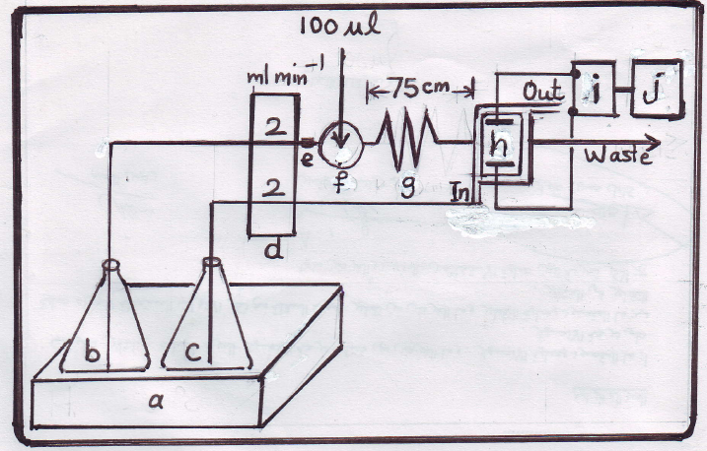

Fig. 1A The diagram of a home-made semi-automated Flow Injection Conductometric System

a) Regulator temperature hot- plate b) Carrier stream c) Circulator water d) Bidirectional pump e) A mini- column ion exchange f) Injection valve g) Mixing coil h) Conductivity flow cell i) Conductivity meter j) Recorder

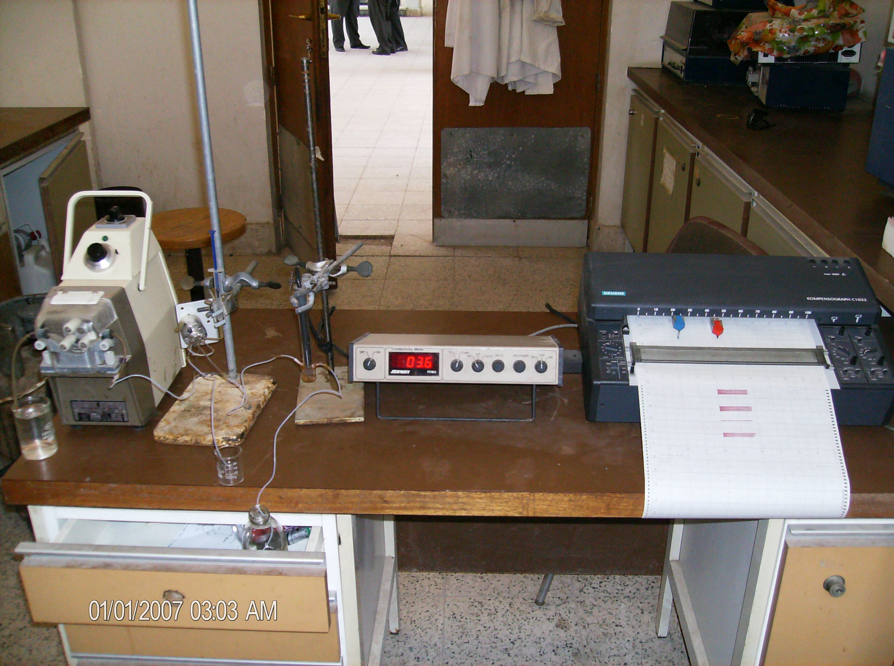
(a)

(b) ( c ) (d) (e)
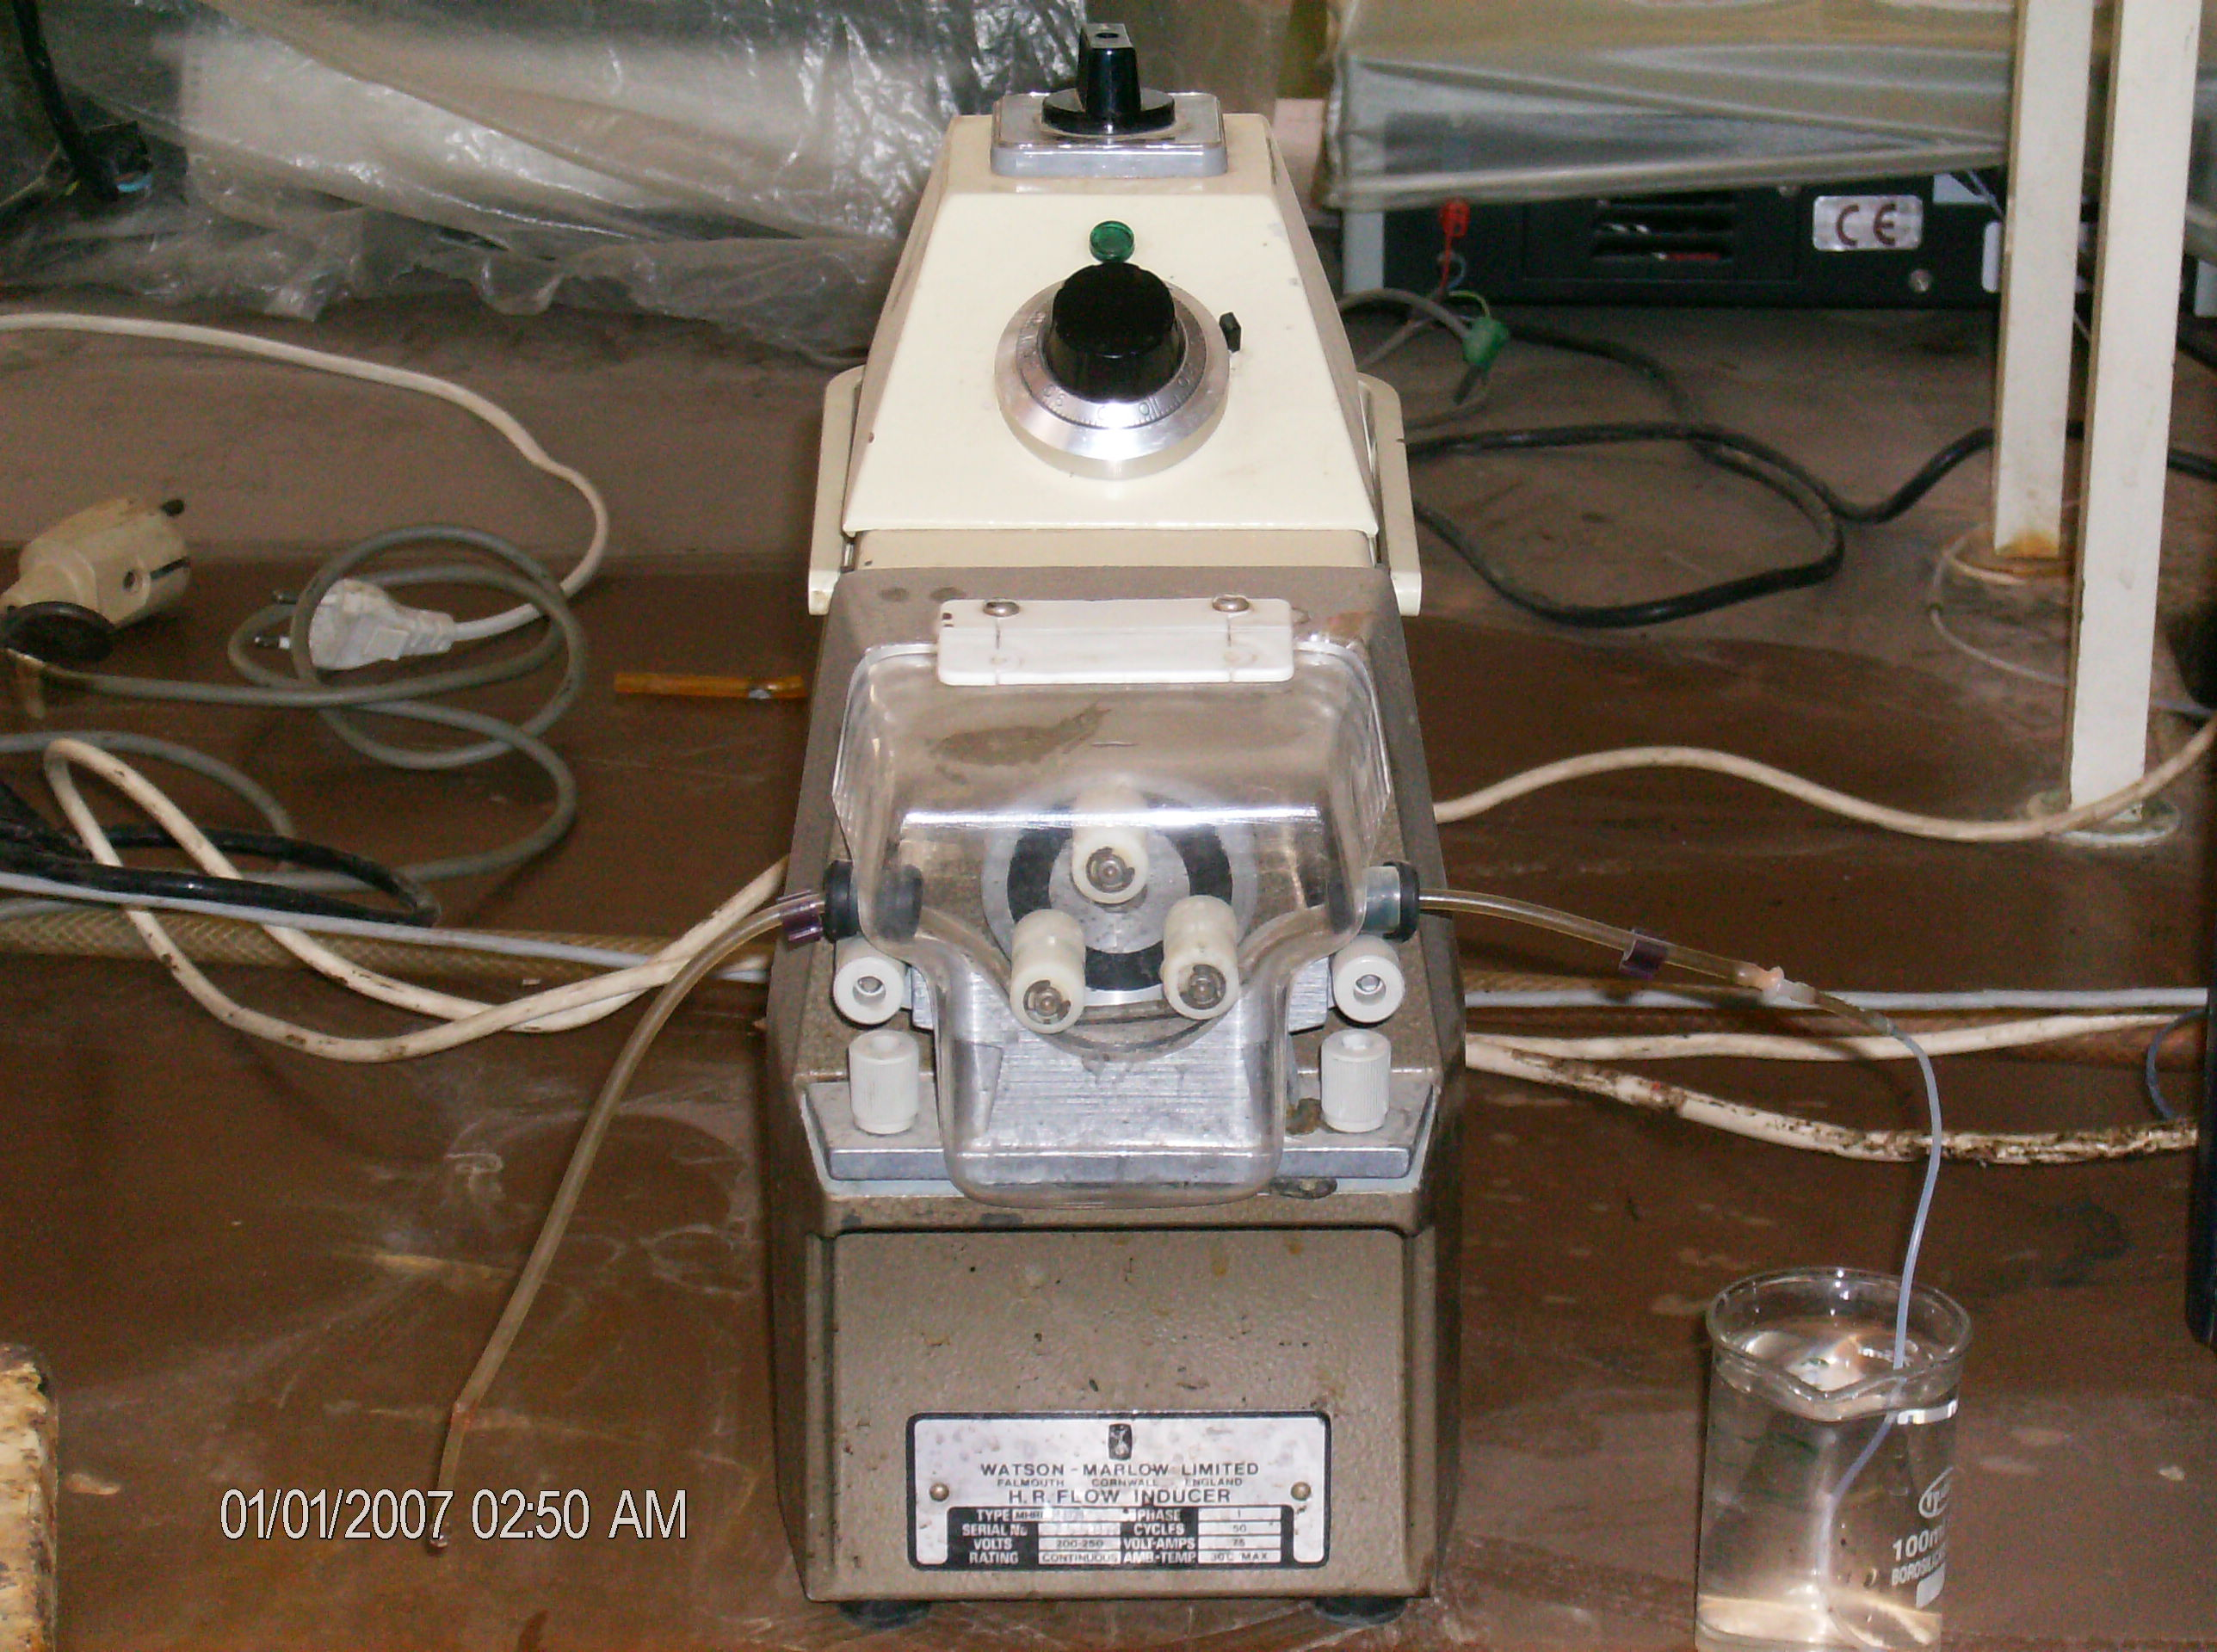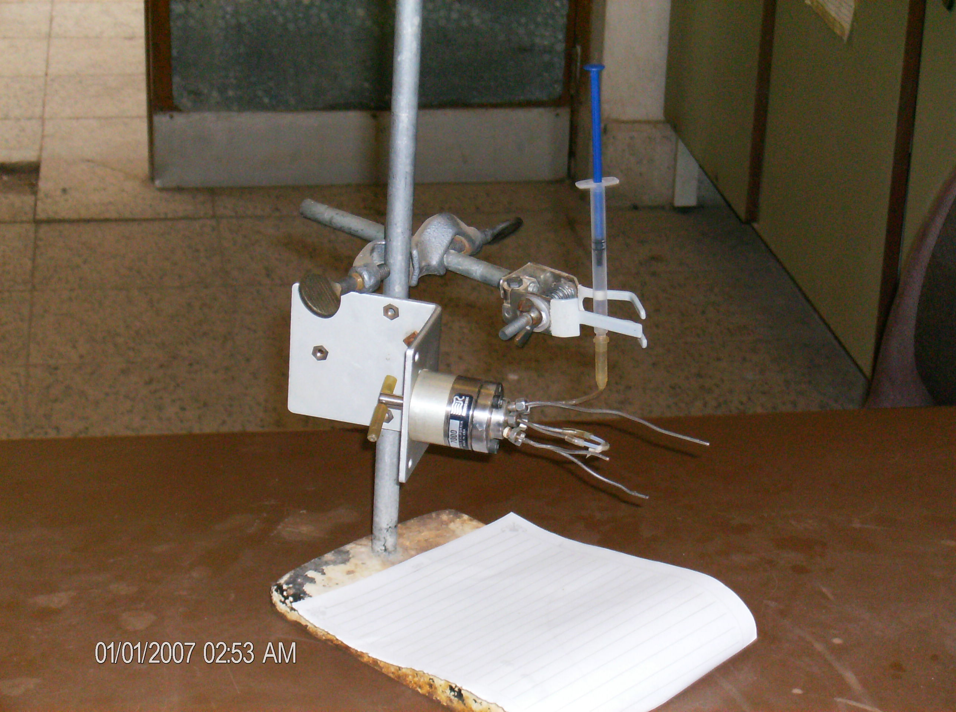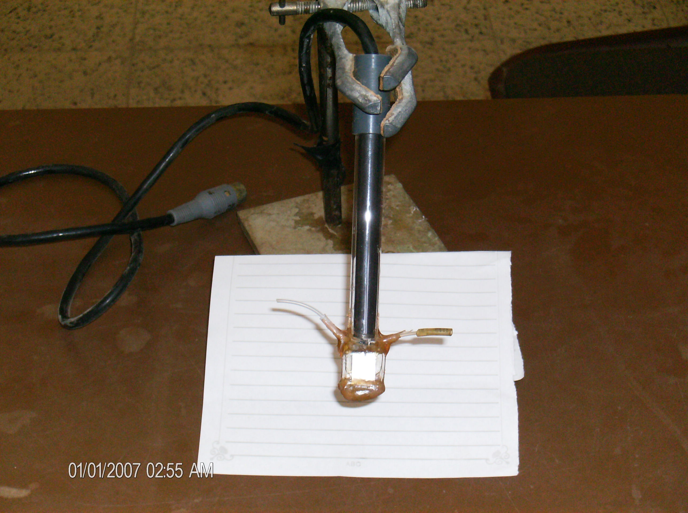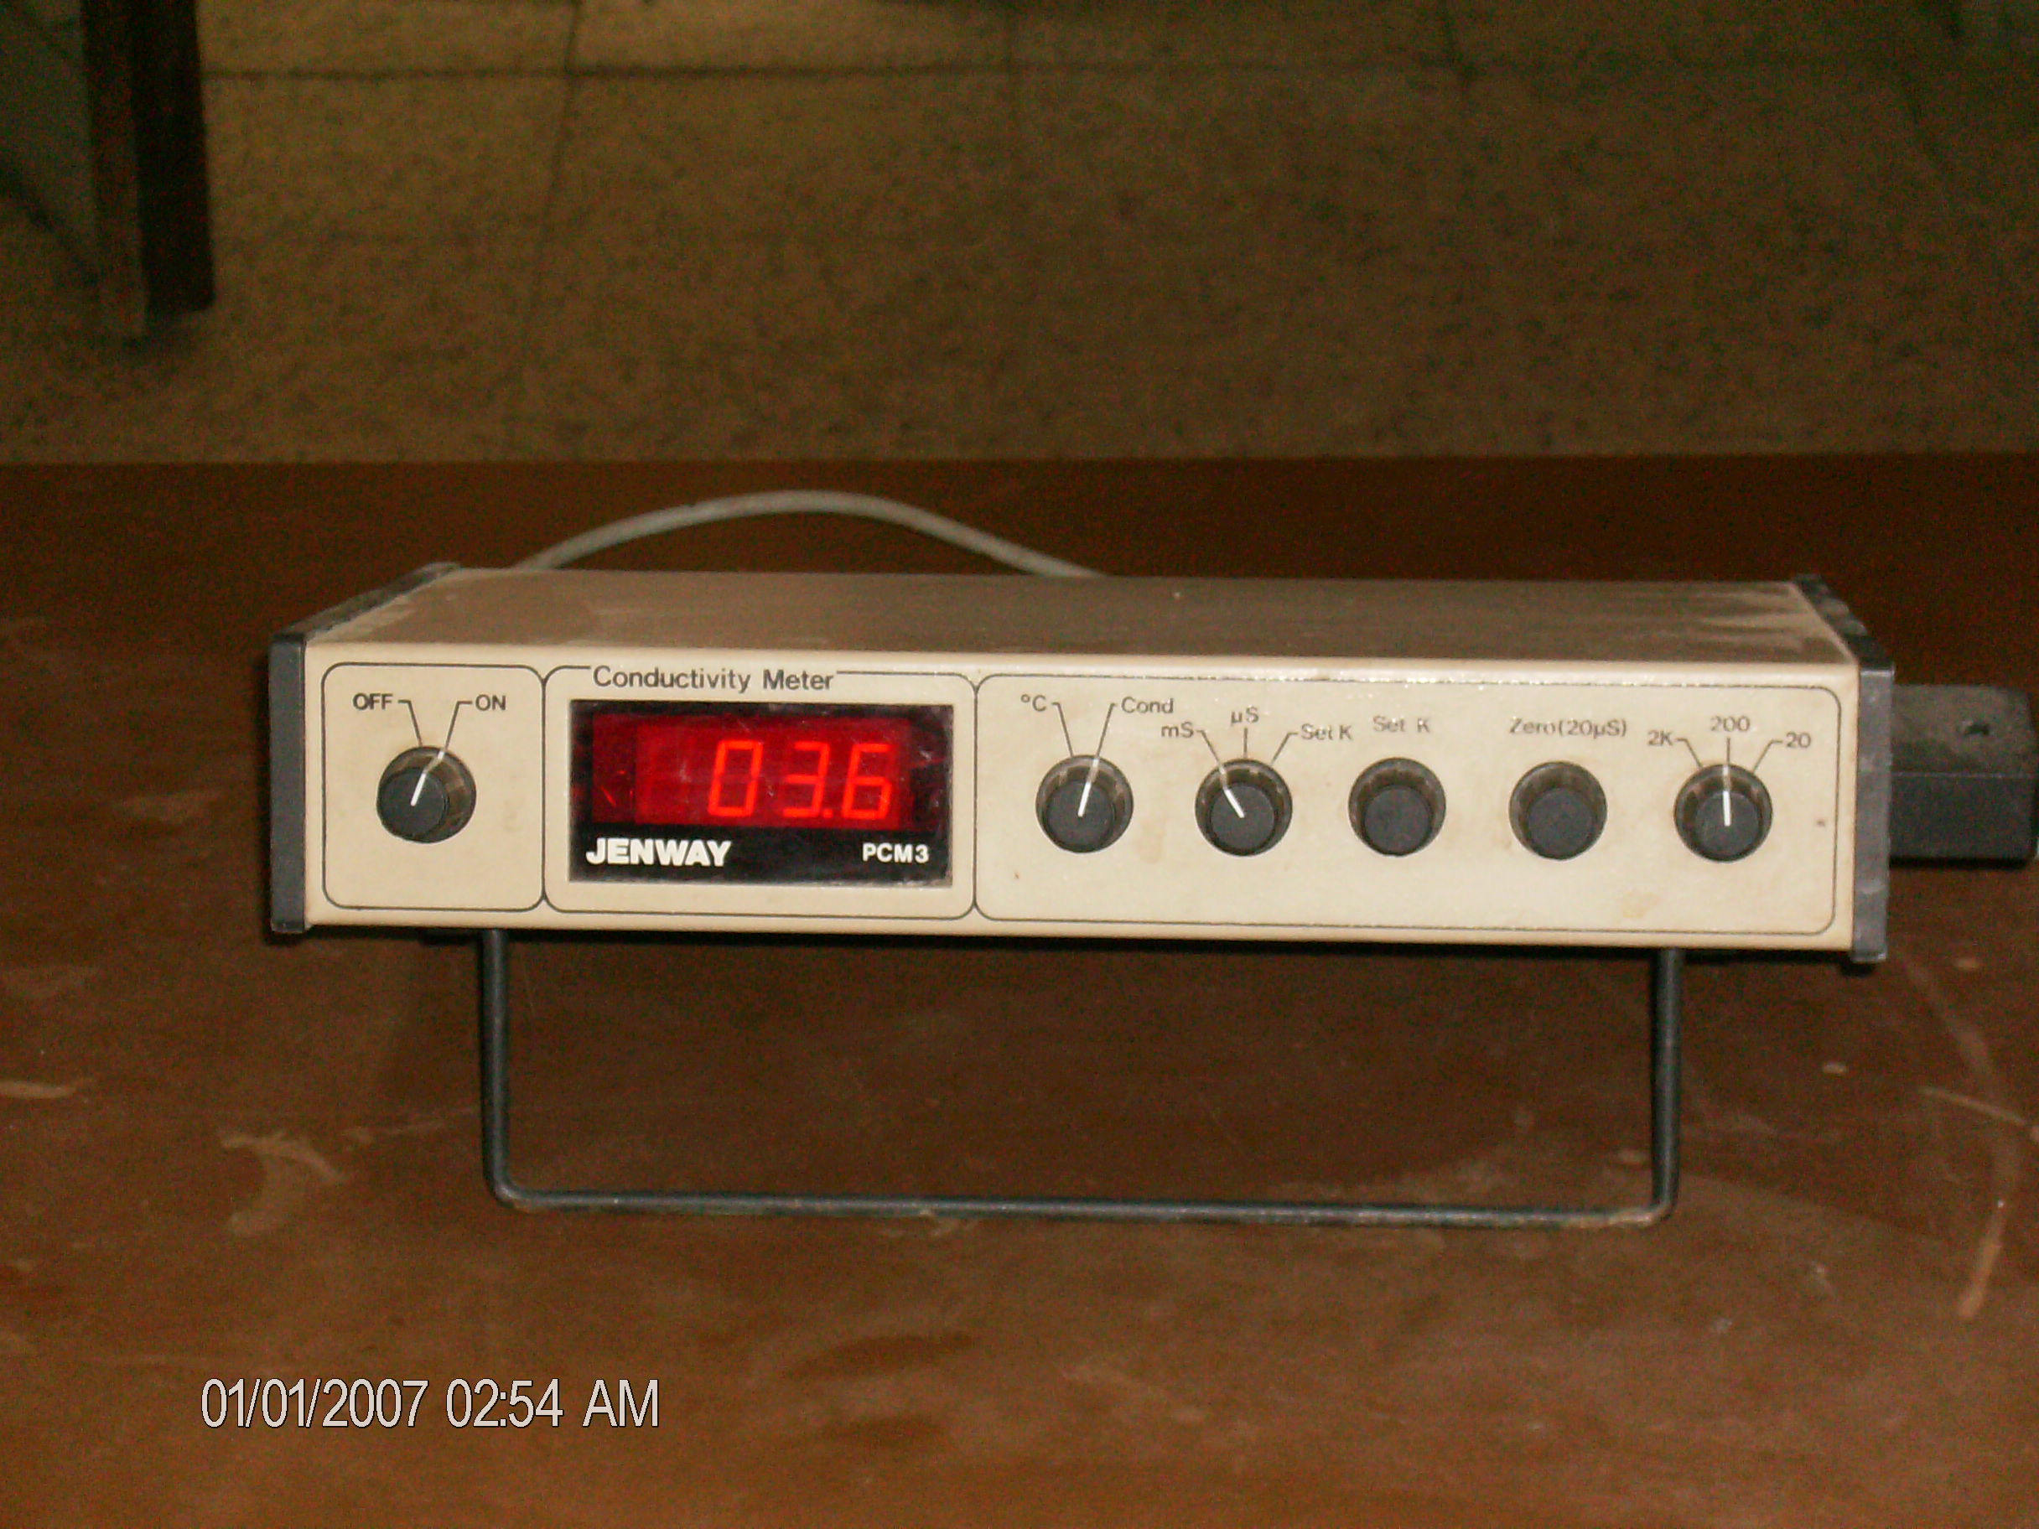
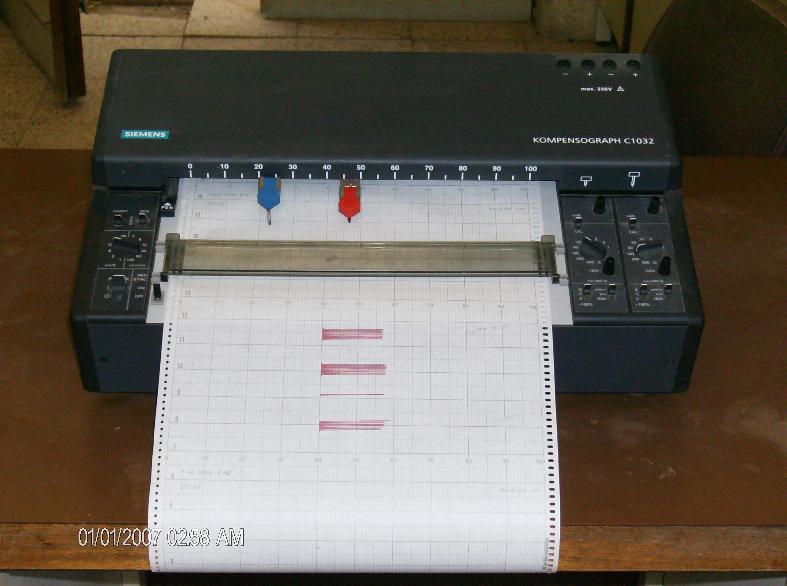
(f)

Fig. 1B (a) The home-made semi-automated Flow Injection
Conductometric System
(b) Bidirectional pump.
(c) Injection valve
(d) Flow cell
(e) Conductivity meter
(f) Recorder

Fig.2 The four home-made flow cells which designed in our laboratory

Fig. 3 Effect of flow rate on the peak height of 0.1 M KCl

Fig. 4 Effect of the injected sample volume on the peak height for 0.1 M KCl

Fig. 5 Effect of mixing coil length on the peak height of 0.1 M KCl

(a)
(b)
0.025 M
0.1 M
0.2 M
0.3 M
0.4 M
37 mm
1 min.

Fig. 6 (a) Correspondence standard calibration graph of KCl
(b) Peaks obtained by injection KCl standards in the concentration range shown above

Table -1 Comparison of the peak height obtained by different designed flow cells

*Cell No. | Mean peak height (mm) of  0.1 M KCl | + R.S.D %
1 | 21.10 | 3.10
2 | 30.00 | 2.50
3 | 28.20 | 2.20
4 | 34.00 | 0.95

* As shown in Fig. 2
+ Mean of three replicate

Table-2 Determination of KCl in two drugs and prepared samples by using Standard addition, Classical conductivity and Flamephotometry methods

Recovery% | Flam-  photometry | Recovery% | *Classical  conductivity | Recovery% | FIA* | Claimed or added  mg / ml | Sample
102.56 | 240 | 97.43 | 228 | 98.29 | 230 | 234 | 1ª
101.66 | 610 | 101.16 | 607 | 101.5 | 609 | 600 | 2ª
 | 12.20 | 114.00 | 11.40 | 95 | 9.5 | 10 | 3^{b}
109.00 | 109.00 | 110.00 | 110.00 | 98.1 | 98.1 | 100 | 4^{b}
a- Drug sample (A. 15% KCl U.S.P, conc. injection solution 2 meq / ml.
B. Strile and Pyrogen free P.S.I, Jeddah, KSA.)
b- Representative sample
* As shown in Fig. 2

References
1. Ruzicka J., and Hansen, E. H, "Flow Injection Analysis" 3rd ed. J. Wiley, New York (2005).
2. www.globalfia.com.
3. Valcarcel M. and Luque de castro M.D.,"Flow Injection Analysis, Principles and Applications "Ellis Horwood, Chichester, J. Wiley (1987).
4. Kalberg,B., and Pacey,C.E., "Flow Injection Analysis, Practical Guide, Elsevier, Amsterdam (1989).
5. Al-Omran, S.S.N., M.Sc. Thesis, Basra University (2007).
6. Ruzick, J., and Hansen E.H., Anal. Chem. Acta, 1980, 114, 19.
7. Strok, J.J., Anal. Chem., 1984, 56, 561A.
8. Ishibashi, N., Kina. K.,and Gato,Y., Anal.Chem.acta., 1980, 114,325.
9. Olsson, B.,Anal. Chem. Acta., 1982, 136,133.
10. Canete,F,Rios,A.,M.D.Luque de Castro and Valcarcel,M.,Analyst, 1988, 113, 739.
11. Betteridge, D., Cheng, W.C, Dagless, E. L, David, P., Good, T. B., Deans, D.R., Newton, D.A., and Pierce, T.B., Analyst, 1980, 108, 17.
12. Miller,T., Adv.Instrum.,1980, 35,21.
13. Reijin,J.M.,Linden,V.d.,and Poppe,H.,Anal.chem.Acta.,1980, 114,105.
14. Altiokka,G.,Alkosar,Z.,and Can,N.O,J.Pharm.Biomed.Anal.,2002, 30(3), 881.
15. American Public Health Association, Standard Methods for Examination of Water and Waste Water.17 th ed., Maryland, USA (1989).
16. Jaylor, D and Nieman, T.A, Anal. Chem. Acta, 1984, 159, 397.
17. IUPAC, Pure Appl. Chem., 2004, 76(6), 1119.
18. Catalogue, Jenway Ltd. Essex, UK (2006).
19. Stark, J.G. S. and Wallace H. G, Chemistry Data book. 2nd. Fletcher and Son Ltd., Norwich, UK,(1982).
20. British pharmacopia, Her Majesties, Stationary office London, (1980).
21. Al-Shammari M. A. K. MSc. Thesis, Basra University (2000).
22. Al-Sowdani, K. H., and Khedher, K. R., Chem. Dept. Univ. of Basra.
(Unpublished work).

