Synthesis and Characteristic of Tin(II) Complex

with Amino Acid (Alanine)

Tariq H.Al-Mgheer
Chemistry Department, Collage of Medicine, Babylon University

(NJC)

(Received on 23/6 /2008) (Accepted for publication 31/12 /2008)

Abstract
This research involves the preparation Complex of Sn(II) with alanine in general formula [Sn(Ala-H)₂] were (Alanine = Ala = C₃H₇NO₂ ) , the complex have been characterized by spectroscopic method [FT-IR , UV –Vis , Atomic absorption]along with molar conductivity measurements , chloride content , melting points and determination of the expected structures for complex , soon the mole ratio (L:M)by continues variation method (Job's method), stability constant(K_{f})and Gibes free energy(ΔG).
The proposed molecular structures of the complex drown according to computed program Chem. office 2003.
الخلاصة
تم تحضير وتشخيص معقد القصدير (II) مع الالانين ذو الصيغة العامة :
وشخص المعقدبالطرق الطيفيةالاتية(الاشعة تحت الحمراء (Alanine=Ala=C₃H₇NO₂, ان اذ [Sn(Ala-H)₂] الاشعة فوق البنفسجية وطيف الامتصاص الذري) ، التوصيلية الكهربائية ، محتوى الكلور ، درجات الانصهار، وتحديد الشكل الفراغي المتوقع من خلال دراسة النسبة المولية (فلز : ليكاند) بطريقة التغيرات المستمرة (طريقة جوب) . تم رسم الشكل المتوقع باستعمال البرنامج الجاهز Chem . Office 3D(2000) . كذلك تم حساب ثابت التكوين (K_{f}) والطاقة الحرة لجبس (ΔG) للمعقد.

Introduction
The discovery of antitumor activity of cis-platin (cis-PtCl₂(NH₃)₂)has led the world wide researches to investigate the antitumor activity of thousand compounds of platinum and other metals . The main interest in transition metal complexes has remained, but the numbers of results for complexes of other complexes of amino acids/ derivatives have recently been discovered.¹⁻³ Besides some new platinum (II) and palladium (II) complexes,^{4,5,6,7} some oregano tin,⁸ lanthanide,⁹ gold,¹⁰ and copper¹¹⁻¹³ complexes.
In this paper we present the synthesis and study the complex Sn (Alaninato)₂ .

Experimental Methods
a- All the chemicals were reagent grad (fluke & BDH) and were used without further purification . FT. IR spectra were recorded as KBr discs using Fourie Transform Infrared Spectrophotometer Shimadzu 24FT-I.R8300. Electronic spectrum of the prepared complex were measured in the in DMF at 25ºC using shimadzu-U. V-160A Ultra Violet Visible- Spectrophotometer with 1.000±0.001 cm matched quartz cell. metal contents of the complex were determined by Atomic Absorption (A.A)Technique using Japan A.A-670 Shimadzu. Electrical conductivity measurements of the complex were recorded at 25ºC for 10 ⁻ ³ M solutions of the samples in DMF using pw 9527 Digital conductivity meter (Philips) . The modeling package chem. 3Dprog (ver 3,5,2)Cambridge soft (2000)
Melting points were recorded by using Stuart melting point apparatus .
b-General method^{14.} Sodium alaninate (Na⁺Ala-—H) is prepared by neutralization of 1mmol( 0.08 gm ) of alanine acid with 1 mmol (0.04 gm) of NaOH according to the following reaction :

(1mmol) (1mmol) (Sodium alaninate)

in water up on addition of aqueous solution of tin (II) chloride mole ratio (1:2), white–yello precipitate which was filtered and washed with (5ml) ethanol (5 ml) ether and
dried at room temperature give (67%) , m.p = 216 (dec) , Sn% (Anal-found 43% - 44%) ,Cl% (Nill)The complexes are insoluble in water and common organic solvents but are soluble in DMF . The low values of the molar conductance (5.26 mhos cm² / mol) of the solutions (10⁻³ M) of the complex in DMF at 298º K indicated that the complex is neutral . ⁽¹⁵⁾

Results and Discuss
Spectral data (Table-1 and 2) are computable with the suggested structure (Fig.1) I.R Spectra
Table1: gives the characteristic absorptions for the free ligand and its complex .
The spectrum of free ligand (Fig.2) : The infra red spectrum of free ligand exhibited a strong band around (3379) cm⁻¹ that corresponds to the stretching vibration of υ (N-H) + υ(O-H), while another strong absorption band at (1618) cm⁻¹ is appeared which could explained as υ(COO-)asym where the υ(COO-) symmetric stretching vibration of alanine or sodium alaninato was assigned band at (1411) cm⁻¹ ⁽¹⁶⁾
The spectrum of complex : The spectrum arising from the complex reveals that the absorption band belonging to the stretching vibration of υ (N-H) of the amine group have been found in the (3421) cm⁻¹ . The IR spectra show strong evidence in support of involvement of carboxylate group in coordination.In comparison with free aminoacids, in comparision with free aminoacids,theυ(COO-) (asym)shows positive shifts and υ(COO-) (sym) records negative shifts,which confirm that the carboxylate group attach to Sn metal as monodentate group.¹⁷
This increase in frequency on formation of the O-M bond may results from one of the carbon-to oxygen bonds having more double bond character than the other carbon-to-oxygen bond , although the bond between the central metal ion and the (COO-) group is essentially electrostatic . The band 356 and 423 cm⁻¹are assigned to υ(Sn-O) and υ(Sn-N) , respectively . ^{17,18}

Table(1): Assignment of infrared frequencies in Cm⁻¹of alanine and its complex
Bis [Sn (Ala-H)2]
Δ (COO⁻ sy COO⁻ asy) | COO⁻)) υ  sy | υ(COO⁻) asy | υ(C-H) | υ(NH₂₎  sy | υNH₂ asy | compound
207 | 1411 | 1618 | 2937 | 3087 | 3379 | Alaniae
252 | 1373 | 1625s | 2894 | 3089 | 3421s-br | Sn (Ala-H)₂

The electronic spectrum of the ligand and its complex are listed in Table(2) together with the proposed assignments .The spectrum of the free ligand (Ala_{-H}) in DMF solvent show two high intensity band in wave length 304 nm (32894 cm⁻¹) εmax (391l.mol⁻¹.cm⁻¹) and277nm. (36101 cm⁻¹) εmax (343l.mol-1.cm⁻¹) assineddto (n → π*) and (π → π*) transition respectively. ¹⁹ The low bands are observed in the region , 2337 ε(max) and assigned as charge - transfer bands , indicating the formation of bond in the -bond and ( pπ - pπ ) bonds ²⁰ between P - orbitals of oxygen and vacant 5d orbitals of tin.

Table (2): The Electronic Spectra for the Free Ligand (Ala) and its Complex
[Sn (Ala-H)₂] in DMF (10⁻³M)
Assignment | E(Kcal /mol) | ε(max) L.mol⁻. cm⁻¹ | υ (cm⁻¹⁾ | λ (nm) | Compounds
π→ π٭ n → π٭ | 103.20 93.08 | 343  391 | 36101  32894 | 277  304 | Ala= (C₃H₇NO₂)
Charge transfer | 84.78  79.36 | 2337  1108 | 29673  27777 | 330  364 | Sn (Ala_{-H})₂

Proposed Molecular Structure
Studying complex on bases of the above analysis, the existence of tetra coordinated
[Sn (Ala-H)₂] , A proposed models of the speciese were built with chem 3D ²¹ shows in Fig (1) .

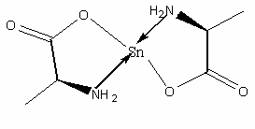

Fig (1) : The proposed molecular structure of the [Sn (Ala-H])₂] .

The Ligand coordinated to the metal ion as uninagative bidentate Ligands through the oxygen atom in the carboxyl group (COO⁻) and the nitrogen atom of the (-NH₂), as shown below/Selected geometric parameter (A,^{O}) selected bond lengths and angles are presented in table(3) .
In the [Sn (Ala-H)₂] complex alanine ligand is coordinated through N7 and O6 atoms as achelate ligand (Fig (1))The tin complex has distorted tetrahedral coordination with N-Sn-O, O-Sn-N, O-Sn-O and O-Sn-Nangles are equal from 104º to 125º.The bond lengths are: Sn(17)- O8:2.050 Aº, Sn-O10:2.050 Aº ^{21,22} .

Table(3):Selected Bond lengths (Aº) & Bond angles(º)

Bond angles (Aº) | Bond lengths (Aº)

The mole ratio (L:M)by continues variation method (Job's method), shows in Fig (2) .
The results showed that Sn(II) complex were found in (2:1) ratio of L:M .
The stability of the complex in solution were investigation by evaluation of (K_{f}) (stability formation constants) by electronic spectra (fig :2 , table 4) and Gibes free energy(ΔG) according to the following equation : ^{22,23}

VL/ (Vm+ VL) | Vm/ (Vm+ VL) | ABS | VL(ml) | Vm(ml)
0.0 | 1.0 | 0.0 | 0 | 10
0.1 | 0.9 | 0.25 | 1 | 9
0.2 | 0.8 | 0.37 | 2 | 8
0.3 | 0.7 | 0.48 | 3 | 7
0.4 | 0.6 | 0.56 | 4 | 6
0.5 | 0.5 | 0.74 | 5 | 5
0.6 | 0.4 | 0.86 | 6 | 4
0.7 | 0.3 | 0.43 | 7 | 3
0.8 | 0.2 | 0.29 | 8 | 2
0.9 | 0.1 | 0.18 | 9 | 1
1 | 0.0 | 0.0 | 10 | 0
Fig(2) : Mole ratio (M:2L) by continuos variation method (Job's method)

[1] ……… M_{X} L_{n} xM +nL =

[Formation Constant](Kf) or (stability Constant)(K)

[2] ……… _{n} = K_{f} 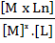_{n} = 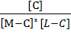

concetration ligand [L] = concentration matel [M] = 1 ×10⁻³
[3] ……… A = εbc_{o}

ΔG = – 2.3 R.T. LogK (Gibs free energy) ………[4]

ΔG = – 2.3 x 1.98x300 (5.90)=-8178 K cal \mol

Table (4) ; Is containing accounts of K, Log K, ΔG, to the complex with its concentration (1×10⁻³ mol. L⁻¹)

ΔG  Kcal \mol | Log  Kf | Kf mol/L | C_{o}  primary concentration  for matel or ligand | ε₁ ε₂ ε_{ava} matel ligand average |  |  | ABS٭  low  concentration  for ligand | ABS٭  low concentration  for matel | Complex
 |  |  |  | ε = 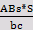  (L.mol-1.cm⁻¹) |  |  | ABS٭  low  concentration  for ligand | ABS٭  low concentration  for matel | Complex
-8178 | 5.90 | 8×10⁵ | 0.00029 | 2400 | 2300 | 2500 | 0.23 | 0. 25 | Sn(Ala_{-H})₂

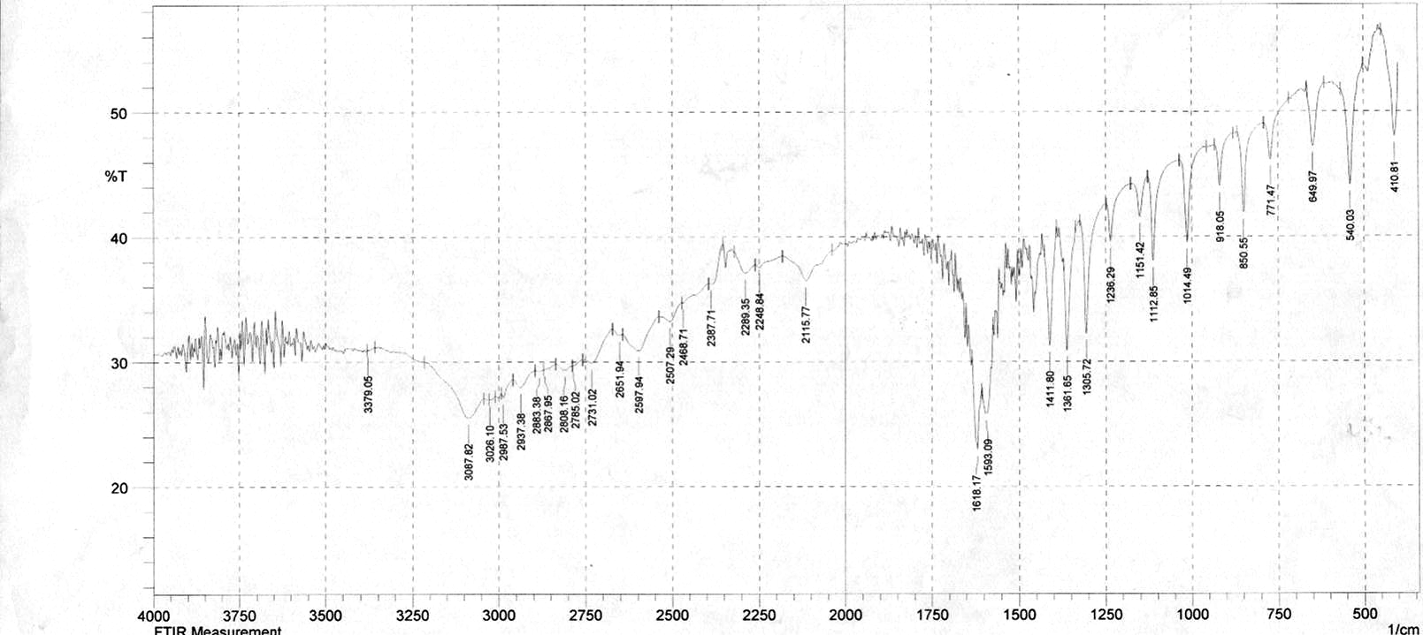
Fig(3) FT-IR Alaninate ion

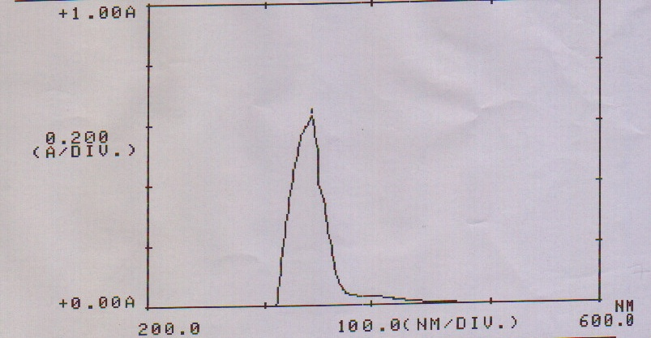

Fig(4 ) Uv –Vis Alaninate ion

References
- H. Kumita, N. Asai, T. Sakurai, K. Jitsukawa, T. Ozawa, H. Masuda and H.
Einaga, Inorg. Chem. Commun., 2000, 3, 185.
2. P. Leverett, J. Petherick, P.A. Williams and R.S. Vagg, J. Coord. Chem., 1999, 49, 83.
3. H.M. Marques, O.Q. Munro, T. Munro, M. de Wet and P.R. Vashi, Inorg. Chem., 1999, 38, 2312.
4. J. Casanova, G. Alzuet, S. Ferrer, J. Latorre, J.A. Ramı´ rez, J. Borra´ s, Inorg. Chim. Acta, 2000, 304, 170.
5. D.I. Pattison, P.A. Lay and M.J. Davies, Inorg. Chem., 2000, 39, 2729.
6. C.T. Dillon, P.A. Lay, A.M. Bonin, M. Cholewa and G.J.F. Legge, Chem. Res.
Toxicol., 2000, 13, 742.
7. O.E. Offiong, E. Nfor, A.A. Ayi and S. Martelli, Trans. Met. Chem., 2000, 25, 369.
8. S.B. Lee, S.C. Song, J.I. Jin and Y.S. Sohn, Polym. J. (Tokyo), 1999, 31, 1247.
9. C.E. Carraher Jr., F. Li, D. Siegmann-Louda, C. Butler, S. Harless and F. Pflueger,Polym. Mater. Sci. Eng., 1999, 80, 363.
10. D. Kong, Q. Chen, Y. Xie and X. Zhou, Zhongguo Yaowu Huaxue Zazhi, 2000, 10,13.
11. M. Sandow, B.L. May, C.J. Easton and S.F. Lincoln, Aust. J. Chem., 2000, 53, 149.
12. K. Jung, S. Ristori, G. Martini, Spectrochimica Acta, A., 2000, 56, 341.
13.C.J. Ziegler, K.E Sandman and S.J. Lippard, J. Biol. Inorg. Chem., 1999, 4, 402.
14. C.Preti and G.Tosi , J.Inorg.Nucl. Chem, 1974, 36, 3725.
15. K.Nakamoto; Infrared spectra of Inorganic and coordination compounds “4ED th ; J.Wiely and Sons, New york, (1996) .
16.Vicente , J.; Chicote , M.T; Rubio, C. and de Arellano, M.C.R .; Organometallics, 1999, 19, 2750 .
17.Prabhakaran, C.P. and pafel , C.C.; J. Inorg . Nucl. Chem., 1969, 31, 3319.
18.Socrates, G. , “Infrared Characteristic Group Frequencies” 1stEd J. Wilay and Sons, New York, 87, (1980).
19.Lever, A.B.P.; “Inorganic Electronic Spectroscopy”, Elsevier publishing company, NewYork , 278, (1968).
20.Pardley SA,Gopinathan S, Gopinathan C., Indian Journal of Chemistry., 1980, 19A, 130.
21.Carloni,P;Andreoni,Hutter,J.;Curioni,A;Giannozzi,P.,Parinello,M.Chem.Phys.Lett., 1995, 234, 50.
22. Chem 3D pro (Ver 3.5.2) Cambridge soft corporation , Cambridg , Massachutes (1997)
23. Daniales,F and Albert.R ,((Physical Chemistry)) 4th Ed(1975).

