Spectrophotometric determination of Pd(II) and Ag (I) by using the organic reagent 2- [(2- carboxy -4- iodophenyl) azo] -4,5- diphenyl imidazole

Saba S. Mohsen
Department of Chemistry, College of Science, Babylon University

(NJC)

(Received on 22/3 /2009) (Accepted for publication 23/4 /2009)

Abstract
The organic reagent, 2- [(2- carboxy -4- iodophenyl) azo] -4,5- diphenyl imidazole (CAPAI), was found to be sensitive and selective reagent for the spectrophotometric determination of trace amounts of palladium and silver. Pd(II) and Ag (I) react with CAPAI in basic medium to form green and orange complexes in molar ratio of 1:2 and 1:1 for palladium and silver ions respectively. The maximum absorbance of the complexes are at 594 & 518 nm with molar absorptivity of 43294.2 L.mol⁻¹.cm⁻¹ and 32425.7 L.mol⁻¹ . cm⁻¹ for Pd and Ag respectively. Beer’s law is obeyed in the concentrations range 0.01-0.9µg. ml⁻¹ for Pd(II), and (0.02-1) µg. ml⁻¹ Ag(I), with detection limit (S/N = 3) 0.004 ppm for Pd(II) and 0.007 ppm for Ag(I). The most important interferences were due to Co²⁺, Ni²⁺, Cu²⁺, Zn²⁺, Cd²⁺, Hg²⁺, were studied, and suitable masking agents were used. The method was successfully applied to the determination of palladium and silver in analytical samples.

الخلاصة
استعمل الكاشف العضوي 2-[(2-كاربوكسي-4-ايودوفنيل) ازو]-5،4- ثنائي فنيل اميدازول في تقدير كميات مايكروغرامية من ايوني البلاديوم (II) والفضة (I) بطريقة تحليلية طيفية سهلة وحساسة وسريعة, يتفاعل الكاشف مع ايون البلاديوم مكون معقد اخضر اللون عند طول موجي لامتصاص اعظم مقداره 594 نانوميتر وبنسبة 1:2 وبوسط قاعدي , بينما يتفاعل الكاشف مع ايون الفضة مكون معقد برتقالي اللون عند طول موجي لامتصاص اعظم مقداره 518 نانوميتر وفي وسط قاعدي ايضاً وبنسبة 1:1. مدى التراكيز التي تطاوع قانون بيير تقع ضمن مدى (0.01 – 0.9) مايكروغرام بلاديوم (II)/مل وبمعامل امتصاص مولاري مقداره 43294.2 لتر.مول-1.سم-1, وبمدى تراكيز (0.02-0.1) مايكروغرام فضة (I)/مل وبمعامل امتصاص مولاري مقداره32425.7 لتر. مول-1. سم-1 . تم تعيين حد الكشف لكل من ايوني البلاديوم والفضة فكان 0.004 مايكروغرام/مل و0.007 مايكروغرام/مل على التوالي. كذلك تم دراسة تأثير الايونات Co²⁺, Ni²⁺, Cu²⁺, Zn²⁺, Cd²⁺, Hg²⁺, والتي تتداخل مع الايونين المدروسين وتم حجبها باستخدام عوامل حجب مناسبة، الطريقة طبقت بنجاح بتقدير البلاديوم والفضة في نماذج قياسية.

Introduction
The determination of trace or ultra trace amounts of elements becomes more important in different fields such as environmental, biological and material sciences ⁽¹⁻³⁾
Silver is a useful element in many respects, it has an important role in electrical and electronic applications, photographic film production and manufacturing of fungicides.⁽⁴⁾ The toxicity of silver is characterized by severe pulmonary edema , hemorrhage, and necrosis of bone marrow, liver, and kidney. ^{(5,6)} Long term human exposure to silver salts or colloidal silver may cause argyria, repeated exposure of animals to silver may produce anemia, cardiac enlargement, growth retardation and degenerative changes in the liver.^{(7,8)}
Palladium is one of the precious metals. Owing to its corrosion resistant nature and alloying ability, it is an important element in metallurgy. Its alloys are used in dental and medicinal devices and in jewelry manufacture. Moreover, palladium is used in automobile exhausts as catalyst together with Pt and Rh to reduce levels of nitrogen oxides, carbon monoxide and hydrocarbons ⁽⁹⁻¹³⁾.
Palladium salts have been found to be very toxic to human (which cause a growth retardation shunting), aquatic plants, invertebrates and vertebrates (fish).⁽¹⁴⁾
Very low concentrations of silver and palladium are present in various complex samples like soil, rock, coal fly ash, air, alloys, plants, sea water, cigarettes and drinking water (5µg Ag/L) and (<24 ng Pd/L),^{(15,16)} therefore it is very important from the analytical point of view to develop sensitive, selective, rapid and economical methods for their quantitative determination even when present in trace amounts. In this paper, a chromogenic reagent 2-[(2-Carboxy-4-iodophenyl)azo]-4,5-diphenyl imidazole (CAPAI) was used to determine silver and palladium, the reagent forms stable colored complexes extend even more than "48 hours".
Various factors influencing the sensitivity of this method (such as pH, concentration of the reagent, temperature, and time) were optimized by using the univariate and simplex methods.

Experimental
Apparatus
Absorption spectra were recorded with (UV-1650) spectrophotometer (Shimadzu - Japan), while absorption measurements were obtained with uv-visible (Spectra SC, U.S.A.) spectrophotometer both with 1 cm quartz cells . The pH measurements were made with digital pH - meter (Philips, PW 9421- England). Digital balance, Sartorius (BP 3015-Germany), and water bath (90, Humbury-England).
Reagents
All chemicals used were of analytical-grade reagents except of the reagent 2-[(2-Carboxy-4-iodophenyl)azo]-4,5-diphenyl imidazole(CAPAI) was prepared and purified according to the method mentioned in the literature. ⁽¹⁷⁾

Standard palladium & silver solutions
Solutions of Pd²⁺ and Ag⁺ (100 ppm) were prepared by dissolving (0.025 g) of Pd(NO₃)₂.2H₂O and (0.0158 g) of AgNO₃ in 100 ml distilled water, working solutions were prepared freshly by appropriate dilution of the stock solution.

CAPAI solution
A solution of (1×10⁻³ M) was prepared by dissolving (0.0495 g) of pure reagent in 100 ml of absolute ethanol, a solution of (1×10⁻⁴ M) was prepared by diluting 10 ml of stock solution in 100 ml of absolute ethanol which was used in all measurements.

General procedure
Into a 10 ml calibrated flask, transfer 1 ml of sample solutions containing not more than 3 ppm & 5 ppm of ions (Pd²⁺ & Ag⁺) and 3 ml of 1×10⁻⁴ M ethanolic reagent (CAPAI) solution, dilute to the volume with distilled water, mix well and after 10 min. measure the absorbance of solutions at 594 nm for Pd²⁺ complex and 518 nm for Ag⁺ complex against reagent blank solution prepared in a similar way but without ions Pd²⁺ & Ag⁺.

Results and Discussion
Physical and chemical properties of (CAPAI)& complexes
The reagent is a deep yellow powder which is not soluble in water. It is soluble in ethanol, acetone, benzene, ether, chloroform and carbon tetrachloride , it is red in alkaline solution but yellow in weakly acidic solution. Pd and Ag complexes are green and orange color respectively. The solid complexes are also insoluble in water but soluble in the same solvents above.

Chromogenic reaction of CAPAI with metals ions
The reaction of the reagent CAPAI with 27 cations was tested. It was found that the CAPAI reagent reacts mainly with Ag⁺, Cd²⁺, Co²⁺, Cu²⁺, Ni²⁺, Pd²⁺, Hg²⁺ and Zn²⁺ ions.
Absorption spectra
The absorption spectra of (CAPAI) and its complexes (Pd-CAPAI & Ag-CAPAI) under the optimum conditions are shown in fig. 1.
The wavelength for the maximum absorption (λ_{max}) of the reagent was found at 440 nm and the λ_{max} of the complexes (Pd-CAPAI & Ag-CAPAI) were found at 594 nm and 518 nm respectively.

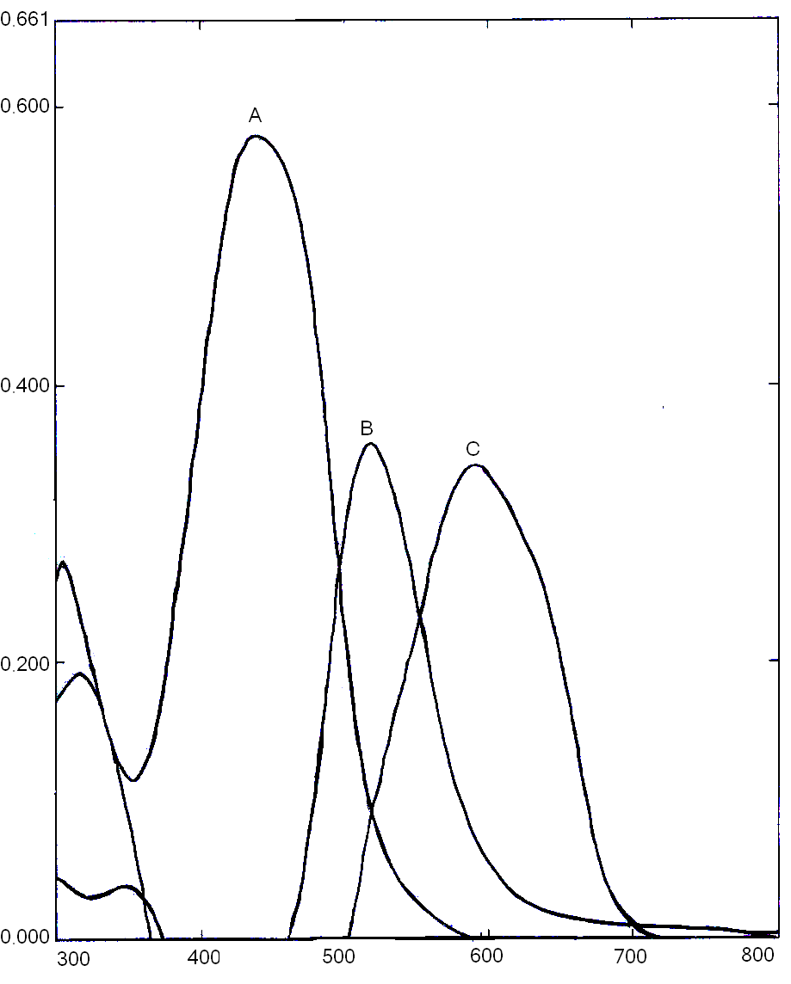
Abs.
wavelength (nm)
A: CAPAI
B: Pd-CAPAI
C: Ag-CAPAI

Fig. 1: Absorption spectra of the reagent and complexes

Effect of reagent concentration
For up 1 µg.ml⁻¹ of Pd²⁺ and Ag⁺, the effect of reagent concentration on the absorbance of two complexes was studied by varying the volume of CAPAI from (0.5-6) ml which its concentration is 1*10⁻⁴ M. The required volumes of CAPAI were found to be 4 ml and 3 ml to complete the reaction of Pd (II) and Ag (II) respectively.

Effect of pH:
The experimental results demonstrated that the absorbance of Pd(II)-CAPAI system is maximum and constant in the pH range (8-10), (fig.2) therefore pH of (9) was adopted as optimum pH, while Ag - CAPAI system, the maximum and constant absorption was found in pH range (9-11), (fig.3) and the pH of (10) was adopted as optimum pH.

Fig 3: Effect of pH on the absorbance of silver complex
at room temperature

Stability of the chromogenic system
A. Effect of Time
Stability of chromogenic system with the time is shown in figure 4;

Fig. (4):-Effect of time on the absorbance of palladium and silver complexes at room temperature

This figure shows that the color of the two complex systems and absorbance reach a maximum value after (15) minutes and remains stable for about 24 hours.

B) Effect of temperature
The effect of temperature on the absorbance of the two complexes; Pd(II)-CAPAI and Ag(I)-CAPAI was studied. The study was performed at temperature between 5-60ºC (fig. 5). The maximum absorption was obtained when the temperature was varied between 10ºC and 40ºC for each complex. At temperature higher than 40ºC the absorbance gradually decreased until it reaches 60ºC, which may be due to dissociation of the complexes.

Fig. 5:- Effect of temperature on the absorbance of palladium and silver complexes

Composition of the complexes
The composition and apparent stability constant were evaluated by both of continuous variation and mole ratio methods (fig. 6-9). Both methods were showed that the molar ratio of pd-CAPAI complex is 1:2 with stability constant of 5*10¹¹ L².mol⁻², and for Ag-CAPAI complex is 1:1, with stability constant of 3.6*10⁴ L.mol⁻¹.

Fig. 6:- Continuous variation method for pd
complex with CAPAI at pH(9)
Fig. 7:- Mole ratio method for pd complex
with CAPAI at pH(9)

Fig. 9:- Mole ratio method for Ag complex
with CAPAI at pH(10)
Fig. 8:- Continuous variation method for Ag
complex with CAPAI at pH(10)

Calibration graph and Sensitivity
The calibration graph was constructed according to the general procedure. Beer's law is obeyed in the concentration range of (0.01-0.9 )µg Pd(II). ml⁻¹ with correlation coefficient r= 0.9996, and the concentration range of (0.02-1) µg Ag(I). ml⁻¹ with correlation coefficient r= 0.9995 . Fig (10&11).
The molar absorptivity (ε) and Sandell sensitivity (S) for two complexes are shown in table (1)

Table (1) shows the molar absorptivity (ε) ans Sandell sensitivity (S) for two complexes
Complexes | ε ,L.mol⁻¹.cm⁻¹ | S, µg.cm⁻²
Pd-CAPAI | 43294.2 | 0.0025
Ag-CAPAI | 32452.7 | 0.0033

Fig 10:- Calibration graph of Pd(II) ion

Fig 11:- Calibration graph of Ag(I) ion

Precision and Accuracy
The precision and accuracy of this analytical procedure was estimated by calculating the R.S.D% and percent relative error Erel.%, and found that the R.S.D% were 0.4% to 0.3µg.ml⁻¹ of Pd(II) and 0.46% to 0.5µg.ml⁻¹ of Ag(I).
The recovery and Erel% for the complex solution containing (0.3) ppm of Pd(II) and (0.5) ppm of Ag(I) were found to be 92.7, 7.3% , and 97.2, 2.8% respectively. The detection limit was found to be 0.004 ppm for Pd(II) and 0.007 ppm for Ag(I). These results indicating that this method is highly precise, very accurate and suitable for the determination of Pd(II) and Ag(I) spectrophotometrically.

Interferences
The selectivity of Pd-CAPAI and Ag-CAPAI systems is enhancement by carrying out the determination of 5 ppm of Pd & Ag in the presence of 10 ppm of foreign ions. (Zn²⁺, Cd²⁺, Hg²⁺, Co²⁺, Ni²⁺, Cu²⁺) which they are also reacting with the reagent CAPAI at the same choosing conditions and they were masked by using suitable masking agent. The results obtained are summarized in table (2)

Table 2: Effect of masking agents
Masking agent 2ml (0.01M) | Absorbance
Masking agent 2ml (0.01M) | Pd(II)-CAPAI  (µg.ml⁻¹) | Ag(I)-CAPAI  (µg.ml⁻¹)
Complex without any addition | 0.204 | 0.157
Tartaric acid | 0.077 | 0.155
Citric acid | 0.11 | 0.142
Ascorbic acid | 0.093 | 0.043
Oxalic acid | 0.142 | 0.056
NaF | 0.201 | 0.087
5-sulphosalicylic acid | 0.199 | 0.033
1,10-phenanethroline | 0.207 | 0.137

The results indicate that NaF, 5-sulfosalicylic acid and 1,10-phenanethroline have no or little effect on the absorbance of Pd-CAPAI complex, so they could be used to mask the other interferences, while each of tartaric acid, citric acid and 1,10-phenanethroline have no or little effect on the absorbance of Ag-CAPAI complex, they could be used to mask the other interferences.
Analytical Application
The proposed method has been successfully applied to determine silver and palladium in standard solutions. The result obtained from the proposed method was compared with those given by atomic absorption spectroscopy (AAS). The concentrations of Pd²⁺ and Ag⁺ analyzed by proposed method and AAS are shown in table 3:

Table 3: Determination of palladium and silver in standard solutions
Samples | Found by proposed method | Found by AAS
Palladium | 0.25 | 0.262
Silver | 0.507 | 0.493
The results show a good agreement of the results obtained by the two methods.

Conclusion
The method is very simple, rapid and sensitive to determine palladium and silver ions with high stability of two complexes.

References
- H. Haraguchi, Bull. Chem. Soc. Jap., 1999, 72, 1163 .
- S. Kozono, R. Kakashi and H. Haraguchi, Anal. Sci., 2000, 16, 69.
- O. Keil, J. Dahm and D.A. Volmer, Freseniusen J. Anal. Chem.,1999, 364, 694 .
- S. M. Golabi and J. Mohammadi, The Jap. Soc. Ana. Chem.,2003, 19, 877.
- W. R. Hill and D. M. Pillsbury, Argyria-The Pharmacology of silver, William and Wilkinson, Baltimore, 1939.
- H. W. Dieti, A.P. Anzil, and P. Mehraein, Clin. Neuropathol, 1984, 3, 32 .
- B. A. Fowler and G. F. Nordberg, Handbook on the Toxicology of Metals, 2nd edn., vol. II, Elsevier/ North-Holland, Amsterdam, 1986, p. 521.
- Seiler H. G., Sigel H., and Sigel A., Handbook on Toxicity of Inorganic Compounds, Marcel Dekker, Inc., New York, 1988.
- A. Tunceli and A.R. Turker, Anal. Sci.,2000, 16, 81 .
- R. Schierl and G. Fruhmann, Sci. Total Environ.,1996, 182, 21 .
- M. Wöber, D. Lasch Ka, and L. Peichl, Z. Umweltchem. Ökotox.,1996, 8, 1.
- F. Zereini, C. zientek, and H. Urban, Z. Umweltchem. Ökotox.,1993, 5, 130 .
- F. Vanhaecke, D. Verstraete, L. Moens, and R. Dams, 3rd Symposium Massenspektrometrische Verfahren der Element-spurenanalyse, Jülich, Germany, 24-26 1996, poster presentation.
- P. L. Goering, In Hazardous Materials Toxicology. Clinical Principles of Enviromental Health, ed. Sullivan, J.B., Jr., and G. R. Krieger, Williams and Wilkins, Baltimore, 1992, pp. 874-881.
- C.Melber, D.Keller, and I.Mangelsdrof, World Health Organization, Hanover Germany, (2002), 37,76.
- H. G. Seiler, H. Sigel, and A. Sigel, Handbook on Toxicity of Inorganic Compounds, Marcel Dekker, Inc., New York, 1988.
- A.M. Ali, N.N. Al-Gatrinie and S. Ratrout, Journal of Al-Qadisiya University/ pure science, 2005, 10, 3 .

