Influence of the Ligand Structure of Diaza Crown
Ethers on the Complexation of Ag(I) In Acetonitrile

Hazim Y.AL-gubury
Chemistry department, College of women, Babylon University

(NJC)

(Received on 18/12/2007) (Accepted for publication 26/10/2008)

Abstract:
The thermodynamic stabilities of the silver ion with some diaza-crown ethers have been determined conductometrically in acetonitrale as a solvent at different temperature both the ligand structure and the lagand-solvent interaction influence the relative stabilities of the complexes. The enthalpy and entropy of complexation were determined from the temperature dependence of the complexation constants. The complexation process is enthalpy governed.
الخلاصة
في هذه الدراسة تم تحديد ثابت الاتزان لتفاعل ايون الفضة مع بعض الايثرات التاجية من خلال قياسات التوصيلية باستخدام محلول الاسيتونايترايل كمذيب في درجات حرارية مختلفة . وقد وجد أن لتركيب الليكاند وكذلك التداخل الحاصل بين الليكاند-المذيب تأثير مهم في أستقرارية المعقدات المتكونة.
كما تم في هذه الدراسة تحديد قيم كل من ºH ∆ و ∆Sº لجميع التفاعلات أعلاه.

Introduction
The ability of mixed nitrogen-oxygen macro cycles to form strong complexes figure ( 1 ) with metal ions have led to extensive studies of these ligands and their complexes with metal ions⁽¹⁻⁶ ⁾ .In spite of large number of experimental data it is mainly focused on stability constants determinations. Literature offers scarceb data about the reaction enthalpies and entropies of diaza macrocyclic ligands ^{( 7, 8).} Without the knowledge of these thermodynamic parameter it is not possible to discuss whether the stability constants are influenced by the reaction enthalpies and /or entropies when compared with other ligands. The stability of metal- macro cycle complex depends upon several factors, these include the number and type of the donor atoms present in the ligand . The relative position of these atoms within the ligand and the nature of the ligand backbone, the number and size of the chelate rings formed on complexation . For transition metal ions, the nature and magnitude of crystal-field effects of the type that contribute to the Irving-Williams stability order. The macro cyclic ring size is a factor that will influence complex stability . Solvation effects will undoubtedly affect the respective free energies⁽⁹⁻¹²⁾ .Previous study on the complexation of Ag (I)with diaza macro cyclic ligand in methanol ⁽⁴⁾ show that the substituted ligand give higher values of the reaction enthalpies than the unsubstituted ones . Theis was assumed to be due to the differences in the solvation strength of the ligand . The present study was undertaken to investigate the effects of the ligand structure on complex stability in acetonitrile solution . The obtained stability constants and the thermodynamic parameters ∆Hº and ∆Sº are compared with literature and their significance will be discussed.
Experimental
The ligands used in this work are show in figure 1. The Cryptand (211) (Merek) Kryptofix 5 (k5,Merek), the diazacron ether (22DD) (Merek), the diazacrown ethers (22TT) (Fluka) and B2A2 15C4 (Fluka) were used without further purification. Anhydrous AgCIO₄ of the highest purity (organics) was used for all experiments. As solvent anhydrous HPLC grade acetonitile (Gainland 99 6% purity ) was used and the specific conductivity was lass than 1×10 ⁻⁷ S cm ⁻¹ . In typical experiment , 25 ml of the desired metal salt solution of (2.03x10⁻ ⁴ M) concentration was placed in titration cell thermostated to the desired temperature and the conductance of the solution was measured. Then , a known amount of another solution containing the same concentration of the salt and the crown ether was added in a stepwise manner using a calibrated microburet with sensitivity ( ± 0.01cm³ ) . After stirring the solution magnetically for about one minute and thermostating it for about five minutes , the conductance was measured after . The same procedure was repeated until the desired ratio of crown to metal salt was attained .
Determination of Stability Constants:
Stability Constants were measured by mean of conductivity measurement . This was carried out with a Metrohm E 518 conductmeter . Conductivity cell (Metrohm EA-645-2) with a cell constant of 2.14cm-¹ was used . This value was checked by measuring the conductivity of aqueous potassium chloride solution of different concentrations ⁽¹³⁾ . In all measurement the cell was thermostatted at the required temperature ± 0.1 C◦ using a Haak-Mess .Technik Gmbh U.Co., TYPe F3 thermostat. Acetonitrile solutions of silver perchlorate With concentration of about(1.0~2.0)×10⁻⁴ mol. dm ⁻ ³ were used.These solutions werealso used as solvent for preparing the macrocycle solutions.To determine the formation constants, 25mL of silver perchlorate solution were placed in a titration cell, thermostatted at the desired temperature, and the conductance was measured. A known amount of the ligand solution (1.8-2.o) x 10⁻³ mol.dm⁻³ was added dropwise using a microburette (with sensitivity ± 0.01 cm³).After stirring the mixture magnetically the cell was placed in the thermostat and the conductivity was measured . This procedure was repeated in the same manner after each addition until the desired ratio of crown to silver ion was attained .The formation constants of the resulting complexes based on a 1: 1 ratio at various temperatures were evaluated by fitting the observed molar conductance at various crown -to-metal ion mole ratios to an equation expression, the observed molar conductance as a function of the free and compelxed metal ion. The formation constants were calculated by using a nonlinear least – squares program ''simplex'' reported elsewhere ^{(14 ,15)}.The mathematical treatment for the 1: 1 binding of cation with ligand can be found else where ^{( 5, 6)}. Least square analysis of log K vs 1/T was carried out using a linear fitting program (Vant Hoff).
Results and Discussion
The molar conductance of silver perchorate in acetonitrile was monitored as a function of crown-to- metal ion mole ratio at various temperatures .The resulting molar conductance mole ratio plots are shown in Figures 2and 3.As can be seen , the addition of crown ether to the solution . Indicates a lower mobility of the silver ion – crown complexes compared to the solvated cation . The slope of the corresponding mole ratio plots changes at the point were the crown - to- cation mole ratio is equal one emphesizing the formation of a stable 1: 1complex.
The values of log K, ∆H⁰and ∆S⁰ for the complexation of Ag⁺ with different crown ethers in acetonitrile are given in Table 1. The macrocyclic ligand 22 TT has shown the highest stability and reaction enthalpy . However, complex formation with this ligand is disfavored by entropic contributions. This clearly indicates ring size effects. The ionic size of Ag⁺(2.3A⁰)fits nicely the 22 TT with a cavity size of (2.3-3.3A⁰) .In addition ,it is well known that the the nitrogen atoms contribute to Ag⁺ binding in diaza crowns and this influence is especially strong when the nitrogen atoms are in anti – linear arrangement. The kryptofix 22 DD withering size 2.8A⁰ is expected to have a nice fit with Ag⁺ (2.3A⁰)as in 22 TT. However the Ag⁺ complex with kryptfix 22DD has lower stability and enthalpy than the Ag⁺ 22TT complex. The substitution of the hydrogens of the nitrogen donor atoms of the macrocyclic ligand by alkyl and benzo groups causes a reduction in macrocyclic complexes stabilities. However, this reduction effect is expected to be higher in kryptofix 22DD than 22TT due to steric reasons which hinder the Ag⁺ from approaching closely the macrocycle as a result, this will reduce the interaction between Ag ⁺ and kyrptofix 22 DD. The smaller value of ∆H⁰ of Ag⁺ kryptofix 22 DD than ∆H⁰ of Ag⁺ -22TT might supports this explanation . With respect ot the ligand B₂A₂ 15C₄ with cavity size 2.8 A⁰ is expected to have a relatively good match with Ag⁺(2.3A⁰)ion. However, its complex stability with Ag⁺ is lower than that with 22 TT. The presence of two benzo groups will increase its rigidity which might effect its complication stability .In addition , this ligand has the highest solvation among the macrocycles investigated .This will reduce its complex stability with Ag⁺ ion . The noncyclic ligand kryptofix 5-Ag⁺ complex has lower stability than 22TT and higher stability than Kryptofix 22DD – Ag⁺ ion complexes . The kryptofix 5 contains two pyridino groups which interact with the complexed cation . The basicity of this pyridino group is lower when compared with an amino group . The relatively high stability of kryptofix 5 – Ag complex is probably due to the preorganization of this noncyclic ligand via attractive interaction between both end groups ^{( 16 – 17)}.The kryptofix 211 – Ag⁺ complex has the lowest stability constant among the macrocycles investigated . This is probably due to the mismatch between Ag⁺ ionic size (2.3 A⁰) with C211 with size (1.6 A⁰). In contrast to other ligand complexes, the kryptofix 211 – Ag⁺ complex is entropy stabilized . In conclusion , the observed changes the stability constants , complexation enthalpies and entropies are explained by changes in the ligand – solvent interations and the ligand structure as cavity size and substitution on the nitrogen donor atom .

Table 1: Formation contants, enthalpies and entropies for different Ag⁺ - Macrocycles complexes in acetonitrile
ΔS⁰ ΔH⁰_{f}-  (KJ/mole) J/mol.K Ref |  |  | Log K  10 C⁰ 20 C⁰ 30 C⁰ 40 C⁰ |  |  |  | Macrocycle
Thiswork | -40.3 | 38.9 | 4 .40 | 4.56 | 4.84 | 5.07 | 22TT
19 | ----- | ----- | 5.86 |  |  |  | 22TT*
Thiswork | -18.2 | 29.1 | 3.88 | 4.09 | 4.25 | 4.40 | 22DD
Thiswork | -18.2 | 30.6 | 4.13 | 4.37 | 4.50 | 4.69 | B2A215C
18 | ----- | ----- | ----- | ----- | 3.17 | ----- | B2A215C4
Thiswork | -28.0 | 32.4 | 3.89 | 4.18 | 4.33 | 4.48 | Kryptofix 5
Thiswork | 13.3 | 18.6 | 3.80 | 3.89 | 4.01 | 4.12 | C 211

*Log K _{f} value reported at 25 º C

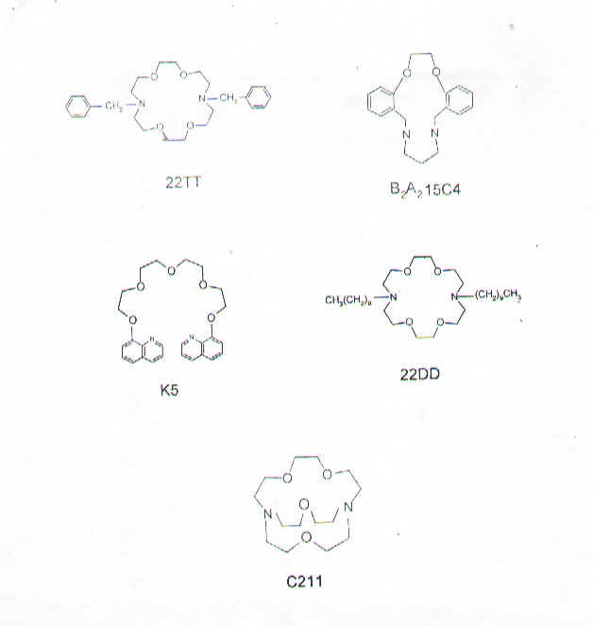
K5
Kryptofix
22TT
7,16-dibenzyl-1,4,10,13-tetraoxa-7,16-diazacyclooctadecane
22DD
Kryptofix 22DD
B₂A₂15C4
5,6,14,15-dibenzo-1,4-diaoxa-8,12-diazacyclopentadeca-5,14-diene
C211
Kryptofix211

Figure 1: Structure of Macrocycle

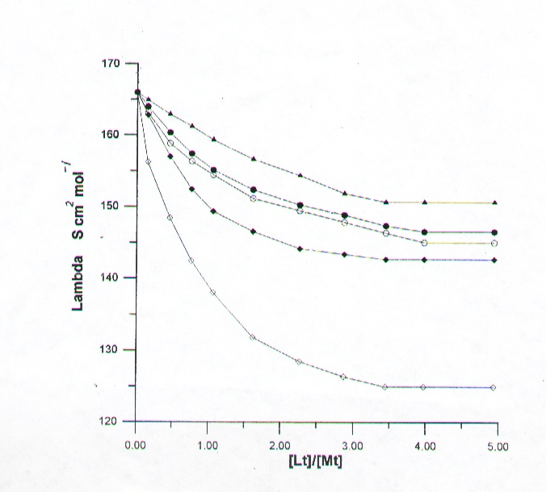

Figure 2. Molar conductance Vs .[Lt ] /[Mt] curves for Ag⁺
with macrocycles K5
□ C211, • 22TT ; οB_{²}A_{²} 15C4;▲22DD at 20 C◦.

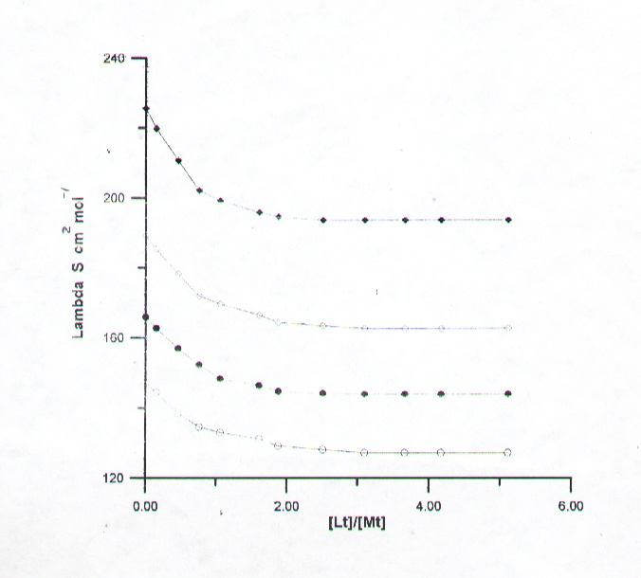
Figure3. Molar conductance vs .[22TT] / [Ag⁺] curves
in acetonitrile at various temperatures .
■40 C◦ ; □ 30 C◦ ; • 20 C◦, ο 40 C◦

References
1. R.M.lzatt, K. pawlak ,J.S. Bradshaw, R.L. Bruening , Chem .Rev .95 (1995),2529.
2. K.R.Adam. D.S.Baldwin, A. Bashall, L .F. Lindoy, M.Mcprllin and H.R. powell, J.Chem. Soc.Dalton Trans., 1994, 237.
3. L. F.Lindoy: The chemistry of Macroclic Ligand Complexes, Cambridge University press, Cambridge (1989).
4.H.J. Buschmann, E.Schollmeyer, R.Trultzsch and J.Beger, Thermochimica Acta, 1993, 213,11.
5. D.Marji and Z.Taha, J.Incl. Phenom, 2000, 37, 331.
6. D.Marji and S.Fraihat, J. Incl. Phenom ., 1999, 33, 99.
7.R. M. Izatt, J.S. Bradshaw and J.Christensen; Chem. Rev., 1990, 91, 1721.
8. R. M. Izatt, J.S. Bradshaw, S.A. Nielsen, J.Lamb and J. Christensen : Chem. Rev., 1985, 85, 271.
9. M.K.Amini and M. Shamsipur: J.Solution Chem., 1991, 21, 275.
10. A.Jabbari, M.Hasani and M.Shamsipur : J. Incl. Phenom .15 (1993), 329.
11. M.Hasani and M.Shamsipur :Inorg. Chem. Acta., 1991, 83, 65.
12.A.J.Smetana and A.I. Popov: J.Chem . Thermodyn., 1979, 11, 1145.
13. Y.C.Wu and W.F.Koch:J. Solution Chem., 1991, 20, 391.
14. K.Tawarah and S.Mizyed : J. Incl. Phenom ., 1988, 6, 55.
15. J.A. Nedler and R.Mead.Comput. J., 1965, 7, 308 .
16. B.Tummler , G. Mass, F.Volgtle, H.Sieger, U.Heimann and E.Weber, J.Am. Chem. Soc., 1979, 101, 2588.
17. F.Volgtle and E. Weber , Angew . Chem. Int. Engl., 1979, 18, 753.

