Synthesis, Semi-Empirical/PM3 studies of the Benzaldehyde
[5-(2-hydroxyphenyl)-1,3,4-oxadiazole-2-yl]hydrazone and some Their Transition Metal Complexes

Moslem Hassan Mohamed Al-Saadi Khaled Jewad Al-Adeli
Dept. of Chemistry, College of Education, Al-Qadisiya University

(NJC)

(Received on 27/1/2008) (Accepted for publication 26/10/2008)

Abstract
A novel derivative of Benzaldehyde [5-(2-hydroxyphenyl)-1,3,4-oxadiazole-2-yl]hydrazone have been synthesized and reacted with following transition metal salts (CoCl₂.6H₂O, NiCl₂.6H₂O and CuCl₂.2H₂O). The free ligand and its complexes have been investigation by atomic absorption, FTIR, UV, magnetic susceptibility, atomic absorption, continuous variation and molar conductivity. The Semi-Empirical (PM3) method was used to calculate the electric energies, binding energy, heat of formation, band length, theoretical IR and UV spectra.
The calculated theoretical values were in good agreement with the experimental measured values.
الخلاصة
في هذا البحث تم تحضير الليكاند الجديد Benzaldehyde [5-(2-hydroxyphenyl)-1,3,4-oxadiazole-2-yl]hydrazone وتم تحضير معقداته بتفاعله مع بعض املاح العناصر الانتقالية التالية CoCl₂.6H₂O, NiCl₂.6H₂O and CuCl₂.2H₂O وشخص الليكاند ومعقداته باستخدام التقنيات التالية: الامتصاص الذري، طيف الاشعة تحت الحمراء، طيف الاشعة فوق البنفسجية والمرئية، الخواص المغناطيسية، طريقة المتغيرات المستمرة، التوصيل المولاري. كما تمت دراسة الليكاند ومعقداته بالطرق النظرية باستخدام طريقة Semi-Empirical (PM3) عن طريق حساب طاقة هذه المركبات المحضرة (طاقة الجزيئة الكلية، طاقة الترابط وكذلك حرارة التكوين) بالاضافة الى قياس اطوال الاواصر لليكاند المحضرة وللمعقدات. تم قياس ودراسة الاطياف الالكترونية واطياف الاشعة تحت الحمراء والخواص المغناطيسية نظريا لليكاند وللمعقدات ومقارنة هذه النتائج مع النتائج العملية فكانت متقاربة الى حد كبير.

Introduction
The first oxadiazole has been prepared in 1952 by the condensation of benzoyl hydrozide with carbon disulphide in alkaline medium lead to 2-phenyl-1,3,4-oxadiazole-5-thiol⁽¹⁾.
Oxadiazole compounds are classified as of five membered ring containing one atom of oxygen and two atoms of nitrogen and exist mainly as the different structure formulas described below⁽²⁾.

Numerous 1,3,4- oxadiazole derivative has been synthesized and recognized as molecules with potential bactericidal and fungicidal activity⁽³⁾.
Most of the compounds which were studied contain on substituted groups at the (2) and (5) positions of 1,3,4- oxadiazole ring, especially the 2-mercapto oxadiazole compounds which recognized that were contain thioamide group (-N-C=S). the present of the toxophorically active group (-N-C=S) in the structure of both nuclei is believed to important grouping in their activity ^{(4,5)}. The thiol group (-SH) which attached to oxadiazole ring cause an increase in antifungal activity⁽⁴⁾.
These compounds are expected to be a potent ligands with a wide variety of metal ions due to the presence of the N- and S- atoms in their structures, metal complexes showed biological activity toward fungal^{(6,7)}.
Moreover, oxadiazole compound is used as dyes, drugs, photosensitive and electrical material ^{(8,9)}.
Computational Details
The Semi-Empirical/PM3 method was used for calculation of geometries, electrostatic potential, electron density, energies, heat of formation, heat complexation, binding energy, symmetry and other geometrical parameters in addition to the theoretical IR and UV-Visible spectra of free ligand and their method complexes (see figure-1).
The theoretically calculated frequencies and complexes showed some deviation from the experimental values. These deviations are generally acceptable in theoretical calculations. The devations that occur in the calculated frequencies are due to (Hartree-Fock Theory) (HFT) is a single point approximation, and therefore can not adequately treat the correlated motion of electron that occurs due to electron-electron interaction. Neglected of electron correlation has been blamed for systematic HF errors⁽¹⁰⁻¹⁴⁾.
All calculations were carried out with program package HyperChem 7.52.
Experimental
Materials and measurements:
Hydrazine 99% (B.D.H. chemicals), absolute ethanol 95%, dimethyl sulfoxides, hydrochloride, methyl salicylats (all Fluka), carbon disulphide (Aldrich). IR spectra were recorded in the 4000-200cm⁻¹ range by test scan shimadzu FT-IR8000 series spectrometer, using CsI discs for the prepared ligand and for the metal ion complexes, the percentages of the transition metals of the prepared complexes were determined by shimadzu A-A-670 Flame spectrophotometer.
The electronic spectra of the prepared ligand and their metal complexes were recorded in the rang of 200-900 nm by Hitachi UV-2000 spectrophotometer. The concentration of solution at (10⁻³ M) using DMSO as solvent.
The magnetic susceptibility was measured by using the susceptibility balance model MSB-MKI. Melting point of ligand and their complexes have measured using Gallen Kamp M.F.B.600 and the molar conductivity was measured by using electrolytic conductivity measuring set model (CRB3) using platinum electrode with cell constant (1cm), concentration (10⁻³M) in DMSO as solvent. All measurements were carried out at room temperature.
Preparation of Benzaldehyde [5-(2-hydroxyphenyl)-1,3,4-oxadiazole-2-yl]hydrazone(BHOH).
A mixture of methyle salicylate (A) (15.2 gm, 0.1 mole) and hydrazine (99%) (10 ml, 0.2 mole) was refluxed in absolute ethanol (25 ml) for (5) hours then allowed to cool. The white precipitate (b) [2-hydroxy-benzohydrazide] was filtered off and recrystallized from ethanole ⁽¹⁵⁾, (12gm, 78.9% yield), m.p. 148-150 ºC.
A mixture of (b) (15.2gm, 0.1 mole), KOH (5.6 gm, 0.1mole) and CS₂ (12 ml, 0.2 mole) was refluxed in absolute ethanol (150 ml) for 5 hours or until evolution of hydrogen sulfide ceases. The excess of solvent was removed under vacuum and the residue was mixed with ice and poured onto ice water containing hydrochloric acid. The white precipitate (c) 2-(5-Mercapto-1,3,4-oxadiazole-2-yl)phenol, which separated was filtered, washed with water and recrystallized from ethanol, (10.5 gm, 69% yield), m.p. 200-202 ºC.
The product (C) (19.4 gm, 0.1 mole) and hydrazine hydrate (7.5 gm, 0.15 mole) was refluxed in absolute ethanol (50 ml) for (5 hours) or until evolution of (H₂S) ceases then allowed to cool. The pale yellow precipitate (D) 2-[5- Hydrazine-1,3,4-oxadiazole-2-yl]phenol was filtered off and recrystallized from ethanol ⁽¹⁵⁾, (15.6 gm, 80.4% yield), m.p 166-168ºC.
A mixture of product (D) (3.84gm, 0.02 mole) and benzaldehyde (2.12gm, 0.02 mole) was refluxed in absolute ethanol for (5-7) hours. The yellow precipitate (E) Benzaldehyde[5-(2- hydroxyl-phenyl)-1,3,4-oxadiazole-2-yl]hydrozon (BHOH) was filtered, washed with ethanol and recrystallized from dimethy foramide (DMF)⁽¹⁷⁾, (3.29gm, 85.6%yield) m.p. 128-130 ºC, as is shown in scheme-1.

Scheme-1
Preparation of Benzaldehyde[5-(2- hydroxyl-phenyl)-1,3,4-oxadiazole-2-yl]hydrozon (BHOH)

Preparation complexes of Benzaldehyde[5-(2- hydroxyl-phenyl)-1,3,4-oxadiazole-2-yl]hydrozone (B.H.O.H).

A solution of (0.56gm, 2 mmole) of (B.H.O.H) in absolute ethanole (15ml was reacted with (1mmole) of transition metal salts (CoCl₂.6H₂O, NiCl₂.6H₂O and CuCl₂.2H₂O) dissolved in hot absolute ethanol (10 ml). the resulting mixture was refluxed for 1.5 hours and the solvent was evaporated in vacuum to half of the original volume and the cooled. The obtained precipitate was then filtered, recrystallization from absolute ethanol afforded crystalline said.
The physical properties of the resulting complexes are properties of the resulting complexes are presented in table-1 and (see figure-1)

Table(1): Physical properties, Formula and names of ligand (B.H.O.H) and its metal Complexes

No. | Formula and names | Color | m.p.ºC | Yield% | $$Λ_{M^{}}$$ | $$μ_{\text{eff}}$$  (B.M) | M%
 |  |  |  |  |  |  | Calc. | Found
B.H.O.H | C₁₅H₁₂N₄O₂  Benzaaldehyde[5-(2- hydroxyphenyl)-1,3,4- oxadiazole-2-yl]hydrazone | Yellow | 128-130 | 85.6 | ----- | ----- | ----- | -----
1- | [Co(B.H.O.H)₂Cl₂]  Dichlorobis{benzaldehyde [5-(2- hydroxyphenyl)-1,3,4- oxadiazole-2-yl] hydrazone}cobalt(11) | Dark green | 227-229 | 75 | 8.7 | 4.02 | 8.53 | (8.37)
2- | [Ni(B.H.O.H)₂]Cl₂  Bis{benzaldehyde [5-(2- hydroxyphenyl)-1,3,4- oxadiazole-2-yl]hydrazone }Nikel(11) chloride | Yellow wish green | 212-214 | 80 | 78.2 | D.M. | 8.51 | (8.39)
3- | [Cu(B.H.O.H)₂]Cl₂  Bis{benzaldehyde [5-(2- hydroxyphenyl)-1,3,4- oxadiazole-2-yl]hydrazone }copper(11) chloride | Light green | 235-237 | 81 | 6.2 | 1.8 | 9.14 | (9.03)
$Λ_{M^{}}$:Molar conductivities in Ohm⁻¹.cm².mole⁻¹
$μ_{\text{eff}}$: Magnetic moment in Bohr Magneton.
D.M: Diamagnetic

Results and Discussion
Vibrational Frequencies:
Table(2) describes the important vibrations and assignment of the Benzaldehyde[5-(2- hydroxyl-phenyl)-1,3,4-oxadiazole-2-yl]hydrozone (B.H.O.H) and its metal complexes. The lignad (B.H.O.H) exhibited bands at frequency 3409cm⁻¹, 3098cm⁻¹ O-H and N-H , 2995-2833cm⁻¹ C-H aliphatic, 3100-3010 cm⁻¹ C-H aromatic, 1618cm⁻¹ C=N⁽¹⁸⁻²⁰⁾.
The IR spectra showed two band in the regions 1142cm⁻¹ and 1250cm⁻¹ attributable to $υ(C−O−C)$ symmetrical and asymmetrical stretching vibration combined with $υ(N−N=C)$ band of 1,3,4-oxadiazole moiety ⁽²¹⁾. For metal complexes, the bands for C=N stretching were weakened and shifted to a lower frequency by about 10-25cm⁻¹ in the metal complexes spectra, this may refer to the linkage of metal ion with the nitrogen^{(7,22)}. However, new bands appeared in the regions (405-460)cm⁻¹ and (240-360)cm⁻¹ which were assigned to the coordinated M-N and M-Cl band respectively⁽²³⁾.
The IR spectra of free ligand (B.H.O.H) and its metal complexes calculated by using the Semi-Empirical (PM3) methods are given in table-2. The agreement between the calculated theoretical and experimental frequencies were excellent. These results help us to predict the most stable structure and indicate that coordination occurred through the nitrogen atom of C=N of oxadiazole ring and Schiff base groups of the B.H.O.H (see figure 2and 3).

Table(2): Comparison between the experimental and (theoretical) vibrational frequencies for (B.H.O.H) and its metal complexes ($υ$cm⁻¹).
No. | Compound | $$υ_{\text{NH}}$$ | $υ$_{C=N} | $$υ_{C−O−C}$$ | $$υ_{M−N}$$ | $$υ_{M−\text{Cl}}$$
B.H.O.H | C₁₅H₁₂N₄O₂ | 3098  (3120)p | 1618  (1613)p | 1250(Asy), 1142(Sy)  [1263(Asy), 1150(Sy)] | ----- | -----
1 | [Co(B.H.O.H)₂Cl₂] | 3095  (3100)p | 1608  (1598)p | 1251(Asy), 1160(sy) | 460  (477)p | 248  (257)p
2 | [Ni(B.H.O.H)₂]Cl₂ | 3102  (3108)p | 1593  (1587)p | 1252(Asy), 1139(Sy)  [1248(Asy), 1164(Sy)] | 405  (413)p | 360  (380)p
3 | [Cu(B.H.O.H)₂]Cl₂ | 3093  (3122)p | 1600  (1602)p | 1237(Asy), 1156(Sy)  [1224(Asy), 1144(Sy)] | 455  (427)p | 240  (267)p
Asy: Asymmetrical vibration
Sy: Symmetrical vibration
p: Semi-Empirical (PM3)

Ultraviolet Spectra:
The ultraviolet spectrum of the ligand, showed bands in the region (387-235)nm assignable to $n→π^{}$, $π→π^{}$ and $n→σ^{}$ transition respectively ^{(7,24)} (see Table-3). The electronic spectrum of the free ligand calculated by using (the Semi-Empirical (PM3))-Singly Excited-Geometry Optimization (0.01K.Cal/mole) exhibited bands falling within the rang (400-243)nm assignable to $n→π^{}$, $π→π^{}$ and $n→σ^{}$ respectively (see table-3 and figure-2). A new additional band was observed for all complexes in the range (328-290)nm. This band can be attributed to the charge transfer transition from the filled ligand orbital (HOMO)(Highest-Occupied Molecular Orbital) to the vacant metal orbital (LUMO)(Lowest-Unoccupied Molecular Orbital)⁽²⁵⁾. The effective magnetic moment of cobalt (11) complex $μ_{\text{eff}}$ (4.02 B.M) suggested an octahedral (high spin) geometry, the value of $μ_{\text{eff}}$ was higher than the theoretical value due to orbital contribution ^{(26,27)}(see table-1). The experimental electronic spectrum of cobalt (11) complex exhibited bands falling within the range (780-360)nm which are assignable to $T_{1g}(F)\vec{V_{1}}T_{2g}(F)$, $T_{1g}(F)\vec{V_{2}}T_{2g}(F)$and $T_{1g}(F)\vec{V_{3}}T_{2g}(P)$ transitions respectively which refer to the octahedral geometry high spin of cobalt (11)^{(26,28,29)}. The (V₂/V₁) ratio was found 1.87, the positions of the bands which also confirmed the octahedral geometry of cobalt(11) complexes⁽²⁸⁾. The theoretical of the electronic spectrum of cobalt(11) complex exhibited bands within the range (810-355)nm (see table-3). Conductivity measurement 8.2(Ohm⁻¹.cm².mole⁻¹) showed that the complex was non electrolyte⁽³⁰⁾.
The nickel(11) complex, found to be square planar ($μ_{\text{eff}}$=Diamagnetic, Low spin) geometry. The experimental electronic spectrum of nickel(11) complex showed bands falling within the range (566-300)nm which are assignable to $A_{1g}\vec{V_{1}}A_{2g}$, $A_{1g}\vec{V_{2}}B_{1g}$ and $A_{1g}\vec{V_{3}}E_{g}$ transitions respectively, supported the square planar geometry ^{(31,32)}. The theoretical of the electronic spectrum of nickel(11) complex exhibited bands within the range (560-300)nm (see table-3). The molar conductivity in DMSO (78.2 Ohm⁻¹.cm².mole⁻¹) indicated that the complex is electrolyte⁽³⁰⁾. The $μ_{\text{eff}}$ value of (1.80 B.M) for Cu(11) complex corresponds to one unpaired (11) complex⁽³³⁾. The electronic spectrum of copper (11) complex show a broad band at (652-420), which can be assigned to $B_{1g}\vec{V_{2}}A_{2g}$, $B_{1g}\vec{V_{3}}E_{g}$ transition which is a characteristic of distorted octahedral configuration ^{(22,28)}. Did not show band for $B_{1g}\vec{V_{1}}A_{1g}$ transition, which are absorbed in lower than (10000)cm⁻¹.
The theoretical of the electronic spectrum of copper (11) complex exhibited bands at (668-319)nm (see Table-3). Conductivity measurement (6.2 ohm⁻¹.cm².mole⁻¹) showed that the complex was non electrolyte⁽³⁰⁾.
The method continuous variation values of these complexed in DMSO, suggest that the metal to ligand stoichiometry is (1:2) for all complexes⁽³⁴⁾.

Table(3): Comparison between the experimental and theoretical of the electronic spectra of ligand (B.H.O.H) and its metal complexes.

No. | Comp. | Band(1) V₁ |  | Band(11) V₂ |  | Band(111) V₃ |  | Charge Transfer |  | V₂/V₁ | Geometry
No. | Comp. | $$λ_{\text{max}}$$  nm | $$υ$$  cm⁻¹ | $$λ_{\text{max}}$$  nm | $$υ$$  cm⁻¹ | $$λ_{\text{max}}$$  nm | $$υ$$  cm⁻¹ | $$λ_{\text{max}}$$  nm | $$υ$$  cm⁻¹ | V₂/V₁ | Geometry
B.H.O.H | C₁₅H₁₂N₄O₂ | 387  (400)p | 25839  25000 | 333  (318)p | 30030  31446 | 235  (243)p | 42553  41152 | ----- | ----- | ----- | -----
1 | [Co(B.H.O.H)₂Cl₂] | 780  (810)p | 12820  12345 | 415  (443)p | 24006  22573 | 360  (355)p | 27777  28169 | 290  (268)p | 34482  37313 | 1.87  ----- | Octahedral
2 | [Ni(B.H.O.H)₂]Cl₂ | 566  (560)p | 17667  17857 | 398  (418)p | 25125  24096 | 352  (360)p | 28409  27777 | 300  300 | 33333  33333 | 1.42  ----- | Squar planar
3 | [Cu(B.H.O.H)₂]Cl₂ | -----  ----- | -----  ----- | 652  (668)p | 15337  14970 | 420  (429)p | 23809  23310 | 328  (319)p | 30487  31347 | -----  ----- | Octahedral

p: Semi-Empirical (PM3)

Optimized Geometries and Energies:
Fully optimized geometries of free ligand and its transitional metal ions complexes are presented in figure-4 and listed in table-4. the surface potential or electrostatic potential of free ligand predicts the reactive sites of the toward the metal ions.
The electrostatic potential of free ligand calculated and plotted as 2D contour to investigated the reactive sites of molecule (see figure-5), they showed how inspection of the shapes (symmetries) of only the highest-filled and lowest-empty molecular orbitals (HOMO and LUMO respectively) could often provide sufficient insight to determine whether or not two molecules would react. The calculated bond lengths of the compounds are in good agreement with the experimental data⁽³⁵⁾. The C=N bond becomes too long when attached to the metal.
The metal-nitrogen coordination bands were shorter the metal-chloride (see table-4). The calculated geometries were in good agreement with our experimental evidences and may serve well for more complex arrangements of these ions.
The conformation of the host and complexes obtained from Molecular Mechanics (MM) calculations were fully re-optimized by using the PM3 method to estimate the binding energy and the enthalpies of formation for the complexes. The total electronic energy are directly connected for the calculation of the complexation energy which can be calculated theoretically as follow^{(36,37)}.

$${ΔE}_{\text{complexation}}=E_{\text{complex}}−(E_{\text{Ion}}+E_{\text{Ligand}})$$

((Where ${ΔE}_{\text{complexation}}$ represents the theoretical complexation energy which refers to the ion selectivity)). Since the binding energy and the enthalpies of formation are directly connected for the calculation of complexation energy, the complexation energy (($E_{\text{complex}}−(E_{\text{Ion}}+E_{\text{Ligand}})$)) is exactly the same as the enthalpies of formation ${ΔH}_{f}={ΔH}_{\text{complex}}−({ΔH}_{\text{Ion}}+{ΔH}_{\text{Ligand}})$.
From the results obtained in table-5, the relative stability of these complexes could be calculated from the total electronic energies.
The smaller the result of total electronic energies (${ΔE}_{\text{complexation}}$), the more stable complex. The Cu complex is the most stable. The relative stability of complexes are increased with the increasing the number of electrons in the outer sheel according to Irving-Williams series⁽²⁵⁾. The Ni complex is the less stable due to decrease of the chelating effect⁽²⁵⁾ (see table-5).

Table(4): Slected Band lengths (Aº) for ligand and its metal complexes.

No. | Compound | C=N | =N-N= | C-O | M-N | M-Cl
B.H.O.H | C₁₅H₁₂N₄O₂ | 1.3061 | 1.357 | 1.385 | ----- | -----
1 | [Co(B.H.O.H)₂Cl₂] | 1.3528 | 1.3491 | 1.354 | 1.852 | 2.188
2 | [Ni(B.H.O.H)₂]Cl₂ | 1.356 | 1.356 | 1.372 | 1.853 | -----
3 | [Cu(B.H.O.H)₂]Cl₂ | 1.388 | 1.379 | 1.371 | 1.891 | 2.357

Table(5): Total energies (Kcal.mole⁻¹), heat of formation in (Kcal.mole⁻¹) and binding energies for (B.H.O.H) and its metal complexes.

No. | Compound | Semi-Empirical (PM3) (Kcal.mole⁻¹) |  |  | Sym-metry | Geometry
No. | Compound | $${ΔE}_{\text{Totalenergy}}$$ | $${ΔH}_{f}^{o}$$ | $${ΔE}_{\text{Binding}}$$ | Sym-metry | Geometry
B.H.O.H | C₁₅H₁₂N₄O₂ | -73672.233 | 65.278 | -3694.41 | C₁ | -----
1 | [Co(B.H.O.H)₂Cl₂] | -180346.228 | -178.490 | -7858.25 | C₁ | Octahedral
2 | [Ni(B.H.O.H)₂]Cl₂ | -171088.585 | -286.831 | -7335.35 | C₁ | Squar planar
3 | [Cu(B.H.O.H)₂]Cl₂ | -189275.451 | -83.6446 | -7574.41 | C₁ | Octahedral

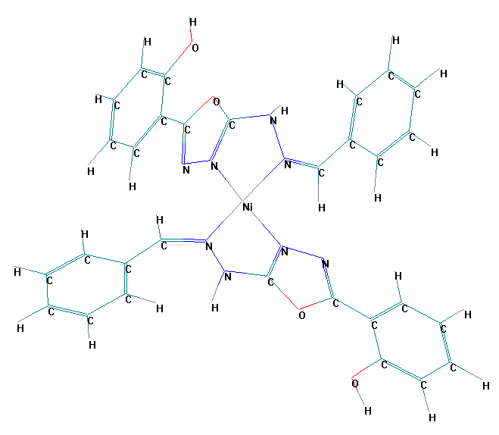 | 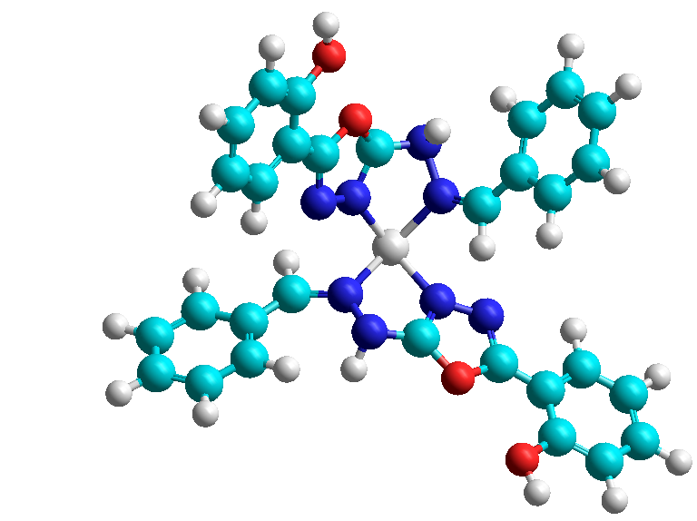  Ni- complex
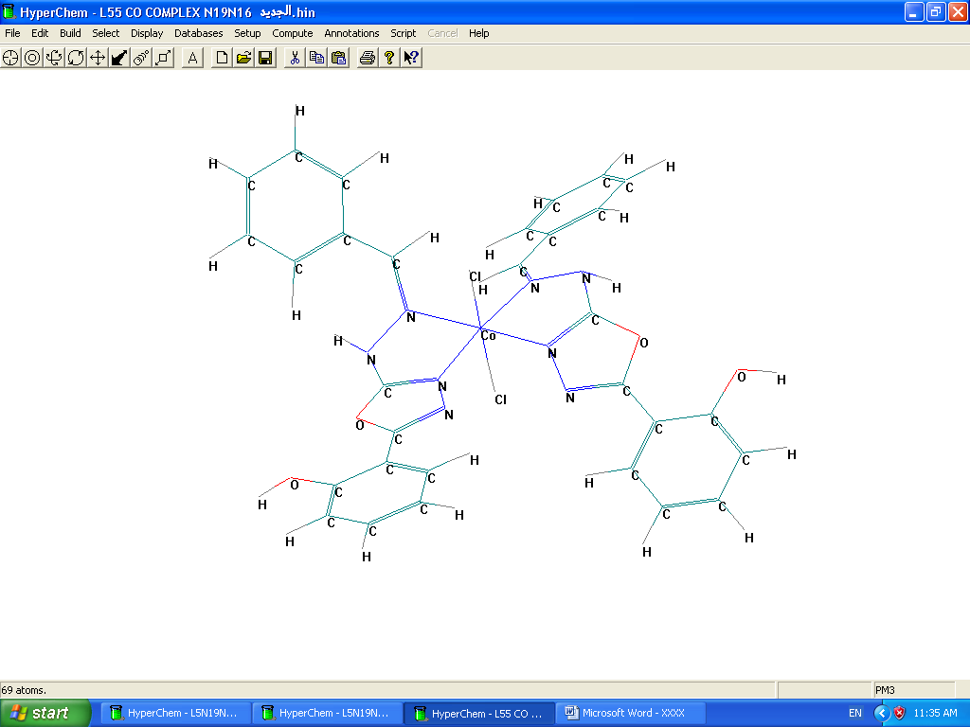 | 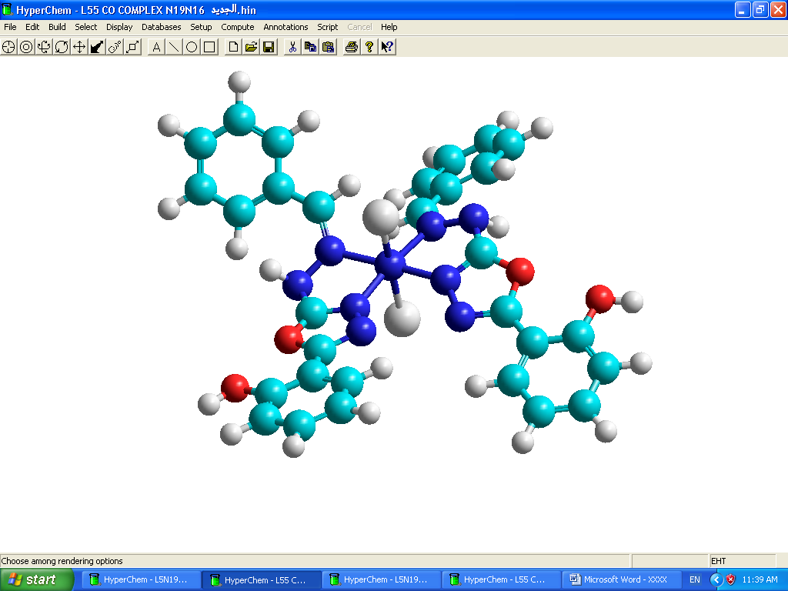  Co-complex
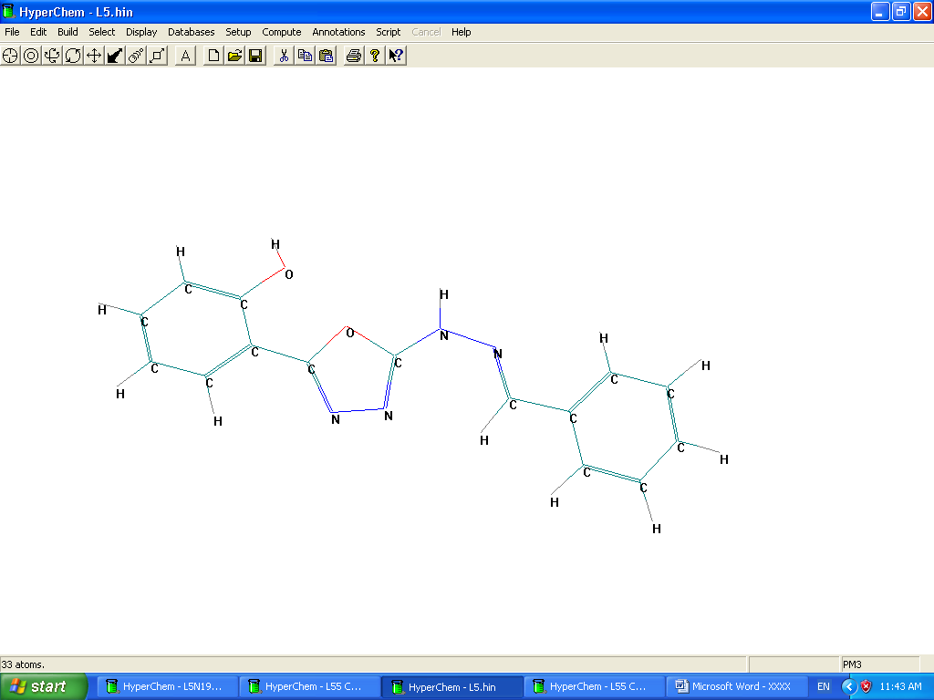  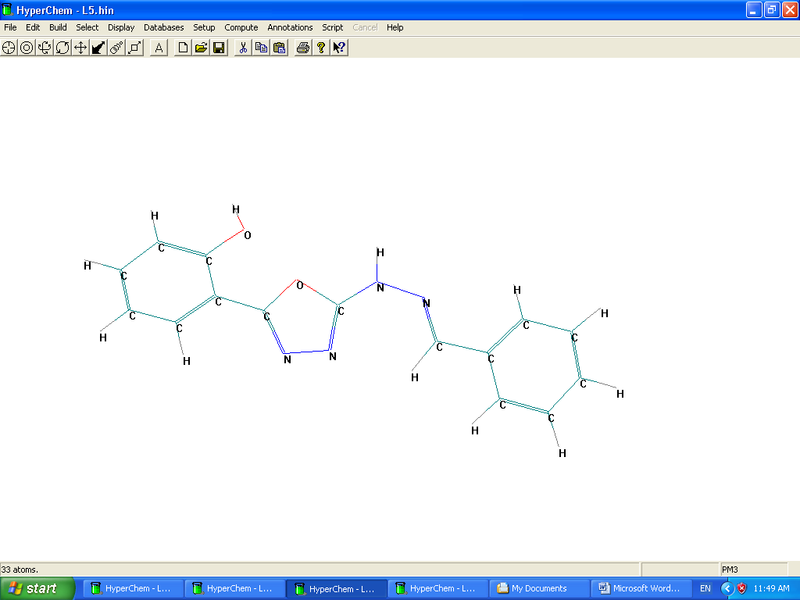 | 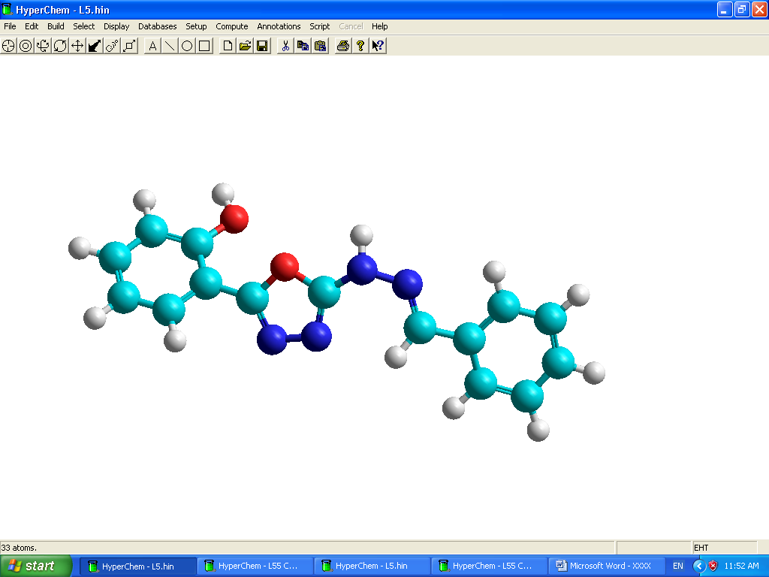  Free ligand B.H.O.H

Figure(1): Geometries of (B.H.O.H) and its metal ions complexes

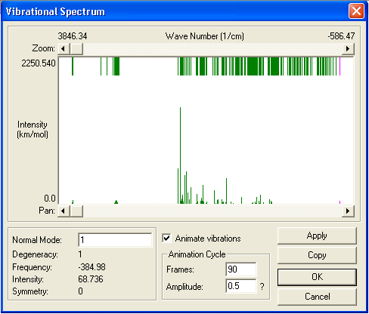

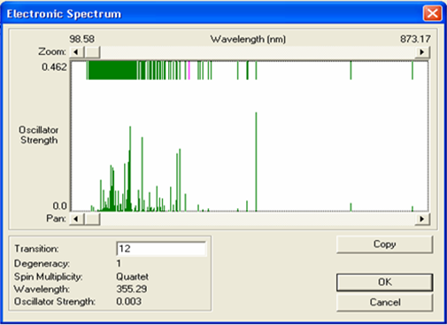

Figure(2): Theoretical IR and UV spectra

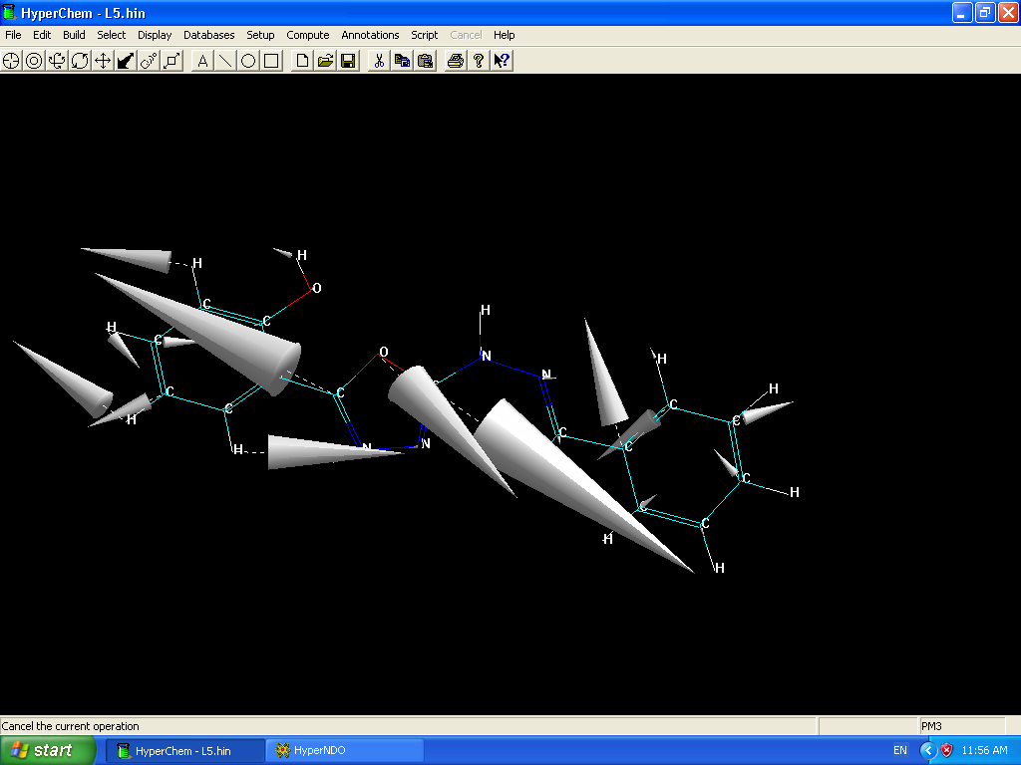  V(C-O-C) of free ligand | 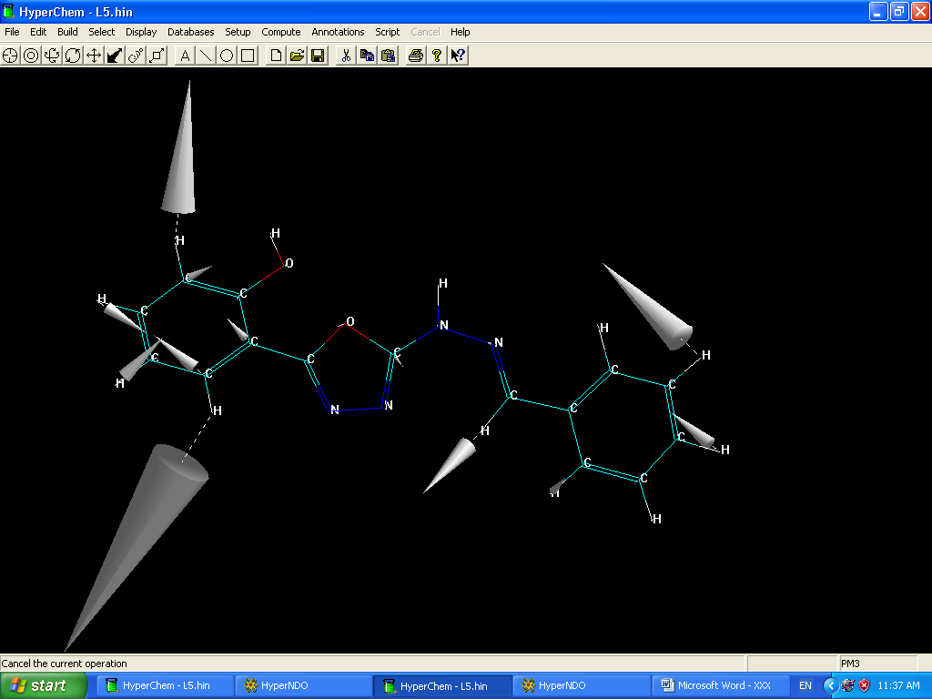  V(C___H) of free ligand
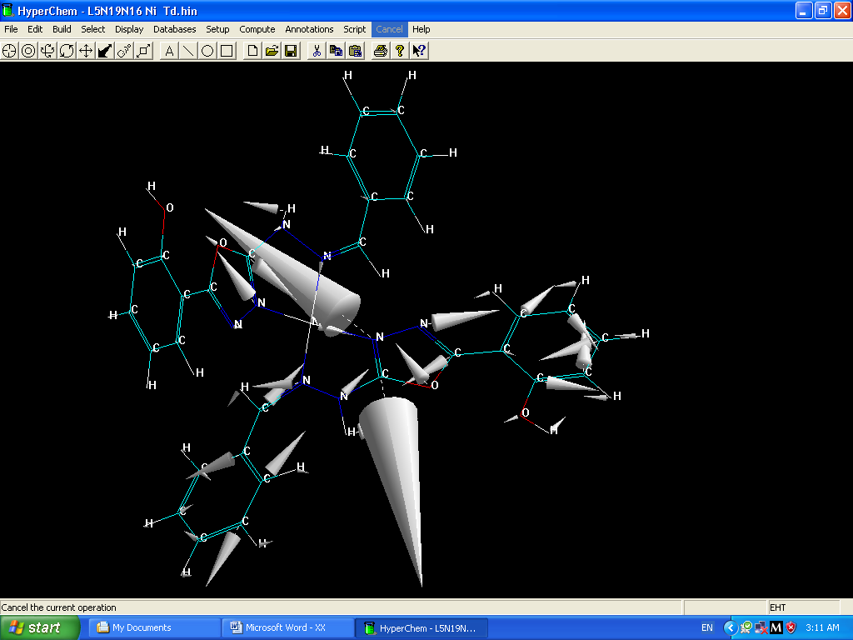  V(C==N)in Ni-complex | 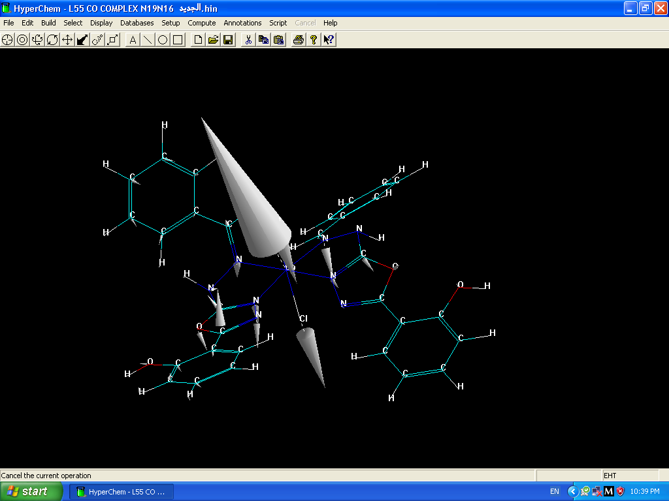  V(M___Cl) in Co-complex

Figure(3): Some frequencies of the (B.H.O.H) and its complexes

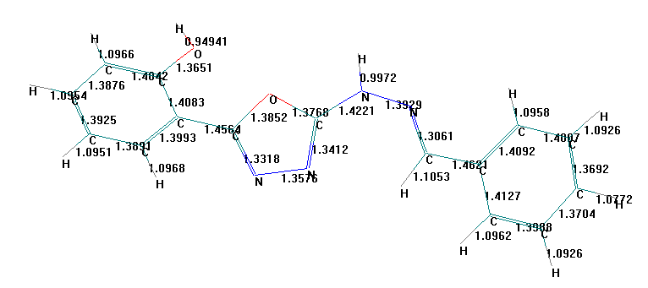

Bond Lengths (Aº) For (B.H.O.H)

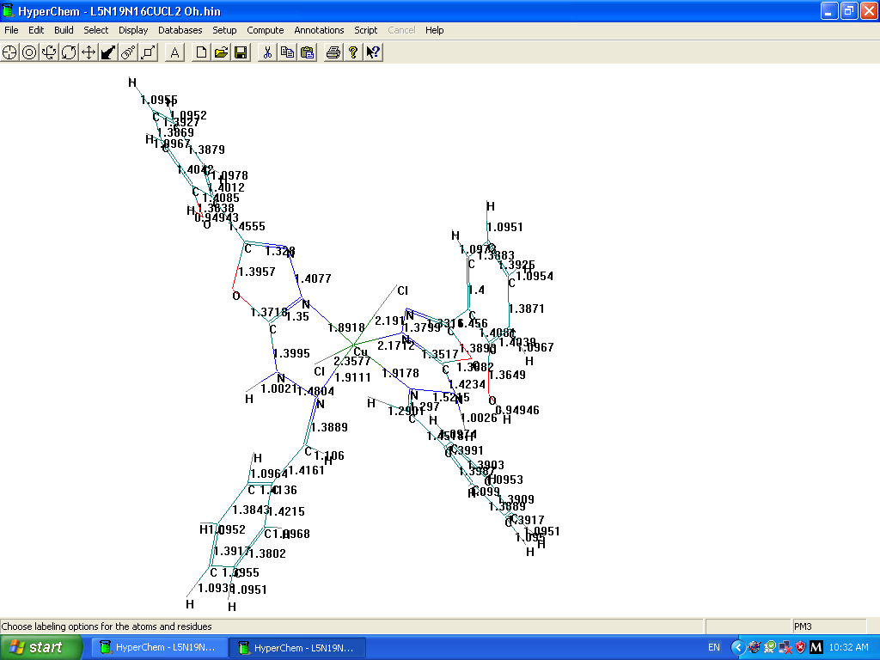

Bond Lengths (Aº) For Cu – complex

Figure(4): Bond lengths (Aº)

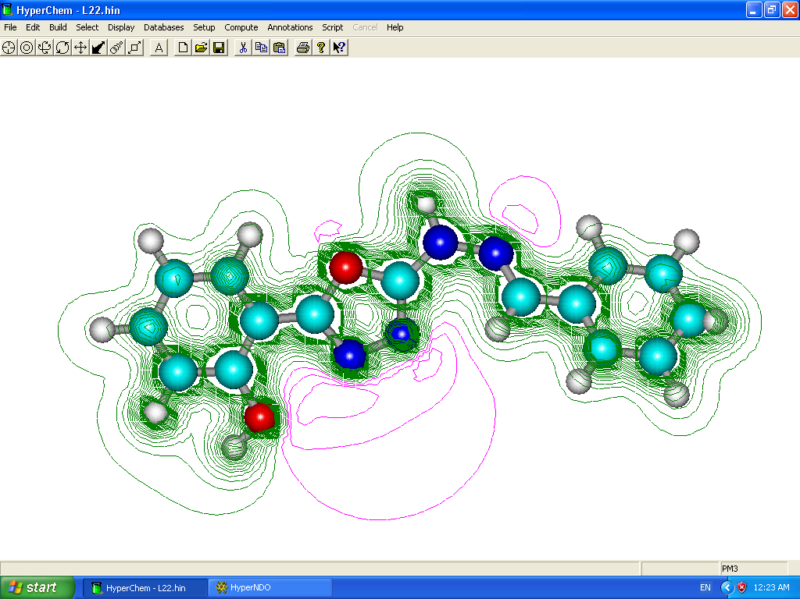

Figure(5): HOMO Electrostatic Potential as 2D Contour of B.H.O.H

References
1- E. Hoggorth, J. Chem. Soc., 1952, 4811.
2- C. Ainsworth, J. Am. Chem. Soc., 1965, 20, 5800.
3- H. Singh et al., J. Inorg. Nucl. Chem., 1981, 43, 712.
4- H. Singh, L.D. Yadav and S.B. Misharo, J. Inorg. Nucl. Chem., 1981, 43, 1701.
5- A.H. Jassim, Iraqi J. Sci., 1998, 39A(3), 3.
6- F.H. Kamel, K.K. Al-Janabi and A.H. Jassim, Iraqi J. Chem., 2001, 27(2), 245.
7- N.J. Al-Obaidy, Kalil K. Abid and Yusra J. Al-Niami, National Journal of Chemistry, 2006, 24, 629.
8- Z. Hang, R. Zhong and K. Bei Ya, Journal of the Chinese Chemical Socity, 2002, 49, 369.
9- S.A. Al-Jibori, I. N. Al-Nassiri, Transition Metal Chemistry, Printed in the Netherlands, 2001, 1-5.
10- A. Dearing, J. computer –Aided Molecular Design, 1988, 2, 179.
11- W. Boyd, K.B. Lipkowitz, Computational Chemistry, 1991, 5(3), 273.
12- A.B. Richon, An Introduction to Molecular Modeling 1994, 1, 83.
13- A.A. El-Azhary, J. Phys. Chem., 1998, 102, 620.
14- J.P. Stewart, Journal of computational Chemistry, 1989, 10(2), 209.
15- O.S. Moustafa and T.I. El-Emary, Bull Korean Chem. Soc., 2002, 23(4), 567.
16- R.W. Young and K.H. Wood, J. Am. Soc., 1955, 77, 400.
17- B.T. Thaker, A. patel and P. Thaker, Indian J. Chem., 1996, 35A, 483.
18- A.K. Sengupta, M. Goyal, J. Indian Chem. Soc., 1983, Lx, 766.
19- N. Demirbas, Turk J. Chem., 2005, 29, 125.
20- S. Ikbal Al-Shibani, K. Nejlaa Al-Yonis and A.H. Al-Dujaili, National Journal of Chemistry, 2006, 21, 94.
21- I.F. Mustafa, A.T. Atto, H.Y.Ahmed, Iraqi J. of Chem., 2001, 27(3), 695.
22- R.T. Mehdi and A.M. Ali, National Journal of Chemistry, 2005, 20, 540.
23- K. Nakamoto, Infrared Spectra of Inorganic and Coordination Compounds, 4th Ed. Wiley, Interscience, New York, 1986.
24- Z. Peng and J. Zhang, Chem. Mater., 1999, 11, 1138.
25- L. Rogger and B. Harry, Chemical Structure and Bonding, 3rd Ed., 1980.
26- A. Syamal and M.R. Maurya, Indian Journal of Chemistry, 1985, 24A, 836.
27- S.A. Al-Jibori, I.N. Al-Nassiri, Transition Metal Chemistry, 2001, 00, 1.
28- C.B. Mahto, J. Indian Chem. Soc., 1980, LVII, 485.
29- N.H. Buttrus, O.M. Al-Ramadane, National Journal of Chemistry, 2006, 23, 344.
30- S.F. Akettle, Coordination Compounds, Thoms Nelson and Sons London, 1975, 186-212.
31- C.B. Mahto, J. Indian Chem. Soc., 1980, LVII, 481.
32- I.P. Khullar and U. Agarwala, Can. J. Chem., 1975, 53, 1165.
33- V.J. Babar, D.V. Khasnis and V.M. Shinde, J. Indian Chem. Soc., 1981, LVIII, 970.
34- V.G. Cootes and D. Ridley, J. Chem. Soc., 1964, 166.
35- H. Keypour, K.P. Wainwright and M.R. Taylor, Journal of the Iranian Chemica Society, 2004, 191, 53.
36- J.I. Choe and S.K. Chang, M. Satoshi and S. Nanbu, Bull. Korean Chem. Soc., 2003, 24(1), 75.
37- J.I. Choe and S.K. Chang, Bull. Korean Chem. Soc., 2002,23(1), 48.

