Photocatalytic Iodometry over Naked and Sensitized Zinc Oxide.

Abbas J. Attia
Babylon University, College of Science , Chemistry Dept.

(NJC)

(Received on 15/4/2008) (Accepted for publication 16/7/2008)

Abstract
Photocatalytic oxidation of iodide ion in the aqueous suspension of zinc oxide and its sensitization with riboflavin has been done . Irradiation of reaction mixture was done by used each of visible , and ultraviolet radiation. The concentration of iodine formed was determined by spectrophotometric method . According to this method the amount of product formed was finding by a suitable calibration curve and measuring the absorbance at ( 350 nm) . The reaction was done at three different temperatures 293,298 and 303 K. Effect of temperature on the rate of reaction was used in calculation of activation energy which was about (24 kJ. mol⁻¹ ). Langmuir- Hinshilwood(LH) kinetic model was applied for the reaction as it first order in its kinetics which gives reaction rate constant of (1.4*10⁻⁶ sec⁻¹ ) and equilibrium adsorption constant of (2.5 * 10⁴ l.mol⁻¹).The results showed that sensitized zinc oxide was more active that naked form . Also used ultraviolet light was more efficient then visible light . The efficiency of reaction increased with elevation in the temperature of reaction .Also the basisity of solution was increased with the development of reaction time.
الخلاصة
تم دراسة الأكسدة الضوئية المحفزة لأيون اليوديد في المحلول المائي بأستعمال أوكسيد الخارصين المجرد والمحسس بصيغة الرايبوفلافين كعامل مساعد ضوئي والتشعيع بأستخدام الضوء المرئي والأشعة فوق البنفسجية . تم تقدير تركيز اليود المتكون بفعل الاكسدة الضوئية بطريقة طيفية حيث تم التقدير بأستعمال منحني معايرة مناسب بأستعمال محاليل قياسية مع قياس الأمتصاصية عند طول موجي (350) نانو متر . تم أجراء التفاعل بثلاث درجات حرارية مختلفة وهي293, 298, 303 كلفن تم الأستفادة من تأثيرات درجة الحرارة على معدل سرعة التفاعل في أيجاد طاقة التنشيط للتفاعل بالأعتماد على معادلة أرينوس ولقد كانت طاقة التنشيط بحدود 24 كيلو جول للمول . تم تطبيق نموذج لانكميور- هنشلوود الحركي لهذا التفاعل على أعتبار أنه تفاعل من الدرجة الأولى حيث تم أيجاد ثابت التوازن الظاهري للأمتزاز وكان ⁴10*2.5 لتر .مول⁻ ¹ . وكذلك ثابت السرعة للتفاعل وكان 1.4 *10⁻⁶ ثا⁻¹ . بينت النتنائج أن أوكسيد الخارصين المحسن بالرايبوفلافين كان أكثر فعالية من العامل المساعد المجرد وكذلك فأن أستخدام الأشعة فوق البنفسجية كان أكثر فعالية من الأشعة المرئية وكذلك فأن كفاءة التفاعل تزداد مع زيادة درجة حرارة التفاعل مع زيادة القاعدية للمحلول مع زيادة زمن التفاعل.

Introduction
Semiconductors have gained much attention in their used as a photocatalysts in a different photochemical reactions⁽¹⁾ . The first step in the illumination of photocatalysts such as ZnO is the generation of conduction band electron ,and valence band hole . These charges are migrated rapidly into the surface of the photocatalyst ⁽²⁾ . At the surface ,these charges are trapped by the preadsorbed substrates on the surface as in the following ⁽³⁾:

Sc+hν e⁻ _{cb} + h⁺ _{vb}……………………..…(1)
O_{2(ads.)} + e⁻ O⁻_{2(ads.)} ………………….…..(2)
OH⁻_{(sur)} + h⁺ OH•_{(sur)}……………………( 3)

These radicals are contributed in the redox reactions on the surface of photocatalyst . when used naked photocatalyst such as ZnO ,back electron transfer is occurred . This process reduces the efficiency of the reaction as follow ⁽⁴⁾ :
e⁻ _{cb} + h⁺ _{vb} h υ …..(4)
Different methods are used in the reduction the rate of recombination reaction , one of those is the used of photosensitizer (D),which may be colored compounds such as dyes,pigmentes,and cheleating compounds. These dyes are absorbed light with high molar absorption coefficient to give singlet or triplet excited state , then inject electron into the conduction band of ZnO as in the follow ⁽⁵⁾
D+ h υ D⁺ ……(5)
D⁺ + Sc Sc⁻ + D⁺ ……(6)
D⁺ + e⁻ D …………..(7)

These processes can be showed in the following figure.
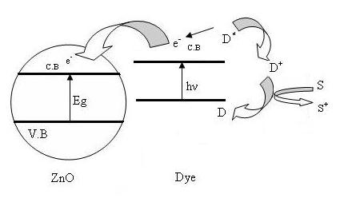

Figure (1): Charge injection between sensitizer molecule
and ZnO particle

Photocatalysts are used in the photoproduction of different halogens⁽⁶⁾ . Photocatalytic oxidation of halide ion the aqueous suspension have been studied by many researchers^{(7,8)}. They showed that this type of reaction required presence of air , light and catalyst .
The present work involve the photocatalytic formation of I₂ from aqeous solution of KI over naked ZnO and RF/ZnO . Irradiation of reaction mixture was done by visible and ultra violet light at three different temperatures .

Experimental
Zinc oxide powder used in this study was supplied by (BDH) with purity of 99.99% .The used riboflavin was supplied by (Aldrich) with purity of 98 % .
In each experiment 150 mg of the catalyst was suspended in 30 ml of 0.5 M of KI solution . Irradiation of reaction mixture was done by tungsten lamp(250 W) and medium pressure mercury lamp (MPML)(150 watt) (TQ 150 Z2) supplied by (karl kolb company ) reaction unit consist of reaction cell which is fitted with the used lamp . The cell has a connections for passing air , and water over and around reaction mixture . The whole apparatus is shown in figure (2).
The concentration of I₂ formed was determined by spectrophotometric method . According to this method a suitable calibration curve was prepared by used a standard solutions of I₂ in KI . The absorbance then measured at (350 nm) which is belong to the maximum absorption of standard solution of I₂ in KI solution . The absorbance was measured by UV-Visible spectrophotometer type (UV-1650 PC) supplied by Shimadzu company Periodically , 2ml of reaction mixture was withdrawing by a microsyrnge , the sample then centrifuged to separate the solid catalyst , then the absorbance is measured to 350 nm .

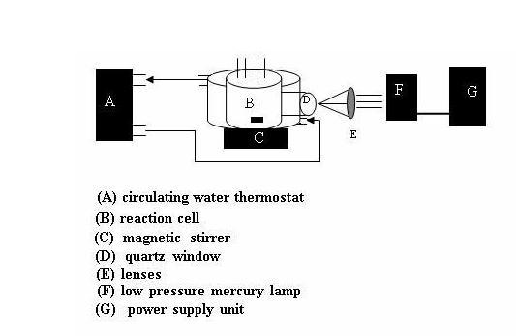

Figure(2): Schematic diagram of the experimental apparatus for the photocatalytic oxidation reaction

Surface Modification
Sensitization of ZnO surface with riboflavin was done by impregnation method ⁽⁹⁾ . according to this method 1% of ZnO powder was added to (1*10⁻³ M) of aqueous solution of the dye with passing air over reaction mixture and continuous stirring for two hours at 298 K . the sample then centrifuged and washed with distilled water for several times to remove anstrogly adsorbed molecules on the surface . The product then dried at 303 K for four hours in vacuum oven . Modification of the surface of ZnO with RF is shown by Figs( 3, 4 ) .

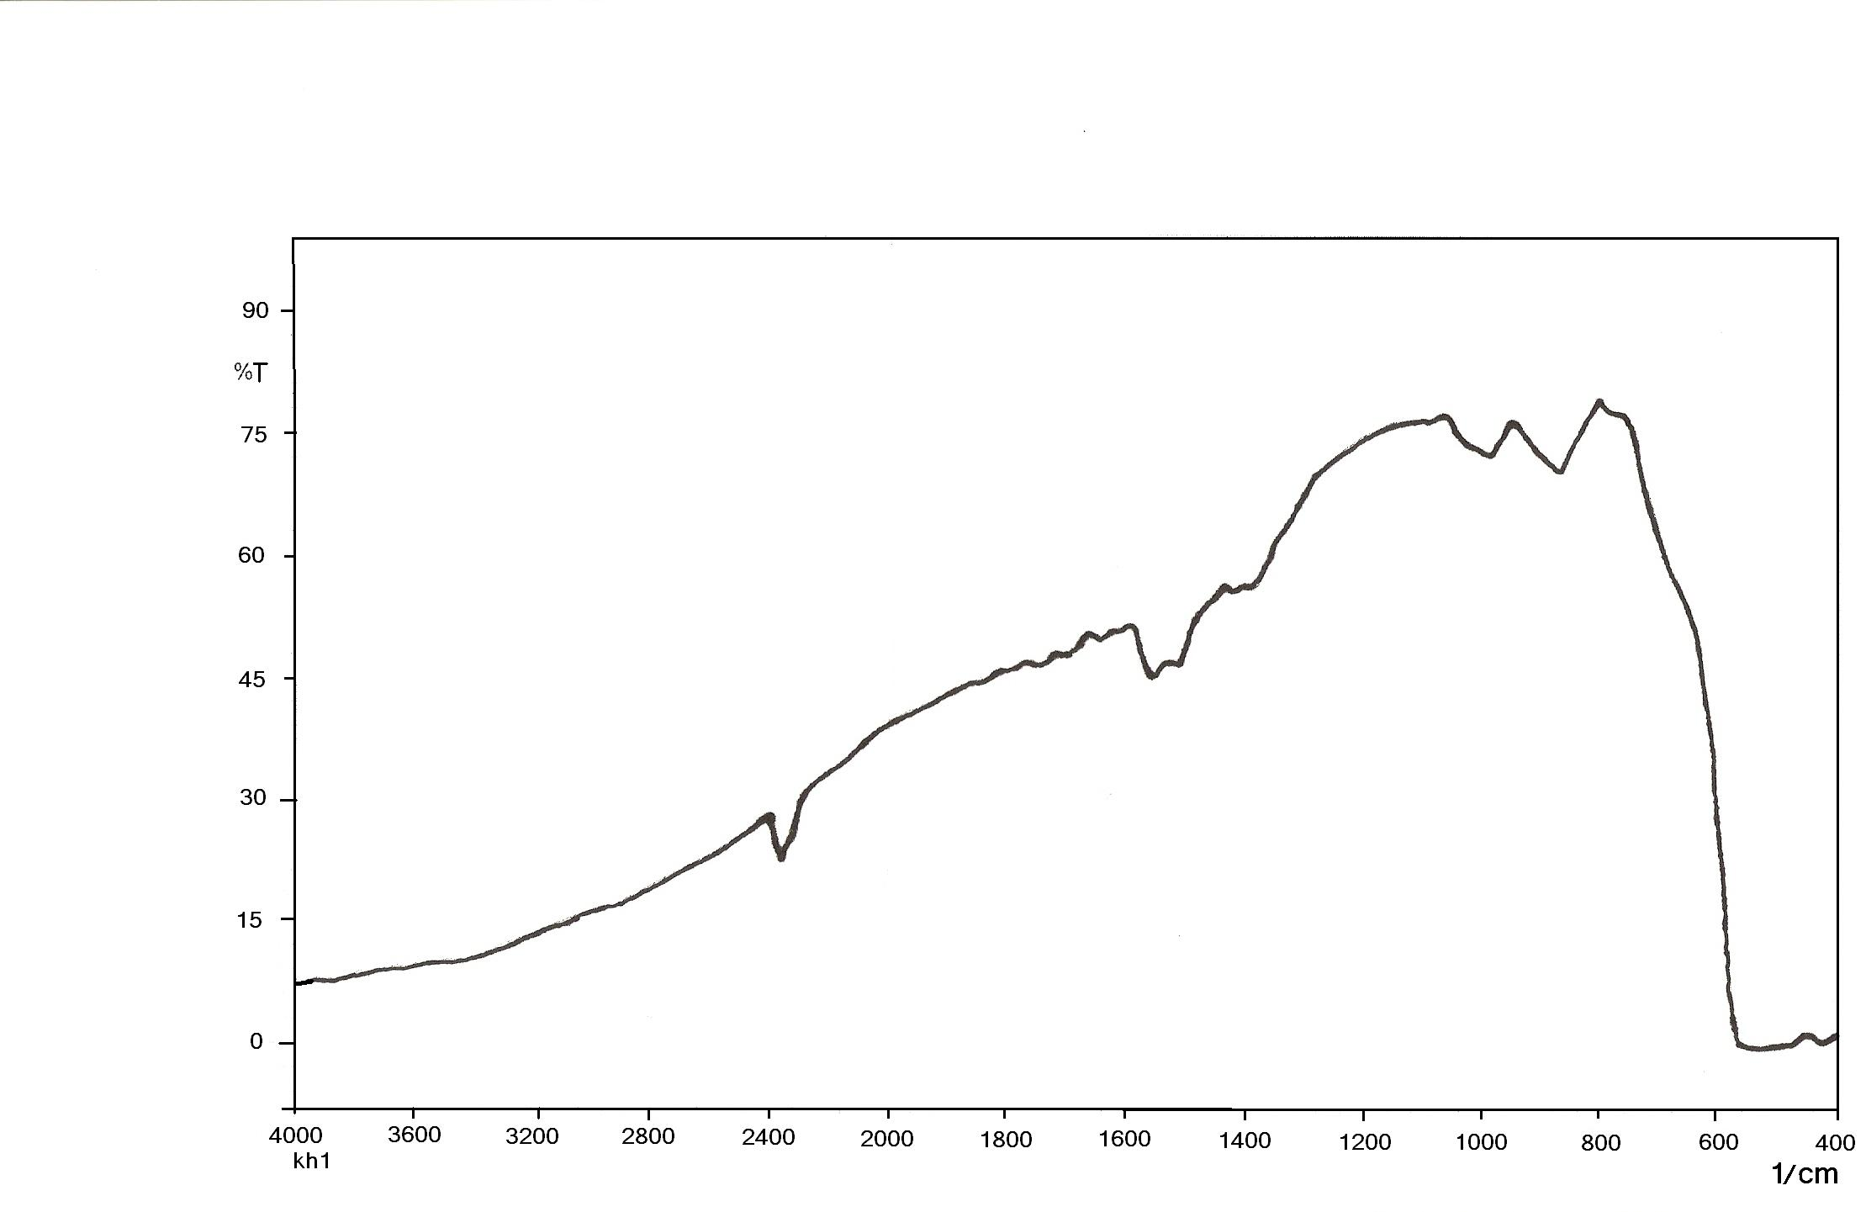

Figure(3):IR Spectrum for ZnO

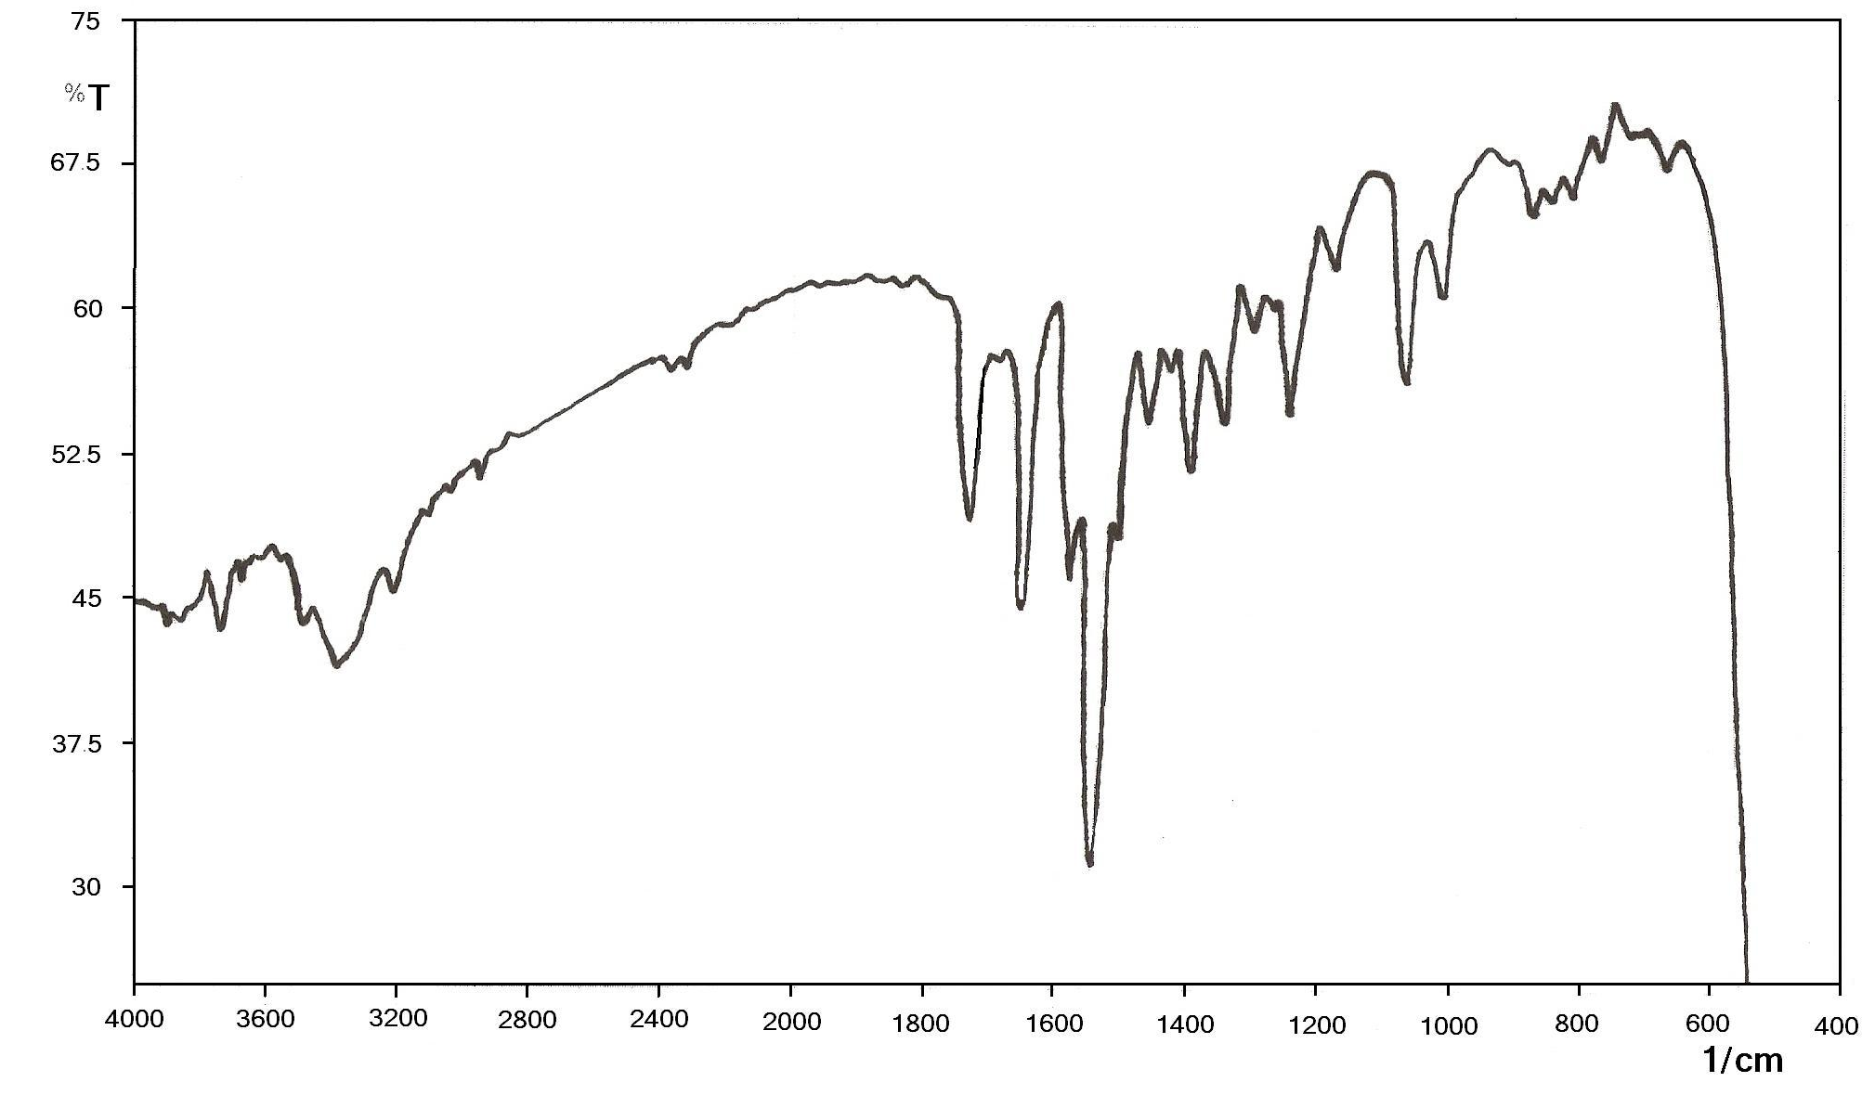

Figure(4):IR Spectrum for RF/ZnO

Results and Discussion
The results showed that , used ultraviolet light in the illumination of reaction mixture give a high concentration of I₂ with respect to that formed under irradiation with visible light in the same conditions of reaction . These results are shown in Figs (5 , 6). High efficiency for uv-light is coming from a wide band gap of ZnO (Eg =3.2 ev )⁽¹⁰⁾ .

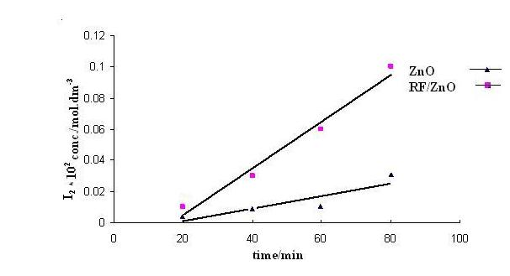

Figure(5):Phtocatalytic formation of I₂ over ZnO,and RF/ZnO under irradiation with visible light from tungsten lamp at 293 Kº
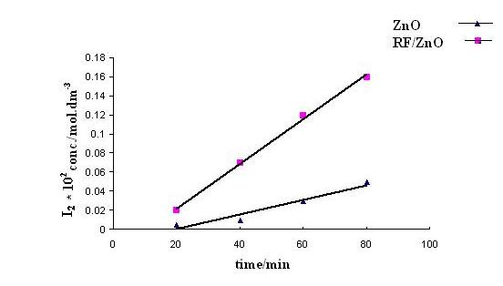

Figure(6): Phtocatalytic formation of I₂ over ZnO,and RF/ZnO
under irradiation with UV light from MPML at 293 Kº

This energy is available in the ultraviolet region of electromagnetic radiation , the visible light provide only 10% of its intensity of uv-light ⁽¹¹⁾ . When used RF/ZnO as a photocatalyst gives high activity for the reaction with the two types of radiation , with respect to use naked ZnO .
Sensitization of ZnO surface can extend its photorespones toward visible region of the solar spectrum ^{(12,13)} . The charge injection process can extend the absorption of the sensitized photocatalyst toward visible region of the spectrum. Also sensitization can prevent recombination reaction which is commonly occurs when used only photocatalyst which inturn reduces the efficiency of photoreaction ⁽¹⁴⁾. The effect of temperature on the rate of reaction is shown in Fig (7),(8) the results showed that the efficiency of reaction is increased as temperature is raised , inspite of photoreaction is slightly effected by the changes in temperature⁽¹⁵⁾. High increasing in rate of reaction with elevation in temperature may be result from effect of temperature on the processes which are occurred on the surface of the photocatalyst⁽¹⁶⁾. These processes involve adsorption of reacted species and adsorption of reaction products , and surface migration groups .However ,these processes are not rate determining step for this type of the reaction ^{(17).} The rate determining step in this case is the electron transfer through catalyst into the conduction band of it⁽¹⁸⁾.

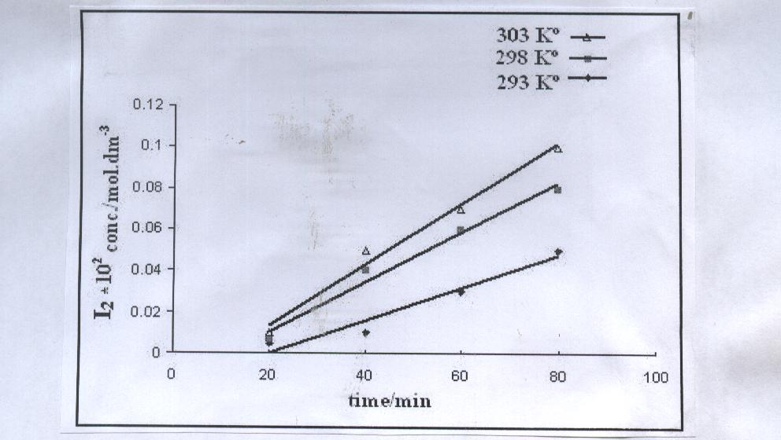

Figure(7):Photocatalytic oxidation of iodide ion over naked ZnO with irradiation by visible light from tungsten lamp at different temperatures.

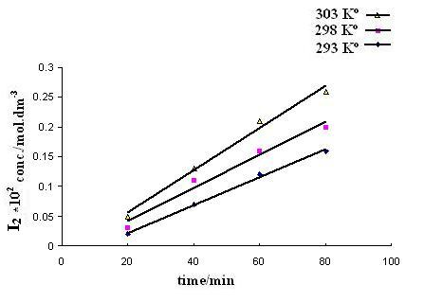
Figure(8):Photocatalytic oxidation of iodide ion over RF/ZnO
with irradiation by ultraviolet light at different temperatures.

Activation Energy
The effect of temperatures on the rate of reaction can be used in the calculation of activation energy of the reaction by used Arrhenius equation as follow: ^{(19, 20)}

k= Ae^{Ea/RT} …..(8)
Whereas k is the rate constant of reaction , E_{a} is the activation energy , R is the gas constant , and T is the absolute temperature of reaction .
The rate constant of reaction can be calculated for each temperature by used the equation
Ln(a-x) = Lna-kt ………(9)

Wherease a= Ao- A∞,and x= Ao- At
Ao is the absorbance before irradiation, At is the absorbance at a given time
A∞ is the absorbance at final time. By substitution of a, and (a-x) in equation gives
Ln(At- A∞) = Ln(Ao- A∞)-kt ……(10)

From this equation rate constant(k) can be calculated by plotting Ln( a/a-x) versus irradiation time for each temperature.Arrhenius plot is obtained by plotting Ln k versus 1/T for the three different temperatures as shown in figure(9) ,which gives an activation energy which was about 24KJ.mol⁻¹ for each ZnO , and RF/ZnO . It has been found that the activation energy was similar for the two catalysts . Although used photosensitizer increases the rate of reaction by increasing the polarity of ZnO particle , and reduce recombination reaction when used naked ZnO.
Activation energy for this type of reaction is believed to be associated with electron transfer in the lattice of catalyst , and its independent on the type of chemical reaction ^{(21,22)} .

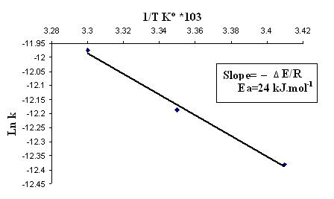
Figure(9):Arrhenius plot for the photocatalytic oxidation of
iodide ion over ZnO.

LH- Kinetic Model
The reactions which are occurred in the heterogeneous photocatalytic systems obey Langmuir-Hinshlwood kinetic model (LH). This model can be used in the finding of apparent adsorption constant (ka) as well as apparent reaction rate constant (kr) for the reaction on the surface , as follow⁽²³⁾ :

Ө = ka C / (1+ka c) ………..(11)
Whereas
Ө Is the surface coverage
c is the initial concentration of reaction .
ka= is the equilibrium adsorption constant
The rate of reaction of product formation (rLH) is given by .

rLH =-dc/dt = kr ka c /(1+Ka c) ………(12)
kr is the reaction rate constant, this equation can be modified as "

1/r_{LH} = 1/ kr + 1/kr kac ………(13)

The linearity of this relation is given by plot ( 1/rLH) vs. (1/C) which give slope of 1/(ka kr) with intercept of 1/kr . These results are shown in Fig(10) according to (LH) kinetic model ka= 2.5*10⁴ l.mol⁻¹ , and kr = 1.4*10⁻⁶ sec⁻¹

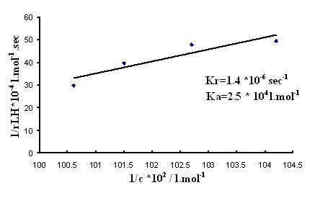

Figure(10):LH kinetic model for the photocatalytic oxidation of iodide ion over ZnO.

pH Measurement :
Photocatalytic formation of I₂ is accompanied by formation of the hydroxyl ion which leads to increase pH of the solution . The overall stoichiometry for reaction as follow: ⁽²⁴⁾

2KI + H₂O I₂ + 2KOH …… (14)

This result is in a good agreement with the previous finding by Rudham and Harvey ⁽²⁴⁾ .The change in pH of solution with reaction time is shown in Figure (11).

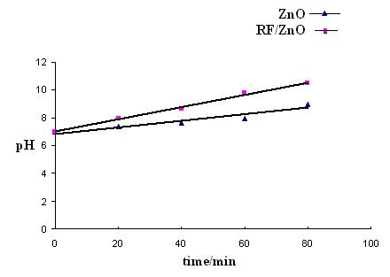

Figure(11):pH variation in the photocatalytic oxidation of iodide ion over ZnO and RF/ZnO

Proposed Mechanism
The first step in the photocatalytic oxidation on the surface of the photocatalyst , is the excitation of semiconductor particles as follow ⁽²⁵⁾ :

SC + hυ h⁺ + e⁻ …… (1)
e⁻ + O_{2 (ads.)} O⁻_{2 (ads.)} ……(2)
h⁺ + OH⁻_{(sur)} OH• _{(sur)}…… (3)
O⁻_{2(ads.)} + H₂O OH•_{(s)} +
HO• _{2(ads.)}……. (15)

The reactive species HO• (ads.) ,and HO• ₂(ads.) are reacted in aqueous solution with prescence of the photocatalyst ⁽²⁶⁾ . The weakly bounded adsorbed iodide ion (I⁻ )ads. is oxidized into iodine by electron transfer to HO•(ads) ,and HO•₂(ads) as follow ⁽²⁷⁾:

I⁻ _{(ads)} + OH•_{(ads)} OH⁻ _{(ads)} + I_{(ads)} …….(16)

I⁻ _{(ad s)} + HO• _{2 (ads)} HO⁻_{2 (ads)} + I_{(ads)} ……. (17)

The reaction of HO⁻_{2(ads)} and with H₂O adsorbed molecules give pyroxide molecules as follow ⁽²⁸⁾ :

HO⁻_{2(ads)} + H₂O_{(ads)} H₂O₂ _{(ads)} + OH⁻ _{(ads)} ….. (18)

H₂O₂ _{(ads)} + I⁻ _{(ads)} OH⁻ _{(ads)} + OH. _{(ads)} + I _{(ads)} …… (19)

Desorption of OH⁻ _{(ads)} , and I (ads) can produce of OH⁻ _{(s)} as well as combination of
I _{(ads)} which give the overall reaction :

O₂ + 2H₂O + 4I⁻ 2I₂ + 4 OH⁻ ……… (20)
When used photosensitizer the first step in this case is the excitation of sensitizer molecules by absorption light as follow⁽²⁹⁾ :

S + hυ S* ………. (21)
The excited state of dye (S*) , then inject electron into the conduction band of the photocatalyst :

S* + ZnO S⁺ + ZnO (e⁻)….. (22)
These electrons are contributed in the photocataltic oxidation of iodide ion as in the above mechanism . The main difference in this mechanism is the absence of the positive hole which may reduce the efficiency of the reaction by back electron transfer which is commonly occurs when used naked photocatalyst . The oxidized from of dye molecule is return to its initial state by received electron from reaction system as follow ⁽³⁰⁾ :

S⁺ + D S + D⁺ …….. (23)

Conclusions
The photocatalytic oxidation of iodide ion in the aqueous solution can be done over ZnO , and RF /ZnO . Used of RF /ZnO gives a good results with respect to use naked ZnO under irradiation with visible and ultra violet light . Irradiation with UV light was more active than visible light for two cases . The activity of reaction is increased with elevation in temperature of reaction . The activation energy is calculated by used Arrhenius equation , and it was same for both ZnO , RF/ ZnO . The basisty of reaction mixture is increased with the development of reaction time due to the formation of hydroxyl ion in a stoichometrical quantity with iodine .
References
1-R.Grieken,J.Aguado,M.Lopez,and J. Marugan, J. Photobiol. A: Chem., 2002, 148, 315.
2-K.Sayamaka,K.Mukasa,R.Yuab,and H.Arakawa, J. Photochem. Photobiol. A: Chem., 2002, 148, 71.
3-A. Topalov, D. Molnar,and M.Kosanic, and B. Abramovic, Water. Res., 2000, 34, 1473.
4-C.Chen,P.Lei,J.Hongwei,and J.Zhao,Environ.Sci.Technol, 2004, 38, 329.
5-F.Hussein,and A.Alkhateeb,Science Direct , 350,209, 2007.
6-J.Herrmann, and P. Pichat, J. Chem. Soc. Faraday Trans. I, 1980, 76, 1138.
7-P. H arvey, R.Rudham, and S. Word, J. Chem. Soc. Faraday Trans. I, 1983, 79, 1381.
8-B. Reichman, and C. Byvik, J. Phys. Chem., 1981, 85, 2255.
9-H.Abbas Habeeb,M.Sc Thesis, Babylon University ,Iraq. 1998.
10-G. Mura, M. Ganadu, P. Lombord, and, V. Moida , Photobiol. A: Chem., 2002, 148, 199.
11-C. Nasr, S. Hotchandani, P. Kamat, S. Ds, and G. Georgye, Langmuir, 1995, 11, 1777.
12-V. Augugliaro, C. Baiocchi, V. Loddo, S. Miato, L. Palmisano, and M. Pazzi, Chemosphere, 2002, 49, 1223.
13-L. Skubal, N. Meshkov, and M. Voget, J. Photochem. Photobiol. A: Chem., 2002, 148, 103.
14-T. Del, M. Ronchella, C. Roll, and G. Sebastiani, J. Phys. Org. Chem., 2000, 13(11), 775.
15-H. Yamashita, M. Hara, J. Misaka, M. Takeuchi, and M. Anpo, J. Photochem., Photobiol. A: Chem., 2002, 148, 257.
16-F. Hussein, and H. Habeeb, J. Al-Qadisia , 2000, 1, 3.
17-F. Hussein, A. Ibrahim, and S. Shakir, Zanco, 1989, 2, 73.
18-F.Hussein,Ph.D.Thesis,Notingham University,U.K.,1984.
19-A.Companion,and R.Wyatt,J.Phys.Chem., 1963, 24,1025.
20-S. Radi,M.Sc.Thesis,Salah Al-Den University,Iraq,1989.
21-J. Herrmann, and P.Pichat,J.Phys.Chem., 1983, 7, 77.
22-E.Borgarello,and E.Pelizzetti,Chem.Indns., 1983, 65, 474.
23- C.Turchi,and D.Ollis,J.Catal., 1990, 122, 178.
24-B.Jenny,and P.Pichat,Langmuir, 1991, 7, 947.
25-J. Cunningham, and S. Srijaranai, J. Photochem. Photobiol. A: Chem., 1991, 58, 361.
26-R.Harvey,and R.Rudham,J.Chem.Soc.Faraday.Trans.І, 1988, 84, 4181.
27-A. Hiskia, A. Mylonas, and E. Panaconstantinou, Chem. Soc. Rev., 2001, 62, 309.
28-A.Troupis,and A.Hiskia,Angew.Chem.Int.Ed., 2002, 41, 1911.
29-C.Jaeger,and A.Bard,J.Phys.Chem., 1979, 83, 3146.
30-A.Abdul Ghani,and S.Abdul Kareem, Int.J.Hydrogen Energy, 1989, 14, 303.

