Lithium and Potassium Ions Transfer Processes across the ITIES in The Presence of Crown Ethers

Elbertine E . Habboush, Nabil S . Nassouri and Kasim K.M. Alasedi
Department of Chemistry, College of Education for Women, University of Kufa
Najaf, Iraq.

(NJC)

(Received on 12/12/2007) (Accepted for publication 7/8/2008)

Abstract
The electrolytic cell with the electrolyte dropping electrode comprised Ag/AgCl as working electrode, Ag/AgCl reference electrode and platinum wire counter electrode. This cell evaluated by the determination of the thermodynamics data for lithium and potassium ions transfer across a liquid-liquid interface in the presence of the crown ethers. In the present system we intend to demonstrate the use of a simple three-electrode assembly with electrolyte dropping electrode for the study of the interfacial ion transfer.
In particular, we focused on the transfer of lithium and potassium ions from water to 1, 2- dichloroethane (1, 2-DCE) facilitated by complex formation with benzo-15-crown -5 (B15C5), 18-crown -6 (18C6), dibenzo-18 – crown-6 (B₂18C6) and dicyclohexyl-18- crown -6 (Cy₂ 18C6).
Extensive thermodynamics data, suggest that the standard Gibbs energies of transfer of lithium and potassium ions from water to 1,2-DCE and stability constant of crown ether complexes depends on the relative cation and ligand cavity size, the number and special arrangements of the ligand binding sites and the substitution on the macrocyclic ring.
الخلاصة
تم تصميم خلية بولاروكرافية تتكون من قطب الماء المتقاطر, Ag / AgCl قطب عامل , Ag / AgCl قطب قياسي وسلك البلاتين كقطب مساعد. تم إيجاد المعطيات الثرموديناميكيه لأنتقال أيوني الليثيوم والبوتاسيوم عبر السطح البيني سائل- سائل بوجود الأيثرات التاجية , حيث تم تطبيق الخلية المتكونة من ثلاثة أقطاب لدراسة انتقال أيوني الليثيوم والبوتاسيوم عبر السطح البيني من الطبقة المائية إلى 1, 2- ثنائي كلورو إيثان من خلال تكوين معقدات مع بنزو- 15- كراون -5 , 18- كراون- 6 , ثنائي بنزو -18- كراون -6 ,ثنائي سايكلوهكسايل-18- كراون- 6.
ألدراسات الثرموديناميكية بينت بأن طاقات ﮔبس القياسية وكذلك ثوابت ألاستقرارية لمعقدات ألايثرات التاجية مع ايوني الليثيوم و البوتاسيوم من الماء إلى 1, 2- ثنائي كلورو إيثان باستخدام قياسات الكيمياء الكهربائية للسطح البيني للمحاليل الالكتروليتية ( ITIES) تعتمد على نسبة ألايون الموجب وحجم حلقة ألا يثر التاجي , عدد ونوع الذرات المرتبة من خلال جهة اتصال الليكاند مع ألايونات وكذلك المجاميع المعوضة في حلقة ألايثر التاجي .

Introduction
Polarographic with the electrolyte dropping electrode (EDE) was pioneered by Koryta et, al. ^{(1, 2)}. A general deal of deserved interest has centered on the nature of ionophore facilitated transfer of ions, such as Li⁺, K⁺ and other alkali-metal cations across the aqueous-immiscible organic liquid interface. A reaction attracting attention from groups as diverse as neuro- physiologists and electro analytical chemists.
The results of electrochemical investigations made on the transfer of ionizable drugs at the interface between two immiscible electrolyte solutions (ITIES) in the last decade have been presented ⁽³⁾. . . The transfer of alkali metal cation facilitated from water to nitrobenzene (NB) and 1, 2- dichloroethane (1, 2-DCE) has been evaluated from linear potential sweep voltammetry measurements at the interface between two immiscible electrolyte solutions (ITIES). The procedure involved an implicit use the tetraphenyl arsonium tetraphenyl borate ⁽⁴⁾. The transfer of Li⁺ and K⁺ facilitated by valinomycin ^{(5,6)} , nonactin ⁽⁷⁾, and crown ethers^{( 5,7)} has been extensively studied by Koryta and his group.
Studied the voltammetric and AC-impedance behavior of the protonated ion of several local anesthetics of the o-nitrophenyl octyl ether/water interface. It was observed that the pharmacological activity of local anesthetic increases with a decrease in their ion-transfer standard potential, which is consistent with the data obtained at the nitrobenzene/water interface^{(8,9)} . . Samec and Papoff ⁽¹⁰⁾ demonstrated that the (current scan ) polarographic waves observed represented the transfer of alkali metal cations from water to NB or 1,2-DCE facilitated by complex formation with B₂18C6 , B₂24C8 or B₂30C10 were used to clarify the mechanism of the ion transfer and to evaluate the stability constant of crown ether complex .
Recently, Sildenafil (Viagra) was examined for its ionization and lipophilicity by electrochemistry at ITIES and two-phase titration in the 1,2-dichloroethane water system⁽¹¹⁾.

Experimental Section
1-Aqueose phase:
0.5M MgSO4. H2O was used as a supporting electrolyte with Lithium chloride and Potassium chloride in the electrolytic cell which were prepared by dissolving an appropriate amount of the salt in 100ml of deionized water.

2-Organic phase:
Samples were prepared individually by dissolving appropriate amounts of crown ethers in 100ml in 1,2-DCE .Each 25ml of sample was mixed with a fixed amount of 0.4188gm of tetraphenylarsonium chloride and analyzed using dropping water electrode.
1,2- dichloroethane(1,2-DCE) (Aldrich Chemical Company Inc. ) was used without further purification . LiCl and KCl Salts from BDH. benzo-15-crown -5(B15C5), 18-crown -6 (18C6) , dibenzo-18 – crown-6 (B₂18C6) and dicyclohexyl-18- crown -6 (Cy₂18C6) [Fluka AG]. The supporting electrolyte of the aqueous phase was 0.5 M magnesium sulfate mono hydrate and that of the organic phase was 0.01M. Tetraphenyl arsonium chloride hydrate (C6H5)4 AsCl._{X}H₂O (Aldrich Chemical Co.Ltd.),water was doubly distilled deionized.

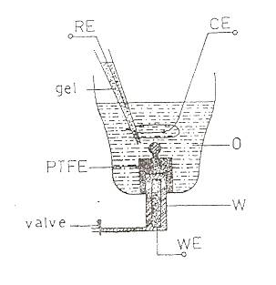

Figure (1). Three- electrodes polarographic cell with the electrolyte dropping electrode: (WE) Ag/ AgCl working electrode, (RE) Ag/ AgCl reference electrode, (CE) platinum wire counter electrode.

Electrolytic cell. Figure(1) shows the scheme of the electrolytic cell .The aqueous phase (density 1.051 g cm⁻³) was dropping upward into 1,2-DCE( density1.251 g cm ⁻³ ) from a PTFE capillary with the flow rate v ≈ 0.0679 g S ⁻¹ and the drop time td = 0.6 -1.2 S. The column height of the aqueous electrolyte solution ( 57 cm to the orifice of the capillary ) and the volumes of the organic and the aqueous electrolyte solutions in the cell were held constant.
The reference Ag/AgCl electrode for the organic solvent phase (RE) was dipped into the 0.01M TPhAsCl aqueous agar-agar gepulvent solution in a Pasteur pipette, the tip of which was about 0.2 cm far from the drop .The counter electrode (CE ) was a platinum wire wound round the drop as shown in figure ( 1).
A falt water/1,2–dichloroethane solvent interface, was formed in a three-electrode glass cell ^{(10,12)}.

Ag AgCl xM (LiCl or KCl ) 0.01M TPhAsCl 0.01M TPhAsCl AgCl Ag⁻
+0.5M MgSO₄.H₂O +0.01M ML
( w ) (0) (w⁻)

Where X =0.01 or 0.1 and L =B15C5, 18C6 ,B ₂ 18C6 and Cy₂ 18C6, was controlled by means of a conventional three – electrode potentiostat .

Results and Discussion
Figures (2,3 ) illustrate the polarographic behavior of various ion transfer systems (Base electrolytes, Ions in the presence of crown ether). The electrical current at the positive potential limit is connected with the transfer of either the cation (Li⁺ or K⁺ ) to the 1,2 – DCE or the anion Cl⁻ to water .Owing to the ion association in 1,2- DCE, the current I of the cation transfer to the organic solvent phase is to be expressed as the sum of two contributions. The first contribution is due to the simple ion transfer, e. g.

B⁺ (w) ↔ B⁺ (o) ……… (1)

and the second one is due to the formation of the ion pair with the counter ion in the organic solvent phase, e. g.

B ⁺ ( w ) + A⁻ (o ) ↔ B⁺A⁻ ( 0 )…..(2)

In the case that the bulk concentration of the counter ion is much higher than that of the transferred ion, the reversible half – wave potential ( E_{1∕ 2}) ^{rev} ,which can be derived from the polarogram of a diffusion–controlled charge transfer ⁽¹³⁾ (e.g. Fig.(2)), Should correspond to the half-wave Galvanic potential difference

w rev w rev
∆ _{o} ¢ = ∆ _{o} ¢ (RT/F) ln (γ º/ γ ^{w}) + (RT/2F) ln(D^{w} / Dº ) _-
^{1/2}
(RT/F) ln[1 K º_{a} α Cº(γ º)² (Dº_{a} / Dº)² ] …… (3)

_{w o}
where ∆ _{o} ¢ is the standard Galvanic potential difference of the simple ion transfer, D ^{w,o} is the diffusion coefficient of the ion ,Dº_{a} or Kº_{a} is the diffusion coefficient or the association constant of the ion pair B⁺A⁻, respectively ,Cº is the bulk concentration of the organic base electrolyte and α is the degree of its dissociation in the organic solvent phase . The parameters γ º and α can be evaluated by solving the system of equation [4] :
_
- log γ º = A√ Cº α / (1+ Ba √ Cº α )…..(4)

Kº_{ab} = (1- α ) / (γ º)² Cº α² ….(5)

Where A, B and an are the parameters of the Debye – Hückel theory and Kº_{ab} is the association constant of the base electrolyte in the 1,2 DCE solvent phase .

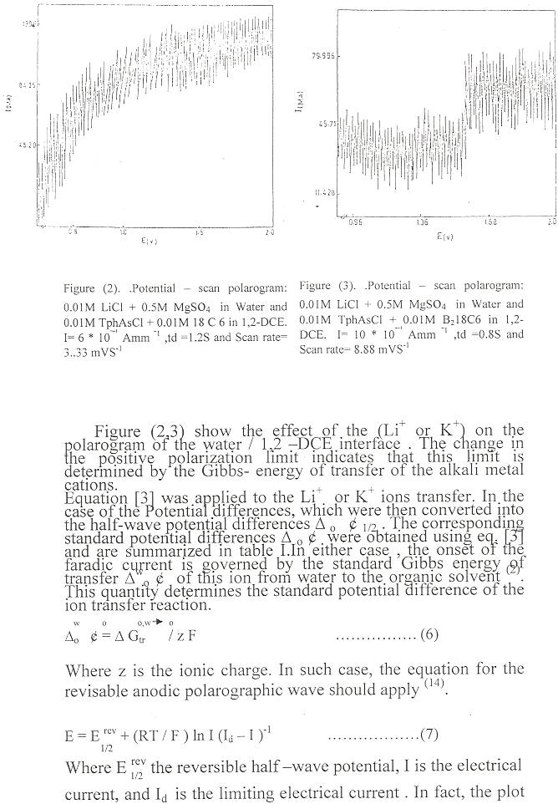

Figure (2). .Potential – scan polarogram: 0.01M LiCl + 0.5M MgSo₄ in Water and 0.01M TphAsCl + 0.01M 18 C 6 in 1,2-DCE. I= 6 * 10^{ˉ‾¹} Amm ^{‾1} ,td =1.2S and Scan rate= 3..33 mVS⁻¹ | Figure (3). .Potential – scan polarogram: 0.01M LiCl + 0.5M MgSo₄ in Water and 0.01M TphAsCl + 0.01M B₂18C6 in 1,2-DCE. I= 10 * 10^{ˉ‾¹} Amm ^{‾1} ,td =0.8S and Scan rate= 8.88 mVS⁻¹

Figure (2,3) show the effect of the (Li⁺ or K⁺) on the polarogram of the water / 1,2 –DCE interface . The change in the positive polarization limit indicates that this limit is determined by the Gibbs- energy of transfer of the alkali metal cations. Equation [3] was applied to the Li⁺ or K⁺ ions transfer. In the case of the Potential differences, which were then converted into the half-wave potential differences ∆ _{o} ¢ _{1/2} . The corresponding standard potential differences ∆ _{o} ¢ were obtained using eq. [3] and are summarized in table I.In either case , the onset of the faradic current is governed by the standard Gibbs energy of transfer ∆^{w}_{o} ¢ of this ion from water to the organic solvent ⁽²⁾. This quantity determines the standard potential difference of the ion transfer reaction.
_{w o} _{o,w o}
∆_{o} ¢ = ∆ G_{tr} / z F ……. (6)

Where z is the ionic charge. In such case, the equation for the revisable anodic polarographic wave should apply ⁽¹⁴⁾.

E = E ^{rev} + (RT / F ) ln I (I_{d} – I )⁻¹ ……(7)
^{1/2}
Where E ^{rev} the reversible half –wave potential, І is the electrical
^{1/2} current, and I_{d} is the limiting electrical current . In fact, the plot of log I (I_{d} – I)⁻¹) vs. E is a straight line with the slope of 62 ± 2mV, giving values E ^{rev} are shown in figures (4) and (5).
^{1/2}
A comparison eq.(3) with data for other organic solvents has indicated that Gibbs energies of transfer of alkali- metal cations correlate with the Gutmann donor numbers ⁽¹¹⁾ , i.e. the highest transfer energies are found for the transfer to solvents having the lowest donating strength ; cf. Table II . Large and positive values of ion transfer energies seem to be responsible for the high stability of complexes ions in these solvents.

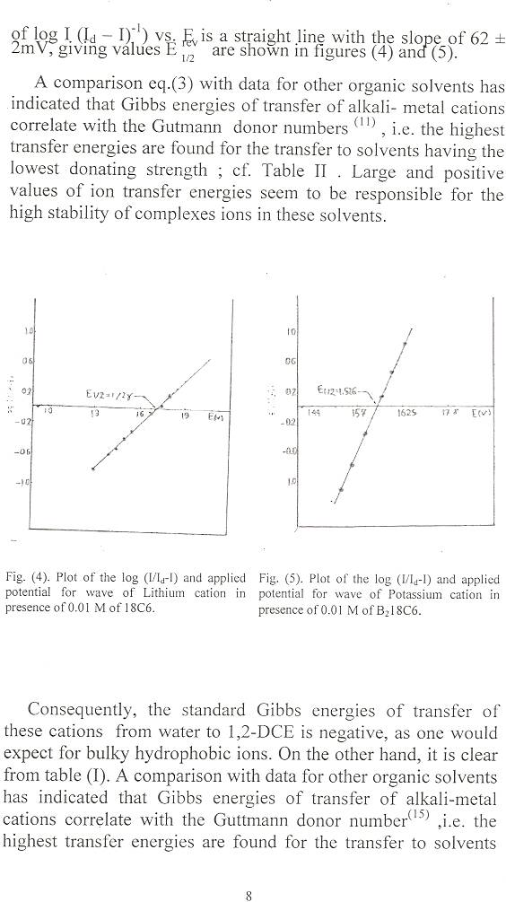
Fig. (4). Plot of the log (I/I_{d}-I) and applied potential for wave of Lithium cation in presence of 0.01 M of 18C6. | Fig. (5). Plot of the log (I/I_{d}-I) and applied potential for wave of Potassium cation in presence of 0.01 M of B₂18C6.

Consequently, the standard Gibbs energies of transfer of these cations from water to 1,2-DCE is negative, as one would expect for bulky hydrophobic ions. On the other hand, it is clear from table (I). A comparison with data for other organic solvents has indicated that Gibbs energies of transfer of alkali-metal cations correlate with the Guttmann donor number⁽¹⁵⁾ ,i.e. the highest transfer energies are found for the transfer to solvents having the lowest donating strength (Table II). Large and positive values of ion transfer energies seem to be responsible for the high stability of complexes ions in these solvents. A comparison of the cavity size of B₂18 C6 and the diameters of unsolvated ions shows that the optimal spatial fit is reached for the potassium cation ^{(16, 17)} , Actually. In 1,2-DCE the selectivity sequence is quite different, Li ⁺ > K⁺ and it seems to follow mainly the change in the cation salvation. The cavity size effect no longer dominates. A similar behavior was found for the other three crown ethers studied.

Table I. polarographic data for the facilitated ion transfer
from water to 1,2-DCE.

 | B15C5 |  | 18C6 |  | B₂18C6 |  | Cy₂18C6
ion | Li ⁺ | K⁺ | Li ⁺ | K⁺ | Li ⁺ | K⁺ | Li ⁺ | K⁺
E rev  ^{1/2} | 1.462 | 1.440 | 1.720 | 1.420 | 1.540 | 1.578 | 1.326 | 1.234
∆ G ^{o,w → o}KJ mol⁻¹  ^{tr} | 38.23 | 36.19 | 63.21 | 34.21 | 45.84 | 49.32 | 25.19 | 16.22

Table II. Relative stabilities of B₂18 C6 complexes
of K+ ion in various solvents.

*  solvent | **  DN,Kcal mol ⁻¹ | ***  ∆ G ^{o,w → o}KJ mol⁻¹  ^{tr} | ***  Log K
DMSO  DMF  MeOH  H₂O  PC  MeCN  NB  1,2-DCE | 29.8  26.6  19.0  18.0  15.1  14.1  4.4  0.0 | -13.0  -10.3  9.6  0.0  5.3  8.1  23  49.32 | 3.43  3.55  5.00  1.60  5.08  4.80  7.20  9.90

* Abbreviations : DMSO, dimethyl sulfoxide; DMF, N,N-dimethyl formamide; MeOH, methanol; PC,1,2-propylene carbonate; MeCN, actonitrile; NB, nitro benzene; 1,2-DCE, 1,2- dichloro ethane.
** The Guttmann donor numbers from ref. (15).
*** From ref. (10) and table I.

References
- Koryta, J.; Vanysck, P.; Brezina, M., J. Electroanal.chem. Interfacial Electrochem., 1`976, 67, 263.
- Koryta, J.; Vanysck, P.; Brezina, M., J. Electroanal.chem. Interfacial Electrochem. , 1977, 75, 211.
- IUPAC Pure Appl. Chem., 2004, 76, 697.
- Samee, Z.; Marecek,V. J. Electroanal.chem ., 1988, 257, 147.
- Koryta, J., Electrochim. Acta., 1979, 24, 293.
- Vanysek ,P.; Ruth., W.; Koryta, J. Electroanal.chem., 1983, 148, 117.
- Hofmanova, Le.; Hung, Q.; Khalil,W.; J. Electroanal.chem., 1982, 135, 257.
- K.Arari, M. Ohsawa, F. Kusu, K. Takamura. Bioelectrochem Bioenerg., 1993, 31, 65
- Y. Kubota, H. Katano, M. Senda. Anal. Sci., 2001, 17, 65.
- Samec, Z.; P., Anal. Chem.., 1990, 62,1010.
- V. Gobry, G. Bouchard, P. A. Carrupt, B. Teseta, H. H. Girault., Helv. Chem. Acta., 2000, 83, 1465.
- Marecek, V., Samec, Z., J. Electroanal. Chem., 1985, 263, 263.
- Nicholson, R, S.; Shain, I., Anal. Chem., 1964, 36, 706.
- Makrlik, E.; Hong, Le. Q., J. Electroanal.chem., 1983, 158, 277.
- Marcus, Y., J. solution chem., 1984, 13, 599.
- De Jong , F.; Reinhoudt, D. N. Adv. Phys. Org. chem., 1980, 27, 89.
- Izatt, R. M.; Bradshaw, J. S. ; Nielsen, S. A.; Lamb, J. D.; Sen, D.; Christensen , J., J. chem.. Rev., 1985, 85, 271.

