Synthesis, Characterization and Photocrosslinking of
Negative Photoresist Polymers

Nadhir. N.A.Jafar
Department of Chemistry/ Faculty of Science/ University of Babylon
IRAQ/ e: mail nathernajim@yahoo.com
Mousa Al-Smadi
Department of Chemistry/ Faculty of Science/Jordan University of Science and Technology/JORDAN

Key words: Thiadiazole, Polymer, Photoresist, Negative, Photocrosslinking

Acknowledgement:
Our sincerest, thanks are du to Prof. H.Meier from Mainz University / Germany and du to Dr. G. Jaradat from Mutah University/ Jordan for help in analysis and spectroscopic measurements of the products.

(NJC)

(Received on 10/4/2008) (Accepted for publication 31/8/2008)

Abstract
In this study, a new polymers (8) and (13) that contain 1,2,3-Thiadiazole or 1,2,3-Selenadiazole heterocyclic rings in the side chains from the reaction of the commercial available Polymer (Poly[4-hydroxystyrene]) with substituted 1,2,3-Thiadiazole or 1,2,3-Selenadiazole were prepared.
The 1,2,3-Thiadiazole and 1,2,3-Selenadiazole heterocyclic rings in the side chains of the polymers are able to undergo cycloaddition reaction with evolution of nitrogen, when treated with UV- light either in solution or as thin films. These reactions were followed up by using spectroscopic techniques like (UV-Visible and Infrared) spectroscopy.
The decrease of the absorption peaks in the UV-spectra and the emission peaks in the IR-spectra that are characteristic of the 1,2,3-Thiadiazoles and of the 1,2,3-Selenadiazoles is followed.
The crosslinking reactions of the polymers were carried out in solution and as a thin film through irradiation with UV-lamp λ_{max}=294 light source (150 watt). These compounds showed an importance in microlithography, manufacturing of electronic devices and in pharmacological uses as antibacterial and fungus because they contain 1,2,3-Thiadiazole and 1,2,3-Selenadiazole heterocyclic rings.
الخلاصة
تصف هذه الدراسة تحضير مبلمرات جديدة (8) و (13) و التي تحتوي على حلقات غير متجانسة من1،2،3- ثايادايازول و 1،2،3- سيلينا دايازول في السلالسل الجانبية. تم تحضير هذه المبلمرات من تفاعل المبلمّر المعروف تجاريا بولي (4- هيدروكسي ستايرين) مع معوضات2,1،3- ثايادايازول أو 1،2،3- سيلينادايازول. الحلقات غير المتجانسة 2,1،3- ثايادايازول و 1،2،3- سيلينا دايازول قادرة على تحقيق تفاعلات الإضافة الحلقية و ذلك بتصاعد غاز النيتروجين عند معاملتها حراريا أو بوجود الأشعة فوق البنفسجية.تم أجراء تفاعلات الإضافة الحلقية ما بين سلاسل المبلمرات في المحاليل أوعلى شكل أفلام رقيقة باستخدام مصدر للأشعة فوق البنفسجية(λ_{max}=294) بطاقة (150 واط) أو عن طريق تسخينها إلى درجات حرارة مرتفعة. تمت متابعة التفاعلات الضوئية للمبلمرات باستخدام طيف الأشعة فوق البنفسجية - المرئية و طيف الأشعة تحت الحمراء و ذلك بمتابعة نقصان أو اختفاء خواص الامتصاصية الضوئية للحلقات غير المتجانسة من2,1،3- ثايادايازول أ و 1،2،3- سيلينا دايازول.
يتوقع أن يكون لهذه المركبات أهمية صناعية في الطباعة و الأجهزة الالكترونية و الاستخدامات الصيدلانية حيث أن أغلب المركبات التي تحتوي الحلقات غير المتجانسة المذكورة أعلاه, أظهرت خصائص مميزة كمضادات لأنواع من البكتيريا ا و الفطريات.

Introduction
Polymer chemistry is one of the most interesting and certainly rapidly growing area of chemical research. A new type of compounds and new reactions has been discovered. It has become an interesting area of science, which will grow in many directions. Much attention has been directed to 1,2,3-Thiadiazole and 1,2,3-Selenadiazole rings, which can be linked to the side chains of polymers that represent good materials for photocrosslinking processes and for the generation of photoresist polymers^{[1]}. Although 1,2,3-Thiadiazoles have been known for long time, 1,2,3,-Thiadiazoles account for least literature citation. A mainly amount of this literature has focused on thermal and photochemical reactions of 1,2,3,-Thiadiazoles and 1,2,3-Selenadiazoles. Still many gaps, which exist in our knowledge, leave this field area opened for further research. The most general and widely employed synthesis of 1,2,3-Thiadiazoles is Hurd and Mori method, starting from α-methylene ketones. A variety of ketones (aromatic, cyclic and acyclic) have been converted into their corresponding hydrazones (tosyl or acyl). The reaction of the hydrazones with Thionyl chloride produces 1,2,3-Thiadiazole in good yield^{[2]}. 1,2,3-Selenadiazoles, including the parent ring are prepared by Selenium dioxide oxidative ring closure of semicarbazones as described by Lalezari et al, they prepared substituted 1,2,3,-Selenadiazoles by reacting acetophenone semicarbazone with Selenium dioxide in acetic acid^{[3]}. By using the two methods (Hurd, Mori, and Lalezari et al) for preparation 1,2,3-Thiadiazole and 1,2,3-Selenadiazole heterocyclic ring derivatives, many compounds derived from 1,2,3-Thiadiazoles and 1,2,3-Selenadiazoles have been prepared ^{[3, 4-9]}.
In addition to these compounds, Meier et al have prepared other compounds with multiple heterocyclic 1,2,3-Thiadiazole rings^{[10]}. During the last decades several compounds with two or more 1,2,3-thiadiazole heterocyclic rings with different spacers have been synthesized using Hurd and Mori reaction^{[10]}. Recently, the same strategy mentioned above is applied for the synthesis of multi-arm 1,2,3-Thiadiazole systems^{[11]}. There have been wide research on synthesis of polymer containing reactive photo functional groups, owing to their wide applications in microlithography, printing materials, electronic industry and medical fields^{[12]}. These compounds must have a high photosensitivity and thermal stability. The crosslinking with ultra violet (UV) light is an excellent method to build-up the network through photolysis^{[13]}. Many sensitive polymers have been prepared and tested for photosensitivity in solution and in thin polymer film ^{[13]}. The irradiation induces chemical changes in the polymer, resulting in chain crosslinking which causes increase in molecular weight and forms network that causes the polymer to be no longer completely soluble.
The chemical changes are not random, some chemical bonds and groups are sensitive to radiation-induced reaction. These groups include -COOH, -C-X, -SO₂, -NH₂, C=C^{[12]}.Chemical structure of polymers will be changed by evolution of small molecules products. ¹HNMR, UV and IR spectroscopy have been used to observe these structural changes^{[14]}. 1,2,3-Selenadiazole possessing antibacterial activity and exhibited the highest activity of growth inhibition against some bacteria and fungi have been reported^{[15-16]}.
Experimental
1.General
Melting points (m.p) were determined on an electro thermal digital melting point apparatus and are uncorrected. Infrared (IR) spectra were rerecorded using a NICOLET 410 FT-IR spectrometer (ν max in cm⁻¹). The pure substances were measured as film between NaCl plates, as KBr-pellets or in the presence of a solvent using IR-cells with NaCl windows. Proton nuclear magnetic resonance (¹H-NMR) spectra were recorded on 200MHz with AC200 instrument from Bruker Company. Using Tetramethylsilane TMS as internal reference. The spectral data were reported in delta (δ) units relative to TMS reference line. Multiplicities (s=singlet, d=doublet, t=triplet, q=quartet and m=multiples), coupling constant, number of protons and the assigned protons are given in parentheses.
Ultra-violet spectra were recorded by using UV-2401 P(s) Shimadzu Corporation spectrometer the wave length was recorded by nanometer (nm) units with absorption (Abs). Ultra violet source for photolysis employed with mercury lamp150 Watt purchased from Heraus. The Mass spectra were carried out by using instruments MAT CH7A of the Varian Company (EI: 70eV Ionizing energy, electron ionization) and using MAT95 of the Finnigan Company (FD: 5KV Ionizing energy, field desorption). The signals were given as m/z with the relative intensity between brackets. The analytical thin layer chromatography (TLC) was carried out using TLC-silica plates 60F254 (0.2 mm) of the Merck Company.
The detection was followed by UV-lamp or through coloring with iodine. The chromatography separation was carried out using Merck silica gel (60-230 mesh). The ratios of the solvents and mixed mobile phase were given in volume ratios.

2. Materials and Methods:
Hexane was dried over sodium; ethyl acetate was purified by distillation. Acetone was dried and distilled prior to use from phosphorous pentaoxide (P₂O₅). THF and ether were dried over sodium metal and distilled prior to use from blue solution of sodium benzophenone ketyl. Chloroform and dichloromethane were dried and distilled over anhydrous calcium chloride collected over magnesium sulphate then filtrated, stored over molecular saves. Ethanol dried and distilled over magnesium and CCl₄. Glacial acetic acid dried in 5% acid anhydride and 2% chromium oxide (CrO₃) and distilled. All these solvents obtained from Scharalau. Poly(4-hydroxystyrene) (M.Wt=5000), 1,6-dibromohexane and ethyl hydrazine carboxylate were obtained from Aldrich. 4-hydroxyacetophenone, selenium dioxide and thionyl chloride were obtained from ACROS. These chemicals were used without further purification.

3. Synthesis:
- Synthesis of the hydrazones and semicarbazones ^{[2,3]}
N'-{1-[4-(6-Bromo-hexyloxy)-phenyl]-ethylidene}- hydrazine carboxylic acid ethyl ester

(16)

A mixture of 4-(6-Bromo-hexyloxy) acetophenone (3) (1.0 g, 3.34 mmol) was reacted with ethyl hydrazine carboxylate (6) (0.34 g, 3.26 mmol) dissolved in dry chloroform (50 ml) under nitrogen gas. When the reaction mixtures started refluxing, two drops of concentrated hydrochloric acid were added. Then the mixture was refluxing over night. The water generated was continuously removed by using soxhlet with magnesium sulphate as drying agent. The precipitated hydrazone obtained was filtered off and washed with cold diethyl ether. The result of the reaction was a colorless solid substance, (0.6 g, 56% yield), melted at 114-115ºC, scheme 3
Figure 13 showed the infrared spectrum (KBr disk) of compound (16).
Figure 14 showed the proton NMR-spectrum in CDCl₃ of compound (16).
MS (FD): m/z=385 (M^{+.}).
N'-[1-(Hydroxy-phenyl)-ethylidene]-hydrazine carboxylic acid ethyl ester

(9)

A mixture of 4-hydroxyacetophenone (1) (10 g, 73 mmol) was reacted with ethyl hydrazine carboxylate (6) (8 g, 76 mmol). They were dissolved in (80 ml) of dry chloroform. When the reaction mixture started refluxing, two drops of concentrated hydrochloric acid were added. Then the mixture was left refluxing over night. The water generated was continuously removed by using soxhlet with magnesium sulphate as drying agent. After two hours a white precipitate was formed, which increased with time. After five hours the reaction was completed. The precipitated hydrazone obtained was filtered off and washed with cold diethyl ether. The result of the reaction was colorless solid product (16.2 g, 99% yield), melted at 181ºC, scheme 2.
Figure 6 showed the infrared spectrum (KBr disk) of compound (9).
N'-(1-{4-[6-(4-sec-Butyl-phenoxy)-hexyloxy-phenyl}-ethylidene)-hydrazine carboxylic acid ethyl ester polymer
(7)
A mixture of ketone polymer (5) (0.2 g, 0.6 mmol) and ethyl hydrazine carboxylate (6) (0.4 g, 3.8 mmol) were dissolved in (50 ml) dry chloroform. When the reaction mixtures started refluxing, two drops of concentrated hydrochloric acid were added. Then the mixture was left refluxing over night. The water generated was continuously removed by using soxhlet with magnesium sulphate as drying agent. The reaction was followed by TLC ethyl acetate/hexane; 3:1. The product was obtained after separation by using column chromatography. Our product was obtained firstly after elution from the column using ethyl acetate/hexane; 3:1. The solvent was dried using a rotary evaporator affording the desired product (0.015 g, 88% yield), melted at 109-110ºC, scheme 3.1.
Figure 3 showed the infrared spectrum of polymer (7).
Figure 4 showed the proton NMR-spectrum in CDCl₃ of compound (7).
Elemental analysis:
[C₂₅H₃₂N₂O₄]_{n} (424.53)_{n}
Found: C, 71.97; H, 8.87; N, 5.93
4-(6-Bromohexyloxy) semicarbazone

(15)

A solution of semicarbazid hydrochloride (1.0 g, 10 mmol) and sodium acetate (1.0 g, 12 mmol) were dissolved in (50 ml) absolute ethanol and heated for 15 minutes under reflux. The product (14a) was filtered while hot to remove precipitated sodium chloride salt. Then equivalent amount (1.79 g, 10.0 mmol) of monoketone (3) was added to the product solution. This mixture was refluxed for 30 minutes and followed by TLC (Chloroform). When the reaction was completed, ethanol was removed and the residue was washed with diethyl ether. The colorless solid obtained (1.92 g, 93% yield), melted at 132-133ºC, scheme 3.
- General procedure for the etherification reactions
4-(6-Bromo-hexyloxy)-acetophenone
(3)

A mixture of 4-hydroxy acetophenone (1) (2.79 g, 20.51 mmol), excess amount of 1,6-dibromohexane (2) (50 g, 205.1 mmol), potassium carbonate (20 g, 145 mmole), and few drops of Aliquate 336 were dissolved in dry acetone (80 ml). This mixture was refluxed for 52 hours. The reaction was followed with TLC in chloroform. After completion of the reaction, it was cooled and the precipitated salt was removed by filtration and the organic solvent was dried in vacuo. Firstly the product was separated from traces amount of 1,6-dibromohexane by column chromatography (40 cm) on a Silica gel with petroleum ether (40-70ºC). Then the product which was remained in the top of the column was eluted with chloroform. The solvent evaporated in vacuo to give light yellow oil which crystallized slowly at the room temperature. The pale yellow solid obtained in (3.86 g, 93% yield) was melted at 39-40ºC, scheme 1.
Figure 1 showed the proton NMR-spectrum in CDCl₃ of compound (3).
MS (FD): m/z =299 ( M^{+.} )

4-[4-(6-Bromo-hexyloxy)-phenyl]-[1,2,3]thiadiazole
(12)

A mixture of 4-(1,2,3–thiadiazole-4-yl)phenol compound (11) (1.0 g, 5.6 mmol), potassium carbonate (5.42 g, 39.3 mmol),potassium iodide (10.42 g, 39.2 mmol), 1,6–dibromohexane (2) (13.66 g, 56.0 mmol) in (50ml) of dry acetone and 2-3 drops of Aliquate 336 was refluxed for 62 hours. The reaction was followed by TLC in chloroform until completion. Then the reaction mixture was cooled to room temperature, the precipitated salt was removed by filtration. The organic solvent was dried in vacuo together with the excess of 1,6–dibromohexane. After that the product was separated from the traces of 1,6–dibromohexane on a Silica gel column (40 cm) with petroleum ether (40-70ºC). Then, the product which was remained at upper the part of the column was eluted by chloroform. The pale yellow oil that was obtained is crystallized very slowly in ice bath (1.8 g, 94% yield) to give yellow solid of compound (12) that melted at 77-78ºC, scheme 2.
Figure 10 showed the infrared spectrum (KBr disk) of compound (12).
Figure 11 showed the proton NMR-spectrum in CDCl₃ of compound (12).
MS (FD): m/z=341(M^{+.}).
4-{(4-Ethylene-phenoxy)-hexyloxy}- acetophenone polymer
(5)

poly(4-hydroxy styrene) (4) (0.6 g, 1.8 mmol) are mixed with 4-(6-bromohexyloxy) acetophenone (3) (1.54 g, 5.14 mmol), potassium carbonate (0.75 g, 5.0 mmol), potassium iodide (0.8 g, 4.8 mmol) and two drops of Aliquate 336 in (80 ml) dry acetone. The mixture was refluxed for 42 hours and the reaction was followed by TLC in hexane/chloroform; 1:1. When the reaction is complete, (40 ml) water was added to the reaction mixture and stirred for 5 minutes. Then the product was extracted three times with chloroform the companied organic layer was dried over magnesium sulphate, and the solvent was dried in vacuo. The product was obtained as pale yellow solid of polymer (5) in (0.8 g, 47% yield) that melted at 55-56ºC, scheme 1.
Figure 2 showed the proton NMR-spectrum in CDCl₃ of polymer (5).
Elemental analysis:
[C₂₂H₂₆O₃]_{n} (338.44)_{n}
Found: C, 77.90; H, 7.18

4-{4-[6-(4-Etylene-phenoxy)-hexyloxy]-phenyl}-[1,2,3] thiadiazole polymer
(13)

4-[4-(6-Bromohexyloxy)phenyl]-1,2,3–thiadiazole (12) (0.5 g, 1.4 mmol) was added to poly(4-hydroxystyrene) (4) (0.2 g, 1.6 mmol), potassium carbonate (0.24 g, 1.6 mmol), potassium iodide (0.6 g, 3.6 mmol) and two drops of Aliquate 336 in (30 ml) dry acetone was refluxed for 25 hours. After refluxing for 10 minutes the turbidity of the reaction mixture increases and after 6 hours the solution color becomes brown. The reaction was followed by TLC (Acetone) until completion. The system was cooled and the solvent was evaporated in vacuo. The residue was washed with water, the organic layer was dried over magnesium sulphate and the solvent was evaporated to dryness. The product was solid brown color (0.46 g, 86% yield) and melted at 286-288ºC, scheme 3.2.
Figure 12 showed the infrared spectrum (KBr disk) of polymer (13).
Elemental analysis:
[C₂₂H₂₄N₂O₂S]_{n} (380.50)_{n}
Found: C, 69.93; H, 6.87; N, 6.98; S, 8.62
- Synthesis of 1,2,3–Thiadiazoles ^{[2]}
4-[1,2,3]Thiadiazol-4-yl-phenol
(11)

N'-[1-(4-Hydroxy-phenyl)-ethyliden]-hydrazine caroxylic acid ethyl ester (9) (6.0 g, 27.0 mmol) was slowly added to cold thionyl chloride (35.37 g, 29.7 mmol) at 0ºC in several portions with vigorous stirring. The mixture was stirred at room temperature for seven hours until no more hydrogen chloride produced. The thionyl chloride was removed in vacuo. The remaining residue was washed with several portions of diethyl ether. The product was pale brown color (4.06 g, 84% yield), and melted at 153-155ºC, scheme 2.
Figure 7 showed the infrared spectrum (KBr disk) of compound (11).

4-[4-[6-Bromo-hexyloxy)-phenyl]-[1,2,3]thiadiazole
(12)

Compound (12) was prepared by two reaction procedures:
A. 4-(6-Bromohexyloxy) acetophenone (ethoxycarbonyl hydrazone) (16) (0.2 g, 0.5 mmol) was added in several portions to thionyl chloride (13 g, 0.10 mol). The mixture was left stirring for seven hours at room temperature until no more hydrogen chloride was produced. The un reacted thionyl chloride was removed in vacuo and the remaining product was washed with cold diethyl ether and dried in vacuo to give a yellow solid of compound (12) (0.14 g, 79% yield) that melted at 79-80ºC, scheme 3.
B. 4-(6-Bromohexyloxy) acetophenone (Semicarbazone) (15) (0.5 g, 1.47 mmol) was added in several portions to thionyl chloride (16.3 g, 0.13 mol) at 0ºC. The mixture was stirred over night at room temperature until no more hydrogen chloride is produced. The un reacted thionyl chloride was removed in vacuo and, the remaining product was washed with cold diethyl ether and dried in vacuo. The obtained yellow solid of compound (12) (0.22 g, 44% yield), was melted at 78-79ºC, scheme 3.
Figure 10 showed the infrared (KBr disk) of compound (12).
Figure 11 showed the proton NMR-spectrum in CDCl₃ of compound (12).
MS (FD): m/z=341 (M^{+.})
- Synthesis of 1,2,3–Selenadiazole ^{[3]}
4-[1,2,3]Selenadiazol-4-yl-phenol
(10)

The semicarbazone (14) [17] (0.5 g, 1.97 mmol) was dissolved in dry glacial acetic acid (50 ml) with vigorously stirring and gently heating 35-40ºC. The solution was treated with Selenium dioxide powder (0.3 g, 2.72 mmol). The mixture was gently heated with vigorously stirring until the evolution of the ammonia gas ceased. After completion of the reaction, the mixture was filtered, the filtrate poured in ice water and saturated sodium bicarbonate solution was added. The product was extracted with chloroform (3×50ml). The combined organic layers were dried over magnesium sulfate and the solvent was evaporated to dryness. Recrystallization from acetone/ hexane, was afford a faint grey solid (0.35 g, 79% yield) which was melted at 132-133ºC,
Figure 8 showed the infrared spectrum (KBr disk) of compound (10).
Figure 9 showed the proton NMR-spectrum in CDCl₃ of compound (10).

4-[4-(6-Bromo-hexyloxy)-phenyl]-[1,2,3]selenadiazole
(17)

4-(6-Bromohexyloxy) semicarbazone (15) (0.5 g, 1.4 mmol) was dissolved in dry glacial acetic acid (50 ml) under vigorously stirring and with gently heating (35-40)ºC. Selenium dioxide powder (0.15 g, 2.72 mmol) was added in portions to the reaction mixture. The mixture was left stirring until the evolution of the ammonia gas ceased. After completion of the reaction, the mixture was filtered and the filtrate was poured over ice water and neutralized with saturated sodium bicarbonate solution. The product was extracted with chloroform (150 ml × 3). The combined organic layer was dried over magnesium sulphate, and the solvent was evaporated to affording a yellow solid of compound (17) (0.28 g, 50% yield) that melted at 85-86ºC, scheme 3.
Figure 15 showed the proton NMR-spectrum in CDCl₃ of compound (17).
4-{4-[6-(4-Ethylene-phenoxy)-hexyloxy]-phenyl}[1,2,3]selenadiazole polymer
(8)

A mixture of the N'-(1-{4-[6-(4-sec-Butyl-phenoxy)-hexyloxy-phenyl}-ethylidene)-hydrazine carboxylic acid ethyl ester polymer (7) (0.2 g, 0.49 mmol) was treated with selenium dioxide powder (0.057 g, 0.51 mmol) in (25 ml) of glacial acetic acid. The reaction mixture was heated gently at temperature (35-40)ºC with vigorously stirring until the evolution of ammonia gas ceased after (eight hours). The reaction mixture was filtered which was neutralized with saturated sodium bicarbonate solution. The product was extracted with chloroform (3×20 ml). The organic layer was washed with water then dried over magnesium sulfate. The organic solvent was removed in vacuo and the remaining product was recrystallized from acetone/hexane to give a pale red solid product of polymer (8) (0.12 g, 70% yield), melted at 118-119ºC, scheme 1. Figure 5 showed the infrared (KBr disk) of polymer (8). Elemental analysis:
[C₂₂H₂₄N₂O₂Se]_{n} (427.40)_{n}
Found: C, 61.96; H, 5.85; N, 6.72; Se, 18.17.
- Photolysis of Polymers (8) and (13) in Solution
- General
Experimental utilizing photolysis was performed employing mercury immersion (UV) lamp (150Watt) purchased from Herause.
A dilute solution of the polymer to photolysed is prepared and degassed with nitrogen gas for 15 minutes then it was exposed to the UV-irradiation with continuous stirring, in cooling system. The photolysis process is followed by measuring UV and IR-spectra.
- Photolysis of 1,2,3-Thiadiazole Polymer (13) ^{[1]}
1,2,3-Thiadiazole polymer (13) (5 mg) was dissolved in absolute ethanol (3 ml) and degassed through bubbling of nitrogen gas through it for 15 minutes. The solution was irradiated for 6 hours using the UV lamp and the reaction was followed by measuring the UV-spectrum of the solution each an hour.
After six hours the spectrum showed a decrease in the absorbance to half its initial value (Hypochromic) with an (Hypsochromic shift).
Figure 19 showed the UV-spectrum of polymer (13).
- Photolysis of 1,2,3-Selenadiazole polymer (8)
1,2,3-Selenadiazole polymer (8) (5 mg) was dissolved in dichloromethane (3 ml) and degassed through bubbling of nitrogen gas through it for 15 minutes. The solution was irradiated for 6 hours using the UV lamp and the reaction was followed by measuring the UV-spectrum of the solution each an hour.
After six hours the spectrum showed a decrease in the absorbance to small its initial value (Hypochromic) with an (Hypsochromic shift).
Figure 18 showed the UV-spectrum of polymer (8).
- Photolysis of the Polymers (8) and (13) in Thin Film ^{[1]}
High pressure mercury (Hg) lamp was used for irradiated the polymers samples that prepared as thin films.
A dilute solution of the 1,2,3-Selenadiazole polymer (8) and the 1,2,3-thiadiazole polymer (13) was prepared by dissolving 5 mg of (8) in 10 ml dichloromethane and 5 mg of (13) in10 ml ethanol each sparely.
A thin film of each was prepared on a glass {26 x 76 x (0.95-1.05) mm} then the coated plates were exposed to UV-irradiation for four hours. The irradiated polymer was collected and IR-spectrum was measured. Large changes in the spectra of the polymers were observed (Figure 16 and Figure 17 ).
The obtained material became darker in color and insoluble in most organic solvents.
- Thermolysis of 1,2,3-Thiadiazole polymer (13) ^{[1]}
In a (100) ml round bottom flask fitted with a reflux condenser and a magnetic stirrer, 1,2,3-Thiadiazolepolymer (13) (0.1 g) was completely dissolved by rapid stirring in THF 40 ml and left refluxing over night. The color of the solution was changed from light brown to yellow with bad smell. During the thermolysis process, the solution became turbid and a yellow solid precipitated. The IR-spectra for the produced material was measured.
Result and Discussion
1. Synthesis and Characterization:
The projected synthesis for preparing compounds (8) and (13) which are our target was carried out by two schemes as illustrated in schemes (1), (2). An attempted was conducted to prepare the polymers precursors as in scheme (3). In scheme (1) the reaction was started by nucleophilic substitution reaction of the commercially available 4-hydroxyacetophenoe (1) with 1,6-dibromohexane (2) in presence of potassium carbonate, potassium iodide, and 2-3 drops of Aliquate336 in refluxing acetone. The reaction lasted in 52 hours to give the expected bromo ketone (3) in good yield (93%). The structure of the product (3) was confirmed by IR-spectrum. The IR-spectrum of compound (3) exhibited strong absorption band at1681 cm⁻¹ for carbonyl group, and was confirmed by proton NMR- spectrum showed m(8H, CH₂ aliphatic spacer, 1.4-2.0 δ), s(3H, CH₃, 2.6 δ ), t(2H, CH₂-Br, 3.4 δ), t(2H, CH₂-O, 4.0 δ ) and 4H( two doublet peaks between 6.8-7.8 δ for AA',BB'-system) as in figure 1. The mass spectrum of this compounds showed MS (FD): m/z =299 ( M^{+.} ) The m.p was 39-40ºC.
Having compound (3) in hand, the next step was another nucleophilic substitution reaction of commercially available poly(4-hydroxystyrene) polymer (M.W=5000) g/mole (4) with (5). The reaction lasted in 42 hours to give the corresponding ketopolymer with (CH₂)₆ spacer (5) in a yield (47%). The structure of product (5) was confirmed by IR-spectrum. The IR-spectrum of compound (5) exhibited absorption band at 1684cm⁻¹ for C=O ketone. There is no difference in IR-spectrum in the region (1500-3000) cm⁻¹ between compound (3) and (5) for carbonyl group only an evidence to the formation of compound (5), in addition, it gives a positive test with 2,4-dinitrophenyl hydrazine, and was confirmed by proton NMR- spectrum that exhibit m(8H, CH₂ aliphatic spacer, 1.5-2.0 δ), s(3H, CH₃, 2.6 δ), t( 2H, CH₂-O behind polymer, 3.4 δ), t( 1H, CH-in polymer, 3.5 δ), t(2H, CH₂-O-behined carbonyl group, 4.0 δ) and 8H (two doublet peaks between 6.8-8.0 δ for AA,'BB'-system) shown in figure 2. The m.p was 55-56ºC.
The next step was to obtain the hydrazone polymer (7). It was prepared by condensation reaction of ketone (5) with hydrazine ethyl carboxylate (6) at 80ºC to yield 88% of hydrazone polymer (7) with m.p 109-110ºC scheme 1.
The structure of (7) was confirmed by IR-spectrum shown in figure 3. The IR-spectrum of (7) exhibited absorption band at 3244cm⁻¹ for –NH group, 1706cm⁻¹ for C=O and 1533cm⁻¹ for C=N, and was confirmed by proton NMR-spectrum that exhibit t(3H, CH₃-CH₂-O, 1.2 δ), m(2H, CH₂-O, 1.25 δ), m(11H, aliphatic spacer, 1.26-2.0 δ), s(3H, CH₃, 2.2 δ), t(2H, CH₂-O behind polymer,3.2 δ), t(2H, CH₂O behind hydrazone, 4.0) t(Nuclear Overhouse Effect "NOE" for Z form, 4.2), 8H(two doublet peaks between 6.8-7.8 δ for AA',BB'-system) and s(1H, NH, 8.6 δ) the presence of singlet peak at 8.6 δ for proton-NH was an evidence to conformed this compound and from previous studies in the preparation of semicarbazones or hydrazones [10,18,19], the R₂-C=N-NH bond can exist in either E or Z forms. The E form was found to be the major product according to the nuclear overhouse effect experiment (NOE) of the ¹H-NMR spectrum. The reason for the preference of E form is due to less steric factor^{[19]}. Therefore small peaks of Z form were usually observed in the ¹H-NMR spectrum of the semicarbazones and hydrazones beside the main peaks and have the same shape as shown in figure 4.
The previous results incited us to complete the synthesis of the polymer (8) that bears 1,2,3-Selenadiazole heterocyclic ring in its side chains with (CH₂)₆ spacer. The method which is used by Lalezari and Shafiee ^{[3]} was followed in preparing the polymer (8). It was prepared by reacting polymer (7) with Selenium dioxide in glacial acetic acid at 35-40ºC for eight hours. The product (8) obtained in good yield 70% that melted at 118-119ºC. The structure of product (8) which was confirmed by IR-spectrum as shown in figure 5 exhibited characteristics absorption bands at 1591, 1245cm⁻¹ for 1,2,3-Selenadiazole heterocyclic ring. The disappearance of the band at 3244cm⁻¹ for N-H group was evidence of the formation of 1,2,3-Selenadiazole rings ^{[4]}. The presence of nitrogen and selenium in the elemental analysis was another evidence of the formation of 1,2,3-Selenadiazole heterocyclic ring. The reaction occurs readily under mild conditions of gently heating and vigorously stirring in glacial acetic acid. The product was obtained after neutralization of the reaction mixture with sodium bicarbonate followed by extraction with chloroform. The crude compound was purified by recrystallization from acetone.

To synthesize the 1,2,3-Thiadiazole polymer (13) another pathway was conducted that is illustrated in scheme 2.
The first step in this pathway was the synthesis of compound (9) by the condensation of p-hydroxy acetophenone (1) with ethyl hydrazine carboxylate (6) in dry chloroform. The resulted water was continuously removed by a drying agent. The hydrazone product (9) was obtained as fine crystal with 99% yield that melted at 181-182ºC. The structure of compound (9) was confirmed by IR-spectrum as shown in figure 6, that exhibited absorption bands at 3385cm⁻¹ for OH group, 3263cm⁻¹ for N-H group and 1713cm⁻¹ for C=O. Hurd and Mori method ^{[2]} was applied for the preparation of compound (11) by reacting the hydrazone (9) with Thionyl chloride at 0⁰C. The reaction mixture was vigorously stirred for seven hours until no more HCl was observed. Compound (11) was obtained in good yield (84%) and melted at 156-157ºC. The structure of compound (11) was confirmed by IR-spectrum as shown in figure 7 exhibited absorption bands at 3173cm⁻¹ for O-H group and 1597, 1501, 1450cm⁻¹for Thiadiazole heterocyclic ring.
A great deal of efforts and time has been spent on synthesizing compound (10) by using selenic acid in 1,4-dioxane as solvent. Several attempts failed for producing this compound, because of the sensitivity to light and heat, the difficulty of evaporating 1,4-dioxane (b.p 101ºC) at low temperature and the use of selenic acid in the presence of water which leads to the hydrolysis of the hydrazone (9) in to the starting ketone (1).
The Lalezari and Shafiee method ^{[3]} illustrated in scheme 2 was found to be the suitable way if glacial acetic acid is very dry and the temperature is about 40-45ºC reacted with semicarbazone (14). Following these reaction conditions it was possible to obtain compound (10) in good yield 79%. The structure of compound (10) was confirmed by IR-spectrum as shown in Figure 8 that exhibited absorption band at 3442cm⁻¹ for O-H group and characteristic absorption bands for 1,2,3-Selenadiazole heterocyclic ring 1521, 1604, 1456cm⁻¹, and was confirmed by proton NMR-spectrum that exhibit s(1H, OH, 2.0 δ), 4H( two doublet peaks between 6.8-7.8 δ for AA',BB'-system) and s( 1H, proton in heterocyclic ring, 9.2 δ) the presence of the singlet peak in 9.2 δ for proton in the heterocyclic ring was an evidence to confirmed the structure of this compound as shown in figure 9.
Having compound (11) in hand it was possible to prepare compound (12) by reacting compound (11) with 1,6-dibromohexane (2). Compound (12) was prepared in nearly quantitative yield 94%, and melted at 79-80ºC. The structure of compound (12) was confirmed by IR-spectrum that exhibited absorption band characteristic of the 1,2,3- thiadiazole heterocyclic ring at 1462 and 1252cm⁻¹ as shown in figure 10, and was confirmed by proton NMR-spectrum that exhibits m( 8H, aliphatic spacer, 1.4-2.0 δ), t( 2H, CH₂-Br, 3.4 δ), t( 2H, CH₂-O, 4.0 δ), 4H( two doublet peaks between 6.8-8.0 δ for AA,,BB'-system) and s(1H, proton in heterocyclic ring, 8.5 δ) these data showed new singlet signal in 8.5 δ for the proton in the heterocyclic ring were confirmed the structure of this compound as shown in figure 11. The mass spectrum of this compound showed MS (FD): m/z=341 (M^{+.}).
The target polymer (13) could be prepared by reacting compound (12) with poly(4-hydroxystyrene) (4) in presence of K₂CO₃, KI in refluxing acetone for 42 hours. Polymer (13) was obtained in 86% yield and melted at 288-299ºC. The structure of compound (13) was confirmed by IR-spectrum as shown in figure 12 that exhibited absorption band at 1610, 1514, 1450 and 1230 cm⁻¹ for 1,2,3-Thiadiazole heterocyclic rings. The presence of nitrogen and sulpher in the elemental analysis was another evidence of the formation of 1,2,3-Thiadiazole heterocyclic ring.
The 1,2,3-Thiadiazole polymer (13) is expected to have a biological activity [5,15,18]. Both of the prepared polymers (8) and (13) are capable of being tested as negative photoresist polymers.
The precursor compounds (12) and (17) were prepared as shown in scheme 3. Compound (3) was prepared by the same procedure as in scheme 1, and then it was reacted with two different hydrazine derivatives. When compound (3) was refluxed with ethyl hydrazine carboxylate (6) in chloroform over night, the hydrazone compound (16) was obtained in 46% yield and melted at 114-115ºC. The structure of compound (16) was confirmed by IR-spectrum as shown in figure 13 which exhibited absorption band at 3205cm⁻¹for N-H group, 1694cm⁻¹for C=O group, and confirmed by proton NMR spectrum that exhibits t( 3H, CH₃-CH₂-O, 1.4 δ), m( 8H, aliphatic spacer, 1.5-2.0 δ), s( 3H, CH₃, 2.2 δ), t( 2H, CH₂-Br, 3.5 δ), t( 2H, CH₂-O, 4.0 δ), m( 2H, CH₂-O-C=O, 4.4 δ), 4H( two doublet peaks between 6.8-7.8 δ for AA',BB'-system) and s( 1H, NH, 8.0 δ) this data showed that downfield singlet peak at 8.0 δ was assigned to the proton of NH as shown in figure 14. The mass spectrum of this compound showed MS (FD): m/z=385 (M^{+.}).
But when compound (3) was reacted with the semicarbazide acetic acid (14a) in refluxing absolute ethanol for half hour, the semicarbazone (15) was obtained in 93% yield and melted at 132-133⁰C. The structure of compound (15) was confirmed by IR-spectrum which exhibited absorption bands at 3474 cm⁻¹ for –NH₂ group, 3276 cm⁻¹ for –NH group and 1758cm⁻¹ for C=O group. Then the two compounds prepared in the previous step (15) and (16) were used to prepare compound (12), by reacting them each one separately with Thionyl chloride at 0ºC. The hydrazone (16) gave compound (12) in 79% yield which melted at 79-80ºC. The IR-spectrum of compound (12) as shown in figure 10, The absence of absorption band at 3276 cm⁻¹ for –NH group and the appearance of bands at 1462cm⁻¹ for thiadiazole ring was good evidence for producing compound (12). But the semicarbazone (15) gave compound (12) in only 44% yield, melted at 79-80ºC.

Therefore hydrazone derivatives was found to react better than semicarbazone with thionyl chloride and gave high yield of the corresponding 1,2,3-Thiadiazoles. On the other hand, when the semicarbazone (15) is reacted with selenium dioxide, compound (17) was obtained in 48% yield and melted at 85-86ºC. The structure of this compound (17) was confirmed by IR-spectrum that exhibited absorption bands at 1604, 1527, 1463cm⁻¹ for 1,2,3- Selenadiazole heterocyclic ring, and was confirmed by proton NMR-spectrum that exhibit m( 8H, aliphatic spacer, 1.4-2.0 δ), t( 2H, CH₂-Br, 3.4 δ), t( 2H, CH₂-O, 4.0 δ), 4H( two doublet peaks between 7.0-8.0 δ for AA',BB'-system) and s(1H, proton in heterocyclic ring, 9.4 δ) the downfield singlet peak showed at 9.4 δ was assigned to the proton of the heterocyclic ring as shown in figure 15.

2. Photolysis and Thermolysis
One hour time intervals have been adopted to measure the UV-spectra of the polymer solution during exposure to UV-radiation for 6 hours irradiation time and four hours in case of thin films. The UV-spectra of polymer (13) solution in absolute ethanol showed a large decrease in the absorbance with decrease in the λ_{max} from 314.8 nm before irradiation to 294.8 nm after irradiation and for polymer (8) showed a small decrease in the absorbance with decrease in the λ_{max} from 276.8 nm before irradiation to 274.2 nm after irradiation. The photolysis reaction of the polymers (8) and (13) was followed up using IR-spectroscopy. The IR-spectroscopy provides us with significant information about the disappearance of the 1,2,3-Thiadiazole and the 1,2,3-Selenadiazole rings from the side chains of the polymers.
By using thin film of 1,2,3-selenadiazole polymer (8) in the photolysis experiment, the IR-spectrum of the film after irradiation as shown in figure 16 showed the complete disappearance of the 1,2,3-Selenadiazole rings and figure 17 showed the IR-spectrum of the thin film for (13) after irradiation.
Depending on a previous study, crosslinking reactions between the polymer chains could be expected[1,12, 13]. The resulted product was a more rigid structure with very low solubility in most organic solvents.
Thermolysis of 1,2,3-Thiadiazole polymer in THF solvent give us liquid and solid products, the products followed by IR spectrum showed the complete disappearance of the 1,2,3-thiadiazole ring.

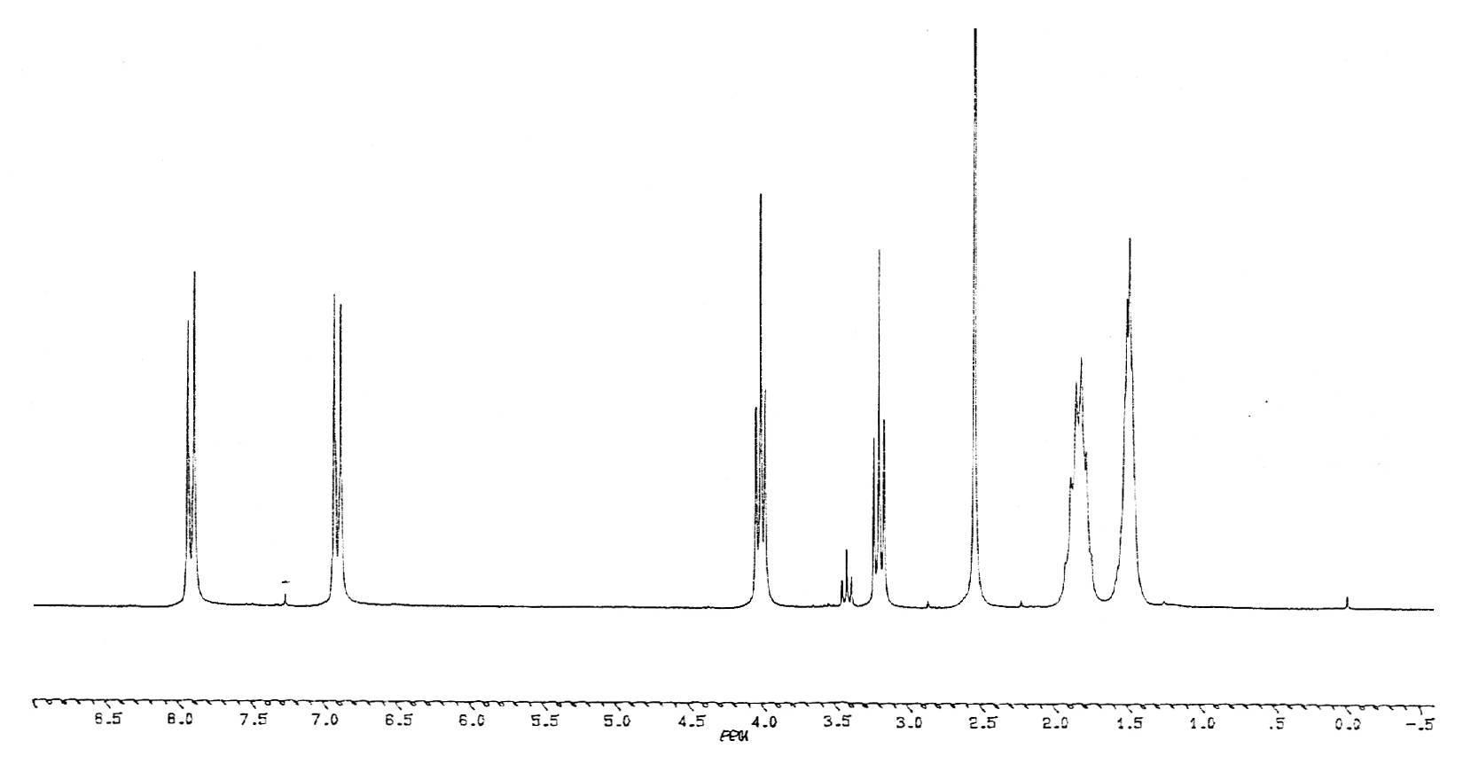  Figure 2 ¹H-NMR-spectrum of polymer (5)  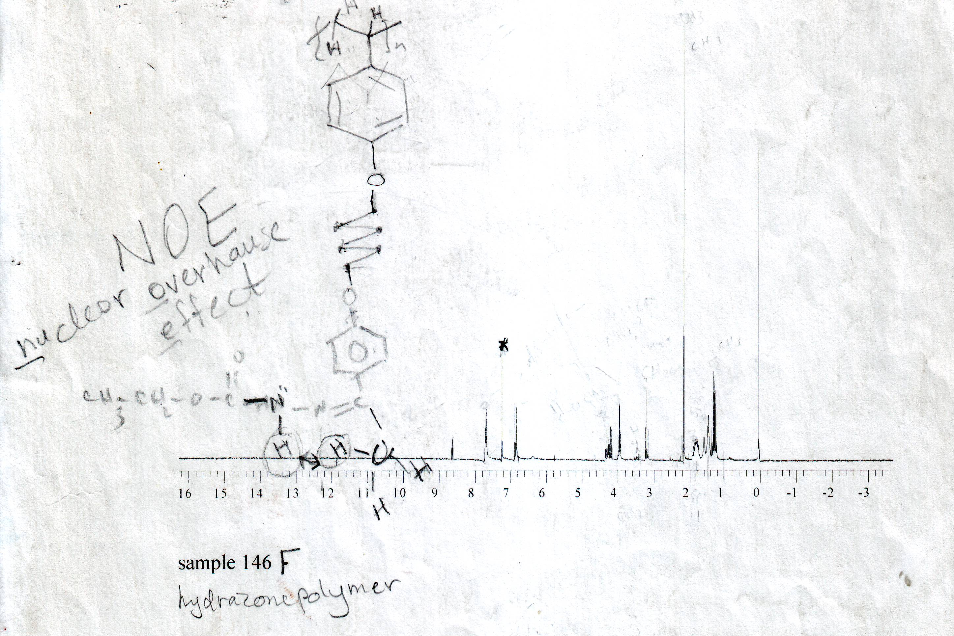  Figure 4 ¹H-NMR-spectrum of polymer (7)  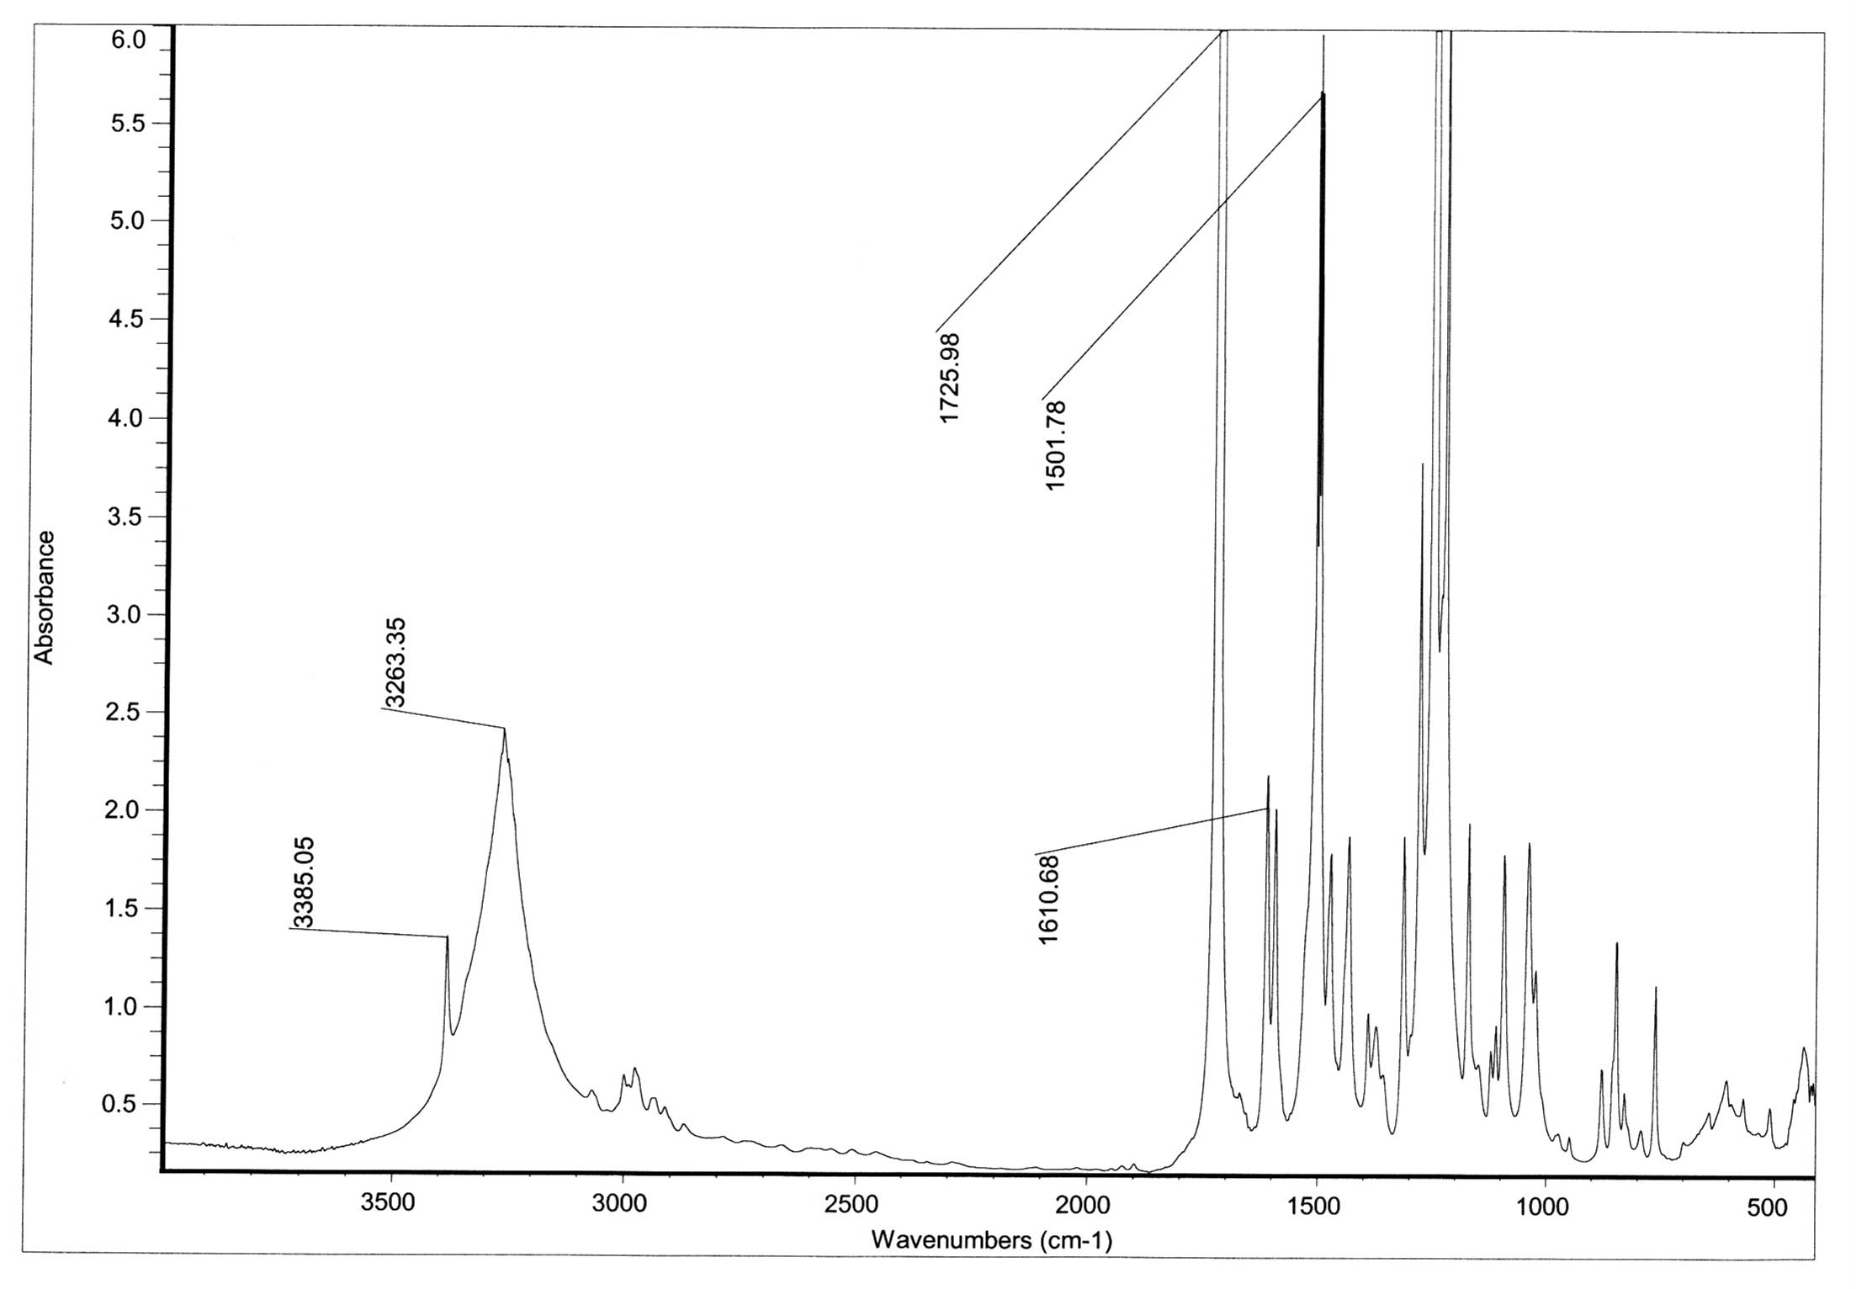  Figure 6 IR-spectrum of compound (9) in KBr disk  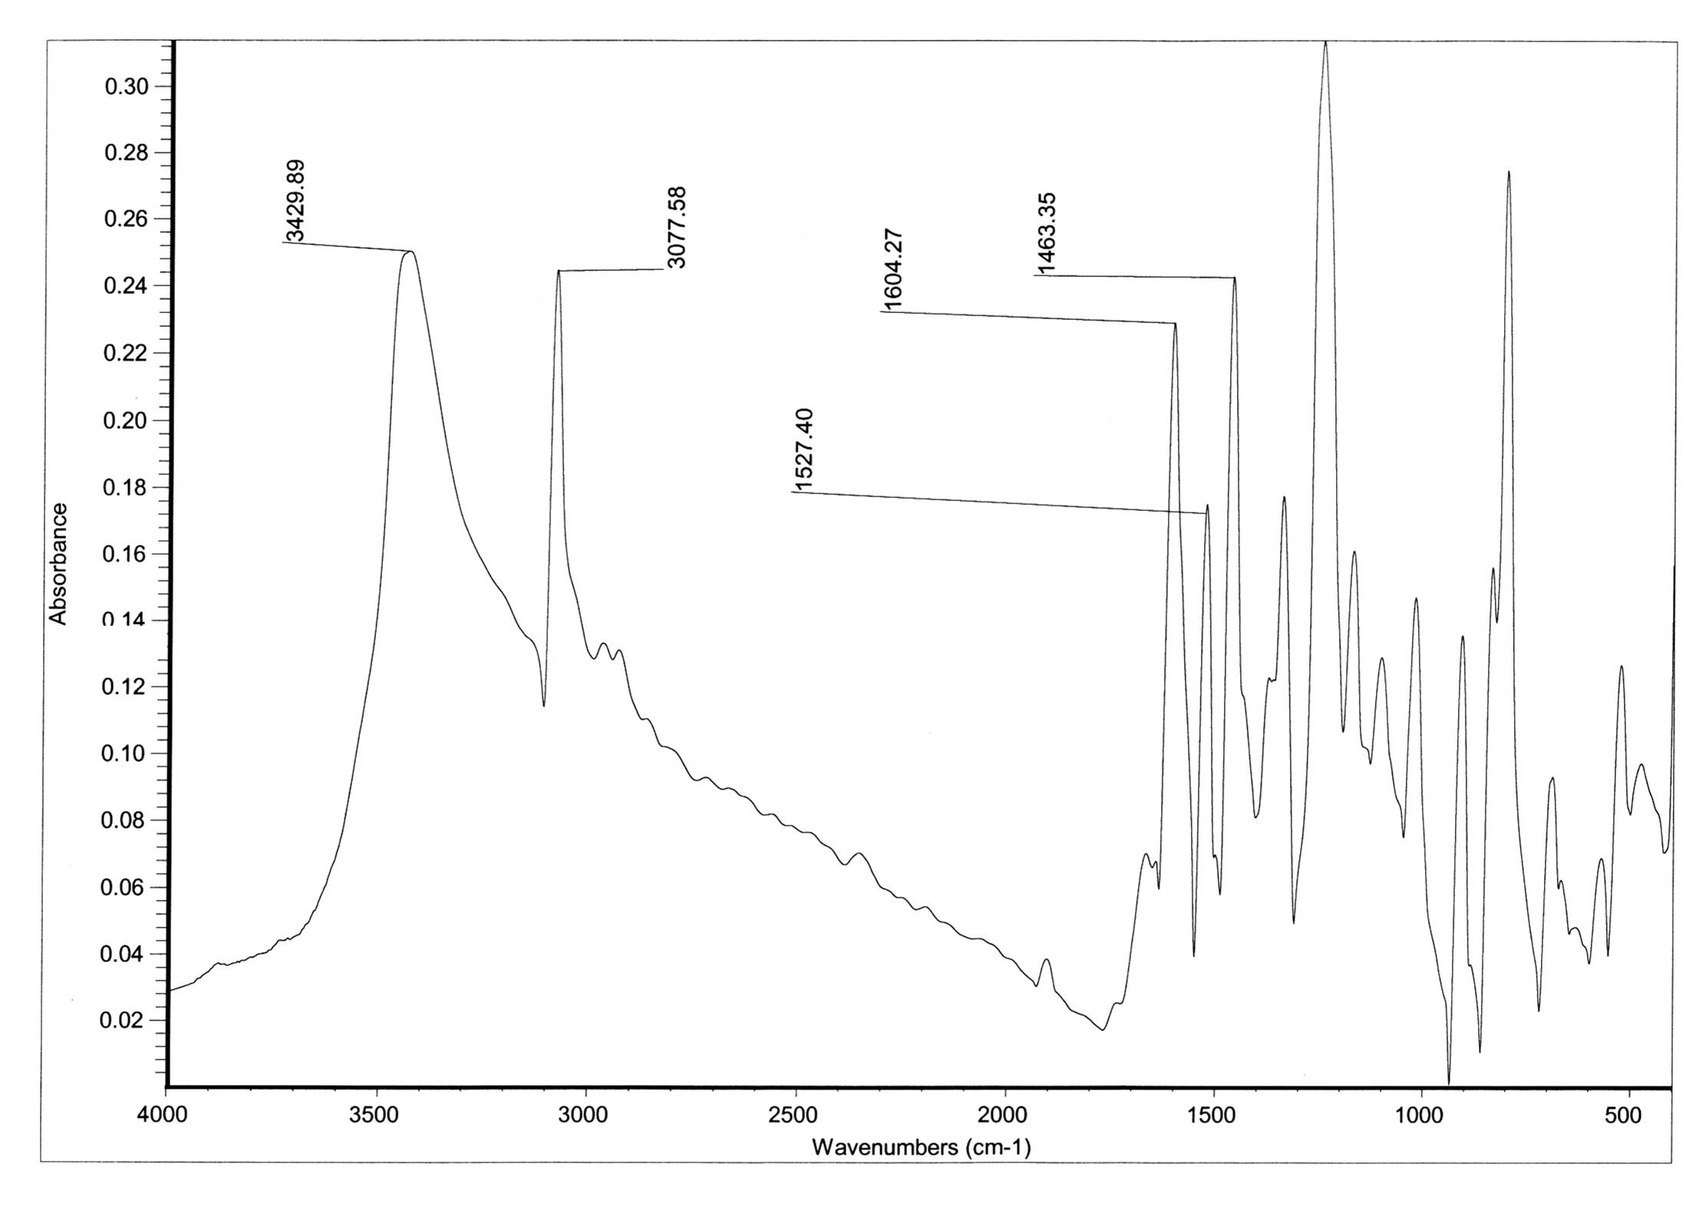  Figure 8 IR-spectrum of compound (10) in KBr disk  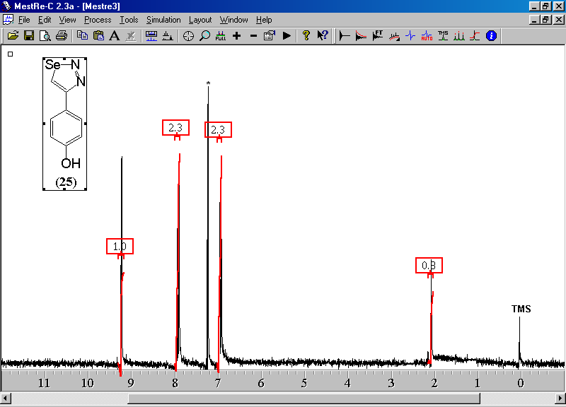  Figure 9 ¹H-NMR-spectrum of compound (10)  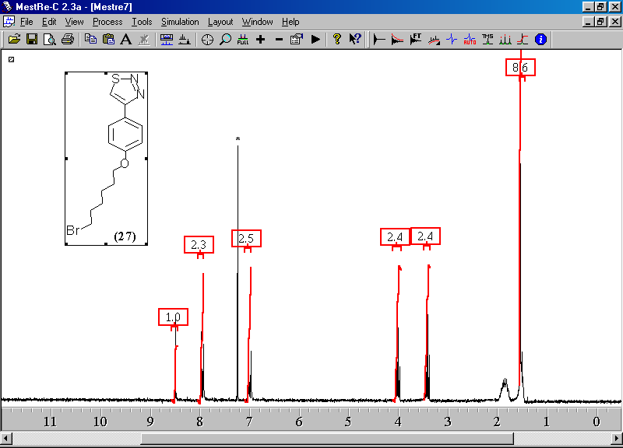  Figure 11¹H-NMR-spectrum of compound (12)  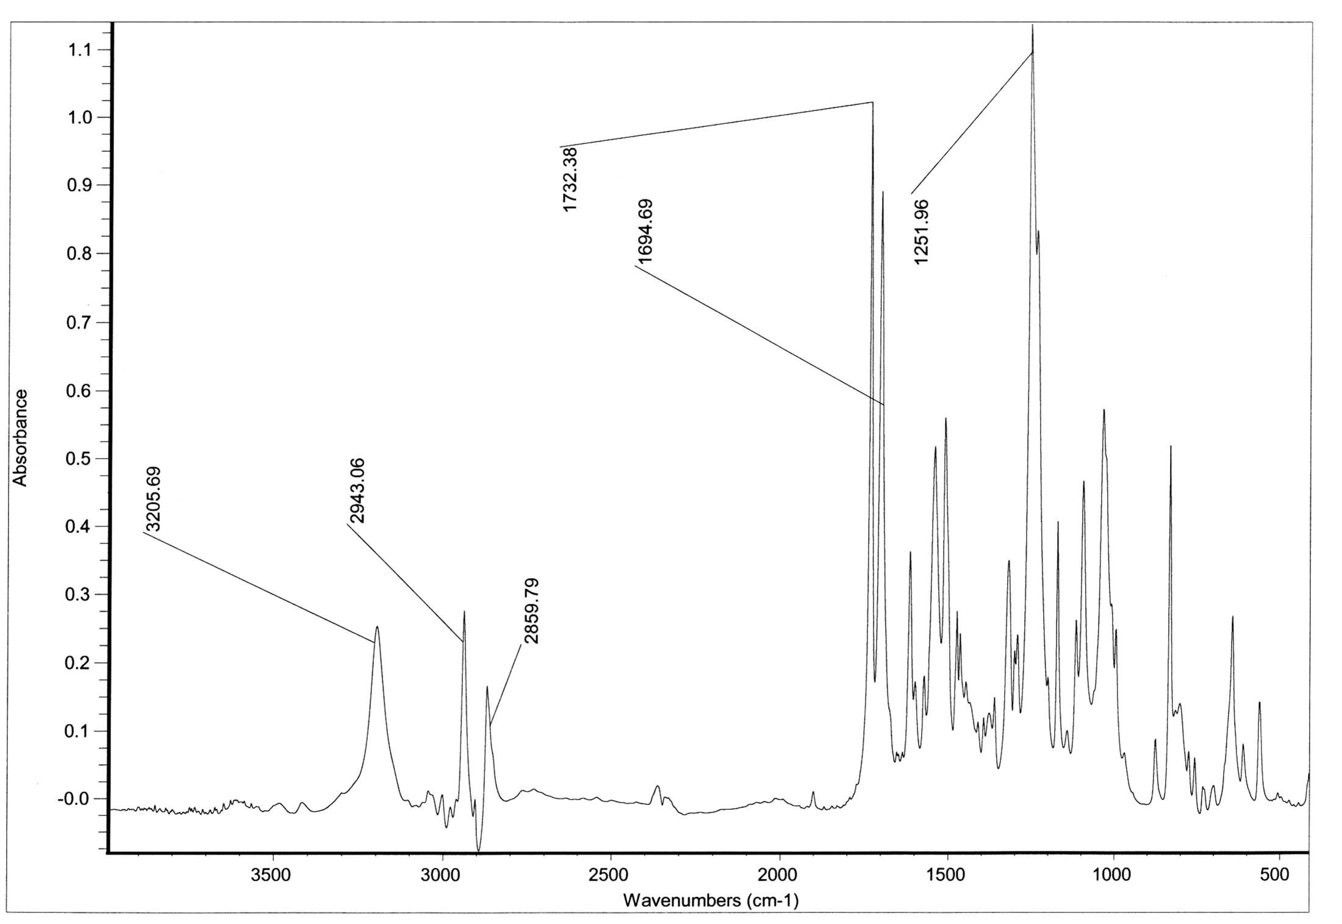  Figure 13 IR-spectrum of polymer (16)  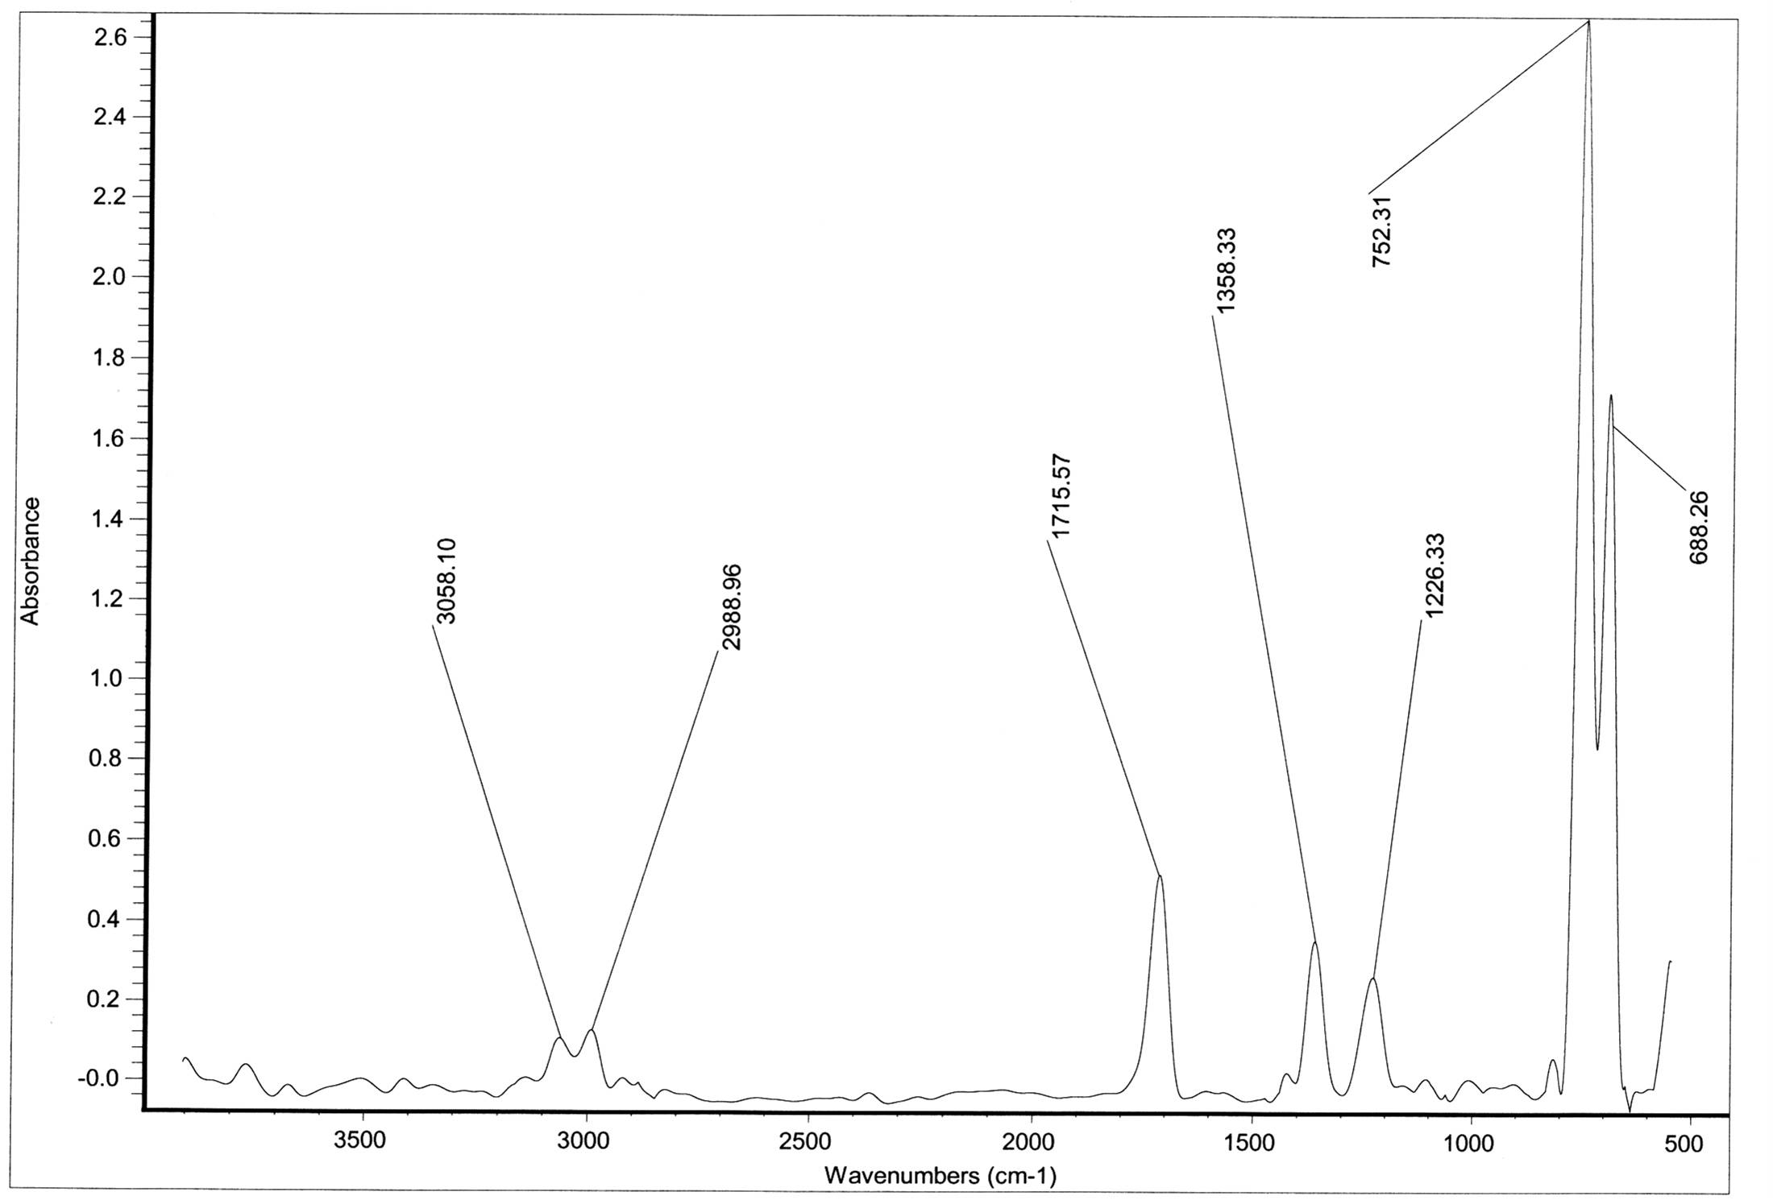  Figure 16 IR-spectrum of polymer (8) after irradiation in KBr disk | 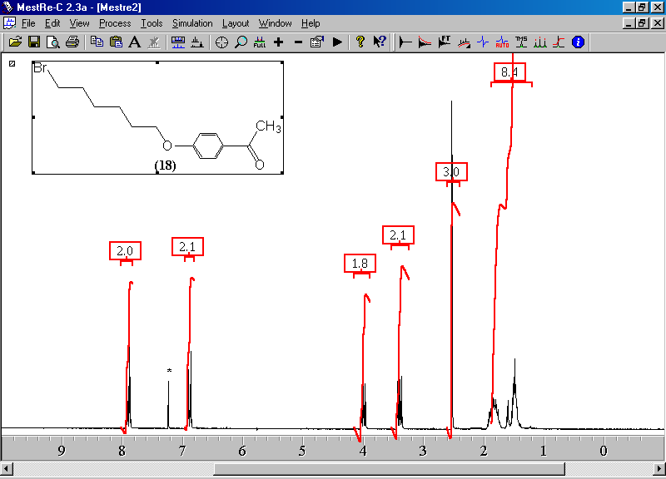  Figure 1 ¹H-NMR-spectrum of compound (3)  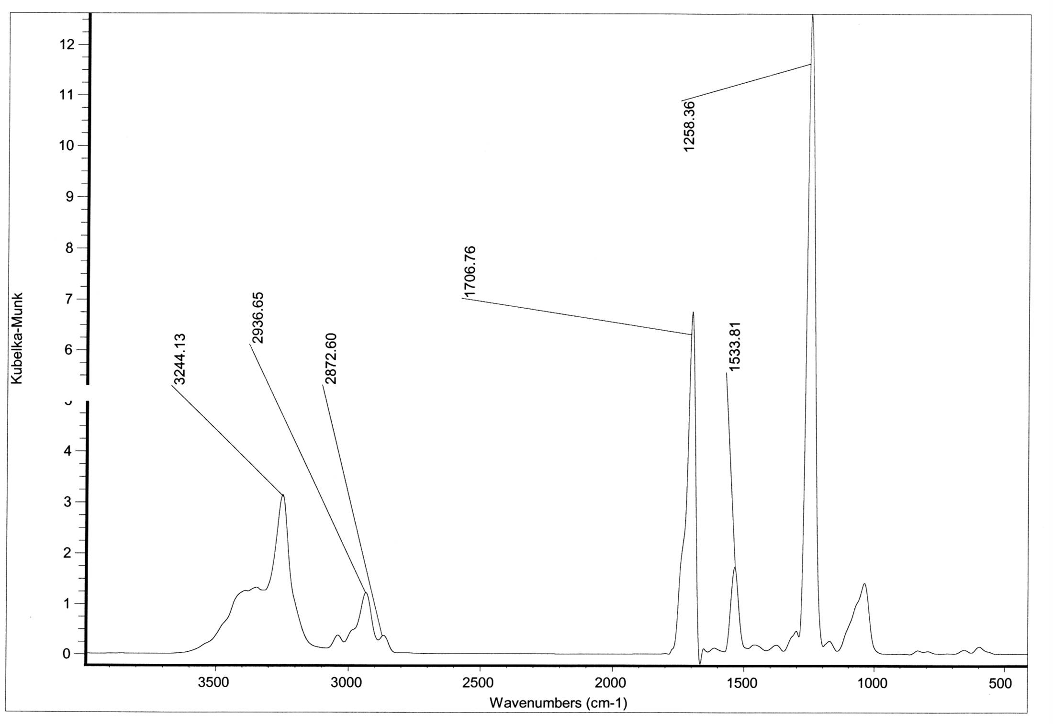  Figure 3 IR-spectrum of polymer (7) in KBr disk  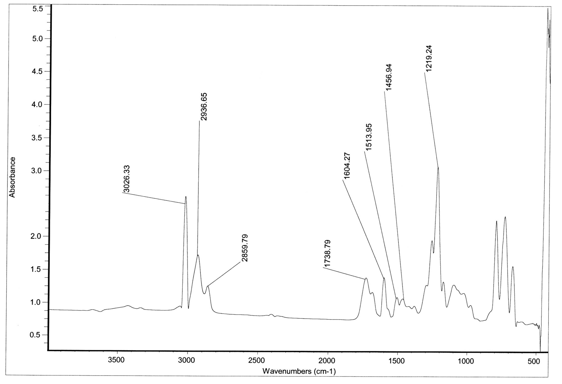  Figure 5 IR-spectrum of polymer (8) in KBr disk  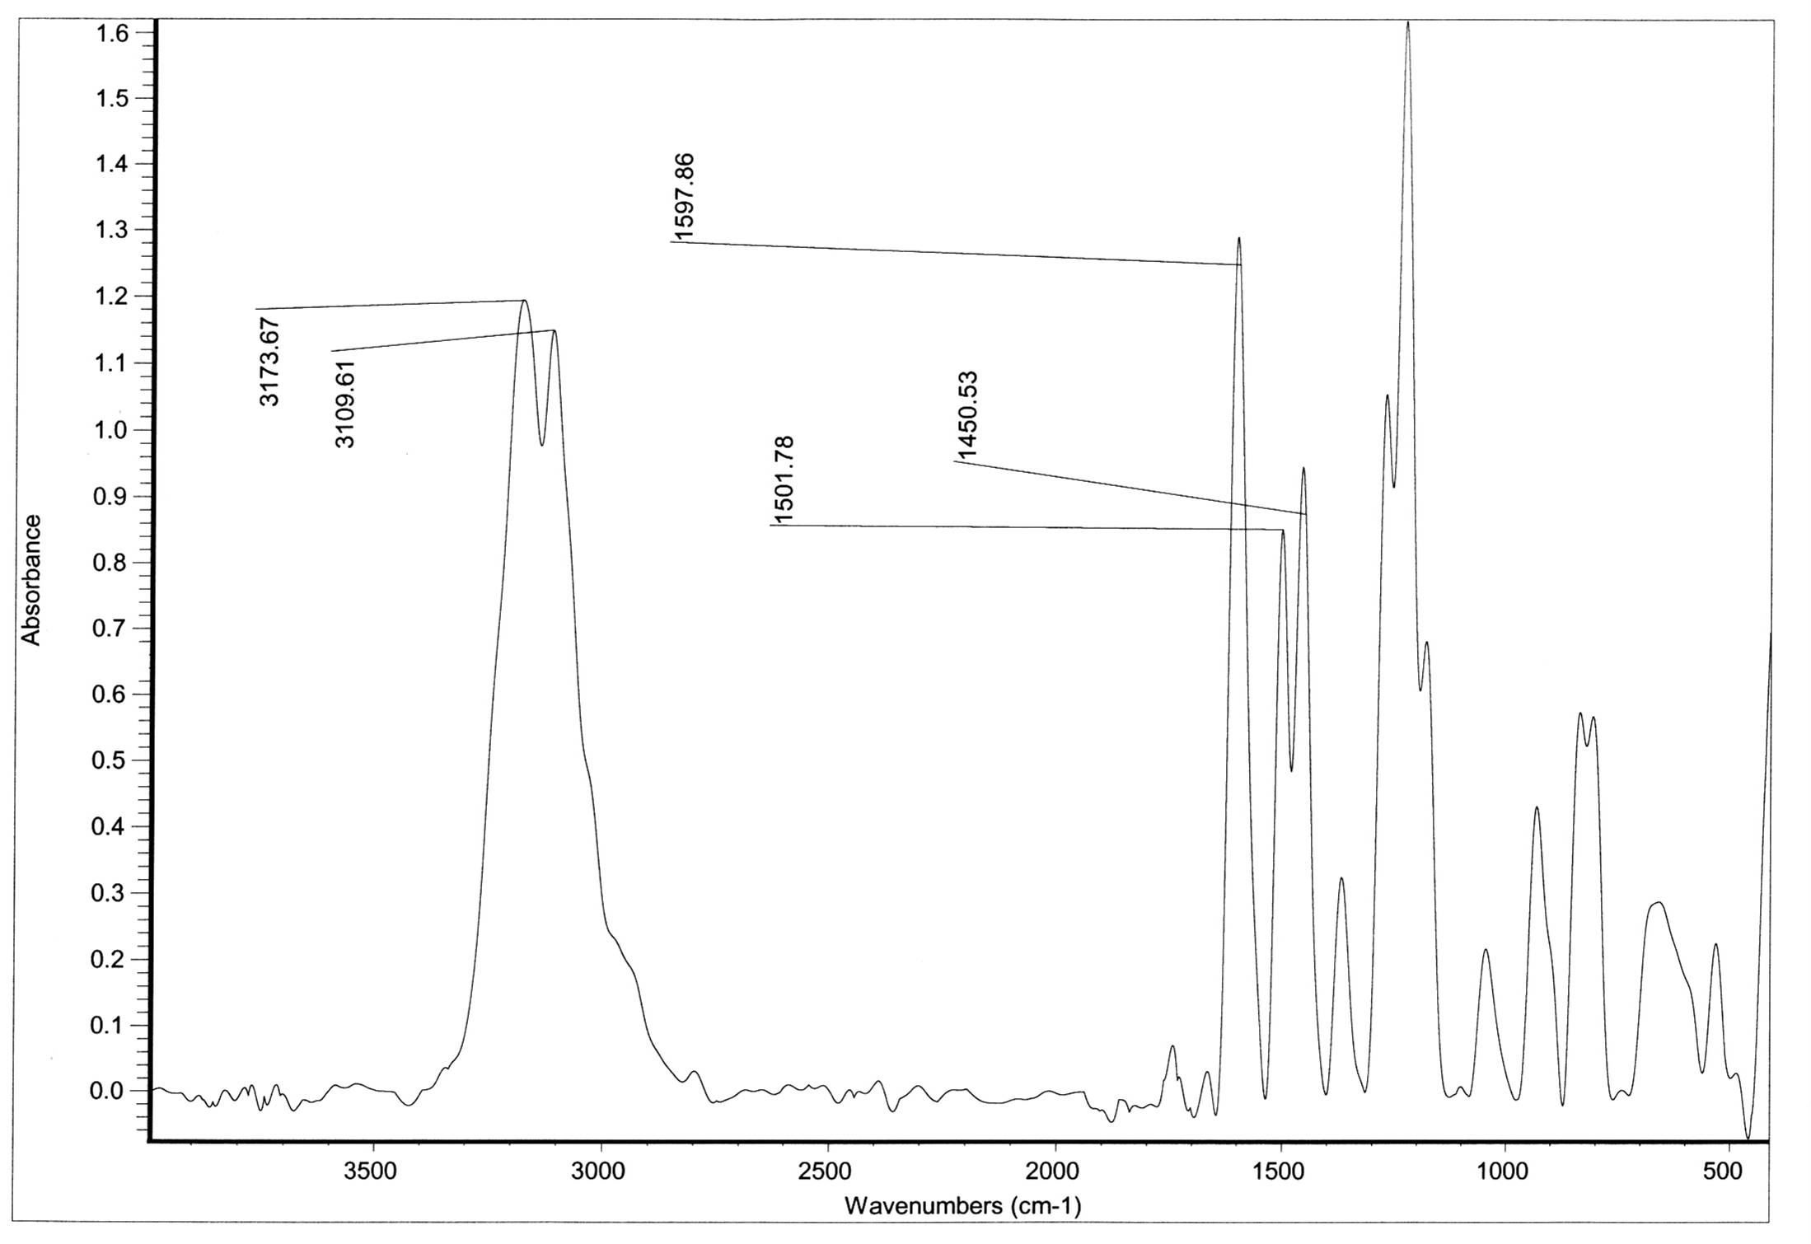  Figure 7 IR-spectrum of compound (11) in KBr disk  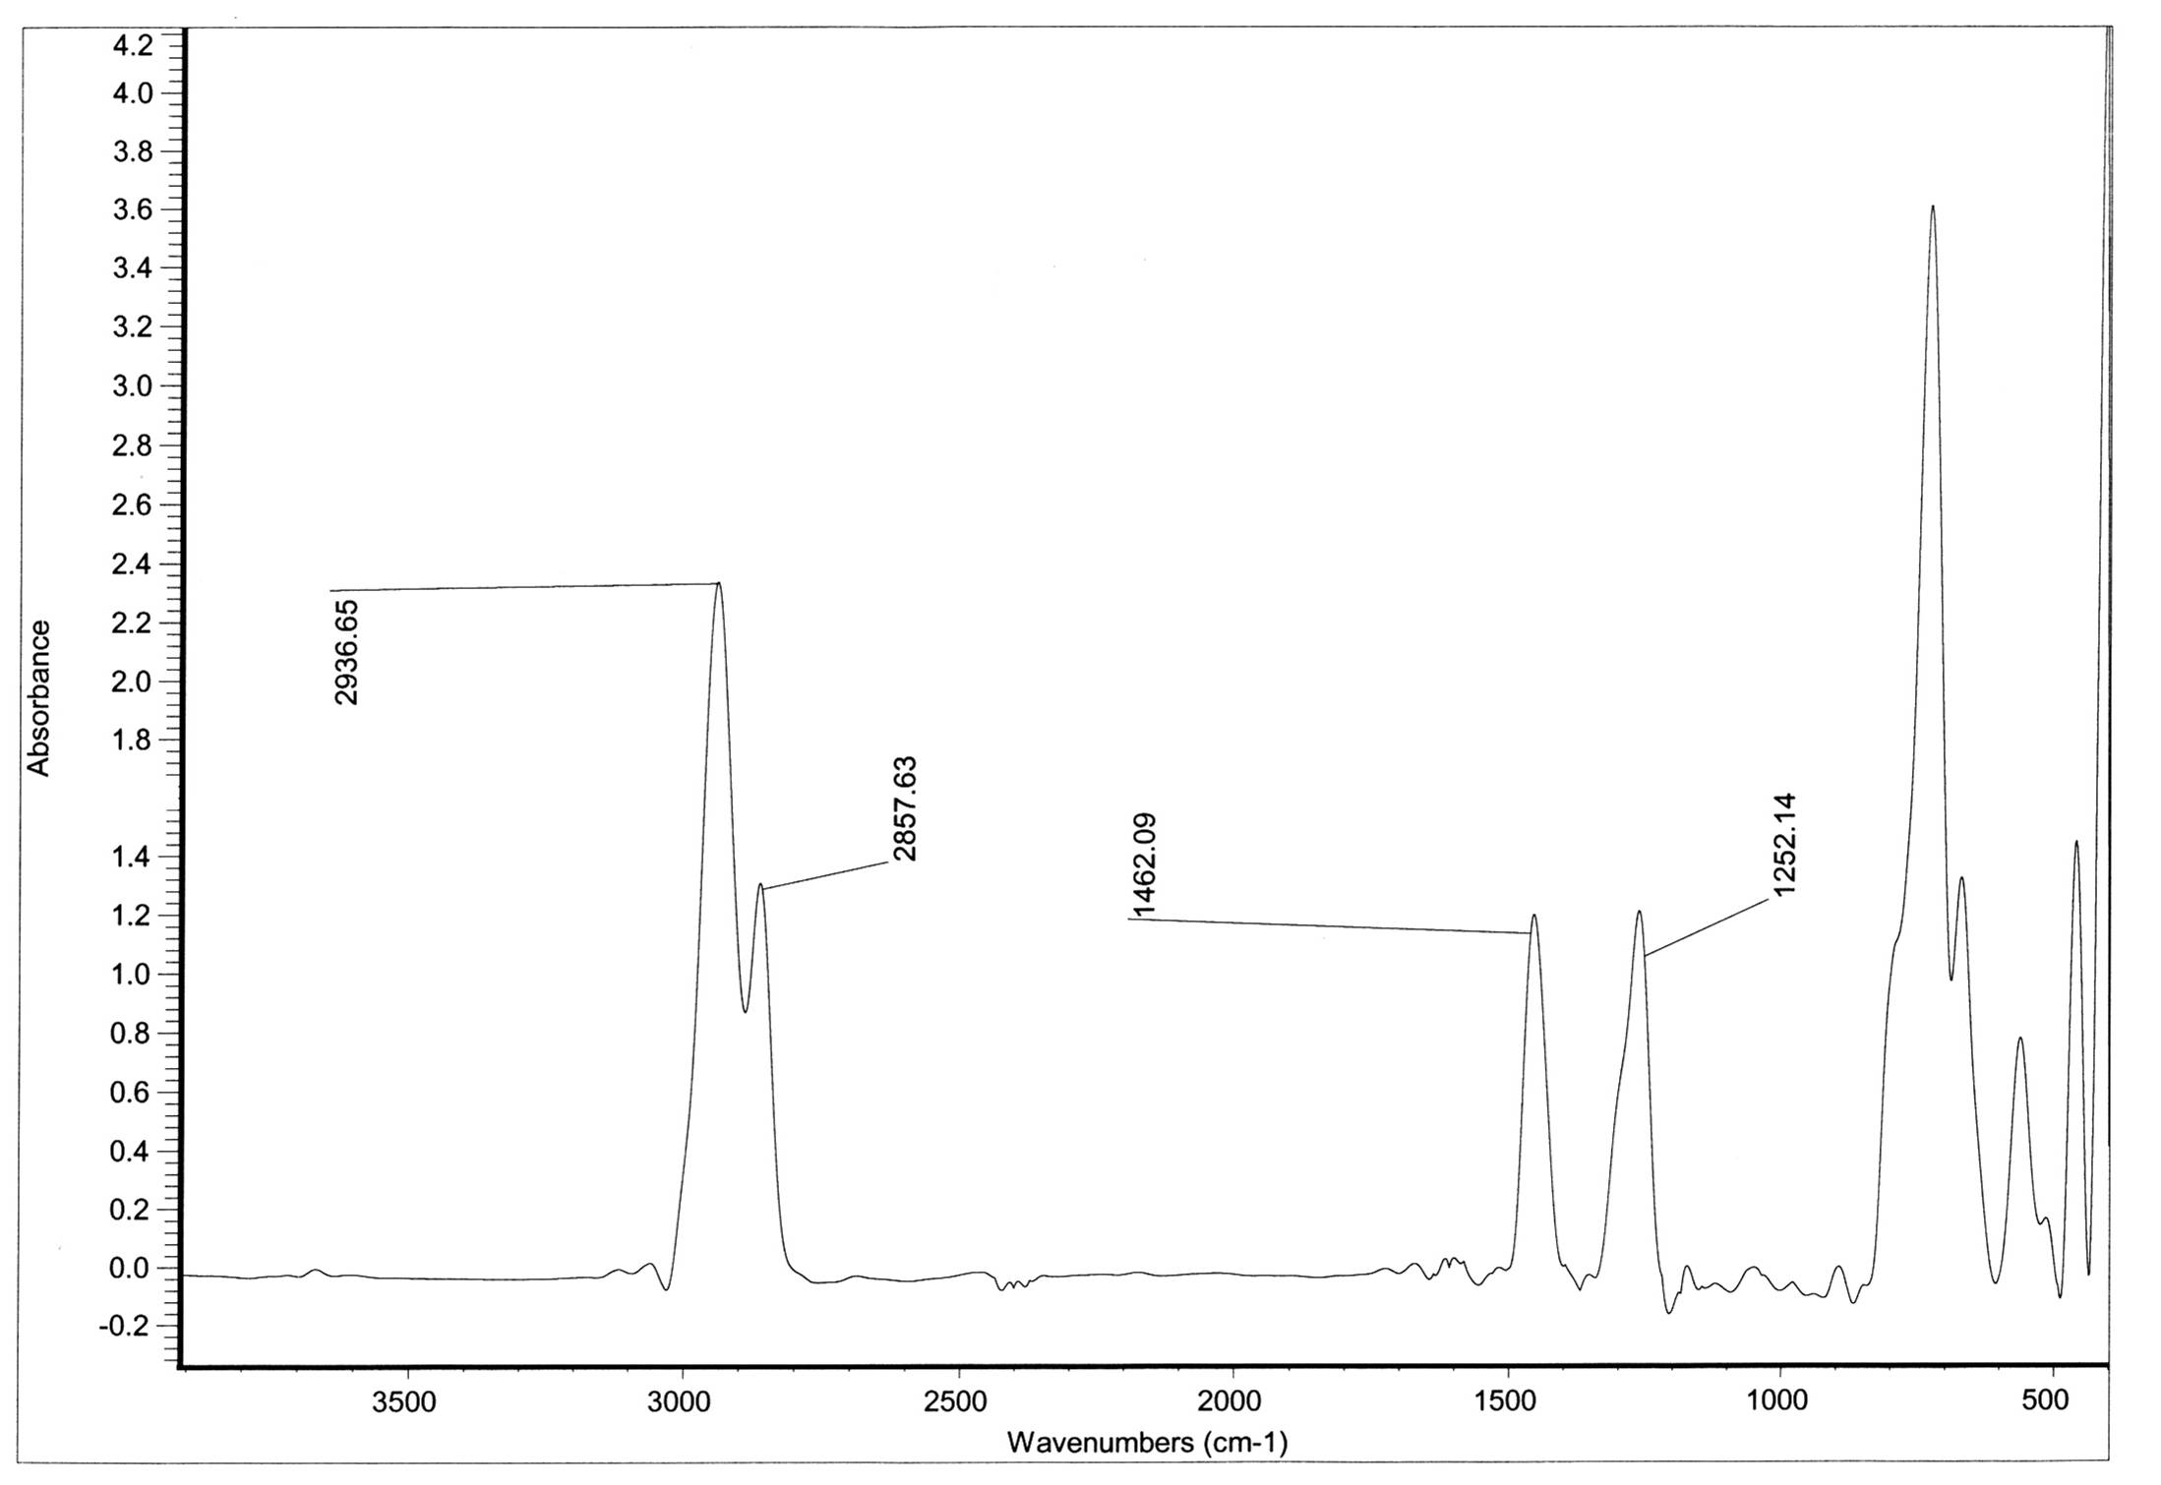  Figure 10 IR-spectrum of compound (12) in KBr disk  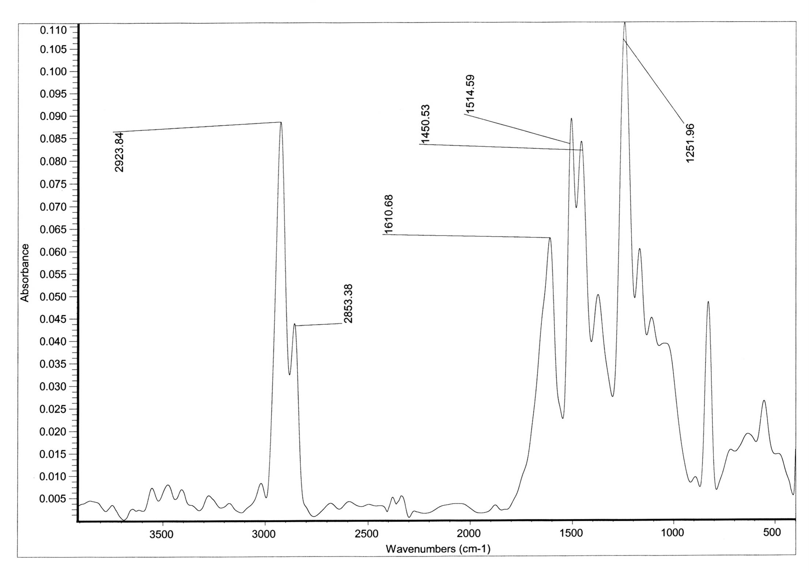  Figure 12 IR-spectrum of polymer (13)  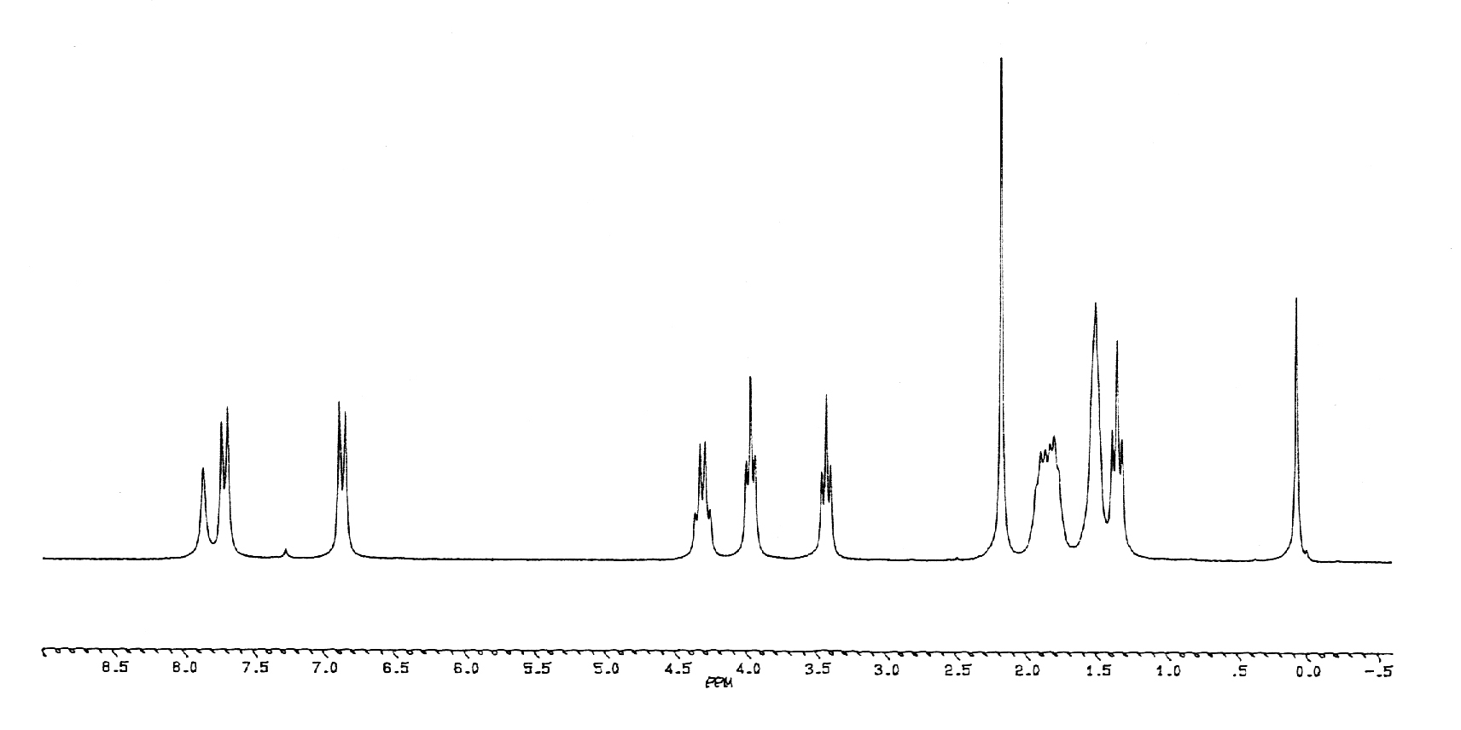  Figure 14¹H-NMR-spectrum of compound (16)  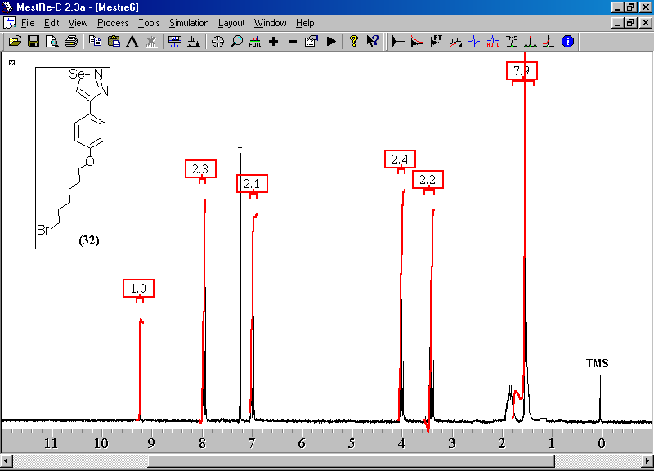  Figure 15¹H-NMR-spectrum of compound (17)  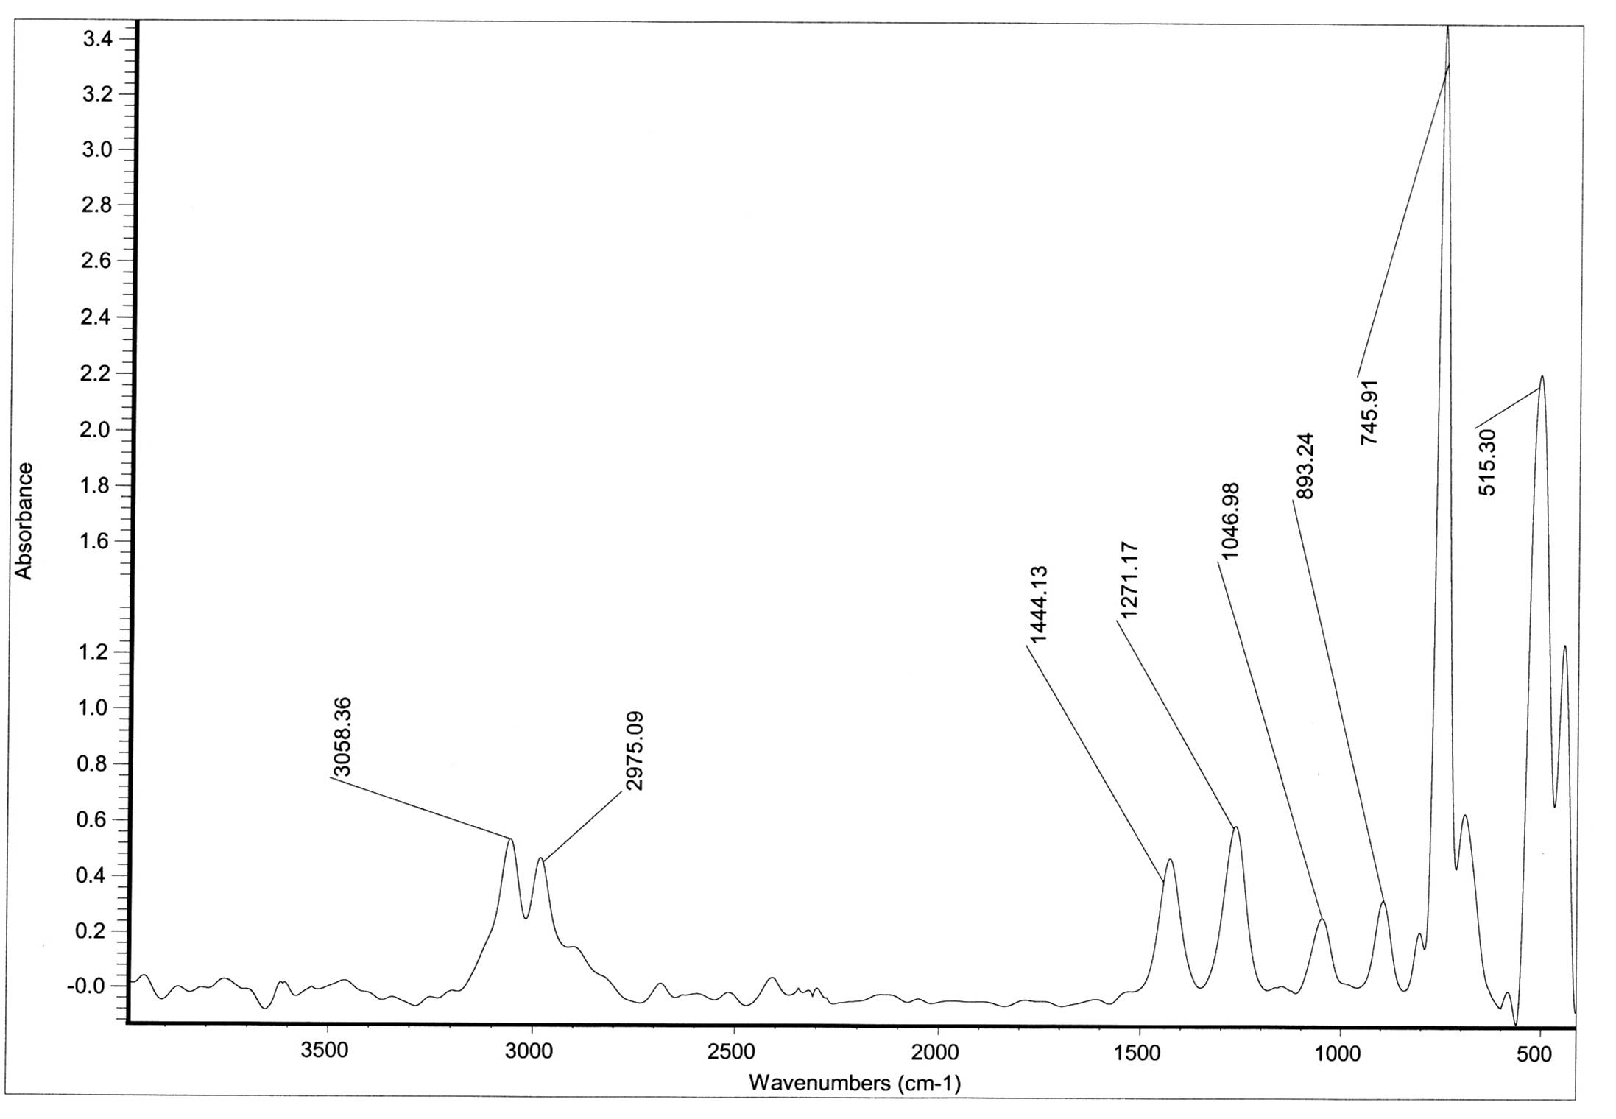  Figure 17 IR-spectrum of polymer (13) after irradiation in KBr disk
λ=314.8  314.8  λ=294.8  Figure 18 UV-spectrum of polymer (8) | λ=276.8  λ=274.2 nm n  _{q2adfdddsmax} = 274.2  Figure 19 UV-spectrum of polymer (13)

References
1. M. Pieper, H. Meier. Chem, Liebigs.Ann. , 1986, 1353.
2. C. D.Hurd, R. I. Mori. J. Am. Chem. Soc, 1955, 77, 5359.
3. I. Lalezari, A. Shafiee. Tetrahedron letters, 1969, 58, 5105.
4. I. Lalezari, A. Shafiee, M. Yalpani. J. Org. Chem, 1971, 36, 2836.
5. W. V. Curran, M. L. Sassiver, J. H. Boothe, L. Jacob. J. Heterocycl. Chem, 1985, 22, 479.
6. S. Ford, P. K. Khanna, C. P. Morley, M. D. Di Vaira. J. Chem. Soc., Dalton, 1999, 791.
7. V. Pandmavathi, R. P. Sumathi, M. V. Ramana, R. Baskar. Org, prep and proc int, 1998, 30 (2), 187.
8. Y. Nishiyama, Y. Hada, K. Iwase, N. Sonoda. J. Organomet. Chem, 2000, 611, 488.
9. D. B. Reedy, V. Padmavathi, A. Pamaja, M. V. Ramana Reddy, A. S. Reddy, A. Balaiah, T. V. Ramana Reddy. The fifth international Electronic Conference on synthesis Organic Chemistry,(ECSOC-5),http://WWW.mdpi.org/ecsoc-5.htm, 1-30, September 2001.
10. M. Al-Smadi, N. Hanold, H. Meier. J. Heterocycl. Chem, 1997, 34, 605.
11. M. Al-Smadi, H. Meier. Liebigs. Ann, 1997, 2357.
19. D. H. R. Banton, W. d. Ollis. Comprehensive Organic Chemistry, Ed. pergamon, Oxford, 1979, 4, 1033.
12. K. Subramaian, S. Nanjundan, A. V. Rami Reddy. Eur. polym. J, 2001, 37(4), 691.
13. J. H. O, Donnell. Am. Chem. Soc, 1989, 1.
14. L. L. Bambas. The Chemistry of Heterocyclic compounds, Inter. science Publisher, Inc, New york, 1952, 3.
15. I. Laezari, A. Shafiee, J. Khorrami, A. Soltani. J. of. Pharm Sci,1987, 67 (9), 1336.
16. M. Fujihashi, H. Aota, A. Matsumoto. polymer network,s, 2000, 60.
17. M. Al-Smadi and S. Ratrout, Molecule, 2004, 9, 957.
18. N. Tokitoh, T. Sadahiro, K. Hatano, T. Sasaki, N. Takeda, R. Okazaki. Chem..Lett, 2002, 34.
19. H. Igs. Detert and H. Meier, Liebigs. Ann., 1997, 1557.

