The Effect of New Metal Complexes on the Photo Degradation of Poly(vinyl chloride) Films.

Basim M.AL-Shimary
Polymer Research Unit ,College of Science, Al-Mustansiriya University
Iraq, Baghdad.
Al-Jibouri M. N., A.H.Ismael
Chemistry Department, College of Science, Al-Mustansiriya University
Iraq, Baghdad.

(NJC)

(Received on 18/9 /2007) (Accepted for publication 1/6 /2008)

Abstract
In the present work, the photo degradation of poly (vinyl chloride) films (80μ m in thickness) has been studied using two complexes, these are:
- Sodium –bis (3-mercapto-5-salicyldimino-1,2,4,-thiodiazole) dichloro-chromate (III)
- bis (3-mercapto-5-salicyldimino-1,2,4,-thiodiazole) diaqua iron(III) chloride .
The prepared complexes were identified by spectral methods (infrared& ultraviolet- visible spectroscopy) as well as by C.H.N .and (M) analyses and conductivity technique . The degree of photo degradation was monitored by measuring the carbonyl index using I.R spectrophotometry .
The variation of the number average molecular weight of P.V.C films during irradiation (λ =254nm) was determined by viscometric technique, as well as the determination of quantum yield of scission (Фcs) through following the changes in electronic spectra of samples.
According to the kinetic data and other experimental results , it is found that the Cr (III) complex stabilizes the P.V.C films , while Fe(III) complex enhances the photo degradation and this was confirmed by the suggested mechanism under the experimental conditions employed .
الخلاصة
تم خلال هذا البحث دراسة التحطيم الضوئي لرقائق البولي (كلوريد الفاينيل ) بسمك 80مايكرون بستخدام معقدات الكروم و الحديد الثلاثية لقاعدة شف و هذين المعقدين هما:-
- صوديوم– ثنائي (3-ميركابتو– 5- ساليسالدايمينو– 4,2,1 ثايادايازول) ثنائي كلورو– كرومات (III).
- ثنائي (3-ميركابتو – 5- ساليسالدايمينو – 4,2,1 ثايادايازول) ثنائي اكوا الحديد (III) كلورايد.
تم تشخيص المعقدات بالطرق الطيفية (الاشعة تحت الحمراء و الاطياف الالكترونية) ,التحليل الدقيق للعناصر (C.H.N) , قياس نسبة الفلز في المعقدات الصلبة بواسطة طيف الامتصاص الذري اللهبي و كذلك قياس الموصلية المولارية في محاليلها . تم دراسة تاثير المعقد ين C₁, C₂ بنسب وزنية (2-2.5%) على التحطيم الضوئي لافلام البولي (كلوريد الفاينيل ) من خلال تعيين التغير في المعدل العددي للوزن الجزيئي باستخدام تقنية اللزوجة .
تم متابعة درجة التجزئة الضوئية بتعيين معامل الكاربونيل باستخدام مطيافية الاشعة تحت الحمراء اضافة الى قياس منتوج كم التجزئة بواسطة متابعة التغير بالاطياف الالكترونية . ومن خلال الدراسة الضوئية و النتائج الحركية الطيفية تم اقتراح ميكانيكية لعملية التثبيت و التجزئة الضوئية لرقائق البولي ( كلوريد الفاينيل ) وقد استنتج ان معقد الكروم الثلاثي يعمل استقرار ضوئي بينما معقد الحديد الثلاثي يزيد من سرعة التحطيم الضوئي.

Introduction The chemical pathways by which common polymers photodegrade are fairly well known, but various aspects of the mechanisms involved remain unelucidated . However it is important to take into account very significant influence of compounding additives in modifying these pathways⁽¹⁾ . Typically these are pigments, extenders, photostabilizers and thermalstabilizers . The many concurrent chemical processes taking place in polymers exposed to U.V. radiation result in served different modes of damage, each processing at different rate⁽²⁾ . It is usually the critical first – observed damage process ⁽³⁾ that determines the useful service life of the product . For instance poly ( vinyl chloride ) P.V.C, window frame exposed to sunlight under goes discoloration ⁽⁴⁾ , chalking , loss of impact strength, and a reduction in tensile, properties as well as a host of other chemical changes ⁽⁵⁾ .
It is well – known that trace amounts of metallic impurities or additives present in polymers play an important role in the photodegredation of the substrates⁽⁶ ⁻ ⁸⁾. Some such additives act as photosensitizers which others act as quenchers.
In the present investigation therefore, we set out to study the effect of Cr(III) and Fe(III) chelates derived from 3-mercapto-5-salicyaldimino -1,2,4 – thiadiazole (structures I and II) on the photodegredation of P.V.C films.

Structure (I) : Sodium Bis ( 3 - mercapto - 5 - salicyaldimino - 1,2,4 - thiadiazole) - dichloro – chromate ( III )

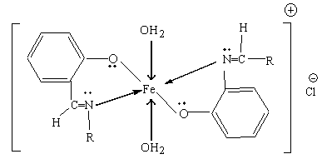

Structure (II) : Bis ( 3 - mercapto - 5 - salicyaldimino - 1,2,4 - thiadiazole) diaqua Iron ( III ) chloride

where: R = 3 – mercapto - 1,2,4 - thiadiazoyl group

Experimentals
Samples Preparation :
The new schiff bcse ( HL ) derived from 5- amino - 3- mercapto - 1,2,4 - thiadiazole has been prepared according to the published literatures as scheme (1) :

Scheme (1) : preparation of HL

Complexes of Fe ( III ) & Cr ( III ) with ( HL ) ligand have been prepared according to the method described by Al – jibouri . M.N ⁽¹⁰⁾ , and was obtained as dark – green needles and pale brown cystals reapeetively.
( HL ) Ligand and its metal comploxes ( C₁ & C₂ ) have been fully identified by spectral techniques ( UV – Vis. and F.T.I.R ) , molar conductivity A_{m} in D.M.F.solvent, morever the elemental analysis % M by flame atomic absorption( F.A.A.S.).
The films of p.v.c have been prepared by dissolving 0.01 g ( p.v.c ) in 10ml of dry tetra hydro furan (T.H.F) to make films of even thickness (80 μm. ) by casting this solution with or without 0.1 % ( w/w) of metal complex C₁ or C₂ on quartz plate . The films were dried in air at 35ºC for 24 hrs.
Molecular weight measurements :
Molecular weights of P.V.C films with and with out additives were calculated from intrinsic viscosities measured in T.H.F solution at 25^{O}C with an Ostwald U-tube viscometer .Mark Houwink equation was used to deduce the molecular weight :
η =k M_{n} ^{α} ……….(2)
Where η Is the intrinsic viscosity and α, k are constants for agiven polymer-solvent system and equal to 0.61 and 13.2*10⁻⁴ for T.H.F respectively .
Identification of the prepared compounds:
The Schiff base (HL) and its metal complexes (C₁&C₂) have been fully identified by microelemental analysis (C.H.N) with Carlo-Earba elemental analyzer model EA 1108 , the percents of Cr, &Fe in metal chelates were estimated by flame atomic absorption spectroscopy (F.A.A.S) using Shimadzu AA-670 spectrophotometr .
I.R spectra were recorded in KBr-medium on a Pye-Unicam SP2000 spectrophotometer in the range (4000-600 ) cm⁻¹ . The electronic spectra of the prepard compounds in their solutions in T.H.F were recorded using Uv/visible SP3200 –spectrophotometer ,more ever the molar conductivity of complexes in T.H.F (10⁻³ M) solution were done using Set-Mark conductivity meter .
Determination of carbonyl index(Ico):
The changes in I.R spectra of the P.V.C samples due to carbonyl goup were analysed by a base line method ⁽¹¹⁾, and the effects of C₁or C₂ complexes were estimated .
Carbonyl index was calculated by comparison of the I.R absoption peak at 1720 cm⁻¹ with reference peak at 1890cm-¹ ,figures (1&2)
I_{co}= A₁₇₂₀/A₁₈₉₀…………..(3)

Photodegradation :
Accelerated weathering Q.U.V. tester (Q. panal company, U.S.A) was used for irradiation of P.V.C films. The samples are fixed vertically and paralleraly to the lamps to be sure that the ultraviolet incident radiation is vertically on the samples, the temprature of the tester chamber is constant at 50ºC for all samples.
The quantum yield φ_{cs} values of polymer chain scission were determined from the equation⁽¹¹⁾ :

$\begin{aligned}\frac{1}{P_{n,t}}−\frac{1}{P_{n,o}} =\frac{m}{\text{WN}}ϕΙ_{a}t\text{.}\text{.}\text{.}\text{.}\text{.}\text{.}\text{.}\text{.}(1) \\ \end{aligned}$ Where w is the weight of the irradiated polymer film sample, m is the molecular weight of vinyl chloride ( monomer ) , N is the Avegadro's number ( 6.214 x 10²³ mol⁻¹ ) , I_{a} is the light absorbed by the polymer sample, and P_{n,o} , P_{n},_{t} are the number average degree of polymerization initially and at any exposure time (t) during the degradation .
The electronic spectrum of the irradiated P.V.C films were determined in T.H.F. solution using sp 3200 spectrophotometer.
The F.T.I.R. of P.V.C films blended with Cr(III) or Fe(III) complexes were determined by Perkin – Elmer mode sp3600, to evoluet carboyl index (I_{co}), figures (1 and 2).

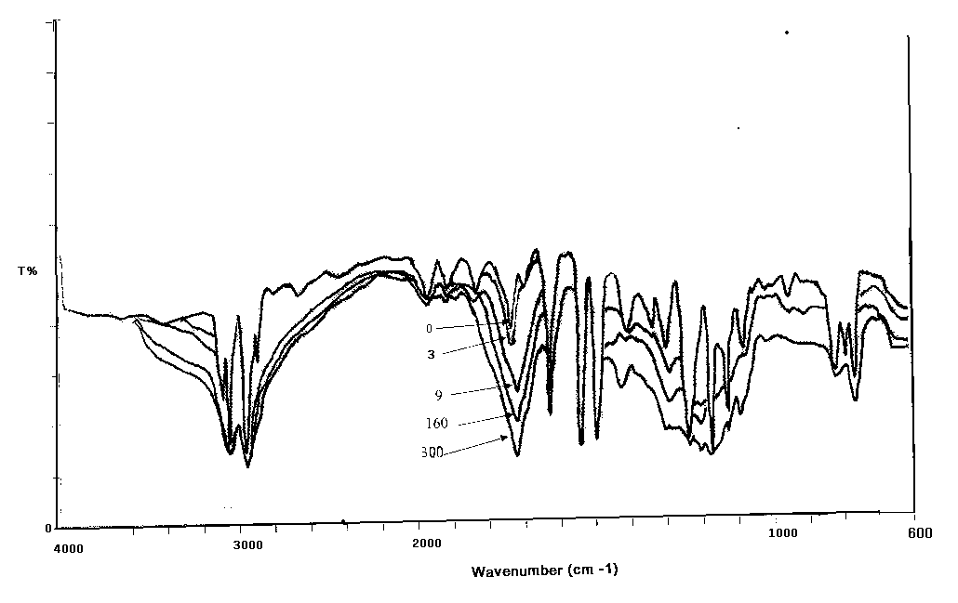
Fig.(1): Chang in I.R spectrum P.V.C films blended with C₁ complex with time irradiated by 253nm.
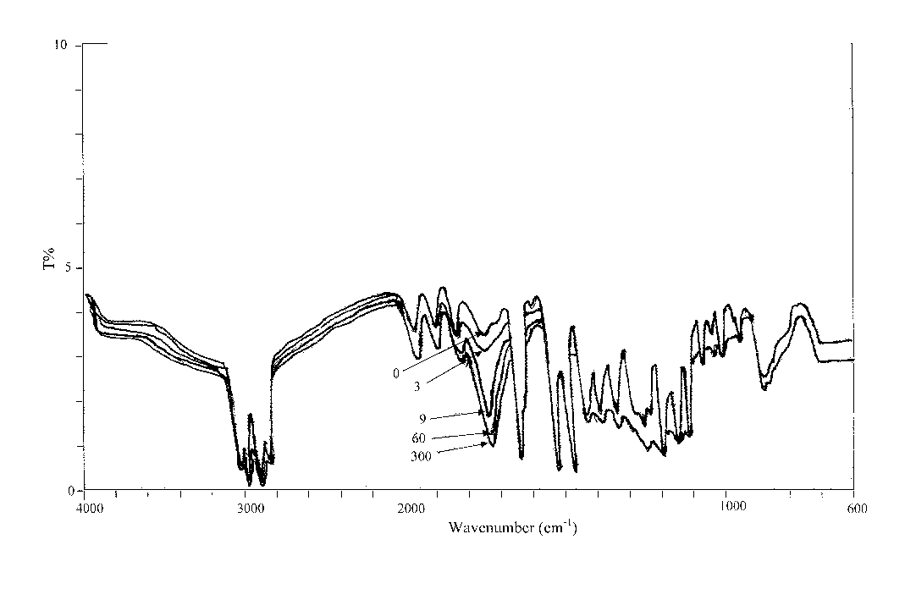

Fig.(2): Chang in I.R spectrum P.V.C films blended with C₂ complex with time irradiated by 253nm of irradiation.

Results & Discusion
- Identification of the prepared complexes (C₁ & C₂)
- I.R spectra :-
In order to study the binding mode of Schiff base (HL) to Cr or Fe (III) ions in the complexes I.R spectrum of the free ligand was compared with the spectra of metal complexes .
(HL) shows its characteristics absorption bands in the 1340,1630 and 1350cm⁻¹ assignable to phenolic O-H
C=N , and N-S vibrations ^{.(12)} The band of azomethine of the ligand underwent ashift to alower frequency (1575-1590 cm⁻¹) after complexation , indicating the coordination of azomethine nitrogen to metal atom and this can be explained by the donation of electrons from nitrogen to empty d-orbitls of the metal atom . Further more ,the absence of absorption at 1340 cm⁻¹ was investigated on the deprotonation of the ligand to behave mono basic bidentate via nitrogen and oxygen atoms of C=N and phenoxy groups .

- Electronic absorption spectra:
The electronic absorption spectra are often very helpful in the evaluation of results furnished by other methods of structural investigation .
The electronic spectrum of the ligand (HL) and its complexes Cr &Fe (III) were recorded in dry T.H.F as asolvent .
The electronic spectrum of Cr (III) complex showed free
A₂g⁴ →T₂g⁴ , A₁g⁴ →T₁g ⁴ and A₁g⁴ →T₁g ⁴(P) figure (6) , and are in conformity with octahedral geometry ⁽¹³⁾ .
The appearance of peaks at 610 and780 nm due to A₁g⁶→Eg² and A₁g⁶→T₂g² transitions favour an-octahedral geometry for Fe (III) complex ⁽¹⁴⁾
However the electrolytic behavior of the complexes solutions in10⁻³ M T.H.F was 1:1 ratio supports the proposed structures.
As well as the magnetic moments values of the complexes are 3.05 and 4.5B.M respectively suggests the octahedral geometry around the metal ion with an- expected high spin ⁽¹⁵⁾

B- Analysis of the relative changes in M.wt was recently described by Scott ⁽¹⁶⁾ has been shown to provide aversatile test for random chain scission .
Arandom nature of bond scission is necessary when polymer decomposition does not occur in the primary photolysis prosess. This would be expected from the well-known energy migration by various photophysical processes within polymer until bond rupture occurs at a weak point in the structure . Figure (3) shows aplot of M.wt as afunction of time of irradiation for P.V.C film with and without 0.01 wt% of C₁ or C₂ complexes in air with a light flux of 2.38 x 10⁻⁹ enstein . sec⁻¹. cm⁻² .
The plots show a rapid decrease in M.wt, initially which then slows- down , suggesting that the initial rapid drop in Mwt is due to scission of bonds at various weak links that may be distributed along the polymer chain, and the initial rate at which the bonds are broken is not sustained . The process becomes slower and the bond scission may be random .

0
1
0
0
2
0
0
3
0
0
T
i
m
e

(
h
r
s
)
2
0
.
0
3
0
.
0
4
0
.
0
5
0
.
0
P
.
V
.
C
P
.
V
.
C
+
C
1
P
.
V
.
C
+
C
2

Mwt

Fig (3) : Variation of M.Wt of P.V.C films with time of irradiation

The low quantum yield of scission φ_{cs} values also indicat that most of the light energy is dissipated by non-reactive process . The values of φ_{cs} increases with increase the percentages of the complexes C₁ or C₂ incorporated in the matrix of p.v.c films ⁽¹⁷⁾ .
The values of φ_{cs} for chain scission was calculated for p.v.c films with and without 0.01 wt% C₁ or C₂ after different times of irradiation by plotting 1/p_{w,t} verse irradiation time ,Fig (4) .

0
1
0
0
2
0
0
3
0
0
T
i
m
e

(
h
r
s
)
0
.
0
1
0
.
0
2
0
.
0
P
.
V
.
C
P
.
V
.
C
+
C
1
P
.
V
.
C
+
C
2
1/Pwt × 10⁵

Fig (4) : Changes in reciprocal value of average degree of polymerization (1/p_{w,t} ) during 254nm irradiation of P.V.C films with and without 0.01wt% C₁ or C₂ .

Fig (5) shows the variation of carbonyl index (I_{co}) with time of irradiation for p.v.c films with and without 0.01 wt% C₁ or C₂ . The values of carbonyl index (I_{co}) decrease with increase the percentages of the complexes C₁ or C₂ incorporated in the matrix of P.V.C films

0
5
0
1
0
0
1
5
0
2
0
0
2
5
0
3
0
0
I
r
r
a
d
i
a
t
i
o
n

t
i
m
e

(
h
r
)
0
.
5
0
1
.
5
0
0
1
2

P
.
V
.
C
+
C
1
P
.
V
.
C
+
C
2
Ico
P.V.C

Fig (5) : The variation of carbonyl index (I_{co}) with time of irradiation.

The solution of Cr(III)complex blended with P.V.C films in T.H.F showed low intensity peaks in the visible region 390,425,590 nm which are attributed to A₂g⁴ → T₂g⁽⁴⁾ , A₂g⁴ →T₁g⁴ and A₂g⁴ → T₁g⁽⁴⁾ (p)⁽¹⁸⁾ ,fig (6).
However the spectrum of Fe(III) complex blended with P.V.C film in T.H.F, showed A₁g⁶ → Eg² ⁽¹⁸⁾ peaks at 320,610 and 780 nm wich are assigned as intra-ligand charge transfar band (INCT)⁽¹⁹⁾ , fig. (7).

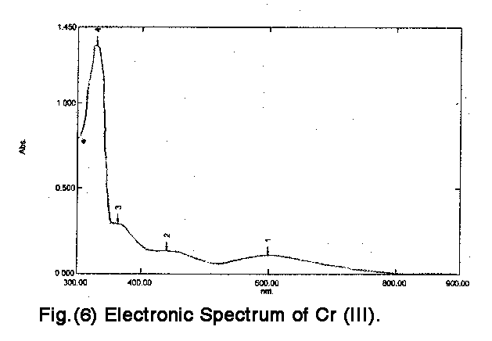

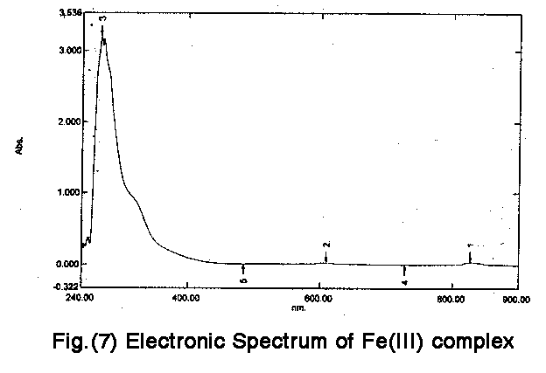

The u.v. light and the free radicals (R· ) generated effectively initiating the photodegredation of the poly ( vinyl chlorid) as :-

K [ Cr (L)₂ Cl₂ ] hυ K⁺ + [Cr^{III} (L)₂ Cl₂ ]

Redox.
Cl + [Cr^{II} (L)₂ Cl ]

or [ Cr^{III} (L)₂ Cl₂ ]⁻ [Cr (L)₂ Cl₂ ] + L⁻

The radicals Cl or R will abstract hydrogen atom from P.V.C chain and this reaction is leading to degradation of P.V.C as follow :

Scheme (2 ): The proprosed mechanisim of photodegredation of P.V.C film with metal chelate.

The suggestcd mechanism of photo stabilization of P.V.C films by C₂ complex involves both interfernce with the propogation of the oxidative chain reaction and decomposition of the polymer hydroperoxide ⁽¹⁹⁾ .
As shown in figure (5), the growth of carbonyl index with irradiation time for P.V.C incorporated with metal chelate is more than P.V.C control , so there metal chelate might be considered as photostabilizer .
The φ_{cs} vales for P.V.C films in the presenes of Cr(III),and Fe(III)complexes are 0.5×10⁻⁵ and 0.70×10⁻⁵ respectively, are much less than that for control P.V.C films 1.5×10⁻⁵ .
The explaination of the low values of φ_{cs}, is that in alarge molecule of P.V.C ,the energy is absorbed at one site and their the electronic excitation is distributed over many bonds so that the probability of asingle bond breaking is small ,or the absorbed energy is dissipated by quenching reaction⁽²⁰⁾ .

References
- J.E.Guillet, Plast Eng., 1974, 30(8), 48.
- D.T.Turner, J.Polym. Sci. Polym. Chem. Ed., 1964, 2, 1699.
- P.Alexander. R.M.Black and A.Charlesby, Proc. Roy. Soc., (London),1955, A232,31.
- N.Grassie, Chemisty of High polymer Degredation Processes, Interscience, New York ( 1958) .
- B.Ranly and J.F.Rabek , Wiley , New York , 1973, 81.
- R.Chandra, B.P.Singh, S.Singh and S.P.Handa, polymer J., 1981, 22, 523.
- Y.Kato , D.J.Carlesson and M.J.wiles, Appl. polym SCI., 1969, 13,1447.
- J.E.Pohs, suppl., 1984, 654.
- Al-Jibouri M.N., Al-obaidi N. & A.H. Esmaeel, Diala Journal, 2004, 18, 87.
- Mahmuod N. Al-Jouburi, Ph.D. Thesis, Al-Mustansyreia University (2003).
- K.Sugita ,T.Klip and J.E.Guillet , J.Polym.Sci., 1975, A1,13, 483.
- Scott G. , Europ. Polym.J.suppl., 1976, 189
- A.F.Al-Niami ,Ph.D. Thesis,Al-Mustansiryah Univerisity ,College of Science ,May (1997)
- A.B.Lever ,"Inorganic Spectroscopy" ,Elsiever Company , London,New York ,(1968)
- B.N.Figgis, Interscience New York , 1966, 12.
- Mishra S. and chaturved: N , J.Indian Council Chem., 1994, 10,7.
- Ray R.K. and Hoffman G.R, Inorg. Chem. Acto, 1990, 173, 207.
- Singh P., Goel R.L and Singh B.P , J.Indian chem.Soc., 1975, 52,958.
- R.Chandra and S.P.Hamda , J.Appl.Polym.Sci., 1982, 27,1945.
- E.A. Yousif, Ph.D. Thesis, Al-Nahrain University, (2004), Baghdad , Iraq.

