Synthesis and Biological study of N-Cysteine Derivatives Via a Schiff Base

Kasim Mohammed Hello
Department of chemistry, Collage of Sciences, Al-Muthanna University

(NJC)

(Received on 11/11/2007) (Accepted for publication 24/3/2008)

Abstract
This work includes the synthesis of some derivatives of cysteine and the biological activity was investigated. The aromatic Schiff base which prepared from aniline and benzaldehyde was reacted with α-chloroacetic acid and with different acid halide in dry benzene to give benzyl chloride (Compounds : 2, 3, 4, 6) which were reacted with L&D-Cysteine to give N-α-N¯-cystylbenzyl-N-alkanilide. The last synthesized compounds were identified by melting points, UV-Visible, IR and ¹H-NMR spectrum. Thy were also tested against E.coli, Staphyllococus aureus, Klebsilla spp., Streptococcus pyogen, Listeria Moncytogen, Sallmonela typhi., Pseudoms aerugenosa and Brucella.
الخلاصة
في هذه الدراسة تم تحضير مشتقات جديدة للسيستين كما تم دراسة الفعالية البيولوجية للمركبات المحضرة . تضمنت الخطوة الأولى مفاعلة البنزالديهيد مع الانلين لتحضير قاعدة شف والتي صعدت مع أحماض وكلوريدات الأحماض الكربوكسيلية ( propionyl chloride, benzoyl chloride, Phenoxy chloride and α-chloro acetic acid ) لتحضير مشتقات كلوريدات البنزايل(6,4,3,2), بعدها حضرت مشتقات السيستين بتصعيد مشتقات كلوريدات البنزايل المحضرة مع السيستين . شخصت المركبات المحضرة بنقاط الانصهار وأطياف الأشعة فوق البنفسجية- المرئية وأطياف الأشعة تحت الحمراء وأطياف الرنين النووي المغناطيسي . كما تم فحص الفعالية البيولوجية للمركبات المحضرة تجاه بعض البكتريا والتي اظهر قسما منها مقاومه عالية تجاه بعض المركبات بينما أظهرت تحسسا عاليا تجاه المركبات الاخرى المحضرة .

Introduction
In 1810 Cysteine was discovered and known as a strong reducing agent, it can prevent oxidation of some other substances, it is found that too much Cysteine in a cell culture medium can inactivate the hormone insulin in the medium⁽¹⁾. Another study showed that L&D-cysteine reduced acetaldehyde to ethanol, the human blood was used as a medium for this reaction⁽²⁾. Clinical study on HIV-infection patients, found there are a decrease in plasma Cysteine and Glutathione levels, and the study suggested that N-acetyl cysteine is a good drug for treatment⁽³⁾.
Many kinds of benzyl chloride derivatives were prepared, structure formula are showing below, via Schiff's bases and show biological activity⁽⁴⁾

The treatment of phenoxyacetonyl chloride and amino acid with aromatic aldehyde gives the oxazolones⁽⁵⁾, structure formula are showing below , which play very vital role in manufacturing various biological active drugs as analgesic⁽⁶⁾, anti-inflammatory⁽⁷⁾, anti-depressant⁽⁸⁾, anti-cancer⁽⁹⁾, anti-microbial, anti-daibtic, and antiobesity⁽¹⁰⁾ ⁽¹¹⁾.

In our laboratory, we prepared a new type of N-Cystiene derivatives and the biological activity of those compounds was tested against eight types of bacteria .
Experiment
Melting points were determined by Stuart melting point apparatus and uncorrected. IR spectra were recorded on a Shimadzu FT-IR 8400S spectrophotometer in the range 4000 –400 cm⁻¹ using KBr discs. UV-Vis. spectra were recorded on Shimadzu 1665PC, in the range (190- 1000) nm, and it was used 10⁻³M solution of compounds in ethanol. The ¹H-NMR spectra were recorded on a Bruker 400 MHz in Baath university, Collage of Science in Syria, CDCl₃ was used as a solvent and TMS as an internal reference.
1- Synthesis of Schiff Base (1):
A mixture of 0.01mole (0.93 ml) of aniline , 0.01 mole (1.1ml) of benzaldehyde , 10 ml ethanol and one drop of glacial acetic acid were refluxed in a water bath for 30 min., then left to cool in a bath of ice-water, whereby yellowish white crystals separated out . The crystals were filtered, washed with 2% HCl, then with water and recryastallized from ethanol ^{(12,13)}. Yield (80%), m.p (49-50).
2- Synthesis of N-(α-chlorobenzyl)-N-(phenyl)glycine (2):
0.011 mole (1.03 ml) of α-chloroacetic acid was added to 0.011 mole (1.9g) N-benzilidenebenzeneamine (Schiff base) dissolved in 10 ml of dry benzene and the mixture was heated in water bath for 1 hr. The solvent was evaporated and the remaining green crystals were separated and recrystallized from ethanol⁽¹⁴⁾.
3- Synthesis of N-(α-chlorobenzyl)-N-(benz or prop)anilide (3,4):
0.011 mole of acid chloride( benzoyl chloride or propanoyl chloride ) was added to 0.011 mole (1.9g)of N-benzilidenebenzeneamine (Schiff base) dissolved in 10 ml of dry benzene and the mixture was refluxed with stirring in water bath for 45 min. The solvent was evaporated and the crystals were filtered and washed with 2% Na₂CO₃ solution, then with distilled water and recrystallized from ethanol-water⁽¹⁵⁾ (1:1).
4- Synthesis of Phenoxyacetic acid (5):
A solution of 10% sodium hydroxide (20 ml) was added slowly to 0.05 mol of phenol and (4.8g , 0.05mol) of α-chloroacetic acid. The mixture was heated with stirring until most of the solvent was evaporated. 100ml of distilled water was added, the precipitate was filtered off and recrystallized from ethanol⁽¹⁶⁾. See Fig. (1).
5- Synthesis of N-(α- chlorobenzyl)-N-phenoxyacetanilide(6):
A mixture of phenoxyacetic acid (5) 0.013mol (2g), thionyl chloride 0.013 mol (0.94ml) and two drops of DMF were heated gently for 30 min. then cooled in ice bath, then 0.026mol (4.76g) from Schiff bases (1) in 5 ml DMF was added. The mixture was refluxed for 15 min. then left to cool in a bath of ice-water, the crystals that separated out where filtered, and washed with 2% NaHCO₃, then with water and recryastallized from ethanol-water (1:1).
6- Synthesis of N-α-(N¯-cystylbenzyl)-N-alkanilide (7,8,9,10):-
A mixture of (0.0018mol) acid halide(2,3,4 or 6), (0.0018mol) L-Cysteine, and 25ml DMF, was refluxed with stirring in oil bath for 4 hrs., then left to cool in a bath of ice-water, a few drops of distilled water were added, the crystal was separated out, and filtered, washed with 2% Na₂CO₃ , then with distilled water, and recrystallized from DMF.
Biological Test:- Bacteria strain
All of bacteria strain was obtained from biology department, collage of Sciences, Al-Muthanna University. The bacteria cultured in nutrient Moller- Hanten agar at 37 Cº, (0.5 ml ) of each bacteria was separated over surface of Moller- Hanten agar⁽⁹⁾
Antibacterial activity :
Disc of filter paper ( 6mm ) was sterilized at 140 Cº for 1 hr. and impregnated with (1 ml) of a concentration ( 10 , 1, 0.1 , 0.01 ) mg\ml of solution of each compounds and then dried, dry dimethylsulphoxid (DMSO) was used as a solvent for all compounds and blank disc, of DMSO was used as a control. The inoculated plate was incubated at 37 Cº for 24 hrs., and the inhibition zones were measured in all experiments, the mean of each triplicate was measured^{(17, 18)} . All data listed in table (3).
Results and Discussion
Aniline reacted with benzaldehyde in boiling ethanol to give Schiff bases (1), the reaction is usually catalyzed by a drop of glacial acetic acid^{(12,13,19,20)}.The IR absorption spectra of Schiff base showed the absence of two absorption bands due to NH₂ stretching of aniline, and C=O absorption band at 1700 cm⁻¹ of benzaldehyde, and appearance of C=N absorption band at 1630 cm⁻¹ in its IR spectra.
Aromatic Schiff base (1) reacted with α-chloroacetic acid to give N-(α-chlorobezyl)-N-(phenyl)glycine⁽¹⁴⁾ (2) and reacted with benzoyl chloride to give N-(α-chlorobenzyl)-N-benzanilide (3), and reacted with propinoyl chloride to give N-(α-chlorobenzyl)-N-propanilide (4), and reacted with phenoxyacetnoyl chloride to give N-(α-chlorobenzyl)-N-phenoxyacetanilide (6). The reaction is indicated by disappearance of C=N absorption band at about 1630 cm⁻¹, and appearance of a OH absorption band at about 3450 cm⁻¹ (in compound 2), appearance of C=O absorption band at (1650, 1660, 1670,1700)cm⁻¹ sequinetly for the compounds (2,3,4, 6), in addition to appearance of C-Cl absorption bands in their IR spectra. See table (2).
The compounds (2,3,4,6) as their name indicates are benzyl chloride and expected to be relatively reactive toward nucleophilies⁽²¹⁾. In fact, they react with L-cystiene in DMF to give compounds (7, 8, 9& 10). The reaction is followed by disappearance of the C-Cl absorption band and appearance both of N-H absorption and OH absorption in their IR spectra see table (2) .
The UV-Visible spectra give absorption band at different wave length for the result prepared compounds ( in ethanol) due to( n - π* ) and (π - π* ) transitions and all these transition are listed in Table⁽²²⁾ (1).
The ¹H-NMR spectra of the synthesized (2&7) in CDCl₃ are listed in Table 1, in the ¹H-NMR spectra of these compounds the appearance of (NH and SH ) protons in figure (4) established that the cysteine molecule connected with the structure. See fig. 3, 4.
All bacteria show higher sensitivity against compound 10 and 9, Streptococcus pyogen show resistance against 9. While all bacteria show resistance against compounds 7 & 8 except Listeria Moncytogen, Sallmonela & Ps. Aerugenosa showed sensitivity against compound 8. The anti bacteria activity diameter of inhibition zone are listed in Table (3).

Table (1) Melting points, Yield, UV-Visible and ¹H-NMR spectra for the synthesized compounds.
Comp. No. | R | m.p Cº | Yield % | λmax (nm) | ¹H-NMR  δ(ppm)
2 | -CH₂COOH | 120-122 | 70 | 350,420 | 1.1(s,2H,-CH₂), 4.3(s,1H,-CHCl), 7-8 (m,8H,Armoatics), 10(s,1H,OH).
3 | -COC₆H₅ | 150-152 | 75.8 | 325, 400 | -
4 | -COCH₂CH₃ | 99-101 | 61.5 | 380 | -
6 | -COCH₂OC₆H₅ | 225-230 | 55.1 | 217,309,393,422,599 | -
7 | -CH₂COOH | 62-64 | 72.1 | 360,380,595 | 1.2(q,1H,CH₂), 2.9(d,2H,CH), 7.3(s,10H,C₆H₅) 8.2(t,1H,NH), 10.1(s,2H,OH), 11.9(t,1H,SH).
8 | -COC₆H₅ | 132-134 | 33.3 | 227, 340, 570 | -
9 | -COCH₂CH₃ | 76-80 | 45.7 | 219, 330, 610 | -
10 | -COCH₂OC₆H₅ | 45-47 | 41.6 | 315,400,620 | -

Table (2) υ (cm⁻¹) of IR spectra results of the function groups for the synthesized compounds of (1-10) in KBr discs.
Comp. No. | OH  Str. | NH  Str. | C-H  Aromatc  Str. | C=O  I  Str. | C=O  II  Str. | C=N  Str. | C=C  Str. | C-Cl  Str.
1 | - | - | 3190 | - | - | 1630 | 1585 – 1480 | -
2 | 3400 | - | 3100 | 1650 | - |  | 1590 – 1485 | 700
3 | - | - | 3100 | 1660 | - | - | 1600-1500 | 800
4 | - | - | 3160 | 1670 | - | - | 1600–1500 | 750
6 | - | - | 3100 | 1700 | - | - | 1600–1500 | 700
7 | 3500-3400 | 3190 | 3180 | 1710 | 1650 | - | 1610-1500 | -
8 | 3400 | 3200 | 3120 | 1710 | 1690 | - | 1600–1500 | -
9 | 3500 | 3250 | 3100 | 1700 | 1650 | - | 1510- 1605 | -
10 | 3400 | 3300 | 3090 | 1750 | 1690 | - | 1600–1500 | -
Str.= Stretching, I for CO amide, II for CO acid
Table (3) Antimicrobial activity in millimeter of inhibition zone of compounds (7-10).
Type of Bacteria | Comp.No. 7 | Comp. No. 8 | Comp.No. 9 | Comp. No.10
The Concentrations | 10/1/0.1/0.01  mg/ml | 10/1/0.1/0.01  mg/ml | 10/1/0.1/0.01  mg/ml | 10/1/0.1/0.01 mg/ml
E.Coli | -/-/-/- | 6.8/-/-/- | 8/6.8 /5/- | 12.6/12/10/8
Staph aureus | -/-/-/- | 7.2/-/-/- | 8.3/4.5/-/- | 9/8.8/7/6.5
Klebsilla spp | -/-/-/- | -/-/-/- | 9.7/8.8/8.5/8 | 11/10.9/10/8
Listeria Moncytogen | -/-/-/- | 8.8/7.1/6.8/- | 10.4/6.6/6/6 | 13/12/10/7
Streptococcus pyogen | -/-/-/- | -/-/-/- | -/-/-/- | 8/7.8/7/6
Sallmonela | -/-/-/- | 8/7..7 /7.4 /7 | 9.9/9/8.9/8 | 11/7/6.5 /6
Ps. aerugenosa | -/-/-/- | 8.2/7.4/6.5/6.3 | 7.6 /7/6.9 /6 | 8.9/8/7.7/6
Brucella | *-/-/-/- | -/-/-/- | -/-/-/- | 9.8/6.7 /5.9/-
* -/-/-/- = No effect.

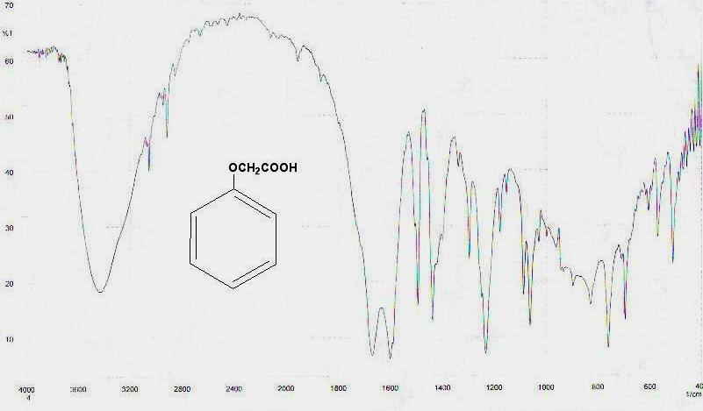

Fig. (1) the IR spectrum for the compound (5) in KBr disc.

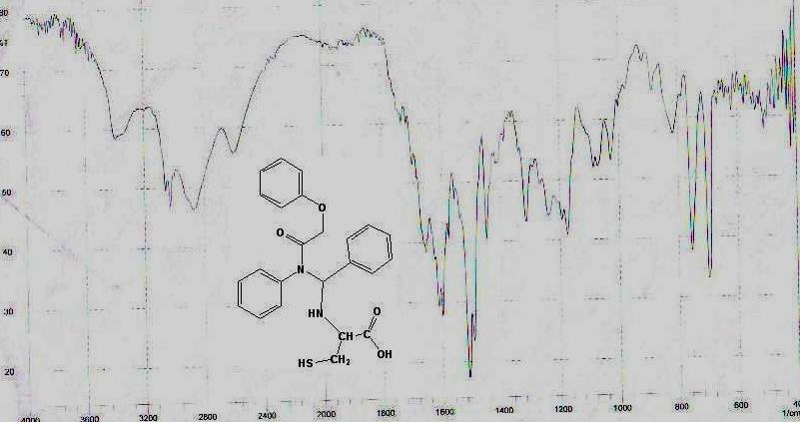

Fig. (2) the IR spectrum for the compound (10) in KBr disc.
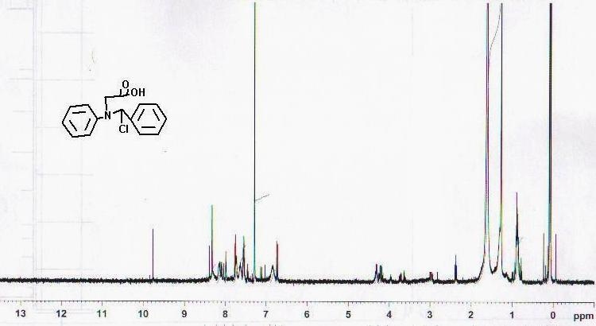

Fig. (3) the HNMR of compound 2 in CDCl₃

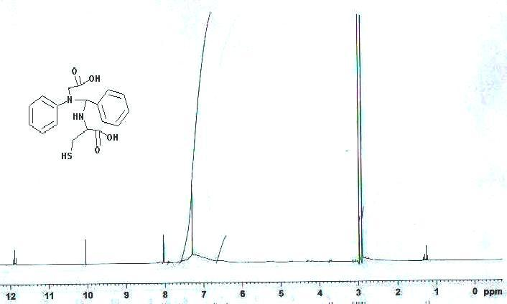

Fig. (4) the HNMR of compound 7 in CDCl₃

The Scheme below show all reactions in this work:-

References
1. Internet Reference: Anti-Aging News, Vol.2, No.1, 1982, 6-7.
- Internet Reference:Arukoru Kenkyuto Yakubutsu Ison (japan),25,5, 1990, 40.
- Internet Reference: Aids Forschung (Germany), 7, 4, 1992, 197-199.
- K.M. Hello, R.J. Nahi, H.H. Mitab, Al-Qadissya J. for medicine Sci., 2006, 5, 2, 21.
- M.J. Agalawe, S.S. Dhule, S.S. Bahekar, P.S. Wakte and D.B.Shinde, Journal of The Korean Chemical Society, 2003, 47, 2, 133.
- H. L. Aichaw, EUR PAT , 390, 673, 03 OCT 1990; Chem. Abstr., 1991,114, 143.
- K. Ando, N.Asai, EUR PAT, 385, 664, 05 SEPT 1990.
- P. Descas, C. Jarry, EUR PAT, 392, 929, 17 OCT 1990 Chem. Abstr.,1991,114, 143.
- D. Benedlt, V. Daniel, J. Med. Chem., 1994, 37, 710.
- E.R Pereira, M. Sancelme, A. Voldoire and M. Prudhomme, Bio-Org, Med- Chem. Lit. 1997, 7(190), 2503.
- G. Viti, R. Namnicine, R Ricci, V. Pestelline L. Abeli and M. Funo, Eur. J. Med. Chem. , 1994, 29,401.
- H.Schiff,Ann; 1864,131,118.
- S. Patai "The Chemistry of The Carbon- Nitrogen Double Bond, John Wiley and Sons, New York, 1970, 68.
- K.M. Hello, National J. of Chem., 2006, 24, 620.
- K.M. Hello, T. A. Musa and K. J. Al-Adeily, Al-Qadissia J. for Pure Sci., 2006, 11, 1.
- B.V. Smith and N. M. Waldron, Vogel's Elementary Practical Organic Chemistry, (1980).
- L.P. Garrod, H.P. Lambert, D. Grady and P. Water-worth, Antibiotic and Chemotherapy, 5th ed., Churchil Livingston , N.Y., (1981).
- H.W. Seely, Jr.P.J. Vandemerk, Microles in Action, 3rd ed., Freeman and Company, (1981).
- M. Scholz, A. Schumke, and M.G. Numchstolt, J. Chem., 1962, 2,309.
- S.N.Z. Paddar, Anorg. Chem., 1963, 322,326.
- R.G. Hiskey and G.M. Gung, J. Am. Chem. Soc., 1963, 85, 578.
- A.A Saeed, and M.J. Habib, J. Iraqi Chem. Soc., 1987, 12, 2, 271.

