Studying of Photodegradation of Prepared Azo-dyes by TiO₂
Abbas A. A. Kadhum
Chem. Dept. College of Education, Univ. of AL – Qadisiya

(NJC)

(Received on 25/10/2007) (Accepted for publication 24/3/2008)

Abstract
The work consists of two parts . The first deals with the preparation of some mono azo dyes : 4- phenyl azo – α – fluoro phenol (BAFP) , 4 – phenyl azo – α – chloro benzoic acid(BACB) , 4- phenyl azo – α – methyl phenol (BAMP ) . The prepared compounds have been identified by FT-IR ,and UV-Visible absorption spectroscopy .
The second part consists of photodegradation of the azo compounds mentioned above at lab temperature in presence and absence of titanium dioxide (anatase ) as suspension by exposure of aqueous solution of dyes using light from a 150 w lamp with wavelength 350-800 nm. Generally it has been found that the rates of photodegradation of three dyes were higher in presence of TiO₂ suspention .
In this paper some physicochemical properties of the dyes , such as the electron – donor or electron – withdrawing character of dyes have been employed to asses their photodegradability.The results of photodegradation of all dyes illustrate that the rate of the degradation process depends on the conc. Of TiO₂ , and physicochemical properties of the dyes .
الخلاصة
يشتمل البحث علي جزئيين , الأول يتضمن تحضير ثلاث أصباغ ازو أحادية وهي 4- فنيل ازو –ألفا – فلو رو فينول , 4- فنيل ازو –ألفا –كلورو فينول و 4- فنيل ازو –ألفا –مثيل فينول .تم تشخيص الأصباغ المحضرة بواسطة مطافية الأشعة تحت الحمراء وكذلك سجلت أطياف الأشعة المرئية والفوق البنفسجية .
تضمن الجزء الثاني من البحث دراسة التحطم الضوئي للأصباغ المحضرة وفي درجة حرارة المختبر بوجود وغياب ثاني اوكسيد التيتانيوم واستخدام مصباح من الضوء المرئي .وجد وبصورة عامة أن سرعة الأكسدة الضوئية بوجود ثاني اوكسيد التيتانيوم اعلي منها في حالة غيابه ولجميع الأصباغ . تضمن البحث أيضا دراسة تأثير بعض الخواص الفيزاوية والكيماوية مثل المجاميع الدافعة والساحبة
للالكترونات في سرعة تحطم الأصباغ . توضح النتائج بان سرعة تحطم الأصباغ تعتمد علي تراكيز كل من الصبغة ,ثاني اوكسيد التيتانيوم وكذلك الخواص الفيزياويئة للأصباغ .

Introduction
In the present work we prepared three azo – dyes , which are different in the electronegativity of their substituents in the aromatic ring . Generally , many studies show clearly that the efficiency of a photocatalytic for the degradation of organic and inorganic compounds is strongly dependent on their chemical nature of the dye ⁽¹⁻ ⁴⁾.TiO₂ catalyst can not absorb visible light and only makes use of 3-5 % of the solar beam that can reach the earth necessitating the utilization of an ultraviolet light source . It is necessary to develop a photo catalytic system which can be applied under visible and / or solar light irradiation ^{(5,6)} .TiO₂ photocatalyst initiates upon absorbing UV photons with generation conduction band (CB) electron and valence band (VB) holes within the particle .The hydroxyl radicals in particular , generated through the reaction of VB holes account for the strong oxidizing power of the TiO₂ photocatalytic system .
Although TiO₂ has been widely used as a photocatalyst , the bandgap excitation of TiO₂ proceeds only in the presence of UV light (λ < 388 nm) . Sensitized TiO₂ by ruthenium-based complexes or various dyes ⁽⁷⁻¹¹⁾ has been extensively investigated in order to extend the spectral response into the visible region .The dye/TiO₂/visible light system where the system serves as both a sensitizer and a substrate to be degraded could develop into a viable technology for treating dye-polluted wastewaters .
Experimental.
Materials
All reagents were from commercial sources and were used without further purification. Hydrochloric acid , 2- amino benzoic acid , o-chloro phenol , o- fluoro phenol , o- methyl phenol and ethanol were supplied by BDH. Titanium dioxide ( TiO₂) Degussa –P25 mainly anatase 70 %with surface area of 55m²/g and mean size of 22035 nm ⁽¹²⁾ .
Synthesis .
All dyes were prepared by general coupling reaction method using equimolar quantities⁽¹²⁾ , the dyes products were filtrated and washed with cold distilled water for several times and purified by chromatography on a silica column ( pentane/EtOAc 3:3:1 ) and then recrystallised from EtOH/H₂O to yield 4-(2-benzoic acid azo )-2-fluoro phenol (BAFP) as yellow-orange crystals ,m.p.199-202 º C ,UV-Vis λmax ( 350 ) nm ; 4-(2-benzoic acid azo ) -2-chloro phenol(BACB) as brownish –orange crystals 185-188 º C ; UV – Vis λmax ( 357 nm ) ; 4-(2- benzoic acid azo )-2-methel phenol (BAMP ) as yellow crystals , m.p. 155-159 º C ;UV-Vis λmax (384 nm ) . Fig.1, shows the scheme structural formula of dyes .
Photodegradation experiments .
The photocatalytic experiments were performed by irradiating the aqueous solution of dyes by using 50 ml Pyrex cell. The radiation source was a OSRAM lamp , the emitted spectrum between 350- 800 nm . Sample for kinetic study were taken from reactor by syringe through the reaction .The solution were magnetically stirred during irradiation .The quantity of degraded dye was estimated in the λmax of dye using shemadzu UV spectrophotometer .
Spectroscopic measurements .
FT-IR spectra of prepared dyes were recorded on Shimadzu FT-IR 84005 spectrophotometer using KBr disk in the range 400-4000 cm⁻¹.UV –Visible absorption spectra for aqueous solution of dyes (1x 10 ⁻⁴ M )were obtained by shemadzu UV-Visible1650pcspectrophotometer. .

Fig . 1. Chemical structure for azo dyes .

Results and discussion
Direct photolysis essay .
for 6 h of irradiation , no direct photodegradation was observed for the three dyes because the molar absorptivities are very low at the radiation wavelength range used . Consequently , there is no place to a possible photoalteration process of the molecules . Thus , degradation of these dyes is exclusively due to photoactivation of the TiO₂ catalyst .
Photo assisted catalyse via TiO₂ .
Effect of TiO₂ concentration
To optimize the concentration of TiO₂ needed for the highest degradation rate the following quantities were used starting from 0.1 to 5.0gl⁻¹ depending on the nature of the compounds ^{(14,15)} .The most efficient TiO₂ concentration is not the same for all compounds .Above 2.5 g l⁻¹ of TiO₂ the initial rate of dyes oxidation is negatively affected by the progressive increase of TiO₂ . This observation may be due to the aggregation of TiO₂ particles at high concentration , causing a decrease in the number of surface active sites . Several authors ⁽¹⁶⁻¹⁸⁾ related this observation to the light scattering and consequent reduction in light penetration through the solution induced by lightproof suspended catalyst . According to Fig. 2, shows a plot of the initial reaction rate ( R₀ ) as a function of the catalyst concentration for the three dyes .It can be observed that the initial degradation rate increases proportionally toTiO₂ concentration .The degradation rate appears at TiO₂ concentration of around 2.0 g l⁻¹ in the case of BAMP and BAFP , and at values of around 2.5 g l⁻¹ in the case of BACP .To study the Photodegradation rates of different compounds have to be compared using the same optimal TiO₂ concentration for each substrate .For this reason , according to Fig. 2, a TiO₂ concentration of 2.0 g l⁻¹ was used in this study .

Fig. 2. Effect of TiO₂ concentration on the initial degradation rates of dyes .

Effect of initial dyes concentration.
Different dyes concentrations were used ranging from 5 x 10⁻⁴ to 5 x 10⁻³ M and 2.0 g l⁻¹ of TiO₂ at ( pH=7.2 ) as a function of time .It was found that the best degradation was obtained with 0.0029 M (Fig. 3,4,and 5 ) .The degradation efficiency increased with decreasing concentration of dyes .It seems that degradation reaches a saturation limit at high concentration of the reactant .

Fig. 3. Photodegradation of BAMP as a function of time in presence of 2.0 g L⁻¹ of TiO₂ for various initial concentration of BAMP .

Fig. 4. Photodegradation of BAFP as a function of time in presence of 2.0 g L⁻¹ of TiO₂ for various initial concentration of BAFP.

Fig. 5. Photodegradation of BACP as a function of time in presence of 2.0 g L⁻¹ of TiO₂ for various initial concentration of BACP .

Effect of time .
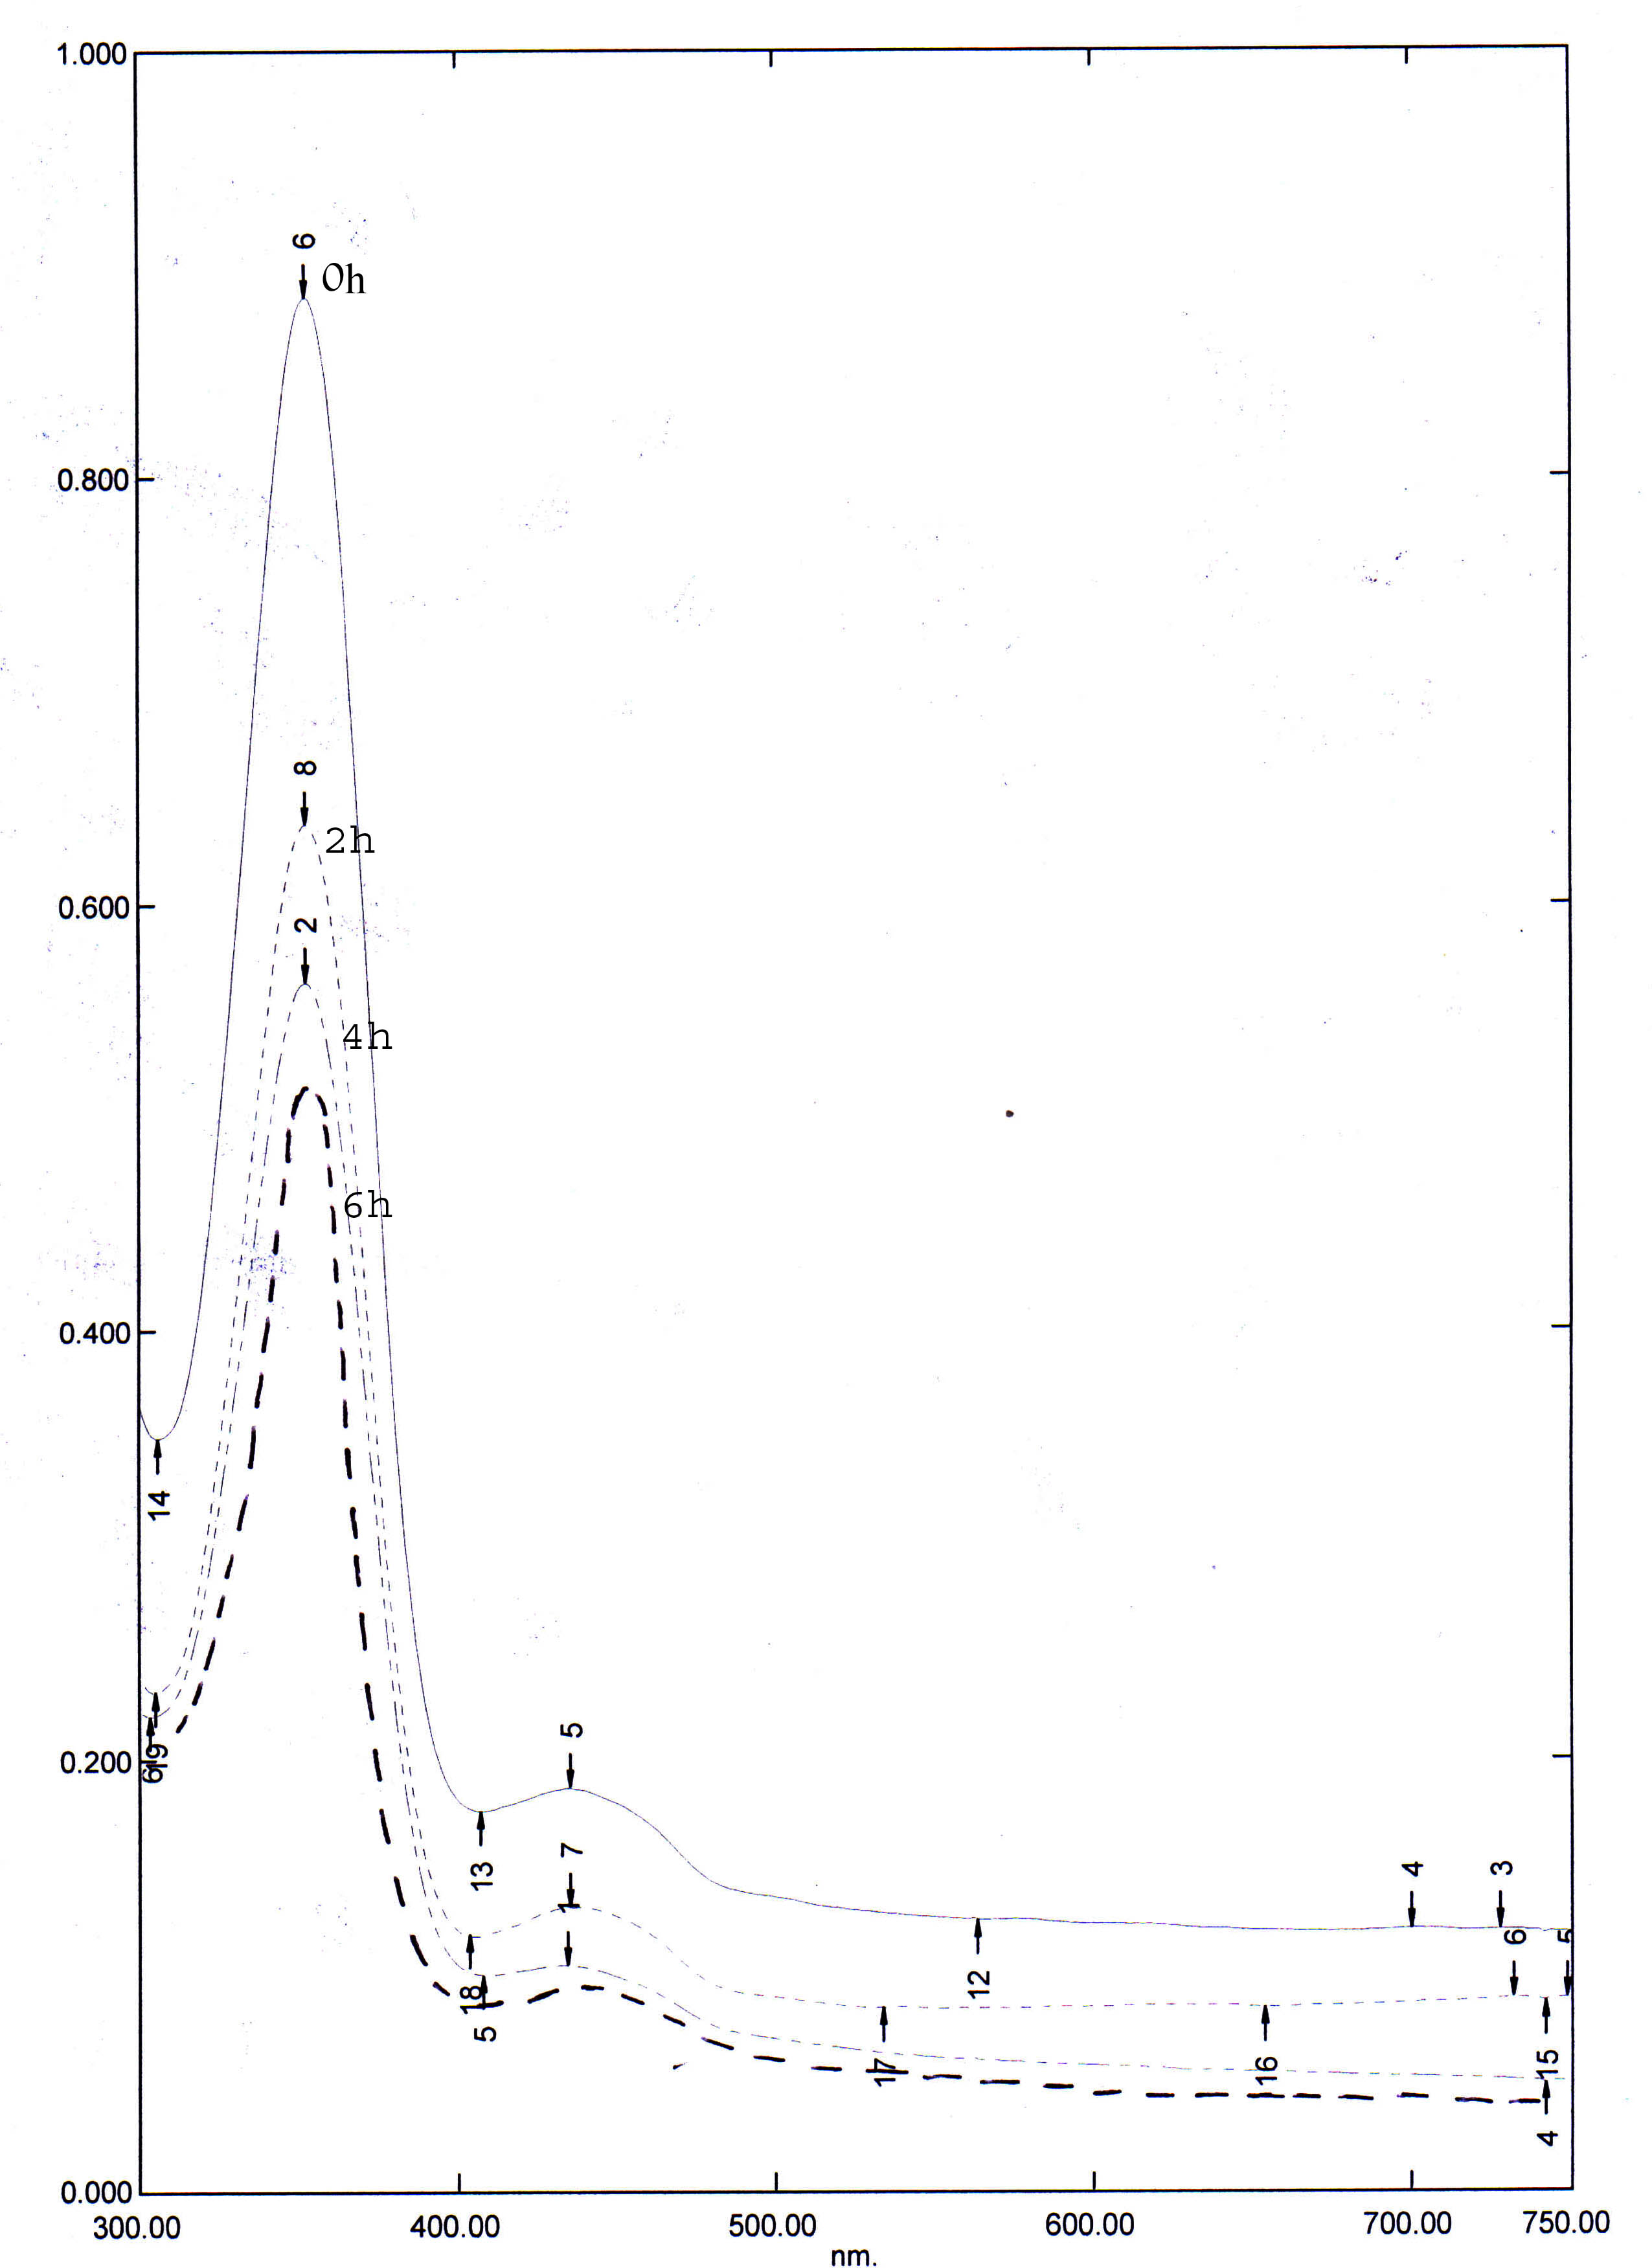
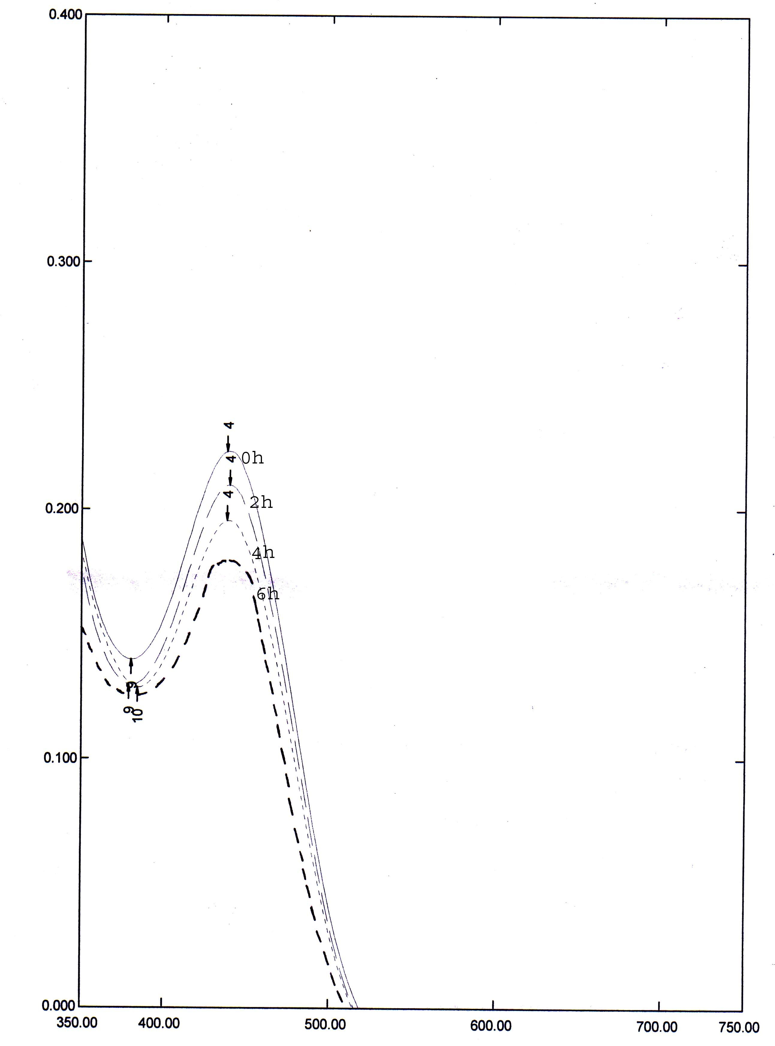
It is interesting to note from Fig. 6 , that the absorption of the visible band at λmax of all dyes decreased with the time (0,2,4,6 h) but with BAMP , it becomes greater . This trend suggests that the dyes start to degrade with time .
Abs
Abs
λ nm
λ nm

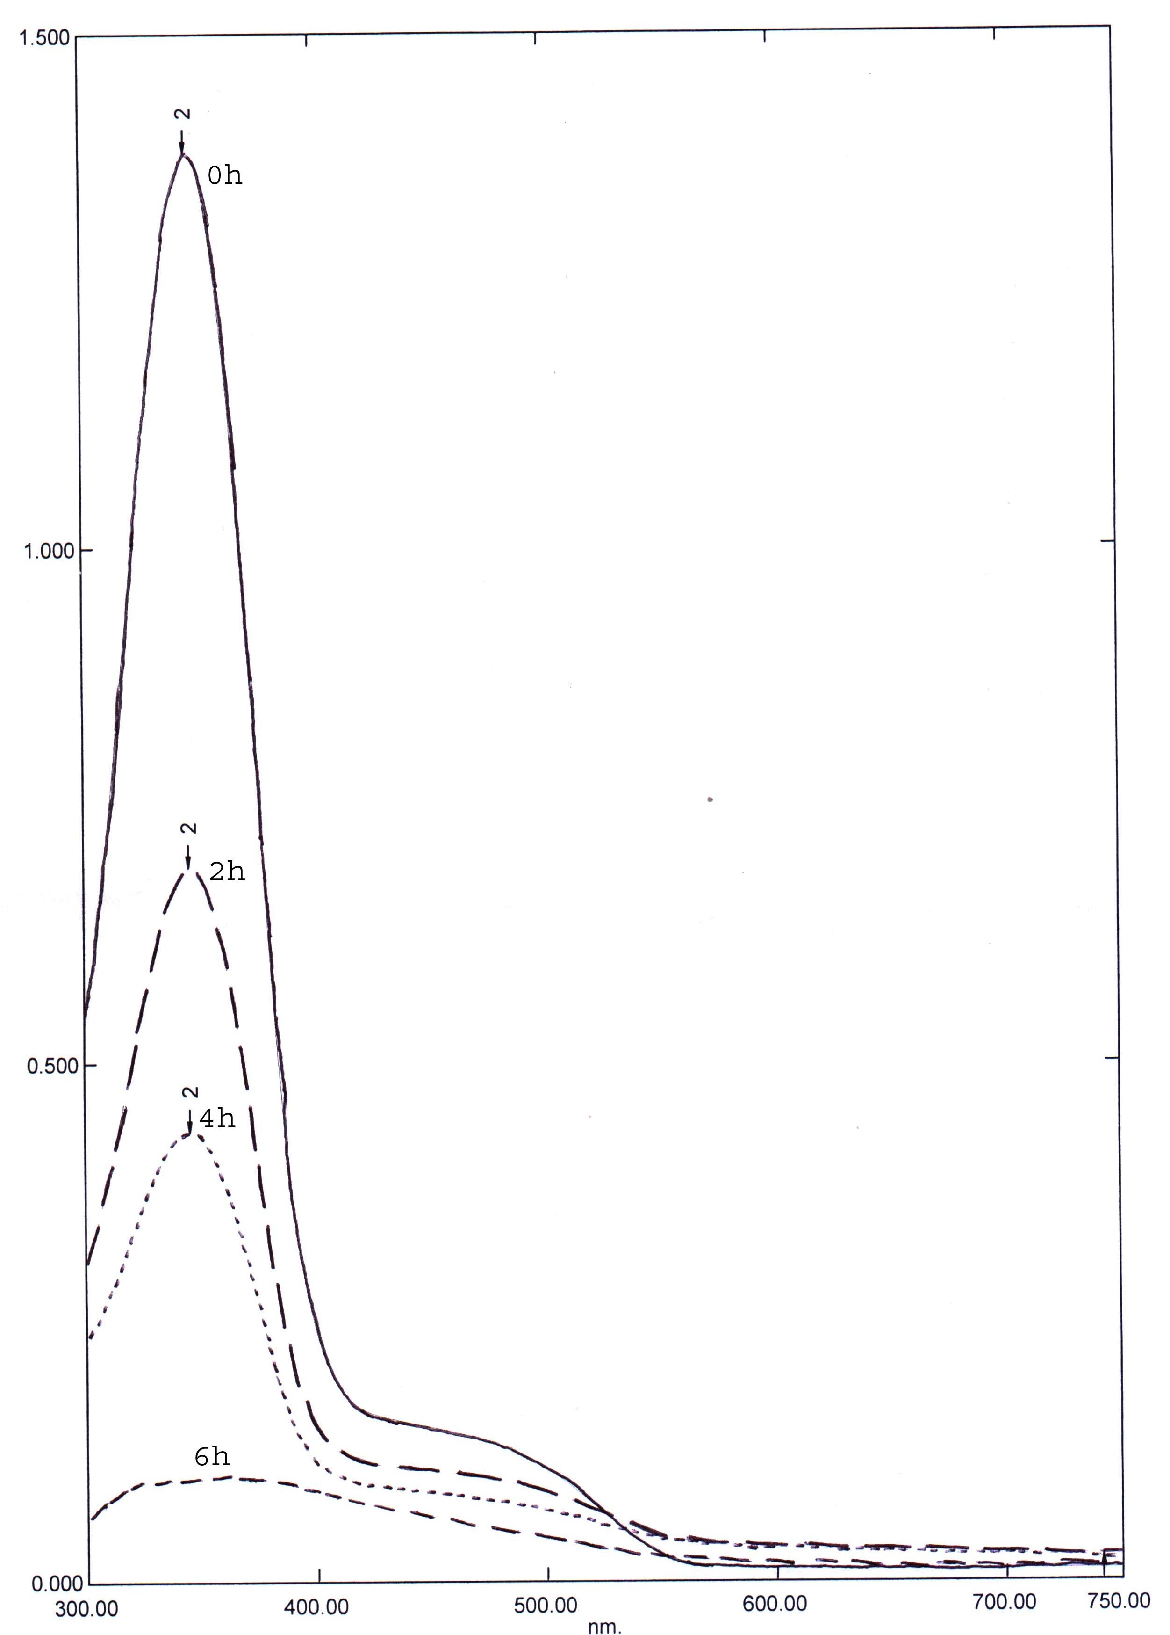
BACP BAFP
Abs
λ nm

BAMP
Fig. 6. Absorption spectra for irradiated of dyes at different time.

Influence of physicochemical properties of dyes on their photodegradability.
The differences in photoreactivity discussed in the precedent section suggest that ( R₀ ) is directly related to the electron-donor or electron-withdrawing character of the different substituents in the dyes aromatic ring , which can activate or deactivate the ring with respect to electrophilic attack of the OH˙ radical . This radical is very reactive in the oxidation of organic substances and is generated when the TiO₂ powder suspended in water , which is irradiated with near UV at λ < 385 nm ⁽¹⁹⁻²¹⁾ .To explain these results , only the effect of substituents in positions 2 , Fig.1, is taken into account since the substituent in other positions are similar in all cases .
4-(2- benzoic acid azo )-2- methyl phenol was the most reactive substance due to the presence of the CH₃ group which had a greater electron donor ability ( inductive effect of the methyl group ) ⁽²²⁾ , which is benzene ring activating , and to the absence of halogen substituents Fig. 1, . The other dyes contain halogen atoms which are considered as deactivating.
Comparison of the photocatalytic degradation of the three dyes .
Fig. 7, shows the kinetics of disappearance, as a function of time, of illuminated dyes with an initial concentration 2.0 g l⁻¹ of TiO₂ . The curves behave as an apparent first order process as confirmed by the linear transform shown in the figure .The total photodegradation of dyes was reached in approximately 1 h (BAMP ) and 2 h for (BAFP) and (BACB).
The initial degradation rates (R₀ ) and the apparent first order rate constants (K_{app} ) for the three dyes are presented in Table 1 .

Table 1, Initial degradation rates (R₀ ) and apparent first order rate constants (K_{app} ) for the abatement of the three dyes .
Abs

K_{app} (h⁻¹) | R₀ (mmol l⁻¹ h⁻¹) | Dyes
4.69 | 0.28 | BAFP
1.8 | 0.16 | BACP
1.41 | 0.12 | BAMP

Fig. 7. Photodegradation of dyes solution (0.0029 M) as a function of time in presence of TiO₂ ( 2.0 g l ⁻¹ ) .

Conclusions
The photodegradation rate of the studied dyes is affected by the TiO₂ concentration . The photpdgradation order found for the three dyes ( BAMP >> BACP ,BAFP ) suggests that their photoreactivity is directly related to the donor or withdrawing effect induced by the different substituents on the aromatic ring.

References
1- J. He, J.Zhao , T. Shen , H. Hidaka ,and N. Serpone , J. Phys. Chem. B , 9027 , 101 ,
1997 .
2- J. Hodak, C. Quinteros , M.I.Litter , and E.San Roman , J.Chem. Soc. , Faraday
Trans . , 5081, 92 , 1996 .
3- E. San Roman , J. A.Navio , and M.I.Litter , J. Adv. Oxid. Technol. , 261 , 3 , 1998 .
4-D. Bockelmann , M. Lindner , and D. Bahnemann , in:E. Pelizetti (Ed.) , Fine Particles
Science and Technology , NATO-ASI Series 3 , High Technology , 675 , 12 , 1996 .
5-K. Sayama , and H. Arakawa , J. Chem. Soc. , Faraday Trans . , 1647, 93 , 1997 .
6-A. Kudo , and M. Sekizawa , Chem. Commun. 1371 , 2000 .
7- A. Hagfeldt , and M. Gratzel , Chem. Rev. , 671 , 93 , 1995 .
8- N. J. Cherepy , G. P. Smestad , m. Gratzel, and J.Z.Zhang , J. Phys. Chem. B ,9342 ,
101 ,1997.
9- A. Kay, R. Hamphry-Baker , and M. Gratzel, J. Phys. Chem. , 952 , 98 , 1994 .
10-B. Patrick , and P.V. Kamat , J. Phys. Chem., 1423 , 96 , 1992 .
11-Y. Cho. , W.Chi , C.H.Lee , T.Hyeon , and H.I.Lee , Environ. Sci. Technol. , 966 ,
35 , 2001 .
12- I. Vogel , “ A Text book of practical organic chemistry’’ , 3rd ed. , Longmans , Green and
Co.Ltd.London , pp.622-623 , 1964 .
13- n. Serpone ,EPA Newsletter , 5 , 59 , 1997 .
14- J. Gimenez, and D. Curco, M.A. Queral, Catal. Today , 229, 54 , 1999 .
15- D. Chen , and A.K.Ray , Appl. Catal. B:Environ . ,143, 23 ,1999 .
16- J. Bandara, J. Kiwi, R. Humphry-Baker, C. Pulgarin, J. Adv. Oxid. Technol. , 162 ,
1 , 1996 .
17 – L. Le campion , and C. Giannotti , J. Ouazzani, Chemosphere , 1561, 38 , 1999 .
18- Y. Inel , and A.N. Okte, J. Photochem . Photobiol. A:Chem. , 175 ,96 , 1996 .
19- S. Parra, V.Sarria, S. Malato, P. Peringer, and C. Pulgarin , Appl.Catal. B:Environ.,
153, 27 , 2000 .
20- P. F. Schwarz , and J . N. Turro , J. Phys. Chem. B , 7127 , 101 , 1997 .
21-M .R .Hoffmann , S .T . Martin , W . Choi , Chem. Rev . 69-96 , 95 , 1995 .
22- A . Bahl , B . S. Bahl , Advanced organic chemistry , sixth edition , 2004 .

