Quantum Chemical Study on some substituted thiourea as corrosion inhibition for aluminum

Qhatan Adnan Yousif
Department of Chemistry, Al-Qadisiya University – College of Education

(NJC)

(Received on 18/11/2007 ) (Accepted for publication on 13/ 4/2008)

Abstract
The present work involved use the computational molecular modeling that it dependent on the semi-empirical methods such as MINDO/3 , MNDO , AM1 and PM3 to study the quantum chemical for some substituted thiourea that it used as corrosion inhibitor for aluminum in nitric acid were carried out in gaseous and aqueous phase .
The possible correlations between experimentally obtained efficiencies and calculated highest occupied molecular orbital energy level (E_{HOMO}) , lowest unoccupied molecular energy level (E_{LUMO}) and the difference between highest occupied molecular orbital (HOMO) and lowest unoccupied molecular orbital (LUMO) were studied . Correlation between inhibition efficiencies and charges on nitrogen and sulfur atoms were also investigated .
Regression analysis were fulfilled for all quantum parameters and protection efficiencies that it introduced in this research .
الخلاصة
تضم هذا البحث استعمال برمجيات النمذجة الجزيئية المعتمدة على الطرق الشبة التجريبية والمتمثلة بتقريب الإهمال المتوسط المعدل على التداخل التفاضلي الأنموذج الثالث (MINDO/3) ، الإهمال المعدل للتداخل ثنائي الذرة (MNDO) ، أنموذج اوستن (AM1)و تقريب إدخال المعاملات لأنموذج MNDO/3 (PM3) للدراسة الكمية لمعوضات الثايوريا والمستخدمة كمثبطات لتآكل الألمنيوم في حامض النتريك المنفذة في الطورين الغازي و السائل .
أيجاد الترابط الممكن بين كفاءة التثبيط للمادة المثبطة مع التركيب الجزيئي من خلال حساب طاقة أعلى مدار جزيئي مشغول و أوطأ مدار جزيئي غير مشغول إضافةً إلى حساب طاقة الفجوة بين المداريين . أيضا، تم إيجاد ودراسة الترابط بين كفاءة التثبيط مع الشحنات الموجودة على ذرات النتروجين والكبريت .
تحليل الانحدار أنجَز لكل المعاملات الكمية ولكفاءات التثبيط لمثبطات التآكل المدروسة في هذا البحث .

Introduction
Corrosion is the destructive attack of metal or alloy by chemical or electrochemical reaction with it's environment . Aqueous solutions of acids are among the most corrosive media . The rate at which metals are destroyed in acidic media is very high , especially when soluble corrosion products are formed ⁽¹⁾ . The corrosion process consists of a set redox reaction which are electrochemical in nature . Thus , the metal is oxidized to corrosion products at anodic sites and some species are reduced at cathodic sites ⁽²⁾. Addition of inhibitors remains one of the necessary procedures used to protect metals and alloys against attack in many industrial environments . Therefore , the development of corrosion inhibitors based on organic compounds containing nitrogen , sulfur and oxygen atoms are of growing interest in the field of corrosion and industrial chemistries as corrosion poses a serious problem to the service life time of alloys used in industry ⁽³⁾. Recently , quantitative structure activity relationship (QSAR) has been a subject of intense interest in many disciplines of chemistry . The development of semi-empirical quantum chemical calculations emphasizes the scientific approaches involved in the selection of inhibitors by correlating the experimental data with quantum-chemical properties . The highest occupied molecular orbital ( HOMO ) , lowest unoccupied molecular orbital (LUMO ) , charges on reactive center , dipole moment ( μ ) and conformations of molecules have been used to achieve the appropriate correlations ⁽³⁻⁵⁾ . The application of (QSAR) in corrosion research was reported by several authors ⁽⁶⁻¹¹⁾ . The present paper is concerned with a theoretical investigation of the inhibition efficiency of some substituted thioureas of aluminum using molecular orbital calculations
Methods of Calculation
Quantum chemistry uses a variety of approaches to approximate the solution of the Schrödinger equation for the system of interest . Semi-empirical methods , as the name suggests , use some parameters derived from experimental work and deal only with valence electrons . Within these two broad divisions there are many different methods which vary in the approximations made , the computational effort involved and the accuracy of the results . Semi-empirical calculations are generally several orders of magnitude faster than higher level calculations ( both ab Initio and DFT methods ) and can therefore be used for larger systems and can also provide a useful first step in deciding which structures and reactions to investigate at higher levels of theory ⁽¹²⁻¹⁶ ⁾
Theoretical calculations were carried out at the Restricted Hartree – Fock level (RHF) using MNDO " Modified Neglect of Diatomic Overlap method based on the Neglect Diatomic Differential Overlap (NDDO) approximation", MINDO/3 " Modified Intermediate Neglect of Differential Overlap , version 3 , it is a modification of the INDO method " , AM1" Austin Model 1 " and PM3 " Parameterized Method 3 " are both based on the Neglect of Diatomic Differential Overlap (NDDO) approximate Hamiltonian , all this methods were proposed and developed by M.J.S. Dewar and co-works ⁽¹⁷⁻²⁵⁾ . Semi empirical SCF-MO methods in the CS MOPAC 8.0 pro packet program ⁽²⁶⁾ , implemented on an Intel Celeron M processor 420 ( 1.6 GHZ , 533 MHZ FSB , 1MB L2 cache , 40 GB HDD and 256 DDR2 ) computer . The geometry of the molecules investigated was determined all optimizing geometrical variables ( bond lengths and angles …. ) using Eigenvector following (EF) by semi empirical MNDO , MINDO/3 , PM3 and AM1 quantum chemical methods in CS MOPAC 8.0 pro packet program .
Results and Discussion
Structures of studied molecules in this work and experimentally observed percent inhibitions efficiencies are given in figure ( 1 ) and table ( 1 ) , respectively .
To investigate the effect of molecular structure on the inhibition efficiency , some quantum chemical calculations were performed . Quantum chemical parameters such as the energy of the highest occupied molecular orbital , E_{HOMO} ; the energy of lowest unoccupied molecular orbital , E_{LUMO} of molecules and the charges densities on the N and S atoms in molecules are calculated and summarized in tables ( 2 – 9 ) .
The studied molecules in tables ( 2 – 9 ) were divided into two series according to their behaviors in order to make systematic studies between structures and inhibition efficiencies .
Series 1 : 1 , 2 , 3 , 4 , 5 .
Series 2 : 1 , 2 , 6 , 7 , 8 .
Using the obtained data to interpret the results for series one and two . Generally , the group of thiourea and it's derivatives the charge ( electron density ) at the primary adsorption center S-atom , as well at the N-atom , ( which is the second adsorption ^{(27,28)}) , charges in dependence of their substitutes . If compares thiourea with derivatives , the phenyl ring as in N – phenyl thiourea , together with introducing electron-withdrawing Cl group ( chloro-phenyl thiourea ) decreases the electron density at the primary adsorption site , the S-atom . The chemisorptions behaviour of the thiourea and it's derivatives on the metal surfaces is investigated in documented ⁽²⁸⁻³⁰⁾ . It is shown that the inhibiting effectiveness of thiourea and it's derivatives increase with increase of the temperature of the corrosion medium . Also their presence in the solutions decreases the values of the apparent activation energy of the hydrogen evolution reaction . The adsorption of the investigated thioureas is the best described by the isotherm of Temkin⁽²⁸⁾ .The higher values of free energy of adsorption are another phenomena that support the chemisorptions of thiourea and it's derivatives . This leads to explain the thiourea compound is less effective than N-phenyl thiourea and chloro-phenyl thioureas . This is attributed to the higher surface area projected by the ring-substituted inhibitors on the metal surface through the delocalized electrons which it parallel to the electrode surface . 1: 3 Di – substituted phenyl thioureas are not as effective as N-phenyl thioureas because of the presence of two phenyl groups at 1,3 positions of thiourea , which may cause steric hindrance during the adsorption of molecules on the metallic surface . Also , the presence of the Cl group in the ortho and mata position does not have any beneficial effect . But , when it is in the para position the inhibitive efficiency is increased ⁽²⁷⁾ . This is due to reduce of the negative charge ( electron density ) at the adsorption's centers of the molecule giving rise to an increase in the inhibition effect ( tables 2 – 9 ) , this is confirm by the best correlation obtained in AM1 ( aqueous phase ) , PM3 ( gas phase ) and MINDO/3 ( aqueous phase ) for series one . The first – order linear regression analysis ^{(31,32)} was made of the relationship between inhibition efficiencies and the charges of molecules ( figures 2-4 ) . Also , the best correction obtained in PM3 (aqueous phase) for series two ( figure , 5) . General variation of charge ( electron density ) atoms for inhibitor molecules with protection efficiency P% are linearity . Generally , the obtained good correlations between the charges and inhibition efficiencies can be interpreted as physical adsorption of inhibitor molecule on metal surface . Physical adsorption although weak is usually an inevitable stage precede ⁽³³⁻³⁶⁾to chemisorption . The molecules were adsorbed in parallel mode to the surface metal there should be good correlations between calculated charges of each molecule versus inhibition efficiencies . Organic molecules may offer electrons to unoccupied d-orbitals of metals and accept the electrons in the d-orbitals of metals by using anti-bonding ⁽ ²⁹ ⁾ . As it seen from figures (6,7) the best correlations were obtained using ( AM1 and MINDO/3 ) in aqueous phase and PM3 in gas phase for series one . Generally , Correlations are almost in the same order both in AM1 and MINDO/3 in aqueous phase for series one . correlations coefficients grater than 60% were well accepted in quantum chemical calculations of corrosion studies ⁽⁹⁾ . The higher the E_{HOMO} of organic molecules , the easier is it to offer electrons to unoccupied d-orbitals of metals , and the higher is the inhibition efficiency . The lower the E_{LUMO} of organic molecules , the easier is the acceptance of electrons of d-orbitals of metals and the higher is the inhibition efficiency . Actually , this is the case that is observed . In order to prove the formation of feedback bonds , a second-order linear regression⁽³¹⁻³²⁾ analysis was performed on the inhibition efficiency , E_{HOMO} and E_{LUMO} . The following equation were obtained .
P% = 266.965 + 20.180HOMO-1.585LUMO R² = 0.999 , AM1 , aqueous phase for series one ….(1)
P% = 285.152 +23.968HOMO-6.155LUMO R² = 0.996 , MINDO/3 , aqueous phase for series one….(2)
P% = 800.572+74.282HOMO +31.673LUMO R² = 0.728 , PM3 aqueous phase for series two ….(3)
The coefficients of E_{HOMO} and E_{LUMO} are positive and negative respectively indicate the acceptor properties of thiourea and it's derivatives which are acting as inhibitors , this is evident in equations ( 1 , 2 ) for series one . Another point regarding MO level is the gap between the E_{LUMO} and E_{HOMO} of the molecules , figures (8-10) . This gap can be used as a characteristic quantity for metallic complexes . Cherry and Fpiotis ⁽³⁷⁾ have used the concept of E_{LUMO} - E_{HOMO} gap in developing a theoretical model capable of qualitatively explaining the structural stability and conformation in many molecular systems . Furthermore , the energy gap may be related to the redox potential and electrical sensitivities of the complexes ^{(38,39)} . The first –order linear regression analysis was made of the relationship between inhibition efficiency and E_{LUMO} - E_{HOMO} . The regression equations for the series one and two , respectively .
P% = 205.899-14.412gap R² = 0.96 , AMI , aqueous phase for series one …..(4)
P% = 220.420-16.624gap R² = 0.946 , MINDO/3 , aqueous phase for series one…..(5)
P% = 329.372-32.613gap R² = 0.787 , PM3, gas phase for series one ……..(6)
P% = 230.004 – 18.717gap R² = 0.116 , PM3 , aqueous phase for series two ……(7)
As can be seen from inhibition efficiency versus E_{LUMO} - E_{HOMO} graphs and from the regression equations (4 – 6 ) the correlation values for series one is higher ( accepted ) than from series two (see equation , 7 ) , which indicate the stability of formation complexes for series one . But , on reversal in series two .
Conclusions
The protection efficiency of thiourea and its derivatives inhibitors may be explained in terms of molecular parameters . Using QSAR approach we have established a direct correlation , for the different molecules studies , between their molecular structure and their protection efficiency by using a LR ( linear regression ) model . The best correlation found in aqueous phase especially at MINDO/3 and AM1 methods among the another methods .

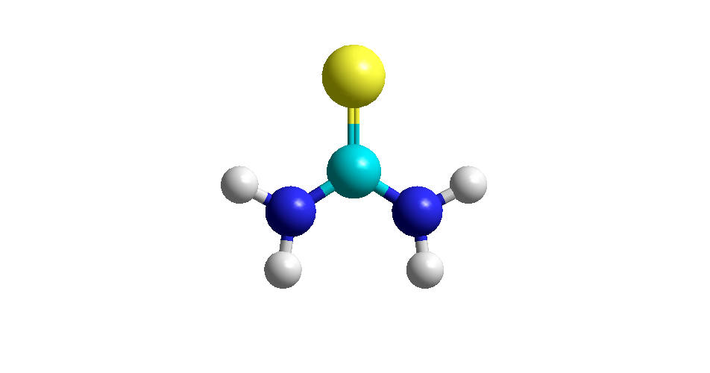
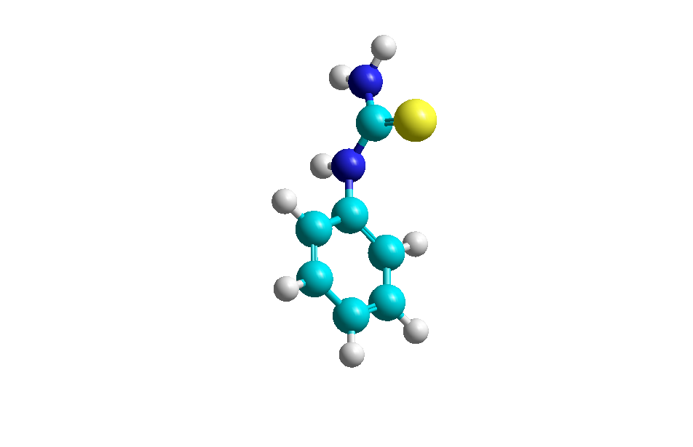
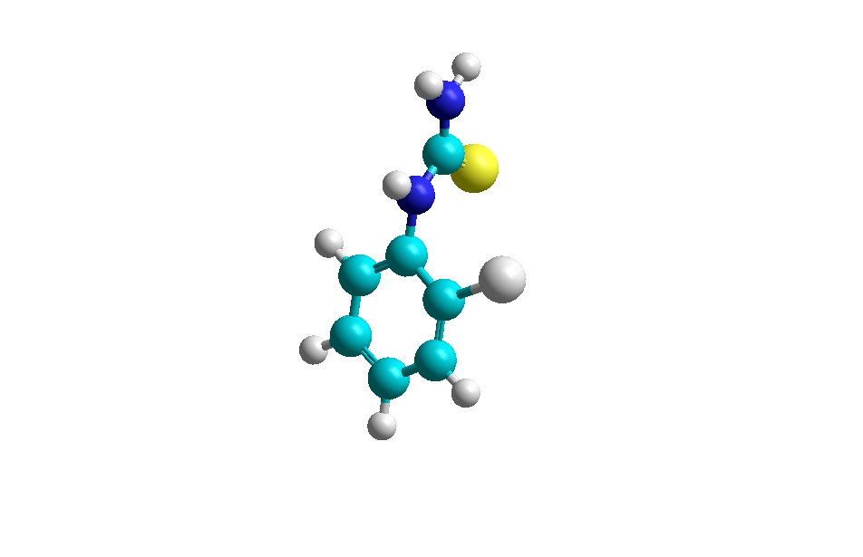
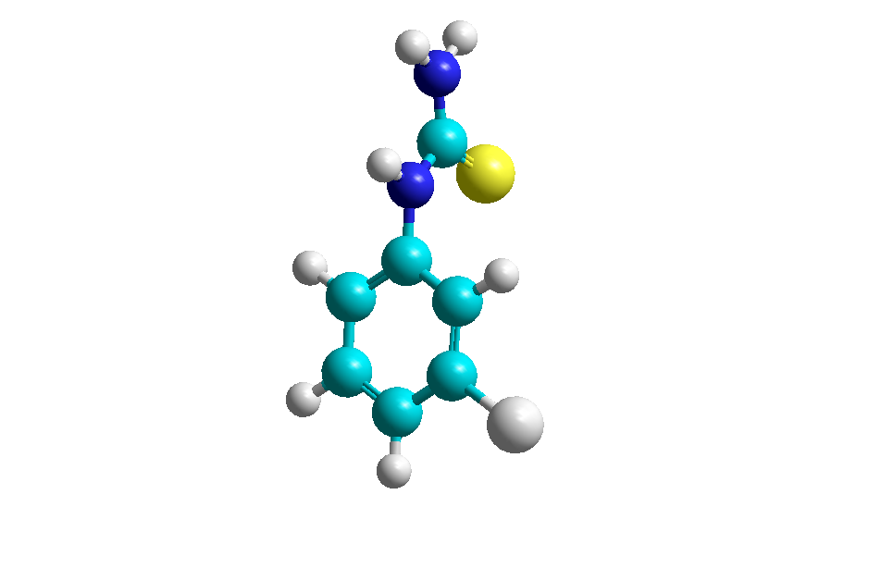
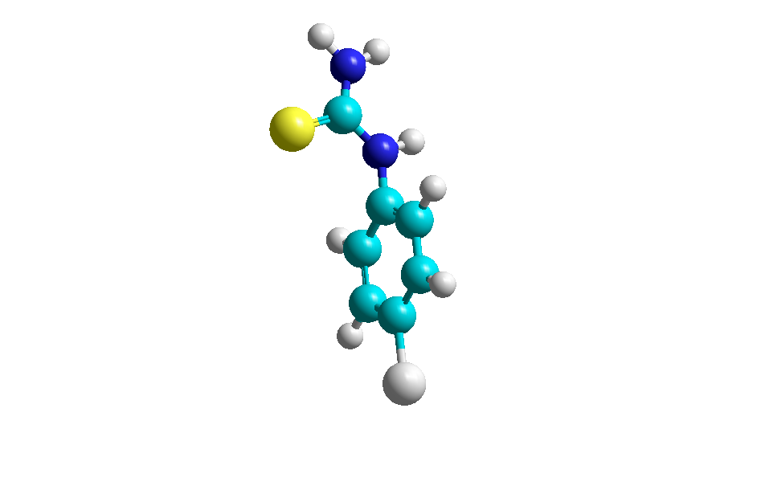

P% 60
P% 55

P% 68
P% 68

P% 68

P% 68 P% 70

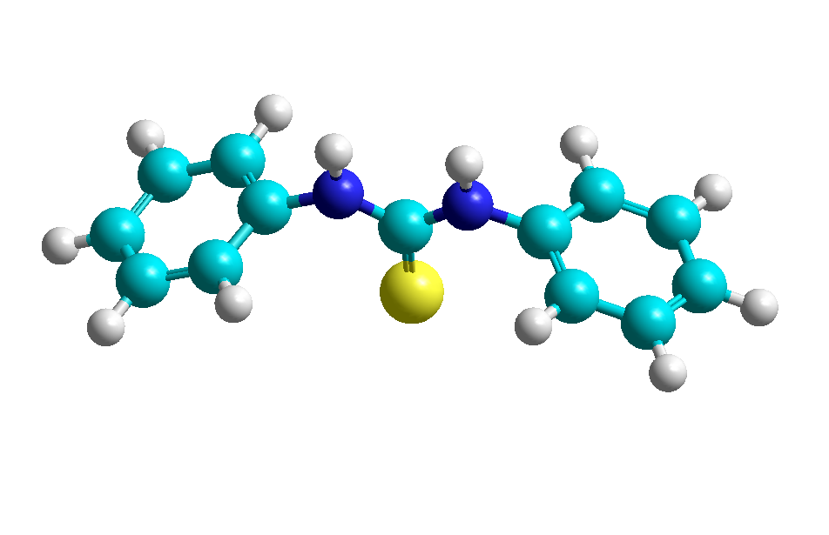
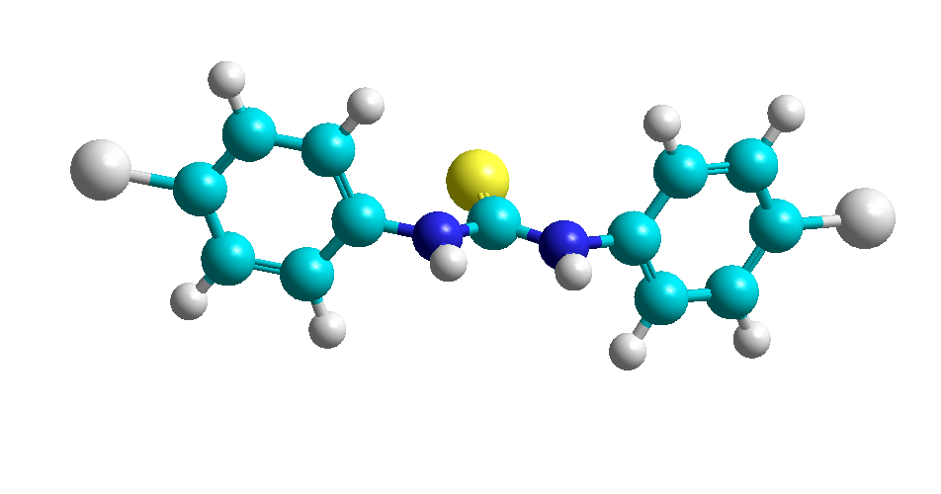
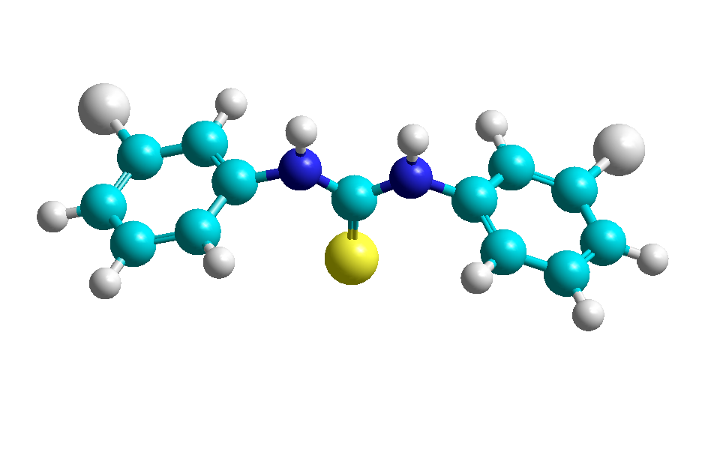

P% 55

P% 55

P% 60

Figure (1) : Structure of studied molecules

Table (1) : percent inhibition efficiencies , P% of some substituted thioureas for the corrosion of aluminum in 20% HNO₃ by 250 ppm inhibitors at ²⁵ ⁰C.

Inhibitors (Molecules ) | P%*
Thiourea | 55
Phenyl thiourea | 68
O-chloro-phenyl thiourea | 68
m-chloro-phenyl thiourea | 68
P-chloro-phenyl thiourea | 70
1:3 Di- phenyl thiourea | 55
1:2 Di-m-chloro phenyl thiourea | 55
1:2 Di -p-chloro phenyl thiourea | 55
* percent inhibition efficiencies have been taken from Reference ⁽²⁷⁾
Table (2) : Calculated the quantum chemical parameters , higher occupied molecular orbital energy ( HOMO ) , lower unoccupied molecular orbital energy ( LUMO ) , the energy gap, charges on nitrogen atoms and sulfur atom for gas phase PM3 for thiourea derivatives .

Inhibitor  P% | E_{HOMO}  _{eV} | E_{LUMO}  _{eV} | E_{gap}  _{eV} | Z_{(1N)} | Z_{(4N)} | Z_{(S)} | Z^{π}_{(1N)} | Z^{π} _{(4N)} | Z^{π}_{(S)}
55 | -8.783 | -0.728 | 8.0550 | 0.1157 | 0.1154 | -0.3113 | 0.022117 | 0.021919 | -0.263703
68 | -8.64 | -0.952 | 7.6880 | 0.2306 | 0.0603 | -0.3093 | 0.165676 | -0.029836 | -0.281809
68 | -8.715 | -1.058 | 7.6570 | 0.2144 | 0.0681 | -0.3046 | 0.14806 | -0.023305 | -0.279179
68 | -8.734 | -1.057 | 7.6770 | 0.2181 | 0.0636 | -0.2973 | 0.152705 | -0.027303 | -0.270208
70 | -8.757 | -0.958 | 7.7990 | 0.1752 | 0.0836 | -0.2941 | 0.116146 | -0.008333 | -0.249082
55 | -8.526 | -1.011 | 7.5150 | 0.1504 | 0.1821 | -0.3013 | 0.091905 | 0.120605 | -0.279514
55 | -8.693 | -1.215 | 7.4780 | 0.1505 | 0.1847 | -0.2944 | 0.091731 | 0.121761 | -0.276095
60 | -8.69 | -1.228 | 7.4620 | 0.1523 | 0.185 | -0.2941 | 0.093731 | 0.12306 | -0.274482

Table (3) : Calculated the quantum chemical parameters , higher occupied molecular orbital energy ( HOMO ) , lower unoccupied molecular orbital energy ( LUMO ) , the energy gap, charges on nitrogen atoms and sulfur atom for gas phase AM1 for thiourea derivatives.

Inhibitor  P% | E_{HOMO}  _{eV} | E_{LUMO}  _{eV} | E_{gap}  _{eV} | Z_{(1N)} | Z_{(4N)} | Z_{(S)} | Z^{π}_{(1N)} | Z^{π} _{(4N)} | Z^{π}_{(S)}
55 | -8.533 | 0.3350 | 8.868 | -.3959 | -.3959 | -.3295 | -.555435 | -.555403 | -.283457
68 | -8.440 | -.1780 | 8.262 | -.2783 | -.3974 | -.2907 | -.410083 | -.554004 | -.248651
68 | -9.877 | -.3570 | 9.520 | -.2683 | -.3053 | -.7758 | -.411143 | -.481089 | -.769460
68 | -8.572 | -.3630 | 8.209 | -.2802 | -.3957 | -.2849 | -.411879 | -.553029 | -.242568
70 | -8.575 | -.4080 | 8.167 | -.2801 | -.3969 | -.2851 | -.412430 | -.554261 | -.243029
55 | -8.296 | -.4010 | 7.895 | -.2780 | -.2780 | -.2446 | -.404885 | -.404727 | -.202809
55 | -8.530 | -.6930 | 7.837 | -.2906 | -.2906 | -.2463 | -.422051 | -.421950 | -.203961
60 | -8.538 | -.7120 | 7.826 | -.2783 | -.2783 | -.2354 | -.405740 | -.405576 | -.193310

Table (4) : Calculated the quantum chemical parameters , higher occupied molecular orbital energy ( HOMO ) , lower unoccupied molecular orbital energy ( LUMO ) , the energy gap, charges on nitrogen atoms and sulfur atom for gas phase MNDO for thiourea derivatives

Inhibitor  P% | E_{HOMO}  _{eV} | E_{LUMO}  _{eV} | E_{gap}  _{eV} | Z_{(1N)} | Z_{(4N)} | Z_{(S)} | Z^{π}_{(1N)} | Z^{π} _{(4N)} | Z^{π}_{(S)}
55 | -9.107 | -.1860 | 8.9210 | -.2884 | -.2885 | -.1735 | -.418289 | -.418348 | -.128614
68 | -8.927 | -.0990 | 8.8280 | -.2960 | -.2933 | -.1804 | -.413990 | -.421030 | -.135068
68 | -8.940 | -.4850 | 8.4550 | -.3174 | -.2939 | -.2020 | -.444429 | -.422915 | -.156447
68 | -9.078 | -.4380 | 8.640 | -.2996 | -.2924 | -.1723 | -.417142 | -.420638 | -.126657
70 | -8.782 | -.4380 | 8.3440 | -.3567 | -.3816 | -.2502 | -.486823 | -.536593 | -.203336
55 | -8.763 | -.0240 | 8.7390 | -.3034 | -.3041 | -.1843 | -.419647 | -.420589 | -.138201
55 | -9.053 | -.4480 | 8.6050 | -.3066 | -.3040 | -.1721 | -.423323 | -.420442 | -.125575
60 | -9.086 | -.5220 | 8.5640 | -.3050 | -.3056 | -.1724 | -.421498 | -.422380 | -.125834

Table (5) : Calculated the quantum chemical parameters , higher occupied molecular orbital energy ( HOMO ) , lower unoccupied molecular orbital energy ( LUMO ) , the energy gap, charges on nitrogen atoms and sulfur atom for gas phase MINDO/3 for thiourea derivatives

Inhibitor  P% | E_{HOMO}  _{eV} | E_{LUMO}  _{eV} | E_{gap}  _{eV} | Z_{(1N)} | Z_{(4N)} | Z_{(S)} | Z^{π}_{(1N)} | Z^{π} _{(4N)} | Z^{π}_{(S)}
55 | -8.576 | .7550 | 9.3310 | -.1636 | -.1637 | -.5270 | -.251281 | -.251331 | -.585930
68 | -8.357 | .6380 | 8.9950 | -.1277 | -.1618 | -.5340 | -.195735 | -.248046 | -.592924
68 | -8.364 | .1260 | 8.4900 | -.1121 | -.1522 | -.5297 | -.181499 | -.238767 | -.596541
68 | -8.475 | .0510 | 8.5260 | -.1316 | -.1562 | -.5274 | -.200863 | -.242974 | -.585927
70 | -8.492 | .1620 | 8.6540 | -.1247 | -.1598 | -.5304 | -.191852 | -.246479 | -.587704
55 | -8.169 | .5390 | 8.7080 | -.1261 | -.1262 | -.5397 | -.192838 | -.192885 | -.596524
55 | -8.1420 | -.2250 | 7.9170 | -.1021 | -.1021 | -.5138 | -.174342 | -.174317 | -.657137
60 | -8.4140 | .0620 | 8.4760 | -.1208 | -.1208 | -.5331 | -.187019 | -.187054 | -.588679

Table (6) : Calculated the quantum chemical parameters , higher occupied molecular orbital energy ( HOMO ) , lower unoccupied molecular orbital energy ( LUMO ) , the energy gap, charges on nitrogen atoms and sulfur atom for aqueous phase PM3 for thiourea derivatives

Inhibitor  P% | E_{HOMO}  _{eV} | E_{LUMO}  _{eV} | E_{gap}  _{eV} | Z_{(1N)} | Z_{(4N)} | Z_{(S)} | Z^{π}_{(1N)} | Z^{π} _{(4N)} | Z^{π}_{(S)}
55 | -9.746 | -.536 | 9.210 | .4232 | .2054 | -.8413 | .327257 | .106225 | -.834803
68 | -9.672 | -.521 | 9.151 | .2283 | .3839 | -.8201 | .158743 | .286654 | -.809413
68 | -9.838 | -.545 | 9.293 | .2796 | .2782 | -.7829 | .211317 | .209836 | -.766907
68 | -9.753 | -.633 | 9.120 | .2760 | .2762 | -.7761 | .207325 | .207462 | -.759307
70 | -9.692 | -.677 | 9.015 | .2758 | .2740 | -.7760 | .206992 | .205298 | -.759147
55 | -9.838 | -.545 | 9.293 | .2796 | .2782 | -.7829 | .211317 | .209836 | -.766907
55 | -9.753 | -.633 | 9.120 | .276 | .2762 | -.7761 | .207325 | .207462 | -.759307
60 | -9.692 | -.677 | 9.015 | .2758 | .2740 | -.7760 | .206992 | .205298 | -.759147

Table (7) : Calculated the quantum chemical parameters , higher occupied molecular orbital energy ( HOMO ) , lower unoccupied molecular orbital energy ( LUMO ) , the energy gap, charges on nitrogen atoms and sulfur atom for aqueous phase AM1 for thiourea derivatives

Inhibitor  P% | E_{HOMO}  _{eV} | E_{LUMO}  _{eV} | E_{gap}  _{eV} | Z_{(1N)} | Z_{(4N)} | Z_{(S)} | Z^{π}_{(1N)} | Z^{π} _{(4N)} | Z^{π}_{(S)}
55 | -10.511 | -.080 | 10.431 | -.31680 | -.3186 | -.8383 | -.491589 | -.493174 | -.838554
68 | -9.874 | -.156 | 9.7180 | -.2630 | -.3116 | -.7912 | -.406469 | -.487181 | -.786443
68 | -9.876 | -.352 | 9.5240 | -.2688 | -.3053 | -.7756 | -.411508 | -.481181 | -.769316
68 | -9.882 | -.332 | 9.550 | -.2672 | -.3070 | -.7868 | -.410435 | -.482866 | -.781608
70 | -9.804 | -.423 | 9.3810 | -.2671 | -.3081 | -.7869 | -.410479 | -.483801 | -.781756
55 | -9.608 | -.228 | 9.380 | -.2570 | -.2562 | -.7334 | -.399945 | -.399181 | -.722895
55 | -9.668 | -.411 | 9.2570 | -.2579 | -.2572 | -.7209 | -.400841 | -.400189 | -.709151
60 | -9.590 | -.497 | 9.0930 | -.2581 | -.2578 | -.7236 | -.401079 | -.400813 | -.712146

Table (8) : Calculated the quantum chemical parameters , higher occupied molecular orbital energy ( HOMO ) , lower unoccupied molecular orbital energy ( LUMO ) , the energy gap, charges on nitrogen atoms and sulfur atom for aqueous phase MNDO for thiourea derivatives

Inhibitor  P% | E_{HOMO}  _{eV} | E_{LUMO}  _{eV} | E_{gap}  _{eV} | Z_{(1N)} | Z_{(4N)} | Z_{(S)} | Z^{π}_{(1N)} | Z^{π} _{(4N)} | Z^{π}_{(S)}
55 | -9.972 | -.05900 | 9.9130 | -.3030 | -.3029 | -.6201 | -.459671 | -.457914 | -.595291
68 | -9.626 | -.06900 | 9.5570 | -.3117 | -.3213 | -.6411 | -.450778 | -.489369 | -.615601
68 | -9.788 | -.37300 | 9.4150 | -.3168 | -.3145 | -.6289 | -.455393 | -.482919 | -.602494
68 | -9.795 | -.34400 | 9.4510 | -.3158 | -.3174 | -.6365 | -.454650 | -.485732 | -.610689
70 | -9.787 | -.4410 | 9.3460 | -.3181 | -.3171 | -.6368 | -.457073 | -.485460 | -.611006
55 | -9.581 | -.0960 | 9.4850 | -.3089 | -.3089 | -.6010 | -.447740 | -.447521 | -.573306
55 | -9.734 | -.3660 | 9.3680 | -.3098 | -.3091 | -.5921 | -.448638 | -.447867 | -.563900
60 | -9.733 | -.4700 | 9.2630 | -.3122 | -.3131 | -.5905 | -.451326 | -.451918 | -.562196

Table (9) : Calculated the quantum chemical parameters , higher occupied molecular orbital energy ( HOMO ) , lower unoccupied molecular orbital energy ( LUMO ) , the energy gap, charges on nitrogen atoms and sulfur atom for aqueous phase MINDO/3 for thiourea derivatives :
Inhibitor  P% | E_{HOMO}  _{eV} | E_{LUMO}  _{eV} | E_{gap}  _{eV} | Z_{(1N)} | Z_{(4N)} | Z_{(S)} | Z^{π}_{(1N)} | Z^{π} _{(4N)} | Z^{π}_{(S)}
55 | -9.972 | -.0590 | 9.9130 | -.30300 | -.30290 | -.6201 | -.459671 | -.457914 | -.595291
68 | -9.626 | -.0690 | 9.5570 | -.3117 | -.3213 | -.6411 | -.450778 | -.489369 | -.615601
68 | -9.581 | -.0960 | 9.4850 | -.3089 | -.3089 | -.6010 | -.447740 | -.447521 | -.573306
68 | -9.734 | -.3660 | 9.3680 | -.3098 | -.3091 | -.5921 | -.448638 | -.447867 | -.563900
70 | -9.733 | -.4700 | 9.2630 | -.3122 | -.3131 | -.5905 | -.451326 | -.451918 | -.562196
55 | -9.581 | -.0960 | 9.4850 | -.3089 | -.3089 | -.6010 | -.447740 | -.447521 | -.573306
55 | -9.734 | -.3660 | 9.3680 | -.3098 | -.3091 | -.5921 | -.448638 | -.447867 | -.563900
60 | -9.733 | -.470 | 9.2630 | -.3122 | -.3131 | -.5905 | -.451326 | -.451918 | -.562196

Figure ( 2 ) : Graph of protection efficiency ( P% ) versus charges of nitrogen atoms and sulfur for aqueous phase AM1 for thiourea derivatives to the series one

Figure ( 2 ) : ( Continued )
Figure ( 2 ) : ( Continued )

Figure ( 3 ) : Graph of protection efficiency ( P% ) versus charges of nitrogen atoms and sulfur for aqueous phase MINDO/3 for thiourea derivatives to the series one

Figure ( 3 ) : ( Continued )

Figure ( 4 ) : Graph of protection efficiency ( P% ) versus charges of nitrogen atoms and sulfur for gas phase PM3 for thiourea derivatives to the series one.

Figure ( 5 ) : Graph of protection efficiency ( P% ) versus charges of nitrogen atoms and sulfur for aqueous phase PM3 for thiourea derivatives to the series two .
Figure ( 6 ) : Graph of protection efficiency ( P% ) versus higher occupied molecular orbital energy ( HOMO ) and lower unoccupied molecular orbital energy ( LUMO ) , respectively for aqueous phase AM1 for thiourea derivatives to the series one .

Figure ( 7 ) : Graph of protection efficiency ( P% ) versus higher occupied molecular orbital energy ( HOMO ) and lower unoccupied molecular orbital energy ( LUMO ) , respectively for aqueous phase MINDO/3 for thiourea derivatives to the series one .

R square = 0.960
Figure ( 8 ) : Graph of protection efficiency ( P% ) versus the energy gap for aqueous phase AM1 for thiourea derivatives to the series one.

R square = 0.946

Figure ( 9 ) : Graph of protection efficiency ( P% ) versus the energy gap for aqueous phase MINDO/3 for thiourea derivatives to the series one

R square = 0.787
Figure ( 10 ) : Graph of protection efficiency ( P% ) versus the energy gap for gas phase PM3 for thiourea derivatives to the series one.

References
- M.K.Awad , F.M.Mahgoub and M.M.EL-iskandarani , J.Mol.Struct., 2000, 31,105 .
- A.H.Ali , Q.A.Yousif , National Journal of Chemistry "NJC" , 2007 , 25 , 171 .
- N.K.Allam , Applied surface science , 2006 , 25 , 4570 .
- F.Bentiss , M.Lagrenee and M.Traisnel , Corrosion , 2000 , 56 , 733 .
- L.G.Qiu , A.J.xie and Y.H.Shen , Corros.Sci. , 2005 , 47 , 273 .
- F.B.Growcock , Corrosion , 1989 , 45 , 1003 .
- I.Lukovits , E.Kalman and G.palinkas , Corrosion , 1995 , 51 , 201 .
- I.Lukovits , K.palifi and E.Kalman , Corrosion , 1997 , 53 , 915 .
- G.Bereket , C.Ogretir and A.Yort , J.Mol.Strcut. , 2001 , 571 , 139 .
- G.Bereket , C.Ogretir and E.Hur , J.Mol.Struct. , 2001 , 578 , 88 .
- K.C.Emregul and O.Atakol , Mater.Chem.Phys., 2004 , 82 , 188 .
- K.C.Emregul and O.Atakol , Mater.Chem.Phys., 2004 , 83 , 373 .
- H.Ashassi-Sorkhabi , B.Shaabani and D.Seifzadch , Electrochem.Acta , 2005 , 50 , 3446 .
- H.Ashassi-Sorkhabi , BShaabani and D.Seifazadch , Appl.Surf.Sci. , 2005 , 23 , 3446 .
- M.Ajmal , A.S.Mideen and M.A.Quraishi , Corros . Sci. . 1994 , 36 , 79 .
- D.Wang , Y.Ying and H.Xiao , Corros.Sci. , 1999 , 41 , 1911 .
- M. J. Dewar and N. C. Barid, J. Chem. Phys., 1969, 50, 1262
- M. J.Dewar and E. Haselbach, J. Am. Chem. Soc., 1970, 92, 590
- R. C.Bingham , M. J. Dewar and D. H. LC, J. Am. Chem. Soc., 1975, 97, 1285.
- M. J.Dewar and W. Thiel, j. Am. Chem. Soc., 1977, 99, 4899, 4907 .
- M. J.Dewar, E. Zoebisch, E. F. Healy and J. J. Stewart, Am. Chem. Soc., 1985,107,3902-3909 .
- J. J.Stewart, J. Comput. Chem., 1989, 10, 209-221.
- R. L.Andrew, "Molecular Modeling Principles and Applications", Second Edition, Prentice Hall, London (2001).
- I. N. Levine,"Quantum Chemistry", Third Edition Allyn and Bacon, Boston. (1983) .
- L.Piela " Ideas of quantum chemistry " , First Edition , published by Elsevier B.V. (2007) .
- CS Chemoffice Pro for Microscoft Windows , CambridgeScientific Computing Inc. , USA .
- D.D.Singh , R.S.Chaudhary and C.V.Agarwal , Br.Corros. J. , 1997 , 14 , 235 .
- A.Stoyanova and S.Raicheva , Corros. Sci. , 1997 , 39 , 1595 .
- S.Raicheva , E.Sokolova and A.Stoyanova , Bulg.Chem.Comm. , 1994 , 27 , 363 .
- Q.A.Yousif , M.Sc. , Thesis , College of Science , University of Baghdad , July , 2001 .
- C.P.Melanie , L.B.Sanford and P.M.David " Levine's Guide to SPSS for analysis of variance " Second Edition , L.E.Associates , Inc. publishers , New Jersey , (2003).
- W.Stanley and C.Daniel , " Statistics for Research " Third Edition , John Wiely and Sons,INC. publication ,(2004).
- L.L.Shrier , "Corrosion " ; Metal / Environment Reactions ,Third Edition , Newnes-Butterworths , London , Vol. 1 , (1994).
- G.Chond , " Catalysis by Metals " , First Edition , Academic press , New York , (1962).
- R.G.Mortimer , " Physical Chemistry " Second Edition , V.C.H. publication , (2004).
- K.J.Laidler " Chemical Kinetics " Second Edition ,McGraw Hill press, New York ,(1967).
- W.Chery and N.Fpiotis , Acc.Chem.Res. , 1977 , 16 , 167 .
- Y.G.Wang and S.H.Chen , Corros.Sci. , 1999 , 41 , 1769 .
- E.J.Rosa and G.Schrarzer , J.Phys.Chem. , 1969 , 73 , 2432 .

