Isolation, identification and antibacterial activity of flavonoid compound from vitex aguns castus L. seed

Iqbal J. B. Alassadi *and Zainab S. Abd-alla **
Chemistry Dept.,/College of Science,Basrah University
Basrah, Iraq
* dr_iqbal2008@yahoo.com, ** Zainab1976@yahoo.com

(NJC)

(Received on 11/11/2007) (Accepted for publication 24/3/2008)

Abstract
We isolated the flavonoid compound from vitex aguns castus L. seed as red powder at (50ºC). The chemical and physical properties were studied by using thin layer chromatography (TLC), IR-spectrum, ultraviolet-visible spectrum, melting point (m.p) and qualitative testes of it. The Isolated flavonoid compound is shown high antibacterial activity against types of standard strains of bacteria (Staphylococcus aureus NCTC 6571 and Escherichia coli NCTC 5933). The minimum inhibition concentration (MIC) of the isolated flavonoid compound has against gram positive and negative bacteria equal to (1 µgm/ml). We prepared flavonoid complex, where it shows high degree of inhibiting the test organism comparable to the isolated flavonoid compound alone.

Keyword: vitex aguns castus L. seed, TLC, flavonoid compound, antibacterial activity, Chemical composition.
الخلاصة
عزل مركب فلافونيدي من بذور نبات كف مريم بشكل مسحوق احمر اللون في درجة حرارة (50 ◦ C).درست الصفات الكيميائية و الفيزيائية للمركب الفلافونيدي المعزول باستعمال تقنية كروماتوغرافيا الطبقة الرقيقة Thin layer chromatography (TLC) و طيف الأشعة تحت الحمراء (IR-spectrum) وطيف الأشعة المرئية وفوق البنفسجية (UV-VIS. spectrum) فضلا عن قياس درجة الانصهار (Melting point) وإجراء الكشوفات النوعية له. حددت فعالية المركب الفلافونيدي تجاه نمو عزلات جرثومية قياسية موجبة و سالبة لصبغة كرام هي (Staphylococcus aureus NCTC 6571 ) و (Escherichia coli NCTC 5933 ).وأوضحت النتائج قابلية المركب الفلافونيدي المعزول في تثبيط كلا النوعين من العزلات. تم تقدير التركيز المثبط الأدنى للمركب الفلافونيدي تجاه نمو عزلات جرثومية قياسية موجبة و سالبة لصبغة كرام،حيث كان أدنى تركيز مثبط لنمو العزلة الجرثومية الموجبة والسالبة لصبغة كرام مساويا إلى (1 µg/ml). تم تحضير معقد فلافونيدي ، ووجد أن لهو قابلية أكبر على تثبيط كلا النوعين من العزلات الجرثومية مقارنة بالمركب الفلافونيدي وحده.

Introduction
From the beginning of the life on our earth ,plants have been faithful to human being .It is well known that plants precede human in their existence on earth and they are used as a main source of nutrition as well as their useful therapeutic properties. Finding healing power in plants is an ancient idea. Dating back to prehistory, there is evidence that Neanderthals lived 60,000 years ago used plants such as hollyhock ^{[1]}. These plants are still widely used in ethno medicine around the world. Chaste berry (vitex agnus-castus) or monks pepper is the fruit of the chaste tree .Chaste berry has been used for more than 2,500 years to treat various conditions, in ancient Egypt, Greece, and Rome ^{[2]}. The beery of the chaste tree contains a number of active constituents: flavonoids (i.e., casticin, kaempferol, orientin, quercetagetin and isovitexin), iridoid glycosides (i.e., limonene, cineol, pinene and sbinene) ^{[3]}. Chasteberry shows central dopaminergic activity in vitro ^{[4]} and in vivo ^{[5]}. The pharmacological properties and chemical composition of the aguns vitex, in particular, of the mediterranean species vitex aguns castus L. are reviewed. The uses of the drug by ancient monastic communities as an aphrodisiac and its present potential uses as traditional medicine for the treatment of diseases connected with the female hormone system ^{[6]}.
The aim of this study was isolation of flavonoid compound, from the local medical plant vitex aguns castus L. seed and study of the physiochemical properties and the antibacterial activity of this medical herb.
Experimental Procedures
A-Material:
1-Vitex aguns castus L. seed were collected, dried, broken and kept at (4ºC).
2-Standard bacteria strains: Staphylococcus aureus NCTC 6571 and Escherichia coli NCTC 5933.
3-Ready culture media: Culture media (Muller Hinton Agar MHA/DIFCO) was prepared according to information of the manufacture company.
B- Isolation of flavonoid compound from vitex aguns castus L. seed:
Twenty gram of ground vitex aguns castus L. seed were refluxed with (80%) ethanol (250ml) for (24h) at (50ºC). The extract was filtered; to the filtrate (50ml) of (1%) lead acetate was added. The mixture was filtered by the buchner funnel, the precipitate treated with (70ml) acetone and (75ml) conc. HCl, where the filtered was evaporated by (Freeze dryer-LABCONCO-England) to afford (0.5gm) as red powder, their color may fade slowly due to exposure to light.
C- Identification:
1- Preliminary qualitative test: the chemical family of the isolated compound was implemented using several tests such as:
- Flavonoid test: use alcoholic KOH (5N) ^{[7]}.
- Carbohydrate test: use Molish's test ^{[8]}.
- Glycoside test: use Bendict's test ^{[9]}.
- Saponin test: use mercuric chloride (5%) ^{[10]}.
- Alkaloid test; Dragendroff test ^{[9]}.
- Amino acid test: use Ninhydrin test ^{[9]}.
2- Thin layer chromatography (TLC):
To determine the purity and relative to front (R_{f}) of isolated compound, a thin layer chromatography was carried out for (90min). On silica gel plates (2x9cm) in a presaturated chamber of the mixture of (butanol: acetic acid: water) (4:1:5), the plate were dried and the spot which appeared were developed with UV-lamp at (336nm), iodine vapor and ferric chloride (1%)^{[9]}.
3- The determination of meting point:
Melting point electro-thermal is used for the determination of melting point of the isolated compounds.
4- Spectroscopy:
a- Inferred spectrum: FT-IR spectrum of the isolated compound was recorded with (FT-IR 8400S SHIMADZU–Japan) in the college of Science, Chemistry Department, University of Basrah.
b- Ultraviolet and visible spectra: ultraviolet and visible spectrum of the isolated compound was carried out in the College of Science, Department of Biology, by using ethanol as the solvent, and the spectrum recorded with the (BECKMAN-COULTER-DU530-Life Science UV/VISIBLE Spectrophotometer).
5- The determination of the antibacterial activity:
A filter disk assay was used to determine the antibacterial activity of the isolated compound (30,000 µgm/ml) against types of reference strains of gram positive and gram negative bacteria (Staphylococcus aureus NCTC 6571 and Escherichia coli NCTC 5933) which are tested using plate of Muller-Hinton agar. The antibacterial activity was defined as the clear zone of growth inhibition ^{[11]}. The minimum concentration (MIC) of the isolated compound was estimated against types of reference strains of gram positive and negative bacteria with different concentration of the isolated compound ranging from (1-1000 µgm/ml) ^{[11]}.
6- The preparation of flavonoid complex:
The (0.1gm) of dried isolated flavonoid compound was recently react with (0.1gm) of mercury acetate, the precipitate complex was filtered and then determine the antibacterial activity of flavonoid complex were tested against types of reference strains of gram positive and negative bacteria using the same method in (5).
Results and Discussion
The results of preliminary qualitative test shown in a table (1), where the appearance of isolated compound from flavonoid family, which then gave a negative result for each of carbohydrate, glycoside, saponin, alkaloid and amino acid testes. The early search appeared the seed of vitex aguns castus L. contains a number of active constituents like flavonoid ^{[12]}.
Thin layer chromatography study for isolated compound give only one spot using different solvent system and different types of (TLC) plates by using some reagent as a developer for this spot, shown in a table (2), relative of front (R_{f} ) equal (0.62), it is organic compound have conjugated double bonds and phenol group.
Melting point (m.p), was also tested and it was found that the isolated compound has sharp melting point (94-96ºC), which means the isolated compound is pure. The FT-IR spectrum for the isolated compound is shown in figure (1) and table (3), the appearance of a single broad peak at (3415 cm⁻¹) related to the vibration stretching for (-OH) bond indicated the presence of phenol group. The band at (1726 cm⁻¹) is related to the vibration stretching for (C=O) bond of carbonyl group. The band at (1649 cm⁻¹) is due to the vibration stretching for ring bond of benzene ring in aromatic compound. The band at (1118 cm⁻¹) is due to the vibration stretching for (C-O) bond of ether. And the band at (875 cm⁻¹) is related to the vibration stretching for (C-H) bond of benzene ring. The result of FT- IR spectrum appear, the isolated compound is aromatic compound contains of phenol, carbonyl and ether group ^{[13]}. The ultraviolet-visible spectrum, figure (2), has shown two peaks at λ_{max} equal to (290nm) and (390nm), due to presence the pairs of electrons (nonbonding type n-π*) on the oxygen atom ^{[14]}.
The antibacterial activity of isolated compound was determined by using filter disk assay. The results, in table (4), show that the isolated compound has good antibacterial activity against gram positive and gram negative bacteria: which are (Staphylococcus aureus NCTC 6571 and Escherichia coli NCTC 5933). And the results, in table (5), shows that the (MIC) values of the isolated compound were (1 µgm/ml) against gram positive and gram negative bacteria, this may due to the presence of (OH) group in the structure of the studied increase the activity of the isolated compound to inhibit the bacteria growth, by the changing the nature of cell protein (Denaturation) and increases the permeability of cell membranes ^{[15]}. And a significant number of studies provide that the antibacterial activity of flavonoid may play a dual role in mutagenesis and carcinogenesis ^{[16]}. The antibacterial activity of flavonoid complex were tested against the growth of gram positive and gram negative bacteria was show in table (6),the results indicated that flavonoid complex inhibit the growth of these bacteria effectively more than the isolated flavonoid compound alone. This may be due to the bending between the complex and the extra cellular, because the flavonoid complex is lipophilic ^{[17]}.

Table (1) the qualitative chemical analysis for the isolated compound of vitex aguns castus L. seed.
the tests  compound | Flavonoid test | Carbohydrate test | Glycoside test | Saponin test | Alkaloide test | Amino acid test
Isolated compound | + | - | - | - | - | -
Notes | Yellow precipitate | No formation white precipitate | No formation orange precipitate | No formation white precipitate | No formation orange precipitate | No formation violet precipitate

Table (2) the thin layer chromatography, R_{f} values for the isolated compound of vitex aguns castus L. seed.
Solvent systems | Developers | Number of spot | R_{f} values | Notes
 | The eyes | 1-spot | 0.62 | Pure compound
Butanole: | I₂ Vapor | 1-spot | 0.62 | Organic nature
Acetic acid:water | UV-lamp (366 nm) | 1-spot | 0.62 | Conjugated double bond
(4: 1:5) | Fecl₃ (1%) | 1-spot | 0.62 | Phenol group

Table (3) the infrared absorption peak and their related functional group for the isolated compound of vitex aguns castus L. seed.
Frequency rang intensities (cm⁻¹) | Group or class | Assignment of remark
3415 (broad) | Alcoholic or phenol | O-H stretch
1726 (strong) | Carbonyl compound | C=O stretch
1649 (strong) | Benzene ring in aromatic compound | Ring stretch
1118 (medium) | Ether | C-O-C stretch
875 (medium) | Benzene ring substitution | C-H stretch out of plane deformation

Table (4) the antibacterial activity for the isolated compound of vitex aguns castus L. seed.
Bacteria strains | Inhibition zone (mm)
Staphylococcus aureus NCTC 6571 | 8
Escherichia coli NCTC 5933 | 14

Table (5) the minimum inhibition concentration (MIC) for the isolated compound of vitex castus L. seed.
Bacteria strains | MIC (µgm/ml)
Staphylococcus aureus NCTC 6571 | 1
Escherichia coli NCTC 5933 | 1

Table (6) the antibacterial activity for the flavonoid complex.
Bacteria strains | Inhibition zone (MM)
Staphylococcus aureus NCTC 6571 | 19
Escherichia coli NCTC 5933 | 21

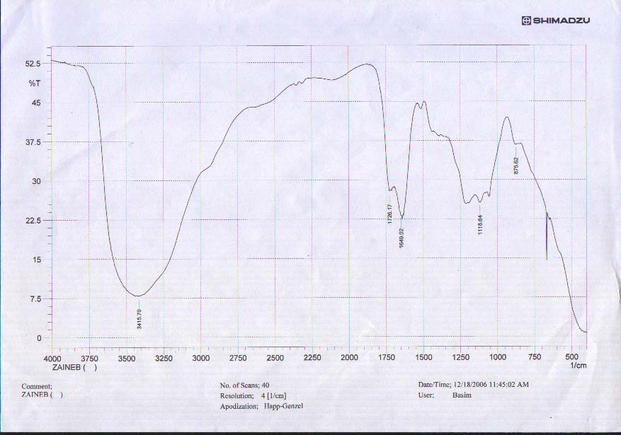

Figure (1) the infrared spectrum for the isolated compound of vitex agune castus L. seed.

Figure (2) the ultraviolet and visible spectrum for the isolated compound of vitex agune castus L. seed.

References
1. M. Tada, Y. Hiroe, S. Klyohara and S. Suzoki, Nematiadal and antimicrobial constituents from Allium grayiregel and Allium fistulosum L. var. eaespitosion, Agric. Biol. Chem., 1988, 52, 2383.
2. F.C. Czygan and J.G.Mayer, Vitex agnus ctuass L. der Oder das keuschlamm, Ein kulturhistorischer essay [in german], http://www.Klostermedizin.de/html/moenchspfeffer.html. (2005).
3. R. Upton, Chaste tree fruit: vitex aguns castus: standards of analysis, quality control and therapeutic, American Herbal Pharmacopoeia and therapeutic compendium, Santa Cruz, Calif, American Herbal Pharmacopoeia, (2001).
4. B. Meier, D. Berger, E. Hoberg, O. Sticher and W. Schaffner, Pharmacological activities of vitex agnus-castus extracts in vitro, Phytomedicine, 2000, 7, 373.
5. W. Wuttke, Dopaminergic Action of Extracts of Agnus Castus, Forschende Komplementarmedizen, 1996, 3, 329.
6. M. Russo and C.G. Guido, Medical properties and chemical composition of vitex aguns castus L. review, ISHS Acta Horticulturae 426, Accessed online: File: //D:\MEDICNAL PROPERTIES AND CHEMICAL COMPSITION OF VITEX…. . (2005).
7. S.M. Al-khazraji, Biopharmacological study of Artemisia Herba Alba, M.Sc. thesis, College of Pharmacy, Baghdad Univ., Iraq (1991).
8. P.B. Hawk, B.L. Oser and H.W. Sumerson, Practical physiological chemistry, 17th ed, Long medical publication, USA (1954).
9. J.B. Harborne, Phytochemical methods. 2nd ed, Chapman and hall, New York, USA. (1985).
10. D.Y. Haddad, The chemistry of vegetable drugs, Cairo Univ. press, Cairo, Egypt, part 2 1-27(1965).
11. J. Collee, A. Fraser, B. Marmion and A. Bimon, Practical Medical Microbiology, Mackie and Mc Carteney, 14th ed, Churchill Livingston, New York, 978 (1996).
12. M.D. Beatrix Roemheld-Hamm, Chasteberry, American Family Physician, 2005, 72, 821.
13. R.M. Silverstein and F.X. Webster, Spectrometric identification of organic compounds, John Wiley and Sons Inc, 6th ed, Publishers / London (1997).
14. J.B. Lambert, F.S. Herbert, L. David and R. Graham- Cooks, Introduction to organic spectroscopy, Macmillan Publishing Company, New York, Collier Macmillan (1987).
15. P. Feeny, Inhibitory effect of Oak Leaf Tannins on The Hydrolysis of Proteins by Trypsine, J. Phytochemistry, 1998, 8, 2116.
16. C.F. Skibola and M.T. Smith, Potential health impacts of excessive flaonoid intake free radical biology and medicine, 2000, 29, 375 (2000).
17. A. M. Hirsh, M.R. Lvm and J.A. Dowine, Plant Physiology, 2001, 127, 1484.

.

