Synthesis and characterization of new Ligand Schiff base 2-[2-(1- carboxy – ethyldeneamino) - phenylimino]- Sodium Propaneat and study of extraction it with Zinc ion (II)

Alaa.F.Hussain
Dept.of chem.colleg of science – university of Karbala

(NJC)

(Received on 31/5 /2007) (Accepted for publication on 24/1 /2008)

Abstract
This work included the Synthesis and characterization tetra dentate Schiff base Ligand (Na₂L) contaning (N₂ and O₂) as donor atoms type (N₂O₂) . This Ligand was prepared by reaction of 1,2- phenylen diamine with sodium pyruvate under reflex in methanol and drops of CH₃COOH gave the Ligand (Na₂L).
The extraction of zinc(II) with above ligand has been studied . The effect of different parameters such as type of medium and time of equilibration, concentration of metal ion, type of organic solvent and effect temperature. The function of thermodynamic (∆S, ∆G, ∆H) was calculated. The stoichiometry of the extract species was determined using three methods such as slope analysis, mole retio and Job's methods and found to be (M:L) (1:1).
The system found to be effective in separating milligram amounts of Zn(II) and in determining trace amount of Zn(II) spectrometrically.

الخلاصة
تضمن البحث تحضير وتشخيص أحد قواعد شيف رباعي السن (N2L) الحاوي على النتروجين والاوكسجين كذرات واهية للالكترونات نوع (N2O2) حضر هذا الليكاند من خلال تفاعل مادة 1،-2 فنيلين ثنائي أمين مع sodium pyruvate تحت التصعيد الارجاعي في الميثانول مع اضافة قطرات من حامض الخليك إذا أعطي التفاعل الليكاند (N2L).
تناولت الدراسة امكانية استخلاص بالمذيب لايون الزنك الثنائي مع الكاشف المحضر . تم دراسة تأثير عدة عوامل مهمة منها وسط الاستخلاص ، زمن الاتزان (الرج) ، تركيز أيون العنصر ، نوع المذيبات العضوية وتأثير درجة الحرارة . حسب الدوال الثروموديناميكية (∆S, ∆G, ∆H) للاستخلاص كما تم دراسة تكافؤية الاجزاء المستخلصة بثلاث طرق هما طريقة تحليل الميل وطريقة تحليل النسب المولية وطريقة جوب وقد أثبتت الطرق ان نسب الكاشف الى الفلز هي بنسبة (1:1) (M:L) وجد أن هذا النظام ملائم لفصل كميات بالمايكروغرام من أيون الزنك الثنائي وتقدير كميات ضئيلة منه طيفا.

Introduction
The term " Schiff bases " was firstly used to define those organic compounds which contain the functional groups (-C=N- ), these Schiff bases have several names, anils, azomethines, bnzanils and benzylideneniline ⁽¹⁾ these compounds were firstly prepared by Schiff in (1864), forms a simple condensation reation of aldehydes or ketones with primary amines and for this reason, these imines were called " Schiff bases " .
Schiff bases are rapidly decomposed in aqueous midia of acidic metals, but are they stable in aqueous solution of basic metals ⁽²⁾ . several Schiff bases compounds are used as ligands and the bidentate ligands have been among those that are extensively used in preparing metal complexes. These ligands are described according to their donor set as N,N donor and N,O donor Schiff bases ⁽³⁻⁵⁾.
Study of extracted of zineion by use different organic compounds. In this regard, Argoud el.al^{.(6)} used 2- amiobenzimidazole and other derivatives as complexing agent in the purification of water from heavy metals. Agrer et.al study the extraction of ( Zn , Ni , and Cd ) with mono – 2ethyl hexyl ) phosphoric acid ⁽⁷⁾ and wang ⁽⁸⁾ et.al study extraction of transition metal with di-2-methy│non │phosphoric acid into heptane. Beniamin et al⁽⁹⁾ study the comparison of the extraction process of Zn and Ni complex by use 1-octylimdazole and 1-octly│-2-methylimidazole.
Lenarcik⁽¹⁰⁾ et.al used benzimidazol, 2-aminobenzimidazole and 2-methyl benzimidazole for study the stability and extrasbility of Co, Zn, Ni and Mohamed et.al.⁽¹¹⁾ study the complexes Zn and Cd with 2(2-benzimidazolyl azo) -4-acetamidophenol Xuezhong et.al. synthesized (2-[2-(5-methyl benzoThiozoly ) azo]-5-deminithyl amino benzoic acid and study its application to the spectrophotometric determination of zinc ^{(12).}
In this work synthesis Schiff base ligand , these ligand was used to solvent extraction of zinc (II) from aqueous solution .

Experimental
- Chemicals

All chemicals and solvents were obtained from commerical sources and used as received.

- Instrumental
- Infrared spectra (I.R)
Infrared spectra of the prepared compound were recorded as (KBr) disc by using shimadzu, (8300) (F?FR) spectrophotometer in the range (400-4000) cm⁻¹.
- Electronic (VV-Visib.) spectra :
The electronic spectra of the ligand and complex were obtained by using double – beam (vv- Visib.) spectrophotometer type vv.1650 (shimadzu), equipped with micro processor, monitor and printer (canon) in the range (200-1100) nm.
- Chloride contents. Type
( 686-Titro processor -665 Dosimat metrohn swiss )
- Elemental micro analysis
Elemental micro analysis for the ligand were performed on a (C.H.N) analysis modile 1106 carlo Eroba .
- Nuclear magnetic resonance spectra 'H13C NMR.
- High performance liguid chromatography H.P.L.C.

Synthesis of the ligand (Na₂L)
A solution of sodium pyruvate (0.5 gm , 4.545 m.mol in methanol (5ml) was added to a mixture of 1,2- phenylenediamine (0.5 gm, 4.543 mmole ) dissolved in methanol (5ml), 10 drops of CH₃COOH was added to that mixture . The mixture was refluxed for ( 4 hours ) with stirring , then the mixture was filtered and washed with an excess of MeOH and dried at room temperature during (24 hours ). A dark green was solid obtained. Yield (83 % ) , (0.98) gm, has a milting point (82 – 84 Cْ ).

O
O
N = C – H₃C
C = O
ONa
C = O
NaO
MeOH
CH₃COOH
1,2- phenylene diamine (a)
Sodium pyruvale
(b)

+H₃C-C-C-O-Na

N = C –H₃C

2-[2-(1-carboxy –ethylideneamino)- phenylimino] – sodium prpaneate
(c)

Scheme (1): The synthesis route of the ligand (Na₂L)

Extraction Procedure:
A solution containing [2.44X10⁻⁴ M] of zinc ion and (0.2%) ligand (N₂L) in ethanol is poured into a separatory funnel .The aqueous phase in completed to ( 5ml) with doubly distilled water . The PH of the solution is adjusted with dilluted HCl and NH₃ solution . The aqueous phase is then equilibrated with (5ml) of Benzene for ⁽¹⁰⁾ minutes. The aqueous and the organic phase are allowed to separate. An aliquot of the aqueous phase in the cells for absorbance measurements at ($λ$_{max} =485) ⁽¹³⁾
Results and discussion
Table (1) shows the solubility of the ligand in different solvents .The ligand were characterized by spectroscopic methods ( FT.IR , UV-Vis) and microanalysis . Table (2) shows physical properties of the prepared ligand.

Table (1) : The solubility of the prepared ligand in different solvents

Comp. | H2O | DMF | DM5O | MeOH | AOH | Acetone | Benzene | CCl₄ | CHCl₄ | 2- propanol | Petroleum ether
Na₂l | ÷ | + | + | + | + | + | ÷ | ÷ | ÷ | ÷ | ÷

(+) soluble, (÷) sparingly

Table (2) : The microanalysis results and some physical properties for the prepared ligand

Ompund | Compound formula | Molecular weight | Yield % | M.P C | Colour | Found (calc.)
Na₂L | C₁₂H₁₀N₂O₄Na₂ | 292.20 | 83 | 82-84 | Dark green | C | H | N
 |  |  |  |  |  | (49.33)  47.26 | (3.45)  3.01 | (9.59)  8.15

Dec.=decomposition , calc.=calculion, ( ) = theoretical

Identification of Na₂L prepared ligand
I.R spectrum for the ligand (Na₂L):

Figure (1) display the (I.R) spectrum for the starting material
1.2- phenylenediamine which exhibit bands at (3560), and (3480) cm⁻¹ due to ν_{as}(N-H ⁻), and ν_{s}( N-H) stretching vibration ¹⁴. The bands at (1180)cm⁻¹ and (2990)cm⁻¹ were assigned to the ν( C=C) and ν(C-H) aromatic stretching vibration⁽¹⁵⁾
Figer(2) display the (I.R) spectrum for the starting material sodium pyruvate which exhibited band at (1730 )cm⁻¹ due to the ν(C=O) stretching vibration .The bands at (1530), and (1450)cm⁻¹ due to ν_{as}(COO⁻) , and ν_{s} (COO⁻) stretching vibration¹⁶.The bands at (1180)cm⁻¹ and (2990)cm⁻¹ were assigned to the ν(C-C) and ν(C-H) aliphatic stretching vibration respectively ¹⁵ .
Figure (3) displays the (I.R) spectrum for the ligand (Na₂L) The band at (1631) cm⁻¹ due to the ν(C=N) stretching vibration of the ligand, while The bands at (1554), and (1450)cm⁻¹ were assigned to the ν_{as}(COO⁻), and ν_{s}(COO) stretching vibration respectively ¹⁵. The bands at (1417)cm⁻¹ and (3057) cm⁻¹ were assigned to the ν(C=C) and ν(C-H) aromatic stretching vibration, while the bands (1028)cm⁻¹, [(2991), and (2850)cm⁻¹] were assigned to the ν(C-C) and ν(C-H) aliphatic stretching vibration respectively ⁽¹⁵⁾
The broad band at (3600)cm⁻¹ is due to ν(HO---H) hydrogen bonding between oxygen atom in (C=O) group, and hydrogen atom in (CH₃) group ⁽¹⁵⁾ table (3) .

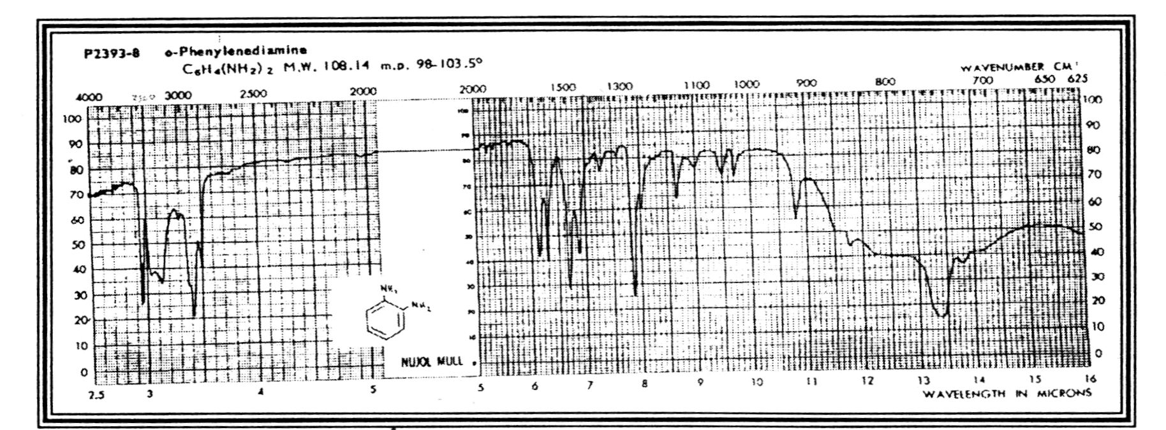

Fig (1) Infrared spectrum of (a)

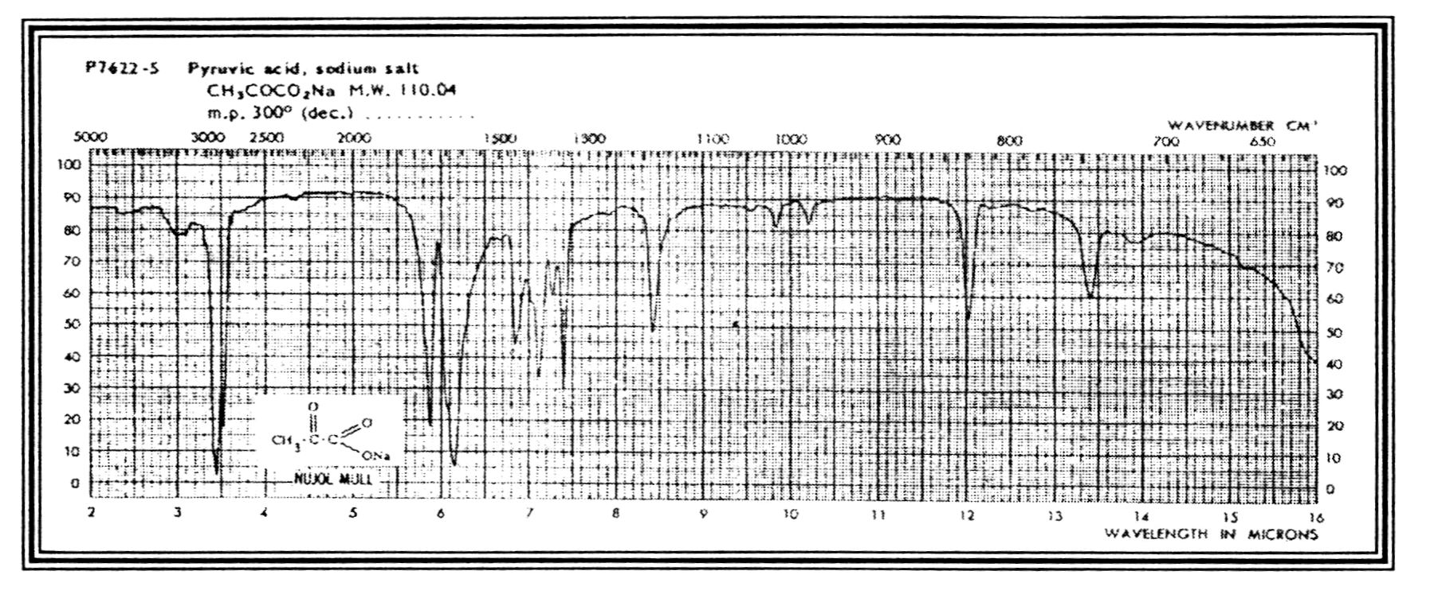

Fig (2) Infrared spectrum of (b)

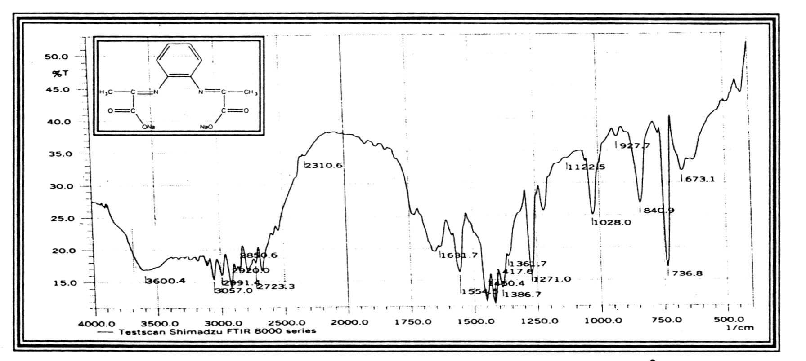

Fig (3) Infrared spectrum of the ligand (Na₂L)

Fig (3) Infrared spectrum of the ligand (Na₂L)

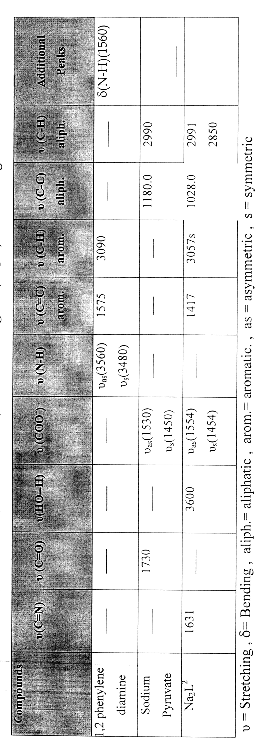
Table (3) Infrared spectral data (wave number ) cm⁻¹ for the ligand (Na₂L) and starting materials

(U.V-Vis) spectrum for the ligand (Na₂L) :-
The (U.V-Vis) spectrum for the ligand (Na₂L), Figure 4 exhibits a high intense absorption peak at (243 nm ) (41152.28 cm⁻¹)($ε$_{max}=1676 molar⁻¹.cm⁻¹), an intense absorption peak at (274 nm)(36490.0 cm⁻¹) ($ε$_{max}=1379 molar⁻¹.cm⁻¹) and an intense absorption at (355 nm) (281690.0 cm⁻¹) (800 molar⁻¹.cm⁻¹), which assigned to ($π→π^{}$),($π→π^{}$), and ($n→π^{}$), transition respectively ¹⁷, Table ( 4 ).

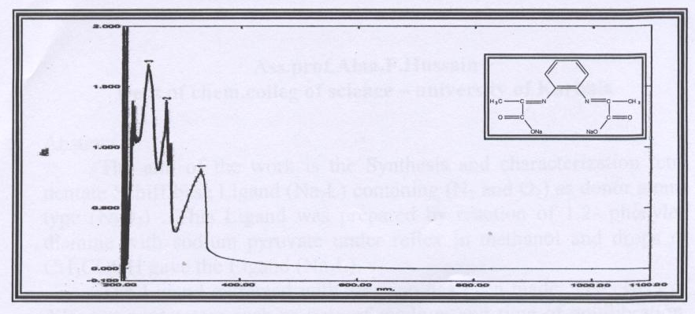
Fig(4) Electronic spectral data of the ligand (Na₂L)

Table 4 Electronic spectral data of the ligand (Na₂L)
Compound | λ nm | ν cm⁻¹ | $ε$_{max} (molar⁻¹.cm⁻¹) | Assignments
Na₂L | 243 | 41125.26 | 1676 | $$π→π^{}$$
Na₂L | 274 | 36496.35 | 1379 | $$π→π^{}$$
Na₂L | 255 | 28169.01 | 800 | $$n→π^{}$$

¹H NMR spevtrum for the ligand (Na₂L):
The ¹H NMR spectrum of (Na₂L), Figure 5 in DMSO-d⁶ shows protons of aromatic hydrogen of carbon (C₂, C₅), (C₃,C₄) the multiplet signals at (7.4460, 7.4368 , 7.4240 ) ppm, (7.0953 , 7.0852 , 7.0733 ) ppm respectively ¹⁵.
The three protons of carbon (C₈,C₁₁) appear as a singal at (1.7005) ppm Table 5 .

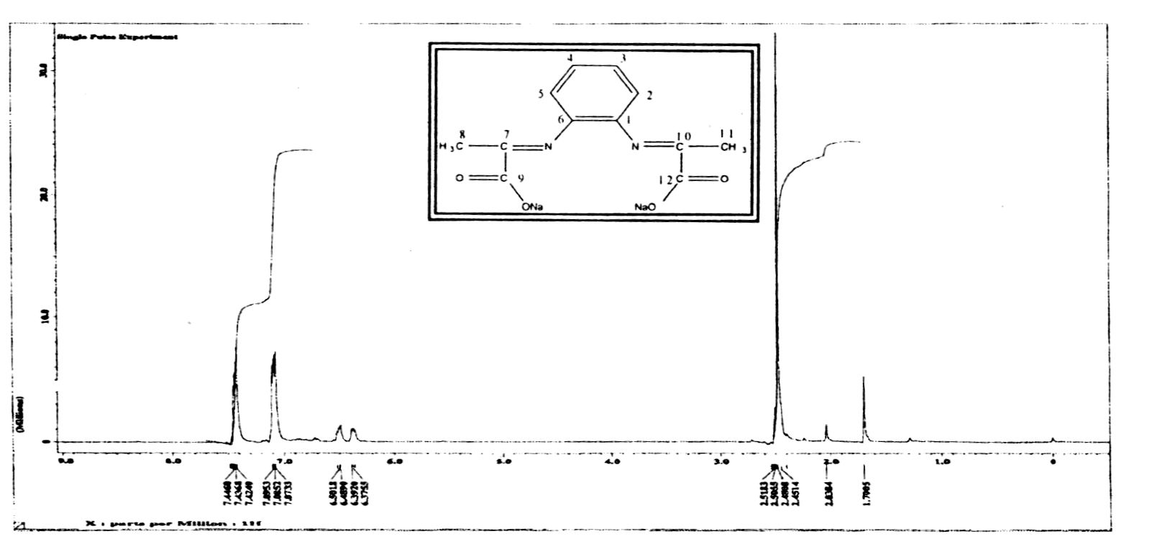

Figure (5) ¹H NMR spectrum of the ligand (Na₂L²)

Table (5) ¹H NMR data for the ligand (Na₂L) measured (DMSO-d⁶) and chemical shift in (λ ppm)

Compound | Functional Group | $δ$ ppm
Na₂L | C₂-H , C₅-H | 7.446  7.4368  7.4240
Na₂L | C₃-H , C₄-H | 7.0953  7.0852  7.0733
Na₂L | DMSO | 2.5055
Na₂L | C₈-H , C₁₁-H | 1.7005

¹³C-NMR of the ligand (Na₂L)
¹³C-NMR of the ligand (Na₂L),
figure 6, Table 6 in ( DMSO-d⁶) shows
the chemical shifts as follow ¹⁵.

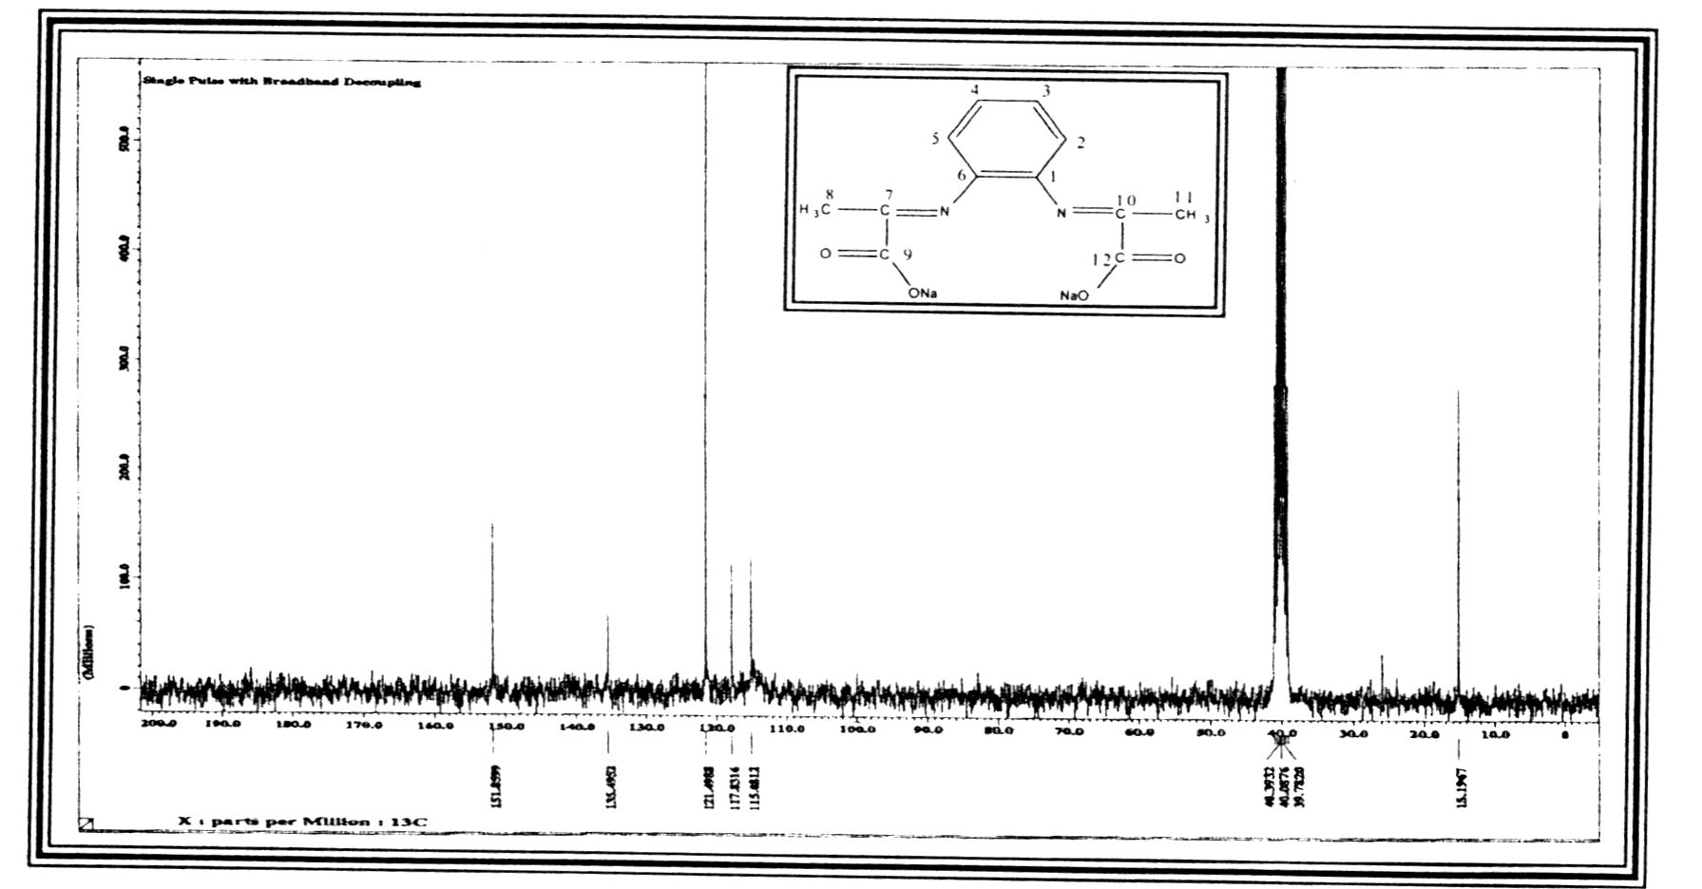

Fig(6) ¹³C-NMR spectrum of the ligand (Na₂L)

Table (6) ¹³C-NMR of the ligand (Na₂L) measured in ( DMSO-D⁶) and chemical shift in ($δ$ ppm)
Compound | Funct. Group | $δ$ ppm
Na₂L | C₉ , C₁₂ | 151.8599
Na₂L | C₇ , C₁₀ | 135.4952
Na₂L | C₃,C₄ | 121.4988
Na₂L | C₂, C₅ | 117.8316
Na₂L | C₁,C₆ | 115.0812
Na₂L | C₈,C₁₁ | 15.1967

Effect of PH
In order to settle the solvent extraction system for the separation and determination of Zn(II) the effect of PH on the extraction was studied for the PH range of (1-8). It is found that the complex given the highest distribution ration (D) an extraction percentage (E%) at pH (3) . The complex formed at acidic media although higher pH values shows lower extraction yield, table (7).

Table : (7) PH effect on the extraction

pH | 1 | 2 | 3 | 4 | 5 | 6 | 7 | 8
D | 8.70 | 10.68 | 12.22 | 11.61 | 7.00 | 4.13 | 2.05 | 0.52
% E | 89.69 | 91.14 | 92.43 | 92.06 | 87.50 | 80.51 | 67.21 | 34.21

Effect of shaking time
For the kinetic side of extraction method studied effect of shaking time on the extraction activity and distribution ratio values, the results of this study in table (8) demonstrate the optimum shaking time of two layers was (8 min ) to reach the equilibria of extraction and at this time obtained the maximum distribution ratio value .

Table (8): effect shaking time on the extraction

Time(min.) | 2 | 4 | 6 | 8 | 10 | 12 | 14
D | 2.83 | 6.07 | 8.45 | 12.22 | 11.89 | 9.60 | 7.59
% E | 73.89 | 85.85 | 89.41 | 92.43 | 92.22 | 90.56 | 88.35

Effect of metal ion concentration
The results in figure (8) demonstrate the effect of metal ion concentration on the extraction method and distributions ratio. The optimum concentration of metal ion was 75 µg(2.29X10⁻⁴ M) give higher distribution ratio,
The results indicate the possibility of determining trace amounts (micro-amounts ) of Zn(II) ion spectrometetically, although the extraction shows a very good color development and separation. The slope of the straight line obtained by plotting log [M] v/s log [D] is 1.00 for the range of (10- 75 µg ) of Zn (II)

Fig (8) Effect of metal ion concentration

Effect of organic solvents on this extraction :-
According to solvent extraction method which is depend on the organic solvent used in extraction method the results in table (9) demonstrate there is not any linear relation between distribution ratio and dielectric constant of the organic solvent and appear chloroform was the best solvent for extraction zinc ion and suggest the different of organic solvent structure on the extraction method.

Table (9) Effect of organic solvents on the extraction

Organic solvents | ε | D_{zn} | %E
Nitrobenzene | 35.74 | 6.66 | 86.94
Amyl alcohol | 15.08 | 8.31 | 89.26
1,2-dichloro methane | 9.10 | 4.04 | 80.15
Amyl acetate | 5.26 | 3.78 | 79.08
Chloroform | 4.90 | 10.32 | 91.16
Diethyl ether | 4.19 | 5.76 | 82.20
Benzene | 2.80 | 12.22 | 92.43
Carbon tetrachloride | 2.20 | 10.22 | 91.08

$Δ\text{Gt}=\frac{{\text{Ze}}^{2}}{Z_{r}}[\frac{1}{ε_{w}}−\frac{1}{ε_{0}}]$ -----------------------Born equation

Effect of Temperature
Extraction of zinc ion from aqueous solution at optimum by temperature from (10-50 C^{ο}) the results in figure (9) demonstrate the reaction between Zn⁺² with ligand was exothermic reaction that is mean the increase in temperature may be effect to increase in dissociation equilibria and thermodynamic behaviour of extraction reaction and the lower value of ∆H_{ex} demonstrate the dissociation of the complex as well as the large value of ∆S_{ex} appear the reaction in intropic in region and this results appear the effect of Zn⁺² in aqueous phase give difficulty for extraction by ligand (N₂L) and the lower stability of Zn⁺² – complex in benzene solvent. Which used for extraction .The thermodynamic data of extraction Zn⁺² in table (10).

Fig(9) Effect of Temperature

Table (10): Thermodynamic data of zinc ion

T (Kْ ) | ∆H KJ-mol⁻¹ | ∆G KJ-mol⁻¹ | ∆S KJ.mol⁻¹.k⁻¹
283 | -41.09 | -7.943 | - 0.1171
293 | -41.09 | -6.793 | - 0.1170
303 | -41.09 | -5.743 | - 0.1166
313 | -41.09 | -4.823 | - 0.1158
323 | -41.09 | -3.572 | - 0.1161

Stoichiometry determination
The stoichiometry of the extraction species (M:L) is determined by different methods.
a. slope analysis method :
50 µg of Zn(II) is extraction with increasing amounts (30-80 µg) of ligand (N₂L) in ethanol .plotting of log [L] v/s Log D gave a straight line of slope values = 0.95 indicating the stoichiometry of ( l:l ), figure (10).

Figure (10) slope analysis method

b. mole ration method
The results in figure (11) for mole ratio method study demonstrate the more probable structure of chelate complex extraction was (1:1) (metal : ligand ) [Zn(L)] which is identify with the results in slope analysis.

Figure (11) Mole ration

c. Job's method :
The results in figure (12) demonstrate the more probable structure of chelate complex extraction was (1:1)(M:L) identify with the results of slope analysis and mole ratio for structure which is [Zn(L)].

Figure (12) Job's method

Reference
S.Dayagi and Y. Degani " The chemistry of carbon-nitrogen Double Bond" Ed.S.Pat Ai. John wiley and sons. Inter sciences , New York.;1970, 64.
G. Reddelien and H. Danilof, Ber.; 1921, 5413, 3132 .
V.Casellato,. P.Gerriero, S. Tamburini and P.A. Vigato Inorg. Chem. Acta.; 1986 , 119, 75.
D. P. Freybery, G.M. Mockler and sinn E, J.chem. Soc. Dalton Trans.; 1976, 5, 445.
J.A. Goodiwn, L.J. Wilson, D.M. stanbury and R.A. scott, Inorg. Chem.; 1986, 28, 42.
J.C. Argoudi, C. Disant, R. Massot, A.cornu. Bull. Inf. Sci. Tech. commis Energy At.; 1979, 203 , 230-231.
M. Agrer and O. Emmaned, Anal. Sci.; 2004, 22(4) , 694-712.
Tao. Wang, N. Yukio, J of chem.. Technology and Biotechnology.; 2002,77, 1316-1322.
Beniamin L. , Teresa, R and Agnieszka , K, XVIII-th ARS separatoria – zloty potok, polaned .; 2003.

B.lenarcik, J.Cloeacki, M, Gabryszewski, R. czopek. Pol. J. chem.; 1999, 64, 43.
G.G. Mohamed, Nadia, E.A.El-Gamel, F. Teixidor polyhedron.; 2001, 20 ,2689 – 2696.
Xuezhong Fan, Guofang Zhang and Chunhua Zhu Analyst, January.; 1998 ,123 , 109-112.
Zygment, Marczenko "Spectrophotometric determination of elements" , John wiley and sonc, Inc.;1986.
M. Bhavna, P. Krishna, A. Pralhad, J. Molecular catalysis.; 1992, 75 , 109.
V. M. Parikh "Absorption Spectroscopy of organic Molecules " Translated by Abdul Hussain khuthier, Jasim M.A. ALRawi and mohammed A.AL-Iraqi ".; 1985.
K.KaKomoto " Infrared spectra of Inorganic and coordination compound " 4th ed, J. wiely and sons, New York.; 1996, 8 , 241.
William kemp, " organic spectroscopy " 2nd Edition, 1987.

