Study the adsorption of eosin dye by modified clay
With urea-formaldehyde polymer

Zeyad Umraan  College of sciences for women | Abass S. Al-Watefi  College of Agriculture | Ayad F. Al-Kaim  College of sciences for women
University of Babylon

(NJC)
(Received on 25/2 /2007) (Accepted for publication on 9/12 /2007)

Abstract:
Adsorption of eosin dye on attapulgite and AUFP composite was investigated by uv-visible technique. While the adsorption of eosin dye had no affinity for the attapulgite, but the AUFP showed significant adsorption from aqueous solution.
The Freundlich and Langmuir isotherm equations were applied to the data and values of parameter of these isotherm equations were evaluated the adsorption.
The extent of the adsorption found to decrease as the temperature increased, i.e, exothermic adsorption. The thermodynamic functions ∆Hº, ∆Gº and ∆Sº were calculated and explained in the mean of the chemical structure of the adsorbate.
Kinetic of adsorption was studied using Lagergren's equation and the adsorption rate constant K_{ad} was calculated, the kinetic results indicated that the adsorption was pseudo first order and the rate determining step was demonstrated.
Activation energy was calculated using Arrehenius equation and it was found to be dependent on the nature of the adsorbents surfaces.
الخلاصة
تم دراسة امتزاز صبغة الايوسين على سطح كل من طين الاتابلكايت "attapulgite" و بوليمر "AUFP" بوساطة مطيافية الاشعة المرئية – الفوق بنفسجية, ووجد ان امتزاز صبغة الايوسين على البوليمر يكون بنسبة جيدة, بينما امتزازها على سطح الطين يكون بنسبة اقل.
تم استخدام كل من معادلتي فرندلج "Freundlich" و لانكماير "Langmuir" الايسوثرميتين وتم حساب الثوابت لكلتا المعادلتين, تم حساب كمية الامتزاز لصبغة الايوسين على كلا السطحين بدرجات حرارية مختلفة ( 298 و 308 و 318) كلفن, ووجد ان كمية الامتزاز تقل مع زيادة درجة الحرارة وهذا يبين ان الامتزاز هو باعث للحرارة.
الدوال الثرموديناميكية " ∆Sº و ∆Gº و ∆Hº " تم حسابها ومن خلالها تم دراسة سلوكية التركيب الكيميائي للمادة الممتزة.
درست حركية الامتزاز باستخدام معادلة Lagergreen ومن خلالها ثابت السرعة, نتائج الحركية بينت ان الامتزاز يتبع حركية المرتبة الاولى ووجد بانها هي المحددة لسرعة التفاعل, طاقة التنشيط تم حسابها باستخدام معادلة ارينيوس ووجد بانها تعتمد على طبيعة السطوح المازة.

Introduction:
Colour removal from textile effluents has been the subject of great attention in the last few years, not only because of its toxicity but mainly due to its visibility.⁽¹⁾ Through hundreds of years, the scale of production and the nature of dyes has changed drastically, consequently the negative impact of dyes on the environment has increased.⁽²⁾ Adsorption processes which produce good quality effluents that are low in concentration of dissolved organic compounds, such as dyes,^{(3,4)} are rapidly gaining importance as treatment processes.
Widespread contamination of soil and groundwater by synthetic organic chemicals (e.g., dyes) has been recognized as an issue of growing importance in recent years. Most of these compounds are potential or known human carcinogens and are of considerable health concern, even at low concentrations. For this reason, the fate and transportation of these compounds has been the subject of much research. Methods for decolorization have therefore become important in recent years. In principle, decoloration is possible with one or more of the following methods: adsorption, precipitation, chemical degradation, photodegradation and biodegradation ⁽⁵⁾.
The purification of waste waters contaminated by hazardous pollutants of inorganic and organic nature is among the serious problems of conservation, especially when such toxic materials, e.g., dyes, contaminating the environment even in insignificant concentrations, are involved. The elimination of such pollutants from aqueous solutions is an important problem not only from a technical but also from an economic point of view. Discoloration in drinking water may be due to the presence of coloured organic substances or highly coloured industrial wastes, of which pulp, paper and textile wastes are most common. Highly coloured, polluted water will frequently have an associated objectionable taste, but the degree to which this association is causative is not known. Synthetic dyes represent a relatively large group of organic chemicals which are encountered in practically all spheres of our daily life. It is therefore possible that such chemicals have undesirable effects not only on the environment, but also on humans. In order to minimize the possible damage to people and the environment arising from the production and application of dyes, several studies have been conducted around the world ⁽⁶⁻⁹⁾. A number of researchers have used various organoclays for the removal of textile dyes from aqueous solutions ^{(10, 11)}.
The development of sorbents of different types is carried out by many research and commercial institutions. Active carbon, for example, is known as an effective sorbent of toxic materials from water solution. Its sorbent characteristics are regenerable by thermal desorption; however, a significant part of the sorbent is lost in each desorption cycle. This is the main reason for low economical efficiency in its application. Therefore, the interest in the development of sorbents of specific surface, e.g., organoclays, has significantly increased in recent years ⁽¹²⁾.
Eosin is an acidic dye where, on dissolution, the sodium ion enters the aqueous solution ensuring the negatively charged oxygen group provides the dye with an overall negative charge. The negative charge of the dye should repel that of an anionic adsorbent. Scheme below show the structure of eosin⁽¹³⁾

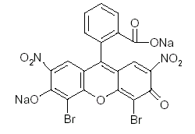
Structure of eosin

Although the sorption of organic contaminants by soils is mainly controlled by the organic fraction, the increasing use of organoclays in environmental applications is making the organic-clay interactions of increasing importance. In our previous work, adsorption of eosin derivatives, cationic dyes and herbicides by organoclays have been investigated ^{(14, 15)}.
Experimental
Chemicals
The chemicals which were used in this work are listed in Table (1) together with the purity and sources. All chemicals were used without further purification

.

Table .1. Chemical and their purity and manufacture used in this study.
Purity % | Source | Chemical
99 | Aldrich | Urea
98 | Aldrich | Formaldehyde
37 | BDH | Hydrochloric Acid
96 | BDH | Eosin

Instruments
The following instruments were used in this study
- Uv-Visible Spectrometer, Cintra (5) GBC Scientific Equipment (England).
- Digital pH-Meter, Knick (England).
- Centrifuge machine, Hettich: EDA. 35 (Japan).
- Shaker Bath, SB-16-Te, Tecam, Temperor, England
- Digital balance, Sartoris, BP 3015 (Germany).
- Oven, Heracus (D-6450), Hanau, (England)..
- FT.IR –8300 Schimadzu, single beam bath Laser, Japan.

Properties of Clay
Attapulgite clay used in this study was obtained from the general company for geological survey and mining, Baghdad, Iraq. It was obtained from Akashatt area in Iraqi western desert. It was collected from an opened mine. It is a buff material, yellow-light orange powder and is practically insoluble in water, organic and inorganic acids and in solutions of the alkali hydroxides. The chemical analysis of attapulgite is listed in Table (2).

Table 2. The chemical analysis of attapulgite
Chemical | Wt%
SiO₂ | 44.66
Al₂O₃ | 13.36
CaO | 13.71
Fe₂O₃ | 4.2
MgO | 3.2
SO₃ | 0.23
Loss on ignition | 17.97
Total | 97.33

Preparation of Clay Powder
Attapulgite clay was supplied in the powder form. It was suspended in HCl solution pH=3 to remove carbonate and it was washed with an excess amount of distilled water to remove the soluble materials⁽¹⁶⁾. Using the available sieve (200 mesh) the maximum particle size was (75μm).
Preparation of Attapulgite -Urea formaldehyde polymer.
Sample of 5g of attapulgite clay was placed in (100 ml) stoppered Erlenmeyer flask, and 50 ml of saturated solution of urea was added to it⁽¹⁶⁾. Then Sample of 5g of AUC “attapulgite urea complex” was placed in (25 ml) conical flask, and (5ml) formaldehyde was added to the mixture, about 5 minute⁽¹⁷⁾.

Equilibrium time of adsorption systems
To determine the equilibrium time that is needed for the adsorption system to reach equilibrium at a given temperature, the following procedure was carried out: A concentration of (40 ppm) for eosin that putting in 20 ml glass bottles was shaken with (0.02 g) from the adsorbent attapulgite (A), and attapulgite–urea-formaldehyde polymer (AUFP). Then the concentration of adsorbate solutions were determined spectrophotometrically at different intervals 15, 30, 45, 60, 75, 90, 105, 120, 150, and 200 minutes, until reaching equilibrium. Equilibrium times of adsorption systems studied are listed in Table 3.

Table .3. Equilibrium time for each pair adsorbent –adsorbate system.
Adsorbate | Adsorbent | Equilibrium time /(min)
Eosin | A  AUFP | 75  75

Adsorption Isotherm
To determine the adsorption isotherm for eosin on the adsorbents A and AUFP. the following procedure was carried out: A volume of (20ml) from each of the 10 different concentration of eosin solution the ranging used from 10 - 100 ppm at a certain pH and temperature was shaken with 0.02 g of the adsorbents, by using thermostat shaker bath at speed 70 cycles per minute. After the period of equilibrium time, the mixture was allowed to settle and the clear liquid was centrifuged at (2000 rpm) for (5 minutes). The equilibrium concentrations were obtained by usual manner of comparing the experimental data with calibration curves.
90

Effect of temperature
The study the effect of temperatures were obtained by agitating the solution of (20 ml) of eosin concentration ranges from 10 - 100 ppm with a 0.02 g of adsorbents A and AUFP in (25 ml) glass bottles. These bottles were sealed and agitating in a constant temperature 298, 308, and 318 K until the equilibrium time for each adsorbents are attend and the solution were separated by a combination of centrifugation and filtered. The clear solution was analyzed by U.V spectrophotometer at suitable wavelength of eosin 415 nm.
Kinetics Study
Kinetic study was obtained by agitating the solution of (20 ml) of eosin at different concentrations from 10 -100 ppm and composition with a (0.02 g) of adsorbents A and AUFP in (25 ml) glass bottles. These bottles were sealed and agitating in a constant temperature thermostat 298, 308, and 318 K at different time 15, 30, 45, 60, 75, 90, 105, 120, and 150 minutes. For each adsorbent the solutions were separated by a combination of centrifugation and filtered, the clear solution was analyzed by U.V spectrophotometer at suitable wavelength of eosin is 415 nm.
Results and discussion

Characterization of Adsorbents
The synthesized compounds, attapulgite (A), and attapulgite -urea -formaldehyde polymer composite (AUFP) were characterized by FTIR spectroscopy and X-ray diffraction technique.
The characteristic FTIR absorption bands of A, and AUFP are showed in Tables (4, 5) and are illustrated in Figures (1-2). The bands 3421-3820 cm-1 in attapulgite spectrum could be attributed to νO –H vibration in different environments, i.e., terminal silanol –OH, bridge Si– O – Si (Al) and the hydrogen bonded Si (Al) OH^{(18, 19)}. The bonded water absorption broad bands are found at 3421 cm⁻¹ and the bending vibration of H₂O is found at 1645 cm⁻¹. The latter has as expected suffered shift to higher frequency as compared to molecular water ⁽¹⁷⁾.The spectrum also clearly shows the characteristic asymmetric stretching vibrations, which appear as strong band at 1036 cm⁻¹ and a prominent shoulder at 920cm⁻¹ due to different phillipsite.

Table 4. The characteristic IR. absorption bands of A.
Group | -OH | -OH | -OH | Si-O-Si(Al) | Si-O-Si(Al) | Si-O-Si(Al)
νcm⁻¹ | 3720 | 3421 | 1645 | 1035 | 920 | 790

Table 5. The characteristic IR. absorption bands of AUFP.
Group | -OH | -NH₂  (sym) | -CH2 | C=O | N-C-N  (asy) | C-H  bending | Si-O-Si(Al)
νcm⁻¹ | 3690 | 3354 | 2974 | 1645 | 1554.5 | 1384.8 | 1037.6

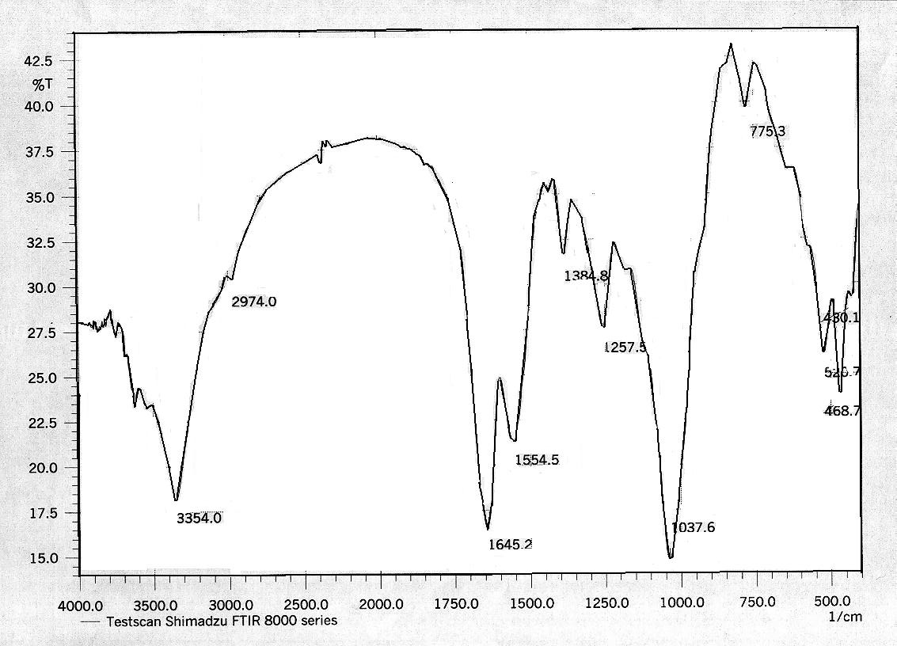
Figure (2) IR Spectrum of AUFP composite.

91

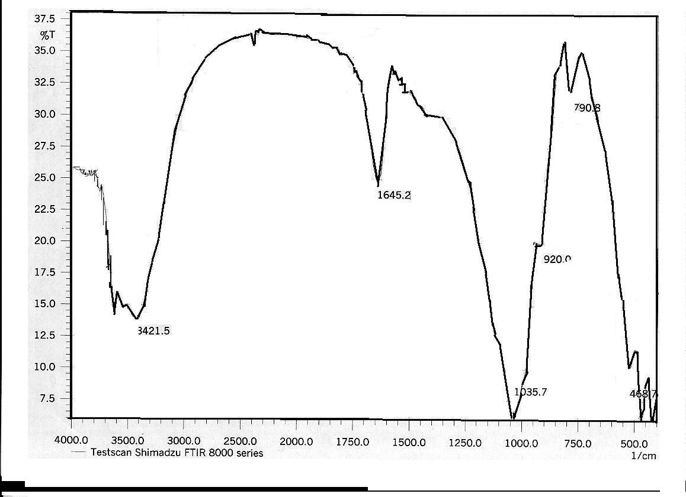
Figure (1). IR Spectrum of A.

Figure (2) IR Spectrum of AUFP composite.

92

The characteristic attapulgite bands in the region 1200- 400 cm^{–1} seem to have hardly been effected by the presence of urea as shown in Figure 2. Taken together with the observed shifts in νNH2, it seems

that the interaction is among urea molecules and with the matrix is mainly through the hydrogen bonding with –NH₂ moiety, the shift in those band are listed in Table (6).

Table (6). The shift in characteristic IR. band of U and AUFP.
Vibration | Urea | AUFP | ∆
νNH₂ | 3439 | 3354 | -85
νCO | 1606 | 1645 | +39
νNCN | 1466 | 1384 | -82

All adsorbent are also characterized by X-ray diffraction patterns, the lattice distances obtained for the original attapulgite, and AUFP samples, along with their intensities, are listed in Table 7 and illustrated in Figures (3-4).

Table (7). The X-ray diffraction spacing d and angle 2θ of A, and AUFP ⁽¹⁷⁾.

Compound | 2θ | d/Ao | Intensity %
A | 20.9 | 4.242 | 75.48
A | 26.7 | 3.329 | 98.7
AUFP | 20.7 | 4.272 | 69.7
AUFP | 26.4 | 3.365 | 97.26

The diffraction pattern of A as shown in Figure 3 shows that A has many diffraction peaks, as is typical of high degree of crystallinity with characteristic attapulgite diffraction spacing 4.242 and 3.329 Aº with intensity 75.5% and 98.7% respectively. The treated of AUC with formaldehyde seems as shown in figure 4 to have no effect on diffraction pattern of the original sample. The two distinguished peaks occur at 4.272 and 3.365 Aº with almost the same intensity of the attapulgite samples. This could be interpreted by the fact that formaldehyde releases urea and polymerized with active group forming urea –formaldehyde polymer. The polymer formed interacts with attapulgite at the surface through the hydrogen bond forces. On the other hand, the formaldehyde molecules interpenetration the attapulgite retains its crystalline lattice structure with the same spacing and intensity as shown in figure 4.

93

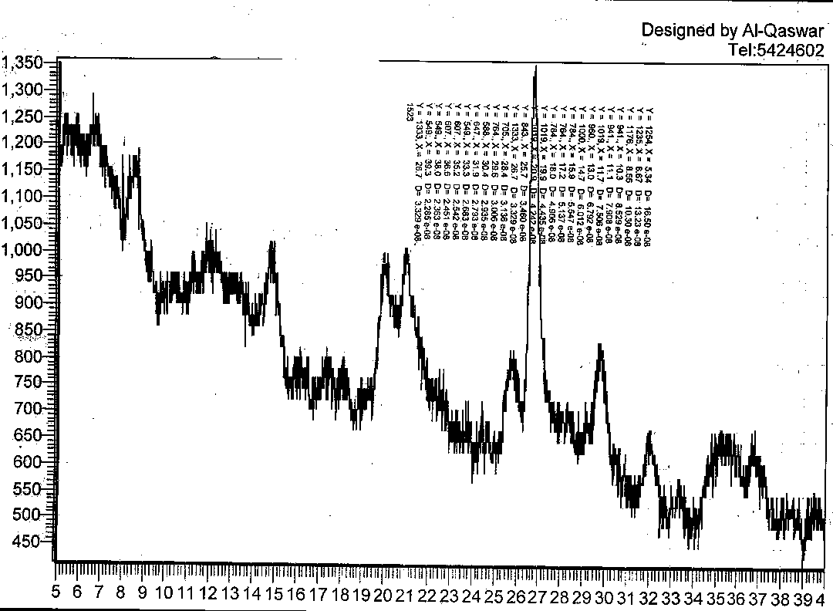
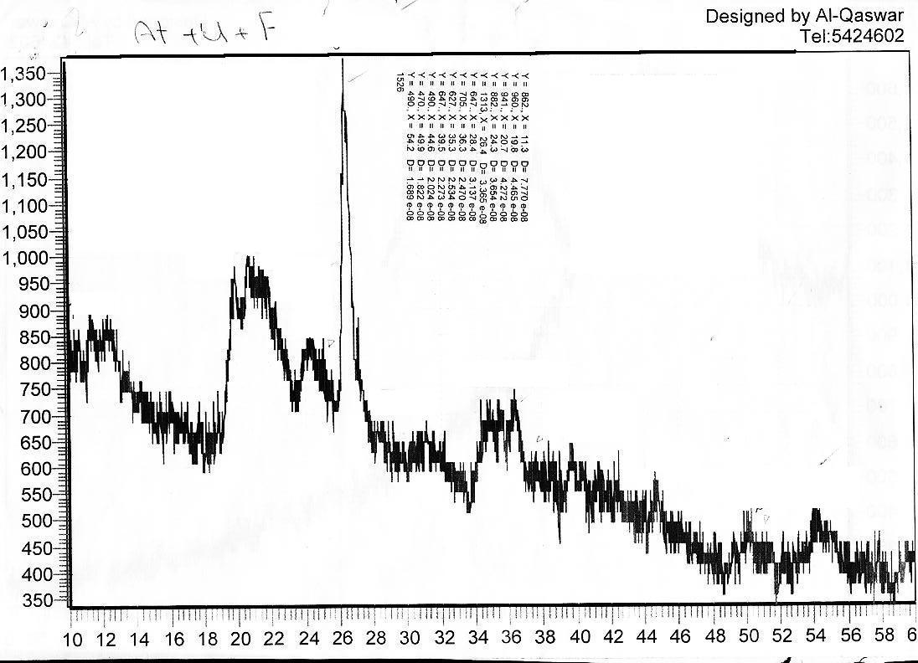
Figure 3. X-ray diffraction pattern of A.
Intensity
2
Figure 4. X-ray diffraction pattern of AUFP composite.

Intensity

94

Adsorption Isotherms
Adsorption at equilibrium conditions was determined for eosin dye on A, and AUFP adsorbents. The adsorbed quantities at
equilibrium concentrations were calculated by using the following equation:

$Q_{e}=\frac{V(C_{o}−C_{e})}{m}\text{.}\text{.}\text{.}\text{.}\text{.}\text{.}\text{.}\text{.}\text{.}\text{.}\text{.}\text{.}\text{.}\text{.}\text{.}\text{.}\text{.}\text{.}\text{.}\text{.}\text{.}\text{.}\text{.}\text{.}\text{.}\text{.}\text{.}\text{.}\text{.}\text{.}\text{.}\text{.}\text{.}\text{.}\text{.}(1)$

Where Q_{e} is the amount adsorbed per unit mass of adsorbent, Co and Ce (mg/L) is the initial and equilibrium concentration respectively, m (g) is the weight of adsorbent and V (L) is the volume of solution, the parameters of adsorption capacity (Qe).
This plot is obtained by using the average values obtained from three replicates. The data are listed in Table (8) for adsorption of eosin.
Figures 5 shows the adsorption isotherms of the eosin dye at 298 K using attapulgite and AUFP surfaces. The equilibrium adsorption capacity Qe increased with the increase in dye concentration. The shape of the isotherms looks sigmoid because at low equilibrium dye concentrations Ce, the equilibrium adsorption capacity Qe of the two adsorbents surfaces A and AUFP reach almost the same Qe as those at high equilibrium dye concentrations. It indicates that the AUFP has high adsorption capacity even at low equilibrium dye concentrations. The sigmoid shape of the isotherms was also obtained in Gills classification ⁽²⁰⁾.

Figure 5. Adsorption isotherm of eosin dye on
attapulgite and AUFP at 298 K.

95

The adsorption curves were applied to both the Freundlich and Langmuir equations. The widely used Freundlich

isotherm has found successful application too many real sorption processes and is expressed as:

$$\text{Qe}=K_{f}C_{e}^{1/n}\text{.}\text{.}\text{.}\text{.}\text{.}\text{.}\text{.}\text{.}\text{.}\text{.}\text{.}\text{.}\text{.}\text{.}\text{.}\text{.}\text{.}\text{.}\text{.}\text{.}\text{.}\text{.}\text{.}\text{.}\text{.}\text{.}\text{.}(2)$$

Where Q_{e} is the adsorption capacity (mg/gm), K_{f} is the Freundlich constant and (1/n) of the adsorption intensity. K_{f} and (1/n) can be determined from the linear plot of ln (Q_{e}) versus ln (C_{e}). In Figure 6 a linear form of Freundlich isotherm are presented by plotting ln Q_{e} as a function of ln Ce of eosin adsorbed on A, and AUFP. The value of 1/n was calculated from the slope of the straight line which gives an indicator for the intensity of adsorption, while the intercept with y-axis gives K_{f} Freundlich constant which is the measure of the adsorption capacity. Freundlich constants are listed in Table (9) of eosin adsorption on attapulgite and AUFP surfaces.

Figure 6. Linearized Freundlich plot for eosin on attapulgite
and AUFP at 298 K.
at 298 K

96

The Langmuir isotherm is expressed as:
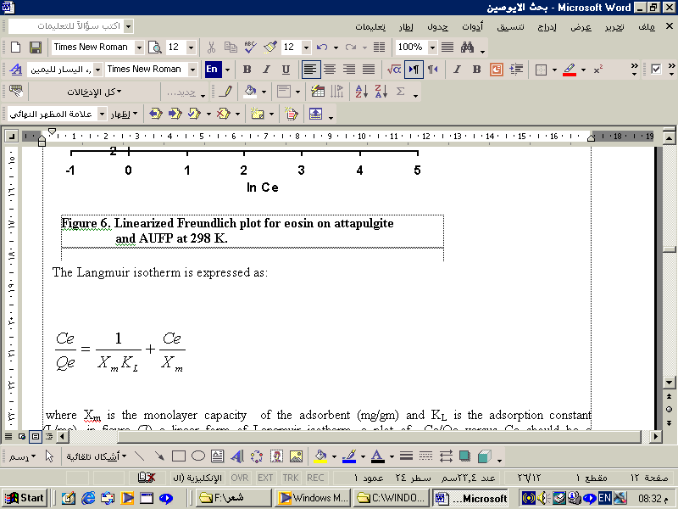

where Xm is the monolayer capacity of the adsorbent (mg/gm) and K_{L} is the adsorption constant (L/mg), in figure (7) a linear form of Langmuir isotherm, a plot of C_{e}/Q_{e} versus Ce should be a straight line with a slope (1/X_{m}) and intercept (1/X_{m}K_{L}). Langmuir constants are listed in Table (9) of eosin adsorption on attapulgite and AUFP surfaces.

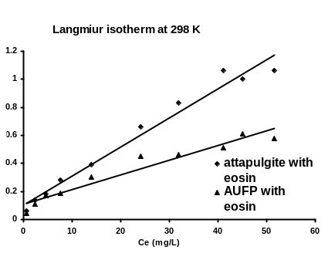
Figure 7. Linearized Langmuir plot for eosin on attapulgite
and AUFP at 298 K.

C_{e} / Q_{e} (g/L)

97

C_{o} (mg/L) | C_{e} (mg/L) | Q_{e} (mg/gm) | C_{e}/Q_{e} | ln C_{e} | ln Q_{e}
C_{o} (mg/L) | Attapulgite
10 | 0.564 | 9.436 | 0.059 | -0.57 | 2.24
20 | 2.4 | 17.6 | 0.136 | 0.87 | 2.87
30 | 4.6 | 23.39 | 0.19 | 1.52 | 3.23
40 | 7.61 | 32.27 | 0.23 | 2.029 | 3.47
50 | 14.03 | 35.97 | 0.39 | 2.64 | 3.6
60 | 24.19 | 36.2 | 0.66 | 3.18 | 3.59
70 | 31.9 | 38.1 | 0.83 | 3.46 | 3.64
80 | 41.16 | 38.9 | 1.06 | 3.72 | 3.66
90 | 45.03 | 44.97 | 1 | 3.8 | 3.808
100 | 51.567 | 48.4 | 1.06 | 3.94 | 3.87
C_{o} (mg/L) | Ce (mg/L) | Q_{e} (mg/gm) | C_{e}/Q_{e} | ln C_{e} | ln Q_{e}
C_{o} (mg/L) | AUFP
10 | 0.42 | 9.58 | 0.043 | -0.86 | 2.26
20 | 1.98 | 18 | 0.11 | 0.68 | 2.89
30 | 4.3 | 25.7 | 0.17 | 1.45 | 3.246
40 | 6.3 | 33.7 | 0.187 | 1.84 | 3.51
50 | 11.7 | 38.3 | 0.305 | 2.46 | 3.64
60 | 18.8 | 41.2 | 0.45 | 2.93 | 3.7
70 | 21.9 | 48.1 | 0.46 | 3.08 | 3.87
80 | 27.3 | 52.7 | 0.51 | 3.306 | 3.96
90 | 35.4 | 54.6 | 0.64 | 3.56 | 4
100 | 36.9 | 63.1 | 0.58 | 3.608 | 4.14

Table (8) Adsorption isotherms values of eosin on the A and AUFP at 298 K.

Table (9) Langmuir and Freundlich isotherms constant of adsorption of eosin on
attapulgite and AUFP at 298 K.
Adsorbent | Langmuir constants |  |  | Freundlich constants
Adsorbent | X_{m} | K_{L} | R² | K_{f} | 1/n | R²
Attapulgite | 48.07 | 0.204 | 0.975 | 13.46 | 0.325 | 0.935
AUFP | 96.153 | 0.094 | 0.94 | 13.065 | 0.386 | 0.98

The adsorption on different active sites occurs throughout different types of forces leading to the formation of clusters or packed line of the adsorbed molecules on the surface. The maximum quantities adsorbated of eosin on two adsorbents follow the order AUFP> A.
These differences in adsorbents ability of adsorption could be attributed to the differences in the surface morphology. Structurally, AUFP is described as composed of attapulgite stuck with urea- formaldehyde polymer in which each attapulgite surface is shared between two adjacent polymers. Thus, AUFP showed be capable of adsorption layer amount of eosin⁽¹⁷⁾.

98

Temperature Dependence of the Adsorption
The effect of temperature variation on the adsorption extent of eosin on the two adsorbents surface A, and AUFP has been studied at neutral media pH= 7. Table 10, and Figures (8,9) illustrates the general shapes of eosin adsorption isotherm at 298, 308 and 318 K. it can be seen that as the temperature increased, the adsorption quantity decreased which refers the adsorption is physical.

Table 10. Adsorption quantities of eosin on the Attapulgite and AUFP surface at
different temperature.

Attapulgite
C_{o} (mg/L) | 298 K |  | 308 K |  | 318 K
C_{o} (mg/L) | C_{e} mg/L | Q_{e} mg/g | C_{e} mg/L | Q_{e} mg/g | C_{e} mg/L | Q_{e} mg/g
10 | 0.564 | 9.436 | 0.578 | 9.42 | 0.628 | 9.372
20 | 2.4 | 17.6 | 2.49 | 17.51 | 2.6 | 17.4
30 | 4.6 | 23.39 | 4.92 | 25.08 | 6.98 | 23.02
40 | 7.61 | 32.27 | 8.66 | 31.34 | 9.55 | 30.45
50 | 14.03 | 35.97 | 15.18 | 34.82 | 16.87 | 33.13
60 | 24.19 | 36.2 | 25.32 | 35.68 | 27.33 | 32.67
70 | 31.9 | 38.1 | 32.9 | 37.1 | 34.66 | 35.34
80 | 41.16 | 38.9 | 42.37 | 37.6 | 43.658 | 36.34
90 | 45.03 | 44.97 | 46.94 | 43.06 | 48.69 | 41.31
100 | 51.567 | 48.4 | 52.14 | 47.86 | 54.64 | 45.36

AUFP
C_{o} (mg/L) | 298 K |  | 308 K |  | 318 K
C_{o} (mg/L) | C_{e} mg/L | Q_{e} mg/g | C_{e} mg/L | C_{e} mg/L | Q_{e} mg/g | C_{e} mg/L
10 | 0.42 | 9.58 | 0.478 | 9.52 | 0.525 | 9.472
20 | 1.98 | 18 | 2.1 | 17.9 | 2.2 | 17.8
30 | 4.3 | 25.7 | 4.7 | 25.3 | 6.1 | 23.9
40 | 6.3 | 33.7 | 7.6 | 32.4 | 8 | 32
50 | 11.7 | 38.3 | 12.4 | 37.6 | 13.2 | 36.8
60 | 18.8 | 41.2 | 19.5 | 40.5 | 21.4 | 38.6
70 | 21.9 | 48.1 | 23.4 | 46.6 | 26.5 | 43.5
80 | 27.3 | 52.7 | 28.7 | 51.3 | 31.9 | 48.1
90 | 35.4 | 54.6 | 34.9 | 55.1 | 35.7 | 54.3
100 | 36.9 | 63.1 | 37.9 | 62.1 | 38.4 | 61.6

99

Figure 8 .Temperature dependence of the adsorption
of eosin on the attapulgite surface.

Figure 9.Temperature dependence of the adsorption
of eosin on the AUFP surface.

100

The study of the temperature effect on adsorption will also help in calculation the basic thermodynamic functions Gibbs free energy) ∆G), enthalpy (∆H) and entropy (∆S) of the adsorption process. The equilibrium constant (K_{e}) of the adsorption process at each temperature, is calculated from the equation:

$$\text{Ke}=\frac{(\text{Qe})(0\text{.}\text{02}g)}{(\text{Ce})(0\text{.}\text{02}L)}\text{.}\text{.}\text{.}\text{.}\text{.}\text{.}\text{.}\text{.}\text{.}\text{.}\text{.}\text{.}\text{.}\text{.}\text{.}\text{.}\text{.}(3)$$

Where Qe is the amount adsorbed in milligram per one gram adsorbent, Ce is the equilibrium concentration of the adsorbate expressed in mg/L, 0.02g represents the weight of the adsorbent that has been used, and 0.02 L represents the volume of the eosin dye solution used in the adsorption process. The change in the free energy could be determined from the equation:

∆Gº = -RT ln Ke …………………. (4)

Where R, is the gas constant (8.314 JK ⁻¹mole⁻¹), T is the absolute temperature in Kelvin. The enthalpy of adsorption may be obtained from the Clausis-Clapeyron equation:

ln Xm = -∆Hº/RT + Constant (5)

When Xm: is the maximum value of adsorption at a certain value of equilibrium concentration (Ce). Table 11 gives Xm values at different temperatures for eosin dye.
Plotting ln Xm versus (1/T) should produce a straight line with a slope -∆Hº/R as shown in Figures (10-11).

Table 11. Maximum adsorption quantity X_{m} values of eosin on the A and AUFP surfaces
at different temperature.

Eosin dye
AUFP |  |  | Attapulgite
ln X_{m} | C_{e}=36.4 mg/L | T/(K) | ln X_{m} | C_{e}=52.7 mg/L | T/(K)
4.16 | 64.3 | 298 | 3.88 | 48.4 | 298
4.09 | 59.2 | 308 | 3.83 | 46.2 | 308
4.01 | 55.0 | 318 | 3.77 | 43.7 | 318

Figure 10. Plot of ln X_{m} versus 1/T of eosin on
the adsorbent surface for attapulgite.
1000 K/T

101

Figure 10. Plot of ln X_{m} versus 1/T of eosin on
the adsorbent surface for attapulgite.

Figure 11. Plot of ln X_{m} versus 1/T of eosin on
the adsorbent surface for AUFP.
1000 K/T
1000 K/ T

102

The change in entropy (∆Sº) was calculated from Gibbs-Helmholtz equation ⁽²¹⁾:

∆ Gº =∆ Hº - T∆ Sº ……………… (6)

Table (12) gives the quantitative thermodynamic data of eosin on the adsorbent surfaces A and AUFP. Table 12 shows that a ∆Hº value of eosin adsorption is negative indicating that the adsorption

process is exothermic reaction. All process of adsorption consider spontaneous from the negative value of ∆Gº. While, ∆Sº have positive value for each eosin and, that refer the interaction of molecules caused random of the total system

.

Table 12. Thermodynamic function ∆Gº, ∆Sº and, ∆Hº of eosin on the adsorbent surfaces A, and AUFP.
Eosin
∆Hº (kJ/mole)*1000 | ∆Sº  (J/mole.K ) | ∆Gº  (kJ/mole) | Adsorbent
-5.966 | 3.580 | - 1.073 | AUFP
-4.345 | 1.462 | -0.440 | Attapulgite

Adsorption Kinetics
The contact time data can be effectively used to test if the adsorption or sorption process is a rate – controlling step^{(20, 21)}. Figures 12-13 show the plots of ln q_{e}-q_{t} against contact time. All plots give straight line, indicated that the adsorption of eosin have obeyed the pseudo-first order equation of Lagergreen equation ⁽²²⁾ which is generally expressed as follow:

dq_{t} /d_{t} = k₁(q_{e}-q_{t}) ( 7)

Where q_{e} and q_{t} (mg/g) are the sorption capacity at equilibrium and at time t, respectively and k1 is the rate constant of pseudo-first order sorption (min⁻¹). After integration and applying boundary conditions t=0 to t=t and q_{e}=0 to q_{t}=q_{t}, the integrated form of equation (7) becomes:

ln (q_{e}-q_{t}) = -k₁t +ln q_{e} ( 8)

This kinetic indicates that system variables, should be more extensively tested and that several kinetic models and correlation coefficients should be used to test experimental sorption data if a mechanism cannot be confirmed. The variables should include agitation speed, sorbent diameter, and solute concentration, sorbent mass and solute temperature. Our experiments data carry out by depending on the Lagergreen equation ^{(23, 24)}.
103

Figure. 12. Kinetic study of adsorption of eosin on the
attapulgite surface at 298 K.

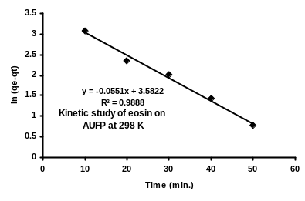
Figure. 13. kinetic study of adsorption of eosin dye on the
AUFP surface at 298 K.

Temperature Dependence of the rate of Adsorption
Temperature effect on adsorption process normally achieved by measuring the activation energy and adsorption rate constant:

$K_{\text{ad}}=A∗e^{{−\text{Ea}}/{\text{RT}}}$
………(9)

104

According to Arrehenius equation the dependency of rate constant of adsorption Kad on temperature are limited over a narrow range of temperature. Where Kad the adsorption rate constant, A is the pre-exponential factor, Ea is activation energy and R and T have the usual physical meaning.
The pre - exponential factor A has the same units as the adsorption rate constant, equation (9) can be written in logarithmic form:

lnK_{ad}=lnA –Ea/RT ……………………. (10)

According to this equation a straight line should be obtained when ln K_{ad} is plotted against the reciprocal of the absolute temperature (1/T) The parameter A, which is given by the intercept of the straight line at 1/T =0, and Ea, which is obtained from the slope of the straight line (-Ea/R), collectively the two quantities are called the Arrehenius parameters.
Activation energy Ea of adsorption of eosin dye on the adsorbent surfaces at temperature rang 298- 318 K are calculated. Ea values are listed in Table 13. Values of K_{ad} are calculated from Figures (14, 15) and listed in Tables 14 and 15. These values are found to be increased for some adsorbent and decreased for the other with increases of temperature. Increasing behavior could be attributed to the possibility of diffusion rate of the adsorbent more than desorption rate for the adsorption process. While the decreases of K_{ad} values with increase in of temperature could be interpretated in term of that the gained thermal energy from the adsorbate molecules decreases from their bounded energy to the adsorbent surfaces, leading to increase the desorption rate of intra – molecules from intra-layer lattice surfaces of adsorbent ⁽²⁴⁾.

Table 13. Kinetics adsorption of eosin on the adsorbent surfaces for each
(Attapulgite, and AUFP) at different temperature.

Attapulgite
ln (q_{e}-q_{t}) |  |  | Time (min)
318 K | 308 K | 298 K | Time (min)
3.06 | 3.16 | 3.12 | 10
2.39 | 2.43 | 2.37 | 20
1.88 | 2.03 | 1.96 | 30
0.91 | 1.37 | 1.14 | 40
0 | 0.223 | 0.43 | 50
AUFP
ln (q_{e}-q_{t}) |  |  | Time (min)
318 K | 308 K | 298 K | Time (min)
3.09 | 3.06 | 3.08 | 10
2.39 | 2.27 | 2.34 | 20
2.04 | 1.88 | 2.016 | 30
1.28 | 1.22 | 1.43 | 40
0.53 | 0.53 | 0.78 | 50

105
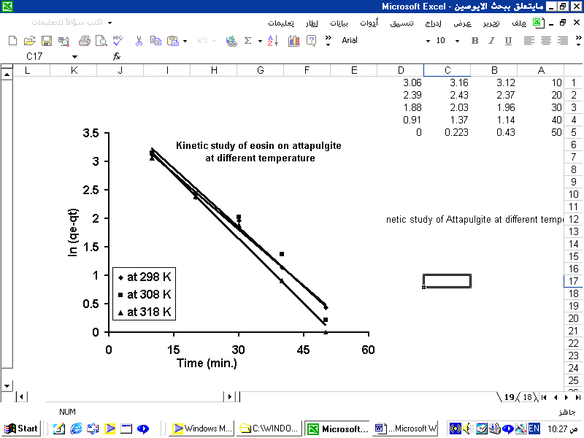
Figure. 14. Pseudo- first order adsorption kinetic of eosin
on the attapulgite surface at different temperature.
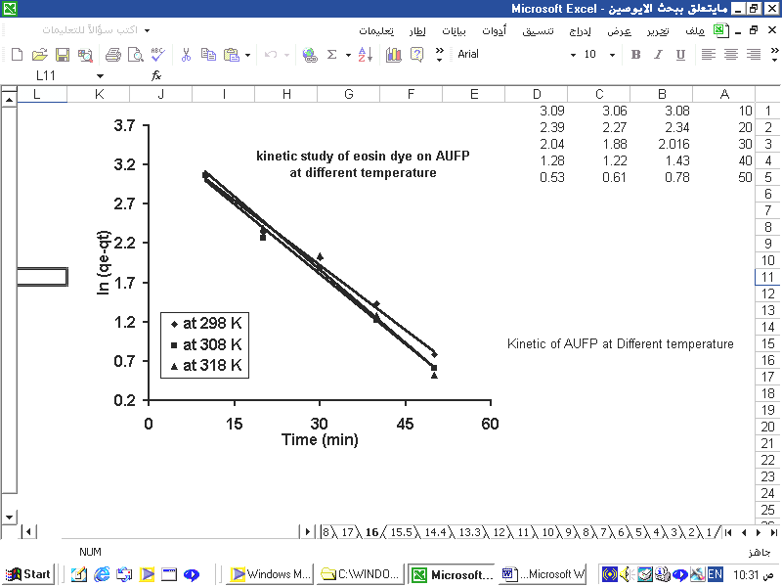
Figure. 15. Pseudo- first order adsorption kinetic of eosin
on the AUFP surface at different temperature.
106

Table 14. A comparison of rate constant of the pseudo -first order Kinetic for each eosin at different temperature.
Eosin dye
K_{ad} / (min⁻¹) |  |  | Temperature  Adsorbent
318 K | 308 K | 298 K | Temperature  Adsorbent
0.076 | 0.0693 | 0.0661 | Attapulgite
0.0643 | 0.0611 | 0.0551 | AUFP
Table 15. Activation energy values for eosin

Activation energy (kJ/mole ) |  | Adsorbent  Compound
AUFP | Attapulgite | Adsorbent  Compound
7.887 | 3.607 | Eosin

Conclusions:
1. The adsorption isotherms show that the quantity of adsorption for eosin by AUFP and attapulgite from their aqueous solutions increase by increased their concentration.
2. The adsorption of eosin on the two adsorbent surfaces is of exothermic process.
3. The adsorptivity of eosin on the AUFP is better than that of attapulgite surface.
4. The adsorption capacity of eosin on the AUFP is high when compared with attapulgite.
5. The adsorption kinetics of eosin on the two adsorbent surfaces obeyed the pseudo-first order
equation and show that the adsorption is complex due to different factors that control the rate of reaction.
6. the adsorption capacity of eosin on two adsorbent surfaces is decreases with increase in
temperature.
Nomenclature:
C_{o} initial solution concentration, mg/L.
Ce equilibrium solution concentration, mg/L.
K_{ad} rate constant of pseudo- first order adsorption, min⁻¹.
1/n adsorption intensity.
Q adsorption capacity mg/gm
K_{f} Freundlich constant.
K_{L} Langmuir constant.
X_{m} the maximum monolayer adsorption.
q_{e} equilibrium adsorption capacity.
q_{t} adsorption capacity at time t.
R² correlation coefficient
t time, min
V volume of the solutions, L
W weight of attapulgite or AUFP, gm.
A attapulgite clay.
AUC attapulgite urea complex
AUFP attapulgite-urea-formaldehyde polymer.

107

References
1. V. Meyer, F. H. H. Carlsson, R. A. Oellermann, Wat. Sci. Tech.; 1992, 16 ,1205 .
2. J. I. Taraskevich, Natural Adsorbents in Wastewater Treatment (in Russian), Naukova Dumka, Kiev,1981.
3. G. McKay, S. J. Allen, I. P. McConvey, J. H. R. Wallters, Ind. Eng. Chem. Process Des. Dev.; 1984, 23, 221.
4. V. Meshko, L. Markovska, M. Mincheva, V. Cibulic, J. Ser. Chem. Soc.; 1998, 63 ,891.
5. H. Zollinger, Color Chemistry, VCH Publishers Inc. New York, 1991.
6. R. Deoraj, R.D. Guy, Clays and Clay Miner.; 1981, 29, 3, 205-212 .
7. G.S. Gupta, S.P. Shuckla, G. Prasad, V.N. Singh, Environ. Tech.;1992, 13, 925-936.
8. J. Cenens and A. Schoonheydt, Proceedings of the 9th International Clay Conference, Strasbourg .;1990, 85, 15-23 .
9. L. Margulies, H. Rozen, S. Nir, Clays and Clay Miner.;1988,36(3),270-276.
10. B.J. Bhalala, J. Bhatt, P.V. Pandya, I. J. Environ. Prot.; 1990,16,186-188.
11. M.M. Socias, M.C. Hermosin, J. Cornejo, Chemosphere.;1998,37, 289-300.
12. M. Kowalska, H. G¨uler, D.L. Cocke, The Science of The Total Environment.; 1994,141, 223-240.

13. R.S., Juang, F.C., Wu, and R.L., Tseng, “The ability of activated clay for the adsorption of dyes from aqueous solutions”, Environmental Technology.;1997,18, 525-531.
14. O. Ceyhan, H. Guler, R. Guler, Adsorp. Science Techno.;1999,17,469-477.
15. O. Ceyhan, H. Guler, C. U. Fen Bilim. Der.;1999,21, 105-116 .
16. Y. Mohammed, M.Sc.Thesis, college of Ibn Al-Haitham education, Baghdad university 2004.
17. A. Al-Kaim, M.Sc.Thesis, college of science, Babylon university 2005.
18. T., Nakamura, T.Tamura, and S. Tanada, J .of Health Sci .; 2003,49 (46)
520 –523.
19. Gilles, C.H., Smith, Authony P.D.Silva and Jan A.Easton., J.Colloid Interface. Sci.; 1974, 74, 755 .
20. S. Glasston, K.J. Laider , and H. Eyring, ”The Theory of Rate Processes University of Utah Press, University of Utah 1941.
21. S.Bekkouche, M. Bouhelassa, N.H. Sulah and F.Z. Meghlaoni, J. of Science Chemistry Desalination.; 2004,166,355-362 .
22. W.Ratanuman, A.David, G.White and R.Radu, J.Chem.E.; 1999,77(B),88-92 .
23. A.Al-Ameene, M.Sc.Thesis, Ibn Al-Haitham, college of education, University of Baghdad 1996.
24. S.Glasston, K. J.Laider and H. Eyring ”The Theory of Rate Processes” University of Utah Press, University of Utah 1941.

108

