Preparation and spectroscopic characterization of some Schiff's bases derived from Sulphanilamide and aromatic aldehydes

Bushrah K. Alsalami  College of Science | Jabbar S. Hadi  College of Education
University of Basrah

(NJC)
(Received on 11/11 /2007) (Accepted for publication on 16/1 /2008)

Abstract
Sulphanilamide has been condensed with five different aromatic aldehyde by heating them together (fusion) or with a small quantity of solvent .The condensation products have been characterized by IR , H’NMR and GC.mass . The spectroscopic data indicate that the condensation under these condition gives Schiff bases with 1:1
ratio of sulphanilamide : aldehyde . Only salicylaldehyde differ from that where the condensation take place on poth sides to give sulphanilamide bis salicylaldehyde .
The yield of all product ranging from 71-87%

الخلاصة
حضرت قواعد شيف من التفاعل المباشر بين السلفانيلاميد مع البنزلديهايد و 4-ميثوكسي بنزلديهايد والسلسلديهايد بطريقة الصهر المباشر مع استخدام زيادة من الالديهايد السائل . كذلك تم مفاعلة السلفانيلاميد مع كل من 2- هيدروكسي نفثالديهايد و 3-ايثوكسي سلسلديهايد وبنسب مولية متساوية وباستخدام الايثانول مذيب, شخصت جميع المركبات الناتجة بمطيافية الاشعة تحت الحمراء والرنين النووي المغناطيسي للبروتون وطيف الكتلة .
بينت النتائج ان تفاعل السلفانيلاميد مع جميع الالديهايدات تحت هذه الظروف يعطي ناتج بنسب مولية 1:1 باستثناء السالسلديهايد حيث اكدت النتائج ان نسبة التفاعل 2:1

Introduction :
Slphanilamide is one of the sulpha drugs which were widely used as drugs for tuberculosis malaria and convulsions ⁽¹⁾ . Sulpha drugs carry aromatic amino group which can react with the aldehydes forming Schiff’s bases .
The condensation products of sulpha drugs with aldehydes and ketones are biologically active^{(2,3)} . Also the Schiff bases derived from sulphanilamide have ability to formation of complexes with metal ions and the biological activity will increase on complexation ^{(3,4)}. In this work Schiff bases are prepared by a direct fusion of sulphanilamide and excess aromatic liquid aldehydes ,and the products were characterized in detail.
Experimental:
- Materials and Measurements :
Sulphanilamide was purchased from Fluka chemical company. and used without further purification , the aldehydes from Aldrich chemical company They were purified by distillation or recrystallized from ethanol
Melting point were taken with a Gallenkam melting point apparatus
IR spectra were recorded on a shimadzu spectrometer as KBr disks. Band intensities are assigned as weak (w) medium (m) strong(s) very strong(vs) and broad(br)
H’NMR proton nuclear magnetic resonance ( 500MHz) spectra were recorded on a Brucker 500 spectrometer in DMSO-d₆ solvent at 25Cº .Multiplicities of proton resonance signal were designated as broad (br), singlet(s) , doublet(d) , tripliet(t) quartet(q) and multiplet(m)
GC.mass spectra were recorded on a Fisons Trio 1000 spectrometer.
2- Preparation methods
(a) Preparation compounds 1,3,5
In a 25 ml round bottom flask ,0.01 mole (1.72 gm) of sulphanilamide and 10 ml ( excess) of appropriate aldehyde was added . the mixture was heated gently for 2-3 hrs. and the mixture were left overnight .Yellow or orange precipitate were formed ,filtered and washed with cold ethanol , followed by recrystallization from ethanol and dried at ~ 70 Cº overnight .
(b) Preparation compounds 2 and 4
In a 50 ml round bottom flask 1.72 gm ( 0.01 mole) of sulphanilamide and
1.72 gm (0.01 mole) of 2-Hydroxy-1-naphthaldehyde , 20 ml of absolute ethanol
was added .The mixture was refluxed ,the color of the solution change in a few minute (~ 15 min ) to red , after 3 hrs reflux the reaction mixture cooled and the
precipitate was filtered off and washed with cold ethanol several time followed by recrystallization from ethanol and dried at (~ 70 Cº) overnight .
By the same method compound 4 was prepared .
Result and discussion:
Reaction of aldehydes {benzaldehyde(1) , 2-hydroxy-1-naphthaldehyde(2),3-ethoxy salicylaldehyde(4), nisaldehyde(5)}with sulphanilamide can be represented as followings

:The purity of all products was checked by TLC using ethylacetate
:benzene (7:3)as eluent .The empirical formula , melting point , physical state and yield percent are give in Table I

Table (I) : Physical properties of the compounds
Compound | Formula | color | M.P. Cº | Yield %
1 | C₁₃H₁₂N₂O₂S | White-yellow | 159-162 | 80
2 | C₁₇H₁₄N₂O₃S | Orange | 241-243 | 85
3 | C₂₀H₁₆N₂O₄S | Yellow | 183-184 | 71
4 | C₁₅H₁₆N₂O₄S | Red | 200-202 | 73
5 | C₁₄H₁₄N₂O₃S | Light yellow | 188-190 | 87

Characterization of compounds:
IR Spectra :
the IR spectra of these compounds (Fig 1 ) and (Table II) shows bands in the region 3221-3296 cm⁻¹ which could be assigned to stretch. Vibration of NH- , this clearly indicates that the condensation of aldehyde takes place only on the NH₂ of the aniline moiety and the other SO₂NH₂ remain unaffected except compound 3 which discus later in addition another strong and broad band were observed at 3316,3300cm⁻¹ in the spectrum of compounds 2 and 4 respectively which attributed to ( OH) , spectrum of compound 3 shows two broad bands at 3343 and 3245 cm ⁻¹ both of them attributed to stretching vibration OH , an intense bands in the region 1617-1623 Cm⁻¹ in all spectra are attributed to azomethine group ( C = N ) this band appear in the lower frequencies about 3-6 cm ⁻¹ in the compounds 2,3,4 compared with compounds 1,5 which indicated the formation of hydrogen bonding with OH group. A very strong band in the region 1330-1340 cm⁻¹ and 1150-1199 cm ⁻¹ in all compounds attributed to asymmetric and symmetric stretch of the SO₂ group ⁽⁵⁾ . Compound 4 and 5 shows a band at < 3000 cm⁻¹ which attribute to C – H stretch. of CH₂ and CH₃ groups .

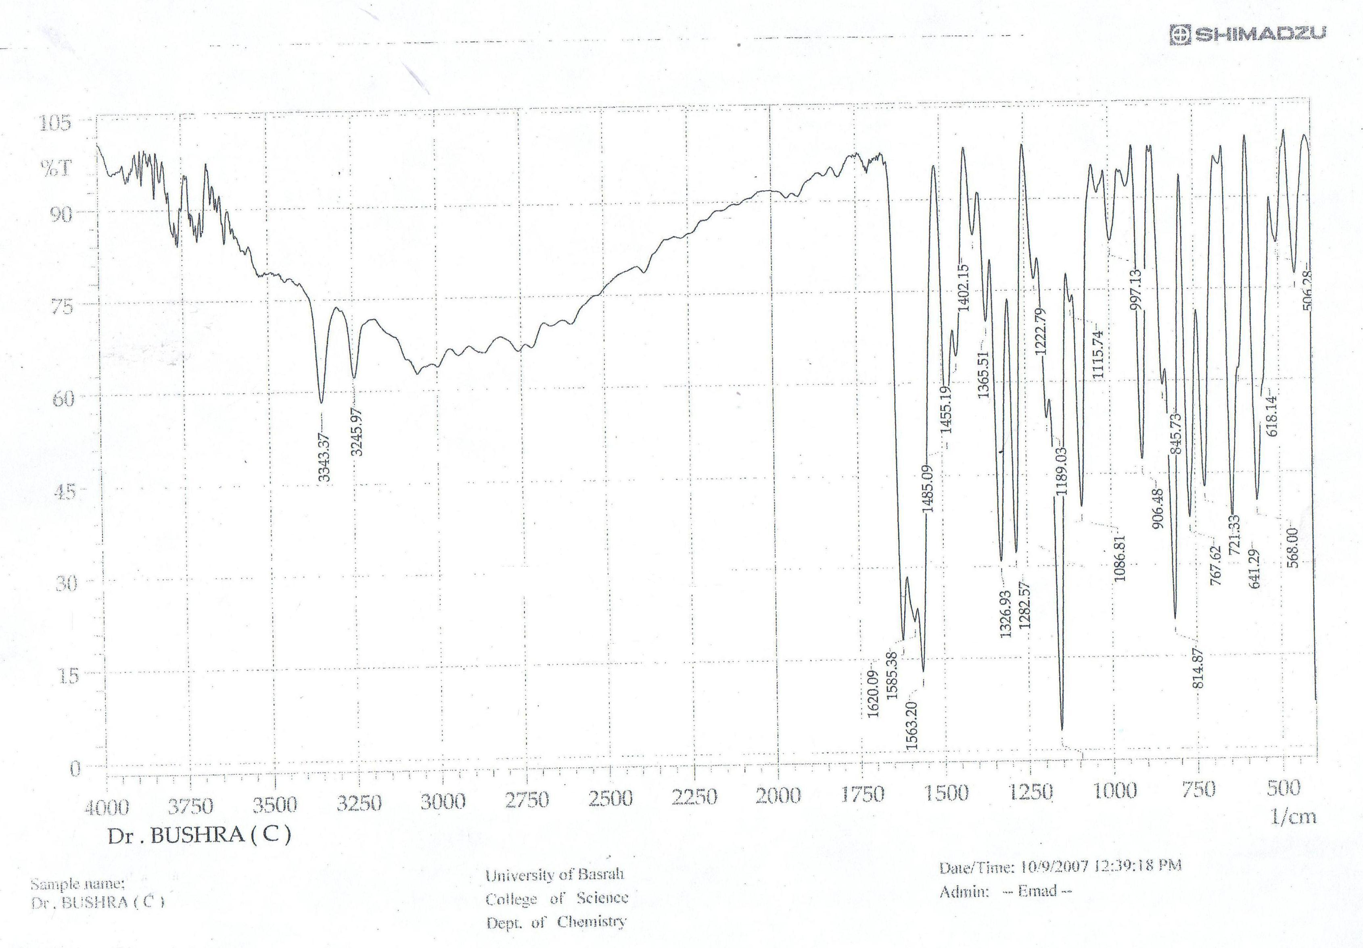

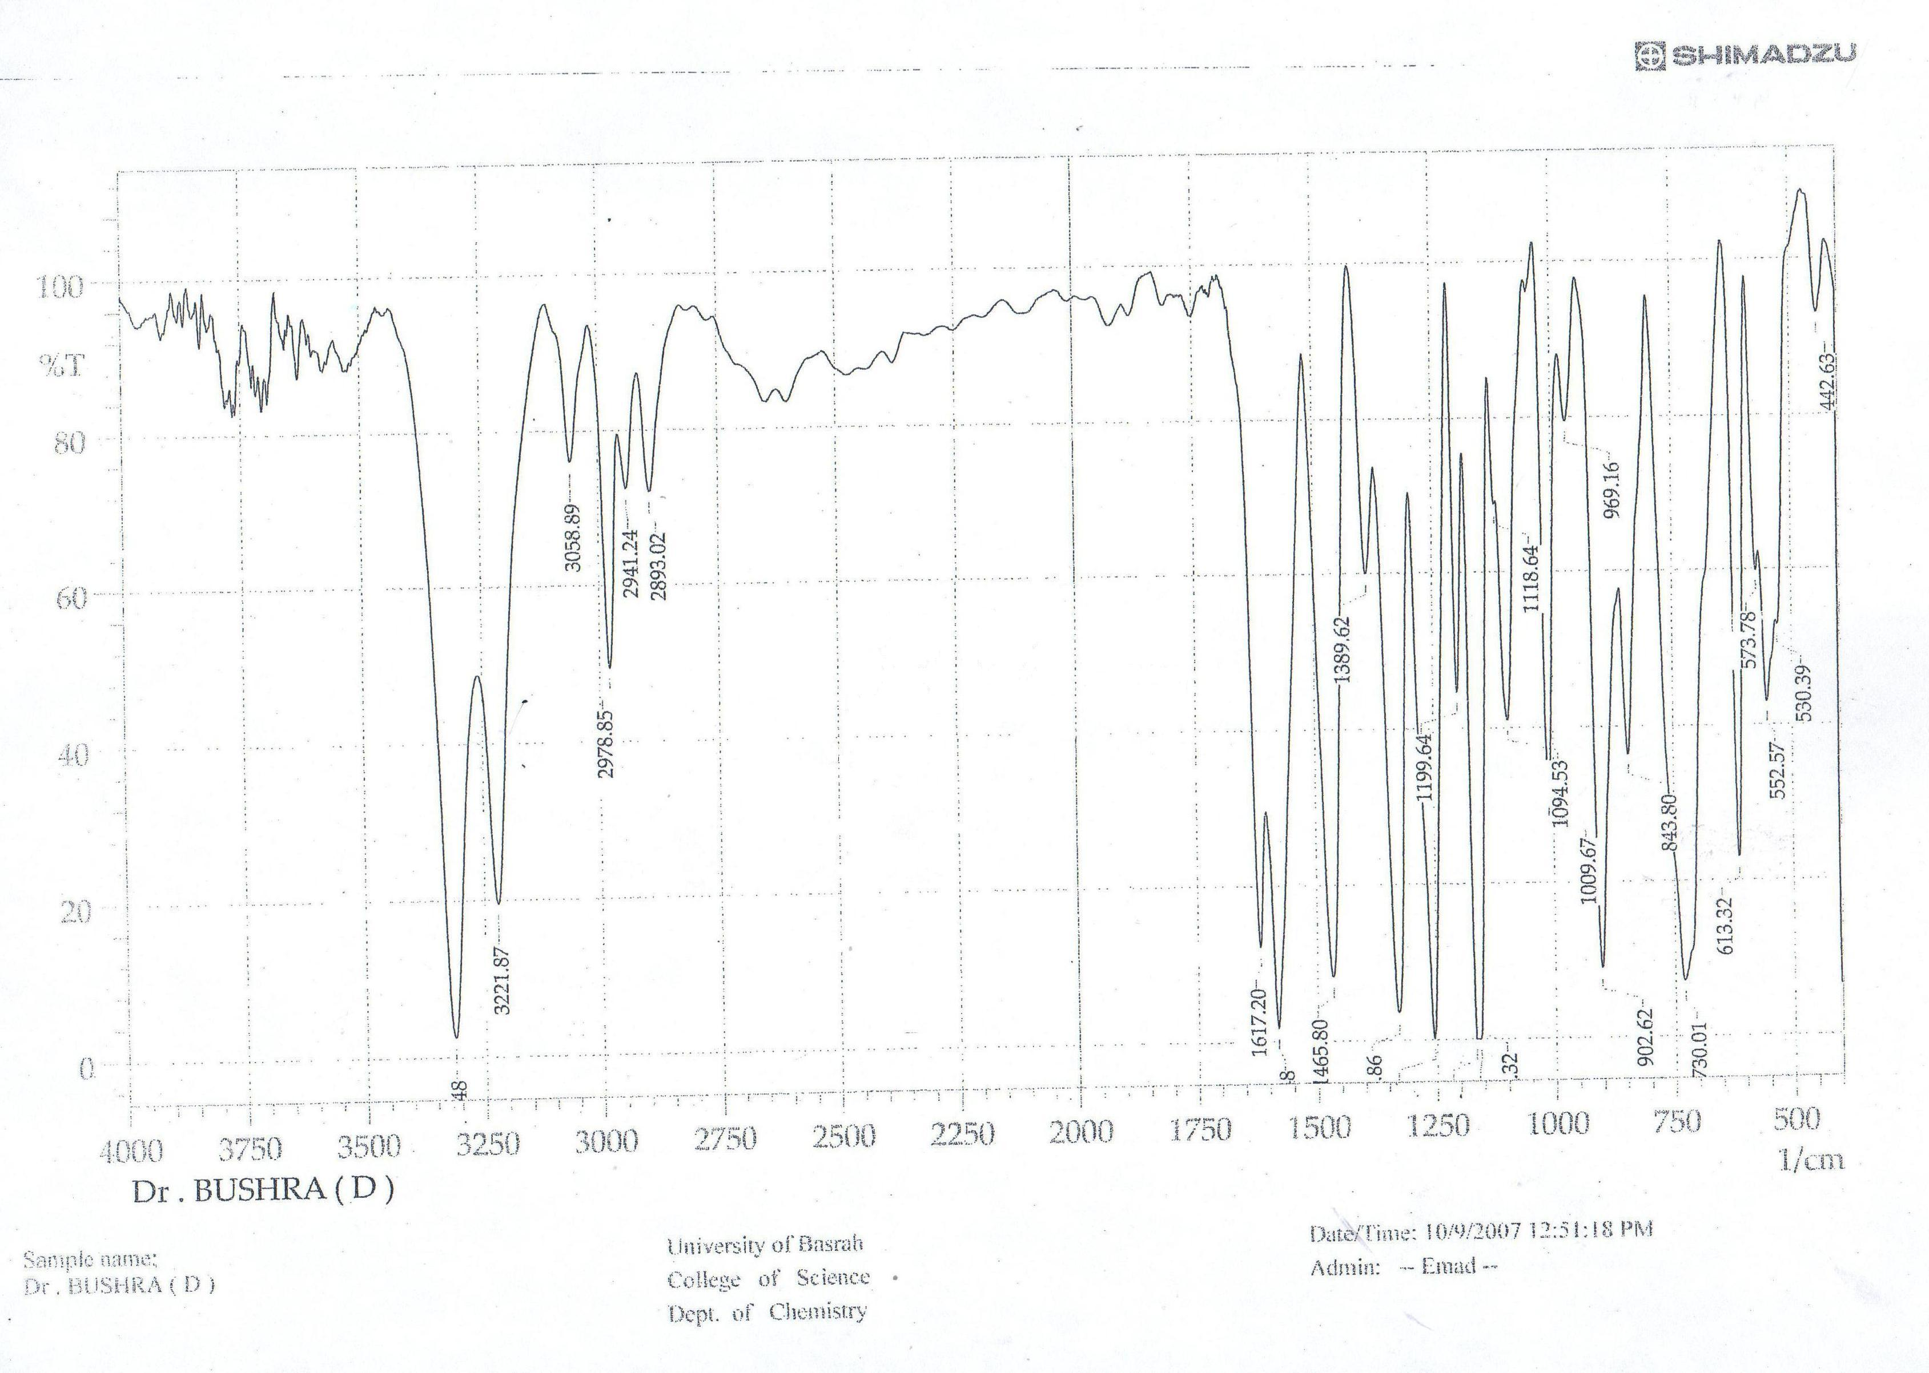

Fig 1 : IR spectra of compounds 3 and 4

Table II: IR and H’NMR data of compounds

compound | IR peaks (cm⁻¹) | H’NMR signals(ppm)
1 | 3296(vs), 3012 (m) ,1623(s), 1585(s)  1494(w), 1435(w),1330(vs), 1150(vs)  1098(m), 1001(m), 899(s), 837(s)  760(s), 713(m), 694(m), 625(s), 555(s) | - (s,br,2H,NH₂)  7.39-7.98 (m,9H,Ar-H)  8.65 ( s, 1H, N=CH)
2 | 3316(br,s), 3156(m), 3058(m), 1620(s)  1590(s), 1545(s), 1492(m), 1404(m)  1338(s), 1168(s), 1094(m), 971(m),  903(m), 827(s), 752(s), 693(s), 631(s)  577(s), 544(s) | 7-8.5 (m, 10H, Ar-H)  7.4 (s, br, 2H, NH₂)  9.7 (d , 1H, J=4.83Hz, N=CH)  15.4 ( d, 1H, OH, J=4.8
3 | 3343(br), 3245(br), 3060(w), 1620(s)  1585(s), 1563(s), 1485(s), 1455(m)  1327(s), 12182(s), 1189(vs), 1115(s),  1086(m), 997(s), 845(s), 814(s), 767(s),721(s), 641(s), 618(s), 568(m) | 6.9-8 (m,14H, Ar-H)  8.99 (s, 1H, N=CH)  9.38 (s,1H, N=CH)  11 (br , 1H,OH)  12.42 (s, H, OH)
4 | 3300(br,s), 3221(s0, 3059(m), 2979(s)  2941(w), 2893(m), 1617(s), 1595(vs)  1465(s), 1389(w), 1340(vs), 1199(vs)  1160(vs), 1094(s), 1009(s), 902(s),  843(m), 730(s), 613(s), 552(s) | 1.36 (t, 3H, CH_{3,}J=7.11 Hz)  4.1 (q , 2H, CH₂, J=7.04 Hz)  6.9-7.9 (m , 7H , Ar-H)  7.4 (s, br,2H, NH₂)  9 (s , 1H, N=CH)  12..77(s , 1H, OH)
5 | 3271(vs), 3057(sh), 2954(s), 2843(s)  1623(s), 1585(s), 1514(m), 1469(m)  1416(m), 1325(s), 1269(vs), 1150(vs),  1102(m), 1026(m), 901(s), 850(s),  787(m), 701(m), 602(s), 553(s) | 3.85 (s , 3H, OCH₃)  7.34 (br, 2H , NH₂)  7.09-7.92 (m , 8H, Ar-H)  8.56 ( s, 1H , N=CH)

H’NMR spectra:
The H’NMR spectrum of sulphanilamide in DMSO-d₆ shows the following signal σ 5.5 (s) and broad attributed to NH₂ protons , σ 6.6-6.8 attributed to SONH₂ protons and a multiplete signal at σ 7.5-7.5 ppm which attributed to aromatic H⁽⁶⁾ . The H’NMR spectra of the Schiff bases which are prepared in this work recorded also in DMSO-d₆ at 500 MHz the chemical shift values relative to the TMS signal are listed in table (II) . The data obtained from H’NMR spectra of compounds 1,2,4 and 5 indicated the absence of the signal arising from NH₂ at ~ 5.5 ppm in the resulting compounds indicate that the condensation take place at the left side NH₂ ( aniline moiety ) ,and appearance of a signal in the region of 8.5-9 ppm which attribute to the proton of azomethine groups (N=CH) ^{(3,7)} .The signal in the region 7-7.4 ppm are assigned for protons of SO₂NH₂ group which appear down field compared with sulphanilamide spectrum.
The signal of OH proton in the spectra of compounds 2,3and 4 appear at down field
(~ 11-15.4) ppm compared with that in free corresponding aldehyde (< 10 ppm) .H’NMR spectrum of compound 3 gives different result with that for another compounds (1,2,4,5) where the following signal observed (Fig :2), Ar-H appears at 6.9-8 ppm with integral value equivalent to 12 protons , two singlet signal, one at 8.9 and the another at 9.3 with integral value equal one for each signal , these two signal attributed to two different ( chemical an equivalent) azomethine proton also another two signal observed the first one is a broad signal at 11 ppm with integral value equal
One and another signal at 12.42 ppm with integral value equal one both these two signal are attributed to two different OH groups. These result illustrated that the condensation between excess salicylaldehyde and sulphanilamide under these condition give the following compound. and this suggestion with agreement with the result given by mass spectrometry which we shall discussed later in this paper.

The suggested chemical structure to compound 3

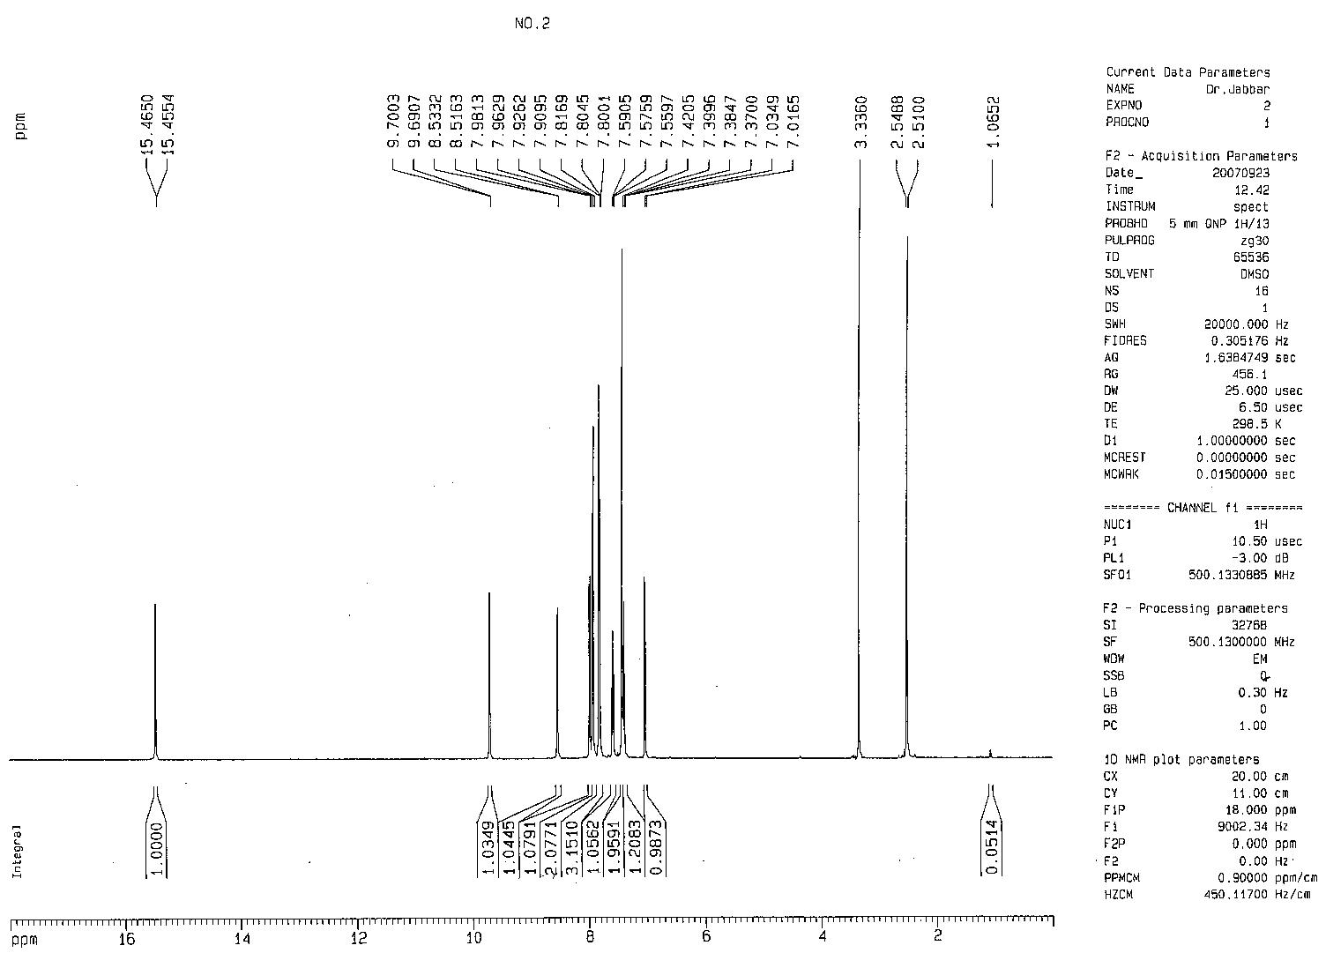
Fig 2 : H'NMR spectra to compounds 2,3 ,5

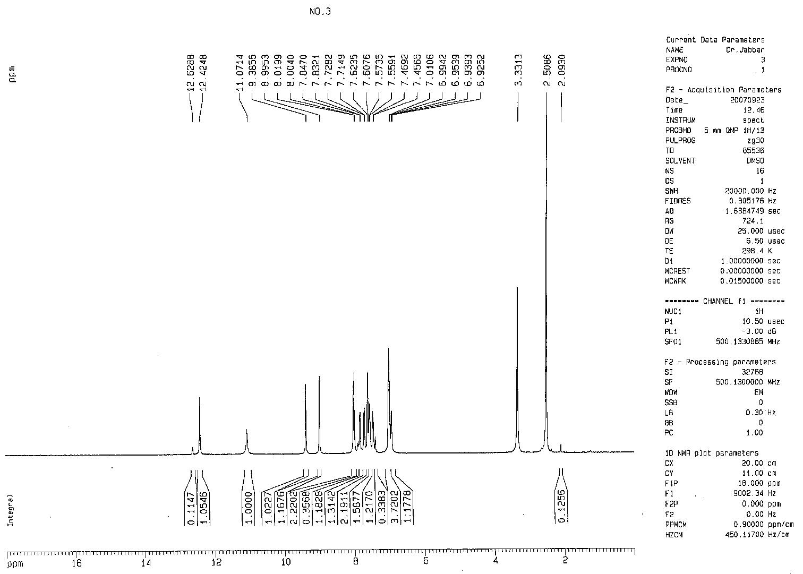

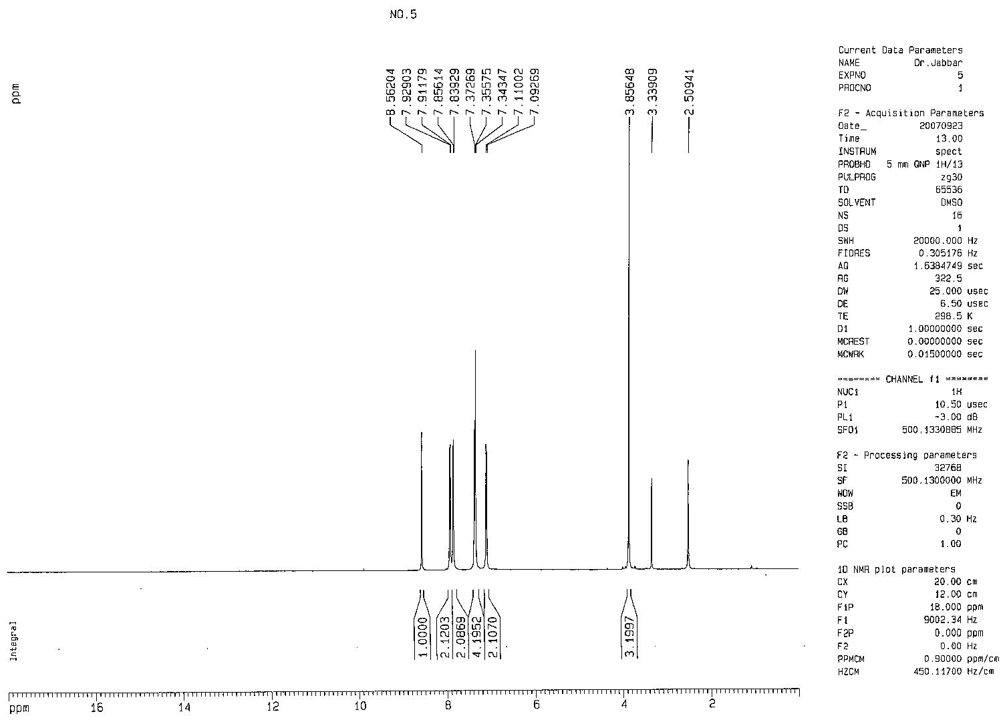

Fig (3) : H'NMR spectrum to compound 4
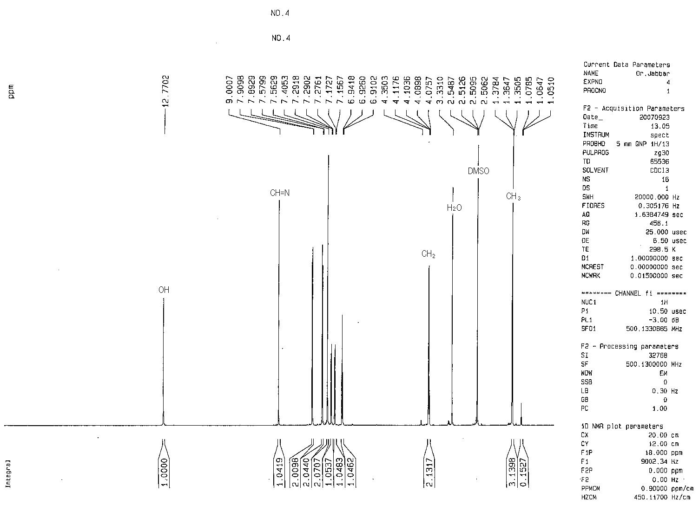

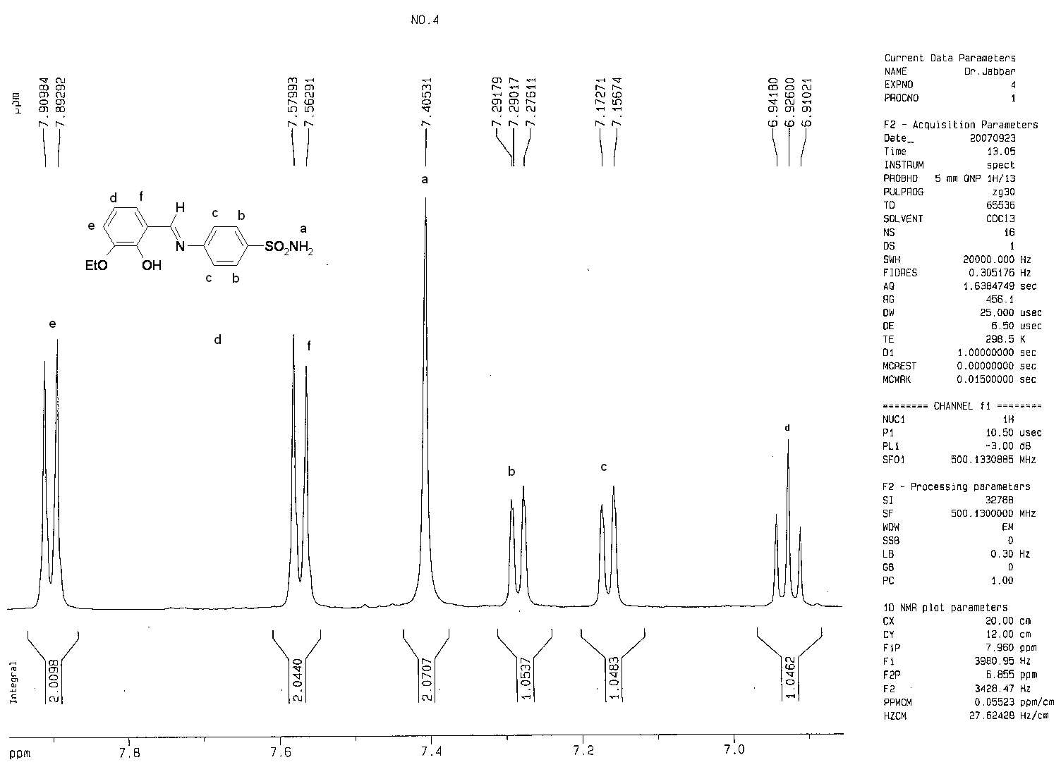

Mass spectra:
The mass spectra data of the compounds are given in Table (III) and Fig:4 , all compounds shows a molecular ion M⁺ . The molecular ion peaks are in good agreement with their empirical formulas. The high relative intensity of M⁺ in most

cases where observed , which illustrated the stability of these compounds.Mass spectrum of compound 3 shows a peak at m/z 380 with R.I. 85% these result indicate that the condensation between salcildehyde with sulphanilamide under these condition in ratio 2:1

Table III:Mass spectra data of compounds

compound | m/z | Relative intensity % | Fragment
1 | 260  259  244  196 | 100  45  11  25 | M⁺ C₁₃H₁₂N₂O₂S  [ M-H]⁺  [M-NH₂]⁺  [M-SO₂NH₂]⁺
2 | 326  309  246 | 100  20  38 | M⁺ C₁₇H₁₄N₂O₃S  [M-NH3]⁺  [M-SO₂NH₂]⁺
3 | 380  196 | 89  100 | M⁺ C₂₀H₁₆N₂O₄S  [M-C₇H₆NO₃S]⁺
4 | 322  320  305  240 | 12  90  100  18 | [M+2]⁺  M⁺ C₁₅H₁₆N₂O₄S  [ M—CH₃]⁺  [M-SO₂NH₂]⁺
5 | 290  289  210 | 100  37  18 | M⁺ C₁₄H₁₄N₂O₃S  [ M-H]⁺  [M-SO₂NH₂]⁺

Fig ( 4) : Mass spectra to the compounds 1 , 3 ,4 and 5

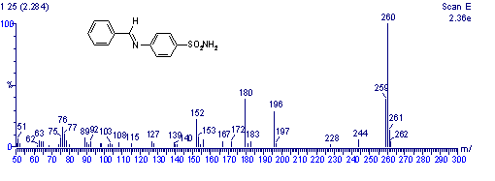

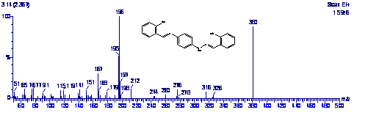

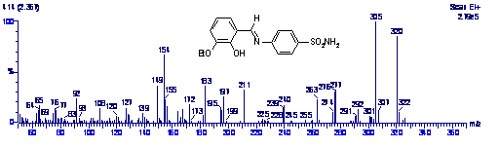

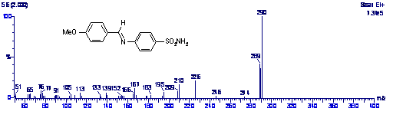

References
1-Anil Varshney and J.p. Tandon . Proc. Indian Acad ,Sci (chem..sci).;1986 , 97 (2), 141-146.
2-S.Baluja,A.Solanki and N.kachhadia: Journal of Iranian chem..soc.; 2006, 3 (4) , 312-317.
3-M.K.Gupta , Har Lal Singh, S. Varshney and A. K. Vareshny: Bioinorganic chemistry and application.; 2003 ,1(3-4) , 309-320.
4-Mukta jain and R.V.Singh: Bioinorganic chemistry and application.; 2006, article 13743 , 1-10
5-G.Sogrates : Infrared characteristic group frequencies , Wiley-interscience
publication .;1980 , 115 .
6-Charles J. Pouchert :The Aldrich Library of NMR spectra , edition II.; 1983 , 2 , 103C , 105B, 109C and 851 D
7-Han Dony Yin, min Hong, Gong Li, Da Qi Wang: Journal of organometallic
chemistry.; 2005 , 690 , 3714 -3719

