Mechanism Study of Acetamiprid reactions with
Peroxide and Oxygen in vacuum by using
Ab Initio and semiemprical calculations

Abbas A. Drea
Department of Chemistry-College of Science
University of Babylon

(NJC)
(Received on 6 /10 /2007) (Accepted for publication on 7 /1 /2008)

Abstract
Study of Acetamiprid reaction with peroxide and oxygen have been done in hypothetical photo vacuumed cell ,by using Quantum methods (Ab-initio &semiemprical ),that’s included in Hyper Chem 7.52 program. to under standing the sequence reaction mechanism ,when UV-light radiation used to produced initiated free radicals, also intermediates ,and transition structures involved during the reactions.
Chemical activity and chemical interaction of reactants and products have been studied by Surface potential energy calculations .to estimated the high probable active sites in attachment of free radicals, the energetic properties have been studied ,as total energy, atomic charge , bond stability bond torsion, electric static field, vibration spectrum ,and heat formation content.
The probable transition state of first cleavage step have been studied through calculation of total energy , zero point energy , electric dipole moment constant , vibration spectrum , and heat change formation .also activation energy barrier calculation of forward and back ward reactions are done for cleavage step of pesticide.
Thirty seven of different chemical structure have been suggested and studied ,that’s represent the most important components of reactions mechanism involved through sequence reactions. All probable occurrence reactions during degradation of pesticide into minerals were studied ,which high probably reactions that’s having lowest activation energy value are testing by comparing with other probable competitive reactions(another probabilities).total change in heat content of reaction have been calculated.
From this work they found Hydroxyl radicals produced at 533.84 nm from peroxide to initiated degradation of acetamiprid. Cleavage reaction step of acetamiprid occurs through N₈—C₁₀ bond with activation energy 51.394 and 128.159 kCal mol⁻¹ for attached reaction and cleavage reaction respectively. first step are exothermic reaction with -28.285 kCal mol⁻¹. two chemical moiety are producing from cleavage step ,which are 2-hydroy-ethyl Cyano amine and 2-Chloro-2-dimethyl amine Pyridil . 9 mole of peroxide and 12 mole of oxygen are required to convert one mole of acetamipride into 8H₂CO₃ , 2CO₂ , 4HNO₃, 2H₂O, HCl ,and 2H₂ .the total heat content change for degraded one mole of acetamipride in vacuum equal to -28177.142 kCal mol⁻¹ .

الخلاصة
تم دراسة تفاعل الاسيتامبرايد مع البيروكسيد والأوكسجين في خلية ضوئية افتراضية مفرغة من الهواء,وذلك بوساطة طرق ميكانيك الكم (الحسابات الأولية وشبه التجريبية) المحملة ضمن البرنامج 7.52 Hyper Chemلمعرفة الإلية التي يحصل فيها التفاعل المتسلسل عند استخدام الأشعة فوق البنفسجية لتوليد الجذور الحرة البادئة وكذلك المركبات الوسطية والانتقالية التي تتكون خلال التفاعل.
تم دراسة الفعالية الكيميائية و التأثر الكيميائي للمواد المتفاعلة ,بوساطة حسابات سطوح جهد الطاقة الكامنة من حيث الطاقة الكلية والشحن الذرية وثبات والتواء الأواصر و المجال الكهربائي والطيف الاهتزازي ومحتوى حرارة التكون, لبيان المواقع الفعالة ذات الاحتمالية الأكبر في حصول هجوم الجذر الحر عليها .
تم دراسة الحالات الانتقالية المحتملة التكون لحدوث خطوة بدء التكسر لجزيئة المبيد بوساطة حسابات الطاقة الكلية و طاقة نقطة الصفر وثابت العزم الكهربائي و الطيف الاهتزازي ومحتوى حرارة التكون ,إضافة إلى احتساب طاقة التنشيط لتفاعلات خطوة بدء التكسر الأمامية والعكسية.
تم اقتراح ودراسة سبعة وثلاثون مركب كيميائي مختلف تمثل أهم مكونات إلية التفاعل التي يتوقع تكونها خلال التفاعل. تم دراسة جميع التفاعلات المحتمل حدوثها خلال عملية التكسر الكلية لجزيء المبيد إلى المكونات الأساسية, حيث تم اختبار التفاعلات ذات الاحتمالية الكبرى التي تمتلك قيمة دنيا من طاقة التنشيط مقارنة بمثيلاتها من التفاعلات المنافسة لها (الاحتمالات الأخرى) .تم احتساب التغير الكلي بالمحتوى الحراري المرافق لتكسر جزيء المبيد واقتراح الإلية التي يتفاعل بها الاسيتامبرايد في الفراغ بوجود البيروكسيد والأوكسجين.
وجد إن الطول الموجي 533.84 نانوميتر هو الطول الامثل لتكون جذور الهيدروكسيل الحرة من جزيئة البيروكسيد ,لبدء تكسر الاسيتامبرايد. يحدث التفاعل بوساطة كسر الآصرة (N₈—C₁₀) بطاقة تنشيط مساوية إلى 51.394 لتفاعل الهجوم و128.159 لتفاعل التجزؤ بوحدة كيلو سعره لكل واحد مول على التوالي,كما تتولد في نهاية التفاعل حرارة مقدارها-38.285 كيلو سعره لكل واحد مول.
تتولد مكونتان من التفاعل وهما :
2-hydroy-ethyl Cyano amine و2-Chloro-2-dimethyl amine Pyridil
يتفاعل مول من الاسيتامبرايد مع 9 مول من البيروكسيد و 12 مول من الأوكسجين لكي يتحول كليا الى 8H₂CO₃و 2CO₂و 4HNO₃و 2H₂Oو HClو2H₂ وبمحتوى حراري يصل إلى -28177.142 كيلو سعره لكل واحد مول.

Introduction
Insecticides have been known since long time ago in their ability and effect in terminating harmful insects ⁽¹⁾ . the agriculture developments and the continuous needed of human foods produced a fasting progress in discovering a great number artificial pesticides after second world war. Organic artificial pesticides such as chlorinated hydrocarbons and others compounds were found to be very effective to reduced the economic losses that’s causes by organisms .for their great importance in agriculture, its represent 80% of the total number of insecticides using in Iraq. But this type of pesticides is not less poisonous than other compound on humans and animals ^{(2,3)} .This polluting agents have been increased in our environments rabidly at recent years with low number of degradation methods and missed using of this chemicals ⁽⁴⁾. In china Acetamiprid has been initially Registration at 2002 as member of pesticides family, classifying into Neonicotinoid Insecticide .Chemical name (E)-N1-[(6-chloro-3-pyridyl)methyl]-N2-cyano-N1-methylacetamidine^{(5,6)}. aerobic mineralization of Acetamiprid come out after 100 day with 0.25% of total amount. Mainly approximately > 90% of Acetamiprid are metabolised to the nicotinic acid derivative and demethylated compound (approx.50%) and IM21,IS-1-1and IS-2-1 (approx.

70%) in case of ring labelled and C≡N labelled, respectively in rats ,were these compounds detected in rat metabolism only by HPLC analysis^{(7,8)}. Extensively and rapidly metabolized occurs in rats, Metabolites 79-86% of administered dose. Profiles similar for males and females for both oral and intravenous dosing. Three-seven percent of dose recovered in urine and faces as unchanged test article. Urinary and faecal metabolites from 15-day repeat dose experiment only showed minor differences from single-dose test^{(9,10)} .
Different chemical methods have been used for photodegradation of the organic pesticides, so called advanced oxidation process have been a usual methods for aquatic detoxidation⁽¹¹⁾ . heterogeneous photocatalysis, has great potential as technique to dispose off enverimentalally harmful or carcinogenic compounds at semiconductor water interface ⁽¹²⁾ .Insecticides can be photodegradation into minerals in aqueous solution containing semiconductor powder suspensions ,and H₂O₂ ,would increases the efficiency of the photodgradation process .H₂O₂ is an electron acceptor which lead to more generated of hydroxyl radicals during reacting with electronic conduction band as follow

H₂O₂ + e_{cb} OH⁻ +OH* (1)

The resulting hydroxyl radicals at the surface of semiconductor are more destruction of most organic pollutants ⁽¹³⁾ .the presence of oxygen molecules on the catalysis surface lead to increment in radical ions generated (O^{*-}₃ , O^{*-}₂ , O^{*-} ) .that’s enhance the photo-oxidative degradation process ⁽¹⁴⁾ .
Chemical reactions can be under standing through potential energy surface calculations ,were quantum mechanically equations are computed . therefore simulation are carried out to find out the real mechanism of reaction. Photochemical reaction have been studied theoretical also through the simulation , light and organic molecule interaction mechanisms are studied by computation of products stabilities and the mechanism of transition state through calculation of energy barrier, MP2 high level of ab initio calculation. The understanding of the chemical interaction of these pollutants is very important because its composition in our environments depends not only on its rate of formation but also on its rate of removal. the investigation of possible reaction paths of chemical species reaction with light current out various accuracy types of mathematical function for theoretical packaged world programs ⁽¹⁵⁾ .
In present work we are interested in study the mechanism of Actamiprid reaction with peroxide and oxygen that’s initiated by UV- light energy . simulation of degradation reaction in vacuum photo cell unite were carried out through theoretically design to examination the sequence reaction components. Look out into chemical stabilities of transition state structures Intermediates, products, and the mechanism of transition state through calculation of energy barrier using MP2 high level of ab initio calculation, and PM3 configuration interaction method of semiemprical calculation. The understanding of the chemical interaction of these sequences reaction is very important because its composition in the in our environments depends not only on its final composition products but also on its intermediate component that’s formation along time of reaction . investigation the possible reaction paths of actamiprid reaction with peroxide and oxygen by using light , namely, abstraction reaction and replacement (oxygenation) reaction through formation of hydrodioxyl radical (HDR) and the radical species OH*+O+RO* which that’s give-up a stable molecules with lowest toxicity , like carbonic acid ,nitric acid and hydrochloric acid result in the final time with help of some thermodynamic properties ΔHº , ΔE, IR-frequencies. Some structures for transition state are suggested based on the possibility of attack of hydroxyl radical and oxygen radical to acetamiprid molecule. We suggested that the attachment of hydroxyl radical after photodissociation of peroxide to the acetamipride molecule might be either to most possible sit according to calculation.
Computational Details
Through this study, various theoretical MO methods have been used. The geometries of the 38 structures of chemical species and their complex structures with peroxide and oxygen have been optimized at MP2//6-31++G level of theory and MP2 levels of theory^{(16,17)} using MP2/6-31G(d,p) MP2//6-31++G**,6-31-G(d), and 3-21G⁽¹⁸⁾ basis sets. IR frequencies, Energizes and bonds length of proposed transition state calculated at 3-21G level and PM3 CI method for characterization of the nature of structures and zero point energy (ZPE) calculations to compute the quantum energies of these reactions. All the stationary points have been positively identified for minimum (number of imaginary frequencies NIMAG=0), transition state (NIMAG=1).IRC calculation have been carried out at 3-21+G**.Energy barrier calculation of competitive reactions are carried out by semiemprical /PM3 through algorithm of synchronous transit/Quadratic-RMS(gradient of 0.1kCal mol⁻¹ ^{(19,20)}. All calculations have been carried out using HyperChem 7.52⁽²¹⁾.
Results and Discussion
Reactions have been carried out in hypothetical photocell unites, which designed to provided gaseous reaction in vacuum. Two path ways in photo cell for several uses, out put air, input acetamiprid ,input peroxide, and oxygen input, also this paths provided with valve to controlling these process. Thermal heating in photocell unite eliminated by using water circular ,the design of photocell described in figure (1).

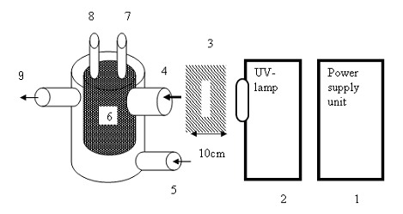

Figure (1)Hypothetical photoreaction cell unite of Acetamipride reaction in vacuum.

- Power supply unit.
- UV-Light Source.
- Lens.
- Input light path of Photocell.
- Input water path of photocell jacket.( Thermostats and water Circulating unit ).
- Photocell(Actamiprid container).
- Input peroxide path of photocell.
- Input oxygen path of photocell.
- output water path of photocell jacket.

The study of photochemical reactions mechanism depend on the chemical reactivity of reactants and energized properties of intermediate ,transition state and product stability. Reactant have been introduced into hypothetical photocell in steps ,which the process of initiated the reaction are carried out by input peroxide with using a proper wave length of UV-light energy radiation at last oxygen come in. 1.Chemical reactivity of reactants
Three chemical species must be found in our assumption to begin the chemical gaseous phase reaction in vacuumed container ,that’s excitation with suitable UV-wave length radiation. Photodegrdation reaction of Acetamiprid give up fine molecules comparing with the original poison pesticide molecule. the dissociation O-O bond in Peroxide molecules to produced two hydroxyl radical which is initiate the photoreactions of Acetamiprid until mineralization complete. Different chemical species are involved through free radical mechanism .
Chemical properties of Acetamiprid Chemical properties of Acetamiprid have been calculated at MP2//6-31++G level of as shown in figure (2).the estimation predicted the positive side and negative side of molecules that’s affords good sits of free radicals attaches for reactions in vacuum .At the same time, free radical involved through reaction simulating vacuumed container ,that’s have two different side of electrostatic potential also, were the opposite sides will attached.

Figure(2)chemical properties of acetamiprid calculated at MP2//6-31++G level .
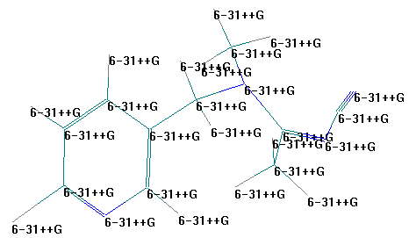 | 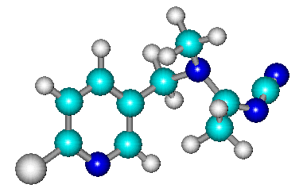
A-Basis set Function | B- Balls &cylinders view
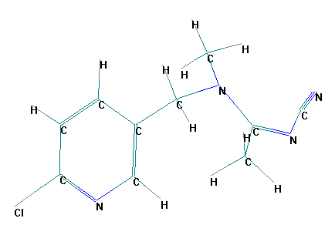 | 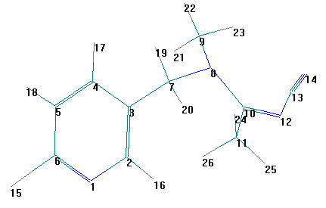
C-Atomic symbol | D-Atomic serial number
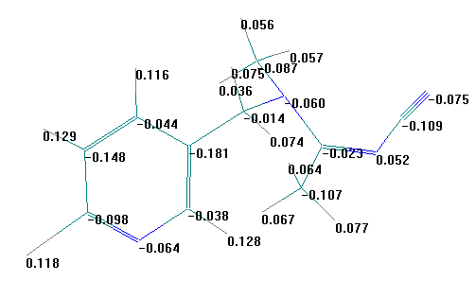 | 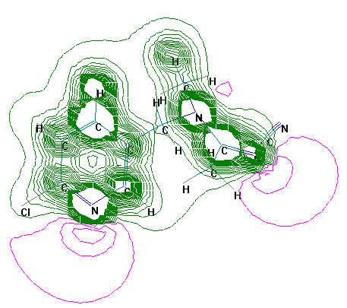
E-Atomic charge | F-Electrostatic potential in 2D

Bond length ,bond order ,bond angles and bond torsion of main bonds have been calculated at MP2//6-31++G level as shown in . table 1. according the compares between these bonds length and bond torsion can be estimate
several bonds are weakness than last or more probable for reactions or broken exchange with free radicals .all of the bond C₇-N₈ , N₈-C₉ , N₈-C₁₀ represented the most probably active sit in acetamiprid for reactions with radicals.

Table (1) Maine Bond properties of Acetamipride calculated at MP2//6-31++G level.
Bond | order | Length °A | Bond | Angle ° | Bond | Torsion °
N₁-C₆ | 2 | 1.3567 | C₇-C₃-C₄ | 120.657 | C₄-C₃-C₇-N₈ | 86.3222
C₃-C₇ | 1 | 1.4385 | C₃-C₇-N₈ | 115.837 | C₃-C₇-N₈-C₉ | -58.552
C₇-N₈ | 1 | 1.4662 | C₇-N₈-C₉ | 114.957 | C₉-N₈-C₁₀-C₁₁ | 45.8156
N₈-C₉ | 1 | 1.4778 | C₇-N₈-C₁₀ | 114.532 | C₉-N₈-C₁₀-N₁₂ | -132.30
N₈-C₁₀ | 1 | 1.4997 | N₈-C₁₀-N₁₂ | 120.434 | N₈-C₁₀-N₁₂-C₁₃ | -1.6688
C₁₀-N₁₂ | 2 | 1.3005 | N₈-C₁₀-C₁₁ | 120.893 | C₁₀-N₁₂-C₁₃-N₁₄ | 175.489
N₁₂-C₁₃ | 1 | 1.3801 | C₁₀-N₁₂-C₁₃ | 125.045 | C₁₁-C₁₀-N₁₂-C₁₃ | -179.83
C₁₃-N₁₄ | 3 | 1.1631 | C₁₀-C₁₁-H₂₆ | 109.955 | N₈-C₁₀-C₁₁-H₂₆ | 64.4951
C₆-Cl₁₅ | 1 | 1.6873 | N₁₂-C₁₃-N₁₄ | 173.923
N₁-C₆ | 2 | 1.35673

Chemical properties of Peroxide and Oxygen
Chemical properties and energize characters of peroxide ,oxygen and their radicals have been calculated by 6-31++G** level of theory as shown in figure (3),

to estimate the proper attachment sit in both them for actamiprid .the first initiation reaction step carried out through the stability of O—O bond ,which calculated from potential energy surface is equal to -94630 kCal mol⁻¹in peroxide. can be broken down at last 2 ^{ο}A as in following equation.

H₂O₂ 2OH* (2 )

Energy barrier of this reaction equal to +53.60512 kCal mol⁻¹, calculated at 6-31G** level, the corresponding wave length for this energy barrier equal to 533.84 nm of UV-light, that’s must be using to initiated degradation reaction of peroxide into hydroxyl radicals. hydroxyl radical has two different side of potential ,that’s using in attached into substrate moiety.
Chemical properties of Oxygen show, that’s molecule has two equal side of electrostatic potential ,which’s both atoms are same in probability of reaction side. Oxygen radicals has two different side of electrostatic potential ,but both of them are spherical to each others .
From above evidence the Negative Sides(nitrogen atoms)in acetamiprid attach to positive side of hydroxyl radicals ,and all positive side (carbon atoms)attach to negative side of radicals to produced transition state. At the same way different sides of electrostatic potential of reactants are combine with each others.

Figure(3)chemical properties of peroxide and Oxygen calculated at MP2//6-31G** level .
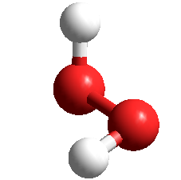 | 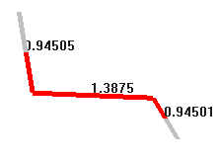 | 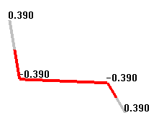
Ball and cylinder view (H₂O₂) | bond length of H₂O₂ | Atomic Charge H₂O₂
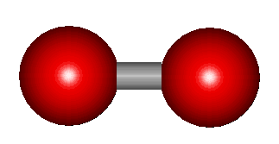 | 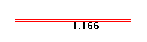 | 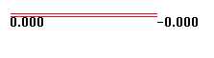
Balls and cylinder view(O₂) | bond length of O₂ | Atomic Charge of O₂
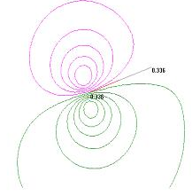 | 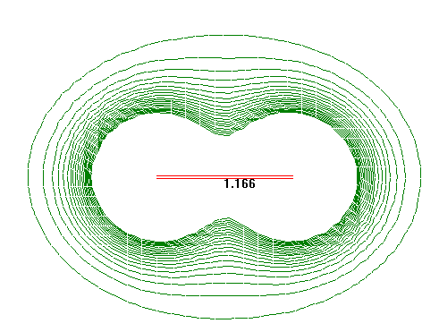 | 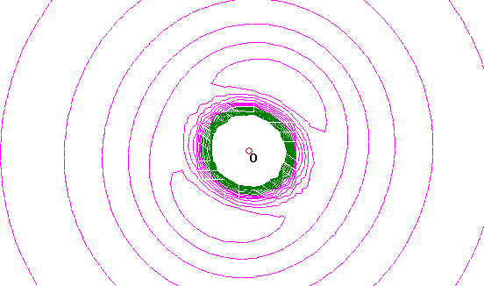
Electro static potential of OH*radical | Electro static potential of O₂ | Electro static potential of O^{*-}radical

The estimation predicted on the stability of O=O bond calculated from potential energy surface is equal to -93900 kCal mol⁻¹ which can be broken down at last 1.3 ^{ο}A as in following equation .

O==O 2O⁻* (3)

According equation (3) ,the energy barrier of this reaction equal to +27.61665 kCal mol⁻¹, calculated at 6-31G** level, the corresponding wavelength for this energy barrier equal to 1036.23 nm. Therefore as soon as Oxygen inter into reaction mixture can be react either as molecules ,or oxygen radical because
its dissociated into two mole of oxygen radical .
- Transition States Calculations
Our techniques that’s have been used to look into the transition state. Is depending on mixing between calculations of the quadratic synchronous transit method (QST) of HyperChem 7.5 which searches for a maximum along a parabola connecting

reactants and products, and for a minimum in all directions perpendicular to the parabola and calculation of searching transition state structure is based on chemical guess in which one can suppose several possible transition states and then examined by IR calculation. This method is good for a well-known reaction mechanism.
Our strategy depend on that’s Vacuumed vassal contained Acetamipride in gas phase and peroxide introduced later with required wave length, finally oxygen gas add . For deep investigation, Ten transition state structures are proposed for reaction of Acetamiprid with hydroxyl radical that’s produced as soon as interred . first step initiated by UV-light energy ,photolysis of oxygen bond in peroxide to produces two moles of hydroxyl radicals that’s one of them participate in the transition state of cleavage bond of Acetamipride.

Due to different probable active site ,that’s may participate in the initial reaction cleavage step of degradation as shown in figure (5) geometries of the proposed transition state are calculated by PM3 configuration interaction(4x3) . IR frequencies, Energizes and bonds length have been calculated to estimate the real transition state ,that’s give up the main reaction products by comparing their features as shown in table 2 .
The first reaction step of Acetamiprid occurs through the first proposed transition state due its first negative frequency of IR spectrum calculations(imaginary value) . higher value of Zero point Energy, which give up low value of energy barrier for transition state dissociation into product . the longest N₈-C₁₀ bond value(weakness bond) than other transition states. Its needed lowest energy to produces the products of cleavage step.

Figure( 4 )Stereo Stick view of Ten proposed transition state calculated by PM3 configuration interaction(4x3) .
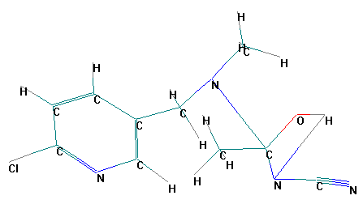 | 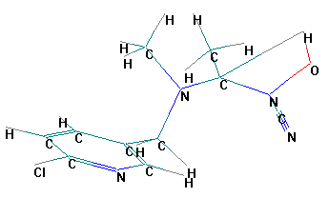
TS1 | TS2
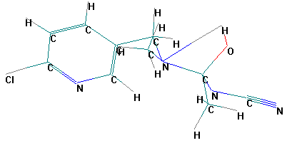 | 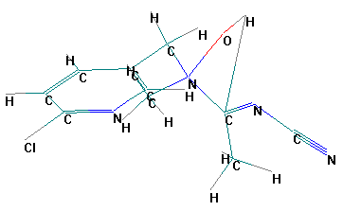
TS3 | TS4
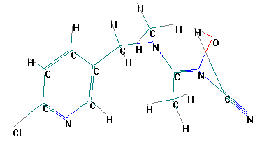 | 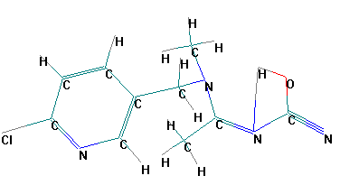
TS5 | TS6
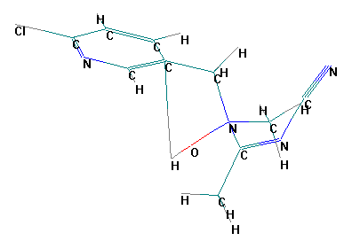 | 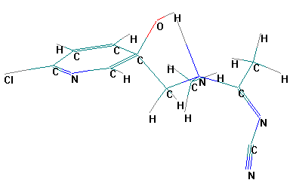
TS7 | TS8
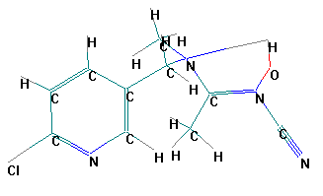 | 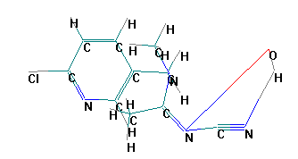
TS9 | TS10

Table (2) IR frequencies, Energizes and bonds length of proposed transition state calculated at 3-21G level and PM3 CI method.
TS NO | IR -Fequncy | Zero Point Energy kCal mol⁻¹ | Heat of formation kCal mol⁻¹ | CI -Energy** kCal mol⁻¹ | BOND LENTH °A
 |  |  |  |  | N₈-C₁₀ | C₁₀-N₁₂ | N₁₂-C₁₃
1 | -22.13 | 135.46955 | 44.3504839 | -52.836751 | 3.912 | 1.312 | 1.380
2 | +7.74 | 131.75828 | 75.1597189 | -48.175815 | 1.446 | 1.438 | 1.402
3 | +12.04 | 132.79094 | 50.1598389 | -50.970140 | 1.511 | 1.484 | 1.345
4 | +24.24 | 132.422098 | 82.0181575 | -51.795368 | 1.451 | 1.312 | 1.379
5 | +12.66 | 131.85264 | 72.4494637 | -49.092716 | 1.450 | 1.427 | 1.404
6 | +2.395 | 133.37362 | 46.5938086 | -63.166327 | 1.480 | 1.297 | 1.436
7 | -10.02 | 132.4974 | 107.1565486 | -45.050672 | 1.496 | 1.360 | 1.361
8 | +12.29 | 132.20574 | 55.8961023 | 55.896102 | 1.461 | 1.302 | 1.377
9 | +17.98 | 132.10958 | 72.1373734 | -48.80936 | 1.450 | 1.427 | 1.40
10 | -6.97 | 129.79240 | 73.8100419 | -40.56988 | 1.461 | 1.303 | 1.380
*Configuration Interaction with HE Correction .

- Cleavage reaction step of Acetamipride
There are some factor may play important role in the formulation of the reaction mechanism, such as the possibility of existence of various reactions sites of radical attack into Acetamiprid molecule from different directions ,and also the influence of H₂O₂ ,temperature, and UV-light on the reaction path way. only One hydroxyl radical ,that’s initiate the degradation reaction through step two of sequential free radical reaction .according to our previous investigation the first suggested cleavage step of acetamiprid pass through first transition state(real state) to give-up two main fragments, as shown in scheme (1). During the second initiated reaction step, that’s occurs in the series of free radical reactions to produced STR1(2-hydroy-ethyl Cyano amine) and STR2( 2-Chloro-2-dimethyl amine Pyridil ). Both of them obeyed to further more free radical reactions by different possibilities of hydroxyl and oxygen radicals respectively. reversibility of free radical reactions have been examined by energy barrier calculations, to estimate what’s the reactions can be refers back to give reactant species because this phenomena is very effective on the reaction rate and its inversely proportional, in another word energy barrier determine what is the high probable reaction .Calculations have been carried out by 3-21G** at level of theory .attacked reaction of hydroxyl radical into Acetamiprid needed 51.394 kCal mol⁻¹ and dissociation reaction of real transition state into reactants needed 145.33kCal mol⁻¹ .at the same time dissociation reaction into product and its refers reaction needed 128.159 and 582.32 kCal mol⁻¹ respectively. there fore,STR1 and STR2 are the main chemical species produced from cleavage step .both of them inters into the serious of free radical reactions to produced fine moieties in the final state of degradation. first suggested cleavage step was exothermic reaction, can be written as in following equation

C₁₀H₁₁N₄Cl + OH* C₃H₃N₂OH + C₇H₈N₂ * (4)
∆H°_{reaction} = -38.285kCal mol⁻¹

Heat formation change have been calculation by PM3 CI(4x3)method of semiemprical calculation. There’re many possible site in Acetamiprid molecule ,which may be attacked initially i.e(C₅ ,C₇ ,C₁₃,N₁ ,N₈ ,N₁₄ ).the other follow up attacking radicals nOH* and nO* were causes the oxidation of carbon atoms into carbonic acid and nitrogen atoms into nitric acid and chlorine atoms into hydrochloric acid and incorporation products. two main line have been proposed to degraded STR1 and STR2,that’s only highest reaction probability are remember.
Scheme(1) Suggested mechanism of first cleavage degradation reaction step of Acetamiprid .

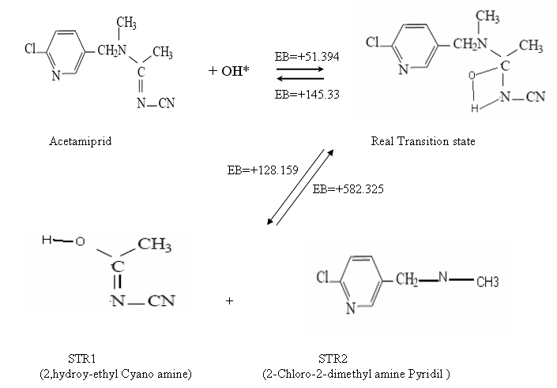

- Structures and energetic of intermediate, transition ,and products
Fully optimized geometries of the sixteen structures obtained from the suggested sequential free radical reactions of two main product molecules. calculation carried out at MP2/6-31 G(d,p)level of theory ,presentation coming in figure (5)shows the ball and stick view representation of these structures that’s coded by numbers(STR00).table(3) shows the energized properties, which total energy ,zero point energy (ZPE) ,dipole moment , and heat of formation have been calculated by PM3 CI method of semiemprical calculations .also the theoretical IR-frequencies calculation are tabulated into same table to identify the transition structure of these suggested reaction products.

Figure(5) optimized geometries ball and cylindrical view of intermediate, transition, and product structures calculated at MP2/6-31G(d,p) level of theory.
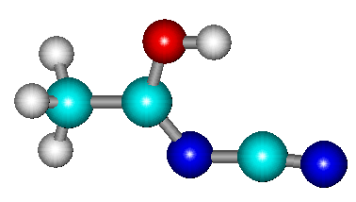 | 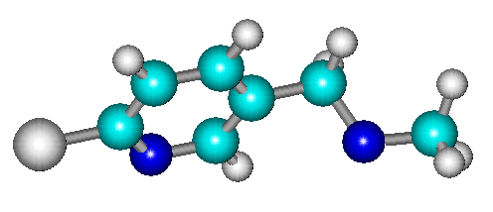 | 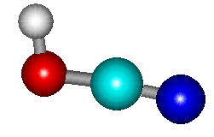
STR1 | STR2 | STR3
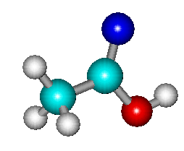 | 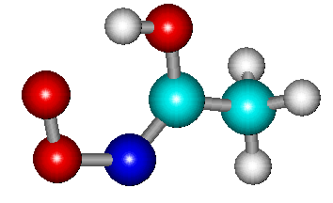 | 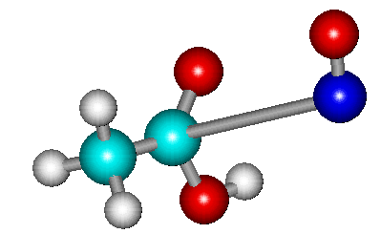
STR4 | STR5 | STR6
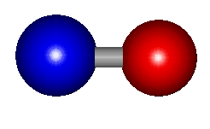 | 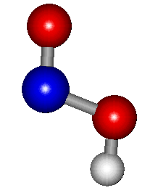 | 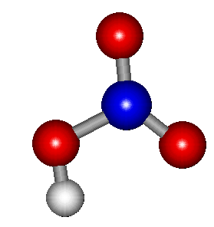
STR7 | STR8 | STR9
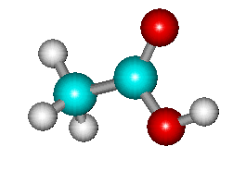 | 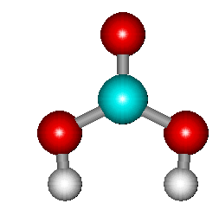 | 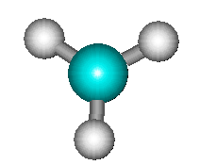
STR10 | STR11 | STR12
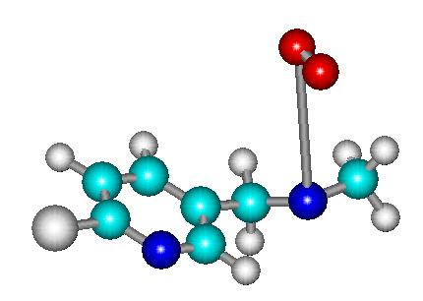 | 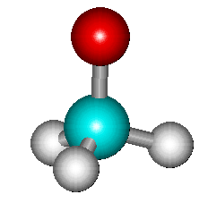 | 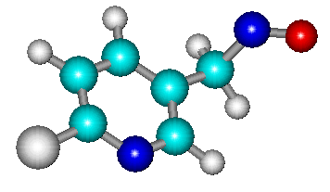
STR13 | STR14 | STR15
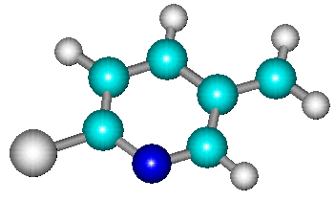 | 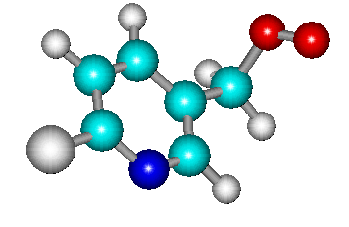 | 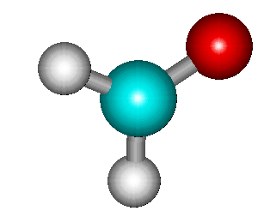
STR16 | STR17 | STR18
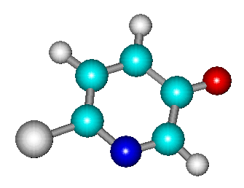 | 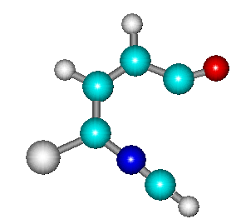 | 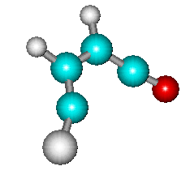
STR19 | STR20 | STR21
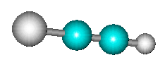 | 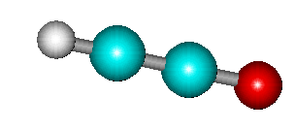 | 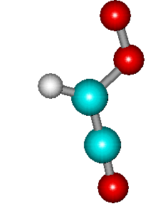
STR22 | STR23 | STR24
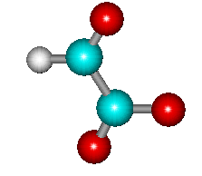 | 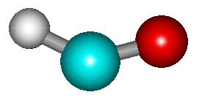 | 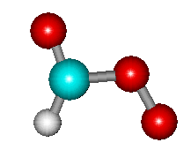
STR25 | STR26 | STR27
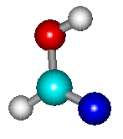 | 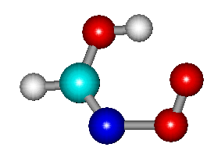 | 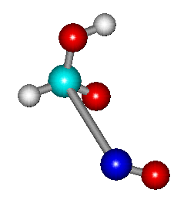
STR28 | STR29 | STR30
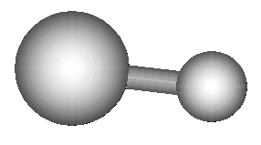 | 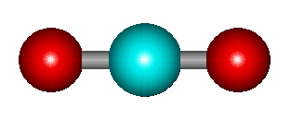 | 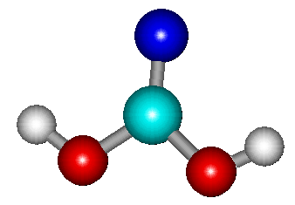
STR31 | STR32 | STR33
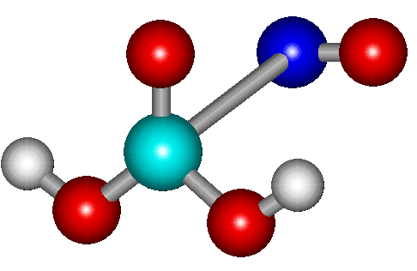 | 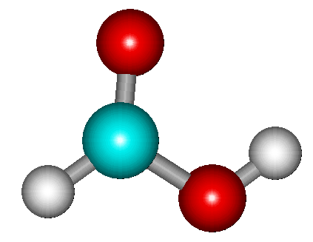 | 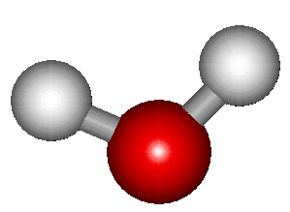
STR34 | STR35 | STR36
CH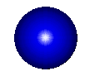NO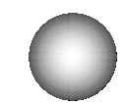Cl Atomic legends

Table(3)Energetic properties of suggested structures ,that’s involved in degradation mechanism of Acetamiprid calculated at MP2/6-31G(d,p) level of theory and PM3 CI method of semiemprical .

Structure code | Total energy* | ZPE* | Dipole moment(Debye) | IR-frequencies | ∆H°_{f} *
STR01 | -23856.773 | 45.340 | 3.77 | + | -7.017
STR02 | -36729.197 | 84.914 | 4.09 | + | 44.360
STR03 | -13585.083 | 13.981 | 3.183 | + | -15.728
STR04 | -1737.024 | 38.095 | 2.023 | + | -6.9695
STR05 | -30828.085 | 43.237 | 1.898 | + | 2.119
STR06 | -30917.631 | 42.159 | 1.609 | + | -87.426
STR07 | -10465.131 | 3.378 | 0.473 | - | 14.679
STR08 | -17580.392 | 13.334 | 2.084 | + | -14.927
STR09 | -24335.623 | 16.342 | 2.32 | + | -38.083
STR10 | -20452.499 | 38.508 | 1.835 | + | -102.105
STR11 | -23779.370 | 23.870 | 4.781 | + | -140.024
STR12 | -3768.779 | 18.336 | 0.000 | + | 27.921
STR13 | -50190.057 | 87.817 | 4.189 | - | 47.649
STR14 | -10539.307 | 23.338 | 1.874 | + | -10.532
STR15 | -39673.716 | 64.591 | 2.719 | + | 35.215
STR16 | -29190.009 | 57.107 | 2.425 | + | 39.111
STR17 | -42661.984 | 63.674 | 2.753 | + | 31.285
STR18 | -10209.319 | 16.288 | 2.164 | + | -34.123
STR19 | -32514.561 | 42.978 | 2.317 | + | 3.511
STR20 | -32460.878 | 41.806 | 3.242 | + | 57.194
STR21 | -25643.934 | 27.695 | 1.484 | + | 36.859
STR22 | -13076.681 | 12.652 | 0.1393 | + | 46.528
STR23 | -12521.232 | 12.253 | 1.592 | + | 36.350
STR24 | -26012.842 | 18.377 | 1.833 | + | 8.890
STR25 | -26091.000 | 18.612 | 1.693 | - | -69.267
STR26 | -9831.862 | 8.673 | 1.602 | + | -10.243
STR27 | -23315.601 | 14.982 | 2.146 | + | -29.833
STR28 | -13917.519 | 19.955 | 1.79 | + | 5.413
STR29 | -27374.994 | 24.274 | 1.909 | - | 12.088
STR30 | -27467.057 | 24.052 | 1.165 | - | -79.974
STR31 | -7671.260 | 4.666 | 1.385 | + | -19.979
STR32 | -16285.203 | 6.963 | 0.000 | + | -85.089
STR33 | -20697.435 | 24.283 | 1.052 | + | -42.427
STR34 | -34251.615 | 27.955 | 0.694 | - | -132.457
STR35 | -17001.750 | 20.572 | 1.502 | + | -94.479
STR36 | -7492.690 | 13.669 | 1.739 | + | -53.458
* kCal mol⁻¹

- Degradation reaction OF first cleavage step product
The products of first step are introduced directly, as soon as, formation into the sequence reaction through propagation reactions of free radicals .end of reaction are controlling by termination reaction of free radicals and also by the collision of initiation radicals with container walls. two different reaction line can be estimated according calculation, to describe the suggested mechanism of acetamiprid with peroxide and oxygen in vacuum as follow:

Degradation reaction OF 2-hydroy-ethyl Cyano amine
According to investigation of calculation . all false reaction didn’t member due its lowest probability to occurs, depending on the energy barrier value condition. degradation carried out into fine moieties by using 7 mole of hydroxyl radicals and 7/2 moles of oxygen to produced 3 moles of carbonic acid ,2 moles of nitric acid ,and 3 mole of hydrogen radicals. the reaction is exothermic reaction ,which produced -326.042 kCal mol⁻¹ as in equation (5). Scheme(2) represent the Suggested mechanism of 2-hydroy-ethyl Cyano amine degradation.

CH₃-C(OH)=N-C≡N +7OH* +7/2O₂ 3H₂CO₃ +2HNO₃+3H* (5)
∆H_{reaction} = -326.042 kCal mol⁻¹

Degradation reaction OF 2-Chloro-2-dimethyl amine Pyridil
Calculation estimation shows after several propagation reaction of free radical reactions, that’s the 2-Chloro-2-dimethyl amine Pyridil degradation are carried out into fine moieties by using 10mole of hydroxyl radicals and 17/2 moles of oxygen to produced 5 moles of carbonic acid ,2 moles of nitric acid , 2 mole of carbon dioxide, 3 mole of hydrogen radicals ,1mole of hydroxyl radical, and 1mole of chlorine radical. Scheme(3-A)and(3-B) represent the Suggested mechanism of 2-Chloro-2-dimethyl amine Pyridil degradation . the reaction is exothermic ,which produced -336.901 kCal mol⁻¹ as in equation (6).

C₇H₇N₂Cl +10OH*+17/2O₂ 5H₂CO₃ +2HNO₃+2CO₂+OH*+3H*+Cl* --(6)
∆H_{reaction} = -336.901 kCal mol⁻¹

the following reaction take pleased in reaction container as termination reaction of free radicals.

H* + Cl* HCl (7)
∆H_{reaction} = -102.919 kCal mol⁻¹

H* +OH* H₂O (8)
∆H_{reaction} =-106.513 kCal mol⁻¹

2H* + 2H* 2H₂ (9)
2x( ∆H_{reaction} = -117.601 kCal mol⁻¹)

The overall reaction of acetamiprid with peroxide and oxygen can be represented in equation(10) ,which is represent the total summation of equations 4,5,6,7,8 and 9 as follow:-

C₁₀H₁₁N₄Cl +9H₂O₂+12O₂ 8H₂CO₃+2CO₂+4HNO₃+2H₂O+HCl+2H₂
------(10)
∆H_{reaction} = -1145.897 kCal mol⁻¹

Scheme(2) Suggested mechanism of free radicals degradation for 2-hydroy-ethyl Cyano amine in vacuum.
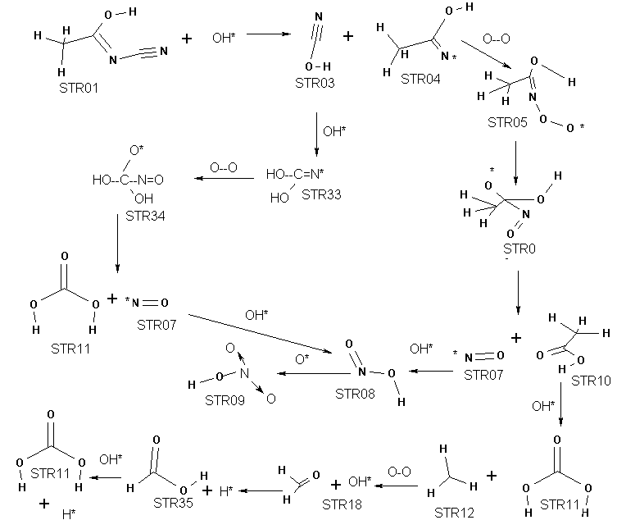

Scheme(3-A) Suggested mechanism of free radicals degradation for2-Chloro-2-dimethyl amine Pyridil.
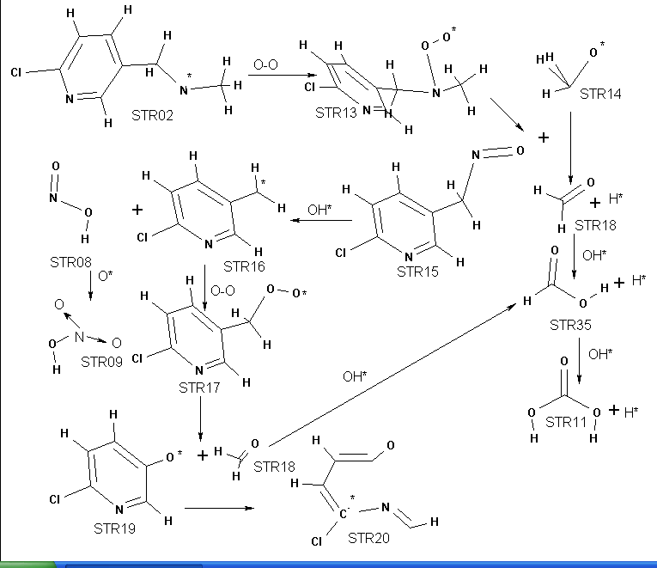

Scheme(3-B) Suggested mechanism of free radicals degradation for2-Chloro-2-dimethyl amine Pyridil.
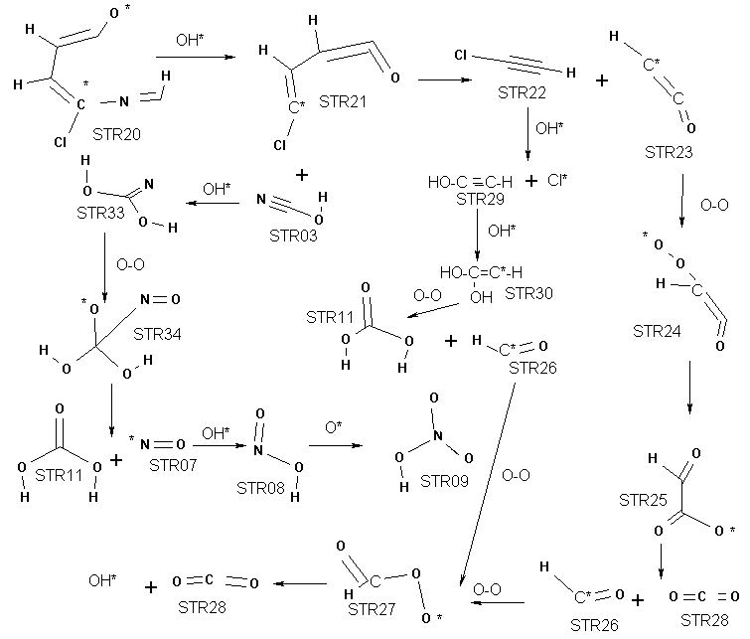

Conclusion
It could be concluded that the reaction of Acetamipride with peroxide and oxygen in hypothetical vacuumed photocell is possible and can be carried out actually by using 533.84 nm of UV-light, to initiated degradation reaction of peroxide into hydroxyl radicals. The most probable Attachment reaction of hydroxyl radical to Acetamiprid occurs at N₈—C₁₀ bond through transition state ,that’s has lowest energy barrier value(51.391 kCal mol⁻¹ )than other suggested state.

two chemical moiety are produced from second initiation free radical reaction, which is at the same time is first cleavage step of Acetamiprid. after long serious of free radical reaction chain ,and termination reaction ,Acetamiprid are converted into fine moieties . The overall reaction of Acetamiprid with peroxide and oxygen are exothermic reaction , which liberate -1145.897 kCal mol⁻¹ and can be written as in following equation :-

C₁₀H₁₁N₄Cl+9H2O₂+12O₂ 8H₂CO₃+2CO₂+4HNO₃+2H₂O+HCl+2H₂

References
- M.D.Morgen , J.M.Moren ,and J..H. Wiersma Environment Science .Oxford ,England , 1993, 173.
- J.K.Al-Kaffagi, S.A. Al-Kasum ,M.R.Humod ,A.H.Al-Dagali ,M.S.Al-Mahdaoi indusrial chemistry Bagdad Univ.,2nd .Ed.; 1999, 406.
- R.G. Repetto , D.Marintez ,and M.Repetto Toxic substance Mechanism .; 1995,15,415 .
- M.H. Zaki , D. Moran, and D. Harris . Am. J. public Health.; 1986, 12,1391 .
- Directorate E – Food Safety: plant health, animal health and welfare, international questions E1–Plant health Acetamiprid . SANCO .; 2004, 16 June, 1392
- Catalog-CHINA SHENGHUA GROUP AGROCHEMICAL COMPANY.http://sunshine.diytrade.com/selp/7582714/main 1064103 html .
- S.Klein , and B.Rosenkranz . Aventis Crop Science ,Report N: C029622, GLP/ 2003 .
- A .Putt . Aventis Crop Science ,Report N°: B004214, GLP / 2003 .
- ENVIRONMENTAL PROTECTION AGENCY ,OPP–Federal Register / 69, No. 178 / Wednesday, September 15, (2004).
- ENVIRONMENTAL PROTECTION AGENCY ,Opp Federal Register / 69, No. 149 / Wednesday, August 4, (2004).
- J.Blano, S.Malato, B.milow, H.Fallmann,T.Krutzler, and R.buacer, J.Phys.Rev.; 1999, 259 .
- I.N.Matyanor ,E.N.Savinov, and N.V.Paran , J.Photo Chemi photobiol. A-chem.; 1997 , 107 ,277.
- J.K.Al-Kuffagi, S.A.Al-kasum, M.R.Humod,A.H.Al-Dagali, and M.S.AL-Mahdaoi ,“Industrial Chemistry”, Bagdad Unv.,2ndEd., 1999, 406.
- G.Mils, and M.R.Hoffman ,Enveron. Sci. Technol.; 1993 ,27 ,1681.
- R. J .Muhyedeen, European Journal of Scientific Research.; 2007, 16 (4) ,490 .
- M. Head-Gordon, J. A. Pople and M. J. Frisch, Chem. Phys. Lett., 1988, 153, 503 .
- M. S. Gordon, Chem. Phys. Lett., 1980, 76, 163 .
- V. Rassolov, J.A. Pople, M. Ratner and T.L. Windus, J.Chem. Phys.; 1998, 109, 1223 .
- J.Baker, J. Comp. Chem; 1986, 7(4), 385 .
- C. Peng, and H. B. Schlegel, Journal of Chemistry, 1993, 33, 449 .
- HyperChem 7.52, Hypercube Inc., FL. 2003.

