The Effect of Linear Alkyl Benzene Sulfonate on Corrosion of Aluminum, Zinc and Lead in 1M HCl.

Khulood Al-Saadie
Department of Chemistry, College of Science, Baghdad University, Iraq

(NJC)
(Received on 16/7 /2007) (Accepted for publication on 9/12 /2007)

Abstract
In this work, the corrosion behavior of aluminum, lead and zinc was investigated in 1M HCl solution containing various concentrations (0,0310^{-4,} 110⁻³, 1.6710⁻³, 3.3410⁻³M) of linear alkyl benzene sulfonate (LAS) at various temperatures ranging (295-325)K, for this purpose, the weight loss measurements and microscope study were achieved and the corrosion rates of the three metals were determined in (1-2)hour. According to the results obtained in this investigabion, LAS in 1M HCl acts on (Al, Pb, Zn) as an inhibitor, corrosion protection get to 90.4% for Al at 325K by using 3.3410⁻³ M LAS, and get to 87.5% for Pb at 325K by using 3.3410⁻³M LAS, and get to maximum protection 76.12% for Zn to 308K by using 0.33410⁻³M.

الخلاصة
في هذا العمل تمت متابعة تآكل معادن الألمنيوم، الخارصين والرصاص في محلول 1مولاري حامض الهيدروكلوريك بوجود تراكيز مختلفة في سلفونات الكيل البنزيـن(0, ³⁻10×0.3, ³⁻10×1, ³⁻10×1.67, ³⁻10×3.34) مولاري وعند مدى حراري تراوح بين(295-325) كلفن.
وتمت متابعة الدراسة من خلال قياسات فرق الوزن ومقارنة أشكال السطح المجهرية، وقد قيست سرع التآكل للمعادن الثلاث خلال زمن تراوح بين (1-2) ساعة وتبين من الدراسة أن المركب العضوي المضاف عمل كمثبط لسرعة التآكل وقد وصلت نسبة الحماية للألمنيوم إلى 90.4% عند درجة 325 كلفن بوجود³⁻ 10×3.34 مولاري من المثبط، ووصلت إلى 87.5% بالنسبة لمعدن الرصاص عند درجة325 كلفن بوجود ³⁻ 10×3.34 مولاري من المثبط. ووصلت نسبة الحماية إلى 76.12% لمعدن الخارصين عند درجة 308 كلفن باستخدام ³⁻10×0.334 مولاري من المثبط.

Introduction
Corrosion of metals depends on the kind of metal and the prevailing conditions in the medium (temperature, pH, pressure, concentration, etc).
Organic substances as well as inorganic ones affect the corrosion rate. It is claimed that if organic molecules have groups like -OH, CHO, -COOH, -CN, -SCN, -CO, -NH₂,-SO₃, double or triple bonds or unpaired electrons, the substance and the metal interact easily, and changing the zero charge potential, an effective protection is provided.
Aluminum and their alloys are the most useful materials in industry and for domestic needs.
There corrosion behavior has been investigated for long time. ⁽¹⁾
Lead was used ancient times as a metal which resistant to water, to the atmosphere and to large number of aggressive solutions.⁽²⁾
Zinc metal and its alloys are a favorable anode in primary batteries because of its high capacity high discharge efficiency and high features associated with its manufacturing processes and use.⁽³⁾
Detergents are very widely used in both industrial and domestic premises to wash equipment, installations, heavy-duty machines, and vehicles and oil soiled materials.⁽⁴⁾
Corrosion inhibitors are used in a wide range of applications.⁽⁴⁾
This study is an attempt to determine the percent protection efficiency (p%) for the corrosion of Al, Pb, Zn, by using various concentration of LAS at various temperatures, using a weight losses measurement and microscopic study.
Experimental:
The metal specimens used had the following composition as revealed by emission spectroscopic analysis.
Zn metal: (Fe:0.001%, Pb:0.01%, Cd:0.001%).
Pb metal: of pure grade material 99.9%.
Al metal: of pure grade material 99.9%.
(All metals obtained form the ministry of industry)
The test pieces (17×13.5×5)mm were cleaned at 28ºC in nitric acid \hydrochloric acid solution, then rinsed with distilled water before being immersed in the corrosive medium (Purum grade) which was obtained form Fluka .
The solution prepared from Analar HCl solution used distilled water.
All other chemicals using were of Analar quality and were employed without further purification.
Results and discussion:
The three metals were dissolved for different periods of immersion in 1M HCl solution without Linear Alkylbenzene Sulfonate(LAS), and with different concentration ranging (0.334-3.34)×10⁻³M.

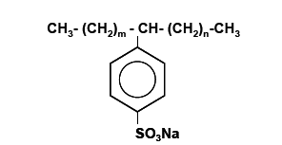

The chemical structure of LAS.

Weight loss as a function of time during the dissolution of metals give a linear relation with slopes equal to the dissolution rates (mg/cm²/ h) .
The percentage protection is calculated form the formula^{(5,6)}

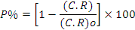
or
……..(1)

Where w_{o} and w are the weight losses of metal without and with inhibitor (LAS) respectively, C.R,(C.R.)_{o} are corrosion rate with and without inhibitor.
Figs 1,2,3 shows the variation of P% with LAS concentration at different temperatures for Al, Zn, and Pb Figs . 4, 5, 6 show the variation of P% with variation of temperature for different LAS concentration for the three metals, and all data giving in table1.
The electrochemical theory of wet corrosion of metals as with dry corrosion are only possible if the free energy of the products of reaction is lower than the free energy of the reactants. The rate of wet corrosion may often be very high compared with dry corrosion on the same metal at the same temperature, and there are two underlying reasons for this:
- The dipolar water molecule stabilizes the free (dissociated) metal ions in solution.
- The metallic structure and water in contact with it can both conduct electric current.
This enables the following reaction:

1/2O₂+ M + H₂O_{(l)} M (OH)_{2(s)}..(2)

To proceed through the coupling of two primary corrosion reaction:

A : M M²⁺+2e⁻ .……...(3)

(Anodic reaction: destroy, metal)

C: O₂+4H⁺+4e⁻ 2H₂O…(4)

(Catholic reaction: consumes electrons)

Clearly, when analyzing the mechanism of the action of organic inhibitors and carrying out quantitative calculations, a number of factors which influence one another have to be allowed for.
The relation between the concentrations of inhibitor in acid corrosion was first investigated by Sieverts and Lueg (1923), who showed that it generally has the form of an adsorption isotherm ⁽⁷⁾. .
The adsorption mechanism for the action of organic inhibitors ⁽⁸⁾ as well as some by- products of manufacture ⁽¹⁾ in acid has also been reported.
From data on the degree of surface coverage by inhibitor, the adsorption isotherm yield valuable information about the properties of the adsorbed substance. Assuming that the inhibitor gives a monolayer of adsorption, the surface coverage () can be determined, according to Damaskin⁽⁹⁾, from the formula:

.……..(5)

The Langmiur adsorption isotherm may be written in the form ⁽⁸⁾

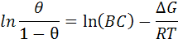
or
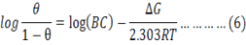

Where Bc is the adsorption equilibrium constant and ΔG is the free energy of adsorption.
Plotting log against log of LAS concentration (C) gives straight lines Fig. 7(at 298K) for the three metals Al, Zn, Pb, indicating almost a general agreement with Langmiur adsorption.

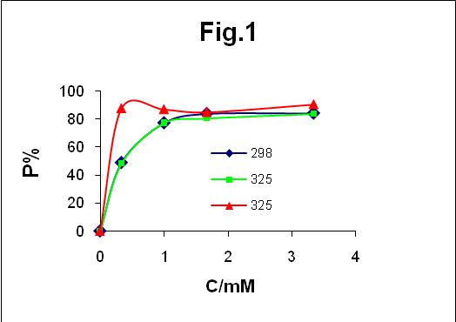

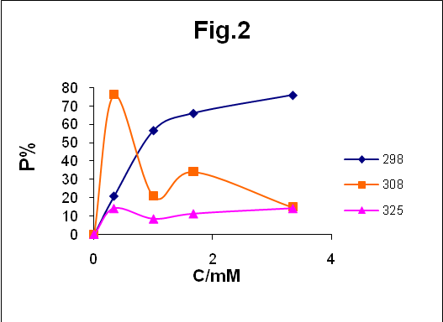

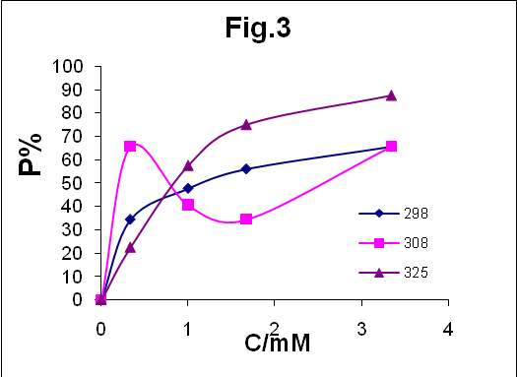

Fig .(1-3)P% against LAS con. For Al, Zn, Pb respectively.

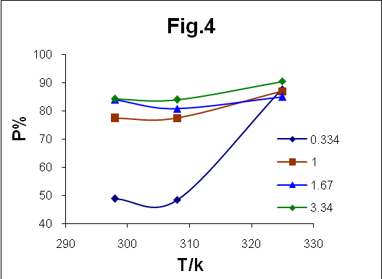

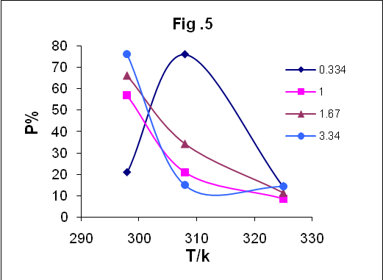

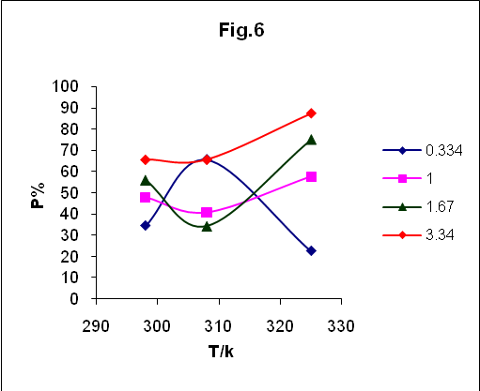

Fig. (4-6) P% against temperature con. For Al, Zn, Pb respectively.

Isotherm
Table 2 gives the values of the
corrosion rate (C.R),

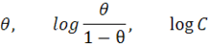

for the three metals at 303K.
The experimental results showing that the adsorption of LAS decreased the corrosion rate (C.R) by the strong interaction between the metal surface and LAS.
The negative free energy of adsorption and high heat of adsorption ⁽¹⁰⁾ (>40Kj/mol ), which are the characteristic features of strong interaction.

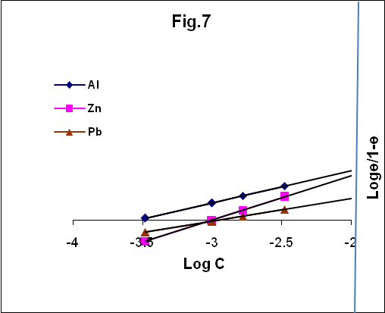

Fig.4.7- Langmuiur Adsorption Isotherm for Al, Zn, Pb at 303K.

Metal | C.R /298 | P%₂₉₈ | C.R/308 | P%₃₀₈ | C.R/325 | P%₃₂₅ | LAS/C/M
AL/IMHCI | 4.5×10⁻⁴ |  | 31×10⁻⁴ |  | 635×10⁻⁴ |  | 0
AL/IMHCI | 2.3×10⁻⁴ | 48.9 | 16×10⁻⁴ | 48.4 | 79×10⁻⁴ | 87.6 | 0.334×10⁻³
AL/IMHCI | 1.02×10⁻⁴ | 77.3 | 7×10⁻⁴ | 77.4 | 83×10⁻⁴ | 86.9 | 1.00×10⁻³
AL/IMHCI | 0.725×10⁻⁴ | 83.9 | 6×10⁻⁴ | 80.7 | 96×10⁻⁴ | 84.9 | 1.67×10⁻³
AL/IMHCI | 0711×10⁻⁴ | 84.2 | 5×10⁻⁴ | 83.9 | 61×10⁻⁴ | 90.4 | 3.34×10⁻³
Zn/IMHCI | C.R/298 | P% | C.R/308 | P% | C.R/290 | P%
Zn/IMHCI | 43.0×10⁻⁴ |  | 53.6×10⁻⁴ |  | 35×10⁻⁴
Zn/IMHCI | 34.0×10⁻⁴ | 20.9 | 12.8×10⁻⁴ | 76.12 | 30×10⁻⁴ | 14.3
Zn/IMHCI | 18.58×10⁻⁴ | 56.8 | 42.4×10⁻⁴ | 20.9 | 32×10⁻⁴ | 8.6
Zn/IMHCI | 14.53×10⁻⁴ | 66.2 | 35.2×10⁻⁴ | 34.3 | 31×10⁻⁴ | 11.4
Zn/IMHCI | 10.28×10⁻⁴ | 76.1 | 45.6×10⁻⁴ | 14.9 | 30×10⁻⁴ | 14.3
Pb/IMHCI | C.R/298 |  | C.R/308 | P% | C.R/325 | P%
Pb/IMHCI | 24.5×10⁻⁴ |  | 32×10⁻⁴ |  | 40×10⁻⁴
Pb/IMHCI | 16.07×10⁻⁴ | 34.4 | 11×10⁻⁴ | 65.6 | 31×10⁻⁴ | 22.5
Pb/IMHCI | 12.81×10⁻⁴ | 47.7 | 19×10⁻⁴ | 40.6 | 17×10⁻⁴ | 57.5
Pb/IMHCI | 10.78×10⁻⁴ | 56.0 | 21×10⁻⁴ | 34.4 | 10×10⁻⁴ | 75.0
Pb/IMHCI | 8.43×10⁻⁴ | 65.6 | 11×10⁻⁴ | 65.6 | 5×10⁻⁴ | 87.5
Table 1. Values of C. R, P% for Al, Zn and Pb with LAS concentration (0.334-3.34×10⁻³) M at three temperature.

Zinc obtained a gain weight at temperature 40,52ºC because the zinc surface converted to zinc oxide at high temperature (>,40ºC) ⁽⁶⁾.

Table (2) values of C.R ,ө lag ,C (LAS) lag C for Al, Zn, and Pb at 298K.
LAS C/M× 10⁻³ | Log C | Al/ C.R/ 303×10⁻⁴ | ө | Log ө/1-ө | Zn/ C.R /303× 10⁻⁴ | ө | Log ө/1-ө | Pb C.R/ 303k× 10⁻⁴ | ө | Log ө/1-ө
0 | 0 | 4.5 |  |  | 43.0 |  |  | 24.5
0.334 | -3.48 | 2.3 | 0.484 | -0.028 | 34.01 | 0.209 | -0.578 | 16.07 | 0.344 | -0.280
1.00 | -3 | 1.02 | 0.774 | 0.535 | 18.58 | 0.568 | 0.119 | 12.81 | 0.477 | -0.04
1.67 | -2.78 | 0.725 | 0.839 | 0.717 | 14.53 | 0.662 | 0.292 | 10.78 | 0.560 | 0.105
3.34 | -2.48 | 6.711 | 0.842 | 0.88 | 10.28 | 0.761 | 0.503 | 8.428 | 0.656 | 0.280

SMA analysis
The surface morphology analysis (SMA) of Al, Zn, Pb, by (polarized microscope lights type (ortho plan).
Figure 8, (a, b) presents the micrographs obtained for Al immersed after 3 hours in IM HCl without addition of LAS, and with addition respectively, while (c, d) are for Zn and, (e,f) for pb.
The effect of the inhibitors on the morphology and prevention of the corrosion is remarkable as can be seen in micrographs (b,d,f) where the addition of (3.34 10⁻³) M of LAS case to protect Al get to 84%, Zn get to 66% and pb get to 65.6%.

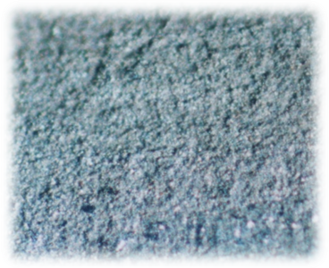

a/Al

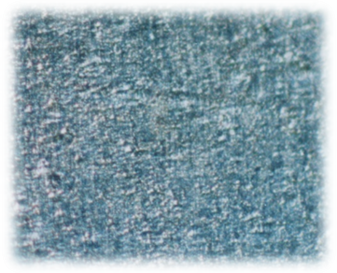

b/AL

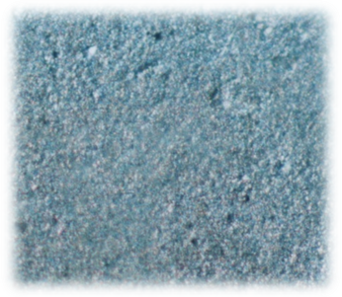
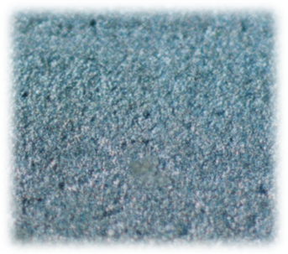

d/Zn
c/Zn

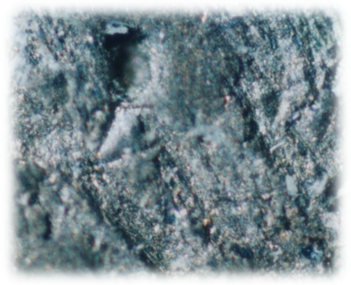
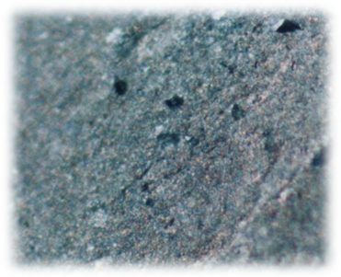

f/Pb
e/Pb

Fig. 8-SMA micrograph (with magnify ×400) of: (a,c,e) for Al, Zn, Pb after corrosion in1 M HCl solution with out LAS and (b, d, f) after corrosion in 1M HCl solution with LAS as inhibitor.

References:

- S. Zor, B. Yazici , and M. Erbil, (The Effect of Detergent Pollution on the Corrosion of Iron and Alumina) Turk .J. chem.;1999, 23, 393-400 .
- Khulood AL- Saadie, Saria A. and Dunya .E, Effect of (1, 4) phenylenediamine on the corrosion of lead, J.um-SALAMA, Received.; 2007, 30 ,3.
- Y. Ein- Eli, M. Auinat, D. Starosvetsky, Electrochemical and surface studies of zinc in alkaline solution containing organic corrosion inhibitors, Journal of power sources.; 2003,114,330-337.
- Ezemonyel .I. N., Ogeleka D. F and Okeimen F.E., Toxicity of Neatex (industrial detergent) and corrosion inhibitors to earthworms, African Journal of Biotechnology.; 2006 ,5(11) ,1113-1117.
- C. Chalkrabarty, M. M.singh and C. V. Agarwal, preventing corrosion of Aluminum in Nitric Acid by Tolyl Guanidine Derivatives, corrosion prevention & control June.; 1986,72-76 .
- Khulood Al- saadie, Nadia A.,Israa M., Inhibition Study of Urea on the Corrosion of Zinc, Al-Nahrin university Journal, accepted .; 2007,2, 7.
- F.M. Abd El wahab and H. A. El shayeb, Corrosion Prevention & Control February.; 1985, 9-15.
- Sibel Zor, The Effects of Benzoic Acid in Chloride Solutions on the corrosion if Iron and Aluminum, Turk.J. Chem.; 2002, 26, 403-408.
- B.B. Damaskin, "Adsorption of Organic Compounds on Electrodes" Plenum Press, New York .; 1971.
- H.B. Rudresh and S. M. Mayanna "n-Decylamine as a Corrosion Inhibitor for zinc in Acidic Solution, Br. Corros .J.; 1977,12 (1), 54-56 .

