Study the adsorption of Basic blue and neutral red dye from aqueous solution by Zeolite clay surface.

Ayad F. Al-Kaim
College of women sciences
University of Babylon

(NJC)

(Receivedon 16/4/2007) (Accepted for publication on 6/9 /2007)

Abstract
In this study, the removal of cationic dye basic blue and neutral red dye used in the aqueous solutions with zeolite was investigated as a function of ionic strength, pH and temperature. Adsorption process was attained to the equilibrium within 1 h.
The adsorbed amount of two dyes basic blue and neutral red dye increased with increasing ionic strength, but decreased with increasing temperature and pH. Adsorption of cationic dye basic blue and neutral red dye was investigated by using uv-visible technique.
The Freundlich and Dubinin- Rasdushkevich (D-R) isotherm equations were applied to the data and values of parameters of these isotherm equations were calculated.
The mean energy of adsorption E, was also calculated from the adsorption energy constant K_{eng}. It’s Value determined from the D-R isotherm equation. Finally thermodynamic functions ∆G, ∆S and ∆H, were calculated by using Freundlich isotherm.
الخلاصة :
تم دراسة امتزاز صبغة المثيل القاعدية الزرقاء وصبغة المثيل الحمراء المتعادل على سطح طين الزيولايت من المحاليل المائية كدالة للقوة الايونية , الدالة الحامضية ودرجة الحرارة .
وجد ان زمن الاتزان هو ساعة واحدة, و ان كمية الامتزاز لكلا الصبغتين تزداد مع زيادة القوة الايونية, بينما تقل مع زيادة درجة الحرارة والدالة الحامضية. النتائج تم تحديدها باستخدام مطيافية الاشعة المرئية – الفوق البنفسجية .uv-visible spectrophotometer
تم استخدام كل من معادلة فرندلج (Freundlich) و معادلة (D-R) وتم حساب كافة معاملاتهما من المعادلات الايسوثرمية.
معدل طاقة الامتزاز E تم حسابها من خلال ثابت طاقة الاكتزاز K_{ads} حيث حسبت قيمته من معادلة D-R و اخيرا الدوال الثرموديناميكية ∆Gو ∆S و ∆H تم حسابها من خلال معادلة فرندلج الايسوثرمية.

Introduction
The adsorption of dyes onto clays has had in the past the unique application of being a rather simple way to determine important properties of clays ⁽¹⁾.
Some specific effluents from industrial production processes may be difficult to purify by traditional wastewater treatment technology, as a result of the complexity of some of their components. Wastewater from textile industries creates a great problem of pollution due to the dyes contained therein ⁽²⁾.
The disposal of coloured wastes such as dyes into receiving waters causes damage to the environment as they are toxic to aquatic life. As it is difficult to remove the dyes from effluents, different adsorbent Activated carbon is the most widely used adsorbent for the removal of color from textile effluents, because it has a high capacity for organic matter, but its use is limited due to its high cost ^{(3, 4)}.
Recently, new adsorbents such as chitosan ⁽⁵⁾, alunite ⁽⁶⁾, cotton ⁽⁷⁾, orange peel ⁽⁸⁾, sludge particles ⁽⁹⁾, palm fruit bunch ⁽¹⁰⁾, shale oil ash ⁽¹¹⁾ have been investigated for the removal of toxic materials from water. Furthermore, perlite as an adsorbent has been used for the removal of dyes and heavy metal ions from aqueous solutions ^{(12, 13)}.
Clays are composed mainly of silica, alumina, and water; frequently with appreciable quantities of iron, alkalis, and alkali earth ⁽¹⁴⁾. Two structural units are involved in the atomic lattices of most clay minerals. One unit consists of closely packed oxygen or hydroxyls in which alumina, iron or magnesium atoms are embedded in one octahedral combination, so that they are equidistant from six oxygen’s or hydroxyls. The second unit is built of silica tetrahedrons. Which are arranged to form a hexagonal network that is repeated indefinitely to form a sheet of composition SiO₆ (OH) ₄ ⁽¹⁴⁾. The surface oxygen in layer silicates, however, is a weak electron donor. The (Si - O) bond, of prime important, is marked by a considerable degree of polarity.
Natural clay minerals such as zeolite, on the other hand, may be a very good alternative to these materials. Zeolite has attracted remarkable attention by its sorptive, rheological and catalytic properties. Therefore the use of zeolitic clays has been increasing ⁽¹⁵⁾.
Zeolite is a clay mineral with a unit cell formula $M_{2/n}\text{.}{\text{Al}}_{2}O_{3}\text{.}{\text{xSiO}}_{2}\text{.}{\text{yH}}_{2}O$, where M is [Mg or Fe] and in it consists⁽¹⁶⁾.
Each block is constructed by two tetrahedral silica sheets enclosing a central magnesia sheet. In some aspects zeolite is similar to other 2:1 tri-octahedral silicates. The molecule formula is Mg₃Si₄O₁₀ (OH) ₂, but it has discontinuities and inversions of the silica sheets that give rise to structural tunnels ⁽¹⁷⁾.
In the inner blocks, all corners of silica tetrahedra are connected to adjacent blocks, but in outer blocks some of the corners are Si atoms bound to hydroxyls (Si-OH).
These silanol groups at the ‘‘external surface’’ of the silicate, are usually accessible to organic species, acting as neutral adsorption sites (denoted as N) ⁽¹⁶⁾.
In addition to that, some isomorphic substitutions in the tetrahedral sheet of the lattice of the mineral, such as Al³⁺ instead of Si⁴⁺, form negatively charged adsorption sites as shown in figure (1) ⁽¹⁶⁾. In this work we present the experimental results for adsorption of cationic dye basic blue and neutral red dye on zeolite.

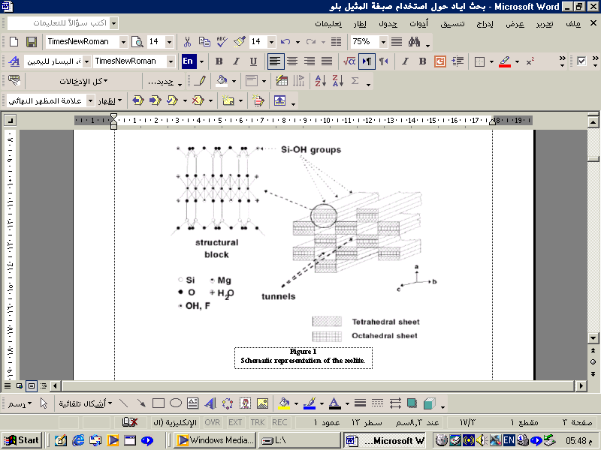

The main aim of the current study has been to visualize the pattern adsorption of these dyes on zeolite to various situations such as concentration, ionic strength, pH and temperature.

Materials and Methods Materials
The Clay
Zeolite clay used in this study was obtained from the general al-raya'a company, Baghdad, Iraq, have the general structure is ${\text{Ca}}_{4\text{.}5}{\text{Na}}_{3}({\text{AlO}}_{2})_{\text{12}}({\text{SiO}}_{2})\text{.}3H_{2}O$.
The chemical analysis of zeolite is listed in Table (1).

Table 1. The chemical analysis of zeolite [from al-raya’a company]
Constituent | Wt. %
SiO₂ | 32.52
Al₂O₃ | 27.64
CaO | 11.38
Na₂O | 4.2
Loss on ignition | 24.25
Total | 99.99

Zeolite clay was supplied in the powder form. It was suspended in HCl solution of pH=3 to remove carbonate and it was washed with an excess amount of distilled water to remove the soluble materials, the result was dried in the oven at 388 K for twenty-four hours then kept in airtight containers. Using the available sieve (200 mesh) the maximum particle size obtained was (75μm). This was used in all experiments through out this work.
The structural form of methyl basic blue and methyl neutral red dyes are given in figure 2, 3 respectively⁽¹⁸⁾.

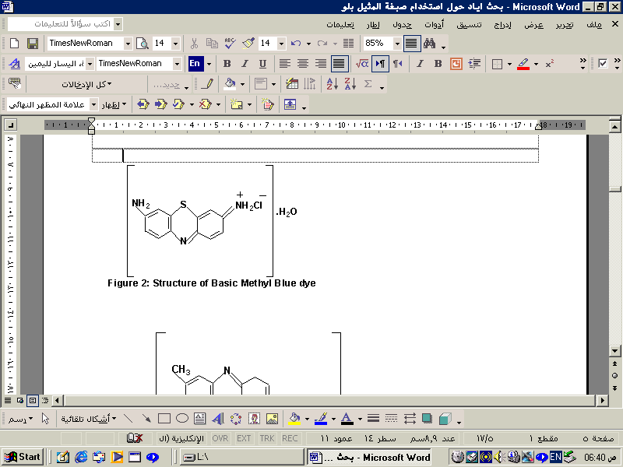
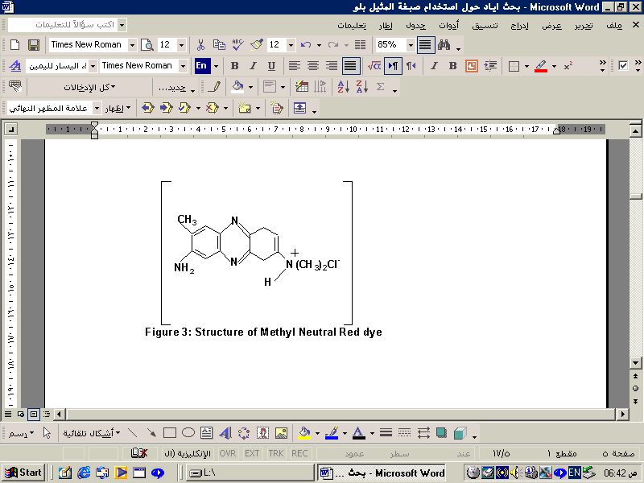

The chemical used for this work are listed in table (2) together with the purity and sources. All chemicals were used without further purification.

Table (2) chemical and their purity and manufactured used in this study.
Chemical | Source | Conc. %
Neutral red dye | Aldrich | 80
Basic methyl blue | Aldrich | 85
Hydrochloric acid | BDH | 35

The following instruments were used in this study:
- Uv-Visible Spectrophotometer meter, Single Beam, Pye Unicam-8700.
- Digital pH-Meter, Hanaa, Roman
- Digital balance, Sartoris, BP 3015 (Germany).
- Oven, Heracus (D-6450), Hanau, (England).
- Shaker Bath, SB. 4, Tecam.

Method
Adsorption experiments were carried out by shaking 0.02 g zeolite samples with 20 mL aqueous solution of dyes of desired concentration at various ionic strengths (0.1, 0.3 and 0.5 M NaCl solutions in water), pHs (4, 7 and 10), temperatures (298, 308 and 318 K) for 1 h (the required time for methyl basic blue "MB" and neutral methyl red "NR" to reach the equilibrium concentrations).
A thermostated shaker bath was used to keep the temperature constant. The initial concentrations of dyes solutes, C₀, were in the range of [2-20 ppm]. All adsorption experiments were performed at 298 K and pH 7.0 except those in which the effects of temperature and pH of the solution were investigated. The pH of the solution was adjusted with NaOH or HCl solution by using pH meter equipped with a combined electrode. At the end of the adsorption period, the solution was centrifuged for 5 min at 3000 rpm and then the concentration of the residual [Ce,] of MB or NR, was determined with the aid of uv- visible Spectrophotometer at a maximum absorbency λ_{max} for methyl blue 660 nm and neutral methyl red 455nm . The adsorbed amounts of two dyes were calculated from the concentrations in solutions before and after adsorption according to the equation (1)

$Q_{e}=(C_{o}−C_{e})\frac{V}{W}\text{.}\text{.}\text{.}\text{.}\text{.}\text{.}\text{.}\text{.}\text{.}\text{.}\text{.}\text{.}\text{.}\text{.}\text{.}\text{.}\text{.}\text{.}\text{.}\text{.}\text{.}(1)$

where C₀ and C_{e} are the initial and equilibrium liquid phase concentrations of dye solution (mg/L), respectively; Qe is equilibrium dye concentration on adsorbent (mg.gm⁻¹), V is the volume of dye solution (L), and W is the mass of zeolite sample used (g). All solutions were prepared using distilled water.
Result and Discussion
The surface hydroxyl groups of the adsorbent have a main effect on the adsorption of MB or NR dye onto the zeolite. Therefore it would be useful to review the surface hydroxyl groups. The silicon atoms at the surface tend to maintain their tetrahedral coordination with oxygen. They complete their coordination at room temperature by attachment to monovalent hydroxyl groups, forming silanol groups.
Theoretically, it is possible to use a pattern in which one silicon atom bears two or three hydroxyl groups, yielding silanediol and silanetriol groups, respectively. It is stated as improbable that silanetriol groups exist at the silica surface. The types of silanol groups are shown below ⁽¹⁹⁾:

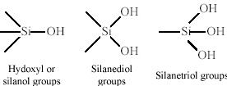

The hydrous oxide surface groups in alumina are given as following ⁽¹⁹⁾:

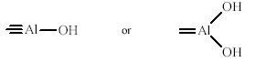

Adsorption Isotherms
Adsorption at equilibrium conditions were determined for methyl basic blue and neutral methyl red on zeolite adsorbent. The adsorbed quantities at equilibrium concentrations were calculated by using the following equation:

$Q_{e}=(C_{o}−C_{e})\frac{V}{W}\text{.}\text{.}\text{.}\text{.}\text{.}\text{.}\text{.}\text{.}\text{.}\text{.}\text{.}\text{.}\text{.}\text{.}\text{.}\text{.}\text{.}\text{.}\text{.}\text{.}\text{.}(1)$

Plots of the Q_{e} (mg.g⁻¹) against equilibrium concentration C_{e}(mg/L) for methyl basic blue and neutral methyl red onto zeolite, the data are listed in table (3) and Figure (4) which showed multilayer adsorption at relatively high

concentration concerning the heterogeneity of the surface S type of Gilles classification ⁽²⁰⁾. Also the adsorption capacity of basic methyl blue is better than neutral methyl red at different conditions.

Table (3) adsorption isotherms values of two dyes (MB and NR) on the zeolite surface at 298 K.
C_{o} (mg/L) | C_{e}  (mg/L) | Q_{e}  (mg/gm) |  | ln C_{e} | ln Q_{e} | C_{e}  (mg/L) | Q_{e}  (mg/gm) |  | ln C_{e} |  | ln Q_{e}
C_{o} (mg/L) | Basic methyl blue |  |  |  |  | Neutral red dye
2 | 0.18 | 1.82 | -1.71 |  | 0.59 | 1.16 | 0.84 | 0.15 |  | -0.17
4 | 1.01 | 2.99 | 0 |  | 1.09 | 1.9 | 2.1 | 0.64 |  | 0.74
6 | 1.4 | 4.6 | 0.33 |  | 1.52 | 2.2 | 3.8 | 0.79 |  | 1.33
8 | 1.51 | 6.49 | 0.4 |  | 1.87 | 2.6 | 5.4 | 0.95 |  | 1.68
10 | 2.07 | 7.99 | 0.69 |  | 2.08 | 2.92 | 7.08 | 1.07 |  | 1.95
12 | 2.76 | 9.24 | 1.01 |  | 2.22 | 2.98 | 9.02 | 1.09 |  | 2.2
14 | 3 | 11 | 1.09 |  | 2.39 | 3.87 | 10.13 | 1.35 |  | 2.31
16 | 3.32 | 12.68 | 1.2 |  | 2.54 | 3.91 | 12.09 | 1.36 |  | 2.49
18 | 3.41 | 14.59 | 1.25 |  | 2.68 | 4.4 | 13.6 | 1.48 |  | 2.61
20 | 3.7 | 16.3 | 1.308 |  | 2.79 | 4.72 | 15.28 | 1.55 |  | 2.73

Figure 4. Adsorption isotherm of MB and NR on zeolite at 298 K.

It is obvious from Figure 4 that the adsorption isotherms of dyes on clay surface is indicates that a large amount of dye is adsorbed at a lower concentration as more active sites of zeolite are available. As the concentration increases, it becomes difficult for a dye molecule to find vacant sites, and so monolayer formation occurs.
Zeolite surface is heterogeneous and this feature could be attributed by the different properties of the unsaturated adsorption sites which lead to different characters of these sites ⁽²¹⁾. The adsorption on different active sites occurs throughout different types of forces leading to the formation of clusters or packed line of the adsorbed molecules on the surface ⁽²²⁾. The results for MB and NR adsorption systems of this study are favorable. Adsorption capacity of MB dye is greater than that of NR dye.
The difference in adsorption capacities must therefore be linked to the solute acidity. The presence of amine groups and nitrogen rings increase the basicity make MB dye less acidic character and enhanced its affinity for adsorption at the adsorbent surface.
Effect of temperature on the adsorption isotherms
The effect of temperature variation on the adsorption extent of MB dye or NR dye on the zeolite surface has been studied at neutral media pH= 7. Figures 5 and 6 illustrate the general shapes of MB dye and NR dye adsorption isotherm at 298, 308 and 318 K. it can be seen that as the temperature increased, the adsorption quantity decreased.

Figure 5. Temperature dependence of the adsorption of MB dye on the Zeolite surface.

Figure 6. Temperature dependence of the adsorption of NR dye on the Zeolite surface.

The study of the temperature effect on adsorption will also help in calculation the basic thermodynamic functions Gibbs energy) ∆G), enthalpy (∆H) and entropy (∆S) of the adsorption process. The equilibrium constant (K_{e}) of the adsorption process at each temperature, is calculated from the equation

$\text{Ke}=\frac{(\text{Qe})}{(\text{Ce})}∗\frac{0\text{.}\text{02}\text{gm}}{0\text{.}\text{02}L}$ (2)

Where Q_{e} is the amount adsorbate in milligram per one gram adsorbent(mg/gm), C_{e} is the equilibrium concentration of the adsorbate expressed in mg/L. The change in the Gibbs energy could be determined from the equation:

${ΔG}^{o}=−\text{RT}\text{ln}K_{e}$ (3)

Where R, is the gas constant (8.314 J K ⁻¹ mole⁻¹), T is the absolute temperature in Kelvin. The enthalpy of adsorption may be obtained from the Clausis-Clapeyron equation:

ln Xm = -∆H/RT + Constant (4)

When Xm (mg/gm) is the maximum value of adsorption at a certain value of equilibrium concentration (Ce). Table 4 gives Xm values at different temperatures for MB and NR dyes.
Plotting ln Xm versus (1/T) should produce a straight line with a slope -∆H/R as shown in Figures (7 and 8).

Table 4. Maximum adsorption quantity X_{m} values of MB dye and NR dye on the Zoelite surface at different temperature.

T/K | 1/T*10⁻³ | C_{e}=3.75 mg/L | Xm  (mg/gm) | ln X_{m} | T/(K) | 1/T*10⁻³ | Xm  (mg/gm) | C_{e}=4.5  mg/L | ln X_{m}
Basic Methyl blue dye |  |  |  |  | Neutral Methyl red dye
298 | 3.35 | 48.4 | 16.02 | 2.77 | 298 | 3.35 | 14.9 | 64.3 | 2.70
308 | 3.25 | 46.2 | 14.2 | 2.65 | 308 | 3.25 | 13.6 | 59.2 | 2.61
318 | 3.15 | 43.7 | 12 | 2.48 | 318 | 3.15 | 11.8 | 55.0 | 2.47

Figure 7. Plot of ln Xm versus 1/T of MB on the Zeolite surface

Figure 8. Plot of ln Xm versus 1/T of NR on the Zeolite surface

The change in entropy (∆S) was calculated from Gibbs-Helmholtz equation ⁽²³⁾:

∆G=∆H - T∆S (5)

Table (5) gives the quantitative thermodynamic data of two dyes (MB and NR) on the adsorbent surface zeolite. Table 5 shows that a ∆H value of of two dyes (MB and NR) are negative indicating that the adsorption process is exothermic reaction. All process of adsorption consider spontaneous from the negative value of ∆G. While, ∆S have positive value for each methyl blue and neutral red dye that refer the interaction of molecules caused random of the total system.

Table 5. Thermodynamic function ∆G, ∆S and, ∆H of (MB and NR) on the adsorbent surface zeolite at 298K.
∆H / (kJ mole⁻¹) | ∆S/ (J mole⁻¹K⁻¹) | ∆G / (kJ mole⁻¹) | Adsorbate
- 17.16 | 45.25 | - 3.67 | Methyl blue dye
- 12.47 | 32.07 | - 2.91 | Neutral red dye

Effect of Ionic Strength
Ionic strength affects the activity coefficients of OH⁻, H₃O⁺ and specifically the adsorbable dye ions. As shown in figures (9) and (10), the increasing ionic strength in the solution causes an increase in the adsorption of two dyes (MB and NR) on zeolite surface at the neutral pH. This indicates that the positive charge of the surface of zeolite, increase with increasing ionic strength, resulting in increasing the adsorption capacity.

Figure 9. The effect of ionic strength on the adsorption of MB on zeolite surface at 298 K.

Figure 10. The effect of ionic strength on the adsorption of NR on zeolite surface at 298 K.

Effect of pH
The adsorption isotherms at various pHs (4, 7 and 10) are shown in Figures (11 and 12). It is seen that the adsorbed amount of two dyes (MB and NR) on zeolite have decreased with increasing pH values.
Figures (11 and 12) have shown that the surface of zeolite is positive at low pH where reaction (1) predominates, and is negative at higher pH when reaction (2) takes over.

$$\text{Si}−\text{OH}+H^{+}⇔\text{Si}−{\text{OH}}_{2}^{+}\text{.}\text{.}\text{.}\text{.}\text{.}\text{.}\text{.}\text{.}\text{.}\text{.}\text{.}\text{.}\text{.}\text{.}\text{.}\text{.}\text{.}\text{.}\text{.}\text{.}\text{.}\text{.}\text{.}1$$
$$\text{Si}−\text{OH}+{\text{OH}}^{−}⇔\text{Si}−O^{−}+H_{2}O\text{.}\text{.}\text{.}\text{.}\text{.}\text{.}\text{.}\text{.}\text{.}\text{.}\text{.}\text{.}\text{.}\text{.}\text{.}\text{.}\text{.}\text{.}\text{.}\text{.}\text{.}2$$

As the pH of dyes solutions become lower than pH 7, the association of dye anions with more positively charged zeolite surface, because of increasing S–OH₂ groups, can more easily take place reaction (3):

$$\text{Si}−{\text{OH}}_{2}^{+}+{\text{Dye}}^{−}⇔\text{Si}−{\text{OH}}_{2}^{+}{\text{Dye}}^{−}\text{.}\text{.}\text{.}\text{.}\text{.}\text{.}\text{.}\text{.}\text{.}\text{.}\text{.}\text{.}\text{.}\text{.}\text{.}\text{.}\text{.}\text{.}\text{.}\text{.}\text{.}\text{.}3$$

Figure 11. The effect of pH on the adsorption of MB on zeolite surface at 298 K.

Figure 12. The effect of pH on the adsorption of NR on zeolite surface at 298 K.

Isotherm Analysis
The purpose of the adsorption isotherms is to relate the adsorbate concentration in the bulk and the adsorbed amount at the interface ⁽²⁴⁾. The analysis of the isotherm data is important to develop an equation which accurately represents the results and which could be used for design purposes ⁽²⁵⁾. Several isotherm equations are available. Two of them have been selected in this study: Freundlich and Dubinin- Rasdushkevich (D-R) isotherm isotherms. The widely used Freundlich isotherm has found successful application too many real sorption processes and is expressed as:

$Q_{e}=K_{f}∗C_{e}^{1/n}$ ………………….(6)

Where Q_{e} is the adsorption capacity (mg/gm), K_{f} is the Freundlich constant and (1/n) of the adsorption intensity. K_{f} and (1/n) can be determined from the linear plot of ln (Q_{e}) versus ln (C_{e}).
Freundlich equation in logarithmic form can be written as follows:

$\text{ln}Q_{e}=\text{ln}K_{F}+\frac{1}{n}\text{ln}C_{e}\text{.}\text{.}\text{.}\text{.}\text{.}\text{.}\text{.}\text{.}\text{.}\text{.}\text{.}\text{.}\text{.}\text{.}\text{.}\text{.}\text{.}\text{.}\text{.}\text{.}\text{.}\text{.}\text{.}\text{.}\text{.}\text{.}\text{.}\text{.}\text{.}\text{.}(7)$

In Figures (13-18) a linear form of Freundlich isotherm are presented by plotting ln Q_{e} as a function of ln Ce of two dyes (MB and NR) adsorbed on zeolite surface at different conditions.

The value of 1/n was calculated from the slope of the straight line which gives an indication for the intensity of adsorption, while the intercept with y-axis gives K_{F} Freundlich constant which is the measure of the adsorption capacity. Freundlich constants are listed in Table (6) of two dyes at different conditions.

Table 6. Freundlich isotherm constants for different ionic strength, PHs, and temperatures of MB and NR dyes on the zeolite surface.
Temp (K) | pH | Ionic strength  (M) | Freundlich constant for NR dye |  |  | Freundlich constant for MB dye
Temp (K) | pH | Ionic strength  (M) | n | K_{f} | R² | n | K_{f} | R²
298 | 7 | ---- | 2.017 | 0.74 | 0.942 | 1.160 | 3.291 | 0.959
308 | 7 | ---- | 0.938 | 1.15 | 0.989 | 1.270 | 2.632 | 0.966
318 | 7 | ---- | 2.081 | 0.66 | 0.949 | 1.360 | 2.149 | 0.984
298 | 4 | ---- | 2.304 | 0.42 | 0.889 | 1.304 | 2.688 | 0.947
298 | 10 | ---- | 2.581 | 0.217 | 0.923 | 1.390 | 2.134 | 0.975
298 | 7 | 0.1 | 2.901 | 0.091 | 0.871 | 2.13 | 0.546 | 0.956
298 | 7 | 0.3 | 2.702 | 0.149 | 0.881 | 1.981 | 0.708 | 0.959
298 | 7 | 0.5 | 2.462 | 0.234 | 0.917 | 1.759 | 1.058 | 0.958

Figure 13. Linearized Freundlich plot of MB adsorption on Zeolite surface at different temperature

Figure 14. Linearized Freundlich plot of NR adsorption on Zeolite surface at different temperature

Figure 15. Linearized Freundlich plot of NR adsorption on Zeolite surface at different pHs.
Figure 16. Linearized Freundlich plot of NR adsorption on Zeolite surface at different pHs.

Figure 17. Linearized Freundlich plot of MB adsorption on Zeolite surface at different ionic strengths.
Figure 18. Linearized Freundlich plot of NR adsorption on Zeolite surface at different ionic strengths.

The adsorption data were also tested for another adsorption isotherm, the Dubinin Radushkevich (D-R) ⁽²⁶⁾. This isotherm is

more general than the Langmuir isotherm since it does not assume a homogenous surface or constant sorption potential. The D-R equation is

$Q=\overset{−}{X_{m}}\text{exp}(−\overset{−}{K}ε^{2})$

where $ε$ (polanyi potential) = RT ln (1+1/C), Q is the amount of dye adsorbed per unit weight of Zeolite clay (mg gm⁻¹), Xm is the adsorption capacity (mg gm⁻¹), C is the equilibrium concentration of dye in solution (mg L⁻¹), $\overset{−}{K}$ is the constant related to the adsorption energy (mol² kJ⁻²), R is the gas constant (0.008314) (kJ K⁻¹ mol⁻¹) and T is the temperature (K).
The D-R isotherm can be linearized as

$\text{ln}Q_{e}=\text{ln}\overset{−}{X_{m}}−\overset{−}{K}ε^{2}$

The plots of lnQ_{e} against $ε^{2}$are shown in Figures (19-24) at different factors that effective on adsorption process.

Figure 19. D-R plot of zeolite / MB dye at different temperatures.

Figure 20. D-R plot of zeolite / NR dye at different temperatures.

Figure 22. D-R plot of zeolite / NR dye at different ionic strengths.
Figure 21. D-R plot of zeolite / MB dye at different ionic strengths.

Figure 23. D-R plot of zeolite / NR dye at
different pHs.

Figure 24. D-R plot of zeolite / MB dye at
different pHs.

Most of the adsorption isotherms fitted the D-R equation with correlation coefficients$R^{2}0\text{.}\text{966}$, by making certain assumptions, the mean energy of adsorption, E, can be calculated from the K values ⁽²⁷⁾ using the relation$E=(2K)^{−0\text{.}5}$, values of E are presented in table 7 The calculated mean energy of adsorption, E, from the D-R isotherm, gives information about the chemical or physical properties of the sorption.
The calculated mean energy values of adsorption of two dyes by zeolite are very small and this implies that the type of adsorption is physical.

Table 7. D-R isotherm parameters and mean energy of the adsorption for different
ionic strength, PHs, temperatures of MB and NR dyes on the zeolite surface.
Temp (K) | pH | Ionic strength  (Molar) | D-R isotherm parameters for NR dye |  |  | D-R isotherm parameters for MB dye
Temp (K) | pH | Ionic strength  (Molar) | X_{m}  (mg.gm⁻¹) | K_{m}  (mole² kJ⁻²) | E  (kJ.mole⁻¹) | X_{m}  (mg.gm⁻¹) | K_{m}  (mole² kJ⁻²) | E  (kJ.mole⁻¹)
298 | 7 | ---- | 27.77 | 3.55 | 0.375 | 16.38 | 0.82 | 0.78
308 | 7 | ---- | 26.21 | 3.47 | 0.379 | 15.92 | 0.78 | 0.80
318 | 7 | ---- | 25.92 | 3.51 | 0.377 | 15.41 | 0.84 | 0.77
298 | 4 | ---- | 28.86 | 3.15 | .398 | 16.28 | 0.723 | 0.83
298 | 10 | ---- | 28.25 | 3.94 | 0.356 | 16.11 | 0.87 | 0.758
298 | 7 | 0.1 | 26.5 | 5.66 | 0.297 | 20.00 | 2.455 | 0.751
298 | 7 | 0.3 | 29.13 | 4.54 | 0.33 | 21.42 | 2.11 | 0.486
298 | 7 | 0.5 | 34.46 | 3.92 | 0.357 | 22.57 | 1.74 | 0.536

Conclusion
Zeolite as an adsorbent has a considerable potential for removing cationic dyes in commercial systems because of its higher surface area. As can be also understood from the present work, the studies about the adsorbent properties of zeolite have been quite limited, so it was considered to be important to investigate. The adsorbed amount of MB and NR dyes decreased with increasing pH and temperature, and increased with increasing ionic strength.
The experimental data correlated reasonably well with the Freundlich adsorption isotherm and the isotherm parameters (K_{F} and n) were calculated also D-R isotherm equation using to determine the mean energy of adsorption. The zeolite sample has a point of zero charge about pH 7. Thus, it can be said that the zeolite sample exhibits positive potential in the pH range 4-6.9 and negative potential in the pH range 7.1-10.
The order of heat of adsorption corresponds to a physical reaction and proved from two equations. It is concluded that the two dyes are physically adsorbed onto zeolite.

Nomenclature:

MB methyl blue dye
NR neutral red dye
C_{o} initial solution concentration, mg/L.
Ce equilibrium solution concentration, mg/L.
K_{ad} rate constant of pseudo- first order adsorption, min⁻¹.
1/n adsorption intensity.
Q adsorption capacity mg/gm
K_{f} Freundlich constant.
E mean adsorption energy
D-R Dubinin- Rasdushkevich equation
X_{m} the maximum monolayer adsorption.
R² correlation coefficient
t time, min
V volume of the solutions, L
weight of Zeolite, gm.

References
1. Neumann, G.M. and Gessner, F. Adsorption of dyes on clay surfaces. Encyclopedia of Surface and Colloid Science, Marcel Dekker, New York, 2002, 307-321.
2. Demirbas, O., Alkan, M. and Dogan, M. The removal of victoria blue from aqueous by solutions adsorption on a low-cost material. Adsorption.; 2002, 8, 341-349.
3. Meshko, V., Markovska, L., Mincheva, M. and Rodrigues, A.E. Adsorption of basic dyes on granular activated carbon and natural zeolite. Wat. Res.; 2001, 35(14), 3357-3366.
4. Walker, G.M. and Weatherley, L.R. Kinetics of acid dye adsorption on GAC. Wat. Res.; 1999, 33 (8), 1895-1899.

5. Chiou, M.S. and Li, H.Y. Adsorption behavior of reactive dye in aqueous
solution on chemical cross-linked chitosan beads. Chemosphere.; 2003, 50, 1095-1105.
6. Ozacar, M. and Şengil, I.A. Adsorption of reactive dyes on calcined alunite from aqueous solutions. Journal of Hazardous Materials.; 2003, B98, 211-224.
7. Bouzaida, I. and Rammah, M.B. Adsorption of acid dyes on treated cotton in a continuous system. Materials Science and Engineering.; 2002, C 21, 151 155.
8. Sivaraj, R., Namasivayam, C. and Kadirvelu, K. Orange peel as an adsorbent in the removal of acid violet 17 (acid dye) from aqueous solutions. Waste Management.; 2001, 21, 105-110.

9. Aksu, Z. Biosorption of reactive dyes by dried activated sludge: 1999 equilibrium and kinetic modeling Biochemical Engineering Journal., 2001, 7, 79-84.
10.Nassar, M.M. Interparticle diffusion of basic red and basic yellow dyes on palm fruit bunch. Wat. Sci. Tech.; 1999, 40 ( 7), 133-139.
11.Al-Qodah, Z. Adsorption of dyes using shale oil ash. Wat. Res.; 2000, 34 ( 17), 4295-4303.
12. Dogan, M. and Alkan, M. Adsorption kinetics of methyl violet onto perlite. Chemosphere.; 2003, 50, 517-528.
13. Alkan, M. and Dogan, M. Adsorption of copper(II) onto perlite. Journal of Colloid and Interface Science.; 2001, 243, 280-291.
14. Grime, R.E., Clay Mineralogy 2nd Edition, McGraw Hill, New York 1986.
15. Unal, H.I. and Erdogan, B. The use of zeolite for decolorization of sugar juice. Applied Clay Science.; 1998, 12, 419-429.
16. M., Y.I., M. Sc. Thesis, College of Education, Ibn Al-Haitham, University of Baghdad, 2004 .
17. Rytwo, G., Tropp, D. and Serban, C. Adsorption of diquat, paraquat and methyl green on zeolite: experimental results and model calculations. Applied Clay Science.; 2002, 20, 273– 282.
18. O’Neill, C., Hawkes, F.R., Hawkes, D.L., Lourenco, N.D., Pinheiro, H.M., and Delee, W., “Colour in textile effluents – sources, measurement,discharge consents and simulation: a review”, Journal of Chemical Technology and Biotechnology.,1999,74,1009-1018.
19. Scott, R.P.W. Silica Gel-its History and Formation, in Silica Gel and
Bonded Phase: Their Production, Properties and Use in LC, R.P.W. Scott and C. Simpson (Eds.), John Wiley, Chichester, UK, 1993, 1-22.
20.Gilles, C. H., Smith, A. D., Silva and Easton, J. Colloid Interface Sci., 1974, 74, 755.
21.Gerasinor, Y. "Physical Chemistry" vol 2 Mir. Publisher, Moscow ,1974.
22. Jalal, M.S., "Surface Chemistry" 1st Baghdad university, press Baghdad ,1980.
23.Adamson, A. W., "Physical Chemistry of Surface" Wiley, New York ,2001.
24. Eastoe, J. and Dalton, J.S. Advances in Colloid and Interface Science.; 2000,85, 103–144.
25. McKay, G., Otterburn, M.S. and Aga, A.J. Water, Air and Soil Pollution.; 1985, 24, 307.
26. N.A. Polyzpoulos, V.Z. Keramidas, H. Kiosse, Soil Sci. Soc. Am. J.; 1985, 49, 81-84
27. R. Qaderr, J. Hanif, Jour. Chem. Soc. Pak.; 1993, 15 (4) ,227-230 .

