Kinetic Study for the Photocatalytic Degradation of Acetic Acid over Zinc Oxide
Abbas J . Attia
Chemistry Dept,College of Science , Babylon University
(NJC)

(Receivedon 7/5/2007) (Accepted for publication on 10/9 /2007)

Abstract :
Photocatalytic degradation of acetic acid over zinc oxide suspended as a photocatalyst was done , under irradiation with ultraviolet light .
The photocatalytic degradation of the acid was followed by using (IR) spectroscopy , which exhibits reduction in the intensity of absorption of carboxyl group of the acid . The remaining quantity of the acid was determined by spectrophotometric method by using a standard calibration curve of standard solutions of the acid . The reaction was done at three different temperatures293,298,and 303 K. The effect of temperature on the rate of reaction used in the estimation of activation energy for the reaction according to Arrhenius plot , the activation energy was about (22)kJ . mol⁻¹ . Langmuir kinetic model was applied for the reaction , it used in the estimation of an approximate adsorption equilibrium constant which was about (1.8 × 10⁻⁴ l . mol⁻¹) . Rate constant for the reaction was calculated by plotting of invers of rate of the reaction versus invers of concentration of the used acid which was equal to (4.5 × 10⁻⁶) sec⁻¹ .

الخلاصة :
تم دراسة التفكك الضوئي لحامض الخليك باستخدام عالق اوكسيد الخارصين كعامل مساعد ضوئي والتشعيع بالاشعة فوق البنفسجية. تم متابعة التفكك الضوئي للحامض طيفيا باستخدام طيف الاشعة تحت الحمراء والتي اظهرت انخفاضا في شدة امتصاص مجموعة الكاربوكسيل للحامض . تم تقدير الكمية المتبقية من الحامض بطريقة طيفية وبالاعتماد على منحنى معايرة قياسي لمحلول الحامض . تم اجراء التفاعل بثلاث درجات حراره 293, 298 ,303 كلفن . تم الاستفادة من تاثير درجة الحرارة على سرعة التفاعل في حساب طاقة التنشيط لهذا التفاعل بالاعتماد على علاقة ارينوس وكانت طاقة التنشيط بحدود 22 كيلو جول مول ⁻¹ . تمَّ في هذه الدراسة تطبيق حركية لانغميور لهذا التفاعل حيث تم حساب ثابت التوازن الامتزازي للتفاعل وكان بحدود ⁴⁻10× 1.8 مول⁻¹ . لتر وكذلك تم حساب ثابت السرعة للتفاعل وذلك برسم مقلوب سرعة التفاعل مع مقلوب التركيز للحامض المستخدم وكان ثابت السرعة للتفاعل حوالي 10 ⁻⁶ × 4.5 ثانية ⁻¹ .

Introduction :
In the beginning of 1970s' a great interest in the photochemistry of semiconductors was done due to its important role that is relating to the photocatalytic decontamination of air , water , and soil pollutants . Also to its role in the utilization of a solar energy . ⁽¹⁻⁴⁾
In the photocatalysis system , usually the excitation of semiconductor particles is occurred by absorption of photone with a suitable energy that is equal to or greater than , that of its band gap energy (hυ≥ Eg). This process can promotes electron from the valence band (VB) to the conduction band (CB) . So that the irradiation of semiconductor particles produces (e⁻,h⁺) pairs as follow ⁽⁵⁻⁷⁾ :

SC $hυ≥\text{Eg}$ SC $(e^{−},h^{+})$ e⁻_{CB} + h⁺_{VB} ---------- 1

The generated available charges can be used for the redox transformations for the organic and inorganic contaminates ⁽⁸⁾. Inorder to creat photochemical change it must compete efficiently with recombination processes which are commonly occur on surface of the photocatalyst when used a naked form of it . Reduction rate of recombination reaction can be done if the band adge position of the used photocatalyst must be appropriate with the catalyzed redox system . ⁽⁹⁾ The produced (e⁻,h⁺) pairs may be recombine in back electron transfer , unless its immediately consumed in a desired redox reaction
Generally , there are three pathways for the recombination reaction . They are a direct recombination which is occured by a direct drops of the photoelectron in the unoccupied holes . The second type is the recombination in the centers in which the electron is primarley captured and then it electrostatically attracts , then recombines with the positive holes . The recombination centers are located in the lattice sites of the solid crystals . The third type is the surface recombination in which both (e⁻,h⁺) must be diffuse into the surface of the catalyst before they combine at sites on the surface . ⁽¹⁰⁻¹¹⁾ In the photocatalysis system , there are many processes which are occured on the surface of the catalyst such as adsorption of reactant molecules , reaction of the adsorbed species, and desorption of the product from the surface .
The present of the adsorbed oxygen in the catalysis system is very important step in the photocatalyzed reaction of adsorbed species on the surface . The chemically adsorbed oxygen on the surface is associated with transfer of electron from conduction band to the adsorbed oxygen molecules (O₂) _{ads}⁽¹²⁻¹⁴⁾ .The predominate form of adsorbed oxygen on the surface is (O₂⁻)_{ads} which is detected by (ESR) spectroscopy ⁽¹⁵⁾ . The adsorbed spieces of oxygen such as O₂⁻ ,and O⁻ are reacted with the surface hydroxyl group (OH⁻)_{sur} to give a free radicals which play a main role in the surface reaction, leading to the final product of the catalyzed reaction. ⁽¹⁶⁾
The present work includes , the study of photocatalytic degradation of acetic acid on ZnO surface under irradiation with ultraviolet light generated by pressure mercury lamp.

Experimentals:
The used photocatalytst in this work was zinc oxide which is provided by (BDH) with purity of 99.97%⁽¹⁷⁾. The unit which is used in this study consist of reaction cell which made up of pyrex with quartz window fitted with the lamp. This cell contains a connections for passing air over reaction mixture , as well as for water circulation around reaction vessel in order to keep temperature at a certain value . The whole apparatus is shown in Fig(1).
In each experiment 150 mg of ZnO powder was suspended in (30)ml of the used acetic acid (1) mol.dm⁻³ .The solution was kept homogenous by continuous stirring with a magnetic stirror . Periodically, samples (2) ml of reaction mixture were withdrawing by a microsyringe . These samples are centrifuged to separate a solid catalyst . The absorbance of the supernatent liquid is measured at (273) nm using ultraviolet-visible spectrophotometer (cintra-5) . The concentration of remaining acid is determined by a suitable calibration curve . The calibration curve was obtained by using standard solutions of acetic acid .
Results and Discussion :
The study involves photocatalytic degradation of acetic acid over ZnO surface as a photocatalyst.When a reaction is carried out in the presence of ZnO , and absence of radiation , there is n't any reduction in the concentration of acid . This means that, the photocatalytic degradation of acid required presence both catalyst ,and altroviolet radiation . Photocatalytic degradation of the acid was followed by using (IR) spectrophotometer which shows reduction in the intensity of carboxyl group of the acid which appears at (1700) cm⁻¹ , the spectrum also exhibits reduction in the absorption of hydroxyl group of the used acid at (3000)cm⁻¹ . These spectra are shown in Figs(2) ,and (3) for acetic acid before irradiation and after (120)minutes of continuous reaction respectively.
Table (1) shows the results of the photocatalytic decomposition of acetic acid over ZnO at 293,298, and 303K. From these results , it's found that , the efficiency of reaction is increased as temperature of the reaction is raised . This result may be related to the effect of temperature on the adsorption of the reacted molecules of the acid . The adsorption of reacted species on the surface is very essential step in their photocatalytic reaction . Also elevation in temperature leads to increase rate of desorption of reaction products from the active sites on the surface. This leads to liberate of anoccupied sites for the further contribution in the adsorption of a new reacted molecules from the used acid .⁽¹⁸⁾
The reduction in acid concentration with the time results from its decomposed under reaction conditions into CO₂ ,and H₂O⁽¹⁹⁾. It has been found that acetic acid molecules extract oxygen from lattice of ZnO in addition to the chemisorbed oxygen from air giving adsorbed H₂O and gas phase CO₂ , and C₂H₆ . The extracted oxygen surface is replaced by the oxygen from the air , so that the surface of the catalyst is return to its initial state always⁽¹⁹⁾ .
Activation Energy (Ea) :
Effect of temperature on the photocatalytic degradation of acetic acid over ZnO is shown in table (1). Generally , photocatalytic reactions which are occured on the surface of the photocatalysts are not depend mainly on the small changes in the temperatures .Effect of temperature on the rate of catalyzed⁽²⁰⁻²¹⁾ reaction is probably resulted from its effect on the catalyzation processes . These processes involve adsorption of reacted molecules , desorption of the products from the surface ,and/or surface group migration .Generally ,these steps are not rate determining step in this type of reaction ⁽²²⁾. The effect of temperature on the rate of reaction is show in Fig (4) .
Calculation of activation energy for the reaction can be obtained from effect of temperature on the rate of reaction as the photocatalytic reaction is first order in its kinetics ⁽²³⁾ by using the equation

Ln(a-x) = Lna –kt …….2
a = Ao- A∞
x = Ao- At
a – x = At – A∞

Ao is the absorbance of the sample before irradiation , A_{t} is the absorbance of sample at a given time , and A∞ is the absorbance at a final time of reaction. Substitution of a and(a-x) in equation (3) gives

Ln (At – A∞) = Ln (A₀ – A∞) – kt ……….3

Plotting Ln (At – A∞) versus irradiation time gives a straight line
with slope of (k) by using Arrhenius equation

k = A e${}^{\frac{−\text{Ea}}{\text{RT}}}$………………. 4

Where Ea is the activation energy ,T is the absolute temperature ,R is the gas constant , and A is the frequency factor. Plotting of Arrhenins equation as Ln k versus 1/T for the three obtained values in table (2) gives a straight line which gives an activation energy of (22) kJ.mol⁻¹ as in Fig (5) . It is believed that , this energy is associated with transition of (e⁻ , h⁺ ) in the catalyst particles , and its
independent on the nature of the chemical reaction ^{(24,25)}.
Langmuir –Hinshelwood Kinetic Model(LH)
The reactions which are occured on the surface of the photocataysts obey Langmuir –Hinshelwood Kinetic model , this equation take the form⁽²⁶⁻²⁹⁾ .

r_{o} = -dc/dt = kr ka C / 1+kaC……………………. 5

r_{o} is the initial reaction rate , k_{r} is the reaction rate constant , k_{a} is the equilibrium adsorption constant , and c is the initial concentration of the substrate .Equation (5) can be modified to linear by plotting (1/r_{o}) versus (1/C) , these results are shown in table (3) and Fig(6). The slope of graph 1/k_{r}k_{a} with an intercept of (1/kr) .
The adsorption constant value (k_{a}) is equal to (10.8*10⁻⁴) l.mol⁻¹, the

value of the intercept gives reaction rate constant (kr) which is equal to (4.5*10⁻⁶) sec⁻¹ .
Proposed Mechanism :
The adsorbed acetic acid molecules react with surface hydroxyl groups produced adsorbed H₂O molecules , gas phase CO₂, and CH₄ ^{(30,31)}as follows :

CH₃COOH CH₃COO∙ _{(ads)} + H∙ _{(ads)} .……6
H∙ _{(ads)} + O H∙ _{(ads)} H₂O_{(ads)} ………………….…7
CH₃COO∙ _{(ads)} CH₃ ∙_{(ads)} + CO₂ _{g} ……….…8
CH₃ ∙_{(ads)} + H∙ _{(ads)} CH₄ ………………………..9

Table(1) Photocatalytic degradation of acetic acid over ZnO at 293,298 and 303k
Time / min | Acetic acid conc/mol.dm-3  at different temperatures
Time / min | 293K | 298K | 303K
0 | 1.0 | 1.0 | 1.0
30 | 0.994 | 0.985 | 0.970
60 | 0.985 | 0.972 | 0.962
90 | 0.974 | 0.965 | 0.940
120 | 0.960 | 0.948 | 0.928

Table (2) : Temperature effects on the specific rate constant for the photodegradation of acetic acid over ZnO .
T/K | 10⁶ x k/sec⁻¹ | LnK
293 | 5.58 | -12.096
298 | 6.20 | -11.991
303 | 7.40 | -11.814

Table (3) : Calculation rate of reaction with a surface coverage (θ) at 293 K.
Time/min | Rate of reaction r_{o} /mol.dm⁻³.sec⁻¹ | $$\text{ka}=\frac{\left[\text{product}\right]}{\left[\text{remaining}\right]}$$ | $$ϑ=\frac{\text{kaC}}{1+\text{kaC}}$$
30 | 3.33*10⁻⁶ | 6.0*10⁻³ | 5.96*10⁻³
60 | 2.78*10⁻⁶ | 9.0*10⁻³ | 9.90*10⁻³
90 | 2.50*10⁻⁶ | 11.3*10⁻³ | 1.96*10⁻²
120 | 2.02*10⁻⁶ | 14.5*10⁻³ | 3.85*10⁻²

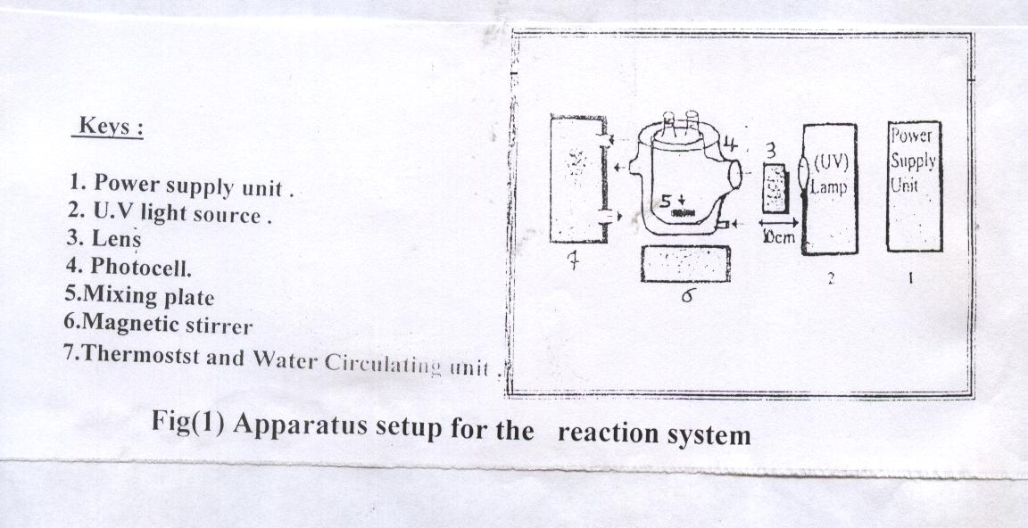

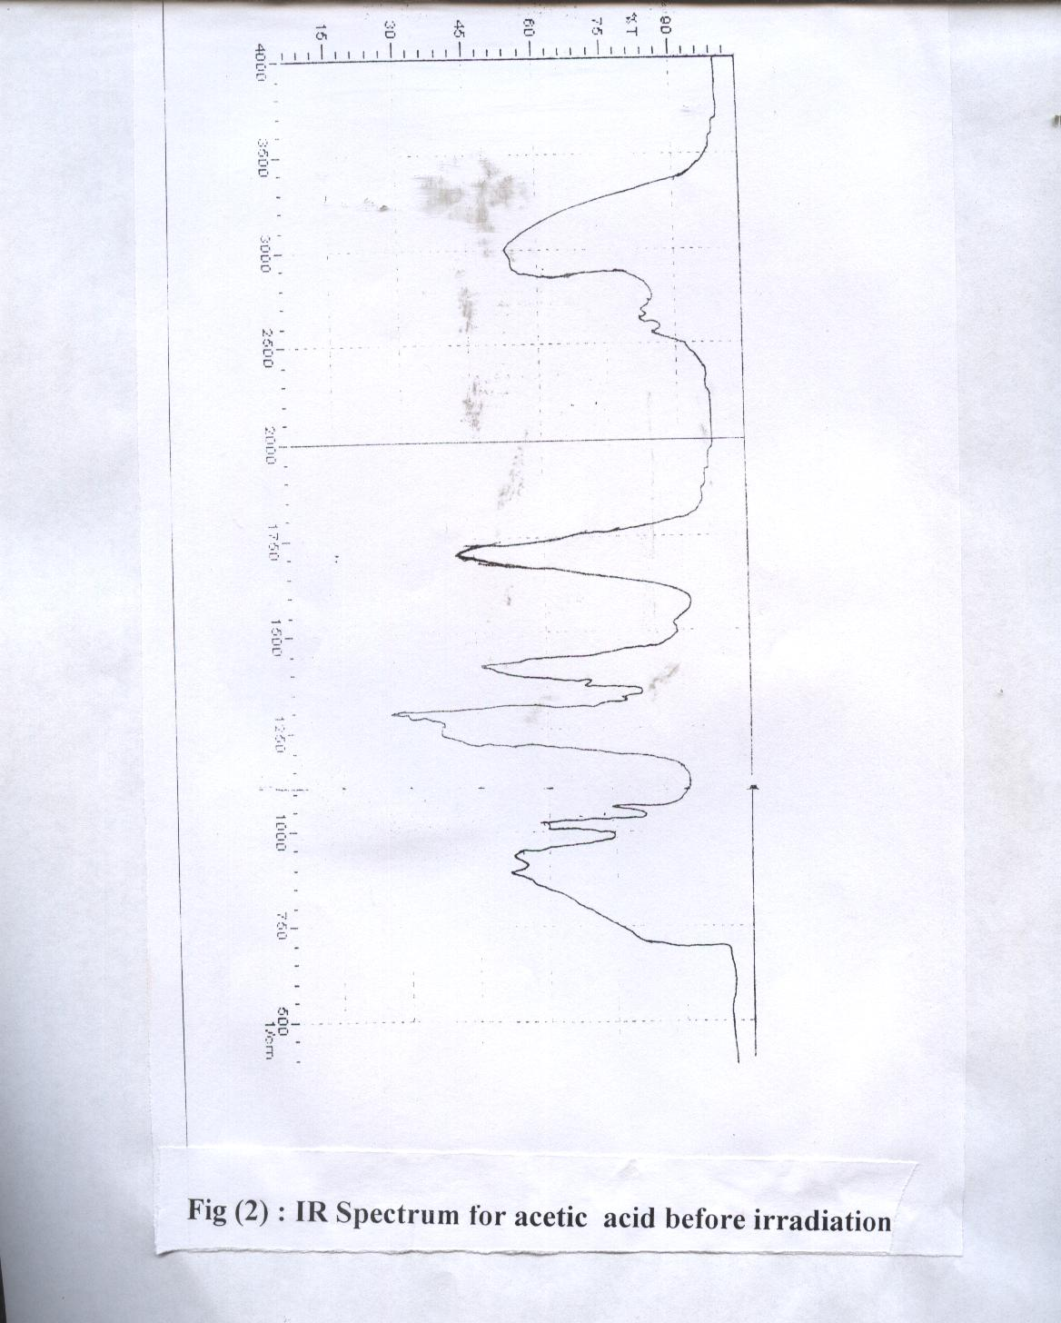

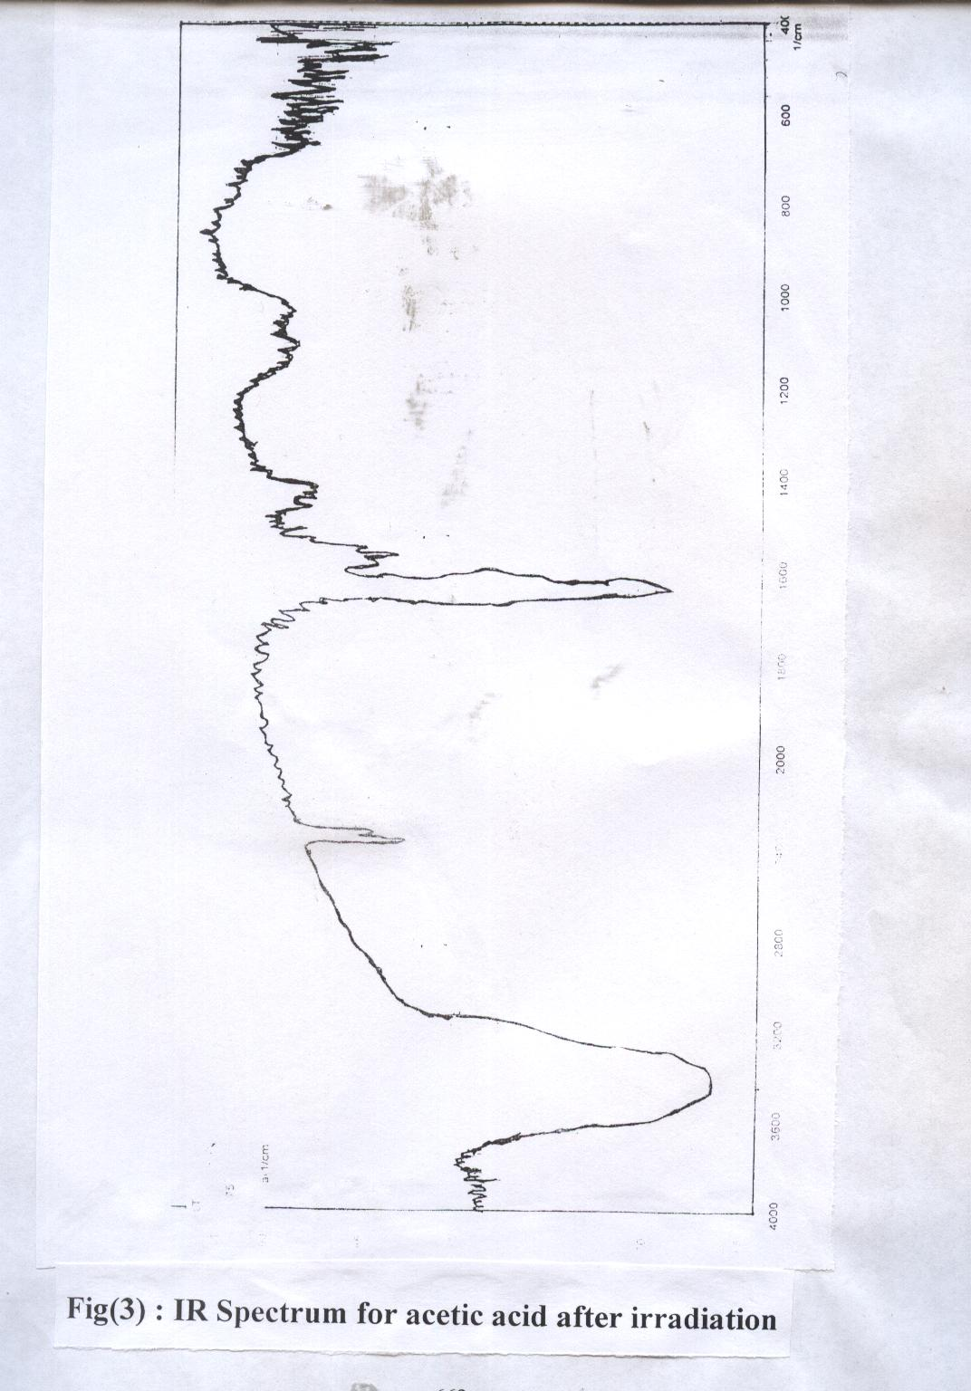

Acetic Acid conc / mol . dm⁻³
0.92
0.93
0.94
0.95
0.96
0.97
0.98
0.99
1
0
20
40
60
80
100
120
140
K
K
K
293
298
303

time/min

Fig(4) : Photocataylitc degradation of acetic acid over ZnO at different temperatures

1000K/T

Lnk
$\text{slope}=\frac{Δy}{Δx}=\frac{−0\text{.}\text{30}}{0\text{.}\text{112}×{\text{10}}^{−3}}$

$\text{slope}=\frac{−\text{Ea}}{R}$

$\text{2678}\text{.}\text{519}=\frac{−\text{Ea}}{R}$

$∴\text{Ea}=\text{22}\text{.}\text{238}\text{kJ}\text{.}{\text{mol}}^{−1}$
$\text{Ea}=\text{22}\text{kJ}\text{.}{\text{mol}}^{−1}$

Fig (5) . Arrhenius plot for the photocatalytic degradation of acetic acid over ZnO

$\text{int}\text{ercept}=\frac{1}{\text{kr}}$

$∴\text{kr}=4\text{.}5×{\text{10}}^{−6}{\text{sec}}^{−1}$
1/r₀ (mol⁻¹.dm³.sec)
$\text{slope}=\frac{1}{\text{kakr}}=\frac{Δy}{Δx}$

$\text{ka}=1\text{.}8×{\text{10}}^{4}l\text{.}{\text{mol}}^{−1}$

$$\frac{1}{\text{kr}}$$

$$\frac{1}{c}{\text{dm}}^{3}\text{.}{\text{mol}}^{−1}$$

Fig (6) : Plot of 1/r₀ Versus 1/c for the photocatalytic degradation of acetic acid
over ZnO at 293 K

References
- H.Hidaka , M.Gartazel , and E.Pelizzeti , J. Photochem .1986,36,219.
- J.Zhoo , Oato , and N.Serpore , J.Photochem .Photobiol ., A:chem.., 1992 ,69.
- S.N. Frank , A.J.Bard , J.Amer . Chem. Soc .,1977, 999304.
- K.Vinodgopal , I.Bedja , and P.Kamat.,Langmuir,1994,1091,1767
- L.Skubal , N.Meshkova and M. Voget ., J.Photochem .Photobiol. A: Chen .,2002,1480,103.
- J.Richarson , Principles of Catalyst Development , Plenum Press , New York ,1989, 1.
- R.Alberty , Physical Chemistry ,John Wiely and Sons , 7th edn , New York , 1987, 873.
- C.Wang , J.Rabin , and J.Dohrmmen .J.Photochem .Photobiol. Chem. , 2002, 148 , 169.
- F.Palmaer , B.Eggins , and H. Colenan , J.Photochem .Photobiol .A : Chem., 2002 , 148,137.
- A.Companian , R .Wyatt , J. Phys . Chem.. Solid ., 1963 , 24 , 1025 .
- R.Blue , Photochemistry of Solids , John Wiley and Sons ,Inc ,1960
- D.Yates , J.Phys . Chem. ,1961 , 65 , 746.
- G.Munera , F.Stone ,Disc Faraday .Soc .,1971,52,205
- P.Jones , J.C.S . Faraday . Trans .I , 1972 , 68,907
- P. Gravella , F. Juillete , Disc . Faraday . Soc .,1971 , 52 , 140
- I . Izuml , F.Ren ., and A. Bard , Amer . Chem. Soc ., 1980 , 84 (24), 3209 .
- N.Serpone , EPA Newsletter , 1997 , 59 , 54.
- J.Beziat , P.Gollezot , J. Catalysis , 1999, 182, 129.
- J.Falconer , D.Muggli , J. Catalysis , 1999, 187, 230 .
- P.Pichat , M.Mozzaneega , J.Herrmann , M.Nouv . J.Chem .Phys,1982 , 11,559.
- N. Blacke , G. Griffin , J.Phys . Chem ., 1988 , 92 , 5697 .
- D.Bahnemann , D .Bockelmann , and R.Goslich , Sol. Energy , Matter , 1991 , 24 , 564.
- F.H.Hussein , PH.D Thesis Nottingham , University , Uk , 1984 .
- P.Harvey,R.Rudham,andS.Ward, J.C.S.Fared.Trans.1,1983,79,2975
- F.Hussein , A.H . Ibrahim , and S.A. Shakir , Zanco , 1989 , 2 ,73.
- C. Turchi , D. Ollis , J. Catalysis ., 1990 , 122, 178.
- B. Jenny , P . Pichat , Langmuir , 1999,70, 947.
- Langrnuir , I . Trans . Faraday.Soc., 1921, 17 , 621.
- R. Mathews , J.Chem .Soc . , Faraday .Trams .I , 1989, 85 , 1291.
- J.Beziat , P. Gallezot , J. Catalysis , 199 , 182 , 129 .
- J. Facloner , D. Muggli , J. Catalysis , 1999 , 187 , 230 .

