III-Preparation and characterization of some Zn⁺² , Cd⁺², and Hg⁺² complexes with Derivatives

Omar Hamad Shehab AL- Obaidi  chemistry department,  College of Women Education | abdulsallam al-ali  hemistry department  College of Science
University of Al-Anbar | University of Al-Mustansirya

(NJC)

(Receivedon 29/10/2006) (Accepted for publication on 3/10/2007)

Abstract
This research consists of the synthesis of some Schiff bases the following types:
1, 3 - Bis - (2-hydroxy-benzylidene) - thiourea = (L1)
1, 3 – Bis - (2-hydroxy-benzylidene) - urea = (L2)
The complexation of these ligands with some of transition metal ions (Zn⁺² , Cd⁺², and Hg⁺².(The Schiff bases together with their corresponding prepared transition metal complexes have been characterized on the bases of their (C.H.N) elemental analysis, IR, UV-VIS, and atomic absorption. Molar conductivity measurement and melting point of prepared complexes were measured. Their structures were propose according to the obtained results.

الخلاصة
يتضمن البحث تحضير بعض مشتقات قواعد شف( كليكندات) ذوات التراكيب التالية:
3, 1 - بس – (2- هيدروكسي – بنزيليدين ) - ثايويوريا =(L1)
3, 1 - بس – (2- هيدروكسي – بنزيليدين ) - يوريا =(L2)
وكذلك تحضير معقدات لهذه الليكندات مع بعض املاح العناصر الانتقالية التي تشمل (Zn⁺² , Cd⁺², and Hg⁺²) وقد تم تشخيص ودراسة تراكيب الليكندات والمعقدات المحضرة منها باستخدام تقنية التحليل الدقيق للعناصر (C.H.N) ومطيافية الاشعة تحت الحمراء والاشعة فوق البنفسجية وتقنية الامتصاص الذري اضافة الى قياس الموصلية الكهربائية المولارية ودرجات الانصهار للمعقدات المحضرة وعلى ضوء النتائج تم التحقق من تراكيب هذه المعقدات.

Introduction

The chemistry of urea thiourea and their derivatives has attracted considerable attention of coordination chemists by virtue of their (1)applicability as potential ligands for a large number of metal ions.
In view of antituberculosis and other pharmacological activities (2) of metal Schiff bases in biological system, the physiochemical studies of the metal complexes are well known for their pharmacological importance (3). Extensive studies on urea and thiourea derivative metal ion complexes have been reported (4).
The complexes have been characterized and their structures have been established with a view to add some thing new to the medicinal science which will show on test , whether they have antidisease activity . Schiff bases have been reported to possess significant biological activity (1). Many urea and thiourea derivative have been known to possess fungicidal (5) and posticidal (6) action, and several (Schiff base) have been reported to exhibit antitubercular (7), anti fungal (8), insecticidal, acaracidal activity (9) and bactericidal (10) properties.
The present paper describes the preparation of two type Schiff base ligands derived from (urea and thiourea) and their complexes. Schiff base ligands are very diverse and usually contain N, S and O donor atoms, although purely N donors are known(11-13), but others ligand N, and S donors(14,15)Schiff base also can be act as mono,di, tri dentite ligand or more with various donor atom combinations .
The presence of nitrogen, sulphur and oxygen atoms in the structure of an organic chelating agent has led to interesting results in the studies of coordination compounds (16).
We have, therefore, undertaken the preparation and character of the above new type of complexes metal (Zn⁺² , Cd⁺², and Hg⁺²؛ (

1, 3-Bis-(2-Hydroxy- benzylidene ) –thiourea

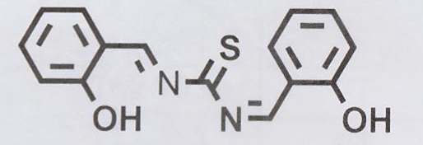

1, 3-Bis-(2-Hydroxy- benzylidene ) -urea

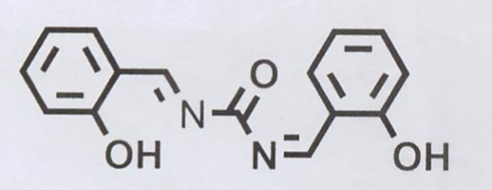

Fig. (1): The Structure of Schiff base ligands

Expermenyal
1- Instrumentation:
A pye – Unicom sp3-100 infrared spectrophotometer was used to recorded the ir spectra as KBr disc and CsI disc , UV/VIS spectra were measured by a
HITACHI U-2000 spectrophotometer, Elemental Analysis were done by
atomic absorption AA-680G (Shimadzu). Electrical conductance was measured at (10⁻³ - 10⁻⁴ M) on conductivity CDC304 (Jenway4070) Melting points determined by an
electric heated block apparatus (GallenKamp), and were uncorrected.
2-Materials
[ZnCl₂.6H₂O], [CdCl₂.6H₂O], [HgCl₂.6H₂O] were supplied by BDH chemicals, absolute ethanol, diethylether, dimethyl sulphoxide (DMSO), urea ,thiourea supplied by Aldrich .
- Preparation of (L1),(L2) was prepared according to the literature (17) The full name of the Schiff base will be replaced by a number (L1,L2) respectively as in shown in Table (1) for the rest of this paper . The physical properties of these compounds (L1, L2) are listed in Table (1). The characters IR bands and uv/vis spectrum in DMSO as shown in table (2), (3).
- General procedure for preparation of complexes :
To a hot solution of ligands (L1 or L2) (2 mmole) in absolute ethanol (5 ml), a hot solution of metal chloride (1 mmole) in absolute ethanol (5 ml) (dissolved in dilute HCl) (18) was mixed and the resultant mixture was stirred and refluxed for 2 hours, the color of the solution was changed immediately, the reaction mixture was cooled, and the solution was evaporated in vacuum, or lifted over night at room temperature , after this time a precipitate formed . This was collected by filtration, washed and recrystallized from absolute ethanol/ether.
The physical properties of prepared complexes are listed in Table (4). The analogous complexes were prepared in a similar manner to that described above by adding a hot solution of (1 m mole) in absolute ethanol (5 ml) to a hot solution of metal chloride (1 m mole) in absolute ethanol (5ml).The molar ratio of the complexes was determined according to the methods (19).

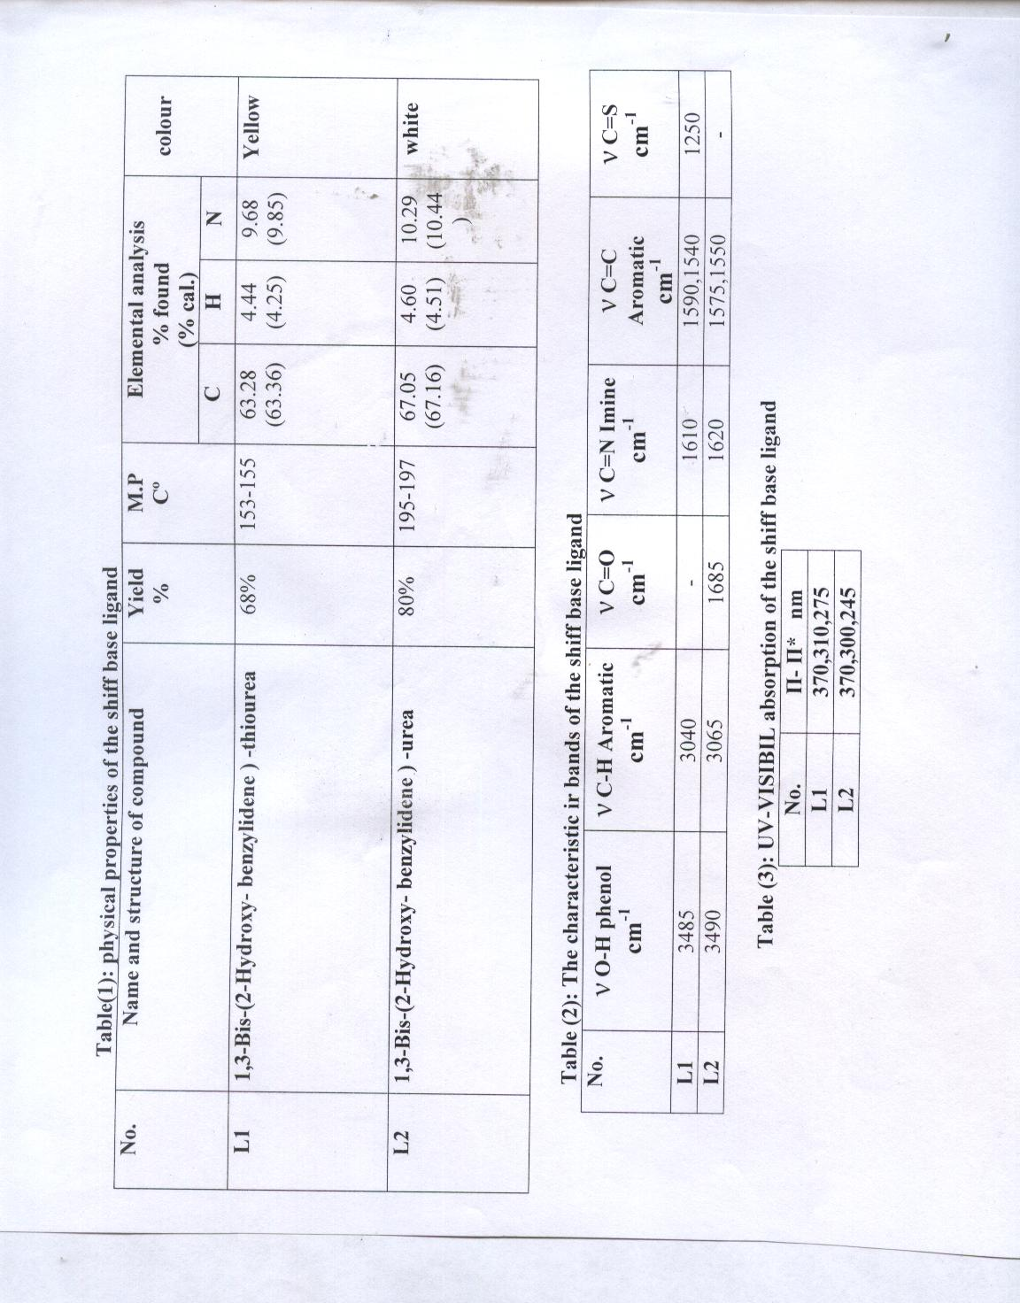

Results and Discussion
The structures of Schiff base complexes were confirmed by spectroscopic techniques like IR and uv /visble. The IR spectra show the band at 1610 cm⁻¹and 1620 cm⁻¹in the spectrum of (L1)and(L2) respectively due to ν C=N stretching which shifted to the lower frequencies in the complexes (20,21) (Table 4).
The negative shift generally in ν (C=N) further suggested the coordination to metal ions through nitrogen atom of (-C=N-) Schiff’s base (22) of the ligand and on complexation indicates involvement of azomethine nitrogen (13, 14, 21) with metal ions.
The band at 1250 cm⁻¹ in the spectrum due to ν C=S stretching vibrations in (L1). In the metal complexes this band is weakened and lowered (14) (Table 4). The observations indicate the coordination of the ligand (L1) through sulphur atom.
The carbonyl stretching frequency in (L2) decreases to (1605-1620) cm⁻¹compared to the free ligand at 1685 cm⁻¹, due to the with drawing of electron density from the ligand to the metal (23),
In metal complexes a new band is found 1265 cm⁻¹ for ν C-O which is very characteristic and ν O-H was observed (24) (Table 4).
New bands which appeared at low frequencies in the spectra of the prepared complexes were probably due to ν (M-N), ν (M-S), and
ν ( M-Cl) band vibration frequencies and ν M-O , ν M-S (bridging) occurs at lower frequencies than ν M-O, ν M-S ( terminal) indicating these type of coordinate (24) (Table 4).
The complexes give different colour from the transition metal salts and the

ligands, then this was important indication to coordinate occurrence (25), therefore these colourd complexes show different characteristic absorption band in position, intensity or together when compared with the bands of ligand and this was another indication for the coordination occurrence (26,27).
The uv/visible spectra of the two prepared ligands (L1, L2) at (10⁻³M) in ethanol were showed three absorption bands (27). The first (370) nm represented (n - П*) while the second (300-310) nm represented (П- П*) and the third band (270-275) nm is called (B-band) for phenyl group (28, 29).
Generally in the new prepared complexes these bands are shifted to short or long wavelength compared with free ligands and high intensity of the bands which indicate the complexation of ligands L1 and L2 with metal ion (26, 27).
The measurements of the molar electrical conductivity of the complexes at (25C) in DMSO are presented in Table (4). These results show the high values of the molar conductivity, these complexes are electrolyte and low values refer to the complexes are non-electrolyte, are in agreement with the proposed structures of the complexes.
The method of continuous variation mole ratio method are employed in this work molar ratio (2:1) metal to ligand for (1-6) complexes and (2:2) metal to ligand for (7-12) complexes (table 4) .
According to the results obtained from (IR, uv/vis, molar ratio, molar conductivity, atomic absorption) measurements for the prepared complexes, the proposed molecular structure of the complexes has an octahedral structure as shown below in Fig.(2):

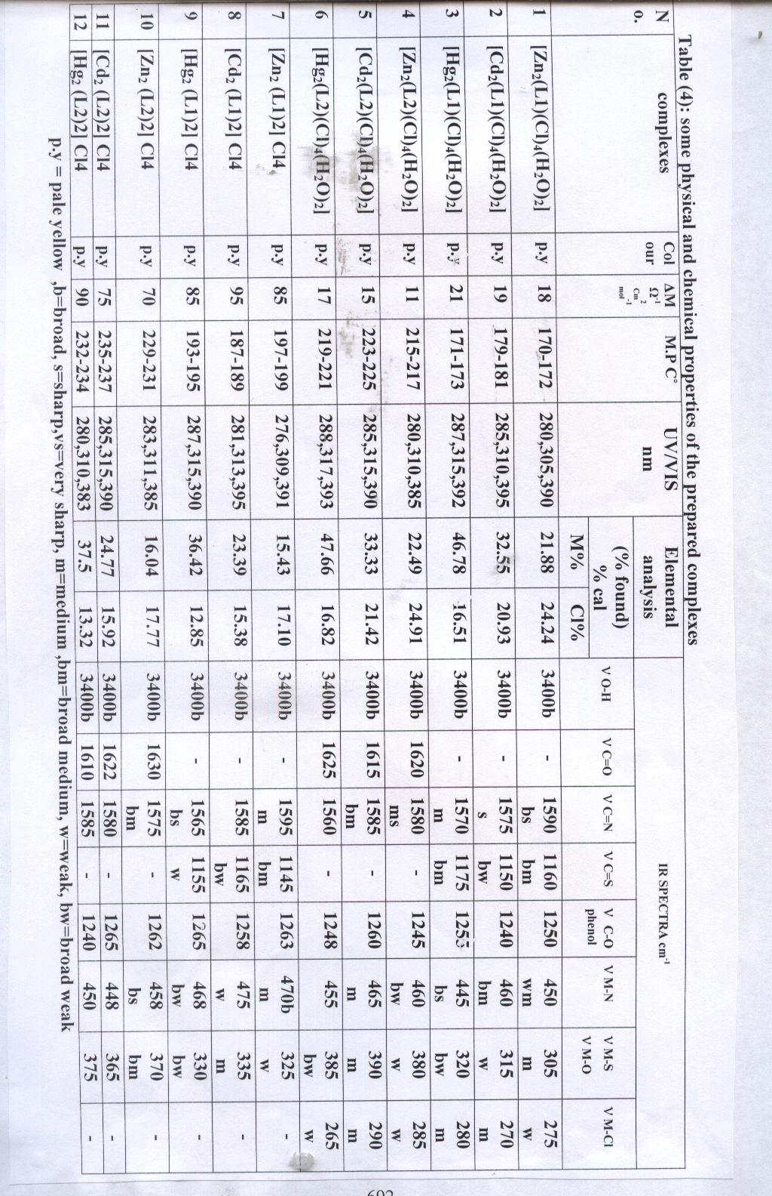

O O - CH=N –C– N=CH-
||
\ Y /
HO / \ OH
M M
/ \ / \
Cl Cl Cl Cl
H₂O H₂O

Y:[(L1)=S, (L2)=O]
Comp. No. (1-6)
M=(Zn⁺² , Cd⁺², Hg⁺²)

O O - CH=N –C– N=CH-
||
\ Y /
HO / \ OH
M M
/ \ / \
HO Y OH
||
O O - CH=N –C– N=CH-

Y:[(L1)=S, (L2)=O]
Comp. No. (7-12)
M=(Zn⁺² , Cd⁺², Hg⁺²)

Fig. (2): Suggested Structures for Complexes

References:

1-R.S.Verna,K.C.Gupta,Amarnath and V.S.Mishra,Indian .J.Microbiol 1966,64,13124 .
2-K.Butler,U.S Patent No. 1968, 3,266-382,266 .
3-V.K.Pandey and A.K.Aggarwal, Acta cienic . Indeca.Chem.; 1960, 6,166.
4-M.M.Mostava,A.M.ShallabyandA .A.El.Asmy, Inorg. Nucl .Chem.; 1981 ,43,2992 .
5-R.B.Pahak,B.Jahan and S.C. Bahal, J. Antibact. Antifung Agents, Japan .; 1980,8,12 .
6-L.Gsell and W. Mayer, Ger.Offen .; 1978, 2,739,84 , Chem.Abs .; 1978 ,88,19044r .
7-G.L.Moheshwari,R.P.Maheshand P. Singh, Curr. Sci.; 1975 ,44,594 .;
Chem.Abs.; 1976 ,83,193185j .
8- S.P.Suman and S.C.Bahel, J.Indian Chem.Soc.; 1979 ,56,374 .
9-A.Chatterjee, B. Das, N. Adityaachauduruand S D .Kirtaniyaniya Indian J. Chem.; 1980, 19,163 .
10- Chiyomaru E. Yoshinago H.Kawata and H.Ito, Japan .; 1973, 7343 ,615 .Chem, Abs.; 1974, 31, 59323 b .
11-R.H.Holm, G.W.Evertt, and Jr. Achakravorty, Prog. Inorg. Chem.; 1966 , 7, 83 .
12-M.D.Hobday and T. D. Smith, Coord. Chem. Rev.; 1972, 9,311 .
13-S.Shibata, Anal .Chem .Acta .; 1960, 23,362 .
14- A. Catsch ,A.E. Harmuth. Hoene and D.P .Meller ,”The Chelation of
Heavy Metals “,Pergamon Press, Oxford, New York ,(1979).
15-E.Ainscough,A.Brodle,W.Denney, G.Finalay and J.Ranford ,J. Inorg Biochem ., 1998,70,175 .

16- K.A. Jensen, Anorg. Allg. Chem.; 1943 ,6 , 22 .
17- W.F.AL-Hitie, Ph.D Thesis , AL-ANbar University 2003 .
18-C.B.Mahto J.Indian.Chem. Soc.; 1981,58,935 .
19-A. Yamaguchi, T. Miyazawa, T. Shimanouchi, and S. Mizushimo,
Normasl vibration of urea and urea-d4., SpectroChim. Acta.; 1957, 10,170 .
20-R.K.Agrawal, H. Agarwal and I. Chakraborti, Qatar Univ. Soc J .; 1994 , 14(C) ,92 .
21-G.B.Mahto, J. Indian. Chem. Soc.; 1980, 57,481 .
22-U.K.Mauthy, N. D. Jaghik and M. GPrjpe, J. Indian. Chem. Soc .; 1976 ,53,419 .
23- J.Tamura, et.al,Tetrahedron Lett .; 1983, 24, 5749 .
24-Waiss, Arg., et. al., Tetrahedron Lett.; 1964 ,513 .
25-C.N.R.Rao (1967)." Ultraviolet and visible spectroscopy chemical application,"2nd., ed. Butter Worths Ltd. London .pp 77-78
26-E.Russeva,V.Kubanand L.Sommer, Coll, Czech. Chem. Commun.; 1979,44,374 .
27- B.G.Saha , R. P. Shatnagan and K. Banerji, J .Indian .Chem. Soc., LIV.; 1982 , 927 .
28-A.E.Gillam and E.S.Strm,"An Introduction to the Electronic Absorption Spectroscopy", 2nd Ed.Edward Arnold Ltd,London .; 1957,115-150 .
29-R.M.Silverstein and G.C.Bassler, "Spectrometric Identification of Organic Compound," 2nd Ed. John Wiely and Sons Ltd .New york 1969 and 4th Ed.,1981.

