Atmospheric Pollution by Lead in Mukalla, Hadhramout.

Najlaa Al-Habeshi  Department of Environmental Science, College of Environmental Science & Marine Biology | Salem R. Bazar  Department of Environmental Science, College of Environmental Science & Marine Biology | Faris J. M. Al-Imarah  Dept of Marine Environmental Chemistry , Marine Science Center
University of Hadhramout for Science & Technology  Hadhramout- Yemen |  | University of Basrah

(NJC)

(Receivedon 8/7/2006) (Accepted for publication on 24/9 /2007)

Abstract

This study focus upon the determination of deposited lead on the surface area of plant leaves spreaded in Mukalla streets, the most crowded traffics. Samples of plant leaves from highway roads were studied as a control. Lead was analyzed spectrophotometrically by using dithiozone method. Determined levels of lead for control samples(50 samples) were in the range 0.0234-0.1032 μg/g dry weight with a mean value of 0.0384 μg/g, in October Q. the range was 0.028-0.115 μg/g dry weight with a mean value of 0.0537 μg/g. In Sharge Q. the range was 0.0237-0.1032 μg/g dry weight with a mean value of 0.0512 μg/g, while in Mukalla Q. the rang was 0.0172-0.1247 μg/g dry weight with a mean value of 0.0532 μg/g . The main source of atmospheric pollution by lead in Mukalla is the waste from exhaust of the petroleum fuel automobile.

(Key words: Atmospheric pollution, Lead, Mukalla, Automobile,plant leaves)

الخلاصة
تركزت هذه الدراسة على تقدير الرصاص المترسب على اسطح اوراق النباتات المنتشرة في اكثر الشوارع ازدحاما" بوسائط النقل في شوارع مدينة المكلا, اليمن. و درست كذلك عينات من اوراق النباتات المنتشرة في شوارع الطرق السريعة لغرض المقارنة. اعتمدت طريقة الداي ثايوزون لتقدير الرصاص طيفيا". كان مدى تركيز الرصاص المقدر في عينات المقارنة (50 عينة) بحدود 0,0234 – 0,1032 مايكروغرام/غرام وزن جاف وبمعدل قيمة بحدود 0,0384 مايكروغرام/غرام . في حي اكتوبر كان مدى ومعدل تركيز الرصاص بحدود 0,028 -- 0,115 و 0,0537 مايكروغرام/غرام وزن جاف على التوالي, وفي حي الشرج كانت القيم بحدود 0,0237-- 0,1032 و 0,0512 مايكروغرام/غرام وزن جاف على التوالي بينما كانت القيم في حي اكتوبر بحدود 0,0172- 01247 و 0,0532 مايكروغرام/غرام وزن جاف على التوالي. ان المصدر الرئيسي للتلوث الجوي بالرصاص في المكلا هو مخلفات وسائط النقل التي تستخدم مشتقات النفط.
( كلمات دالة: تلوث جوي, رصاص, المكلا, وسائط النقل , اوراق النباتات )

Introduction
Air which living organisms are breath should be clean and unpolluted. Air pollution could be arises naturally by gases from volcanoes and fire, pollen, microbes and dust or industrially from fuel consumption and pollutants released from automobile exhaust as well as gases from domestic waste and particulates (Mousa, 1996).
Inside cities, automobiles are represented as the main sources for air pollution due to ejection of different types of pollutants, among them are hydrocarbons as uncompleted fuel consumption(AlaaAl-Din,1990) and lead which is added to automobile fuel for improvement and increase efficiency of automobile engines (Mousa,1996).
Air pollutants will spread in the atmosphere of crowded cities from which they fall down on soil, plants especially on leaves( Abdul-Jawad, 1991). These pollutants may contain lead in high levels. The allowed concentration of lead in air is 0.5 μg/m³ at normal time and 15 μg/m³ during maximum traffics.
Developed countries began to decrease the quantities of added lead to the automobile petroleum fuel or replace tetraethyl lead(TEL) by methyl terbutyl ether(MTBE) ( Al-Khudher,1997).

Experimental
Sampling stations
Three sites in Mukalla district were chosen for this study : 1) October Q., 2) Sherge Q. and 3) Mukalla Q. Within these sites different positions were investigated represented by heavy traffic squares, public gardens, light traffic roads as show in Fig.1. as well as highway roads as control.

Sample collection
Samples of plant leaves were collected from the streets of chosen stations at different periods of time, Jan-May 2002. Fifteen types of plants were used for sampling as they spread every where inside the cities among which and the most abundant plant is Ficus microphylla, 2-3 m hight, with green leaves over all the year .

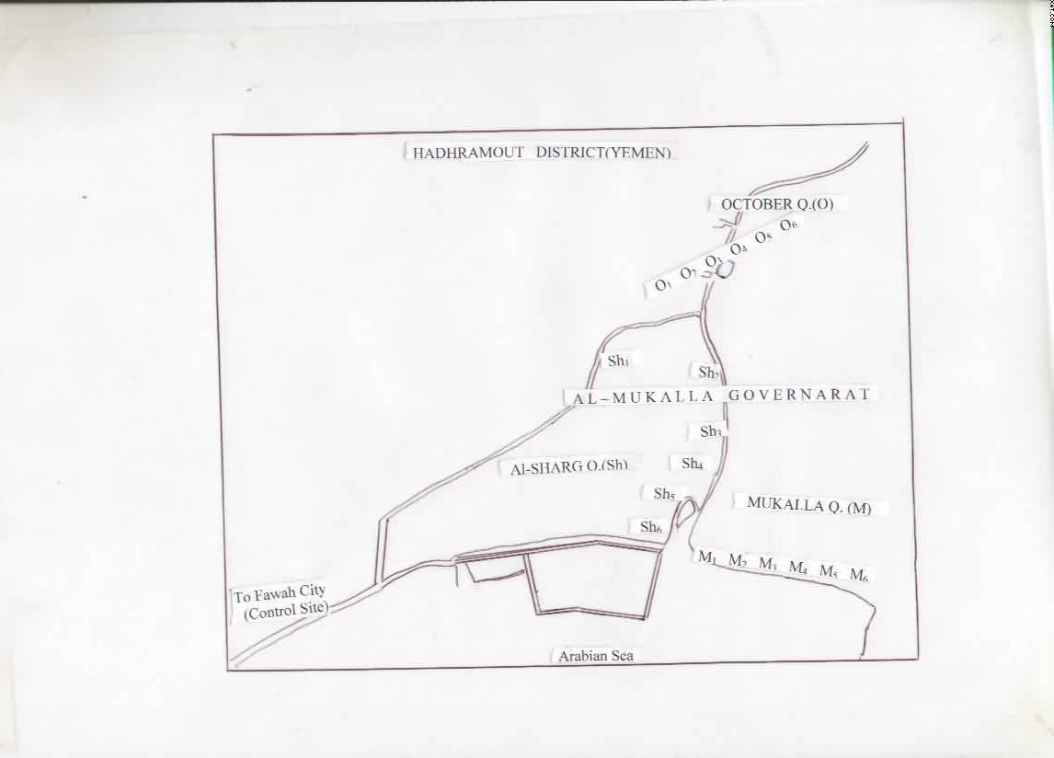
Fig1. Location map of Al-Mukalla Governorate showing the sampling sites.

Analysis
Collected leaves by tongue were put in glass dishes and transferred to the lab, dried at 60°C for 24 hours, ashed at 450°C for 24 hours, then 5 grams from each ashed sample were digested in 10 ml concentrated nitric acid, filtered and diluted to 100 ml with distilled water(ROPME, 1982).
20 ml of the sample heated and adjusted for pH=2 then 2 ml each of hydrazinium solution and cyanide and tartarate solutions as well as 10 ml of dithiozon in chloroform were added and mixed for 10 minutes in separatory funnel( Sandell and Onishi, 1978)

Then the organic layer of chloroform was separated and absorbance was measured by Cecil Spectrophotometer, Series 3000 at wave length of 510 nm.
Lead concentrations in each sample was calculated from the calibration curve and expressed as μg/g.
All liquids used were highly pure spectral grade and water used was deionized.
Results and Discussion
In recent years many researchers used new techniques for detection of pollution with different pollutants and that is using Biological technique. One of the useful method is the use of plant leaves as an indicator of the detection of bioaccumulation of pollutants due to the ability of leaves to uptake of large quantities of atmospheric pollutants (Becker and Agaev, 1989;Knabe,1982).
Due to the lack of proper instruments, technique used for lead measurements adopted in this study was spectrophotometry (Al-Taieeb and Jawad,1988). Analysis was conducted for 12 samples from different sites in October Q. (Oct1-Oct6) at different periods of time ranged from 15 Jan to 17 May 2002. Results of atmospheric lead deposited on the leaves of plants from these sites are listed in table 1. Lead range from 0.0228 μg/g in site Oct 5 to 0.1153 μg/g in site Oct 1 with mean value of 0.0537 μg/g.
Values recorded for lead were alternate from time to time depending upon many factors among which are quite effective ; the traffic sites and sampling after rain as well as type of plant with wide leaves as collected high amounts of deposited lead.
In Sharge Q., 12 samples from different sites were investigated for the period Feb- May 2002. Recorded lead is listed in table 2.

Table 1. Concentrations of lead on plant leaves collected from October Quarter in Mukalla ( 15 Jan.-17 May. 2002).

Sample | Conc. of lead μg/g | Sample | Conc. of lead μg/g
O1 | 0.1153 | O5 | 0.0520
O1 | 0.0886 | O4 | 0.0278
O5 | 0.0280 | O1 | 0.0480
O4 | 0.0477 | O3 | 0.0579
O5 | 0.0228 | O1 | 0.0340
O4 | 0.0960 | O2 | 0.0270

The range of lead was 0.0237-0.1032 μg/g in which high values recorded for sites of heavy traffics, while lower levels were recorded for sites of highways with low traffic The variable values reported during April and May were due to the effect of raining and wind movements which cause losing of dust contains lead on the surface of plant leaves.
For the third sites of sampling , Mukalla Q., 14 samples were collected from different stations( M1-M6) for the period March-May 2002. The values recorded for lead concentrations on the plant leaves are listed in table 3. Range of lead was 0.0127-0.1247 μg/g.

Table 2. Concentrations of lead on plant leaves collected from Al-Sharg Quarter
( 12 Feb.-17 May. 2002).
Sample | Conc. of lead μg/g | Sample | Conc. of lead μg/g
Sh 6 | 0.1032 | Sh 6 | 0.0354
Sh 6 | 0.0957 | Sh 1 | 0.0788
Sh 5 | 0.1009 | Sh 1 | 0.0339
Sh 5 | 0.0713 | Sh 5 | 0.0777
Sh 6 | 0.0261 | Sh 6 | 0.0478
Sh 6 | 0.0474 | Sh 3 | 0.0237
Sh 5 | 0.0417 | Sh 3 | 0.0559
Sh 4 | 0.0306 | Sh 2 | 0.0415
Sh 4 | 0.0326 | Sh 1 | 0.0333
Sh 6 | 0.0383 | Sh 6 | 0.0348
Sh 6 | 0.0355 | Sh 6 | 0.0366
Sh 6 | 0.0494

Table 3. Concentrations of lead on plant leaves from Al-Mukalla Quarter
( 9 March – 17 May 2002).

Sample | Conc. of lead μg/g | Sample | Conc. of lead μg/g
M 1 | 0.0799 | M 5 | 0.0266
M 4 | 0.1247 | M 4 | 0.0349
M 4 | 0.0994 | M 3 | 0.0484
M 5 | 0.0704 | M 1 | 0.0476
M 6 | 0.0311 | M 4 | 0.0476
M 3 | 0.0459 | M 3 | 0.0384
M 6 | 0.0327 | M 2 | 0.0172

The mean values for lead deposited on the plant leaves in Mukallah district were 0.0537, 0.0492, 0.0532 μg/g in October, Sherg and Mukalla Quarters respectively. The trend of lead concentration decreased from Mukalla, Sherg then October Quarters due to the main reason of heavy traffic as lead is added to gasoline to increase the octane number of automobile fuel. The quantities of lead added were increased from 1995-2001 in which it estimated as 155.57, 139.72, 145.86, 451.58, 552.6, 559.75 and 563 Kg during the years 1995, 1996, 1997, 1998, 1999, 2000 and 2001 respectively ( Ba-Issa, et al., 2001). It is clear that the lead added to gasoline is increased heavily during 1998 and later years due to increase the demand for gasoline fuel as number of automobiles are increased. These added quantities of lead will be released to the environment and cause certain problems to living organisms in the atmosphere, sea or land; human, animals, plants etc .
Marine pollution by lead was reported in the water column and sediments from the shorelines of Hadhramout, Mukalla. Levels of lead were recorded as 0.050 μg/l in water and 4.5 μg/g in sediments from the coasts of Mukalla ( Ba-Isa,et al.,2000). This was attributed to the pollution by lead from the atmosphere which running with waste water and rain water as well as domestic water used for cleaning garden plants as bushes of 1 m height and roads inside cities daily.
Conclusion
It is concluded that sites which effected by high traffic showed high levels of precipitated lead on the leaves of plants, while sites of public gardens far away from heavy traffic showed lower concentrations of lead. It is expected that the level of lead concentration may be raised up to 100 time in plants which grow in the middle of roads and streets characterized with high density of transportation movements as compared with grown plants in clean area where the concentration of lead does not exceed more than 1 ppm. The main source of lead in the atmosphere of Mukalla is the gasoline, which used as fuel for automobiles. Mean values recorded during this study are still within the allowed limits by WHO and the Yemeni standard. It is recommended to decrease the quantities of lead compounds added to gasoline and continuous maintanenos should be proceeded for all automobile engines as well as monitoring the ruined ones.

References

1-Abdul-Jawad,A.A; Air pollution. Dar Al-Maarefa Al- Beaeah series, Al-Dar Al-Arabiyah for Publication and Distribution, Cairo,Egypt.; 1991
2-Alaa Al-Din, A. M; Automobiles and Environmental Pollution. 1st edn. Dar Al-Hadatha for Printing, Publication and Distribution, Beirout- Lebanon.; 1990
3-Al-Khudher,M.A; Problems of Environment and Pollution in
Yemen. 1st edn., Sanaa’ University.; 1997
4-Al-Taieb,N.A. and Jawad,B.M ; Determination Environmental
Pollution. Dar Al-Mariech Publication, Al-Ryadh,KSA.; 1998
5-Ba-Isa,A.A.,Shaibi,Y.M., Shawafi, N.A., Ba-Rahyan,S. and Ba-Mousa, A.2000.; An assessment of heavy metals Pollution in Hadramout marine environment. Proceedings of the Science Conference.; Organized By the Yemeni Scientific Research
Foundation.; 2000

6-Ba-Isa,A.A., Shaibi,Y.M., Shawafi, N.A., Ba-Rahyan,S. and Ba-Mousa, A .2001.; An assessment of Pollution by lead in Hadramout Atmospheric environment. Proceedings of the Science Conference ; Organized By the Yemeni Scientific Research Foundation.; 2001
7-Becker,A.A. and Agaev, A.B; Natural environmental protection and pollution control. Hydrometeology Press, Linengrad, USSR, 1989, 286.
8-Knabe,W ; Monitoring of air pollution by wild life plan and plant
exposure. Junk Publication, The Hague, Boston,UK.; 1982, 59-70.
9-Mousa,M.A.; Atmospheric Pollution. Dar El-Fiker Al-Mooaser, Demascus, Syria.; 1996.
10-ROPME.; Manual of oceanographic observation and pollution analysis methods. ROPME, P. O. Box 26388,13124 Safat, Kwuait.; 1982
11-Sandell, E.B. and H. Onishi, H.; Photometric Determination of Traces of Metals: General Aspects. John Wiley & Sons, New York.; 1978.

