Synthesis of Some Substituted Pyrano 1, 3-oxazine

M.S. Al-Ajely  Chemistry Dept.  College of Education | H.A. Basheer  Science dept.  College of Basic Education
Mosul Univ. Mosul, Iraq

(NJC)

(Receivedon 3/10/2006) (Accepted for publication on 9/9 /2007)

Abstract
7-Chloro-2- methyl thio-2-N-ethyl carbazato, 2N-acetyl tyrosyl hydrazido 4,5-dioxo pyrano [ 3, 4-e ] - 1, 3-oxazine -4, 5-dione [2] , 2, 7-di(N-ethyl carbazato) 4,5-dioxo pyrano [ 3, 4-e ] - 1, 3-Oxazine -4, 5-dione [3] and, 7- chloro 2N-acetyl amino acid hydrazido , 2N-benzoyl amino acid Hydrazido-4,5-dioxo pyrano [3, 4-e]-1,3-oxazine 4, 5-dione [4] were synthesized by standard methods. The pyrano -1, 3-oxazine [1] was prepared from condensation of two moles of malonyl chloride with methyl or benzyl thiocyanate. Spectroscopic characteristics (IR, NMR) of the pyrano -1, 3-oxazine derivatives are presented and discussed.

الخلاصة :
في هذا البحث تم تحضير المركبات 7- كلورو- مثيل ثايو- -N-2اثيل كاربازيتو ، -N-2 اسثيل تايروسيل هيدرازيدو-5،4- دايوكسوبايرانو [4،3-أي] - 1 ,3- اوكسازين -5،4- دايون [2] والمركب 7،2- ثنائي [N –اثيل كاربازيتو] -5،4- دايوكسو بايرانو [4،3-أي] - 1 ,3- اوكسازين- 5،4- دايون [3] والمركب 7- كلورو- N2- استيل هيدرازيد الحامض الاميني ، N2- بنزوايل هيدرازيد الحامض الاميني -5،4- دايوكسو بايرانو [4،3-أي] – 1, 3-اوكسازاين 5،4- دايون [4] هذا وقد حضرت تلك المركبات بالاعتماد على طريقة التحضير العامة . أما المركب يايرانو 3،1-اوكسازين [1] فقد حضر من تكاثف مولين من كلوريد المالونيل مع مول واحد من ثايوسينات المثيل أو البنزيل وتم مناقشة أطياف المركبات المحضرة والمتمثلة بالــIR والـــ¹HNMR .

Introduction:
Substantial number of 3,4-dihydro-1,3-2Hbenzoxazine derivatives were synthesized from the reaction of p-substituted phenol with dimethalol amines ¹.
The condensation of naphtols with formaldehyde and primary amines was also used to the synthesis of 2,3-dihydro-2-substituted-1H naphtha[1,2-e[-1,3-oxazines or N,N-bis(2-hydroxy-1- naphthyl methylol amines² .Some dihydro-1,3-benz oxazines were studied and were found to have anti tumour activities³. Coppla and M.Gray prepared 2,3-indoline dione⁴.This compound was used in the preparation of compounds having pharmacological activity which comprises reacting a 1,3-benzoxazine with an alkali or alkali earth metal cyanide to obtain 2- imino-3-indolino derivatives which then subjected to hydrolysis.
Number of 1,3-oxazine derivatives often have analgesic, anti-inflammatory and anti leukaemic activities⁵⁻⁷. Aminoacid ester derivatives of pyrano-1,3-oxazine becomes an area of interest due to their antibacterial or anti fungal activities^{8,9}. Our interest in the synthesis and the biological study of (ethyl carbazato) derivative of pyrano-1,3-oxazine which was found to behave as anti cancer agent¹⁰, brought great attention to study hydrazide as derivatives of pyrano-1,3-oxazine. In view that hydrazides themselves have been studied and were found to pocess anti bacterial, virul and anti fungal activities ¹¹⁻¹⁴.
They also used as plant growth control ¹⁵.Recent study on 1,3-oxazine compounds includes; The synthesis of (RS)-3-tert-butoxycarbonyl-perhydro-1,3-oxazine-2-yl acetic acid and the synthesis of the simple and C-2 substituted 3-tert-butoxycarbonyl-perhydro-1,3-oxazine-2(RS)-yl propionic acids from simple starting materials¹⁶ ,Streocontrolled synthesis of

D- erythrosphinogosine and D-ribo-phytosphingsine which has a variety of physiological value ¹⁷,European patent for the production of photo chromatic pyrano1,3-oxazininonaphthalene derivatives¹⁸,Synthesisof 7-chloro-3-substituted-3,4-dihydro-4,5-dioxo-2-thio-2H,5H-pyrano[3,4-e]1,3-oxazine¹⁹,New approach to the synthesis of Biginellic compounds and their analogues²⁰ ,Synthesis and crystal structure study of 5-(4-methoxy benzyl)-6-(4-methoxyphenyl)-3-phenyl-2,4-dihydro-2H-1,3-oxazine-2,4-one²¹.Among the biological values of 1,3-oxazine compounds are ; The studies of P.Kaylo,J.AL-Rawi and A.H Hugher for the production of some 1,3-benzoxazine derivatives from 2-(hydroxyl,thio or amino)aromatic acid using the triphosphinothiocyanogen reagent,The synthesized compounds were used as antiplatelete agent²².The more recent study on the 1,3-oxazine compounds is the work of AL-Rawi and his coworkers on the synthesis of 2-(ethyl aminoacid estrers)-1,3-oxazine which has the ability to inhibit DNA-Dependent protein Kinase²³.
In this paper we describe an approach to the preparation of amio acid hydrazide derivatives of pyrano-l,3-oxazine . Our next work will be the biological study of the above synthesized compounds.

Experimental
Uncorrected melting points were determined using electrothermal 9300 melting point apparatus. I.R. spectra were recorded by Pye Unicam SP1100 Spectrophotometer as KBr disc. ¹HNMR spectra were measured with Hitachi 60 MHz spectrometer at Education college of Mosul University. 7-chloro-2-benzyl (or methyl) thio-4,5-dioxopyrano [3, 4-e] -1, 3-oxazine 4, 5-diones (la-b) were prepared according to the reported procedure ²⁴ .

Preparation of amino acid ester hydrochloride²⁴:
A stream of dry hydrogen chloride gas was passed rapidly through suspension prepared by dissolving 10 g. of amino acid in 150 ml of absolute ethanol, their melting points were determined and checked with the literature values.

Preparation of amino acid ester :²⁵
A stream of dry ammonia gas was passed through suspension made by dissolving 10 gm. of amino acid ester hydrochloride in 100 ml. of dry methylene chloride. The ammonium chloride was filtered off, the solvent was evaporated under reduced pressure giving yellow color liquid.

Preparation of benzoyl (or acetyl) amino acid ester²⁶ :
To an ice cooled solution of 0.01 mole benzoyl chloride (or acetyl chloride) in 50 ml. dry dichloromethane was added drop-wise a solution of 0.02 mole of amino acid ester in 50 ml dichloromethane with stirring. After the addition has been completed, the reaction mixture was refluxed for 1 hr. cooled and washed with sodium bicarbonate solution (5%) then with water and dried. The melting points together with IR spectral data are presented in (Table 1).

Preparation of benzoyl (or acetyl) amino acid hydrazide²⁷ :
A solution of 0.02 mole of benzoyl (or acetyl) amino acid ester and 0.01 of hydrazine hydrate in 50 ml. of absolute ethanol was refluxed for 1 hr. cooled, the precipitate was filtered off and recrystallized from ethanol. Physical and spectral data are illustrated in (Table 2).
Reaction of benzoyl and acetyl amino acid hydrazide with 2-benzylthio-7-chloro-4,5-dioxopyrano[3,4-e]-l,3-oxazine-4,5-dione; The synthesis ofcompounds (4a-i)⁸
In 100 ml. round bottomed flask fitted with reflux condenser and dropping funnel , was placed (0.01 mol) of compound (1) in 40 ml. of dry chloroform.
The reaction was carried on by dropwise addition of benzoyl (or acetyl) amino acid hydrazide (0.01 mole) in 20 ml dry chloroform through dropping funnel with continuous stirring. After completing the addition the reaction mixture was refluxed for 6 hr, cooled and the solvent was evaporated under reduced pressure. The solid crude product was then recrystallized. The spectral data of the synthesized compounds (4a-i) together with their physical constants are presented in Table (3).

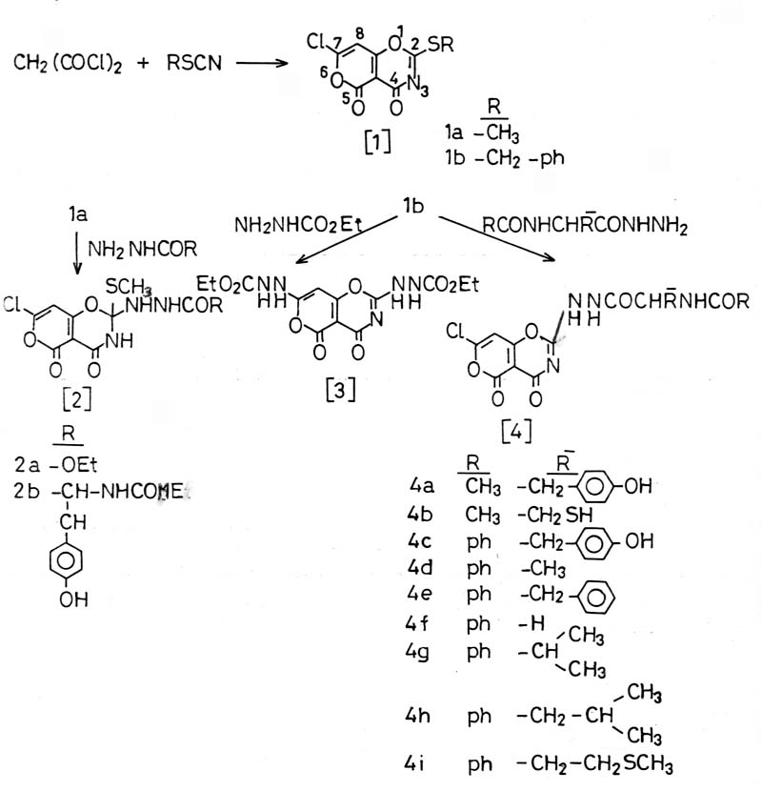

Scheme -1-

Table (1) : Amino acid esters IR spectral data together with their melting points.

Amino acid esters | C=O amide  ν cm⁻¹ | C=O ester  νcm⁻¹ | NH  νcm⁻¹ | M.P⁰C
CH₃CO-tyr-OEt | 1630 | 1735 | 3200 | 245
Ch₃CO-cys-OEt | 1665 | 1740 | 3350 | 109-111
PhCO-tyr-OEt | 1630 | 1745 | 3310 | 107-109
PhCO-ala-OEt | 1650 | 1720 | 3320 | 110-113
PhCO-phe-OEt | 1625 | 1745 | 3350 | 95-97
PhCO-val-OEt | 1635 | 1725 | 3360 | 80-81
PhCO-leu-OEt | 1630 | 1740 | 3300 | 65-67
PhCO-Meth-OEt | 1640 | 1750 | 3310 | 79-82
PhCO-gly-OEt | - | - | - | 58-60 (measured)  60.5 (published)
Note : the yield of the above amino acid esters range was (70-80%).

Results and Discussion:
Amino acid hydrazides (N-acetyl tyrosyi to N-benzoyl methionyl hydrazide) were prepared by treatment of the corresponding esters with hydrazine hydrate as described in the experimental part. Their IR spectra (Table 2) shows the main absorption bands at 1620-1650 cm⁻¹ for CONH 3110-3200 cm⁻¹ for NH amide stretching absorption and 3300-3400 cm⁻¹ for NH₂. The¹HNMR spectra of the above hydrazides showed the following main resonating signals 3.2-3.6 ppm, 8.2-9.0 ppm for NH₂ and NH amide respectively.
The compounds {7-chloro-2 (N-Acetyl tyrosyl hydrazido) -4,5-4- dioxopyrano [3,4-e] -1, 3-oxazine-4,5-dione},4a to { 7-chloro-2- (N-benzoyl methionyl hydrazido) -4, 5-dioxopyrano [ 3, 4-e]-1, 3-oxazine-4,5-dione} 4i were prepared according to the well known procedure ^{28,29} . Their structures were verified using IR, NMR spectra (Table 3). The IR spectra shows the following main signals 1630-1640 cm⁻¹ for CONH, 1660-1670 for other type amide linkage, 3280-3300 cm⁻¹ for amine stretching absorption together with other oxazine C=N, C=O absorption bands. The NMR spectra shows main resonating signals at 6.3-6.5 ppm for pyronic proton, broad band for NH, NH₂ of the hydrazide moiety as illustrated in

(Table 3) together with the other protons of the remainder hydrazide moiety . The above information suggests the replacement of the 2-benzyl thio group by the hydrazide groups, except for compound 2b in which the methyl thio group was retained giving similar unexpected result of our previous work ¹⁰ (compound 2a) in which the hydrazide adds to the C=N of the oxazine ring. The evidence came from the spectral data (Table 3) and the sodium fusion test which gives +ve sulfur test.

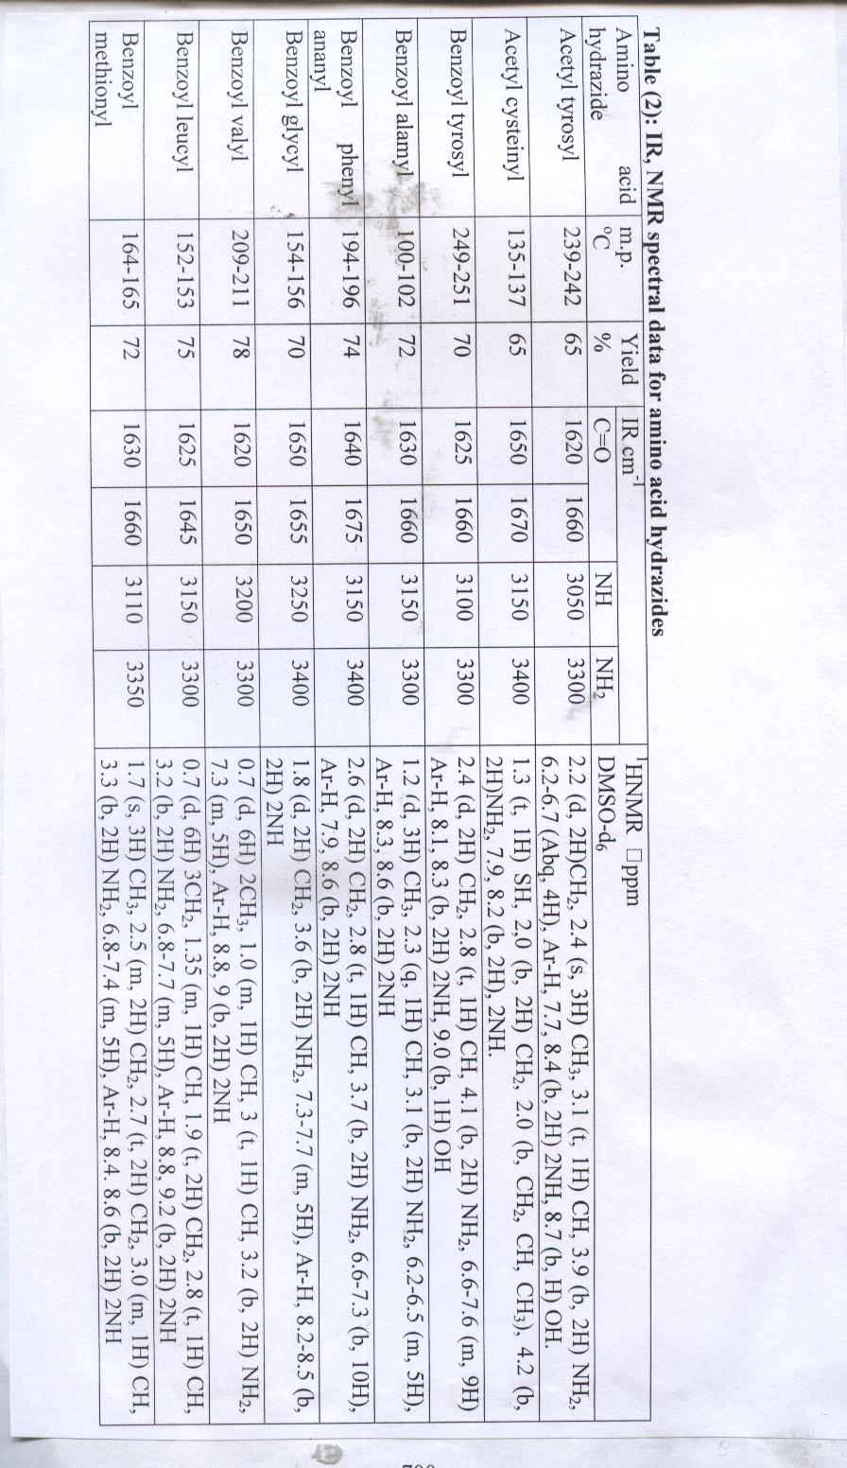
700
700
701
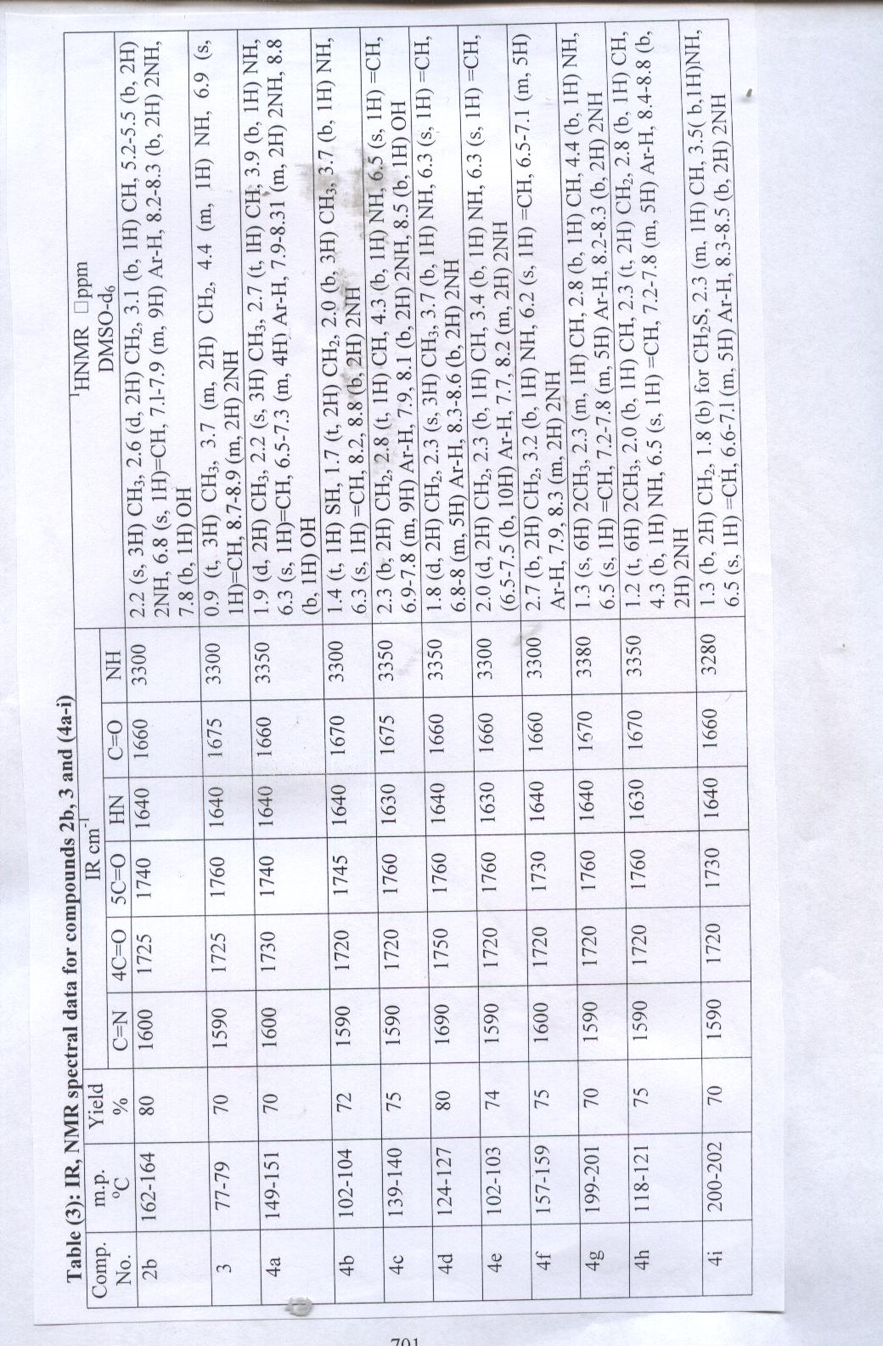

References :
- W.Burke,J.Am.Chem.Soc; 1952,.74, 3601-3605 .
- W.Bruke,J.Am.Chem.Soc; 1954.76,1677.
- Kuhene, J of Med. Pharm. Chem; 1962,5(2), 257-280 .
- Coppola, M.Gray, us pat. No.; 1980, 4, 212, 804 .
- Clemence, Francosis, Delevallee, Franco, us pat. No .; 1988, 4, 735, 951.
- S. M. Kupchan, Y. Komoda. W. A. Court, G. J. Thomas , K. M. Smith, A. Karim, C. S. Gilmore , R. C. Haltivagner and K. F. Bryan; J. Am. Chem. Soc.; 1972, 94, 1354 .
- S. M. Kupchan, Y. Komoda, G. J. Thomas and H. P. J. Hintz; J. Chem. Soc. Chem. Commun.; 1972, 1065 .
- H. Al-Mousawi, J. M. A. Al-Rawi and M. S. Al-Ajely; Arab Gulf Journal Sci. Res.; 1991, 9, 1 .
- J. M. A. Al-Rawi, M. S. Al-Ajely and K. D. Sulaiman; J. of Education and Science.; 1989, 7, 99.
- F. T. Al-Abashi and M.S. Al-Ajely, Iraqi patent .; 2000, 2807.
- A. R. Katritzky, C. W. Rees, Frs, Comprehensive heterocyclic chemistry, the structure, reaction, synthesis and uses of heterocyclic compound.; 1984 , 1, 117.
702
- Y. Sakis George, Y. Skenderian Noubar, G. Abdul Chani Zeki; Iraqi J. of Chem.; 1989, 14 (1), 50-54.
- M.M. Timofeera, I.V. Bruskova; U.S.S.R.; 1978, 600,758 .
- Anghel, A. Silberg, Stud. Univ. Babes; Poly. Ser. Chem.; 1971, 16 (1), 9-12 .
- Merck Index, Eleventh edition , An Encyclopeadia of Chemicals Drugs and Biologicals, 442.
- T. Groth and M. Meldal, J. comb chem.; 2001, 3 (1) 34 .
- S.Ho kang ,Y.sang Hwang and H.Seung Lee ,Bull.Korean chem. Soc.; 2002, 23 ( 9), 1195 .
- G. William, C. Luciana ,M . Vincnzo, EP No. 20010927917 2003.
- J.M.A .AL-Rawi and Abdul-Hakim Th. Mahmood , J. fur Praktische chemie 330, Issue.; 2004, 6,859 .
- A.D Shutalev and N.N. Kurochkin, 8th International Electronic conference on Synthetic organic chemistry .ECSOC.; 2004, 8. 1-30 ovember .
- H. Adam, S.M.Hawxell, M.Sacmaci, S.H-Ungoren, Y. Akcamur and R. Schingoz, Acta Crys.; 2005, E 61,o3910 .
- P. kaylene, J.AL-Rawi and A. Hughes, Synthetic communication .; 2005,35,1601 .
- P. Kaylene , J. M.A AL-Rawi and C. Bradley ,J. Med.Chem. in press 2007.
- H.A. Basheer PhD. Thesis , Mosul University ,Mosul, Iraq (2000)
- M.S. AL-Ajely ,H.A. Basheer and N.S. Ezzat, Raf.J.Sci.; 2005,16(3) ,15 .
- M.S. Al-Ajely , H.A. Basheer and A-Abdul Ghnni, NJC.; 2007 ,26,248
- M.S. Al-Ajely and H.A. Basheer, J. Edu. Sci, 52,29 (2001).
- J. M. A. Al-Rawi and J. A. Elvidge, J. Chem. Soc. Perkin.; 1973, 1, 2433 .
- J.M. Al-Rawi and M. S. Al-Ajely, J. Edu. and Sci.; 1990, 10, 39 .
705
703
703

