Synthesis and Spectrophotometric study of Cobalt, Nickel and Copper Ions Complexes with Some New Azo Dyes Containing
4,5– diphenyl imidazole .

Khalid G . Al – Adely
Dep. Of chemistry, College of scince
University of Al –Qadisiya

(NJC)

(Receivedon 31/1/2007) (Accepted for publication on 24/9 /2007)

Abstract
Three new organic heterocyclic azo dyes compounds which containing 4,5–diphenyl imidazole group which were ( 6–NO₂BTADI ) , ( 6–MBTADI ) and (6–MeBTADI ) have been synthesized . The complexes of these reagents have been prepared with the metal ions Co (II) , Ni(II) and Cu(II) and were spectrally studied after fixing the optimum conditions. The study was complated by investigating the UV–Vis spectra for solutions of forming complexes between reagents and metal ions for a wide range of optimum pH at ( pH = 3.5 – 9.0 ) and the molar concentrations that obey Lambert – Beer's law .
The mole ratios method of the metal: Ligand (M:L) has showed 1: 2 for all the prepared complexes.The solutions of all these complexes prepared in the ethanol showed a bathochromic shift in the visible spectral region, related to $π→π^{}$ transitions of the semiaromatic ring formed by the chelational coordination between the metal ions and the reagents.
The reagents and their complexes were characterized by C.H.N, IR spectra, UV-Vis spectra, molar conductance measurements, magnetic susceptibility measurements and stability constant. Flame atomic absorption and emission spectrophotometer was used to determine the percents of the metal ion in the prepared complexes. The results are explained in the light of these analysis.

الخلاصة
حضرت ثـلاثـة مـركبات جديـدة مـن اصبـاغ الآزو العضويـة الغير متجانسـة الحلقة والمحتـويـة علــى مجمـوعـة – 5 , 4 ثنـائـي فنيــل أميـدازول وهــي ( 6–NO₂BTADI ) و ( 6–MBTADI ) و ( 6–MeBTADI ) .
وقد حضرت معقدات هذه الكواشف مع الايونات الفلزية Co(II) و Ni(II) وCu(II) ودراستها طيفياً بعد تثبيت الظروف الفضلى بوساطة دراسة أطياف ( UV–vis ) لمحاليل خلـط الايـونات الفلـزية مـع محـاليل الكـواشف العضـوية أنفـة الذكـر ولمـدى واسـع مـن الـدالة الحامضية عنـد ( pH = 3.5 – 9.0) والتراكيز المولاريه الخاضعة لقانون لامبرت – بير . تـم إيجاد النسبـة الموليـه للفلـز : الليكاند وقد وجد ان نسبةالفلز : الليكاند هي 2 : 1 للمعقدات المحضرة .
أظهـرت محاليل هـذه المعقدات فـي الايثانول أزاحة حمـراء في منطقـة الطيف المـرئي تعود إلى انتقالات $π→π^{}$ الخاصة بالحلقة شبه الأروماتيه نتيجةً للتناسق الكليتي بين الايونات الفلزية والكواشف العضوية .
وقد شخصت المركبات العضوية ومعقداتها بوساطة التحليل الدقيق للعناصر والاشعة تحت الحمراء والاطياف الالكترونية والتوصيلية المولارية ودراسة الخواص المغناطيسية وثابت الاستقرارية,ومطياف الامتصاص والانبعاث الذري اللهبي لغرض تعيين النسب المئوية للايونات الفلزية في المعقدات المحضرة وقد فسرت النتائج على ضوء هذه التحاليل .

Introduction
The azo dyes of heterocyclic compounds are regarded highly active towards most of the metal ions. They have great importance in chemical analysis because these compounds contain more than one active group , which is able to formulate chelatic coordinational complexes with metal ions distinguished by their color and ability to dissolve in different solvents^{(1–3)} .
The chemistry of these complexes represents a wide field of the practical side. These types of compounds are very important in the biological field because they contain atoms such as oxygen, nitrogen and sulfur, which make them able to connect with different metal ions .Thus little amounts of these elements may lead to decrease bioactivities^{(4, 5)}.These reagents and their complexes are widely used as dyes for tissues, which increase their industrial importance ^{(6, 7)}.
Many researchers succeeded to prepare of some organic reagents and study its characteristics and its biological activities ⁽⁸⁾. This emphasizes the fact that there are different ways to prepare these reagents. They differ according to the raw material, solvent, means, and the way followed for the dizaonium and coupling processes ^{(1–10)}.
The chemical study of imidazole show that it is amixture of pyridine and pyrole characteristics . Imidazole formulates many polarizational salts, and as basic, it is stronger than pyridine ⁽¹¹⁾. This agrees with the hypothesis that there is a little increasing in resonances energy , which is related to the positive charge on the two resonance patterns . It agrees also with the electronic density accounts , which emphasizes that the electrophelic attack must occur in the two positions ( 2 ) and ( 4 )⁽¹²⁾ .The coupling of diazonium salt occurs in position ( 2 ) in alkaline solution to give crimson dyes⁽¹³⁾ . The results clarify that the negative ion of imidazole is the active part in the coupling, process ⁽¹⁴⁾ . Many organic reagents, which contain heterocyclic, are prepared as pyridging azo group^{(14–20)} .
The azo imidazol reagents does not have the same interest in research and investigation because of the rarity preparation of this kind of itَs reagents although the imidazole was known before 150 years ^{(1, 12-14)} .
As a result of this study three new organic reagents were prepared , Which are contain the two rings of imidazole and thiazole , such as (6–NO₂BTADI), (6–MBTADI) and (6–MeBTADI) were prepared. As well as the study was fulfilled through the complexs formed between these a new prepared reagents with metal ions Co(II) , Ni(II) and Cu(II) . The structure of these reagents are shown below:-

Experimental

1- Physical measurements and materials
Elemental analysis were measured by Perkin-Elmer 2400 Elemental analyzer and Pye Unicam SP3–300 infrared spectrophotometer was used for spectral measurement. Absorbance readings were obtained with a Model UV–1650 Shimadzu spectrophotometer with 1cm cells. The magnetic susceptibilities for the prepared complexes were obtained on powdered samples using the Faraday method, for this purpose , Magnetic Balance MSB-MKI was employed. Electronic molar conductivity measurements were carried out at room temperature, at. concentration (10⁻³)M using. conductivity bridge model 31A . Atomic absorption/flame emission spectrophotometer Shimadzu-An-160. Reading pH meter, WTW pH 521 was also used.
All chemicals used were from fluka , Merck and BDH,except 4,5- diphenylimidazole and derivatives of 2-amino benzothiazole which were prepared as described in the literature^{(15,16)}.

2-Synthesis of reagents
The reagents were prepared by coupling reaction between 4,5–diphenyl imidazole group with the appropriate diazotate in alcoholic solution, illustrated as follow :-
2.1:-2–[(6–nitro–$\overline{2}$–benzothiazolyl)azo]–4,5– diphenylimidazole (6–NO₂BTADI )
A diazonium solution was prepared by taking 1.8 gm (0.01 mol) of 2–amino–6–nitro benzothiazole was dissolved in 6 ml of 12 M hydrochloric acid then 50 ml of distilled water was added. To this mixture a solution of 0.7 gm (0.01 mole) of sodium nitrite in 30 ml of distilled water was added dropwise at (0-5) Cº. A 2.2 gm (0.01 mol) from 4,5– diphenyl imidazole was dissolved in 300 ml of ethanol,then added 50 ml of 10% sodium hydroxide and 50 ml of 10 % sodium carbonate. The diazonium
solution prepared was then added dropwise to this solution for coupling at ( 0–5)C° for three hours with stirring . The mixture was allowed to stand overnight, and the solid product was filtered off. The product was recerystallized from ethanol and then dried in an oven at 50°C for several hours. The yield was 81% of dark red crystals.
2.2:- 2–[(6–methoxy–$\overline{2}$–benzothiazolyl)azo ]–4,5–diphenyl imidazole(6–MBTADI )
Sodium nitrite 0.7 gm(0.01mol) was dissolved in 6 ml of 18 M sulfuric acid after cooling in ice bath. 10 ml glacial acetic acid and 3 ml propionic acid and 40 ml of distilled water were added followed by 1.7 gm (0.01mol) 2–amino–6–methoxy benzothiazole was dissolved in distilled water 25ml containing concentrated hydrochloric acid 5 ml.4,5– diphenyl imidazole 2.2 gm(0.01mol) was dissolved in 250mlethanol ,50 ml of 10%sodium hydroxide and 50 ml of 10% Sodium carbonate were also added .The diazoniom solution prepared above was then added drop wise for coupling.The mixture was left at (0-5) °C for two hours with stirring. The precipitate was filtered off, and recrystallized from aqueous ethanol and then dried in an oven at 50 °C for several hours.The yield was 72% of yellowish orange powder.
2.3:-2–[(6–methyl–$\overline{2}$–benzothiazolyl)azo]–4,5–diphenyl..imidazole(6–MeBTADI)
It was prepared by treating 2–amino–6–methyl benzothiazole1.6 gm (0.01mol) with 4,5–diphenyl imidazole 2.2gm(0.01mol)as described in (2).The yield was 68% of brown powder.
3- Synthesis of complexes
The complexes were prepared by dissolving of (0.02 mol) from reagent in hot ethanol 50 cm³ and added dropwise with vigorous stirring to a stoiciometric amount of (1:2) for Co(II),Ni(II)and Cu(II) chloride salts (0.01 mol) dissolved in 20 ml hot buffer solution (ammonium acetate) at optimum pH .The reaction mixture was heated to 50-60^{ە}C for 30-60 min, until solid complexes were precipitated, filtered, washed with 1:1 ethanol/water and dried in desiccators over anhydrous CaCl₂ . Table (1) shows the collects the physical properities and analytical data for the prepared organic reagents and their complexes.

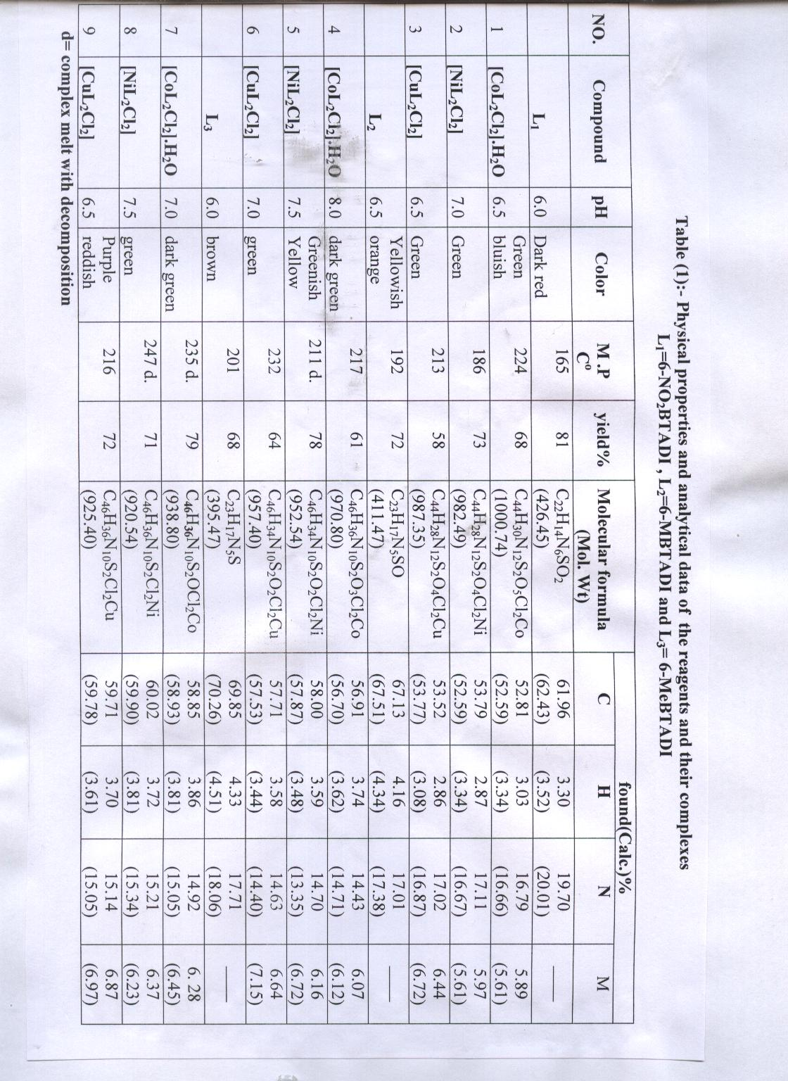

4-Standard metal solutions
Stock solution of 1000 ppm Co(II) , Ni(II) and Cu(II) were prepared by dissolving the appropriate weight of CoCl₂.6H₂O , NiCl₂.6H₂O and CuCl₂ ( purity 99 % , merck ) in buffer solution .
A series of standard Co(II) , Ni(II) and Cu(II) solutions were prepared by several dilutions (10⁻³–10⁻⁵ M) of the stock solution .
5-Standard reagents solutions
Ethanolic solution of the standard reagents 10⁻³ M was prepared. The stock solution of reagents were stable for several months if stored in amber bottle.

6-Buffer solution
0.01M ammonium acetate 0.771 gm of the salt was dissolved in 1 liter of redistilled water (DDDW). 0.2 M Acetic acid and 0.2 M ammonia solution were used for pH adjustment.
Organic solvents were purified by the usual methods ⁽¹⁷⁾ . All the other reagents used were made from high purity materials or from purified reagents, and all solutions were prepared with redistilled water.
4-Results and Discussion
4.1-Acid – dissociation behavior
The reagents are insoluble in water but soluble in organic solvents , including methanol , ethanol , acetone and chloroform . These reagents showed acid – base indicator properties and were red in strongly acidic solution ( pH≤2.5), orange – red in weak acidic solution (pH=3.0-5.5 ) and orange – yellow in neutral solution ( pH = 6.0 – 10.0 ) , but purple – red in strongly alkaline solution ( pH > 12 ) . Four species of these reagents: [ H₃R ]⁺² , [ H₂R ]⁺ , [ HR ] and [R]⁻ , are involved in its acid – base behavior . The PKa values obtained by the spectrophotometric method are listed in table (2). For example, the four forms of ( 6–NO₂BTADI ) involved in its acid – base behavior are related by the following equilibria :-

The wave length of maxima absorbance (λ_{max}), molar absorptivity (ε) and acid dissociation constants pKa of each species in aqueous ethanol solution 50% (v / v) are shown in table (2) .

Table(2):- Acid dissociation constants (PKa) , Absorption maxima( λ_{max}) (nm) and molar absorptivity (ε) of reagents in aqueous ethanolic solution 50%(V / V) .

Reagents | [ H₃R ]⁺² |  | [ H₂R ] ⁺ |  | [ HR ] |  | [ R ] ⁻ |  | pka
Reagents | λ_{max} | ε | λ_{max} | ε | λ_{max} | ε | λ_{max} | ε | Pka₁ | Pka₂ | Pka₃
6 – NO₂BTADI | 491 | 5.1 | 480 | 5.6 | 471 | 5..9 | 523 | 3.2 | 0.93 | 4.1 | 10.9
6 – MBTADI | 482 | 6.7 | 471 | 6.2 | 434 | 8.4 | 506 | 5.7 | 0.74 | 3.2 | 8.4
6 – MeBTADI | 489 | 5.4 | 476 | 6.1 | 414 | 6.8 | 491 | 4.8 | 0.86 | 3.8 | 9.2

ε = molar absorptivity are given as 10³ L. mol ⁻¹ . cm ⁻¹ .

4.2-Color reaction with metal ions
The chelation of three reagents with above metal ions were easily prepared by adding few drops of a solution of the reagents in ethanolic solution to a solution of metal ions, Co(II) , Ni(II)and Cu(II) . UV–visible. Spectra for the prepared complexes in ethanol showed a bathochramic ranging between (150–238 nm), depending on the metal ions and the type of the reagent used .
Generally the solutions containing metal ions and reagents showed green or purple color suitable conditions. The color reactions with metal ions at the optimum pH values are listed in table (3).

Table (3) :- Color reactions with metal ions at optimal pH and T=25 Cº

Reagents | Reagents color  pH=5.5-6.0 | Complexes color
Reagents | Reagents color  pH=5.5-6.0 | Co(II)  pH=6.5-8.5 | Ni(II)  pH=5.5-8.0 | Cu(II)  pH=6.0-8.0
6–NO₂BTADI | R-O | G-b | G – r | G
6–MBTADI | Y | G | G – y | G
6–MeBTADI | O-y | G | G | P-r
O= orange ,R= red ,P= purple ,Y= yellow ,r = reddish ,y = yellowish ,b= bluish ,G=green

4.3-Absorption spectra
The complexes of these reagents with the studied metals are insoluble in water but soluble in aqueous organic solvents.
The spectra of the complexes in aqueous ethanolic solution 50% (v / v) were studied . The absorption spectra of cobalt, nickel and copper chelats of these reagents are shown in Figs.(1–3). The shifts in wave length on chelation of 6–NO₂BTADI, 6–MBTADI and 6–MeBTADI are large (150–238 nm). The absorption maxima (λ_{max} )of all reagents and chelats are shown in table (4) .

Table (4) :- Absorbance maxima(λ_{max}) of reagents in ethanol and their complexes in aqueous ethanolic solution 50%(v/v) at at optimal pH and T=25 Cº.

Reagents | λ_{max}  _{(nm)}  PH=5.5-6.0 | Co(II)  PH=6.5-8.5 |  | Ni(II)  PH=5.5-8.0 |  | Cu(II)  PH=6.0-8.0
Reagents | λ_{max}  _{(nm)}  PH=5.5-6.0 | λ_{max(nm)} | ∆λª_{max(nm)} | λ_{max(nm)} | ∆λª_{max(nm)} | λ_{max(nm)} | ∆λª_{max(nm)}
6 – No₂BTADI | 471 | 687 | 216 | 667 | 196 | 634 | 163
6 – MBTADI | 434 | 649 | 215 | 626 | 192 | 629 | 195
6 – MeBTADI | 414 | 652 | 238 | 630 | 216 | 564 | 150

∆λª_{max =} λ_{max} complex- λ_{max}reagent

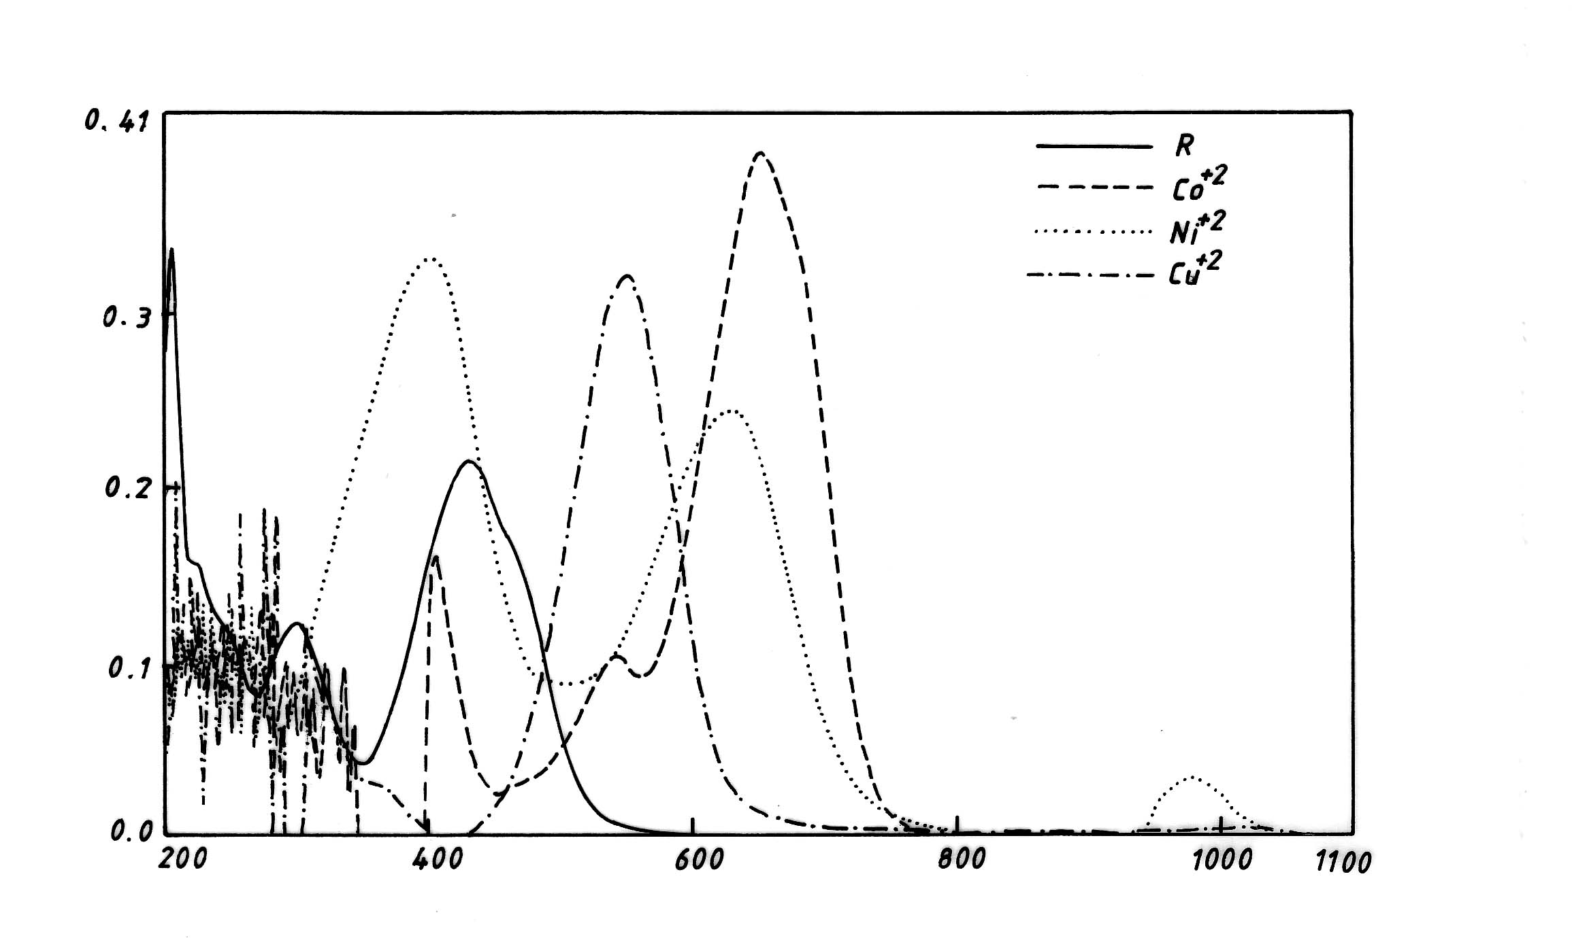

Absorbance

Wave lenght (nm)

Fig(1): Absorbance spectra of 6-No₂BTADI-metal chelats ( 1.25x10⁻⁴ M )
in aqueous ethanolic solution 50% (v/v); (R= 6-NO₂BTADI)

592
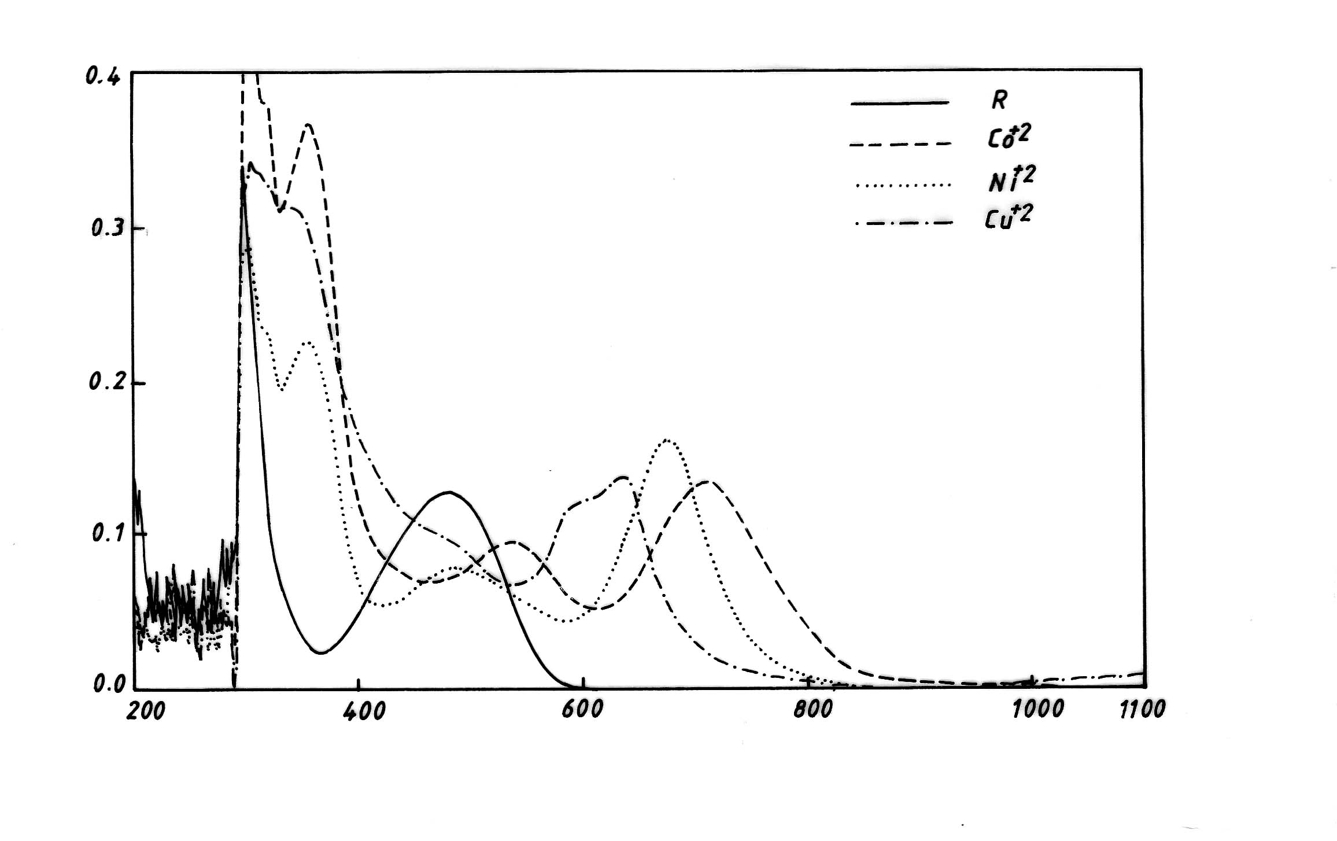
Wave lenght (nm)

Absorbance

Fig.(2):-Absorbance spectra of 6-MBTADI-metal chelats (1.75x10⁻⁴M )
in aqueous ethanolic solution 50% (v/v); ( R = 6-MBTADI )
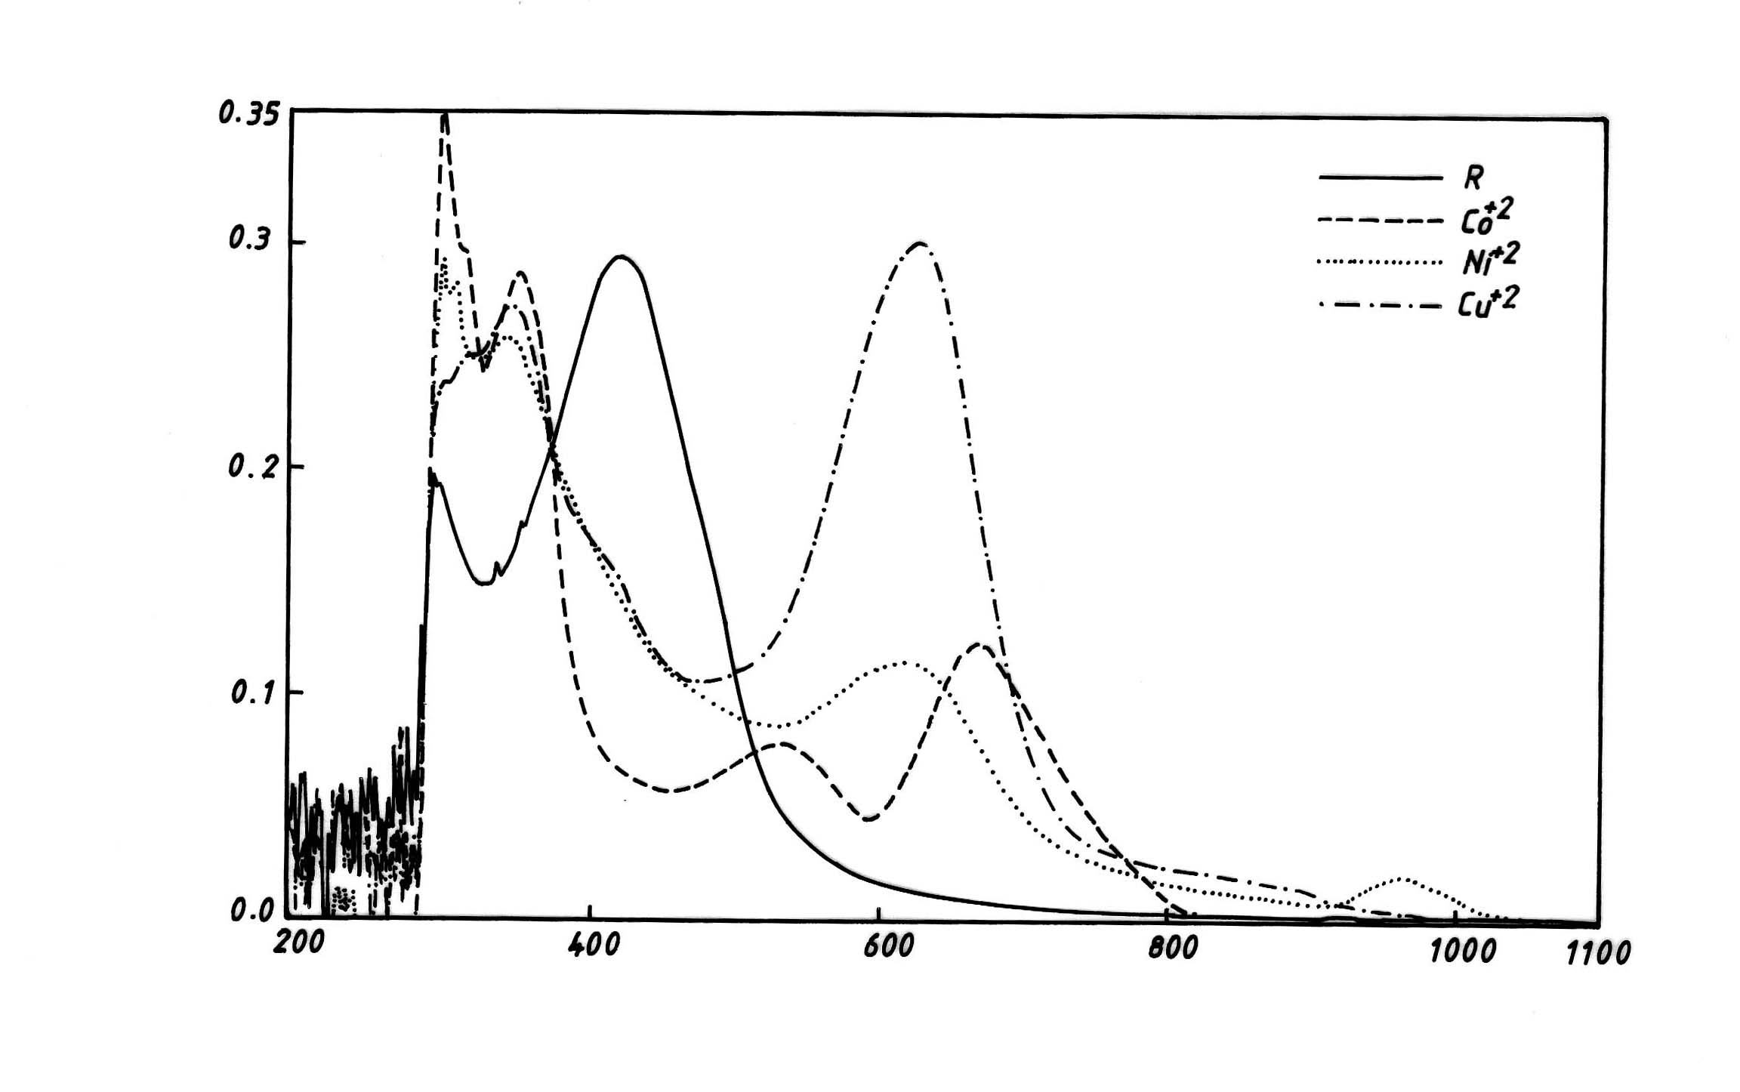

Absorbance

Wave length (nm)

Fig(3):- Absorbance spectra of 6-MeBTADI-metal chelats (1.5x10⁻⁴ M )
in aqueous ethanolic solution 50% (v/v); (R= 6-MeBTADI)

4.4-Effect of pH
The effect of pH on the absorbance of the metal chelate solutions were studied to determine the optimum pH in each case ,

the result are shown in Figs. (4 – 6).The absorption spectra did not change over the whole range. The optimal pH, optimal concentration and wave length (λ_{max}) with molar absorpitivity (ε) of cobalt, nickel and copper complexes are shown in table (5).

593

Fig.(4):-Effect..of..pH..on.Absorbance.of..
6-NO₂BTADI.metal..chelates, .Reagent.Conc.=1.5x10⁻⁴M..,Metal..ion Conc. = 1.25x10⁻⁴M.
Fig.(5):-.Effect..of..pH..on..absorbance. .of..6-MBTADI-metal.chelates.. Reagent..Conc.=2.00x10⁻⁴M,.Metal..ion.
.Conc. =1.75x10⁻⁴M.
Fig.(6):-Effect of pH on absorbance of 6-MeBTADI-metal chelates. Reagent Conc.=1.75x10⁻⁴M ,Metal ion
Conc. = 1.5x10⁻⁴M.

Co⁺²
Ni⁺²
Cu⁺²
Co⁺²
Ni⁺²
Cu⁺²
Co⁺²
Ni⁺²
Cu⁺²
.

Table(5) :- The optimal pH, Concentration values and wave length (λ_{max}) nm with molar absorpitivity(ε) of metal ions in aqueous 50% ( v/v ) ethanol solution .

reagents | Metal  ions | Optimal  pH | Optimal Molar . Conc. x10⁻⁴mol. | Molar absorpitivity (ε) x 10³. L. mol ⁻¹. cm⁻¹ | Optimal wave length(λ_{max})nm
6–NO₂BTADI | Co(II) | 6.5 – 8.0 | 1.25 | 3.84 | 687
6–NO₂BTADI | Ni(II) | 6.0 –7.5 | 1.25 | 2.37 | 667
6–NO₂BTADI | Cu(II) | 6.0-8.5 | 1.5 | 3.29 | 643
6–MBTADI | Co(II) | 7.0 – 8.5 | 1.75 | 1.18 | 649
6–MBTADI | Ni(II) | 5.5– 8.0 | 1.75 | 1.41 | 626
6–MBTADI | Cu(II) | 6.5 – 8.5 | 1.75 | 1.23 | 629
6–MeBTADI | Co(II) | 6.5 – 8.0 | 1.5 | 1.28 | 652
6–MeBTADI | Ni(II) | 6.5-8.0 | 1.5 | 1.24 | 630
6–MeBTADI | Cu(II) | 6.0-8.5 | 1.25 | 3.19 | 564

4.5- Infrared spectra
The I.R.spectral data (CsI.disk) of 6-NO₂BTADI, 6-MBTADI,6-MeBTADT and all complexes are summarized in table (6) .The comparison between spectra of the reagents with those of the coordination complexes have revealed certain characteristic differences. The broad band absorption at (3390-3420)cm⁻¹ in the spectra of Co(II) complexes indicates the presence of water in these complexes^{(10,18)} .The weak band observed at (3020-3065)cm⁻¹ and (2965-2980)cm⁻¹ in the spectra of the reagents are due to$υ$(C-H) aromatic and aliphatic respectively. The spectra of the free reagents show single strong absorption bands at (1580-1595)cm⁻¹ due to $υ$ (C=N) of imidazol ring .This band shifts to lower frequency (1560-1580)cm⁻¹ in the metal complexes spectra .These shifts suggest the linkage of metal ion with nitrogen of imidazol ring⁽¹⁹⁾.The band observed at (1600-1615)cm⁻¹in the free reagents spectrum is considered to be $υ$ (C=N) of thiazol ring ⁽²⁰⁾ .This band is stable in position in all metal complexes, which means it does not link the metal ion with nitrogen of thiazol ring⁽¹⁴⁾.
Two absorption bands due to azo group are absorbed at (1500-1510)cm⁻¹ and (1430-1470)cm⁻¹ in the spectra of reagents. The position of these bands in the spectra of complexes shifted to lower frequency (1470-1495)cm⁻¹ and (1410-1455)cm⁻¹.These shifts suggest the azo group was coordinated to the metal ion ⁽²¹⁾. The $υ$(C-S) of thiazol ring appears at (825-835)cm⁻¹ in the spectra of reagents ⁽²²⁾, The fixed position 0f this band in all metal complexes means that the sulfur atom of thiazole ring does not participate in coordination ^{(10, 17, 20)}.
New weak bands appeared in the region (430-290)cm⁻¹ in the complexes spectra which were not present in the spectra of the reagents,may be attributed to $υ$(M-N) and (M-Cl) ^{(10,23,24)}.
The results presented above lead to suggest that the reagents behave as bidentate chelating agents, coordinating with metals ions by a nitrogen of azo group and nitrogen in imidazole ring forming one five membered chelating ring. The infrared spectra of the reagents and some metal complexes in (4000-200)cm⁻¹ region are shown in figs. (7-9).

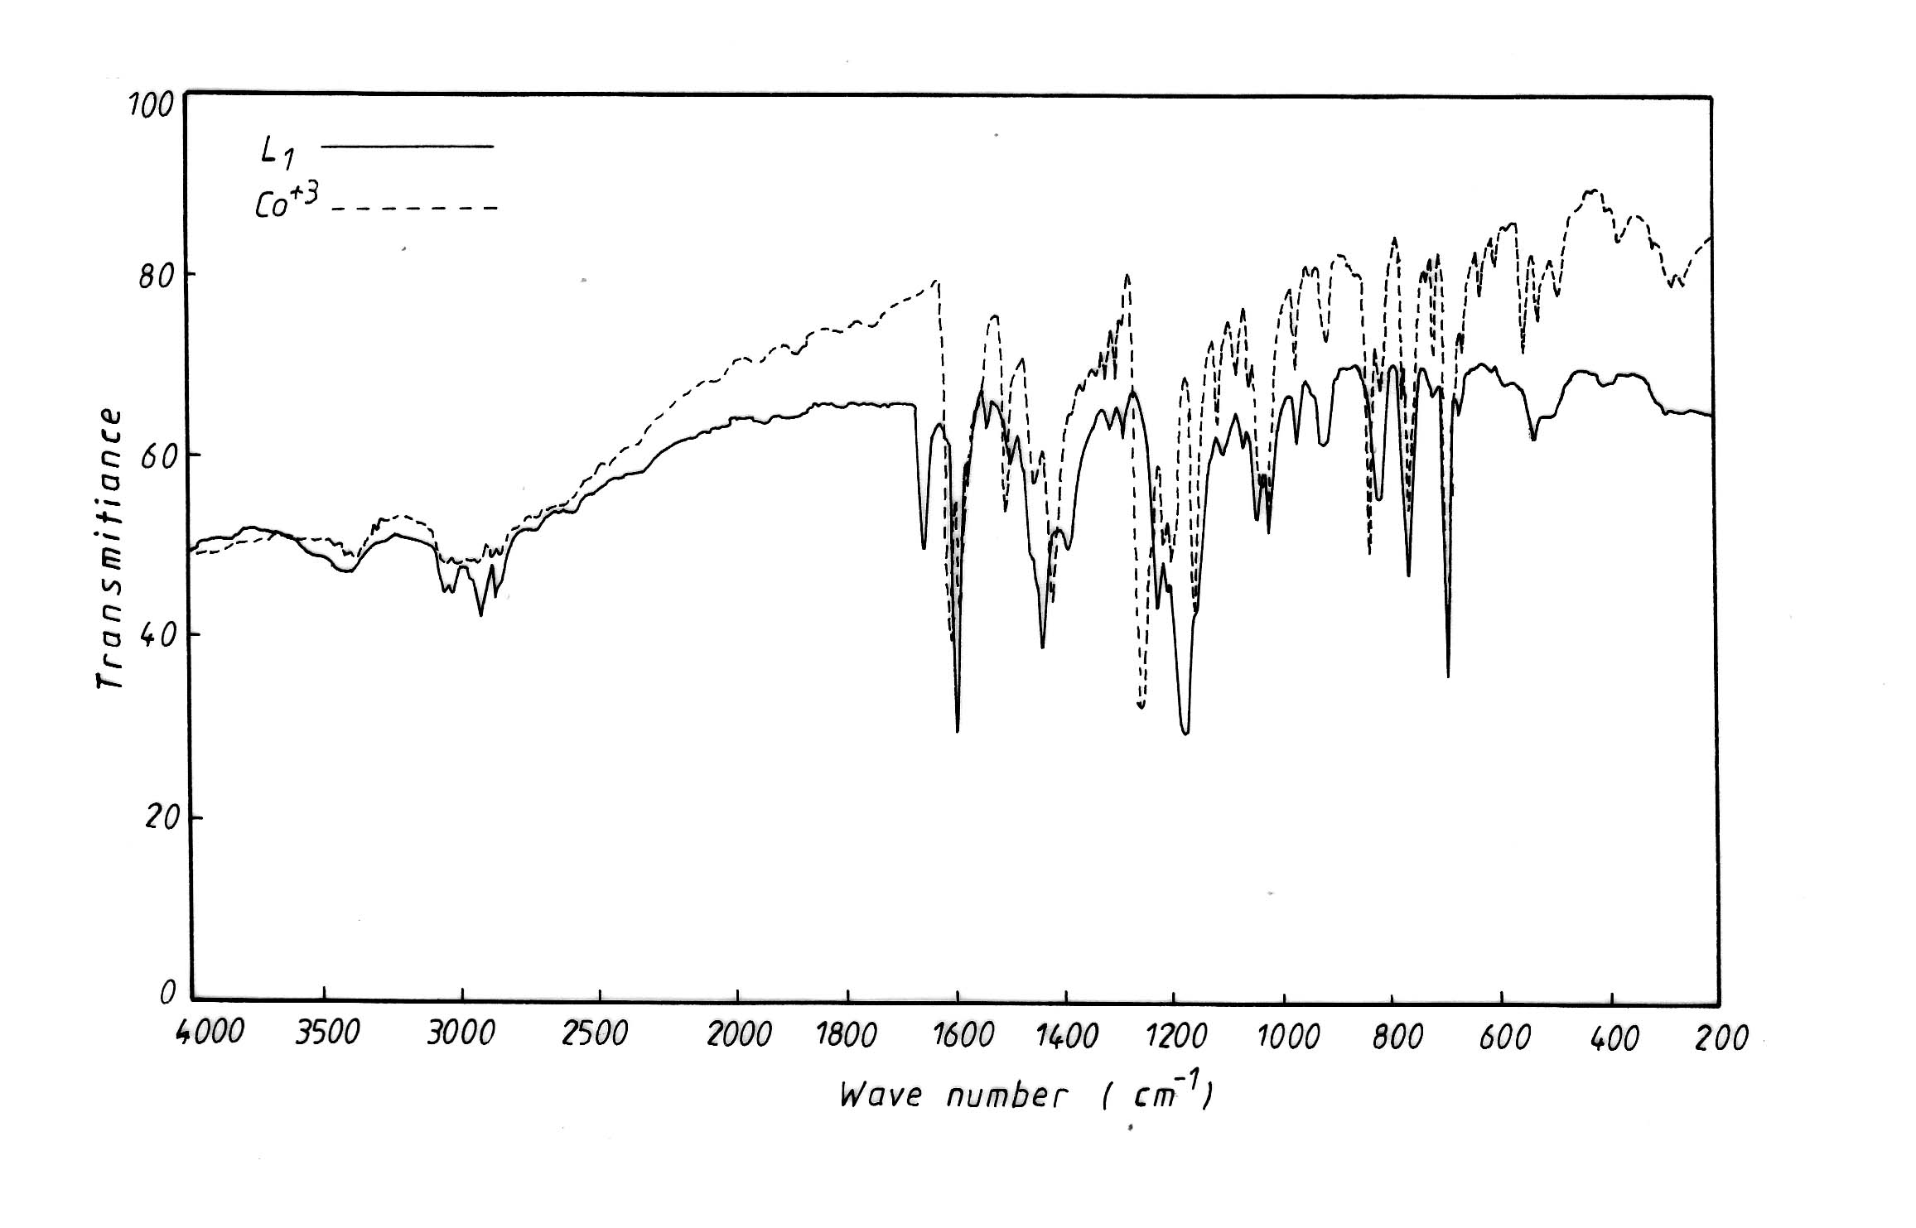

Fig.(7):- Infrared spectra of 6-NO₂BTADI(L₁) and 6-NO₂BTADI-Co(II) complex

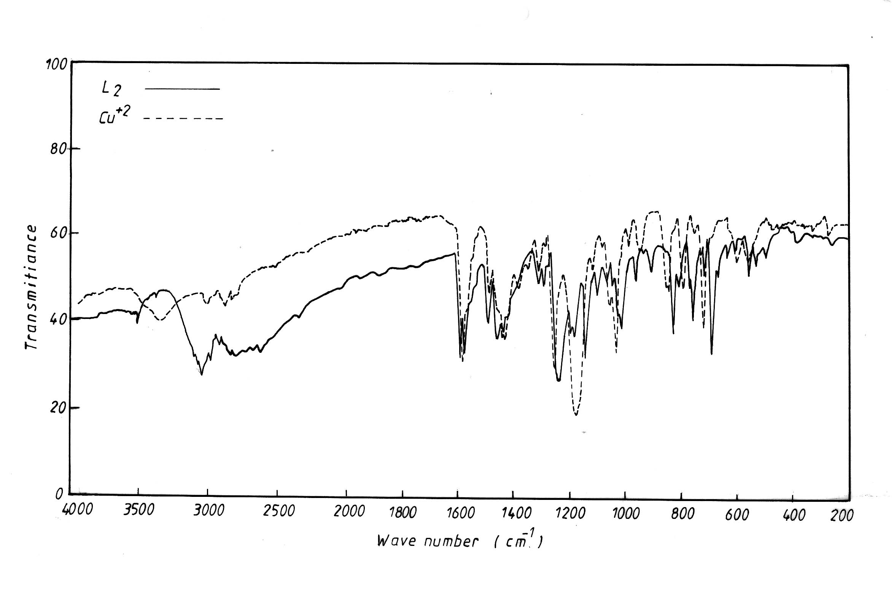

Fig.(8):- Infrared spectra of 6-MBTADI(L₂) and 6-MBTADI-Cu(II) complex
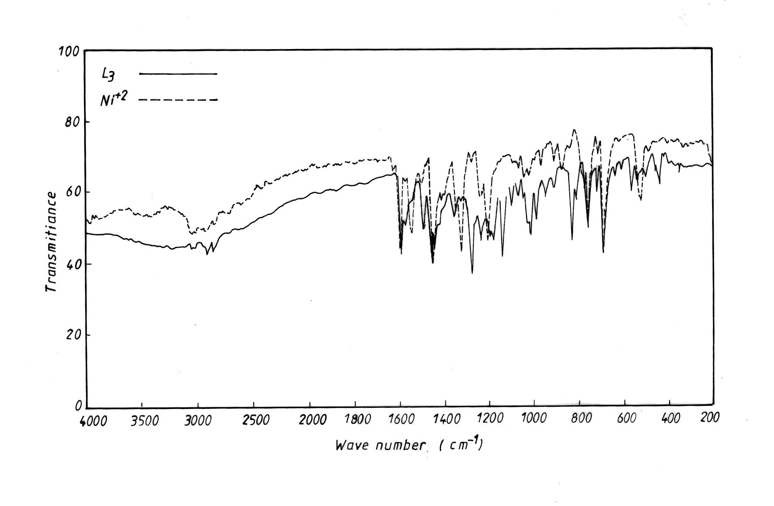

Fig.(9):- Infrared spectra of 6-MeBTADI(L₃) and 6-MeBTADI-Ni(II) complex

Table (6):- Infrared absorption bands of the reagents and its complexes in (cm⁻¹ ) units.

L₁=6-NO₂BTADI, L₂=6-MBTADI, L₃=6-MeBTADI.

NO. | compound | (O-H)  H2O | (C=N)  imidazole | (C=N)  thiazole | (N=N) | (C-S)  thiazole | (M-N) | (M-Cl)
 | L₁ | ___ | 1595m. | 1615m. | 1500w.  1430m. | 830m. | ____ | ____
1 | [CoL₂Cl₂] H₂O | 3420wbr | 1580m. | 1610m. | 1490m.  1410m. | 830m. | 425w. | 290w.
2 | [ Ni L₂Cl₂] | ____ | 1575msh. | 1615msh. | 1470m.  1420w. | 835m. | 415w. | 275w.
3 | [CuL₂Cl₂] | ____ | 1585msh. | 1615msh. | 1480m.  1435m. | 830w. | 405w. | 280w.
 | L₂ | ____ | 1580m. | 1600m. | 1510m.  1450w. | 825m. | _____ | _____
4 | [CoL₂Cl₂] H₂O | 3390wbr | 1575m. | 1605msh. | 1490m.  1415m. | 830m. | 430w. | 275w.
5 | [ Ni L₂Cl₂] | ____ | 1560msh. | 1600m. | 1480m  1435w. | 825w. | 420w. | 260w.
6 | [CuL₂Cl₂] | ____ | 1570msh. | 1600m. | 1495m.  1430w. | 825msh. | 425w. | 280w.
 | L₃ | ____ | 1585m. | 1600m. | 1500m.  1470m | 825m. | _____ | ____
7 | [CoL₂Cl₂].H₂O | 3410wbr | 1575msh. | 1605msh. | 1480m  1445w. | 830w. | 420w. | 285w.
8 | [ Ni L₂Cl₂] | ____ | 1570m. | 1600m. | 1475m.  1455m | 825w. | 425w. | 280w.
9 | [CuL₂Cl₂] | ____ | 1570m. | 1600m. | 1490m  1450w. | 830m. | 430w. | 275w.

m=medium; w=weak; sh= shoulder

4.6-Magnatic measurements and electronic spectra
The data obtained from the measurements of magnetic susceptibility and electronic spectra are shown in table (7)

4.6.1-Cobalt (II) complexes
The magnetic moments for the complexes of the reagents L₁, L₂, and L₃ with Co(II)are found to be (4.97-5.29)B.M which is within the range of octahedral cobalt (II) complexes⁽²⁵⁾. The electronic spectra of these complexes show three absorption bands at (15408-14556)cm⁻¹, (17361-18657) cm⁻¹ and (24755-26178) cm⁻¹. These are assigned to ⁴T₁g(F) → ⁴T₂g (F) ($υ$₁), ⁴T₁g(F) → ⁴A₂g(F) ($υ$₂) and ⁴T₁g(F)→⁴T₁g(P)($υ$₃) transitions respectively, which are characteristic of octahedral stereochemistry^{(26,27)}.

4.6.2-Nickel (II) complexes
The values of magnetic moments for different Nickel complexes are found to be (3.06-3.24) B.M which can be normal values for octahedral high spin Ni(II) complexes ⁽²⁸⁾.The electronic spectra of these complexes show three absorption bands at (10215-10309)cm⁻¹, (14993-15974)cm⁻¹ and (20790-25510)cm⁻¹ .corresponding. to ³A₂g³T₂g(F)($v_{1}$), ³A₂g$→$³T₁g(F)($v_{2}$) and
³A₂g$→$³T₁g(p)($v_{3}$) transitions, respectively^{(29,30)}.

4.6.3:-Copper (II) complexes
The magnetic moments for these copper complexes was found to be (1.72-1.81) B.M due to the presence of one unpaired electron in these complexes. The electronic absorption spectra of these complexes show a broad band around (15773-17730)cm⁻¹.This band is assigned to the transition ²Eg → ²T₂g.It is reasonable to assign distorted octahedral structure at 1:2 (M:L) complexes⁽³¹⁾. There were three absorption bonds appear at the free reagents 6-NO₂ BTADI, 6-MBTADI and 6-Me BTADI spectra which are appearing at the positions, (43103-45248) cm⁻¹, (34129-34602) cm⁻¹ and (21234-24154) cm⁻¹, the bands (43103-45248) cm⁻¹ and (34129-34602) cm⁻¹ yefering to the (π$→$π*) transition while the band at (21234-24154) cm⁻¹ is due to the charge transfer characters⁽³²⁾.

Table( 7) :- Electron spectra, conductivity and magnetic moment data of the metal complexes and stability constant values (β)
NO | Complex | Absorption  Bands (cm⁻¹) | Transition  ₁  ₂  ₃ | conductivity  (S.mol⁻¹.cm² ) | µeff (B.M) | Stability constant(β)  (mol⁻¹.L. ) | log (β)
1 | [CoL₂Cl₂].H₂O  (L₁) | 14556  17361  26178 | ⁴T₁g(F)→⁴T₂g(F)  ⁴T₁g(F)→⁴A₂g(F)  ⁴T₁g(F)→⁴T₁g(P) | 5.63 | 5.13 | 5.74 x 10⁹ | 9.755
2 | [ Ni L₂Cl₂]  (L₁) | 10215  14993  20790 | ³A₂g(F)→³T₂g(F)  ₁  ₂  ₃  ³A₂g(F)→³T₁g(F)  ³A₂g(F)→³T₁g(P) | 4.78 | 3.06 | 1.06 x 10¹⁰ | 10.023
3 | [CuL₂Cl₂]  (L₁) | 15773 | ²Eg→ ²T₂g | 5.17 | 1.81 | 2.21 x 10¹⁰ | 10.344
4 | [CoL₂Cl₂].H₂O  (L₂) | 15408  18657  25737 | ⁴T₁g(F)→⁴T₂g(F)  ⁴T₁g(F)→⁴A₂g(F)  ⁴T₁g(F)→⁴T₁g(P) | 5.21 | 5.29 | 1.56 x 10⁹ | 9.193
5 | [ Ni L₂Cl₂]  (L₂) | 10309  15974  25510 | ³A₂g(F)→³T₂g(F)  ³A₂g(F)→³T₁g(F)  ³A₂g(F)→³T₁g(P) | 4.93 | 3.14 | 3.86 x 10⁹ | 9.586
6 | [CuL₂Cl₂]  (L₂) | 15898 | ²Eg→ ²T₂g  ₁  ₂  ₃  ₁  ₂  ₃ | 4.59 | 1.72 | 1.13 x 10¹⁰ | 10.053
7 | [CoL₂Cl₂].H₂O  (L₃) | 15337  18416  24755 | ⁴T₁g(F)→⁴T₂g(F)  ⁴T₁g(F)→⁴A₂g(F)  ⁴T₁g(F)→⁴T₁g(P) | 6.02 | 4.97 | 2.76 x 10⁹ | 9.440
8 | [ Ni L₂Cl₂]  (L₃) | 10277  15874  24814 | ³A₂g(F)→³T₂g(F)  ³A₂g(F)→³T₁g(F)  ³A₂g(F)→³T₁g(P) | 4.76 | 3.24 | 3.13 x 10¹⁰ | 10.495
9 | [CuL₂Cl₂]  (L₃) | 17730 | ²Eg→ ²T₂g | 5.93 | 1.76 | 4.63 x 10¹⁰ | 10.665
L₁=6-NO₂BTADI, L₂=6-MBTADI, L₃=6-MeBTADI.

4.7-Conductivity measurements
The data obtained from the measurement of electrical conductivity are shown in table (7). All the prepared complexes shown , have conductivity values ranged between (4.59-6.02)S.mol⁻¹cm², in DMF at room temperature, indicating that non conductive species⁽³³⁾.

4.8- Stability constants (β)
The calculation stability constants are obtained spectrophotometrically by measuring the absorbance of solutions of reagent and metal mixture at fixed wave length ( λmax ) and pH values. The degree of formation of the complex is obtained from the relation ship⁽³⁴⁾, α = (Am-As)/Am and β = (1- α)/(4 α³c²), where Am and As

are the absorbance of the partially and fully formed complex respectively at optimum concentration. The calculated log β values for the prepared complexes are given in table (7). The stability follows the sequence Cu(II) >.Ni(II) >.Co(II) agrees with Irving-Williams series of stability⁽³⁴⁾.

4.9-Composition of the complexes
The structures of these complexes were determined by spectrophotometric method (mole ratio) at the optimal pH, molar concentration and wave length in aqueous 50% (v/v) ethanol solution.The curves indicated the formation of a (1:2)
metal:ligand were obtained as shown in figs. (10-12).
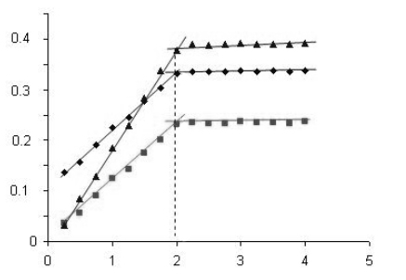
Mole (6- MBTADI ) per mole metal

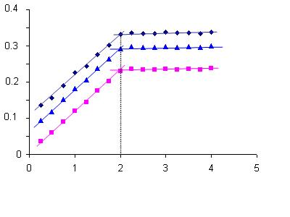
Mole (6- NO₂BTADI) per mole metal

Absorbance

Absorbance

Co(II)
Ni(II)
Cu(II)

Co(II)
Ni(II)
Cu(II)

Fig.(10):-mole ratio (M:L) 6- NO₂BTADI-metal chelates
Fig.(11):-mole ratio (M:L) 6- MBTADI-metal chelates

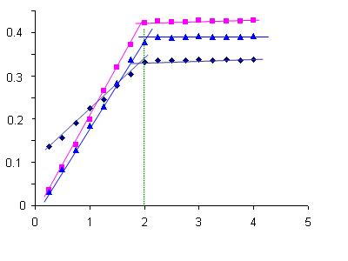
Absorbance

Co(II)
Ni(II)
Cu(II)

Mole (6- MeBTADI ) per mole metal

Fig.(12):-mole ratio (M:L) 6- MBTADI-metal chelates

According to these results the following structure of these complexes may be proposed.

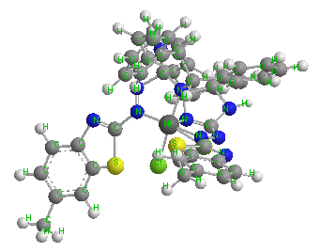

.nH₂O

-a-

-b-

R= NO₂; OCH₃; CH₃ ; M= Co(II); n= 1; M= Ni(II); Cu(II); n=0

Fig.(13):- (a)-The suggested structural formula of Co(II), Ni(II) and Cu(II) complexes

(b) The suggested structural formula of the three dimensions for complexes

Conclusions
Careful examination of the literature revealed that no systematic work was made concerning the spectral study of the solution of metal ions with those reagents derived from thiazole and imidazole groups , and no quantitative spectral study has been done to the optimum conditions for the preparation of these complexes.
All preparations were performed after fixing the optimum pH and molar concentration that obeyed Lambert–Beers in the studies of pH ranges . Thiazolyl group contains N and S doner atoms but imidazole group contains two N atoms which as sites of coordination with metal ions. As photometric reagents, these compounds seem to be promising because of their remarkable high molar absorptivity , and large bathochromic shifts produced on chelation . Further work on the solvent extraction and analytical application of these reagents for determination of metal ions is now in progress .

References
1.B.K.Reddy,J.R.Kumer,K.J.ReddyandA.V.Reddy;Chem.Anal.Sci: 2003,19, 42
2.S.Tautkus; Chem.Anal.(WarSaw); 2004, 49, 271.
3.Wonless,Si–Eunlee,Mi–Kyoungkim young–sang kim,J.Bull. Koreanchem Soc, 2002,23 (8),1067.
4.L.Z.Xu,P.S.Zhao,S.S.Zhang;Cin.J.Chem; 2001,19,436.
5.S.L.Belanger and A.L.Beauchamp; Inorg.Chem; 1996,35, 7836.
6. W.Lee,S.E.Lee ,M.K.Kim,C.H.Leeand Y.S.Kim;Bull.Korean.Chem.Soc.,2002,23,1067.
7.M.K.Bekle.misher,T.A.Stoyan.and.L.Polmanva,Fresenius,J.Anal.Chem.,2000, 367,17.
8. M . S . Masoud , G. B. Mohomed and A.E . Ali , J. Korean chem. Soc ; 2002 ,46 ( 2) , 99.
9. K . G . Al – adely and F . H . Hussen , National J . chem. : 2001, 1 ,87 .
10.R.T.Mehdi and A.M.Ali,Ibn Al-haitham J.for Pure and Appl.Sci. 2005, 18(3) ,50.
11.A.Albert and E.P.Serjeant"Ionization constants of Acids and Bases " John Wiely and sons Inc.New York; 1962.
12.H.P.Patel and J.M.Tedder J.Chem.Soc.;1963 ,4586.
13.J.D.Vaughan,D.G.Lambert and V.L.Vaughan; J.Am.Chem.Soc., 1964,86 ,2857.
14. - S . Shibata , M . Furkaw and R . nakashima , J . Chem . Acta; 1976 , 81 , 131.
15.K.Hofman . "Imidazole and its derivatives"Interscience;New York 1953.
16.Kaufman Kuchler;Ber; 1934, 67.,944.
17. Paolini , J . P ; Lendvay , L . J ; J . Med . Chem .; 1969, 12,1031 .
18.A.M.Ali. PhD thesis; Universiy of Baghdad ,1999.

19.O.Yamach and H.Tanaka; Talanta.; 1970 ,20,203.
20.E.D.Faisal; PhD thesis; Universiy of Baghdad ,1983.
21.R.CDening and Tatecter ,J.Am.Chem.Soc.; 1986,909,5917.
22.K.c.Satpfy and H.P.Mishra; Indian.J.Chem; 1981, 20A ,612.
23.S.N.Duby and K.Beena;Indian. J.Chem ; 1985, 24A,950.
24.X.Kumar and S.P.Tolani ;Croat.Chem.Acta; 1989, 62(1) ,73.
25. Nichola S. D. ,"Pergamon Texts in Inorganic Chemistry", pergamon press, Oxford 11st Ed., 1973, 24, 1087-1090, 1152-1154 .
26. K. Mochizuki,T.Imamura,T.Ito and M. Fujimoto,J.Bull. Chem. soc. Jap; 1978, 51,1745.
27.J.C.Bailer,H.Emeleus and R.Nypholm" Compernesave inorganic chemistry" pergamon press.
28.B.N.Figgis.and.J.Lewis"Modern.Coordination.Chemistry"Interscience,New York.

29.C.T.Ballhausen"Introdiction.to.ligand.field.theory"McGreHill ,New York ,1962.
30.W.Manch and W.C.Fernlias ; J.Chem.Educ; 1961, 38,192.
31.L.Sacconi and M.Champolin; J.Chem.Soc.,1964 ,276.
32.M.R.Mahmod, A. M. Hammam and S. A. Ibrahim; Z. phys.chemi; lepizig; 1984, 265,302.

33.H.A.Al-Shirayda,I.S.Al-Naimi and.K.G.Al-Adely; Arab Gulf, J.Scient;Res.; 1992,10,13
34.Skoog,D.A ; "foundamental of analytical chemistry" 5th Ed. New York,1988.

