A New Keynote of β –Thalassemia Major Patients As Oxidative Stress Accompanying

Lamia, A.M. Al-Mashhedy
Chemistry Dept. College of Science , Babylon University.

(NJC)

(Receivedon 10/4/2007) (Accepted for publication on 6/9/2007)

Abstract.
This study evaluated the total thiols group(-SH), total serum protein, albumin concentration and vitamin E, as well as peroxynitrite in serum as a parameter of peroxidative stress for patients with β– thalassemia major, transfusion dependent, compared with healthy controls. We found that the levels of total thiols and total protein are significant decreased, while the albumin concentration slightly decreased in patients compared with controls where as the depletion of the vitamin E concentration in serum of patients is accompanying the increasing of peroxynitrite levels. The results suggest that the measurement of peroxidative product matched with evaluation of antioxidants, may be a simple measure of iron toxicity in thalassemia.

الخلاصة
تطرقــت الدراســة الى تقدير الثايول الكــلي( (-SH, بروتين المصــل الكــلي, تركــيز الألبومين وفيتامين E اضافــة الى البيروكــسي نايتريت لكونه احد العوامل المسببه للجهــد التأكــسدي لدى مرضى فقر الدم البحري ( متماثل الابوين- نوع بيتا), والمعتمدين على عمليات نقل الدم مقارنة بمجموعة الأصحاء. أظهرت النتائج انخفاضا معنويا في مستوى الثايول الكــلي والبروتين الكــلي وانخفاضا غير معنويا في تركــيز الألبومــين لدى المرضى مقارنة بمجموعة الســيطرة. واوضحت الدراســة ان اســتنزاف فيتامين E يرافق الزيادة في مستوى البيروكــسي نايتريت. وهذه النتائج توضح تأثير مرض فقر الدم البحري وارتفاع مستوى الحديد المرافق لهذا المرض على مضادات الأكــسدة.

Introduction.
Thalassemias are hereditary hemolytic disease in which an imbalance occurs in the synthesis of globin chains. As a group, they are the most common single gene disorders in human. Normally, Synthesis of the α and β globin chain are coordinated, So that each α-globin chain has a β-globin chain partner. This leads to the formation of α₂β₂ (HbA).
Thalassemias are divided into the β – thalassemia, in which the production of β – globin that is deficient, and α – thalassemia in which the production of α – globin that is deficient ^{(1, 2)}.
In β- thalassemia, synthesis of β- globin chains is decreased or absent, whereas α- globin chain synthesis is normal. Α Globin chains cannot form stable tetramers and, therefore precipitate, causing the premature death of cells initially destined to become mature red blood cells.
Accumulation of α₂γ₂( fetal hemoglobin )also occurs. The defects have either β- thalassemia minor or β- thalassemia major. The individuals born with β- thalassemia major have the sad fate of being seemingly healthy at birth, but becoming severely anemic, usually during the first or second year of life^{(1,3)}. The ineffective erythropoiesis in β-Thalassemia major is due to defective hemoglobin synthesis, leading to severe anemia, increased erythrocyte turnover and excessive iron absorption, this lead to iron overload in the patients tissues⁽⁴⁾. To treat the anemia, patients have regular blood transfusions that lead to secondary iron overload⁽⁵⁾.
Iron toxicity is largely based on reactions are catalytic the amount of iron are sufficient to yield hydroxyl(OH·), superoxide(O₂^{·-}), peroxyl(LOO·) and hydrogen peroxide( H₂O₂)^{(6, 7)}. superoxide(O₂^{·-}) can react with nitric oxide(NO·) to produce the peroxynitrite ONOO⁻ in living organisms⁽⁶⁾. The oxidative stress has been defined as an imbalance of the pro-

oxidant/ antioxidant equilibrium in favor of the pro- oxidants⁽⁸⁾.
Thiols group are contain potential sulfhydryl group(SH) in their structure, these can range from the simply amino acids, cysteine, methionine and protein contain them, thiols exist in two pools, protein and non protein. Serum protein play a key role in varied functions ranging from nutrition and control of body water distribution, transport and protection as well as their central role as hormones and enzymes also, some protein act as antioxidants. Total protein measurements can give an indication of gross changes brought about by a number of different disease states^{(9, 10)}. Albumin, the most abundant serum protein, is among the most study of all proteins, being important for clinical monitoring, physiological and therapeutic perspectives⁽¹⁰⁾.
Vitamin E (α – tocopherol) is an example of a phenolic antioxidant readily donate the hydrogen from the hydroxyl group on the ring to the free radicals, which then become unreactive . On donating the hydrogen, the α – tocopherol itself become a relatively unreactive free radical because the unpaired electron on the oxygen atom is usually delocalized into the aromatic ring structure thereby increasing its stability⁽¹¹⁾. While the peroxynitrite is a powerful oxidant formed in vivo by the diffusion controlled reaction between nitric oxide (NO·) and superoxide (O₂^{·-} ) radicals and contributes as pathogenic mediator in a variety of disease state⁽¹²⁾.
Subjects.
Patients affected by β – thalassemia major, 15 males and 10 females aged 7 to 25 years( mean ± SD = 14.2 ± 5.7) and healthy subjects 15 males and 10 females aged 7 to 25 years( mean ± SD =17.6 ± 3.4) as a control group, were volunteer.

Blood sampling.
Blood from thalassemic patients who attended the Thalassemia center in the Babylon Maternity and children Hospital were collected just before the transfusion. After clotting, serum was separated by centrifugation and divided in several aliquots. The analytical determinations described below were either performed immediately or serum was stored at -20°C and used within 72 hours.

Methods.
the total thiols group were evaluated in 200 μL serum samples by colorimetric reaction with 5,5′-dithiobis( 2-nitrobenzoic acid ) as reported⁽¹³⁾, total serum protein and albumin concentration were express as g/100 ml and measurement as the biuret method⁽¹⁴⁾, based on copper in alkaline solution react with the peptide linkage of amino acids in protein producing a violet compound absorbance at 540 nm. Vitamin E was measurement using the methods described by Toro et al.⁽¹⁵⁾, α–tocopherol react with α‚α'- dipyridyl to produce a complex, which has λmax in 520nm, vitamin E concentration was express as mg/L. While the determined of peroxynitrite concentration described by (Vanuffelen B.E. 1998), the principles was based on the radical of peroxynitrite mediates nitration of phenol to form nitrophenol compound which is detected at wavelength 412 nm⁽¹⁶⁾.
Statistic analysis.
All results are expressed as mean ± SD(standard deviation), comparison between controls and thalassemia patients was preformed by the student’s t-test, and correlation test taking p≤ 0.05 as the lowest limit of significance.

Results and Discussion.
A significantly decreased in levels of the serum total thiols group for male and female patients were observed (P= 0.00, P= 0.0001) (Fig. 1), under conditions of oxidative stress for patients compared with apparent healthy control groups ( male and female), this result may be due to the oxidized of sulfhydryl group in protein by the overproduction of free radicals such as superoxide anion (O₂^{·-}) thus the oxidize glutathione (GSSG)/reduce glutathione (GSH) ratio is increased ⁽⁵⁾. It has been noted that serum SH- groups are susceptible to oxidative damage and often low in patients suffering from thalassemia, hence the estimation of thiols group may serve as an adjutant for the diagnosis of the disease complication ⁽¹⁷⁾.

135.6± 18.3
70.2±20.3
136.9±15.2
69.75±19.4
0
20
40
60
80
100
120
140
Mean of total SH- groups
μmole/L
female
controls
female
patients
male
controls
male
patients

Fig.1. The levels of total SH- groups(μmole/L) for patients and controls

Total serum proteins concentration were significantly decreased, and albumin concentration were non significantly decreased in patients (males and females) compared with healthy controls, (Fig. 2,3) respectively. These results were attributed to the scavenging property of serum protein against oxidative stress ⁽⁹⁾, alteration in serum protein concentration is used commonly in clinical practice as a nonspecific indicator of underlying disease or monitor disease activity, it can be influenced by many variables
and thus changes in one protein or group of proteins can be masked by opposite changes in other proteins⁽¹⁰⁾. Serum proteins play several roles in the human body, some of them, such as albumin may be considered an important component of plasma antioxidant activity, binding free fatty acid, bilirubin, scavenging of O₂^{·-} and ONOO⁻ ⁽¹⁸⁾, thus, total serum proteins concentration may be changed under oxidative stress associated with β – thalassemia major^{(8,19)}.

6.05 ± 0.11
5.15 ± 0.7
6.3 ± 0.14
5.92 ± 1.1
0
1
2
3
4
5
6
7
Mean of serum protein
(g/100 ml)
female
controls
female
patients
male
controls
male
patients

Fig. 2. The levels of serum protein (g/100 ml) for patients and controls

4.2 ± 0.1
3.8 ± 0.5
4.4 ± 0.12
4.1 ± 0.7
3.5
3.6
3.7
3.8
3.9
4
4.1
4.2
4.3
4.4
Mean of serum albumin
(g/100 ml)

female
controls
female
patients
male
controls
male
patients

Fig. 3. The levels of serum albumin(g/100 ml) for patients and controls

The vitamin E levels in serum of patients, males and females( P= 0.004, P= 0.001) compared with healthy controls were measured, (Fig. 4) shown a significant decrease in vitamin E

levels in patients with β - thalassemia major. The depletion of serum vitamin E in patients indicated hyperconsumption as a radicals scavenger to guard against oxidative hemolysis due to an iron overload⁽²⁰⁾.

10.44 ± 2.5
5.72 ± 3.2
12.03 ± 2.1
5.8 ± 2.9
0
2
4
6
8
10
12
14
Mean of serum vitamin E
(mg/L)
female
controls
female
patients
male
controls
male
patients

Fig.4. The levels of serum vitamin E(mg/L) for patients and controls

A high significant increase in levels of peroxynitrite for patient groups (P = 0.00, P = 0.001) compared with control groups (Fig 5).

80.5 ± 10.5
112.6 ± 12.4
71.7 ± 10.3
113.7 ± 12.2
0
20
40
60
80
100
120
female
controls
female
patients
male
controls
male
patients
Mean of peroxynitrite
(μmole/L)

Fig.5. The levels of peroxynitrite(μmole/L) for patients and controls

The elevated of peroxynitrite levels of thalassemia patients could be the essential cause to depletion vitamin E concentration because α - tocopherol
was regarded as a defense substrate against peroxynitrite attack, the protective action of the α – tocopherol was shown below^{(5, 21)}.

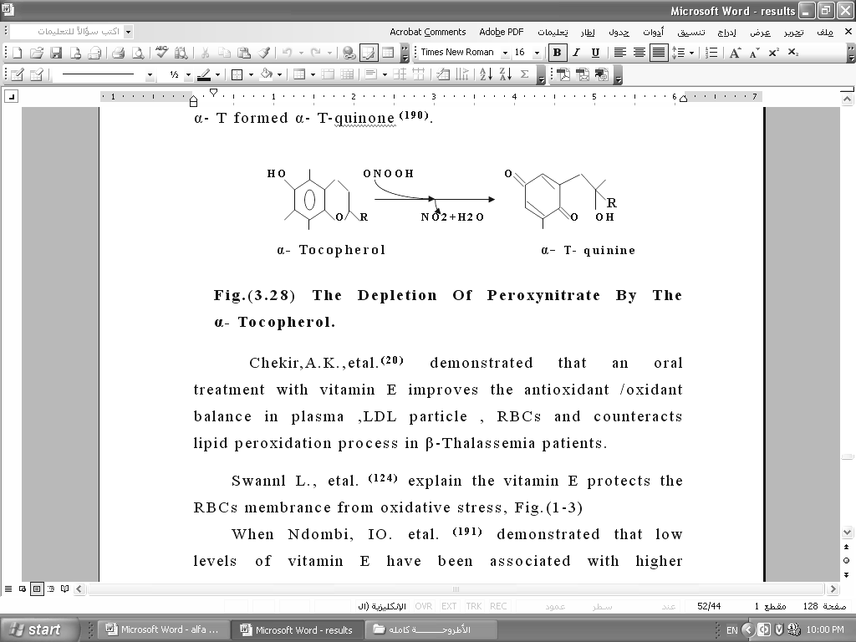

Peroxynitrite can reacts directly with different targets including thiols⁽²²⁾ and heme proteins⁽²³⁾.
These results expected since our β – thalassemia major patients are under conditions of iron overload, in this case, there is evidence of an increase in serum iron and in the intracellular transit of iron promotes peroxidative damage

References.
1- Pamela C.Ch., Richard A.H., Denise R.F. ״Lippincott’s Illustrated Reviews: Biochemistry″. 2005; Lippincott Williams and Wilkins, New York, London. P. 39. ″
2- Forget B.G., Thalassemia Syndromes. In: Hoffman, R., Bens E.J., Shatil S.J. et al. 2000; ״Hematology; Basic Principles and Practice״ 3rd ed., Churchill Livingston, New York, P. 485.
3- Higgs DR. and Weatherall DJ. The Hemoglobinopathies Clinic. Hematolog 1993, 6(1).
4- Wang, C. and Richardson,D.R. (2003), The Interna. Jour. Biochem. And Cell Biol., 35:1144.
5- Al- Mashhedy L. M. 2005, Ph. D Thesis, College of Education, University of Basra.
6- Aruoma OI., Asia Pacific J. Clin. Nutr.1999, 8(1), 53.
7- Halliwell B. and Gutteridge J.M.C. Methods Enzymol. 1990,1 , 186 .
8- Susanna K., Mustafa A., Seppo H., Arja L., Osmo H. and Niku O. J. of Sport, Sci. Med. 2005,4, 415.
9- Halliwell B., Advan. In Pharma., 1997, 3, 38 .
10- Alia’ee A.H., Ewadh M.J., Al-Zamely O.M. National J. Chem. 2004, 13, 100.
11- Human vitamin and minerals Requirements, Report of a joint FAO/WHO expert consultation Bangkok, Thailand, 2001.
12- Radi R., Peluffo G., Alvarez M.N., Naviliat M., Cayota A. free radic. Biol. Med. 2001,30, 463.
13- Hu M.L. Methods in Enzymology, San Diego, CA, Academic, 1994,233-380.
14- Luxton R., Clinical Biochemistry, 1st edition, Oxford, Butterworth- Heinemann, 1999.
15- Toro, G., Acherman, P.G., Practical Clinical Chemistry, 1st edition, little, Brown and Company, 1975, 222.

16-Vanuffelen B.E., Van Der Zee J., De Koster B.M. et al, Biochem. J. 1998, 330- 719.
17- Shivoanda B, Yashwanth S., Sneha M.P., Vinutha R.B. and Srimathi S.M. Indian J. Physiol. Pharmacol. 2005,49(3), 341.
18- Dean R.T., Fu S., Stocker R. and Davies M. J., J. Biochem.,1997,1, 324 .
19- Lunec J. Ann. Clin. Biochem. 1990, 27, 173.
20- Marwash SS., Wheelwright D., Blann AD. Br. J. Heamatol. 2001,112(4), 917
21- Hoeldtke R.D., Bryner K.D. Neill D.R., Hobbs G.R., Riggs J.E., Werehime S.S., Christic I., Gancer GH., Dyke K.V. Diabetes, 2002, 51, 2817.
22- Radi R., Denicola A., Alvarez B., Ferrer- Sueta G., Rubbo H., In: Ignarro L., ED Nitric Oxide: Biology and Pathobiology, San Diego: Elsevier, 2000, 57.
23- Radi R., Beckman J. S., bush K. M., Freeman B.A., J. Biol. Chem. 1991, 266-4244.

