Synthesis , Characterization and study of some electrical properties of 1 , 4 – diazophenylene – bridged iron phthalocyanine polymer

Hassan Sabbeh Jabure

Thi-Qar Director Education

(NJC)

(Received on 27 /2 /2007) (Accepted for publication on 10 /7 /2007)

Abstract
The compound of phthalocynine polymer , 1 , 4 – diazophenylene – bridged Fe-phthalocyanine , was prepared from the diazonium salt of diaminobenzene and Fe ( II ) tetraamino phthalocyanine . The polymer is partilly soluble in ( DMSO , DMF and THF ) , Characterization of the polymer was measured by using the iodine doping . It was found that the electrical condutivity increased up to ( 10 ^{–4} ohm ^{–1} . cm ^{–1} ) .

الخلاصة
حضر البوليمر الجسري ( 1 ، 4 – داي أزوفنيل فثالوسيانين الحديد II ) من مزج أملاح الدايزونيوم مع داي أمينو بنزين و رباعي أمينو فثالوسيانين الحديد II . تم قياس التوصيلية الكهربائية باستخدام اليوم المشوب حيث ازدادت التوصيلية الكهربائية الى 10⁻⁴ أوم ⁻¹ سم ⁻¹ .

Introduction
Phthalocyanine are the second most important class of colorant and iron phthalocynine is the largest volum colorant sold . Phthalocyanine have also found extensive use in many moddern hight technologies^{(1,2)} for instance they are used catalyst in the merox process and photoconductor xerographic double layers of laser printers and copy machines . Also some infrared – absorbing phthalocyanines cover many important high technical applications including the phthalocyanine therapy cancer , optical data storage and reverse storable absorbers . Phthalocyanine in polymer phases is part of macromolecular metal complexes . Several authors have described the synthesis of phthalocanine polymer ⁽³⁾ .
From phthalocyanine polymer have better performance characteristics than phthalocanine complexes from the structure point of view , the marcrocyclic compounds in polymer phases are subdivided into three types ^{(4,5)} .
- Phthalocyanine is bound to polymer backbond by interaction between the metal of the phthlocyanine and a polymer doner ligand or via statics interaction between a charged phthalocynine and a charged polymer chain . They are mainly investigated for their activity in catalysis or photocatalysis .
- The ligand phthalocyanine is part of a polymer network or chain like in this study . these polymers are insoluble in organic solvents , but exhibit good thermal stability high electrical conducivity and good catalytic or electrochemical activity .
- The metal ion in the core of the phthalocyanine ligand is part of a polymer chain . The stacking of Phthalocyanines to high electrical conductivity of the polymers.
The present study deals with the synthesis and characterization of 1 , 4 – diazothenylene – bridged Fe- phthalocyanine polymer and the preliminary of it’s electrical properties .

Experimental

A. Chemical Materials
FeCl₂, urea, 3– nitrophthalic acid , Ammonium Molybdate, nitrobenzene , methanol , Na₂S.9H₂O , NaNO₂ , HCl , Aceticanhydrid, 1 , 4 – dinitrobenzen and CH₃COONa , DMSO, 3- nitrophthalic anhydried was synthesized according to ref. ⁽⁶⁾.
B. Instruments :
FT-Infrared spectrometer made shimadzu model ( Pye -unicam Sp3 – 300 S ) in the range ( 4000 – 500 cm ^{–1} ) was used .
U.V- Visible spectrometer was recorded on thermosupertonic Iteelios V ( 4. 60 ) was used .
Electrical conductivity ( Voltmeter , power supply , resistance , temperature recorder , and measured sample cell ) was used under vacuum in department of chemistry , college of Sciences .

1-1 Synthesis of Iron ( II ) tetranitrophthalocyanine
0.5 g ( 0.005 mole ) Iron ( II ) chloride , 5 . 54 g (0.092 mole) urea , 3.28 g ( 0.018 mole ) nitrophthalicanhydried and 0.075 g of ammonium molybdate were dissolved and mixed with nitrobenzene . After mixing , It was refluxed at ( 180 – 185 C ) for ( 5 h ) . The product was purified in three steps by methanol , ( 6 m ) HCl , ( 20 % ) NaOH Solution , and them washed with hot water . Iron ( II ) tetranitrophalocyanine shown in the scheme (I) is only one of the possible structural isomers of the complex ⁽⁶⁾ .

1-2 Synthesis of Iron ( II ) tetra aminophthalocyanine
4 g ( 0.005 mole ) from nitro compound was dissolved in (100ml) water and 20 g from Na₂S.9H₂O was added . The mixture was stirred under reflux at ( 60 C ) for ( 18 h ) . The solid product separated by 503initroben and treated with 100 ml (1N HCL) and. The product was washed with water to remove the ( NaCl , NaOH ) .
Iron ( I ) tetra aminophthalocyanine was filtered and dried at (50C ) in a vacuum oven 1 , 4 – 503initrobenzene was prepared by the same procedure ⁽⁸⁾ .
Shown in the scheme ( I ) .

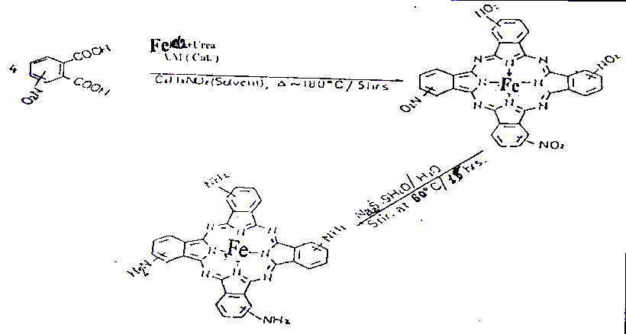

Scheme ( 1 )

1-3 Synthesis of 1, 4 diazophenelyene bridge

Fe- phthalocyanine polymer .
Preparation of the diazonium salt was based on piccard’s study ⁽⁹⁾ . 0.54 g of 1 ,4 – diamino benzene .
Was dissolved in a hot mixture of 2 – 4 ml concentrated HCl and 20 ml of water . Temperature was maintained at ( 0 C ) and the solution was tetraazotised by the addition of 0.7 g of NaNO₂ in 5 ml of water with in 1 min. The tetraazo solution was left in ice for 5 min and then added to a suspension of 0.5 g Iron ( II ) tetra amino phthalocyanine and 4 g of crystallized CH₃COONa in 50 ml of water . It was stirred well and allowed of stand ( 1h ) . The resultant mixture was heated up to (80 C ) and purification was made by hot water .
Scheme ( 2 ) shows only one of the structural isomer of the polymer .

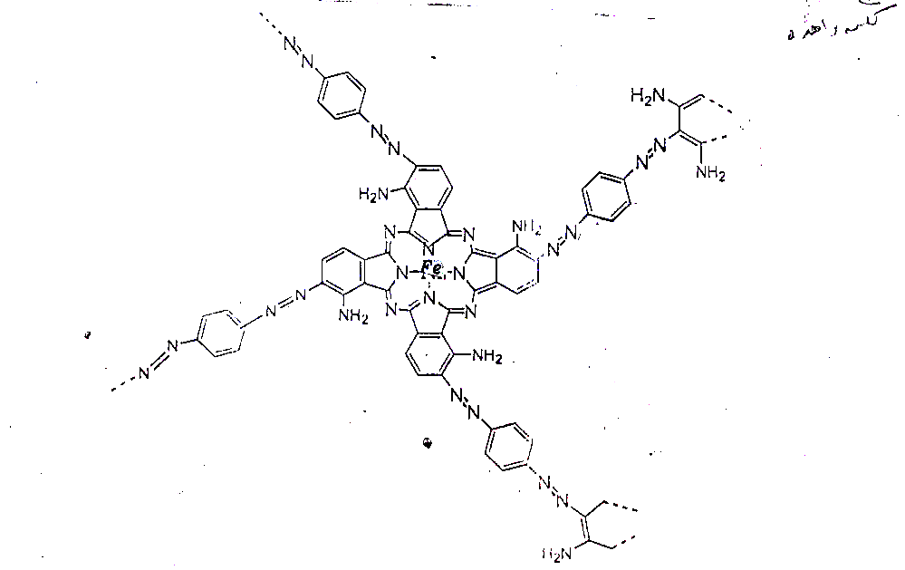

Scheme ( 2 )

Results and discussion :
The synthesis of Iron ( II ) tetranitrophthalocyanine , Iron (II) tetra aminophthalocyanine and 1 , 4 – diazo phenelyene – bridge Fe – phthalocyanine polymer were confirmed by IR-Spectra⁽⁵⁾ taken in KBr. The nitro phthalocyanine complex show characteristic – NO₂ peaks at 1340 cm ^{– 1} and 1540 ^{– 1} . The characteristic nitro peak at 1340 cm ^{–1} disappeared after reduction and the – NH2 stretching peak appeared in the polymer at 3450 cm ^{–1} , C – H at 3000 and 749 cm ^{–1} , C = C peak at 1602 , 1620 , 1506 , 4173 , 1396 , 937 , 816 , 667 , and 560 , and aryl-N-Peak at 1246 cm ^{–1} . These peaks are represented in Fig ( 1 ) . Fig ( 2 ) represent U.V-visible spectra of Iron ( II ) tetranitrophthalocyanine , Iron ( II ) tetra aminophthalocyanine and 1 , 4 – diazophenelyene – bridge Fe – phthalocyanine polymer , have been studied with the using of dimethlylsulphoxide . All of they showed the phthalocyanine special two bands , the first at 600 – 700 nm which is called Q-bands and the second one at 300 – 400 nm which is called B-band⁵.

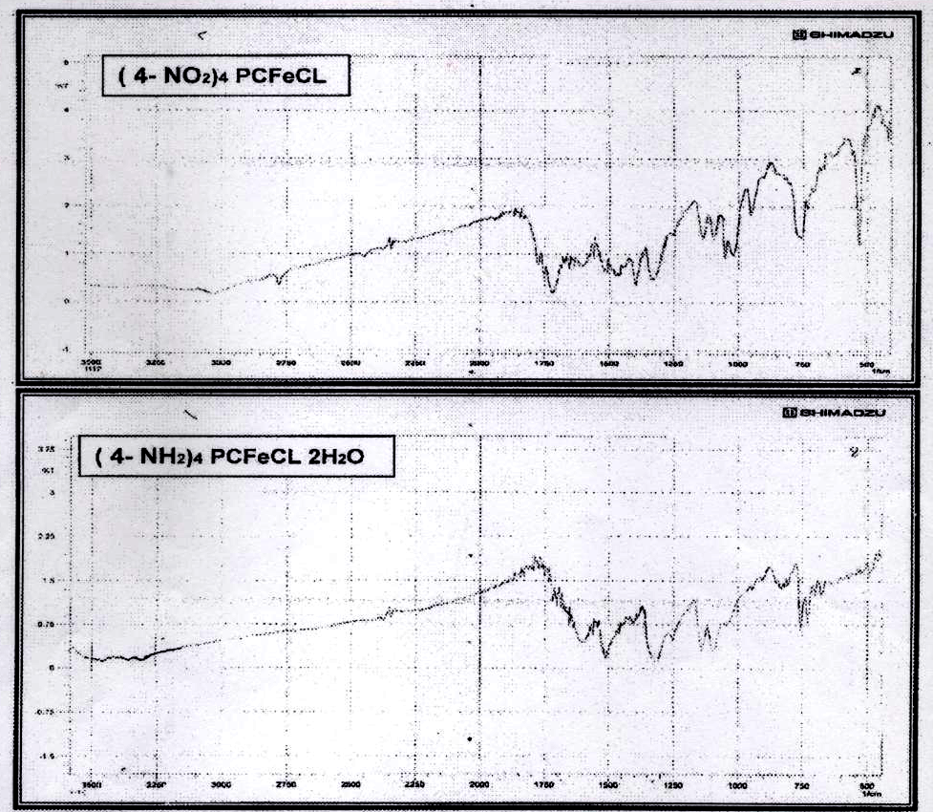
Fe (II) tetranitropthalocyanine ( a )

Fe (II) tetraaminopthalocyanine ( b )

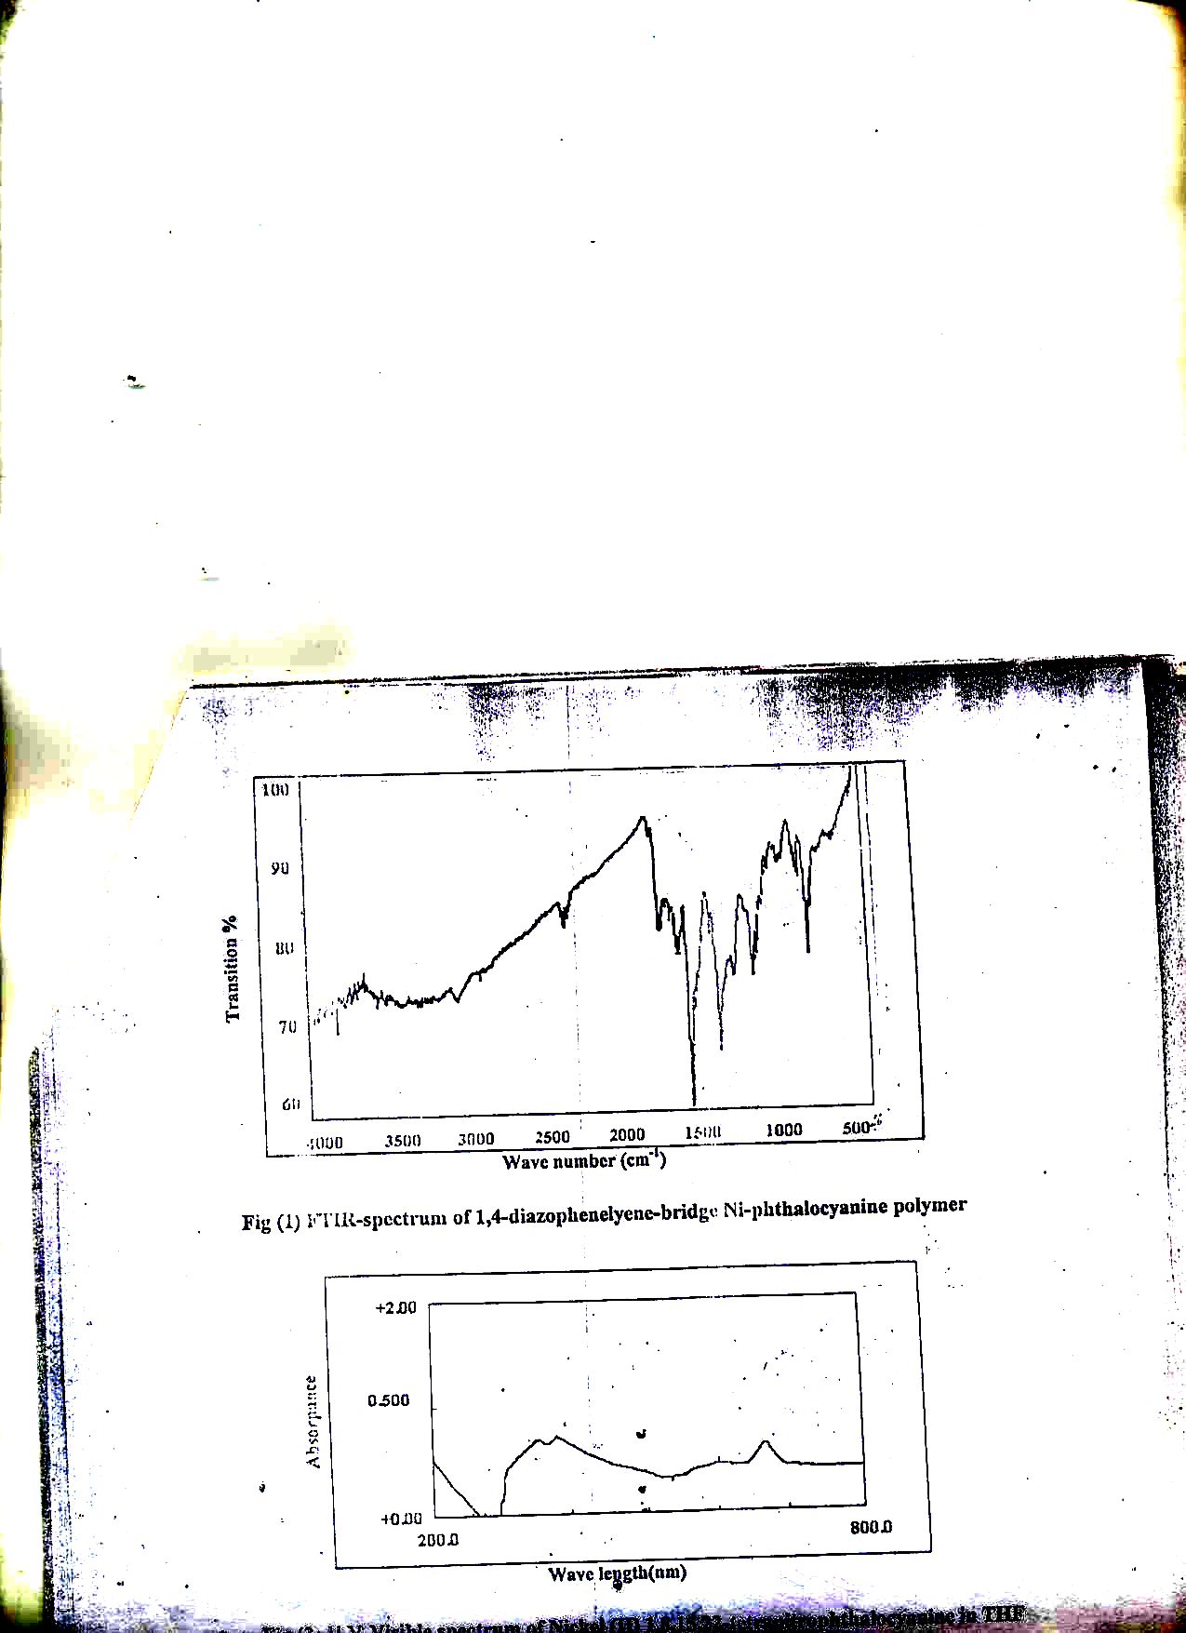
100
Polymer ( c )
90

80

70

60
4000
3500
3000
2500
2000
1500
1000
500

Figure ( 1 ) . Infrared spectrum of compounds a , b , c

Wave number (cm⁻¹)

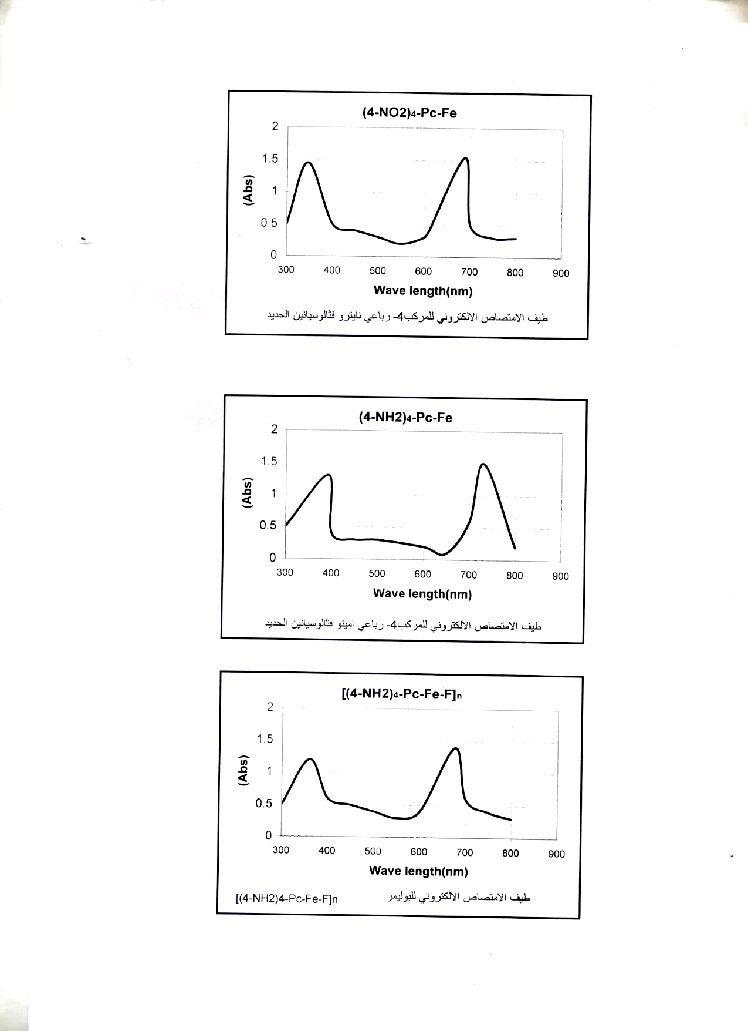

Fe (II) tetranitropthalocyanine ( a )

Fe (II) tetraaminopthalocyanine ( b )

Polymer ( c )

Figure (2) .u-v , v- visible spectrum of compounds a, b, c

Electrical conductivity :

The electrical properties of phthalocyanine and related compounds defend very much up on the morphology of the Macrocyclic systems to achive good semiconducting or even conducting properties .
Doping of the polymer iodine was acheaved by the dissolved of polymer in ccl4 and stirrer at ( 70 C ) for ( 72 h ) , after that the polymer doping was filtered and dried in vaccum oven at (50 C ) .
The maximum conductivity of the doped polymer samples is ( 3–52x10 ^{–4} ohm ^{–1} cm ^{–1} ) . it increases conductivity of conjugated by forming ions ⁽¹⁰⁾ .

Conclusions :
1 , 4 – diazophenelyene – bridge Fe phthalocyanine polymer was synthesized and characterized . The problem in dissolving phthalocyanine polymer makes their characterization or in some cases impossible .
The present of ( - N = N - ) bond was proven by FT-IR absorption band at around 1400 cm ^{–1} and shoulder formation at around 690 nm in the UV-Visb Spectrum . The low conductivity of the polymer was increased up to 10 ^{–1} ohm ^{–1} cm ^{–1} by doping with iodine and the values of ( E ) and ( ) were calculated to the polymer and iodine – doped polymer that it’s showed in table ( 1 ) .

Table ( 1 ) shown the values of ∆ E and
Sample | E (ev) | 6 (ohm ^{–1} cm ^{–1} )
Polymer | 0.247 | 1.841 x 10 ^{–4}
Iodine – doped polymer | 0.0254 | 6.112 x 10 ^{–4}

The conductivity was increased to the peroximity of distance between the energy levels which was ralated reversally with the value of conductivity .

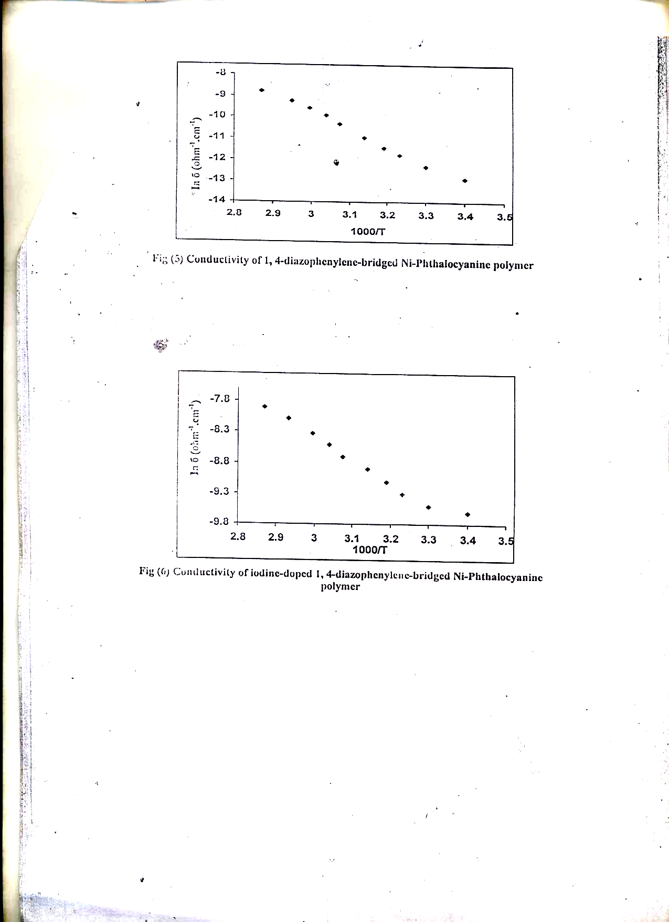

Fig ( 3 ) Conductivity of 1 , 4 – diazophenylene – bridged Fe – Phthalocyanine polymer

Fig ( 4 ) Conductivity of iodine – doped 1 , 4 – diazophenylene – bridged Fe – Phthalocyanine polymer

References :
1- Thami, T. Simon , J. and Jaffrezic , N ; Bull Soc. Chem Fr ; 1996,133,762
2- Boas, J , F. Feilding, P.E.and mockoy,A. G; Aust. J. Chem.; 1974, 27 ,7 .
3- Gregory P . ; J . Purphyrins phthalocyanines ; 2000, 4, 432.
4- Lezonff ,C.C.; phthalocyanines: Properties and Applications 1999,2 ,59 .
5- Somani , P. R ; Materials chemistry and physies .; 2002 , 77 , 117 .

6- Vogel , H. ; Practieal organic chemistry.,1969,9,1076 .

7- Nuchter,M. Microsynth synthesis Application Notes , 2001.
8- Vogel , H. ; Practical organic chemistry ,1969,9 , 837.

9- Piccord , J. Am . Chem . Soc.1926, 48 , 2878 .
10-Wohrle,D.; Adv.Polymer.Sci.1983,
50,46.

