Preparation and Spectroscopic Study of Some SelenoCyclo Pentane Derivatives

Khalid.J. Al-Adely  College of Science |  | Abid Allah. M. Ali  College of Education  for Women | H. T. Ghanem  College of Education  for Women
University of Al – Qadissia | University of Kufa

(NJC)

(Received on 28/12/2006) (Accepted for publication on 10/7 /2007)

Abstract
A new series of cyclic selenium compounds of the type (C₄H₈SeBrCO₂R), derived from selenocyclopentane have been synthesized , where R = H; CH₃; C₂H₅; C₃H₇; C(CH₃)₃.
The conductivity measurements of their solutions in dimethyl sulphoxide (10⁻³–10⁻⁵M), showed that the salts behave as (1 : 1) electrolyte and the conductivity decreases as the alkyl group of the carboalkoxymethyl derivatives is increased.
The I.R, ¹H-NMR and (C.H.N) data are reported and discussed below.

الخلاصة
تم تحضير مجموعة جديدة من مركبات السلينيوم الحلقية ذات الصيغة الجزيئية ) (C₄H₈SeBrCO₂R والمشتقة من السلينوسايكلوبنتان حيث أن : .R = H; CH₃; C₂H₅; C₃H₇; C(CH₃)₃ كما دُرست التوصيلية المولارية لمحاليل هذه المركبات وهي 1-برومو-1-كاربو الكوكسي مثيل-1-سلينوسايكلوبنتان في المذيب ثنائي مثيل أوكسيد الكبريت (DMSO) وبتراكيز تراوحت بين (10⁻³ – 10⁻⁵) مولاري ، وقد أظهرت هذه النتائج إن محاليل هذه المركبات عبارة عن ألكتروليتات ضعيفة تقترب من القيمة (1 : 1) ألكتروليت.
شخصت المركبات المحضرة بوساطة أطياف الأشعة تحت الحمراء وبروتون الرنين النووي المغناطيسي وجهاز التحليل العنصري الدقيق (C.H.N) وتمت مناقشة النتائج على ضوء هذه التحاليل.

Introduction
Selenium is essential micro nutrient for animals and humans, although it was once known only for its toxicity⁽¹⁾. Selenium is a component of many enzymes and proteins in mammals⁽²⁾. More recently, a large body of convincing evidence has indicated that Selenium act as a cancer preventative agent when given in pharmacological amounts⁽³⁻⁵⁾. In addition, some of its compounds are used as antioxidants in some oil grease⁽⁶⁾, and semi – conductives industry⁽⁷⁾.
Very efforts were spent in recent years by the researchers to prepare many hetero cyclic compounds which have heterogeneous atom as one of the sixth group⁽⁸⁻¹⁴⁾. Many selenium salts cyclic and acyclic are prepared⁽¹⁵⁻¹⁷⁾ having the chemical formula of [R₃M]⁺[X]– which means that these compounds have an ionic properties because of the existence of both of cation and anion.
Some researchers have already prepare some selenolanium salts of type trialkyl- (aryl) selenolanium halide^{(8,18)}. Selenolen is regarded as a good nucleophelic reagent because of the existence of the lone pairs of

electron. Depending on this characters of the selenolan some selenolanium salts of the type of alkylacetyldibutyl selenolanium bromide are prepared from the reaction of dibutyl selenolan and alkyl bromo acetate⁽¹⁹⁾.
The present work reports the synthesis of 1-bromo-1-carboalkoxy-1-seleno cyclopentane by the reaction of different bromo alkyl acetates (BrCH₂CO₂R) with cyclo selenolan.
Experimental
A- Materials and Methods
All chemicals are obtained from (Fluka, Merck and BDH), except of 1,1-di iodo selenolan C₄H₈SeI₂ which is prepared as described in the literature⁽¹⁶⁾. The solvents used are purified by standard procedures. The melting points are determined on "P.D-303" APEL and uncorrected. Infrared spectra as CsI discs in the range of (4000 – 200 cm⁻¹) are recorded on a Pye – Unicam SP3 – 300 Spectrophotometer. ¹H– NMR spectra are recorded on SFOI 300 MHz instrument. Analysis for carbon and hydrogen are obtained with Micro analytical unit, 1108 C.H.N Elemental analyzer. Selenium ion concentrations are determined by Shimadzu – AA – 160 Atomic Absorption Flame Emission Spectrophotometer. Molar conductivity are measured by WTW – Conductivity Meter LBR.
B- Preparations
1. Selenocyclopentane C₄H₈Se⁽¹³⁾
1,1-Di iodo selenolan (7.78gm, 0.02mole) is dissolved in (100ml) of hot ethanol. The sodium borohydride (1.51gm, 0.02mole) is then added to the reaction mixture with stirring. After cooling the solution is diluted with water (150ml). The mixture is extracted with diethyl ether (3×100ml) and washed with water, and then dried with (MgSO₄), the solution is filtered off and concentrated by using rotatory evaporator, to give a viscous yellow oil.
2. 1-Bromo-1-carboxy methyl-1-selenocyclopentane C₄H₈SeBrCH₂CO₂H
A solution of α-bromo acetic acid (0.01mole) is added to excess of cycloselenolan in ether solution a pale yellow crystals are formed, it is dried and recrystallized from ethanol to gave a yellow crystals.
3. 1-bromo-1-carbo methoxy methyl-1-seleno cyclopentane C₄H₈SeBrCH₂CO₂ CH₃
It is prepared by treating α-bromomethylacetate (0.01 mole) with excess of cyclo- selenolan in its ether solution in the same method of compound (1). Yellowish white powder was obtained.
4. 1-bromo-1-carbo ethoxy methyl-1-selenocyclopentane: C₄H₈SeBrCH₂CO₂C₂H₅
It is prepared from adding α-bromo ethyl acetate (0.01mole) with excess of cyclo selenolan in its ether solution. The mixture was stirred for 3hr at (60°C), and the yellow precipitate then filtered off, washed with acetone and air dried. Recrystallization from ethanol to gave a pale yellow crystals.
5. 1-Bromo-1-carbopropoxy methyl-1-selenocyclopentane C₄H₈SeBrCH₂CO₂C₃H₇
It is prepared by treating α-bromopropylacetate (0.01mole) with excess of cyclo- selenolan (0.01 mole) in ether. The mixture is heated at (50°C) with stirring for 5hr. the solution is cooled and the precipitate is collected, washed with acetone and air dried. Recrystallization from chloroform gives white crystals .
6. 1-Bromo-1-carbo(tre-.butoxy)methyl-1-selenocyclopentan C₄H₈SeBrCH₂CO₂C(CH₃)₃
A solution of α-bromo t-Butyl acetate (0.01 mole) in (50 ml) ethanol is added with continuous stirring to a hot etheric solution of cycloselenolan (0.01 mole). The mixture was stirring for 3hr, the solution is filtered, the precipitate is washed by acetone and air dried. Recrystallized by ethanol to obtain a yellow crystals. Some physical properties and analytical data are summarized in Table.1.
Results and Discussion
The cycloselenolan contains selenium atom which has lone pair of electrons so it reacts easily with alkyl halide⁽¹⁵⁻¹⁸⁾, depending on this quality of cycloselenolan a new heterocyclic selenolan compounds have been obtained by the reaction between cyclo- selenolan and α-bromoalkylacetate as the following scheme.1, presents

(1)
(2 - 6)
R = H ; CH₃ ; C₂H₅ ; C₃H₇ ; C(CH₃) ₃
(2) (3) (4) (5) (6)
Scheme.1: Methods of preparation of new hetero cyclic selenium compounds

The accurate conclusions of elemental analysis (C.H.N), IR, and ¹H-NMR spectra for these compounds prove that their structures are correct as shown in the Tables 1, 2, and 3 respectively. The elemental analysis data of these compounds which summarized in Table.1, are consistent with the calculated results from the empirical formula of each compound.

Table.1: Some physical properties and analytical data of the prepared compounds
R | Color | Melting point (°C) | Yield % | Anal. Found (Calc.)%
 |  |  |  | C | H | Se
H | Yellow | 122 - 124 | 87 | 26.29 (26.64) | 4.04 (4.24) | 28.81 (28.39)
CH₃ | Yellowish - white | 89 - 91 | 91 | 29.18 (28.81) | 4.55 (4.39) | 27.41 (26.88)
C₂H₅ | Pale yellow | 136 - 138 | 78 | 31.81 (31.35) | 5.00 (4.76) | 26.14 (25.54)
C₃H₇ | White | 223 - 225 | 82 | 34.19 (34.69) | 5.42 (5.11) | 24.98 (25.59)
C(CH₃) ₃ | Yellow | 211 - 213 | 72 | 36.38 (35.89) | 5.80 (5.56) | 23.92 (23.41)

IR Spectra
Through studying IR spectra for 1-bromo-1-carboalkoxyl methyl-1-selenocyclo- pentane compounds, it is noticed that the absorption of carbonyl group is less than that of esters which absorbs in 1735 cm⁻¹. This difference is justified under the existence of mutual interference between oxygen atom of carbonyl group and selenium
atom. The absorption of carbonyl group in compound (2) is less than of the absorption of the other compounds because of hydrogen bonding as well as inductive effect of the alkoxy group.
The IR spectra of all compounds show two weak bands in the range of 570–585 cm⁻¹ which may due to ν_{S} ( C_{2,5}─Se ) and broad bands characteristic of ν_{S} ( Se─C_{alkyl} ) at 605– 620 cm⁻¹ .These are agree with the previous studies^{(15,17,20)}. IR spectra show strong bands characteristic of ν_{S} (CO) group at 1710–1725 cm⁻¹ and weak bands characteristic of ν_{S} ( Se─Br )
were located at 325–340 cm⁻¹. Relevant IR data are presented in Table.2.

495
Table.2: Characteristic IR absorption bands of 1-bromo-1-carboalkoxymethyl-1-selenocyclopentane (C₄H₈SeBrCH₂CO₂R)
R | ν_{as} (C─O─C) | ν(C─O─C) | ν(C═O) | ν(C─H)_{aliph} | ν(Se─Br) | ν(Se─C_{alkyl}) | ν(Se─C_{2,5})
H | 1260 | 1100 | 1710 | 2950 | 335 | 605 | 570
CH₃ | 1250 | 1105 | 1720 | 2945 | 340 | 620 | 580
C₂H₅ | 1265 | 1150 | 1720 | 2950 | 330 | 615 | 575
C₃H₇ | 1270 | 1100 | 1715 | 2955 | 335 | 610 | 585
C(CH₃)₃ | 1285 | 1150 | 1725 | 2950 | 325 | 615 | 570

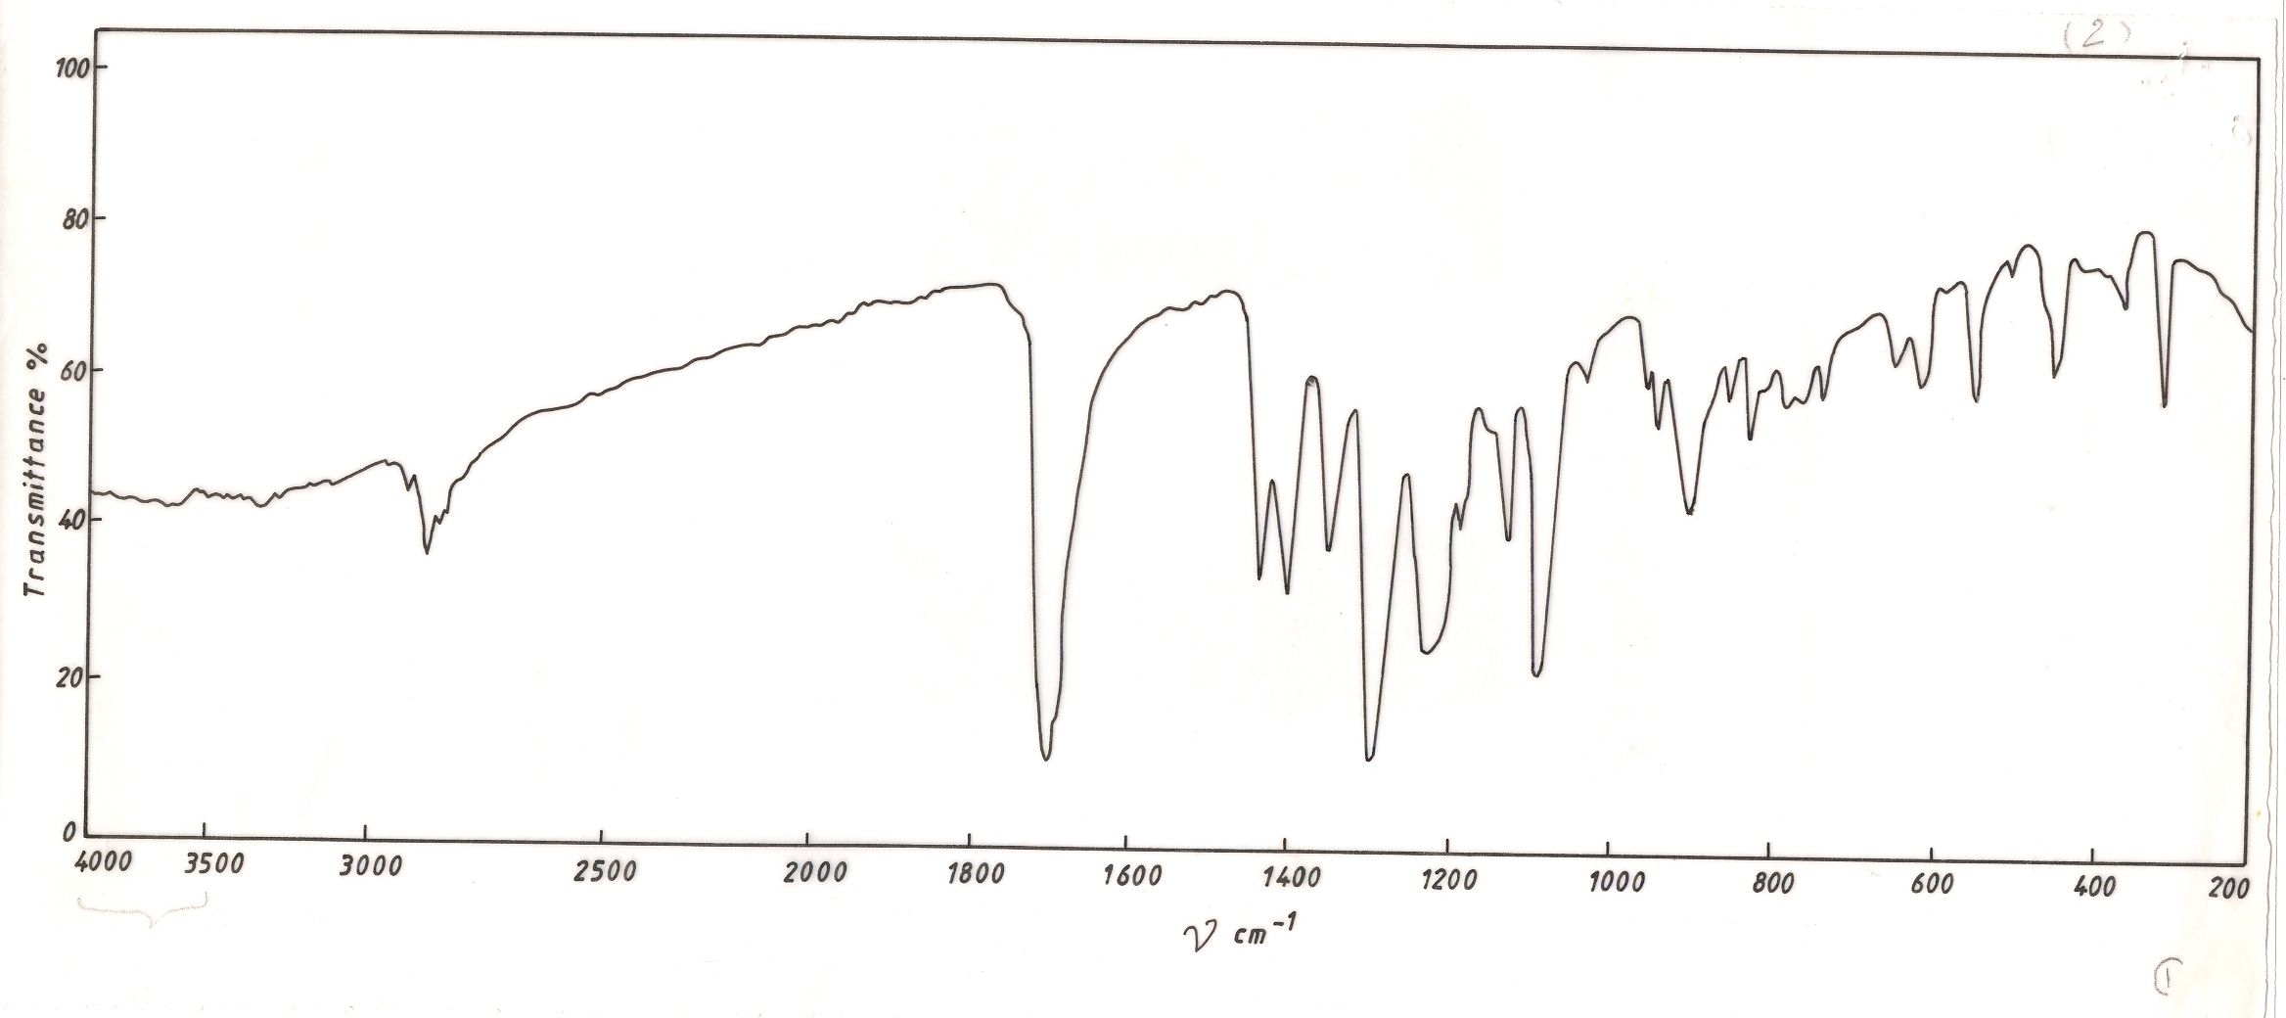
A representative example for these spectra are given in Figs. 1 and 2.

%T

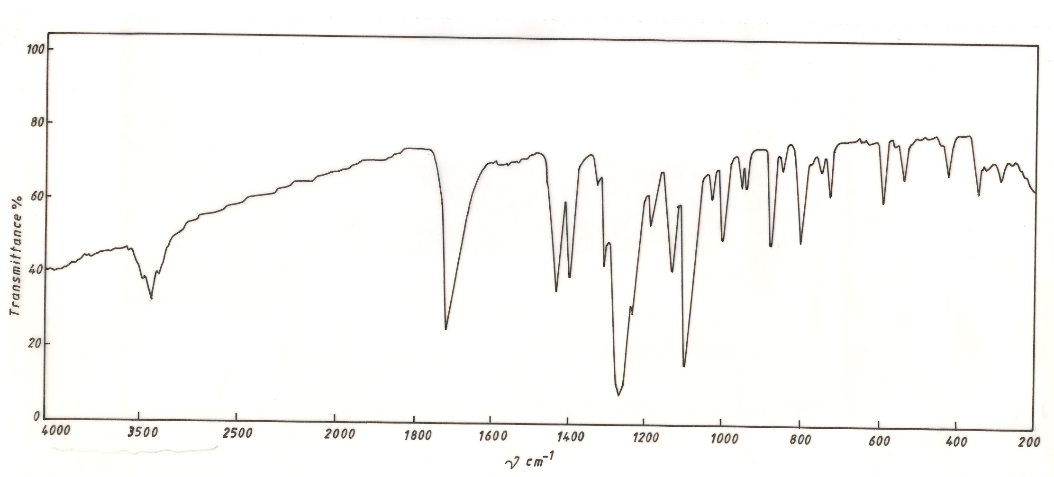
Fig.1: IR spectrum of 1-Bromo-1-carboxymethyl-1-selenocyclopentane C₄H₈SeBrCH₂CO₂H

%T

Fig.2 : IR spectrum of 1-bromo-1-carbomethoxymethyl-1-selenocyclopentane C₄H₈SeBrCH₂CO₂CH₃
496

¹H-NMR Spectra
The ¹H-NMR spectra of the compounds were obtained in d₆ – DMSO at room temperature using TMS as reference. The ¹H-NMR data and assignments of the compounds are presented in Table.3. The signals are identified through chemical shift, intensity, and their frequencies⁽¹⁵⁻²¹⁾.
All these compounds show two identical signals at the chemical shift of δ = 2.6 – 3.7 ppm, and δ = 1.8 – 2.8 ppm, which are related to the (2 , 5) and (3 , 4) methylene ring protons respectively.

Table.3: ¹H-NMR data for the 1-bromo-1-carboalkoxymethyl-1-selenocyclo- pentane C₄H₈SeBrCH₂CO₂R
R | Assignment | Chemical shifts (ppm) TMS = 0 ppm
H | H_{(2,5)} | 3.1 – 3.7 complex over lapping
H | H_{(3,4)} | 2.2 – 2.5 complex over lapping
H | Se─CH₂ | 2.7 (s)
H | O─H | 8.3 (s)
CH₃ | H_{(2,5)} | 3.1 – 3.4 complex over lapping
CH₃ | H_{(3,4)} | 2.4 – 2.8 complex over lapping
CH₃ | Se─CH₂ | 3.7 (s)
CH₃ | O─CH₃ | 4.1 (s)
C₂H₅ | H_{(2,5)} | 3.2 – 3.5 complex over lapping
C₂H₅ | H_{(3,4)} | 2.4 – 2.7 complex over lapping
C₂H₅ | Se─CH₂ | 3.4 (s)
C₂H₅ | O─CH₂ | 4.2 – 4.5 (q)
C₂H₅ | CH₂─CH₃ | 1.4 – 1.7 (m)
C (CH₃)₃ | H_{(2,5)} | 2.6 – 2.9 complex over lapping
C (CH₃)₃ | H_{(3,4)} | 1.8 – 2.1 complex over lapping
C (CH₃)₃ | Se─CH₂ | 3.4 (s)
C (CH₃)₃ | C(CH₃)₃ | 1.5 (s)
A representative examples of their spectra are given in Figs.3, and 4.
497
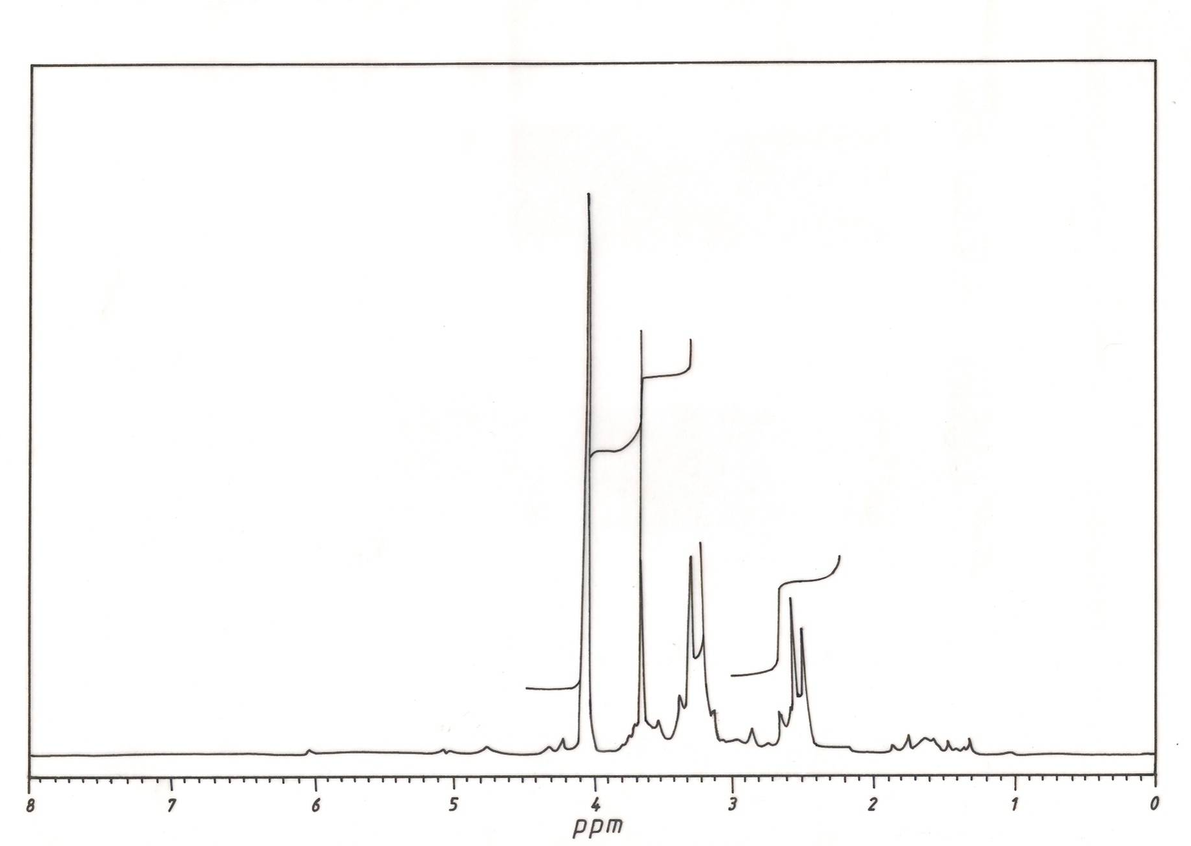

Fig.3 : ¹H-NMR spectrum of 1-Bromo-1-carboxymethyl-1-selenocyclopentane C₄H₈SeBrCH₂CO₂H

Fig.4 : ¹H-NMR spectrum of 1-bromo-1-carbomethoxymethyl-1-selenocyclopentane C₄H₈SeBrCH₂CO₂CH₃
498

Molar Conductivity
The measured molar conductance's (Λm) of the selenolanium salts in (10⁻³ - 10⁻⁵ M) of DMSO solution, for identifying the ionic nature of these salts, as well as determining the effect of alkyl group volume.
The values of Λ_{m} for these salts at 10⁻³ M means that these salts are weak electrolytes⁽¹⁵⁻²²⁾. They are represented in Table.4 and Fig. 5. They showed the plots of Λ_{m} against (conc)^{½} showed a marked curvature for each of these salts, this is a typical of 1:1 electrolyte, this is in favor with the literature and the Λ_{m} values decrease with the increment of the alkyl group volume according to the following order;
-CH₃ > -C₂H₅ > -C₃H₇ > -C(CH₃)₃

And this is related to the large positive ion volume which leads to limiting its motion in the solution. While the Λ_{m} of compound (2) is disagree with order mentioned above because of the hydrogen bond existence which decrease the Λ_{m} value^{(16,17)}, Table.4.

Table.4: Conductivity data of 1-bromo-1-carbalkoxymethyl-1-selenocyclopentane (C₄H₈SeBrCH₂CO₂R)
R | Molar conductance Λ_{m} ohm⁻¹.cm⁻².mol⁻¹ (10⁻³ M, DMSO)*
H | 26.73
CH₃ | 36.31
C₂H₅ | 32.03
C₃H₇ | 28.64
C(CH₃) ₃ | 23.96

*10⁻³ M solutions Et₄NCl, (DMSO) 30. ohm⁻¹.cm².mol⁻¹

$$\sqrt{c}×{\text{10}}^{−1}M$$
Fig.5: Molar conductance of 1-bromo-1-carboalkoxy-1-selenocyclopentane
499

References
- K. Schwarz, and C.M.Foltz; J. Am. Chem. Soc., 1957 ,70 , 3292 .
- G.V. Kryukov , S. Castellano, S.V. Novoselov, A.V. Lobanov, O. Zehtab, R.Guigo, and V.N. Gladyshev; Science., 2003 , 300 , 1439
- G.F. Jr.Combs , and W. P. Gray ; Pharmacol Ther., 1998 , 79, 179.
- J. Fleming, A. Chose , and P.R. Harrison ; Nutr Cancer., (2001, 40 , 42.
- P. D. Whanger ; J. Am. Coll Nutr ., 2002, 21, 223.
- K. J. Irgolic "The Organic Chemistry of Selenium", Gordon and Breach; London , 1974.
- H. J. Emelus, and H. G. Heal ; J. Chem. Soc., 1946 , 1 , 126.
- H. A. Al-Shirayda, A. S. Alnaimi, and K. J. Al-Adely; J. Arab Gulf Sci . Res., 1993 , 10 (1) , 13.
- M. P. Balfe, C. A. Chaplin and H. Phillps ; J. Chem. Soc., 1983, 341.
- A. Z.Al -Rubaie, H. A. Al- Shirayda and A. I. Auoob; J. Organ, metal. Chem ., 1988, 356 , 49.
- A. Z. Al-Rubaie; J. Organometal. Chem ., 1990, 382, 383.
- G. A. Adam, A. Z. Al-Rubaie and H. H. Al-Shirayda ; J. T. Thermo. Chem . Acta ., 1985, 87, 183.
- N. Dans, W. R. Mewhinnie and H. Jahngir ; J. Organometal . Chem ., 1980 , 198 , 131.
- R. F. Ziolo, and W. M. M. Guenther ; J. Organometal . Chem ., 1978 ,146 , 245.
- A. Z. Al-Rubaie ; J. Organometal . Chem ., 1992 , 438 , 77.
- Khalid. J. Aldely, A. M. Ali , and K. A. A. Alrazaq ; J. Al-Qadisiya, pure Sci ., 2001 , 6 (4) , 1.
- Khalid. J. Aldely, K. A. A. Alrazaq , and A. J. Al-Shimaryi ; Iraqi . J. Chem ., 2002 , 28 , (2).
- G. Morgan , and F. Burstall ; J. Chem . Soc ., 1931, 173.
- A. Z. Al-Rubaie, and H. A. Al-Shirayda ; J. Organometal . Chem ., 1985, 294 , 315.
- T. Biorvatten ; Acta. Chem. . Scand ., 1963 , 17, 2292.
- M. Maddox , and J. D. Mcullough ; Acta. Chem. . Cryst ., 1964 , 17, 712.
- A. Z. Al-Rubaie, H. A. Al-Shirayda, P. Granger and D.S. Chapelle ; J. Organo-metal . Chem ., 1985 , 287 , 310.

500

