Generation of Photocurrent using Rhodamine B
Dye and visible Light

Hassan A. Habeb  College of Education? | Saja S. Jabbar Al-Taweel  College of Scienc | Nabeel A. Abed –Al-rudha  College of Education
University o f Al- Qadisiya

(NJC)

(Receivedon 29/5/2007) (Accepted for publication on 22/8 /2007)

Abstract
The photo galvanic effect was studied in a system of photogalvanic cell, containing rhodamine B as photosensitizer, EDTA as reductant, and sodium lauryl sulphate as surfactant. The electrical outputs of this cell were 210 mV and 70μA respectively. The storage capacity of the cell was 20 min in dark after 55 min of illumination. The effect of different parameters on electrical output of this system were studied such as; pH, temperature, light intensity, concentration of dye, concentration of EDTA, and concentration of NaLS. Also, a mechanism of generation of photocurrent in this cell has been proposed.

الخلاصة

تم دراسة التأثير الكلفاني الضوئي في نظام يحتوي خلية كلفانية وصبغة الرودامينRhodamine.B(RB) كمتحسس ضوئي والاثيلين ثنائي الأمين رباعي حامض الخليك EDTA كعامل مختزل و كبريتات لوريل الصوديوم NaLS كمركب فعال سطحيا.
وجد إن الجهد الضوئي والتيار الضوئي لهذه الخلية كانا 210 ملي فولت و70 مايكرو أمبير على التوالي.إن سعة الخزن لهذه الخلية هي 20دقيقة في الظلام بعد شحن الخلية لمدة55 دقيقة.تمت دراسة بعض العوامل المؤثرة على كفاءة توليد التيار الضوئي باستخدام هذه الخلية وشملت تأثير الدالة الحامضية ودرجة الحرارة وشدة الضوء الساقط تركيز كل من الصبغة و EDTA وNaLS على التوالي.تم وضع آلية افتراضية لعملية توليد التيار الضوئي في هذه الخلية.

Introduction
The generation of electrical energy by conversion and storage of solar radiation has a good attention from chemist and physician scientists. The utility of solar energy is one from many renewable sources of energy especially in photogalvanic cells, so the photogalvanic cells are worthwhile source of energy and have future applications and uses. The photogalvanic effect involves the excitation of a molecule by photon and a chemical reaction occurs to yielding new chemicals (high-energy products) which save the chemical energy.
The photogalvanic effect was first reported by Rideal and Williams ⁽¹⁾ but Rabinowitch ^{(2,3)} made the first photogalvanic cell in 1940 at USA by using thionine –Fe⁺² system which serve as absorber of incident photons and conversion the energy to Fe⁺² ions and the results of this cell were 1.09 V and 1.73 μA under sun light (70 mW/cm²). Becquerel ^{(4,5)} first observed in 1839 the generation and flow of current between unsymmetrical illuminated metal electrodes in sun light
The photogalvanic effect of photoredox couples have also investigated by many workers all over the world, for instance
Potter and Thaller ⁽⁴⁾, Ikawa and Yamase ⁽⁶⁾, Kaneko and Yamada ⁽⁷⁾, Ameta et al ⁽⁸⁻¹¹⁾, Aliwi et al ⁽¹²⁾ Gangotri et al ⁽¹³⁻¹⁴⁾ Meena et al^{.(15)} ,and Genwa and Chouhan ⁽¹⁶⁾ . In all works, the conversion efficiency of these cells are quite low (0.03-0.1%) ⁽¹¹⁾ which due to the fast back electron transfer and other deactivated physical processes beside the special phenomenon of dyes such as lower stability of absorbers and aggregates of dye molecule around the electrodes. Recently, an attention has been paid to use of systems containing photosensitizers (dyes & complexes), reductants (EDTA, ascorbic acid, etc) and micelles (surfactants) for improved the solar energy conversion and storage ⁽¹⁷⁻¹⁹⁾.
The present work aims to study the rhodamine B-EDTA-NaLS system in a photogalvanic cell for conversion and storage of solar energy. The effect of dye concentration, pH, temperature, incident light intensity, EDTA concentration, and NaLS concentration have been studied.

Methodology
Rhodamine B dye (RB) (Figure (1)), EDTA, sodium hydroxide supplied by Aldrich. Sodium lauryl sulphate (NaLS) and citrate buffer were supplied by Fluka AG. All the chemicals were used without further purification and all the solutions were prepared in doubly distilled water and kept in amber-coloured containers for protect it from sun light ⁽¹⁶⁾. A mixture of dye solution and other additives were taken in an H-shaped glass tube of capacity 50 cm³ ⁽¹¹⁾. Two platinum electrodes (1x1cm) were used as illuminated and dark electrodes. The wholly cell was placed in a thermostat water path (HAAKE circulator) .The whole system was first placed in dark till a stable potential was obtained, then the one arm of the cell was exposed to a 200W tungsten lamp and the other one was kept in dark ⁽¹⁵⁾. The photopotentials were measured by a digital multimeter and photocurrents were measured by digital pH meter (PW 9420 pH meter). The two half-cell were separated by a sintered glass disc. The electrodes were pretreated by immersed them in dilute hydrochloric acid solution for 1 h ⁽¹²⁾ .The incident light intensity was measured actinometrically by the method described by Haatchard ⁽²⁰⁾. Cintra-5 GBC Scientific equipment spectrophotometer was used to recording the UV-visible spectra of dye in wavelength range between 300 –800 nm by using 1 cm path length quartz cell. In all experiments the cell was irradiated with tungsten lamp for 55 minutes by variation of pH, light intensity, concentration of dye, concentration of EDTA, concentration of NaLS, and temperature.

Figure (1): The chemical structure of Rhodamine B

Results and Discussion
The spectrum of rhodamine B dye locates in the visible range with λ_{max} 545nm and high molar absorption coefficient ε (1.9x10⁴ l.mol⁻¹cm⁻¹). The rhodamine B dye shows a good stability on irradiation with tungsten lamp as shown in Figure (2). From these data, the use of this dye as photosensitizer in performance of photogalvanic cell is worthwhile.
The electrical output of photogalvanic cells is affected by several factors involves effect of pH, temperature, and light intensity, concentration of reductant, concentration of surfactant, and concentration of photosensitizer. The efficiency of present cell was examined by following the variation of photopotential and photocurrent with time. Figure (3) illustrate the variation of electrical output with irradiation time.
It is seen that electrical output of present photogalvanic cell is found to increase as the pH increases. It is observed from Figure (4) that the photopotential and photocurrent reach the maximum value at pH=10, and then decreases on further increase in pH. It is clear that this photogalvanic cell is sensitive to the pH variation. Generally the pH of optimum condition for reductant has a relation with its pKa and the best pH is higher than pKa ^{(15, 16)}.
The electrical output of present photogalvanic cell also affected by the change of concentration of reductant EDTA. Figure (5) shows that at lower concentration of EDTA causes decreasing in photopotential and photocurrent as a result of decreasing of available reducing agent molecule for donating the electrons for oxidized dye molecules. While, in higher concentration also a decreasing in electrical out pout occur which attribute to hindering the dye molecules from reaching the electrode surface by high number of EDTA molecules ⁽¹⁵⁾.
Figure (6) illustrates that electrical output of this cell increases when the concentration of surfactant NaLS is increasing until reaching the optimum concentration, but on further increasing the photopotential and photocurrent are decreasing.
The effect of variation of temperature on photopotential, photocurrent and power has been studied. From the obtained results Figure (7), it seen that a linear relation between electrical output and temperature. But the photocurrent increases and the photopotential decreases. This attributed to decreased in internal resistance of the cell at higher temperature ⁽¹⁶⁾.
The dependence of electrical output on variation of dye concentration has been studied. It is seen from Figure (8) that lower concentrations of rhodamine B dye causes a decreases of photopotential and photocurrent due to lowering of dye molecule in the excited stat and donate the electrons to electrode, and the greater concentration of dye also causes a decreasing in electrical output because the high number of dye molecule are form an inner filter and does not permit the photons to reaching the other dye molecules near the electrode^{. (15,16,21)}
Different intensities of light were used to deduce this on output of photogalvanic cell. It is observed from Figure (9) the linear increasing of photocurrent on increase of light intensity, while the increasing of photopotential is not linearly one. Generally the increasing of light intensity causes an increasing in number of photons that collide with photosensitizer molecule besides the electrode and hence causes an increasing in electrical output values ^{(16, 21)}.

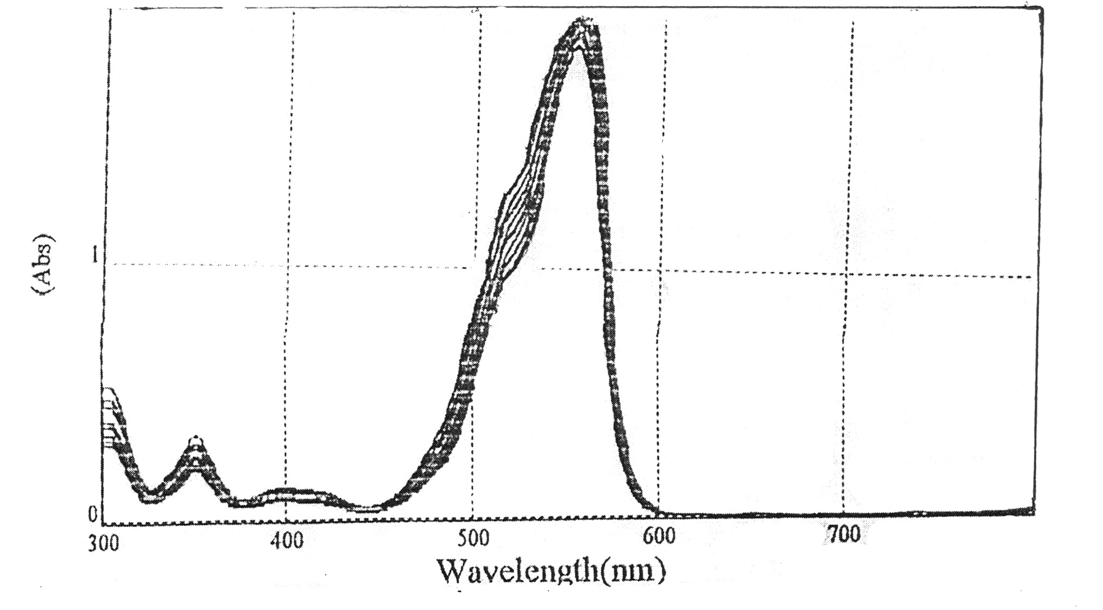
Figure (2): Electroinc spectra of rhodamine B (1 x 10⁻⁴ M)

mV
µA
Figure (3): Effect of variation of irradiation time [RB] = 0.00005M, [NaLS] = 0.006 M, [EDTA] = 0.0075M, pH=9, light intensity =10.5µW/cm², Temp=298K.

mV
µA
Figure (4): Effect of variation of pH. [RB]=.00005M, [EDTA] =0.0075M, [NaLS] =0.006M,
Light intensity=10.5µW/cm2, Temp=298K.
mV
µA
Figure (5): Effect of variation of EDTA. Concentration. [RB]=0.00005M, [NaLS] =0.006 M, pH=9, Light intensity=10.5µW/cm², Temp=298K.

10⁻³M

mV
µA
Figure (6): Effect of variation of NaLS concentration. [RB]=0.00005M, [EDTA] =0.00275 M, Light intensity=10.5µW/cm², pH=9, Temp=298k.
mV
µA
Figure (7): Effect of variation of temperature. [RB]=0.00005M, [NaLS] =0.006M, [EDTA] =0.0075M, pH=9, light intensity=10.5µW/cm².

10³M

10⁻⁴M

mV
µA
Figure (8): Effect of variation of dye concentration. [NaLS]= 0.006 M, [EDTA] = 0.00275M, pH= 9, light intensity= 10.5µW/cm², Temp= 298K.
mV
µA
Figure (9): Effect of variation of light intensity. [RB]= 0.00005M, [NaLS] = 0.006M, [EDTA] = 0.00275M, pH =9, Temp=298k.

References
1- E.K.Riedel, and D.C. Williams, J. Chem. Soc. 1925,258.
2- E.Rabinowitch, J.Chem.Phys.1940, 8,551.
3- E.Rabinowitch, J.Chem.Phys.1940, 8,560.
4- K.Becquerel,C.R.Acad.Sci.(Paris) 1839,9,14.(Cited by reference No. 15).
5- K.Becquerel,C.R.Acad.Sci.(Paris) 1839,9,561.(Cited by reference No. 15).
6- T.Yamase, and T.Ikawa, Inorg. Chim. Acta, 1980,45,L55.
7- Kaneko, and A.Yamada, J.Phys .Chem.1977, 81,1213.
8- S.C.Ameta, S. Khamesra, S. Lodha, and R. Ameta, J. Photochem. Photobiol., 1985,48,8.
9- S.C.Ameta, S. Khamesra, A. K. Chittora, and K. M. Gangorti, Int. J. Enrergy Res, 1989, 13, 643.
10- S. C. Ameta, C. G. Dubey, T. D. Dubey, and R. Ameta, Z. Phys. Chem. (Leipzig), 1984, 265, 200.
11- S.C.Ameta, and K.M.Gangorti, Proccedings of 3rd Arab Int.Solar Energy Conference, Baghdad, 1988.5-27.
12- S.M.Aliwi,S.N.Naman, and I.K.Al-Daghstani, Solar Cells,1986,18,85.
13- K. M. Gangorti and R. C. Meena, J.Photochem.Photobiol.,2001, A141 ,175.
14- K. M. Gangorti and O. P. Regar, J.Indian.Chem.Soc.,2000,77,347.
15- R.C.Meena, S. Gautam, N. Tyagi and M. Kumari, J.Chem.Sci. 2004,116,179.
16- K. R. Genwa and A. Chouhan, J.Chem.Sci. 2004,116,339.
17- K. M. Gangorti and R. C. Meena, and R. Meena, J. Photochem. Photobiol. A, 1999, 123, 175.
18- T.Yamase, Photochem. Photobiol, 1981,34,11.,
19-M. Mukhopadhyay and B. B.Bhowmik, J.Photochem. Photobiol.A,1992,62,223.
20- C. G. Hatchard and C. A. Parker, Proc. Roy. Soc., A.1965, 235, 518 .
21- H. A. Habbeb, MSc Thesis, University of Babylon, Iraq, 1998.

