Determination of Monomer Reactivity Ratios of Poly ( Acrylonitrile – co – vinylacetate )

Tariq S.Najim  College of Scienc | Abdul Hussien K. Sharba  College of Scienc | Nadia A. Butti  College of Scienc
University o f Al-Mustansiryah

(NJC)

(Receivedon 15/11/2006) (Accepted for publication on 22/8 /2007)

Abstract :
Copolymers of Acrylonitrile (AN) and Vinyl Acetate (VAc) were synthesized in dimethyl formamide (DMF) using benzoyl peroxide (BPO) as initiator at 75ºC . The copolymers were analyzed by IR spectroscopy. The monomer reactivity ratios were determined by the methods of Fineman – Ross (F-R) and Kelen – TűdÖs (K-T) giving the results shown in the following table:-
r₁(AN) |  |  |  | r₂(VAc)
F-R |  | K-T |  | F-R |  | K-T
1st | 2nd | 1st | 2nd | 1st | 2nd | 1st | 2nd
2.2347 | 2.5341 | 2.3889 | 2.7087 | 0.0303 | 0.002 | 0.1038 | 0.0719
الخلاصة
تم تحضير البوليمر المشترك للاكريلونايتريل (AN) و الفنيل استيت (V_{Ac}) في مذيب ثنائي مثيل فورمأيد (DMF) باستخدام بيروكسيد البنزويل كبادئ وبدرجة حرارة 75º c . تم تحليل البوليمر المشترك بواسطة مطيافية الاشعة تحت الحمراء .
الفعالية النسبية للمونمرات تم تحديدها بواسطة طريقة فنمان و روس (F-R) وطريقة كلين-ثيودوس (K-T) و النتائج موضحة في الجدول التالي :

r₁(AN) |  |  |  | r₂(VAc)
F-R |  | K-T |  | F-R |  | K-T
1st | 2nd | 1st | 2nd | 1st | 2nd | 1st | 2nd
2.2347 | 2.5341 | 2.3889 | 2.7087 | 0.0303 | 0.002 | 0.1038 | 0.0719

Introduction :
Japan has recently been the leading contributor in the diversification of the production of modified acrylic fibers(1) More than 85% of acrylonitrile monomer must be incorporated into copolymer in order for it to be termed an acrylic fiber(2). Copolymerization of acrylonitrile with various comonomers produces specialty fibers for different applications. Methyl acrylate, methyl methacrylate and vinyl acetate are the commonly used “ neutral” comonomers. They increase solubillity and change the morphology of the fiber(3) . The theory of radical copolymerization leads to the conclusion that the composition of the copolymer is determined by the reactivity ratios (r₁ and r₂ ) which reflect the inherent tendencies of a radical to react with its own monomer relative to the comonomer. copolymerizations are classified according to values of the product r₁r₂. When r₁r₂= 0, an alternating copolymer is produced, when r₁r₂= 1, the copolymerization is said to be ideal, since $r_{1}=\frac{1}{r_{2}}$ , the copolymer is random.
Many methods have been used to estimate reactivity ratios of a large number of comonomers but the method of increasing application are those of Fineman- Ross and Kelen – TÜdŐs (4). ¹H–NMR, ¹³C–NMR and FTIR methodologies are used to determine the copolymer composition(5)...
The aim of the present work is to evaluate the reactivity ratios of comonomers using two methods, both of them depend on the absorption and absorptivity of certain group in the monomers and copolymers.
Experimental :
1- Materials and purification
Acrylouitrile (AN) (Aldrich) was washed with (10% NaOH) to remove inhibitors and then washed with distilled water to remove any trace of NaOH and finally distilled at reduced pressure. Vinyl acetate (VAc) was distilled before use. Dibenzoyl peroxide BPO (Aldrich ) was purified by dissolving in small amounts of chloroform followed by precipitation with n - hexane.

2- Synthesis
For copolymerization , the AN and VAc in various proportions but with the total weight maintained at 4g and the initiator BPO being kept at concentration of ( 3×10^{– 4} mol/L) were dissolved in 25 ml of DMF. The content of the flask was degassed with argon for at least 2 minutes and polymerization was carried out at 75˚C for a period of 30 minutes. Each copolymer was precipitated by ethanol, washed repeatedly in methanol and dried. For the determination of reactivity ratio, the polymer conversions were always less than 5%. Homopolymers of AN and VAc were also prepared and their absorbances were measured using liquid cell with path length of 1cm. The IR spectra of copolymers and homopolymers were recorded by Pye Unicam (SP₃-100 IR) as films on KBr window, figure (1).

Results and Discussion
3-Determination of Molar Fractions (F)
The molar fractions of (AN) and (VAc) in poly (AN-co-VAc) were determined by two methods:-

a) The first method
This method depends on the absorbance of the recorded analytical absorption bands that is CN and CO for (AN) and (VAc) respectively , besides the molecular weights of the (AN) and (VAc) according to the following equations(6) :-

Where A is the absorbance of CN and CO at 2240,1720 cm-1 respectively. F1 and F2 are the molar fractions of (AN) and (VAc) in the copolymer respectively , M1 and M2 are the molecular weights of (AN) and (VAc) respectively.

b) The second method
This method depends on the absorbance of the recorded analytical absorption bands for CN and CO for (AN) and (VAc) respectively, besides the molar absorptivities of the CN and CO groups according to the following equation(7).

F₁ / F₂ = (A_{CN} / A_{CO}) (ε_{CO} / ε_{CN} ) ….(3)
458
Where F1 and F2 are the molar fractions of (AN) and (VAc) in the copolymer, while εCO and εCN are the molar absorptivity of CN and CO respectively. The εCN and εCO were found to be 1.7543 and 3.2166 L.cm-1.mol-1 respectively. From the monomer feed ratio and the resultant copolymer composition, the reactivity ratios of (AN) and (VAc) were evaluated by Fineman – Ross and Kelen – TüdŐs equations that are:-

Fineman - Ross
Kelen – TüdŐs

Where :

A plot of f (F-1)/F against f²/F gives straight line, with slope = r₁, and intercept= -r₂.
A plot of η against ζ gives straight line the slope = r₁+r2 /α while the intercept = –r₂/α the results are presented in the following tables:-
459
%T
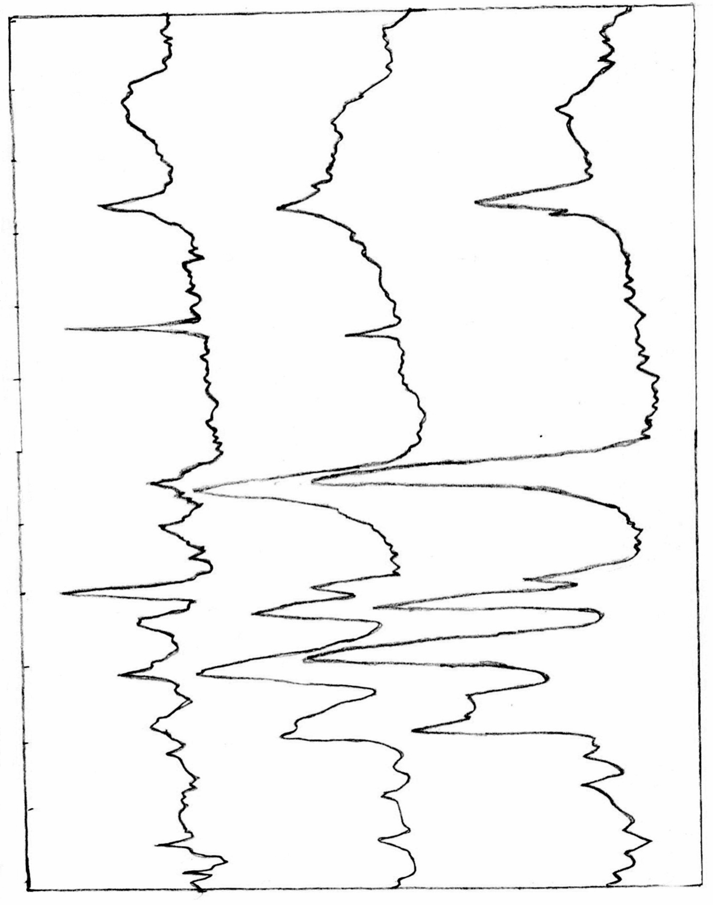
Fig (1) IR spectra of poly (AN – co – VAc ) , PAN and PVAc
4000 3600 3200 2800 2400 2000 1800 1600 1400 1200 1000 800 600 cm^{– 1}

460
Table (1) IR analysis data for determining the composition of poly (AN – co-VAc ) prepared from various initial monomer mixture
Copolymer | Mole Fraction of Monomer in Feed |  | IR Absorbance |  | Mole Fraction of Monomer in Copolymer
Copolymer | f₁ for AN | f₂ for VAc | AN | VAc | F₁ for AN | F₂ for VAc
Copolymer | f₁ for AN | f₂ for VAc | CN | CO | F₁ for AN | F₂ for VAc
A₁ | 0.8295 | 0.1704 | 0.94 | 0.13 | 0.9214 | 0.0785
A₂ | 0.73 | 0.2699 | 1.33 | 0.31 | 0.87439 | 0.1256
A₃ | 0.6187 | 0.38129 | 0.46 | 0.16 | 0.8234 | 0.1765
A₄ | 0.4933 | 0.50669 | 0.378 | 0.16 | 0.7931 | 0.2068
A₅ | 0.351 | 0.6489 | 0.183 | 0.14 | 0.67959 | 0.3204
A₆ | 0.1881 | 0.8118 | 0.108 | 0.24 | 0.422 | 0.5779

The following table shows the values of r₁ and r₂: -
Table (2) : copolymerization constants r₁ and r₂ for poly (AN-co-VAc)
(F-R) equation |  |  |  | (K-T) equation
1st |  | 2nd |  | 1st |  | 2nd
r1 | r2 | r1 | r2 | r1 | r2 | r1 | r2
2.2347 | 0.0303 | 2.5341 | 0.002 | 2.3889 | 0.1038 | 2.7087 | 0.0719

From the values of r₁ and r₂ it seems that (AN) is more reactive than

(VAc) , where the macroradical prefers to add (AN) more than (VAc) .

461
Table (3) Fineman – Ross and Kelen – TüdŐs equations parameters of poly (AN – co- VAc) in DMF at 75ºC when α_{1st} = 0.3852 α2nd = 0.3408
K-T Equation parameters | ξ | 2nd | 0.8398 | 0.7318 | 0.5943 | 0.3908 | 0.2636 | 0.1601
K-T Equation parameters | ξ | 1st | 0.8397 | 0.7317 | 0.5943 | 0.39079 | 0.2636 | 0.1602
K-T Equation parameters | η | 2nd | 2.11489 | 1.8578 | 1.5647 | 1.3381 | 0.681 | -0.1209
K-T Equation parameters | η | 1st | 1.8523 | 1.6128 | 1.34249 | 1.138 | 0.5463 | -0.1866
F-R Equation parameters | f(F-1)/F | 2nd | 4.5007 | 2.3608 | 1.3147 | 0.7487 | 0.3152 | -0.0491
F-R Equation parameters | f(F-1)/F | 1st | 4.4531 | 2.3161 | 1.2747 | 0.7196 | 0.2858 | -0.0856
F-R Equation parameters | f²/F | 2nd | 1.7873 | 0.9299 | 0.4994 | 0.2187 | 0.122 | 0.065
F-R Equation parameters | f²/F | 1st | 2.0188 | 1.0508 | 0.5643 | 0.2471 | 0.1379 | 0.0735
F=F₁/F₂ |  | 2nd | 13.2576 | 7.8663 | 5.2713 | 4.3316 | 2.3966 | 0.825
 |  | 1st | 11.7375 | 6.9617 | 4.6651 | 3.8351 | 2.121 | 0.7302
f=f₁/f₂ |  |  | 4.8679 | 2.7047 | 1.6226 | 0.9735 | 0.5409 | 0.2317
Copoly-mer |  |  | A₁ | A₂ | A₃ | A₄ | A₅ | A₆
462

The following figures show the Plots of Fineman – Ross and Kelen – TüdŐs equations for first and second method :
f(F-1)/F

f²/F

Fig (2) A plot of (F-R) ( 1st method ) for the copolymer
(AN – co – VAc)
η
ζ

Fig (3) A plot of (K-T) ( 1st method ) for the copolymer
(AN – co – VAc)
f²/F

f(F-1)/F

Fig (4) A plot of (F-R) ( 2nd method ) for the copolymer
(AN – co – VAc)
463

η
ζ

Fig (5) A plot of (K-T) ( 2nd method ) for the copolymer
(AN – co – VAc)

3-2 copolymerization behavior
We can predict the copolymer type (alternate, random or block) from

the product (r₁r₂) The values of this product are summarized in table (4 ) :-

Table (4) the values of (r₁r₂) for poly(AN-co-VAc)

r₁r₂
(F-R) equation |  | (K-T) equation
1st | 2nd | 1st | 2nd
0.0677 | 0.005 | 0.2479 | 0.1947

According to these values, the nature of the copolymer sequence of poly (AN-co-VAc) system is tending to alternate since the product r₁r₂ closer to zero, so there is a greater tendency for (AN) and (VAc) to alternate in the copolymer poly (AN-co-VAc) due to big differences in polarity between the two monomers which leads to a transition state stabilized by resonance
464

which prefer to add either of the two monomers by the same preference.
Depending on the experimental values of r_{AN} and r_{VA}, the values of Q and e for each monomer were calculated and found as follows: for AN, Q= 0.539, e = 1.67, for VA, Q= 0.0339, e= -0.189 these values are in good agreement with values in literature(8). The copolymer
composition (F₁) vs initial composition (f₁) (fig 6), shows no resemblance between the feed and the copolymer compositions. From the values of r_{AN} and r_{VA} one can deduce that AN is more reactive than VAc to go into copolymer.
This behavior can be explained on the basis that AN radical is more stable than VAc radical so the growing macroradical prefer to add to AN more than VAc.

f₁
F₁

Fig (6) The relation between mole fraction of acrylonitrile in feed (f₁) and in copolymer (F₁).

Finally, we can conclude that the two methods for reactivity ratio measurement used in the present work are good methods for prediction of copolymer composition and reactivity ratios.

465

References :
1- Baharmi, S. K; S. Bajaj, S.H. in High performance Acrylic Fibers, in J.M. S. Review of Macromolecular chemistry and physics Marcel Dekker Inc.; New York,1996,36,1-7 .
2- Herman F.M ; Norman G.G, “Encyclopedia of polymer Science and Technology”, vol. 6, John Wiley and Sons Inc., New York, (1967).
3- Herman F.M, Norman G.G, “Encyclopedia of Polymer Science and Technology”, vol. 1, John Wiley and Sons Inc., New York, (1985).
4- Herman F.M, Norman G.G, “Encyclopedia of polymer Science and Technology”, vol. 4, John Wiley and Sons Inc., New York, (1960).
5- Ajaib S. B., Rajeev K., Eur. Polym J.,2001, 37,1827 .
6- Nursel P., Nureltin S., Olgan G., Zakir M. O. Rzaev, Eur. Polym. J., 2001, 37, 2443 .
7- Gan L.H., Roshan G.D., GanY.Y., Eur. Polym. J.,1998, 34, 33 .
8- Brandrup J., Imnergut E.H., and Gruke E.A., "Polymer Handbook" wiley interscience, New York 1999.
466

