Synthesis of 2-[(2َ-Carboxy-4-nitrophenyl) azo]-4,5-diphenyl imidazole (CNPAI) and it's usage as an analytical reagent for the determination of Copper (II) and Ferric (III) ions

Abid Allah M. Ali  College of Education | Sadiq Jaafer Baqir  College of Science | Ahmed Ali Alkurymy  College of Science | Ahmed Saadon  College of Science
University of Kufa | University of Babylon

(NJC)

(Receivedon 21/5/2007) (Accepted for publication on 22/ 8 /2007)

Abstract
A study for the determination of Cu²⁺ and Fe³⁺ using 2-[(2َ-Carboxy-4-nitrophenyl) azo]-4,5-diphenyl imidazole (CNPAI)is performed, the wave length of maximum absorption for Copper (CNPAI) and ferric (CNPAI) complexes are 529 and 533 nm respectively.
After optimum condition were constructed, Beer's law was obeyed in the range (0.4-11) ppm for copper and (0.3-10) ppm for ferric ions, the linearity ( R² ) was (0.9996), (0.9995) while the molar absorpitivty (ε) was 9.5631 x 10⁴ L.mol⁻¹.cm⁻¹, 7.4414 x 10⁴ L.mol⁻¹.cm⁻¹ and Sandell sensitivity was 6.6 x 10⁻⁴ µg.cm⁻², 8.7 x 10⁻⁴ µg.cm⁻² for Cu(II) and Fe(III) complex respectively.
The stoichometry of metals to reagent were 1:1 for copper (CNPAI) and 1:2 for ferric (CNPAI) complexes, Precision and accuracy of the analytical procedure for copper and ferric were R.S.D % (1.02 , 1.56)% whereas (E_{rel.}, R_{e}) % were (-2, 98) %, (-3, 97) %, detection limit was (0.03, 0.056) ppm, the interferences of ions (CrO₄²⁻, Mn²⁺, Co²⁺, Ni²⁺, Zn²⁺, Cd²⁺ Ag⁺) were studied and masked by using appropriate masking agents.
الخلاصة
تمت دراسة وتقدير النحاس (II) والحديد (III) بواسطة الكاشف (CNPAI) , وقد وجد ان الامتصاص الاعظم للمعقدين كان عند الطول الموجي (529 nm) للنحاس و (533 nm) للحديد وبعد تحديد الظروف المثلى للمعقدين تم بناء منحني المعايره الذي اظهر مدى من الخطية عند مدى التركيز (0.4-11) جزء بالمليون للنحاس و (0.3-10) جزء بالمليون بالنسبة للحديد .
ان قيمة الخطية (R²) كانت 0.9996 و0.9995 وقيمة معامل الامتصاص المولاري هي 9.5631 x ⁴10 و 7.4414 x ⁴10 للنحاس والحديد على التوالي.
تم تحديد نسبة الفلز الى الكاشف حيث وجد انها تساوي 1:1 بالنسبة للنحاس و 2:1 بالنسبة للحديد كما تم تحديد دقة وضبط الطريقة التحليلية حيث وجد ان قيمة الانحراف القياسي R.S.D% , (1.02 و 1.56)% ,اما قيم الخطأ النسبي( E_{rel.} ) و الاستعادية ( R_{e} ) فكانت للنحاس (-2، 98) % وللحديد (-3، 97) % ، اما قيم حد الكشف (0.030) و (0.056) جزء بالمليون لكل من النحاس والحديد, درس تاثير الايونات المتداخلة CrO₄²⁻, Mn²⁺, Co²⁺, Ni²⁺, Zn²⁺, Cd²⁺ , Ag⁺ وتم تحديد عوامل الحجب الملائمة.

Introduction

Azo-dyes with the heterocyclic diazo-component form coloured complexes with many metal ions in solution⁽¹⁾.Great number of the spectrophotometric methods based on these reactions were developed and used in analytical chemistry⁽²⁾.
In recent years, a lot of researchers deal with the investigations of the mechanism of azo-dyes adsorption on to the solid supports, such as ion-exchangers, PVC, fabrics, silica gel or cellulose⁽³⁾.The reactions between the immobilized reagents and metal ions in solution have been widely investigated, because of their potentially use in the design of chemical optical sensors^{(4,5)}.
The solid phase derivative spectrophotometry using 1-(2-pyridylazo)-2-naphthol (PAN) in Dowex 50W X₂-100 resin was used for the quantitative determination of copper⁽⁶⁾.

Heterocyclic azo dyes are often react with the metal ions as a tridentate ligands forming coordinative bonds with the heterocyclic moiety, -OH or –COOH group and azo group⁽⁷⁾.
Many azo compounds are used to determine some metals such as copper and iron^{(8-15).}
Copper is an element that present naturally in many foods, including vegetables, legumes, nuts, grains and fruits, it is a nutritionally essential metal and is widely distributed in nature⁽¹⁶⁾.
It is an essential element not only for life of mammals but also for plants and lower forms of organism, on the other hand it is used algaeeide and herbicide^{(17,18)}.
At low levels copper is an essential element in the diet, whereas at higher concentrations it is toxic, because of its toxicity and cumulative effect in the body⁽¹⁹⁾.
Copper presents a health problem when it occur in food or water even in minute amounts, hence there is a great need to develop a simple, sensitive, selective and inexpensive methods for the determination of copper in environmental biological and soil samples for continuous monitoring to establish the levels of copper in environmental and biological matrices^{(20,21)}.
Iron has also a similar importance nearly like copper a number of sensitive analytical methods are available for the determination of these metals, some of the most commonly used methods are spectrophotometric⁽²²⁻²⁴⁾.
Experimental
Apparatus
A UV-Probe model (UV-1650) spectrophotometer (Schimadzu-Japan) and spectronic-21 model U.V-Visible single beam with 1 cm cells Bausch and Lomb (USA) was used for all absorbance measurements, pH measurements were made with Knick-Digital pH meter (England), Digital Balance, Sartorius, (BP 3015- Germany) and Water bath, Gesellschaft Fur Labortechnik (Germany) , FTIR 8400S Schimadzu (Japan) was used to get I.R spectrums and CHN elemental analyzer 1108 were used.
Reagents
All chemicals used were of analytical – grade reagent unless other wise stated, all solution were prepared using deionized water.
Synthesis of the reagent (CNPAI)
2-[(2َ-Carboxy-4-nitrophenyl) azo]-4,5-diphenyl imidazole (CNPAI) was prepared⁽²⁵⁾ by dissolving (0.9100g, 5mmol) of 5-nitroanthranilic acid in 30 ml of water and 3 ml of concentrated hydrochloric acid.
The filtered solution was cooled to 0ºc, treated with 8 ml of aqueous (1 M) sodium nitrite drop wise, and stirred for 30 min.
A 4,5-diphenyl imidazole (1.1000g, 5mmol) was dissolved in 100 ml of pyridine, and 5 ml of 10% sodium hydroxide and 25 ml of 10% sodium carbonate were added, the diazonium solution prepared above was then added drop wise for coupling, after the mixture had been stirred for an hour at 5ºc, it was acidified with dilute hydrochloric acid to pH =5.
The precipitate was filtered off, and recrystallized twice from hot ethanol, and then dried in the oven at 60ºc for several hours, the yield was (54%) (2.2300g) of reddish brown powder (m.p = 112-114 ºc), with the formula C₂₂H₁₅N₅O₄ with the theoritcal value C= 63.92%, H= 3.63%, N= 16.94% while the element analysis gave the value of C= 63.58%, H= 3.45% and N= 16.78%.
Standard Copper & Ferric solutions
Solution of Cu²⁺ and Fe³⁺ (100 ppm) were prepared by dissolving (0.0268 g) of CuCl₂.2H₂O and (0.0290g) of FeCl₃ in 100 ml distilled water, working solution were prepared freshly by appropriate dilution of the stock solution.
CNPAI Solution
A solution of (1x10⁻³ M) was prepared by dissolving (0.0413g) of pure reagent in 100 ml of absolute ethanol.
General procedure
Into a 5 ml calibrated flask, transfer (0.5 ml) of sample solution containing not more than 2 ppm and 1.5 ppm of the ion (Cu²⁺ or Fe³⁺) and (0.5 ml) of 1x10⁻⁴ M ethanolic reagent (CNPAI) solution dilute to volume with deionized water, mix well and after 10 minutes measure the absorbance at 529 nm for Cu²⁺ and 533 nm for Fe³⁺ in a 1 cm cell against a blank solution prepared in a similar way but without the presence of the ion under test.
Results & Discussion
Physical and chemical properties of CNPAI
The reagent is a reddish brown powder which is sparingly soluble in water. It has a good solubility in ethanol, methanol, acetone, chloroform and ether.
The color of the solution is red in alkaline medium, yellow in weakly and strong acidic solution.
Effect of pH
The effect of acidity on the absorbance value of the complex was investigated by changing the pH value of the solution and the results are shown in, figures (1&2).

Fig.(1) Effect of pH on the absorbance of copper complex at room temp.
Fig.(2) Effect of pH on the absorbance of ferric complex at room temp.

Figures (1&2) demonstrated that the best absorbance of Cu(II) CNPAI system is in the range (5.5-6.5) and pH (6) was adopted as optimum while for Fe(III) CNPAI system is in the range (7-8) and the pH (7.5) was adopted as optimum pH.
Stability of the chromogenic system with the time
Stability of the chromogenic system with the time is shown in figures (3&4).

Fig.(3) Effect of time on the absorbance of copper complex at room temp.

Fig.(4) Effect of time on the absorbance of ferric complex at room temp.

Figs. (3&4) show that the color of the complex system reaches it's maximum value of absorbance from (5) min. and remain stable for about (24) hours.

Effect of temperature.
The effect of temperature on the absorbance of the two complexes; Cu(II)-CNPAI and Fe(III)-CNPAI was studied figures (5&6) show this effect.

515
Fig.(5) Effect of temperature on the absorbance of copper complex.

Fig.(6) Effect of temperature on the absorbance of ferric complex.

The study was performed at temperatures at the range (10-60) ºc, and the maximum absorption was obtained at 20 ºc for Cu(II)-CNPAI and 10 ºc for Fe(III)-CNPAI complexes, the decrease in absorbance value may be is due to the dissociation of the complex.
516

Composition of the complexes
The composition of the two complexes was determined by Job's⁽²⁶⁾ method of continuous variation and molar ratio⁽²⁷⁾ methods which were applied to ascertain the stoichiometric compositin of each of the complexes as shown in figures (7-10).

Fig.(7) continuous variation method for Cu(II)-CNPAI complex at optimum conditions.
Fig.(8) molar ratio method for Cu(II)-CNPAI complex at optimum condition.
517

Fig.(9) continuous variation method for Fe(III)-CNPAI complex at optimum conditions.
Fig.(10) molar ratio method for Fe(III)-CNPAI complex at optimum conditions.

From the results of continuous variation and molar ratio methods show in figures (7-10), the ratio between copper to CNPAI is (1:1), and between ferric to CNPAI is (1:2) and the stability constant⁽²⁸⁾ (K_{sta.}) was (4.13x10⁷) L.mol⁻¹ and 2.61x10⁸ L².mol⁻²) for Cu(II)-CNPAI and Fe(III)- CNPAI complexes, figures (11,12) shows the proposed composition of the two complexes
518

Fig. (11) the composition of Cu-CNPIA complex

Fig. (12) the composition of Fe-CNPIA complex

Calibration Graphs
Calibration graphs for Cu (II) and Fe (III) complexes were obtained by following the proposed procedure under the optimum conditions.
These are shown in figures (13&14).

519
Figure (13) calibration graph of Cu (II) ion.

Figure (14) calibration graph of Fe (III) ion.

The results indicated that Beer's law was obeyed over the concentration range (0.4-11) ppm for Cu (II) and (0.3-10) ppm for Fe (III), linearity (R²) for copper was (0.9996) and ferric was (0.9995) respectively.
520
The molar absorption coefficient and Sandell's sensitivity were calculated to be (9.5631x10⁴), (6.6x10⁻⁴) for Cu (II) and (7.4414x10⁴), (7.6x10⁻⁴) for Fe (III).
The detection limit was (0.03) ppm for Cu (II) and (0.056) ppm for Fe (III).
Precision and Accuracy
The precision of the present analytical method was evaluated by determining different concentrations of Cu (II) and Fe (III) each analyzed (5 times), the relative standard deviation R.S.D % was (1.02) and (1.56) respectively indicating that this method is highly precise and reproducible.
The reliability of the method was tested by recovery ( Re %) were (-2,98) for Cu (II) and (-3, 97) for Fe (III).
The precision and accuracy of the method were found to be excellent.
Interferences
The selectivity of copper (CNPAI) and ferric (CNPAI) complexes is tested by measuring the absorbance of complex of 2 ppm of Cu (II) and 1.5 ppm Fe (III) at optimum conditions in presence of different foreign ions of 5x10⁻⁴ M concentration which are able to form complexes with (CNPAI)⁽²⁹⁾.

The extent of reaction of these ions is shown in table (1)

Table (1) effect of interference ions

Interference ions  5x10⁻⁴ M | Interference %
Interference ions  5x10⁻⁴ M | Cu²⁺-(CNPAI) | Fe³⁺- (CNPAI)
Cd²⁺ | +3.30 | +2.84
Co²⁺ | +6.45 | +5.23
Ni²⁺ | +7.72 | +2.63
Zn²⁺ | +5.49 | +3.05
Mn²⁺ | +1.22 | +4.13
Ag¹⁺ | +1.43 | +0.85
CrO₄²⁻ | -1.52 | -2.45
Fe³⁺ | +5.25 | -------
Cu²⁺ | ------- | +8.12

The criterion for interference ⁽³⁰⁾ was an absorbance value varying by more than 5% from the expected value for copper (II) or iron (III) complex so there is an obvious interference of Co²⁺, Ni²⁺, Zn²⁺ and Fe³⁺ with Cu-(CNPAI) complex while Fe³⁺-(CNPAI) complex is effected by Co²⁺ and Cu²⁺ interference.
521
Effect of masking agents⁽³¹⁾
The effect of masking agents was studied to increase the selectivity of complexes, this effect is shown in table (2).

Table (2) the effect of masking agents
Masking agents 1x10⁻² (M) | Absorbance of 1x10⁻⁴ M
Masking agents 1x10⁻² (M) | Cu (II)-CNPAI | Fe (III) -CNPAI
Complex without any addition | 0.153 | 0.038
Tartaric acid | 0.103 | 0.009
Oxalic acid | 0.082 | 0.015
Citric acid | 0.108 | 0.049
Ascorbic acid | 0.075 | 0.020

The results shown in table (2) indicates that ascorbic acid and oxalic acid is better masking agents for copper complex while tartaric acid and oxalic acid are better for ferric complex, other masking agents are less effect comparatively.
Absorption spectra
The absorption spectra of the two complexes and the ligand are shown in figure (15) under optimum conditions

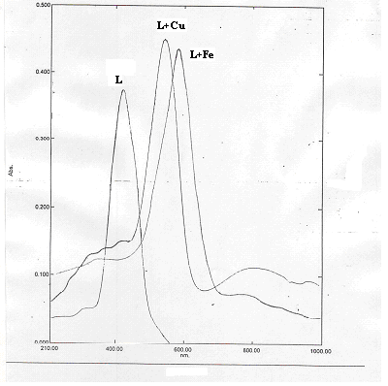
fig.(15) absorption spectra of the two complexes and the ligind.

522

Absorption spectra show that the λ max of absorption of the reagent (CNPAI) is obvious at 425 nm, Cu (CNPAI) complex at 529 nm and Fe (CNPAI) complex at 533 nm, this new λ max mean red shift in λ max of complexes.

FTIR spectrum of (CNPAI) reagent
The structure of CNPAI reagent was demonstrated by using FTIR technique using KBr disc, fig.(16) show the FTIR spectrum.

523

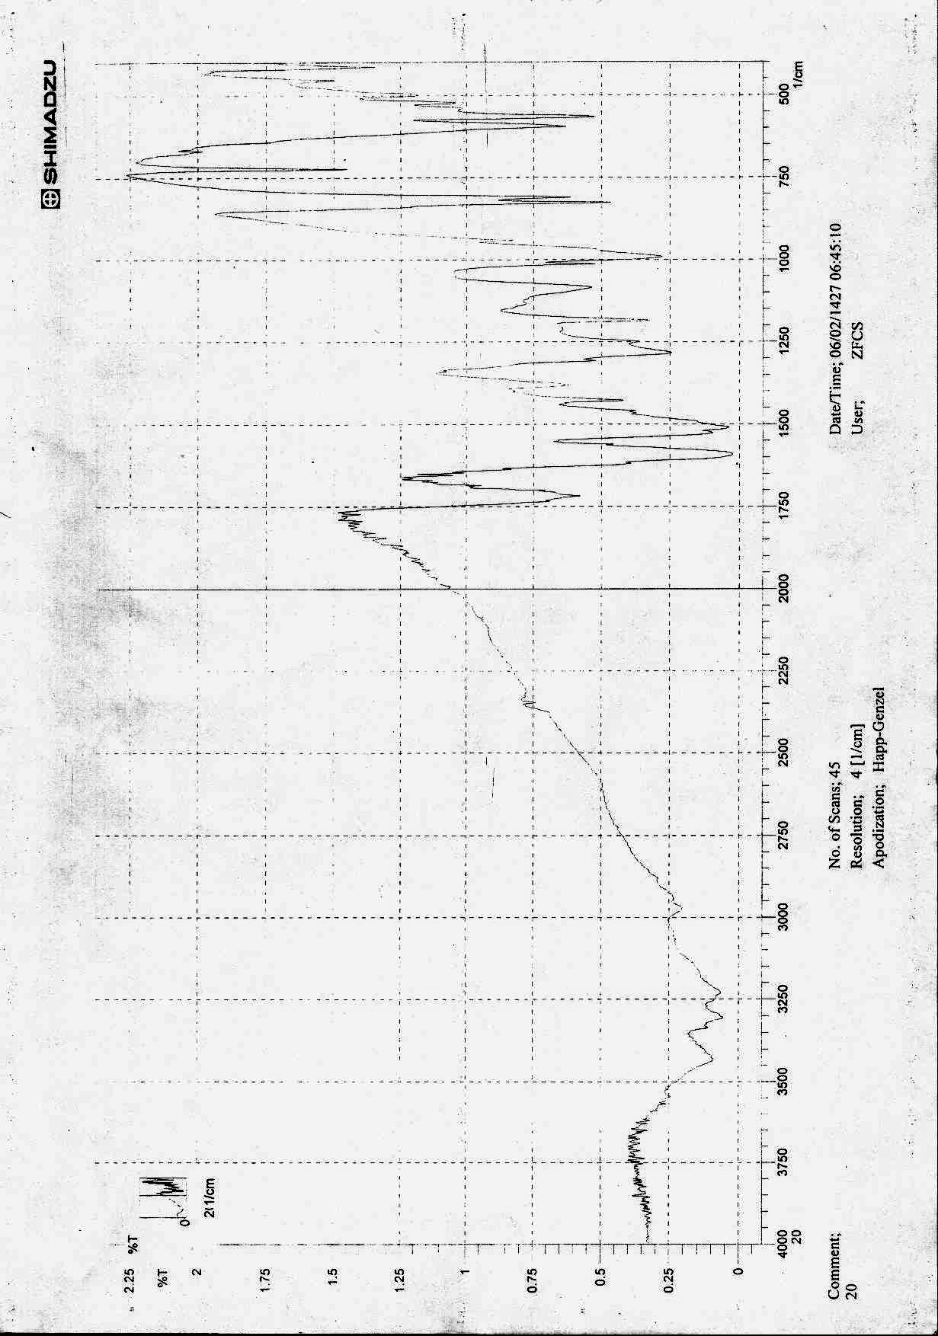
C= O
C= N
N= N
OH
N-H

Figure (16) FTIR spectrum of (CNPAI).

524

The infrared spectrum show in figure (14) give an evidence for the formation of the reagent (CNPAI) where the broad absorption band at (3350-3450) cm⁻¹ referred to the stretching vibration ν (N-H) of the imidazol ring ⁽³²⁾
A weak band appeard at (2980) cm⁻¹ due to ν (C-H), the band at (1690) cm⁻¹ referred to the ν (COOH) group, the band at (1590) cm⁻¹ referred to the ν (C=N) stretching of the heterocyclic imidazol ring, at (1500) cm⁻¹ the stretching vibration ν (N=N) is obvious⁽³³⁾.
Many bands appeared at (1050-1400) cm⁻¹ belong to the stretching vibration of ν (C-N=N-C) also the band at (1000) cm⁻¹ is for ν (C-N)⁽³⁴⁾.
The two mono substituted aromatic rings on the imidazole ring are indicated by the absorption at (690) and (760) cm⁻¹.
Conclusions
- A new, simple, speed and sensitive method to determination of copper and ferric ions.
- Stability constants refer to the high stability of two complexes.
- These two complexes under optimum conditions are stable to more than 24 hour.

Statistical Study
  - Correlation factor
Correlation factor between Cu and Fe was show in table (3)

Table (3) Correlation factor between Cu and Fe
 |  | Cu (II) | Fe (III)
Cu | Pearson Correlation | 1 | 0.997**
 | Sig. (2-tailed) | 0 | 0.001
 | N | 6 | 6
Fe | Pearson Correlation | 0.997** | 1
 | Sig. (2-tailed) | 0 | 0.001
 | N | 6 | 6
** Correlation is significant at the 0.01 level (2-tailed).
  - Regression
The regression model of Cu was show in histogram (1) and figure (17)

525

Histogram (1) dependant variable (Cu)

Figure (17) Normal P-P plot of regression standardized residual dependent variable (Cu)
526

The regression model of Fe was show in histogram (2) and figure (16)
Histogram (2) dependant variable (Fe)

Figure (18) Normal P-P plot of regression standardized residual dependent variable (Fe)

527

References
- S. B. Savvin, V. P. Dedkova, O. P. Shvoeva, Russ. Chem. Rev. 2000, 69, 187.
- S. A. Morozko, V. M. Ivanov, Zh.Anal.Khim. 1996, 51, 631.
- S. A. Morozko, V. M. Ivanov, Zh.Anal.Khim. 1995, 50, 629.
- B. Kuswandi, A. A. Vaughan, R. Narayanaswamy, Anal. Sci. 2001, 17, 181.
- B. Kuswandi, R. Narayanaswamy, Analytical Letters 1999, 32, 649.
- M. L. Toral, N. Lara, J. Narvaes & P. Rich, J.Chil. Chem. Soc.,2004 ,49 (2), 163.
- J. Savice, & V. Vasic, Acta. Chem. Slov., 2006, 53, 36.
- L. Ferreira, A. queiroz, J. Assis, M. Korn & S. Gosta, J. Braz. Chem. Soc., 1997, 8(6), 621.
- L. S. Jensen , J Nutr 1975, 105 (6), 769.
- M. Thakur & M. Kdeb, Talanta; 1999 , 49, 561.
- Y. Zhu, J. Liu, P. Liu & X. Zhou, Mikrochem. Acta, 1993, 112, 127.
- K. Ohshita, H. Wada & G. Nakagawa, Anal.chem. Acta., 1985, 176, 411.
- A.A. Jewad, K.H. Kadhim & A.N. Al-Sharefy, Nat. J. Chem., 2005, 19, 331.
- N. A. Fakhri, S.B. Dekran, H.A. Saleh & A.H. Alkadhumi, J. of College of Edu., University of Salahaddin, 1989, 1, 19.
- M. Zenki, Y. Lwadou, T. Yokoyhama, Anal- Science, 2002, 18, 1077.
- P. Richter, M.I. Toral, A.E. Tapia & E.Fuenzalida, Talanta, 1997, 122, 1045.
- F.W. Oehme, Toxicity of Heavy Metals in the Environment , Marcel Dekker, New York ,1978 .
- J.M. Moor, Inorganic Contaminants of Surface Water, Springer Verlag, New York, 1991.
- S.B. Sonowale, Y.V. Ghalsasi & A.P. Argekar, The Jap. Soc. Anal. Chem., 2001, 17, 285.
- M.N. Khan & A. Sarwar, Anal. Science, 2001, 17(10), 1195.
- M.J. Ahmed, I. Jahan & S. Bano, Anal. Science, 2002, 18(7), 805.
- J.F. Vanstaden & A. Botha, Talanta, 1999 , 49, 1099.
- S. Nohut, S. Karaboecek, S. Guener & Y. Goek, J. Pharm. Biomed. Anal., 1999, 20, 309.
- Y. Zhou & H. Jiang, Fenxi Huaxue, 1992, 20, 1228.
- S. Shibata, M. Furukawa & R. Nakaskima, Analytical Chemical Acta, 1976, 81, 131.
- P. Jop, Ann. Chem, (Paris), 1928, 9, 113.
- J.A. Yoe & A.L. Jones, Chem. Anal. Ed., 1944, 11, 16.
- W.C. Vosburgh & G.R. Cooper, J. Am. Chem. Soc., 1941, 63, 437.
- H. Shuker, M.Sc. Thesis, Mousl University, 1992 .
- C.B. Ojeda, A.G. Detorres, F.S. Rojas & J.M. Canopavon, Analyst, 1987 , 112, 1499.
- W. Abd Al-Azezz, Ph.D Thesis, Mosul University, 1990.
- F.N. Al-Obaidi, Ph.D Thesis, University College of North Wales, Bager, 1981.
- P. Byabartta, S. Pal, T. Misra, C. Sinha, F. Liao, K.P. Selvan & T.H. Lu, J. Coord. Chem., 2002, 55, 479.
- C. Preased & S. Benerji, J. Inorg. Nucl. Chem.,1976,83, 1387.
- D.M. White & J. Sonnenberg, J. Org. Chem.,1924, 29, 1942.

528

