Synthesis and antibacterial evaluation of Some Pyrano-1,3--
Oxazine Derivatives

M.S. AI-Ajely | H. A. Busheer | A. Abdul Ghnni
College of Education | College of Agriculture and forestry | College of Veterinary
Mosul University, Mosul, Iraq

(NJC)

(Received on 17/10/2006) (Accepted for publication on 24/4/2007)

Abstract
Some dipeptide amide and amino derivatives of 7-chloro-4,5-dioxopyrano [3,4-e]-l,3-oxazine, compounds (2a-d) and (3a-e) respectively have been synthesized and studied against five species of bacteria in vitro. A significant activity against staph. Aureus and Bacelus Subtilis were observed by the above derivatives at concentration ranging from (0.1-10 mg./ml.) and remarkable activity was exhibited by 2-(N-glycyl glycine amido)-7-chloro-4,5-dioxopyrano [3,4-e]-l,3-oxazine (2a). Other compounds showed no significant activities. The I.R. and NMR spectral data of the synthesized compounds were also discussed and are included.

الخلاصة
تم تحضير بعض مشتقات 1-3 بايرانو اوكسازين وهي تمثل الببتيدات الثنائية وبعض الامينات وهي المركبات (a-d2) و (a-e3) على التوالي وتمت دراسة هذه المركبات ضد بعض انواع البكترياBacelas Sabtilis, Staph Auroces)) وقد كانت هناك فعالية ملحوظة لهذه المركبات ضد انواع البكتريا اعلاه ، كما وقد درست هذه المركبات المحضرة بالطرق الطيفيةIR و.NMR .

Introduction
Pyrano-1,3-oxazines were first investigated by Davis and Elvidge¹ .
They found that the reaction of malonyl chloride with nitrile compounds afforded 2-substituted-7-chloro-4,5-dioxopyrano [3,4-e]-1,3-oxazines.
Butt, Elvidge and Foster² found that the reaction between malonyl chloride and isocynates gave 3- substituted-7-chloro-3,4-dihydro-2,4-dioxo-2H,5H-pyrano[3,4-e]-1,3-oxazines.Al-Rawi, Elvidge and AL-Ajely^{3,4}found that a bicyclic heterocycle 7-chloro-2-allyl(or benzyl) mercapto-4,5-dioxo-pyrano [3,4-e]-1,3-oxazines were formed upon treating malonyl chloride with allyl or benzyl thiocyanates.
Some inveatigators⁵ prepared 8-ethoxy-3-phenthyl-3,4-dihydro-2H-1,3-oxazine and 8-methoxy-3-(3,4-dimethoxy phenethyl)-3,4-dihydro-2H-1,3-benzoxazines and were found to have antimicrobial activities.
In 1995,Liu.Jingping⁶ has prepared 3,4-dihydro-1,3-benz-oxazines by thermal reaction of paraformaldehyde, phenol and amine in the absence of solvent During the same year, lactam ester comprising a lactam-contaning moiety linked by an ester group to the3-carboxy group of a quinolone moiety which is 1,3-benzoxazine derivatives was studied and found to have antimicrobial activity⁷ .
In 2000 the synthesis and stereochemistry of some new spiro-1,2-perhydrooxazines were investigated by Muntean and his co-workers⁸
P.Luzr, AL-Harrasie and co-workers⁹ investigated the synthesis of dihydroxy-substituted1,2-oxazines from distreoselective hydrogenation of 3,6-dihydro-2H-1,2-oxazine.Cycloaddition reaction of 2-azadienes derived from beta amino acids with electron-rich and electron deficient alkene oxazine derivatives were also studied by Palacios and his co-workers¹⁰.
Microwave reactions of 2-amino-2-methyl-1-propanol or 2-amino ethanol hydrochloride with N-acylbenzotriazoles in the presence of SOC produced 2-substituted-2-oxazolines and 5,6- dihydro-4H-1,3-oxazines as a novel synthetic route reaction¹¹.
Amines and amino acid derivatives of pyrano-1,3-oxazine have found versatile applications in the biological fields as antibacterial and cancer screening agents ¹²⁻¹⁵. They were also found to have antifungil action and used as herbicides ¹⁶⁻¹⁸. The thio derivatives of pyrano-1,3-benzoxazine have also showed inflammantory and antipyretic agents ¹⁹.
Novel series of pyrazolo [5,1-b]-1,3-oxazines were recently synthesized²⁰ and evaluated in vitro for their ability to inhibit cyclooxygenase-1-(COX-1) and cyclooxygenase-2-(COX-2) in human whole blood(HWB).
In the present work the thio derivatives of pyrano -1,3 - oxazine was allowed to react with either amines or peptide derivatives giving new amino or peptide derivatives of pyrano 1,3-oxazine in an attempt to get a combination biological action of the synthesized compounds depending on the fact that these amines and peptides themselves were studied alone and found to have certain types of biological activity ²¹⁻²⁷. Therefore, we are presenting here the synthesis and antibacterial evaluation of some new pyrano-1,3-oxazine derivatives .

Experimental
Uncorrected melting points were determined using electro-thermal type- 9300 melting point apparatus. The I.R. spectra were recorded by pye-unicam SP 1100 spectrophotometer as KBr disc. ¹H NMR Spectra were measured with Hitachi 60 MHz spectro-meter. 7-chloro-2-benzyl thio- 4,5- dioxo pyrano [3,4-e] 1,3-oxazine was prepared according to the reported procedure ³, 1,2,4-Triazole and 3-mercapto- 1,2,4-Triazole were prepared following literature reported procedure ²⁸.

Preparation of chloroacetyl chloride
A mixture of (0.01 mole) of chloroacetic acid and (0.01 mole) or thionyl chloride and (0.01) triethyl amine is healed on a water bath (30-40⁰c) until no more HCl is evolved.The resulted triethyl amine hydrochloride is filtered off and the product isused without further purifaction.

Preparation of chloroacetyl amino acid ester (ii)
A solution of (0.02 mole) of amino acid ester compound(i) in 100 ml of dichloro methane is added to a (0.01 mole) of chloroacetyl chloride with stirring. After the addition has been completed the reaction mixture was refluxed for 1 hr cooled and washed with sodium bicarbonate solution (5%) then with water and dried (92 %yield).

Preparation of dipeptide amides²⁹(1_{a-d})
A stream of dry ammonia gas was passed through a solution made by dissolving (0.01 mole) of chloroacetyl amino acid ester in 100 ml of dichloro methane. the ammonium chloride was filtered off, the solvent was evaporated under reduced pressure giving dipeptide amide, Physical and Spectral data are illustrated in (Table 1).

Reaction of 2-Benzyl thio-7-chloro-4,5-dioxopyrano [3,4-e]-1,3-oxazine (RSR) with dipeptide amide and amines
In a round bottom flask fitted with refluxed condenser and dropping funnel, was placed (0.01 mole) of compound (RSR) in 40ml of dry chloroform. The reaction was carried out by drop-wise addition of amide or amine (0.01 mole) in 20 ml of dry chloroform through dropping funnel with continuous stirring. After completing the addition, the reaction mixture was refluxed for 6 hrs. Cooled and the solvent was removed in vacua. The solid product was recrystallized from ethanol. The spectral data of the synthesized compounds (2a-d) and (3a-e) together with their melting points are presented in (Table 2).

The Biological Methods
1. Bacteria
The bacteria species used are listed in (Table 3). All strains were obtained from biology department, College of Veterinary, Mosul University. They are grown up to the stationary phase in a nutrient bath at 37ºC and a sample of 0.5 ml of each bacteria was spread over a surface of a nutrient agar plate³⁰.

2. Antibacterial Assay
Discs of filter paper (6 mm diameter) were sterilized at 140 ºC for 1 hr. and impregnated with 1 ml. of stock solution (10 mg./ml., 1 mg./ml., 0.1,0.01 mg./ml) of each compound and then dried DMSO (Dimethyl Sulfoxide) was used as a solvent for compounds (2a,c,3b,e), (Scheme 1). The same solvent was used for antibiotics. (Table 3). Blank paper discs of DMSO was used as control. The inoculated plates were incubated at 37 ºC for 24 hrs., and the inhibition zones (mm) were measured ³¹ .In all experiments, the mean of each triplicate was measured³².

Results and Discussion
Dipeptide amide (la-d) were prepared from the reaction of chloro acetyl chloride with appropriate amino acid ester (Scheme) and their melting points together with spectral data are illustrated in (Table 1). The above compounds were condensed with 7-chloro-2-benzyl thio-4,5-dioxopyrano [3,4-e]-l,3-oxazine compound (RSR), Scheme (1) giving new derivatives of 1,3-oxazine (2a-d). The same compound (RSR) was also condensed with thio-semicarbazide, 3-mercapto-l,2,4-triazole, 1,2,4-triazole and chloro derivatives of ethyl amine giving new amino derivatives of 1,3-oxazine compounds (3a-e). The compounds have been purified by the successive crystallization from proper solvents.
The spectral data of the above two-series of substituted 1,3-oxazine were given in (Table 2), their characterizing IR absorption bands together with their chemical shifts are presented for both series of compounds (amino and dipeptide
amide) . The antibacterial
activity data of four compounds representing both 1,3-oxazine derivatives against five species of bacteria are listed in (Table 3). The antibiotics used here (Erythromycin and chloram-phenicol), the data presented here showed that the tested compounds had activity against gram +ve and nearly nil effect against gram-ve type bacteria.
Compound (2a and 2c) showed a significant activity against Staph, Areus and B. Sublilis. Furthermore compound (2a) showed a remarkable activity against Staph, Areus and B. Sublilis at concentration ranging from (0.01-10 mg./ml.) in comparison with the antibiotic used (Table 3). Compounds (3b, 2c) showed lower activity against the above types of bacteria, whereas compound (3e) had no activity against all bacteria used.

Table (1): IR, NMR, spectral data for dipeptide amides (Comp. 1a-d)
Comp  No. | m.p.  ºC | I.R. cm⁻¹ |  |  |  | ¹H NMR ppm  solvent DMSO- d₆
Comp  No. | m.p.  ºC | C=O NH def. |  | NH | OH | ¹H NMR ppm  solvent DMSO- d₆
Comp  No. | m.p.  ºC | amide I | amide II | NH | OH | ¹H NMR ppm  solvent DMSO- d₆
1a | 52-54 | 1675  (s) | 1640  (m) | 3200  (b) | - | 3.6 (s, 4H)2CH₂, 4.1(b, 2H) NH₂,  8.5(b, 3H) CONH, CONH₂.
1b | 118-120 | 1680  (s) | 1650  (m) | 3250  (b) | - | 2.9 (d, 2H)CH₂Ph, 4.5(m, 3H)CH,CH2,  4.9(b, 2H)NH₂, 7-7.3 (m, 5H)Ph,  7.9 (b, 3H)CONH,CONH₂.
1c | 215-217 | 1670  (s) | 1635  (m) | 3300  (b) | 3400  (b) | 2.7 (d, 2H)CH₂Ph, 3.3 (m, 3H)CH,CH₂,  3.8 (b, 2H)NH₂,OH 6.4-6.7 (m, 4H)Ph,  7.6 (b, 3H)CONH,CONH₂.
1d | Oily | 1680  (s) | 1640  (m) | 3200  (b) | - | 1.2 (m, 2H)CH₂, 2 (m, 5H)CH₂,CH₃,  2.6 (m, 3H)CH,CH₂, 4 (b, 2H)NH₂,  4 (b, 3H)NH₂, 7.2 (b, 3H)CONH,CO -NH₂.

Table (2): IR, NMR, spectral data for compounds (2a-d and 3a-e)
Comp.  No. | m.p.  ºC | I.R. cm⁻¹ |  |  |  |  |  |  | ¹H NMR ppm  solvent DMSO- d₆
Comp.  No. | m.p.  ºC | C=N | C=C | 4C=O | 5C=O | C=O , NH def |  | NH | ¹H NMR ppm  solvent DMSO- d₆
 |  |  |  |  |  | amide I | amide II | NH | ¹H NMR ppm  solvent DMSO- d₆
2a | 136-138 | 1585  (m) | 1630  (s) | 1710  (b) | 1755  (s) | 1680  (m) | 1650  (m) | 3300  (b) | 3.9(s,4H)2CH₂, 4.4(b,1H)NH, 6.2(s,1H) =CH,  7(b,3H)CONH,CONH₂
2b | 287-290 | 1600  (s) | 1630  (m) | 1720  (s) | 1750  (w) | 1680  (s) | 1650  (s) | 3350  (b) | 2.3 (d,2H) CH₂Ph, 3.2(m, 3H) CH,CH₂, 4 (b, 1H) NH,  5.9 (s, 1H) =CH,  7 (m, 5H) Ph, 7.7 (b, 3H) CONH,CONH₂
2c | 142-144 | 1590  (s) | 1640  (m) | 1730  (s) | 1765  (m) | 1680  (m) | 1660  (s) | 3300  (b)  (OH)3500  (b) | 2.3 (d, 2H) CH₂Ph, 3.5 (m, 3H) CH,CH₂, 3.9 (b, 1H)NH, 6.1 (s, 1H) =CH, 6.8-7.1 (m, 4H) Ph, 7.5(b, 3H) CONH,CONH₂
2d | 134-137 | 1600  (m) | 1635  (s) | 1720  (w) | 1760  (m) | 1685  (m) | 1660  (s) | 3320  (b) | 1.2 (m, 2H) CH₂, 2(m, 5H) CH₂,CH₃, 4(m, 3H) CH,CH₂, 4.6 (b, 1H) NH,  6.1 (s, lH) =CH, 7.2(b, 3H) CONH,CONH₂
3a | 255 dec. | 1600  (w) | 1635  (m) | 1720  (m) | 1750  (w) | - |  | 3470  (b) | 3.4 (b, 1H)NH,  6.1 (s, 1H) =CH, 8.3(b, 3H) CONH,CONH₂
3b | 88-90 | 1610  (s) | 1640  (m) | 1715  (s) | 1750  (s) | - |  | (SH)2580  (b) | 4.9(b, lH)SH, 5.3(s, 1H)=CH, 5.8 (s, lH) =CH
3c | 117-120 | 1590  (s) | 1630  (m) | 1715  (s) | 1750  (s) | - |  | - | 5.5 (s, 2H) 2 =CH, 6.1 (s, 1H) =CH
3d | 164-166 | 1605  (w) | 1630  (s) | 1720  (m) | 1765  (m) | - |  | 3290  (b) | 2.1(b,1H)NH, 3.1 (t, 2H)CH₂, 3.3(t,2H)CH₂, 5.8(s, 1H) =CH
3e | 252 dec. | 1590  (w) | 1650  (s) | 1710  (s) | 1750  (m) | - |  | - | 3.1 (t, 4H) 2CH₂, 3.6(t, 4H) 2CH₂, 5.8 (s, 1H) =CH

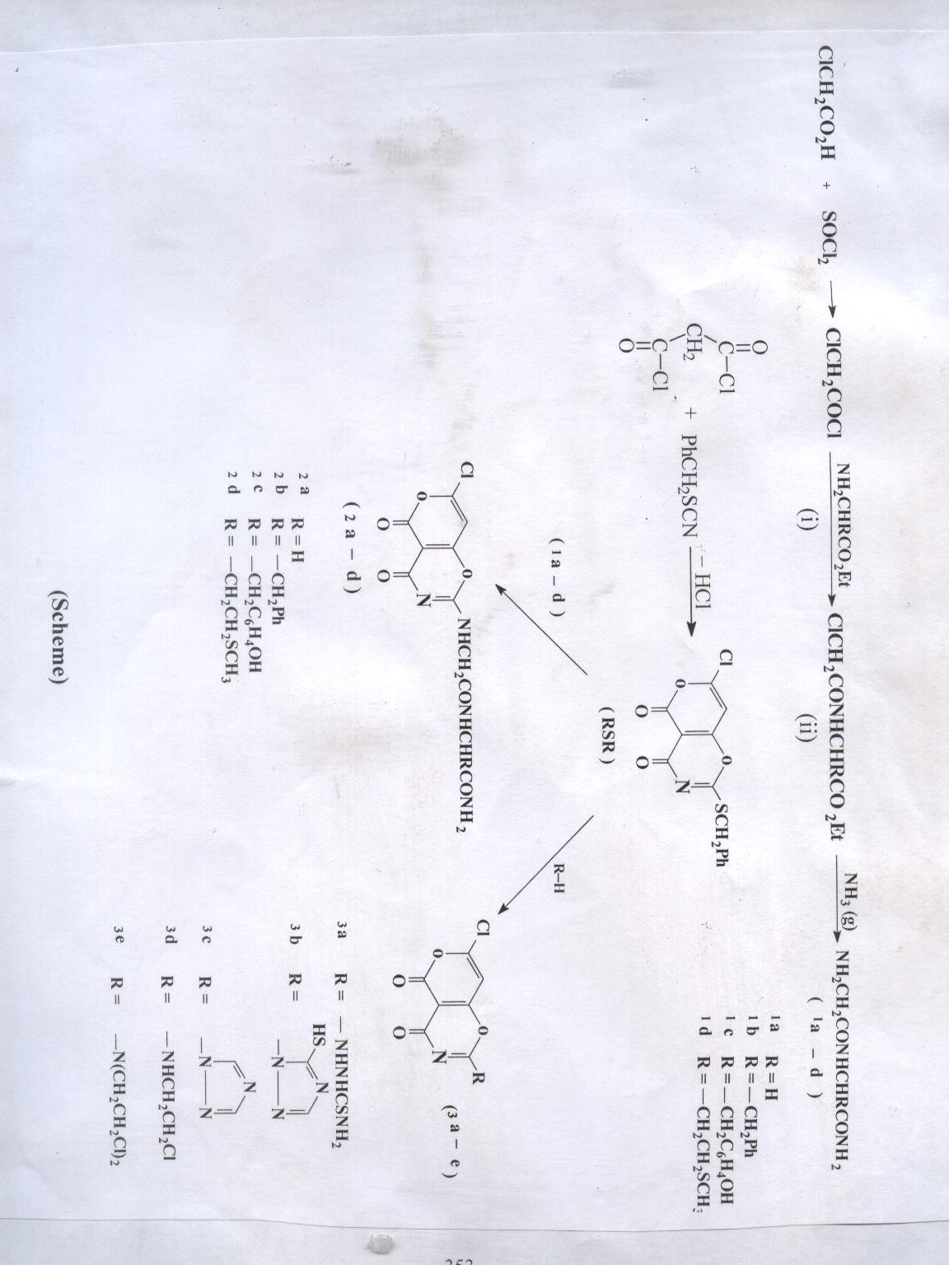
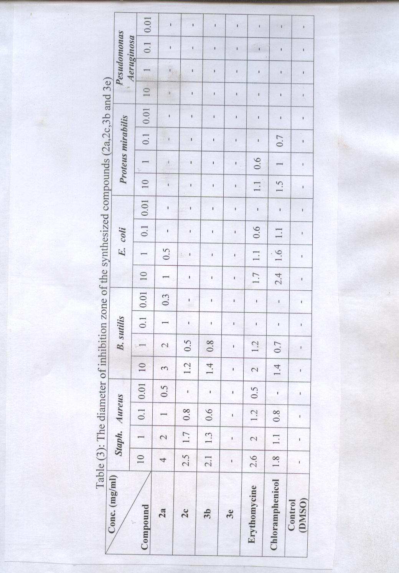
References
- S.J. Davis and J.A. Elvidge, J. Chem. Soc., 1962, 3553.
- M.A. Butt, J.A. Elvidge and A.B. Foster, J. Chem. Soc., 1963, 3069.
- J.AL-Rawi and J.A. Elvidge, J. Chem. Soc., 1973, 2432.
- M.S. AL-Ajely, M.Sc. Thesis, Mosul university,1978.
- OKa, Yoshikazu, Tomimsto and Mistumi, U.S.,.1970 , 598, 670 .
- Liu. Jingping, Ph.D. Thesis, Case Western Reserve University, Macro-molculer science 1995 , 220 .
- White, W. Ronald, Jr. Demult and Sp. Thomas U.S.P No 5, 434 , 147 (1995).
- L. Muntean, I. Grose, G. Ple and S. Mager, Monatch. Chem.2000 , 131, 975.
- P. Luzr, A. AL-Harrasi and HV. Reissig. Org. Lett. 2002, 4 (14) 2353.
- E. Palacios, G. Herran, G. Rubiales and J.M. Ezpeleta, J. Org. Chem. 2002, 67(7), 2131.
- A.R. Katritzky, C. Cai, K. Suzuki and SK. Singh, J. Org. Chem. 2004, 69 (3) , 811.
- J.M. AL-Rawi, M.S. Al-Ajely and K.D. Sulaiman; J. of Educ. and Sci., 1989, 7, 99.
- J. M. A. AL-Rawi, M. S. AL-Ajely; J. of Educ. and Sci, 1998 ,10, 39.
- H. AL-Mosawi, J.M.A. AL-Rawi and M.S. AL-Ajely; Arab Gulf. Sci, Res.,( 1990),1991, 9, 1.
- a- F.T. AL-Abachi and M. S. AL-Ajely 5th Pharmacy College Conference, university of Baghdad, Iraq, 1998.
b- F.T. AL-Abachi and M.S. AL-Ajely; Iraqi patent, 2000 No. 2807 .
- S. M. Kupehan, Y. Komoda, W. A. Court, G. J. Thomas, K. M. Smith, A. Karim, C. S. Gilmore, R. C. Haltivanger and K. F. Bryan; J. Am. Chem. Soc, 1972 , 94, 1354.
- S. M. Kupehan,Y. Komoda, G. J. Thomas and H. P. J. Himtz; J. Chem, Soc., Chem., Commun., 1972, 1065.
- L. Fisher, Mededel. Landouwhosch. Gent, (1963) 1965, 30.
- U. M. Theotino, L. Polo Friz, A. Gandinin and D. Bella, J. Med. Chem. 1963 ,6, 248.
- R.R. Ranaturge, P.S. Gavvy, D.R. Janero and LG LeHs, Bioorg. Med. Chem. 2004, 21 (6) 1357.
- E. S. West, W. R. Todd, H.S. Mason and J. T. Van Bruggen, text book of bio-chemistry, Mohan Primloni, Amerind publishing Co. part (d. 4th ed.); (1966)1429, S. Higa, H. A. Florsheim, Y. Schro and V. gold; Arch. Biochem . Bio-phys, (1960) 86, 204; C. A. vol. 54 (1960).
- S. Sishaukman, H.A Higa, H. FIorsheim, Y. Schro; J. Am. Chem. Soc., 1960, 82, 990.
- S.L-Selagali and M. Himaja; Indian J. Hetero. Chem. 1998, 11, (1) 8.
- L. Gay, J. Vidal, and A. Collet; J. Med. Chem. 1998, 24, 41, 2843.
- A.Ahmed Khayrollah, K. Y. Saour; 1st Regional Conference of Pharmatical Sciences, University of mosul. College of Pharmacy,2000, 12-13,
- M. Cashman, J. Juragj and J.D. Moyer, J. Org Chem., 1990, 55, 3186.
- R.E. Benson; Organic Synthesis; John Wiley and Sons, Inc., 1973, P. 1070.
- H.A. Basher, Ph.D. Thesis (2000), Mosul University.
- D.A. Shitey; Preparation of organic intermediate, John Willey and Sons, Inc, 1951, P. 243.
- H.W. Seely and P.J. Vandemerk, “ Microbes in action”, 3rd ed , Freeman and company, San Francisco, 1981 ,187.
- L.P. Garrod, H.P. Lamberat, D. Grady and P. Waterworth, “Antibiotic and chemotherapy", 5th ed., Churchill Livingstone, 1981.
- L.P. Garrod, H.P. Lamberat, D.Grady and P. Waterworth, "Antibiotic and Chemo-therapy", 5th ed., Churchill Livingstone,1981.

